NPFC-2026-SSC NFS04-WP10

Preliminary stock assessment of the winter-spring cohort of neon flying squid using the stochastic surplus production model in continuous time (SPiCT) from 2005 to 2024

Bungo Nishizawa*, Hajime Matsui, Osamu Sakai, and Kazuhiro Oshima

Fisheries Resources Institute, Japan Fisheries Research and Education Agency

*Corresponding Author
Email: nishizawa_bungo05@fra.go.jp

Summary
We applied the Stochastic Surplus Production Model in Continuous Time (SPiCT) to the winter–spring cohort of neon flying squid in the North Pacific, using annual total catch data reported by NPFC members, two fishery-dependent indices derived from Japanese and Chinese commercial fisheries, and a fishery-independent index obtained from the Japanese scientific driftnet survey. The assessment used data from the 20-year period of 2005–2024, during which annual catch data and all three indices were available, to estimate stock dynamics through 2025. For all input indices, the preliminary relationships with the annual catch data aligned with the general structural assumptions of the surplus production framework. The final parameter estimates were well constrained, with narrow confidence intervals; however, slight diagnostic issues remained in the retrospective analysis. The relative weights of the three indices estimated within the state-space model reflected difference in their reliability: the Chinese fishery CPUE exhibited the lowest estimated observation error, whereas the Japanese fishery CPUE showed the highest error, likely due to large annual fluctuations. The Japanese survey CPUE index occupied an intermediate position. The successful utilization of both fishery-dependent and fishery-independent indices within this state-space framework constitutes a valuable approach for future stock assessments of neon flying squid by the SSC NFS.

Introduction
The neon flying squid (Ommastrephes bartramii; NFS) is an oceanic squid distributed globally in subtropical and temperate waters (Roper et al. 1984). In the North Pacific Ocean, the NFS population consists of an autumn cohort and a winter–spring cohort (Yatsu et al. 1997, 1998). Both cohorts are commercially harvested by NPFC members, including China, Japan, Korea, Russia, Chinese Taipei, and Vanuatu, within the NPFC Convention Area. Previous studies evaluated the annual stock size of both cohorts based primarily on traditional surplus production models or depletion methods (Ichii et al. 2006, Chen et al. 2008, Wang et al. 2016). This report provides an updated application of the SPiCT model to the winter–spring cohort of NFS, incorporating both fishery-dependent and fishery-independent indices to enhance assessment robustness.

Methods

3.1 Catch data
We used the NPFC statistics (Annual Summary Footprint of the neon flying squid, https://www.npfc.int/summary-footprint-squid-fisheries), which include the annual catch of NFS fishery among NPFS members in the North Pacific between 1995 and 2025 (Fig. 1). Based on the agreement regarding separation of catch into two cohorts by the SSC NFS meeting (NPFC-2026-SSC NFS03-Final Report), we defined the NFS catches recorded in the waters west of 170°E as the “winter-spring cohort”.

3.2 Biomass index
We used three relative indices for the winter–spring cohort of NFS: (1) the standardized CPUE of the Chinese jigging fishery (NPFC-2026-SSC NFS03-WP08), (2) the standardized CPUE of the Japanese jigging fishery (NPFC-2026-SSC NFS04-WPXX), and (3) the standardized CPUE of the Japanese scientific driftnet survey (standardized CPUE in calendar year, NPFC-2026-SSC NFS04-WPXX) (Fig. 2).

3.3 SPiCT model
SPiCT is a stochastic surplus production model in continuous time (Pedersen and Berg 2017), that incorporates dynamics in both biomass and fisheries, as well as observation error of both catches and biomass indices, based on the generalized surplus production model in the form of Pella-Tomlinson (1969) (equation 1). The model has a general state-space framework that incorporates process and observation error, while also allowing the assumption of error-free catch data.

$$dB_{t}= \frac{r}{n-1}B_{t}\left(1-{\left[\frac{B_{t}}{K}\right]}^{n-1}\right)dt-F_{t}B_{t}dt+σ_{B}B_{t}dW_{t} (1)$$

where B_{t} is the exploitable stock biomass, F_{t} is the instantaneous fishing mortality rate in year t, r is the intrinsic growth rate of the population, K is the carrying capacity, n is a unitless parameter determining the shape of the production curve, $σ_{B}$ is the standard deviation of the biomass process noise, W_{t} is Brownian motion. Two common assumptions for the shape parameter n, which determines the skewness of the production curve, are: the Schaefer model that assumes a symmetrical production curve with MSY corresponding to the biomass at half of carrying capacity K (n = 2) and the Fox model that has an asymmetrical production curve with MSY at 37% of carrying capacity K (n → 1).

SPiCT can consider seasonal patterns in fisheries dynamics and allows setting of priors on the parameters. It can also provide estimates of exploitable biomass and fishing mortality at any point in time from data sampled at arbitrary and possibly irregular intervals. Biomass and fishing mortality are unobserved processes (random effects), while catch and indices are observed variables. SPiCT requires a catch time series and one or more biomass index time series and does not require life history parameters.

In this study, we selected a 20-year period from 2005 to 2024 for the stock assessment, during which annual total catch and all three indices were available. Five models with distinct parameter configurations were examined (Table 1). Starting with a fully noninformative model with no prior assumptions (M0), informative priors were introduced sequentially until realistic parameter estimates were achieved. The intrinsic growth rate (r) of squid species, including NFS, is known to be highly variable both among and within species, generally ranging from 0.3 to 2.4 (Table 2). Accordingly, the prior mean for the intrinsic growth parameter r was set to 1.5 based on previous study on NFS (1.19 from Ichii et al. 2006, and 1.71 from Wang et al. 2016) (Table 1). For the error structures, observation errors for catch and indices, and process error in biomass, were estimated without prior information in M0, M1, and M2. In models M3 and M4, informative priors were incorporated into the parameters alpha and beta, assuming equal process error and observation errors (logalpha = 0, logbeta = 0, Table 1). Furthermore, we examined a model incorporating prior information that the initial biomass fraction (B₂₀₀₅/K) was assumed to be 0.5 (with sd = 0.5 for M4), reflecting the historical fact that the commercial NFS fishery had been intensively conducted for many years prior to the data start year of 2005. In all models, the observation error for catch (sdc) was not fixed to zero. This is because cohort separation using the 170°E line cannot perfectly separate the cohorts, suggesting a slight mixture of the autumn cohort into the winter–spring cohort.

In SPiCT, the temporal dimension of the continuous-time model is numerically resolved using an Euler scheme that discretizes time into intervals of fixed length. To fit the biological characteristics of the target species, we configured the SPiCT Euler time step to one year (dteuler = 1). Since NFS have a short lifespan of only one year with complete annual generation turnover, an annual discrete-time difference framework is biologically more realistic than a continuous-time differential framework.

4. Results and discussion
The annual total catch of the winter-spring cohort of NFS showed a continuous declining trend over the 20-year period from 2005 to 2024 (Fig. 1). In the initial phase of the fishery (2005–2008), the annual total catch exceeded 120,000 tons. However, the catch sharply decreased to approximately 40,000–50,000 tons during the 2010s. In the recent decade, the decline intensified significantly, remaining at historical low levels thereafter. Throughout the entire time series, China consistently dominated the total harvest, accounting for the vast majority of the cumulative catch.

The long-term trends of the Japanese fishery CPUE and Chinese fishery CPUE were generally similar (Pearson’s r = 0.6), as both indices decreased sharply after 2006 (Fig. 2). However, the Chinese fishery CPUE was more stable with less annual variation, while the Japanese fishery CPUE showed much larger fluctuations. On the other hand, the Japanese survey CPUE showed a different trend from the commercial CPUEs in some specific years, such as its peak in 2008. Despite these short-term differences, the overall long-term decline was similar across all three indices, and they all reached low levels by 2024.

The input data diagnostic plots showed the preliminary relationships between the annual catch and each of the three indices before the final model optimization (Fig. 3). We found that the relationship between the survey CPUE and the effort proxy (catch divided by the index) was characterized by a negative slope; therefore, the optimal effort (Emsy guess) was estimated in all three indices. However, the Japanese fishery CPUE and the Japanese survey CPUE showed large data scatter in their regressions, and their initial Emsy guesses suggested much higher and less realistic production levels (around 380,000 tons and 200,000 tons, respectively).

To select the appropriate model, a diagnostic checklist consisting of seven criteria was applied to all runs from M0 to M4 (Table 3). All five models successfully achieved convergence (Criterion 1), maintained finite variance parameters (Criterion 2), and satisfied basic residual assumptions (Criterion 3), with their estimated production curves remaining within the realistic range (Criterion 5). However, the completely noninformative model (M0) failed to provide realistic credible intervals (Criterion 6) (Tables 3 and 4). Furthermore, the simpler models (M1 and M2) showed clear sensitivity to initial values (Criterion 7). In contrast, by introducing informative priors for the error structures and the initial biomass fraction, M3 and M4 successfully satisfied the remaining diagnostic criteria, although a slight retrospective bias was still observed (Criterion 4) (Figs 8 and 9). Further M3 and M4 were almost satisfactory with slight violations in the Q-Q plots associated with the Japanese fishery CPUE (Figs 4 and 5).

The main outputs from M 3 and M 4 are shown in Figures 6 and 7, and their parameter estimates are summarized in Table 4. The estimated intrinsic growth rate (r) was 0.86 for M3 and 0.88 for M4 (Table 4). The carrying capacity (K) was estimated at 560,224 tons for M3 and 735,406 tons for M4. The initial biomass fraction (B₂₀₀₅/K, bkfrac) was estimated at 0.86 for M3 and 0.55 for M4. The estimated value of the shape parameter (n) for both M3 and M4 was 3.74, which was greater than the initial prior mean (n=2), resulting in a rightward shift of the surplus production curve. This shape indicates that MSY would be achieved when Bmsy/K = 0.618 (Figs. 6 and 7). However, it remains unclear whether this higher Bmsy/K ratio compared to other marine fishes (an average of 0.404 for all fish species; Thorson et al. 2012) is biologically valid for this species, as squid species are generally characterized by short lifespans, high metabolic rates, and rapid growth (Arkhipkin et al. 2021).

The state-space framework automatically optimized the relative weights of the three indices by estimating their respective observation errors. The Chinese fishery CPUE exhibited the lowest estimated observation error (sdi_{China} = 0.37, 95% CI: 0.25–0.56), indicating that it provided the most consistent signal for tracking the long-term stock biomass dynamics. In contrast, the Japanese fishery CPUE showed the highest observation error (sdi_{Japan} = 0.85, 95% CI: 0.63–1.14), likely reflecting substantial interannual fluctuations. The Japanese survey CPUE occupied an intermediate position (sdi_{Survey} = 0.63, 95% CI: 0.46–0.87), capturing the biological fluctuations of the NFS stock with less influence from commercial fishery-related biases. The model successfully integrated the different sources of variability without excluding any input data, providing support for the reliability of the three-index approach.

In this document, we applied the Stochastic Surplus Production Model in Continuous Time (SPiCT) to the winter–spring cohorts of NFS, using the total catch data reported by NPFC members, two fishery-dependent indices, and a fishery-independent index (the Japanese fishery CPUE, the Chinese fishery CPUE, and the Japanese survey CPUE). Although some runs yielded statistically acceptable estimates, these results remain preliminary and should not be used to determine the stock status at this stage. Nevertheless, this document demonstrates that the SPiCT framework integrating multiple indices has strong potential as a robust tool for assessing the stock status of this species, consistent with its successful applications to other cephalopod stocks worldwide (e.g., Larivain et al. 2021).

References
Arkhipkin, A. I., Hendrickson, L. C., Payá, I., Pierce, G. J., Roa-Ureta, R. H., Robin, J.-P., and Winter, A. (2021) Stock assessment and management of cephalopods: advances and challenges for short-lived fishery resources. ICES Journal of Marine Science, doi:10.1093/icesjms/fsaa038. Johan Hjort Symposium 2019. 1-17.
Chen X., Chen Y., Tian S., Liu B., Qian W. (2008) An assessment of the west winter-spring cohort of neon flying squid (Ommastrephes bartramii) in the Northwest Pacific Ocean. Fisheries Research, 92: 221–230.
Csirke, J., A. Alegre, J. Argüelles, R. Guevara-Carrasco, M. Mariátegui, R. Segura, R. Tafúr & C. Yamashiro. (2015) Main biological and fishery aspects of the jumbo squid in the Peruvian Humboldt Current System. 3rd Meeting of the Scientific Committee.
Hendrickson, L.C., Brodziak, J., Basson, M., Rago, P. (1996) Stock assessment of northern shortfin squid in the northwest Atlantic during 1993. Northwest Fisheries Science Center Reference Document, 96-05g, pp. 1–63.
Ichii, T., Mahapatra, K., Okamura, H., and Okada, Y. (2006) Stock assessment of the autumn cohort of neon flying squid (Ommastrephes bartramii) in the North Pacific based on past large-scale high seas driftnet fishery data. Fisheries Research, 78: 286–297.
Larivain, A., M. Petroni, A. Iriondo, E. Abad, J. Valeiras, A. Moreno, D. Dinis, A. Rocha, V. Laptikovsky, JP. Robin, A.M. Power. (2021) North Eastern Atlantic cephalopods stock assessment in a data limited framework Surplus Production in a Continuous Time (SPiCT).
Mildenberger T.K., A. Kokkalis, C.W. Berg. (2022) Guidelines for the stochastic production model in continuous time (SPiCT).
Nishizawa B, Matsui H, Okamoto S, Oshima K (2024) Preliminary application of the stochastic surplus production model in continuous time (SPiCT) to neon flying squid in the North Pacific. NPFC-2024-SSC NFS01-WP12.
Payá I. (2023) Update of the Stochastic Production model in Continuous Time (SPiCT) apply to Dosidicus gigas in FAO area 87. SC11-SQ07. SPRFMO.
Pedersen M.W. and C.W. Berg. (2017) A stochastic surplus production model in continuous time. Fish and Fisheries 18 (2): 226–43.
Pella, J.J. and Tomlinson, P.K. (1969) A generalized stock production model. Bulletin of the Inter-American Tropical Tuna Commission 13: 421–458.
Roper CFE, Sweeney MJ, Nauen CE (1984) FAO species catalogue. Vol 3: cephalopods of the world. An annotated and illustrated catalogue of species of interest to fisheries. FAO Fish Synop 125, Rome.
Thorson, J. T., J. M. Cope, T. A. Branch and O. P. Jensen (2012) Spawning biomass reference points for exploited marine fishes, incorporating taxonomic and body size information. Can. J. Fish Aqua. Sci., 69: 1556–1568.
Urías-Sotomayor, R., G. Rivera-Parra, F. Martínez-Cordero, N. Castañeda-Lomas, R. Pérez-González, G. Rodríguez-Domínguez. (2018) Stock assessment of jumbo squid Dosidicus gigas in northwest Mexico. Lat. Am. J. Aquat. Res 46:2
Wang, J., Yu, W., Chen, X., and Chen, Y. (2016) Stock assessment for the western winter-spring cohort of neon flying squid (Ommastrephes bartramii) using environmentally dependent surplus production models. Scientia Marina, 80: 69–78.
Yatsu A, Midorikawa S, Shimada T, Uozumi Y (1997) Age and growth of the neon flying squid, Ommastrephes bartramii, in the North Pacific Ocean. Fish Res 29:257–270.
Yatsu A, Tanaka H, Mori J (1998) Population structure of the neon flying squid, Ommastrephes bartramii, in the North Pacific Ocean. In: Okutani T (ed) International symposium on large pelagic squids. Japan Marine Fishery Resources Research Center, Tokyo, p 31–48
Yatsu, A., Kinoshita, T. (2002) Application of surplus production model to Japanese common squid, Todarodes Parcificus, with independence parameters for high and low stock regimes. In: Report of the 2002 Meeting on Squid Resouces, Tohoku National Fisheries Research Institute, pp. 29–33 (in Japanese).

Table 1. Prior distributions and parameter configurations for the five sensitivity runs (Models M0 to M4) implemented in the SPiCT assessment for the winter–spring cohorts of NFS.

Table 2. Intrinsic growth rate (r) for squid species estimated by surplus production models.

Table 3. Diagnostic checklist for the acceptance of the SPiCT assessment across the five sensitivity models (M0 to M4). The symbols Y and N denote Yes (checklist passed) and No (checklist failed), respectively.

Table 4. Summary of SPiCT model parameter estimates and stock status across the five model runs (Models M0 to M4) for the winter–spring cohorts of NFS.

Fig. 1. Annual catch of the winter-spring cohorts (catch from the water west of 170°E) of NFS by NPFC members from 2005 to 2025. Annual total catch from all members was used for the SPiCT run. Data are obtained from the NPFC Annual Summary Footprint.

Fig. 2. Time series of the three relative indices for the winter-spring cohorts of NFS, used as input data for the SPiCT assessment from 2005 to 2024. The lines show the commercial fishery CPUE for Japan (red) and China (blue), and the Japanese survey CPUE (black). The Chinese fishery CPUE data were obtained from NPFC-2026-SSC NFS03-WP08.
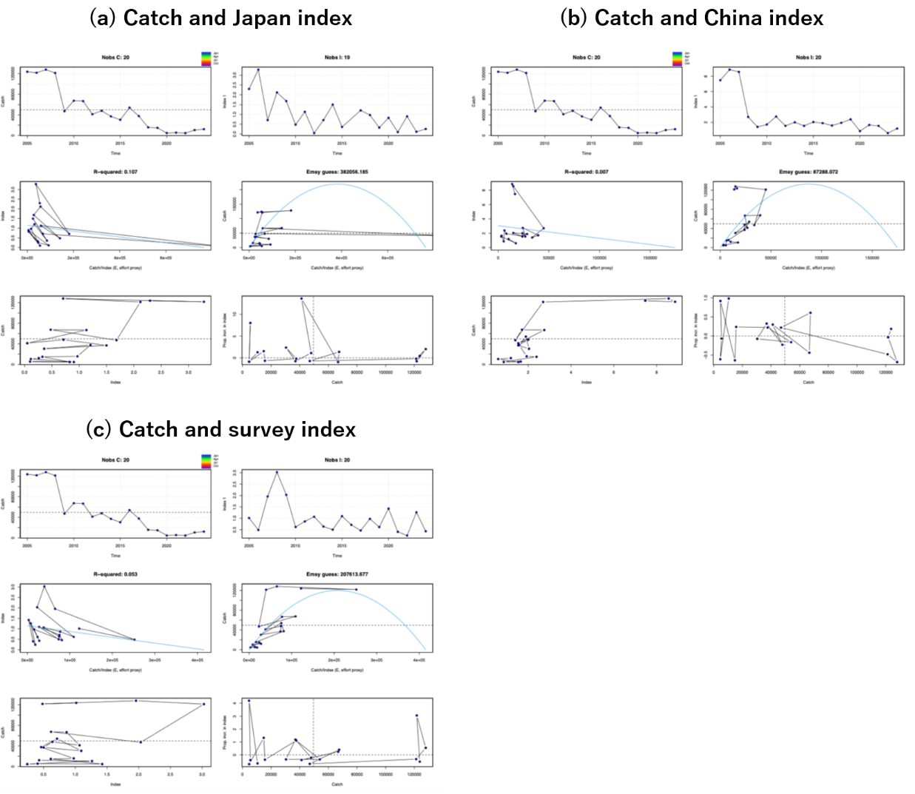
Fig. 3. Input data diagnostic plots for the winter–spring cohorts of NFS, showing the relationships between annual catch and the three indices: (a) Japan fishery index, (b) China fishery index, and (c) Japanese survey CPUE. Each panel illustrates the initial data exploration, including time series of inputs, effort proxy correlations, and initial biomass-production trajectory guesses before the final SPiCT optimization.
Fig. 4. Residual diagnostic plots of the SPiCT model derived from Model 3 (M3) for the winter–spring cohorts of NFS. Panels from left to right display the diagnostics for log catch, log Index 1 (Japanese fishery CPUE), log Index 2 (Chinese fishery CPUE), and log Index 3 (Japanese Survey CPUE). Plots from top to bottom illustrate the log data series, one-step-ahead (OSA) residuals with bias p-values, autocorrelation functions (ACF) with Ljung-Box p-values, and QQ-plots with Shapiro-Wilk normality p-values.
Fig. 5. Residual diagnostic plots of the SPiCT model derived from Model 4 (M4) for the winter–spring cohorts of NFS. Panels from left to right display the diagnostics for log catch, log Index 1 (Japanese fishery CPUE), log Index 2 (Chinese fishery CPUE), and log Index 3 (Japanese Survey CPUE). Plots from top to bottom illustrate the log data series, one-step-ahead (OSA) residuals with bias p-values, autocorrelation functions (ACF) with Ljung-Box p-values, and QQ-plots with Shapiro-Wilk normality p-values.
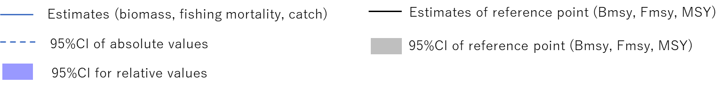

Fig. 6. Main output plots of the SPiCT assessment derived from Model 3 (M3) for the winter–spring cohorts of NFS. The panels display the estimated time series of absolute and relative biomass (with 95% confidence intervals), fishing mortality, catch fits, Kobe plot, production curve, time to stock recovery (Bmsy), and prior-to-posterior density distributions for the shape parameter n.

Fig. 7. Main output plots of the SPiCT assessment derived from Model 4 (M4) for the winter–spring cohorts of NFS. The panels display the estimated time series of absolute and relative biomass (with 95% confidence intervals), fishing mortality, catch fits, Kobe plot, production curve, time to stock recovery (Bmsy), and prior-to-posterior density distributions for the shape parameter n.

Fig. 8. Retrospective analysis plots with 5-year data peels for Model 3 (M3) of the winter–spring cohorts of NFS, showing the retrospective trajectories and Mohn’s ρ values for both absolute and relative estimates of biomass and fishing mortality.
Fig. 9. Retrospective analysis plots with 5-year data peels for Model 4 (M4) of the winter–spring cohorts of NFS, showing the retrospective trajectories and Mohn’s ρ values for both absolute and relative estimates of biomass and fishing mortality.
.

