NPFC-2026-SSC NFS04-WP09

Standardized CPUE for the autumn and winter-spring cohorts of neon flying squid based on Japanese driftnet surveys from 2001 to 2025

Bungo Nishizawa*, Hajime Matsui, Osamu Sakai, and Kazuhiro Oshima

Fisheries Resources Institute, Japan Fisheries Research and Education Agency

*Corresponding Author
Email: nishizawa_bungo05@fra.go.jp

- Summary
We standardized the catch per unit effort (CPUE) for the autumn and winter–spring cohorts of neon flying squid (Ommastrephes bartramii) using data from Japanese driftnet surveys conducted in the western North Pacific from 2001 to 2025. Captured individuals were separated into specific cohorts based on their mantle length. Generalized additive models (GAMs) were applied to standardize the CPUE by incorporating temporal (year and ten-day period), spatial (latitude and longitude), and environmental (sea surface temperature) variables. The standardized CPUE series generally tracked the nominal CPUE trends for both cohorts. These standardized indices can serve as a robust, fishery-independent abundance index for future stock assessments of this species.

Introduction
The neon flying squid (NFS) is an oceanic species that is widely distributed throughout subtropical and temperate waters around the world (Roper et al. 1984). In the North Pacific, the population comprises two distinct seasonal cohorts: an autumn cohort and a winter-spring cohort (Yatsu et al. 1997, 1998). To elucidate the interannual variations in the abundance of these seasonal cohorts, Japan has conducted annual driftnet surveys in the western North Pacific since 2001, providing fishery-independent catch-per-unit-effort (CPUE) data for both cohorts. The CPUE was standardized using a generalized additive model (GAM) that accounted for temporal, spatial, and environmental variables.

Methods
The research vessel Kaiun-maru (Aomori Prefecture, Japan) was deployed to conduct annual driftnet surveys from June to August in the western North Pacific. Surveys were carried out at 14–26 sites each year from 2001 to 2025 (Table 1). Sampling sites were generally located along three longitudinal lines at 144°E, 155°E, and 175.5°E between 30°N and 50°N. At each station, 50 net panels were deployed in the evening and retrieved at sunrise the following morning, with an operational duration of 10–13 hours. Each panel measured 50 m in length and 7 m in depth. To collect various sizes of NFS, the survey employed non-size-selective driftnets consisting of 14 mesh sizes ranging from 22 to 157 mm. The dorsal mantle length (ML) of all NFS caught was measured onboard to the nearest 1 cm.

Between 2001 and 2025, a total of 30,154 NFS were collected during the driftnet surveys. The size distribution of collected NFS exhibited a bimodal distribution, with a boundary of 31 cm ML (Fig. 1). Individuals with an ML of <31 cm and ≥31 cm were classified as the winter-spring cohort and the autumn cohort, respectively (Ichii et al. 2004, Nishizawa et al. 2024).

The winter-spring cohort (individuals < 31 cm ML) was predominantly caught by driftnets with small mesh sizes (93 mm or less), whereas the autumn cohort (individuals ≥ 31 cm ML) was caught by driftnets with large mesh sizes (106 mm or more). Accordingly, the effort corresponding to the catch of each cohort was defined as the number of large-mesh driftnet panels for the autumn cohort, and small-mesh panels for the winter–spring cohort.

CPUE Standardization was conducted following the NFS standardization protocol (NPFC-2024-SSC NFS01-WP02). We developed generalized additive models (GAM) for each cohort. Full model was expressed in the following equation.

$$Squid catch \sim Year+Tendays+te\left(Lat, Lon\right)+s\left(SST\right)+offset(Effort)$$

The response variable was the total number of NFS caught at each driftnet site (n = 466), assuming a negative binomial distribution. Explanatory variables included survey year and ten-day period (late-June, early-July, mid-July, late-July, and early-August) as categorical fixed effects. Environmental factors, such as sea surface temperature (SST), are known to influence the catch rates and spatial distribution of various squid species (e.g., Chen 2010); therefore, in situ SST was incorporated as a continuous predictor using a univariate thin-plate regression spline smooth [s(SST)]. To model spatial variations, a two-dimensional tensor product smooth [te(Lat, Lon)] was used because the study area is longitudinally elongated, and the sampling density differs between axes, being denser along the latitudinal gradient and sparser along the longitudinal gradient (Figs 2 and 3). The tensor product smooth effectively accounts for these differences in scale and sampling intervals by allowing independent smoothing for latitude and longitude. Furthermore, to account for unequal survey effort across sites, the log-transformed number of driftnet panels in the corresponding mesh-size classes used at each sampling site was incorporated as an offset term.

Eight candidate models, all including Year and offset terms, were evaluated for each cohort (Table 2). The best model was selected based on the lowest Akaike Information Criterion (AIC) value, where models with a delta AIC < 2 were considered to be similarly well supported (Burnham and Anderson 2010).

Time series of standardized CPUE were estimated using the best model. To calculate the predicted CPUE values, a spatial grid of explanatory variables was generated using the expand.grid function in R software, constrained within the observed minimum and maximum ranges of latitude and longitude from the dataset. The annual standardized CPUE was then calculated as the mean of these predicted values for each year. Finally, 95% confidence intervals for the standardized CPUE were estimated via residual bootstrapping with 1,000 replications.

Results and discussion
The spatial distributions of CPUE for the autumn and winter-spring cohorts are shown in Figures 2 to 4. The autumn cohort was distributed predominantly in the eastern part of the study area, and this spatial pattern seemed consistent across years. The cohort had a higher CPUE at the operational sites east of 170°E between 40 and 45°N. In contrast, the winter-spring cohort showed a wider distribution range. The CPUE of this cohort seemed to be higher at the operational sites west of 160°E. These results are generally consistent with findings from previous works (e.g., Yatsu et al. 1998, Chen and Chiu 2003, Ichii et al. 2009).

Based on AIC, the full model was selected as the best model for both cohorts (Table 2). For the autumn cohort, two models fell within the delta AIC < 2 threshold; although the full model was not the one with the absolute lowest AIC, it was selected to enable a direct comparison between the two cohorts.

Percentages of deviance explained for the autumn and winter-spring models were 60% and 59%, respectively. The diagnostics of the best model for each cohort are shown in Figures 5 and 6. For both cohorts, the Q-Q plots from gam.check function in R showed an adequate model fit, with no substantial departures from the assumed error distribution. In addition, the plots of residuals versus linear predictors and annual boxplots of deviance residuals showed no clear evidence of heteroscedasticity, with residual medians consistently near zero. These diagnostics confirmed that the model provided an adequate fit to the data and showed no evidence of severe annual bias or systematic errors.

We found that the effect of sea surface temperature (SST) on CPUE differed markedly between the two cohorts. Specifically, the CPUE for the autumn cohort peaked in areas with SSTs ranging from 13°C to 15°C, whereas the winter–spring cohort exhibited higher CPUE in warmer waters around 22–24°C (Figs 7 and 8). This may reflect that the autumn cohort, particularly females, migrates farther north to feed than the winter-spring cohort (Ichii et al. 2009).

The time series of standardized and nominal CPUE for each cohort are shown in Figure 9. For both cohorts, the standardized CPUE closely tracked the nominal trends. For the autumn cohort, the standardized index exhibited high fluctuations, peaking marked in 2004, 2006, and 2009, with noticeably widened 95% confidence intervals during these high-abundance years.
The winter–spring cohort displayed a pronounced peak during 2007–2008, followed by a decline to a lower, stable level throughout the 2010s. Notably, a sharp increase in CPUE occurred in 2025, albeit with substantial uncertainty. This widened confidence interval reflects the effect of spatial sampling bias and extreme localized overdispersion in the catch data. Similarly, the wide confidence intervals observed prior to 2006 can be explained by a lack of survey coverage in the western part of the study area (Fig. 3), where CPUE is generally high.

This study presents cohort-specific abundance indices for the NFS. These fishery-independent indices, derived from the Japanese driftnet survey, will be highly valuable for integration into future stock assessments conducted by the SSC NFS.
References
Burnham KP, Anderson DR (2010) Model selection and multi-model inference: a practical information-theoretic approach, 2nd edn. Springer, New York
Chen C and Chiu T (2003) Variations of life history parameters in two geographical groups of the neon flying squid, Ommastrephes bartramii, from the North Pacific. Fisheries Research 63:349–366
Chen, CS (2010) Abundance trends of two neon flying squid (Ommastrephes bartramii) stocks in the North Pacific. ICES J. Mar. Sci. 67: 1336–1345
Ichii T, Mahapatra K, Sakai M, Inagake D, Okada Y (2004) Differing body size between the autumn and the winter−spring cohorts of neon flying squid (Ommastrephes bartramii) related to the oceanographic regime in the North Pacific: a hypothesis. Fisheries Oceanography 13: 295−309
Ichii T, Mahapatra K, Sakai M, Okada Y (2009) Life history of the neon flying squid: effect of the oceanographic regime in the North Pacific Ocean. Mar Ecol Prog Ser 378: 1−11
Matsui H, Nishizawa B, Okamoto S, Oshima K (2025) Estimation of the relationship between size box categories and the mantle length composition of neon flying squid caught by Japanese squid jigging vessels. NPFC-2025-SSC NFS02-WP04
Matsui H, Nishizawa B, Okamoto S, Oshima K (2026) Size composition of neon flying squid caught by Japanese squid jigging vessels in waters east of 170°E in 2025 and a preliminary estimation of catch by cohort. NPFC-2026-SSC NFS03-WP05 (Rev. 1)
Nishizawa B, Matsui H, Okamoto S, Oshima K (2024) Standardizing catch per unit effort for the autumn and winter-spring cohorts of neon flying squid based on Japanese driftnet surveys. NPFC-2024-SSC NFS01-WP09
Roper CFE, Sweeney MJ, Nauen CE (1984) FAO species catalogue. Vol 3: cephalopods of the world. An annotated and illustrated catalogue of species of interest to fisheries. FAO Fish Synop 125, Rome
Yatsu A, Midorikawa S, Shimada T, Uozumi Y (1997) Age and growth of the neon flying squid, Ommastrephes bartramii, in the North Pacific Ocean. Fisheries Research 29:257–270
Yatsu A, Tanaka H, Mori J (1998) Population structure of the neon flying squid, Ommastrephes bartramii, in the North Pacific Ocean. In: Okutani T (ed) International symposium on large pelagic squids. Japan Marine Fishery Resources Research Center, Tokyo, p 31–48
Table 1. Summary of Japanese driftnet surveys and nominal CPUE (the number of individuals per driftnet panel) and standardized CPUE for the autumn and winter-spring cohorts of Ommastrephes bartramii between 2001 and 2025.

Table 2. Results of model selection based on AIC for the autumn and winter-spring cohorts of Ommastrephes bartramii. The best model for each cohort is shown in bold.

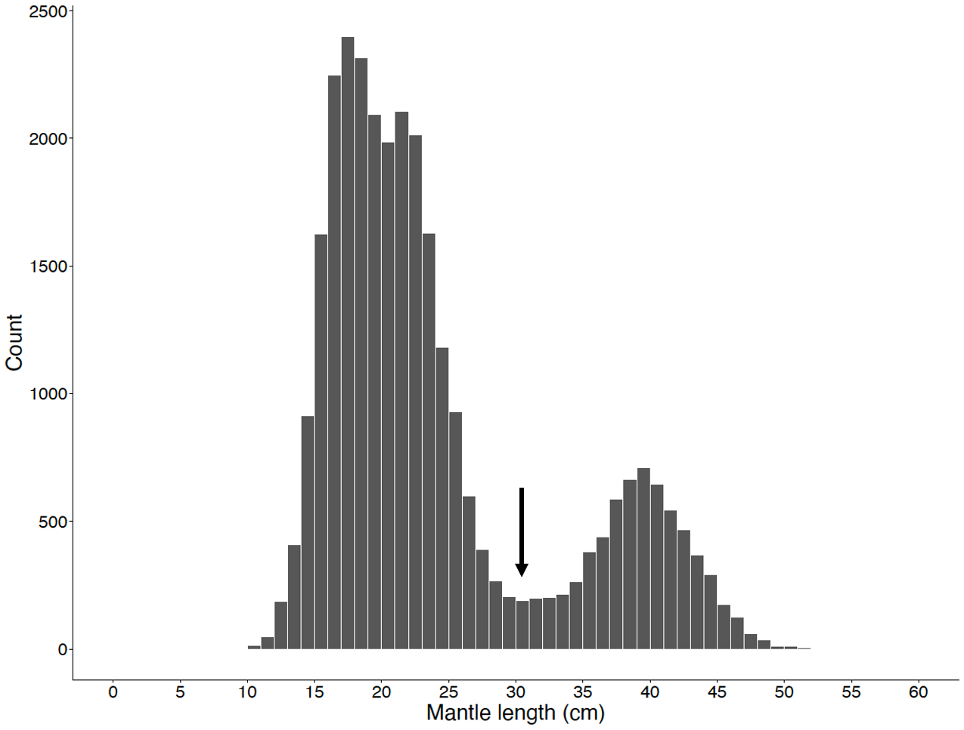
Fig. 1. Histogram for mantle length of Ommastrephes bartramii (n = 30,154 individuals) caught by survey driftnets during 2001–2025. The black arrow indicates the 31 cm boundary, separating the two cohorts (autumn and winter-spring cohorts).

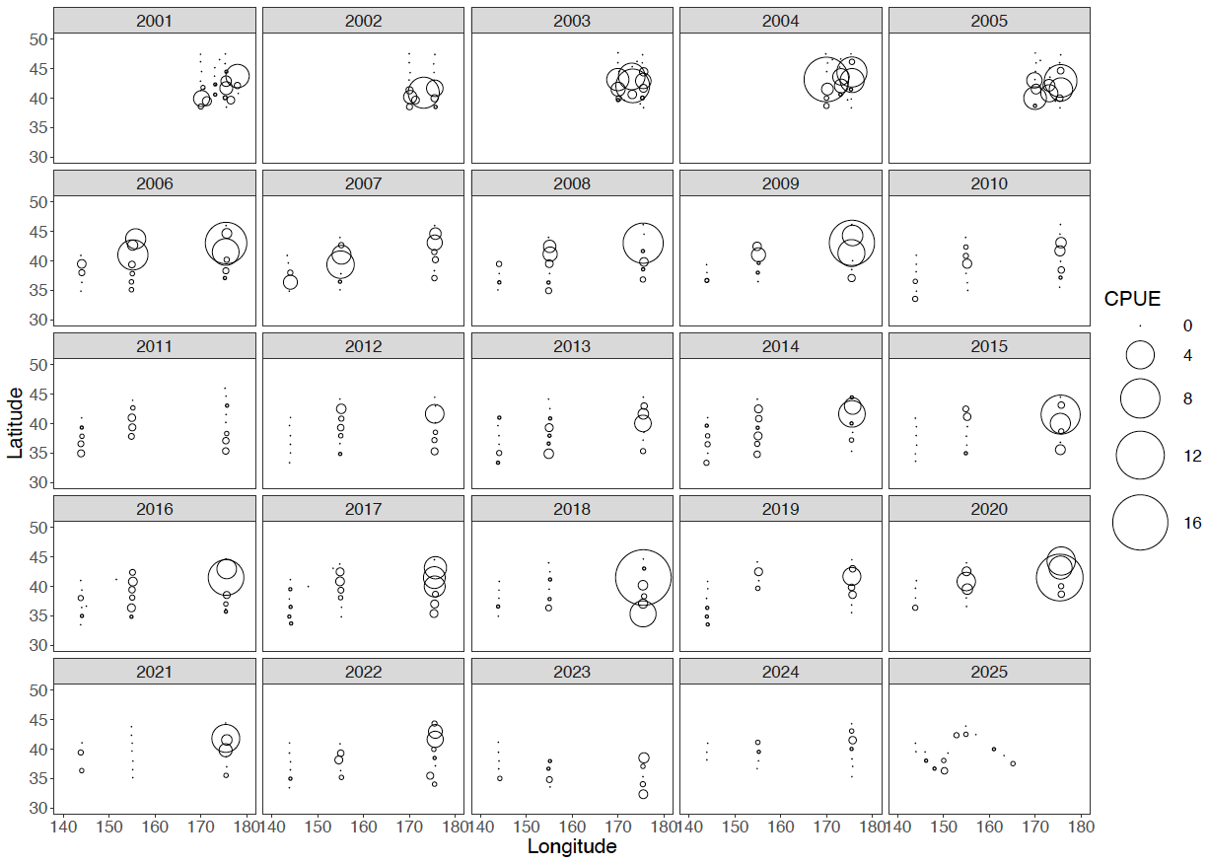
Fig. 2. Interannual changes in the spatial distribution of CPUE for the autumn cohort of neon flying squid (Ommastrephes bartramii) collected during the driftnet surveys from 2001 to 2025. Circle sizes are proportional to the CPUE values.

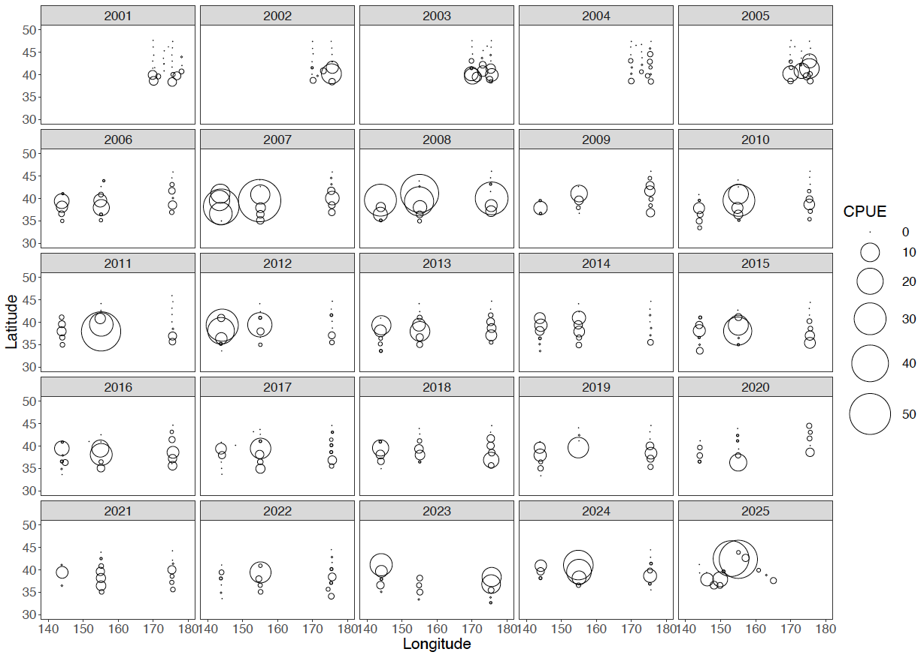
Fig. 3. Interannual changes in the spatial distribution of CPUE for the winter-spring cohort of neon flying squid (Ommastrephes bartramii) collected during the driftnet surveys from 2001 to 2025. Circle sizes are proportional to the CPUE values.

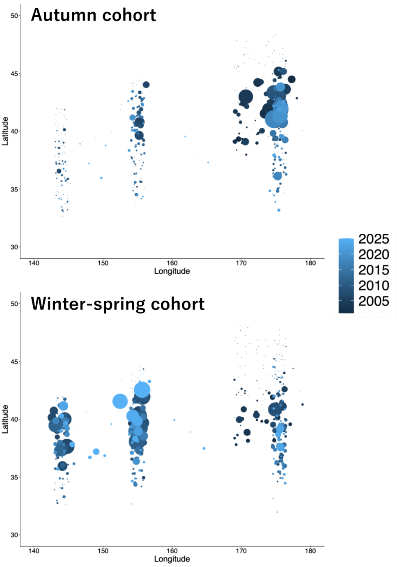
Fig. 4. Spatial distribution of CPUE for the autumn cohort and winter-spring cohort of Ommastrephes bartramii collected by survey driftnets from 2001 to 2025. Circle size indicates CPUE and colors distinguish survey years. For illustration purposes, each dot is a jitter point to avoid overplotting.

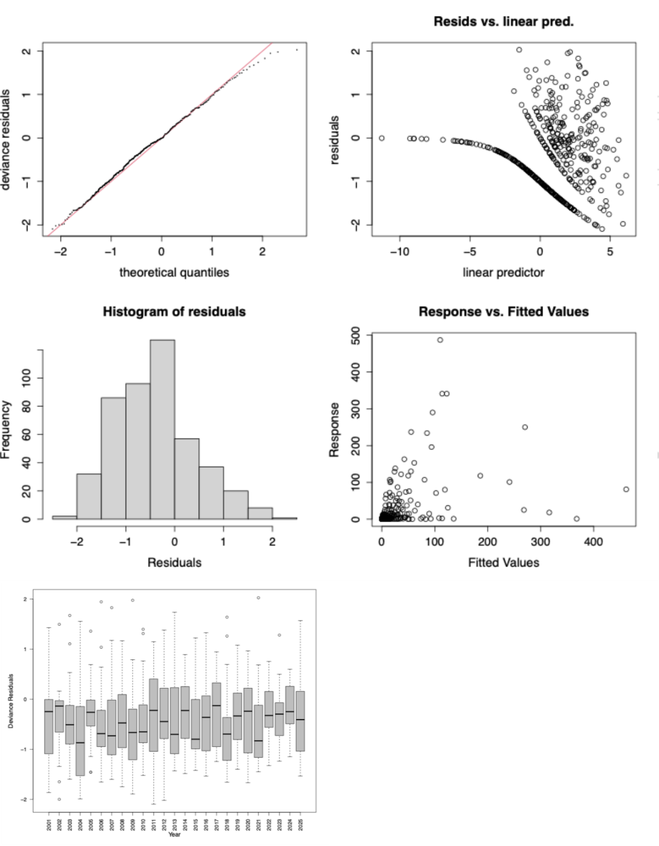
Fig. 5. Diagnostics of the best model for the autumn cohort, including Q-Q plot, histogram of residuals, residual plots across years, and the relationship between observed and fitted values.

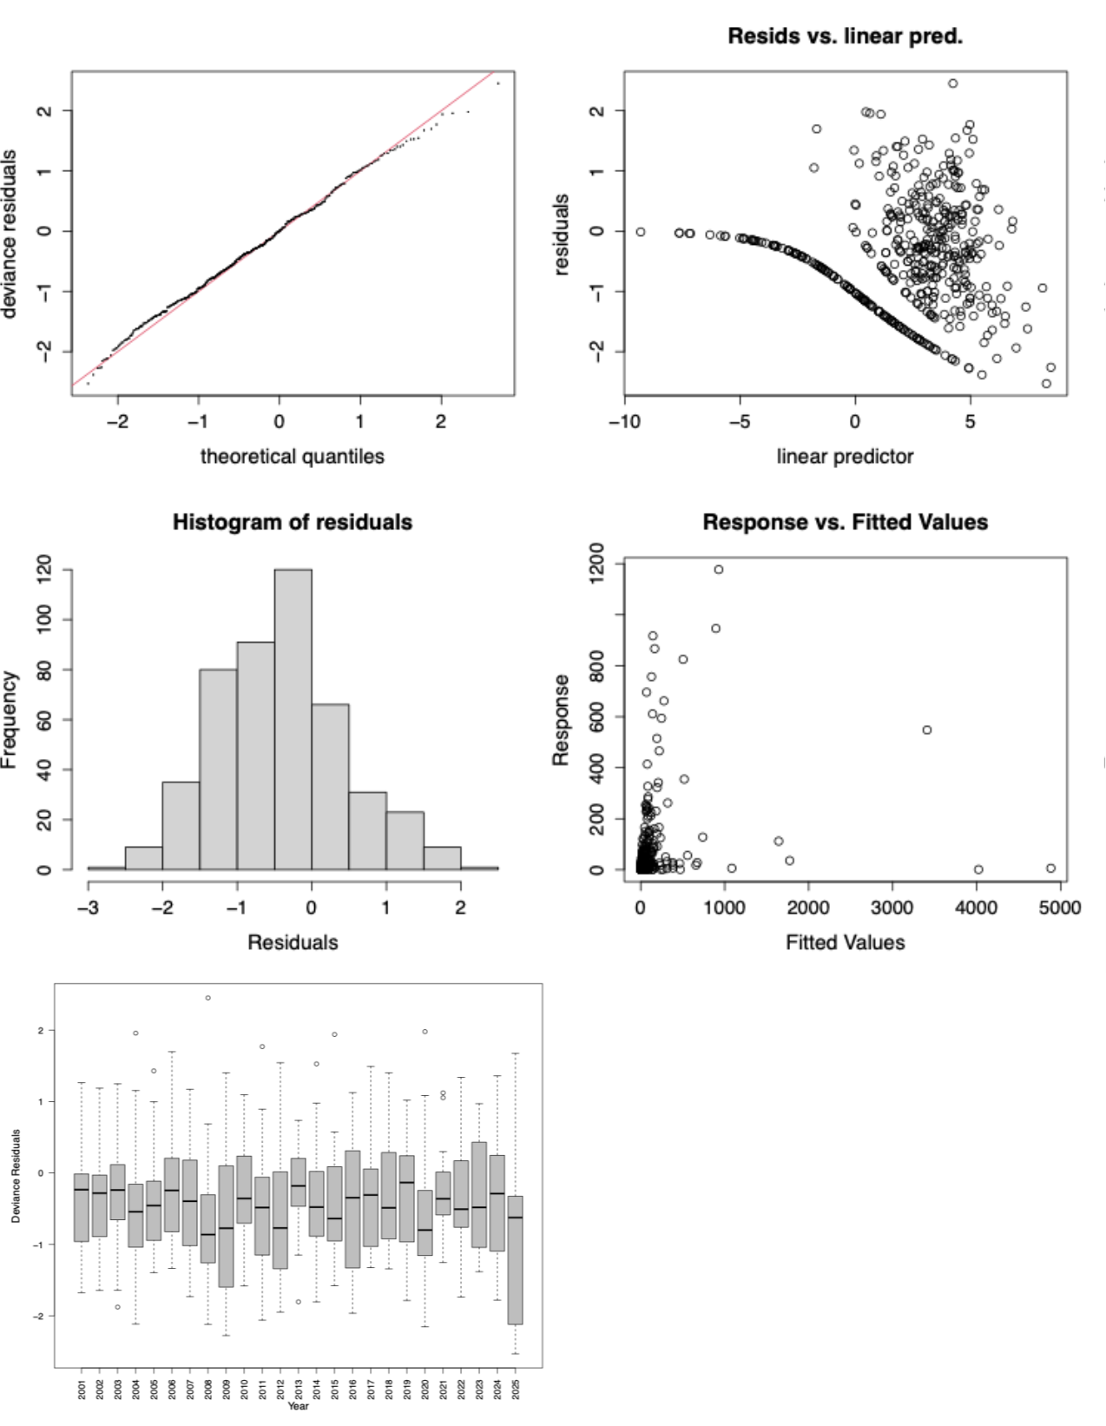
Fig. 6. Diagnostics of the best model for the winter-spring cohort, including Q-Q plot, histogram of residuals, residual plots across years, and the relationship between observed and fitted values.

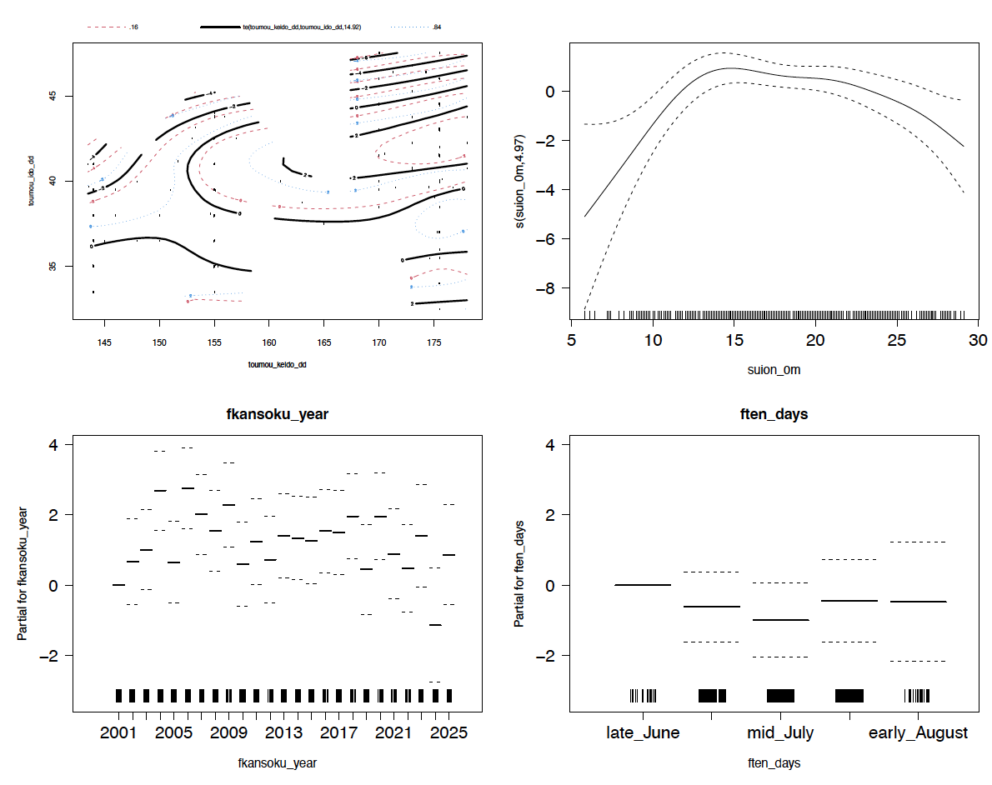
Fig. 7. GAM-derived effect of explanatory variables (a: Lat and Lon, b: SST, c: Year) on CPUE for the autumn cohort in the best model. The dotted lines indicate the 95% conﬁdence intervals, and the solid line shows the ﬁtted GAM function that describes the effect of a predictor variable on CPUE. The relative density of data points is shown by the rug plot on the x-axis.

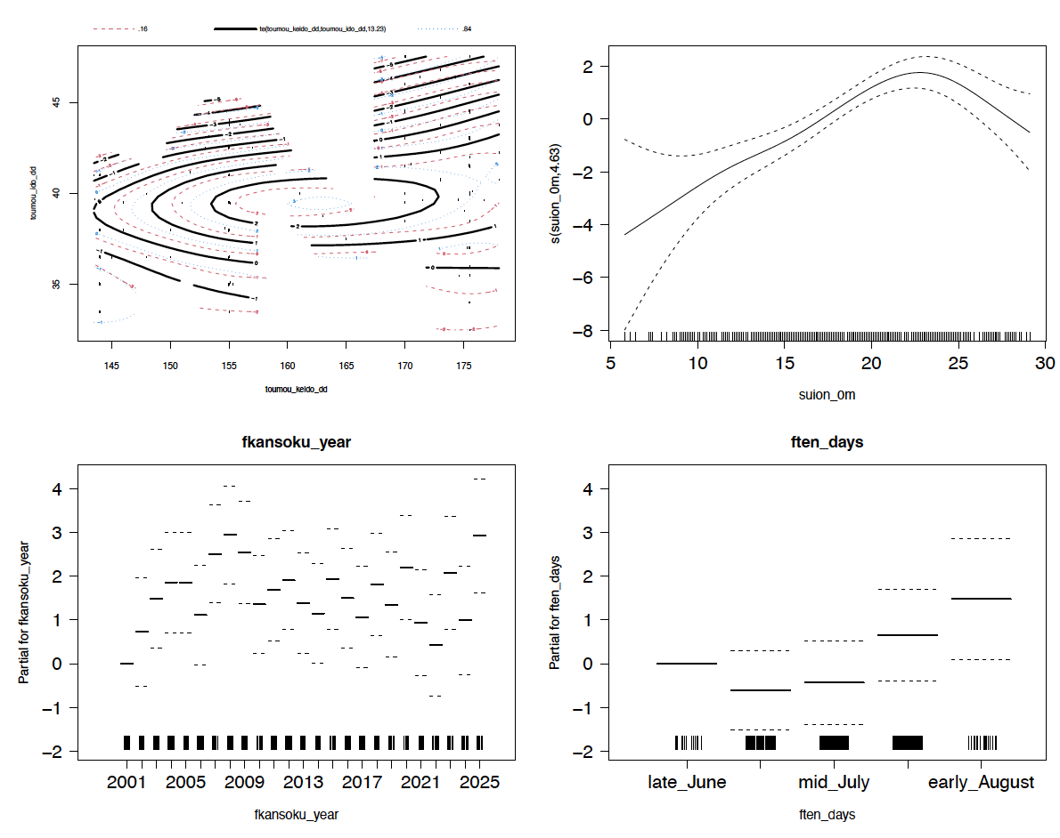
Fig. 8. GAM-derived effect of explanatory variables (a: Lat and Lon, b: SST, c: Year, d: Ten-days) on CPUE for the winter-spring cohort in the best model. The dotted lines indicate the 95% conﬁdence intervals, and the solid line shows the ﬁtted GAM function that describes the effect of a predictor variable on CPUE. The relative density of data points is shown by the rug plot on the x-axis.

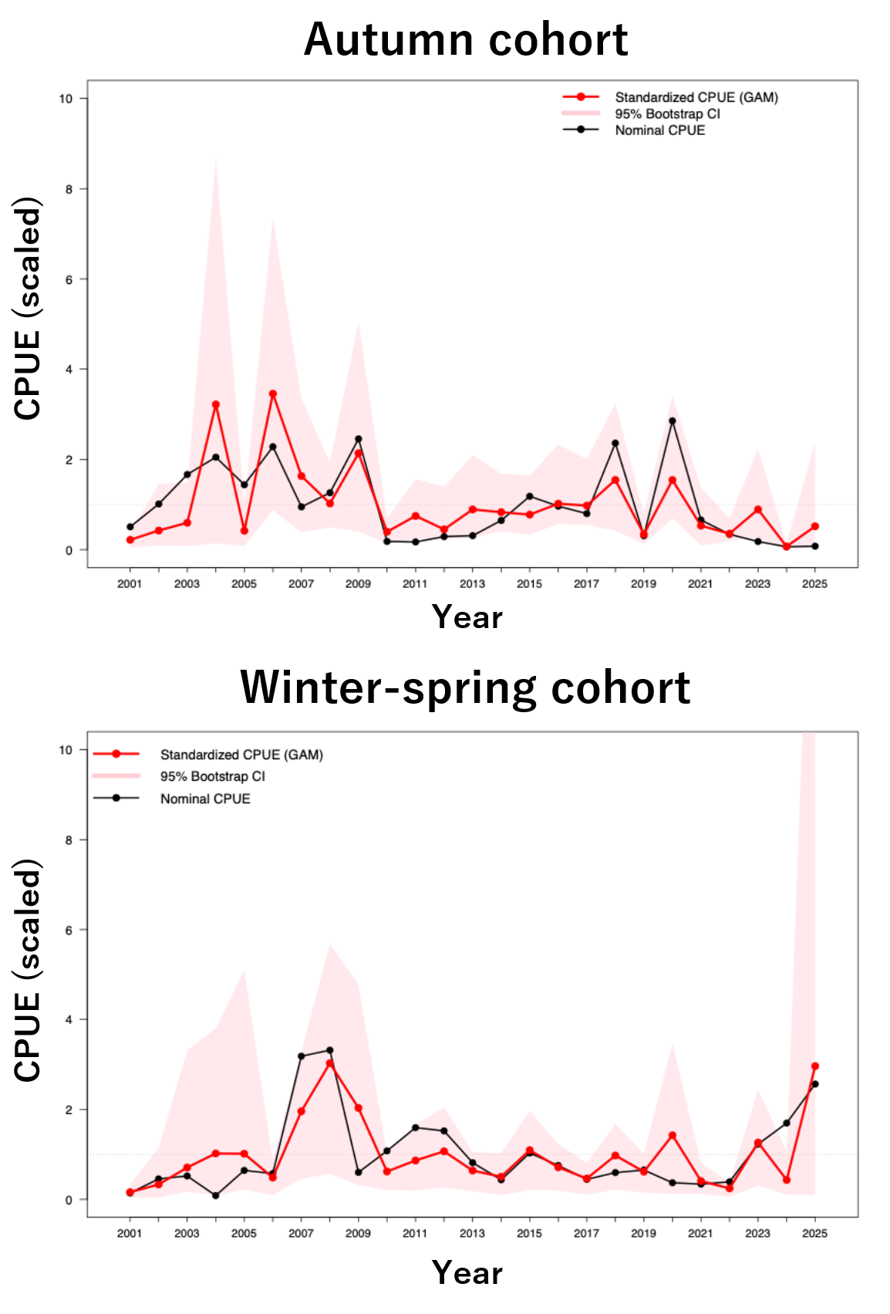
Fig. 9. Interannual changes in CPUE for the autumn and winter-spring cohorts of Ommastrephes bartramii. The black and red lines indicate nominal and standardized CPUE, respectively. The shaded red areas indicate the 95% bootstrap confidence intervals, obtained by resampling the data 1,000 times.

