NPFC-2026-SSC NFS04-WP07
Updated stock assessment of Neon flying squid in the Northwest Pacific using JABBA model up to 2025
Mingyan Song, Jintao Wang
Shanghai Ocean University

SUMMARY
This study provides an updated stock assessment of neon flying squid in the Northwest Pacific Ocean through 2025 using JABBA (Just Another Bayesian Biomass Assessment). The assessment incorporated NPFC-compiled catch data and Chinese squid-jigging CPUE series, including nominal CPUE and standardized CPUE indices derived from generalized additive model (GAM), random forest (RF), and gradient boosting model (GBM). A total of 12 assessment scenarios were conducted, combining three stock units (winter–spring cohort, autumn cohort, and stock-wide population) with four abundance indices. The stock-wide assessment based on GAM-standardized CPUE was selected as the base-case scenario, with additional retrospective analysis and short-term projections conducted. All assessment scenarios showed satisfactory convergence and model diagnostics. The results indicated consistent declines in fishing mortality in recent years, while estimated biomass levels varied among CPUE scenarios. The autumn cohort showed relatively consistent stock status across different CPUE scenarios, whereas the winter–spring cohort and stock-wide assessments showed more conservative stock status when standardized CPUE indices were applied. Projection results suggested that lower catch levels would support stock recovery, while higher fishing pressure could increase the risk of stock depletion. These findings provide updated information on neon flying squid stock status and highlight the importance of considering multiple CPUE scenarios in future assessments under the NPFC management framework.

1. Introduction
The neon flying squid is an important fishery resource in the Northwest Pacific Ocean. Its short life cycle results in substantial interannual fluctuations in stock abundance (Yatsu et al., 1997; Wang et al., 2016). Because complete age-structured data are unavailable, surplus production models provide a practical approach for evaluating stock status using annual catch and relative abundance indices (Winker et al., 2018).
This study builds on the working paper NPFC-2026-SSC NFS03-WP10 submitted at the previous meeting and updates the catch and CPUE data through 2025. In response to the technical suggestions raised during SSC NFS03, improvements were made to the JABBA assessment framework, including parameter settings, convergence diagnostics, and sensitivity analyses. The objectives of this study were to update the JABBA assessments for the winter–spring cohort, autumn cohort, and stock-wide population, and to provide updated information to support future stock assessments and management of neon flying squid.

2. Materials and Methods

2.1. Input Data
Annual catch and fishing-effort data were obtained from the NPFC compilation “NPFC-2026-AR-Annual Summary Footprint - Squids (Rev. 2)”. This dataset summarizes neon flying squid catch and fishing-effort data submitted by NPFC members and was updated through 2025 (Fig. 1). The assessment period covered 2005–2025 for the winter-spring cohort and the stock-wide population, and 2012–2025 for the autumn cohort, consistent with the availability of the Chinese CPUE data.
Relative abundance indices were derived from the Chinese squid-jigging fishery and included nominal CPUE and standardized CPUE estimated using a generalized additive model (GAM), random forest (RF), and gradient boosting model (GBM). Figure 2 shows the interannual variation in the four CPUE indices. The standardized indices and their annual standard errors were obtained from the companion CPUE standardization study.

2.2. Stock assessment model
The stock assessment was conducted using JABBA (Just Another Bayesian Biomass Assessment), a Bayesian state-space surplus production model. JABBA accounts for both process error in population dynamics and observation error in the CPUE indices, and estimates changes in stock biomass together with their associated uncertainty (Winker et al., 2018). The Schaefer production function was applied:
SP=$\frac{r}{m-1}B\left[1-{\left(\frac{B}{K}\right)}^{m-1}\right]$ (1)
where SP is the surplus production, B is the exploitable biomass, r is the intrinsic rate of growth and K is the carrying capacity. This form assumes a symmetric production curve where the biomass at maximum sustainable yield (MSY) is B_{MSY}=K/2. The Schaefer model is widely applied in cephalopod stock assessments and provides a parsimonious and stable model for data-limited situations (Wang et al., 2016).
The observation equation was:
${\text{I}}_{\text{i}\text{，}\text{y}}$=${\text{q}}_{\text{i}}{\text{B}}_{\text{i}}{\text{e}}^{{\text{ε}}_{\text{y}\text{,}\text{i}}}$ (2)
where I_{i,y} is the abundance index from series i in year y, q_{i} is the catchability coefficient for that series, and ε_{y,i} is the observation error, assumed to follow a normal distribution: ${\text{ε}}_{\text{y,i}}\text{\sim }\text{N(}\text{0, }{\text{σ}}_{\text{ε,t}\text{,i}}^{\text{2}}\text{)}$.
A total of 12 JABBA assessment scenarios were developed, comprising combinations of three stock units—the winter-spring cohort, autumn cohort, and stock-wide population—and four abundance indices: nominal CPUE, GAM-standardized CPUE, RF-standardized CPUE, and GBM-standardized CPUE. The stock-wide scenario based on the GAM-standardized CPUE was designated as the base-case scenario. The remaining 11 scenarios were treated as alternative and sensitivity scenarios to evaluate the effects of abundance-index selection and stock-unit definition on the assessment results.

2.3. Model parameterization and priors
Prior distributions for the model parameters were specified with reference to previous applications of JABBA to short-lived cephalopod stocks and earlier stock assessments of neon flying squid (Chen et al., 2008; Ichii et al., 2006). The intrinsic rate of population increase, (r), was assigned a uniform prior ranging from 0.6 to 1.5. The carrying capacity, (K), was also assigned a uniform prior, with bounds set from one to ten times the maximum observed annual catch for each stock unit. The catchability coefficient, (q), and the initial biomass ratio, (psi), were not specified separately and followed the default JABBA settings.
Observation-error inputs were specified on the log scale. For standardized CPUE indices, annual log-scale standard errors (SElog) were calculated from the corresponding 95% confidence intervals, whereas the nominal CPUE index was assigned a fixed coefficient of variation (CV) and converted to the log scale. The annual log-scale standard errors were used as observation-error inputs, with a minimum fixed observation error of 0.01 applied. The process-error variance was assigned a diffuse inverse-gamma prior with parameters 0.001 and 0.001. Catch observation error was represented by a fixed coefficient of variation of 0.1.

2.4. Model diagnostics
Model convergence was assessed using MCMC trace plots and the Gelman–Rubin diagnostic statistic ($\hat{R}$) (Gelman and Rubin, 1992). Model fit was evaluated by comparing observed and predicted CPUE values and was quantified using the root mean square error (RMSE) of the standardized residuals. The standardized residual time series was examined to assess whether residuals were randomly distributed around zero and to identify any systematic patterns.
A retrospective analysis was conducted for the base-case scenario by sequentially removing the most recent 1–5 years of data. Mohn’s ρ was calculated to quantify retrospective bias in the model estimates (Mohn, 1999).

2.5. Model projection
Short-term projections were conducted based on the posterior parameter estimates from the JABBA base-case model, assuming that model parameters remained unchanged during the projection period. Four constant-catch scenarios (10,000, 25,000, 35,000, and 50,000 t/year) were considered to represent different levels of future fishing pressure. Future biomass trajectories and stock status under different catch scenarios were compared to evaluate the potential effects of alternative fishing pressures on future stock conditions.

3. Results

3.1. Model diagnostics and convergence assessment
The MCMC trace plots of the base-case scenario showed stable sampling processes for all estimated parameters, with no apparent trends observed during the iterations (Fig. 3). The Gelman–Rubin diagnostic results indicated that all estimated parameters and derived quantities had $\hat{R}$ values close to 1 and below 1.1, demonstrating satisfactory model convergence (Table 1).
Comparison between prior and posterior distributions showed that the posterior distributions of key parameters were contracted to varying degrees relative to the priors, indicating that the observed data provided additional information for parameter estimation (Fig. 4).
The model adequately captured the long-term variation in observed CPUE, with predicted CPUE generally consistent with observations. In particular, the model successfully represented the early period with high CPUE values and the subsequent period characterized by relatively low and stable fluctuations (Fig. 5). Standardized residuals were generally distributed around zero without obvious systematic patterns, and the model fit RMSE was 19.4% (Fig. 6). Similar random residual patterns were also observed in the remaining 11 assessment scenarios, with no obvious systematic deviations detected.

3.2. Stock status and reference points
Based on the estimated biological parameters from each assessment scenario, management reference points were derived, including the maximum sustainable yield (MSY), the biomass corresponding to MSY (B_{MSY}), and the fishing mortality rate at MSY (F_{MSY}). The estimated reference points and terminal-year (2025) stock status indicators for all assessment scenarios are summarized in Tables 2-4.
Overall, the estimated reference points varied among stock units and CPUE scenarios, reflecting the uncertainty associated with alternative abundance indices and stock-unit definitions.

3.3. Biomass and fishing mortality trajectories
The trajectories of relative biomass (B/B_{MSY}) and relative fishing mortality (F/F_{MSY}) under different CPUE scenarios for the three assessment units are shown in Figs 7–9.
Overall, the different CPUE scenarios showed similar long-term temporal patterns, although differences existed in the magnitude of estimated stock status. The winter–spring cohort and stock-wide assessment both showed relatively high B/B_{MSY} values during the early assessment period, followed by a decline and relatively low fluctuations in recent years. Correspondingly, F/F_{MSY} decreased from relatively high levels in the early period and remained relatively low in recent years. The autumn cohort showed different dynamics, with B/B_{MSY} generally remaining at relatively high levels and reaching higher values around 2017–2020. The estimated F/F_{MSY} values remained below 1 throughout the assessment period, although some scenarios showed an increasing tendency in recent years.
Differences among CPUE scenarios were mainly reflected in the magnitude of estimated B/B_{MSY} and F/F_{MSY} values. The nominal CPUE scenario generally resulted in higher biomass estimates, whereas the standardized CPUE scenarios (GAM, RF, and GBM) produced relatively similar results. Overall, the alternative assessment scenarios captured the major temporal patterns in stock dynamics, while differences in abundance indices and stock-unit definitions contributed to uncertainty in the estimated stock status.

3.4. Retrospective analysis
Retrospective analyses were conducted for the three GAM-based assessment scenarios (winter–spring cohort, autumn cohort, and stock-wide assessment) by sequentially removing the most recent 1–5 years of data to evaluate the stability of model estimates (Figs. 10–12).
The results showed generally consistent biomass and fishing mortality trajectories among different data truncation scenarios, with no apparent systematic retrospective patterns. The winter–spring and autumn cohort assessments showed relatively small Mohn’s ρ values, with values of 0.07 and −0.05 for biomass and fishing mortality in the winter–spring cohort, and 0.04 and −0.04 in the autumn cohort, respectively, indicating stable model estimates. The stock-wide assessment showed slightly larger Mohn’s ρ values (B = −0.12; F = 0.14), but these values remained within an acceptable range and did not indicate substantial retrospective bias.
Overall, all three GAM-based assessment scenarios showed satisfactory retrospective stability, suggesting that the inclusion of additional data did not substantially alter the historical stock estimates.

3.5. Projection results
Short-term projections were conducted based on the stock-wide GAM base-case scenario under four constant catch scenarios (10,000, 25,000, 35,000, and 50,000 t yr⁻¹) to evaluate future stock dynamics under different fishing pressure levels (Table 5; Fig. 13).
The projection results showed a clear response of stock status to different catch levels. Under the low catch scenario (10,000 t yr⁻¹), B/B_{MSY} gradually increased during the projection period and reached 1.0255 in 2030, while F/F_{MSY} remained low (0.1419), indicating a sustainable stock status.
With increasing catch levels, stock risk increased progressively. Under the intermediate catch scenario, the stock showed some potential for recovery, but biomass remained below the B_{MSY} level by 2030. Under the 35,000 t scenario, F/F_{MSY} exceeded 1, indicating a risk of overfishing. The 50,000 t scenario resulted in a clearly unsustainable stock trajectory.
Overall, the projections indicated that reduced fishing pressure would allow stock recovery, whereas maintaining high catch levels would increase the risk of stock depletion.

3.6. Stock status summary
The comparisons of stock status among different CPUE scenarios based on Kobe plots are shown in Figs. 14-16. For the winter–spring cohort, all CPUE scenarios indicated that the 2025 stock status was located in the yellow quadrant, representing an overfished but not subject to overfishing status. This indicates that the estimated biomass was below the MSY-related reference level, while the current fishing pressure remained below the F_{MSY} level. Different CPUE treatments did not change the overall classification of the terminal stock status for this cohort.
For the autumn cohort, the Nominal CPUE, GAM-, RF-, and GBM-standardized CPUE scenarios all indicated that the 2025 stock status was located in the green quadrant, representing a not overfished and not subject to overfishing status. The consistent stock status classification among different CPUE scenarios suggests that the assessment results for the autumn cohort were relatively insensitive to CPUE standardization methods.
In contrast, the stock-wide assessment showed differences among CPUE scenarios. The Nominal CPUE scenario indicated that the 2025 stock status was located in the green quadrant, whereas the GAM-, RF-, and GBM-standardized CPUE scenarios indicated an overfished but not subject to overfishing status. This difference suggests that CPUE standardization may have a substantial influence on the estimated relative biomass level of the stock-wide population. Since nominal CPUE is influenced not only by stock abundance but also by changes in fishing distribution and fishing operations, its temporal pattern may not fully represent changes in true stock abundance.
Overall, the standardized CPUE scenarios showed high consistency among the GAM, RF, and GBM approaches and may reduce the influence of non-abundance-related factors on CPUE trends. Therefore, stock status assessment, particularly for the stock-wide population, should consider standardized CPUE scenarios together with other CPUE information for a comprehensive evaluation.

4. Discussion
This study presents an updated stock assessment of neon flying squid in the Northwest Pacific Ocean using the JABBA model, incorporating NPFC-compiled catch data and Chinese squid-jigging CPUE series updated through 2025. All assessment scenarios showed satisfactory convergence and model diagnostics, and retrospective analyses indicated overall stability of the model estimates.
The assessment results showed that stock status estimates were influenced by both stock-unit definition and CPUE selection. The autumn cohort exhibited relatively consistent and favorable stock status among different CPUE scenarios, whereas the winter–spring cohort and stock-wide assessments showed more conservative biomass estimates when standardized CPUE indices were applied. Despite differences in the magnitude of estimated biomass among scenarios, all assessment scenarios indicated that current fishing pressure remained below the MSY-based reference level.
The differences between nominal and standardized CPUE scenarios highlight the importance of accounting for non-abundance-related factors in CPUE-based assessments. Commercial CPUE may be affected by spatial aggregation of fishing vessels and targeted fishing strategies, leading to potential hyperstability risks. However, due to the lack of independent biomass survey data, the CPUE–biomass relationship was not further evaluated in this study and should be investigated in future assessments.
Overall, this assessment provides updated information on the stock status of neon flying squid and highlights the importance of considering multiple CPUE scenarios when evaluating stock status under the NPFC management framework.

References
Yatsu A, Midorikawa S, Shimada T, Uozumi Y. 1997. Age and growth of the neon flying squid, Ommastrephes bartrami, in the North Pacific Ocean. Fisheries Research, 29: 257-270.
Wang J T, Yu W, Chen X J, Chen Y. 2016. Stock assessment for the western winter-spring cohort of neon flying squid (Ommastrephes bartramii) using environmentally dependent surplus production models. Scientia Marina, 80(1): 69-78.
Winker H, Carvalho F, Kapur, M. 2018. JABBA: Just Another Bayesian Biomass Assessment. Fisheries Research, 204: 275-288.
Chen X J, Chen Y, Tian S Q, Liu B L and Qian W G. 2008. An assessment of the west winter–spring cohort of neon flying squid (Ommastrephes bartramii) in the Northwest Pacific Ocean. Fisheries Research, 92(2-3), 221-230.
Ichii T, Mahapatra K, Okamura, H et al. 2006. Stock assessment of the autumn cohort of neon flying squid (Ommastrephes bartramii) in the North Pacific based on past large-scale high seas driftnet fishery data. Fisheries Research, 78: 286–297.
Gelman A, Rubin D B.1992. Inference from Iterative Simulation Using Multiple Sequences. Statistical Science, 7(4), 457–472.
Mohn, R. 1999. The retrospective problem in sequential population analysis: An investigation using cod fishery and simulated data. ICES J. Mar. Sci. 56, 473-488.

APPENDIX
Appendix1. Checklist for the Stock assessment protocol
1 | Identify the data that will be available to the stock assessment. | Yes (Section 2.1)
2 | Evaluate data quality and quantity and potential error sources (e.g., sampling errors, measurement errors, and associated statistical property (e.g., biased or random errors, statistical  distribution) to ensure that the best available information is used in the assessment. | Yes (Section 2.1 and 2.3)
3 | Select population models describing the dynamics of the stock and observational models linking population variables with the observed variables. | Yes (Section 2.2 and 2.3)
4 | Develop base case scenarios and alternative scenarios for sensitivity analyses. | Yes (Section 2.2)
5 | For each scenario, fit the model to the data, diagnostics of model convergence, plot and evaluate residual patterns, and evaluate biological implications of the estimated parameters. | Yes (Figs. 3-6,  Table 1)
6 | Develop retrospective analysis to verify whether any possible systematic inconsistencies exist among model estimates of biomass and fishing mortality. | Yes (Figs. 10-12)
7 | For each scenario, estimate and plot exploitable stock biomass and fishing mortality (and their relevant credibility distributions) over time. | Yes (Figs. 7-9)
8 | For each scenario, estimate biological reference points (e.g., MSY, B_{MSY}, F_{MSY}) and its associated uncertainty. | Yes (Tables 2-4)
9 | Have the Kobe plot for each scenario. | Yes (Figs. 14-16)
10 | Develop alternative ABCs for the projection (e.g., 2-year projection). | Yes (Table 5,  Fig. 13)
11 | Include relevant ecosystem considerations regarding the stock for future assessment, including data and results from other scientific studies regarding potential impacts on the stock due to  climate change, non-stationary population and fisheries processes, predator-prey dynamics, or impacts of distribution and phenological changes on assessment data. | Not covered in this assessment.

Table 1. Gelman–Rubin convergence diagnostics for model parameters in the base-case scenario
Parameter | Rhat | Upper_CI | ESS | Diagnosis
K | 1.0001 | 1.0003 | 7699.2 | Converged
r | 1 | 1.0003 | 7236.2 | Converged
q | 1.0002 | 1.0005 | 7394.5 | Converged
psi | 1.0005 | 1.0014 | 7855.8 | Converged
sigma² | 1.0001 | 1.0008 | 7389.4 | Converged
tau² | 1.0005 | 1.0005 | 7696 | Converged
MSY | 1 | 1.0005 | 7102.3 | Converged
B/B_{MSY_2025} | 1.0003 | 1.0004 | 7500 | Converged
F/F_{MSY_2025} | 1.0007 | 1.0012 | 7500 | Converged

Table 2. Median posterior estimates (95% credible intervals) of key quantities for the winter-spring cohort of NFS
Parameter | Nominal CPUE | GAM-standardized CPUE | RF-standardized CPUE | GBM-standardized CPUE
MSY | 89489.321  (45186.049-233620.425) | 57379.430  (42468.999-78873.599) | 57616.552  (41134.995-119002.433) | 56367.444  (41067.921-79900.407)
B_{MSY} | 290162.147  (170707.359-643558.779) | 238665.199  (179520.036-342208.911) | 233320.837  (168677.888-413329.320) | 245544.009  (177564.328-371378.654)
F_{MSY} | 0.306  (0.209-0.471) | 0.237  (0.177-0.318) | 0.250  (0.180-0.353) | 0.228  (0.167-0.310)
B₂₀₂₅/B_{MSY} | 0.739  (0.418-1.082) | 0.125  (0.073-0.200) | 0.671  (0.348-1.356) | 0.088  (0.059-0.119)
F₂₀₂₅/F_{MSY} | 0.008  (0.002-0.025) | 0.076  (0.044-0.130) | 0.014  (0.003-0.029) | 0.110  (0.073-0.164)

Table 3. Median posterior estimates (95% credible intervals) of key quantities for the autumn cohort of NFS
Parameter | Nominal CPUE | GAM-standardized CPUE | RF-standardized CPUE | GBM-standardized CPUE
MSY | 15270.472  (8071.743-38109.817) | 12912.741  (7139.283-31697.098) | 17194.504  (8333.447-41265.610) | 19263.707  (9637.224-48315.271)
B_{MSY} | 36810.695  (19875.487-81938.665) | 35567.623  (19565.410-85141.265) | 44085.408  (22082.912-95065.647) | 49139.063  (24339.083-120488.851)
F_{MSY} | 0.415  (0.275-0.701) | 0.363  (0.257-0.500) | 0.392  (0.268-0.586) | 0.395  (0.282-0.533)
B₂₀₂₅/B_{MSY} | 2.041  (1.451-2.605) | 1.623  (1.066-2.282) | 1.863  (1.329-2.429) | 1.963  (1.516-2.417)
F₂₀₂₅/F_{MSY} | 0.563  (0.202-1.427) | 0.845  (0.289-2.086) | 0.555  (0.202-1.501) | 0.465  (0.172-1.126)
Table 4. Median posterior estimates (95% credible intervals) of key quantities for the stock-wide of NFS
Parameter | Nominal CPUE | GAM-standardized CPUE | RF-standardized CPUE | GBM-standardized CPUE
MSY | 83990.240  (52911.252-283860.722) | 70162.692  (52729.678-94541.996) | 61861.420  (46328.199-88774.574) | 71474.508  (54588.805-97896.377)
B_{MSY} | 264657.718  (173431.106-732554.916) | 256649.985  (192521.585-378110.757) | 233669.167  (172904.038-350867.151) | 260397.645  (197967.684-395429.341)
F_{MSY} | 0.324  (0.225-0.480) | 0.271  (0.198-0.360) | 0.263  (0.192-0.355) | 0.273  (0.200-0.357)
B₂₀₂₅/B_{MSY} | 1.757  (1.029-2.476) | 0.279  (0.178-0.413) | 0.596  (0.330-1.078) | 0.298  (0.209-0.384)
F₂₀₂₅/F_{MSY} | 0.124  (0.030-0.297) | 0.939  (0.590-1.513) | 0.506  (0.227-0.901) | 0.865  (0.601-1.221)

Table 5. Short-term (2026–2030) projections for the stock-wide under four alternative catch scenarios based on the GAM-standardized assessment
Strategy | Annual catch (tons) | B₂₀₃₀/B_{MSY} | F₂₀₃₀/F_{MSY} | ΔB/B_{MSY} | Sustainability status
Low | 10000 | 1.0255 | 0.1419 | 0.7389 | Sustainable
Recent average | 25000 | 0.6968 | 0.5235 | 0.4102 | Unsustainable
Moderately high | 35000 | 0.4558 | 1.1214 | 0.1692 | Unsustainable
High | 50000 | 0.0591 | >10 | -0.2275 | Unsustainable

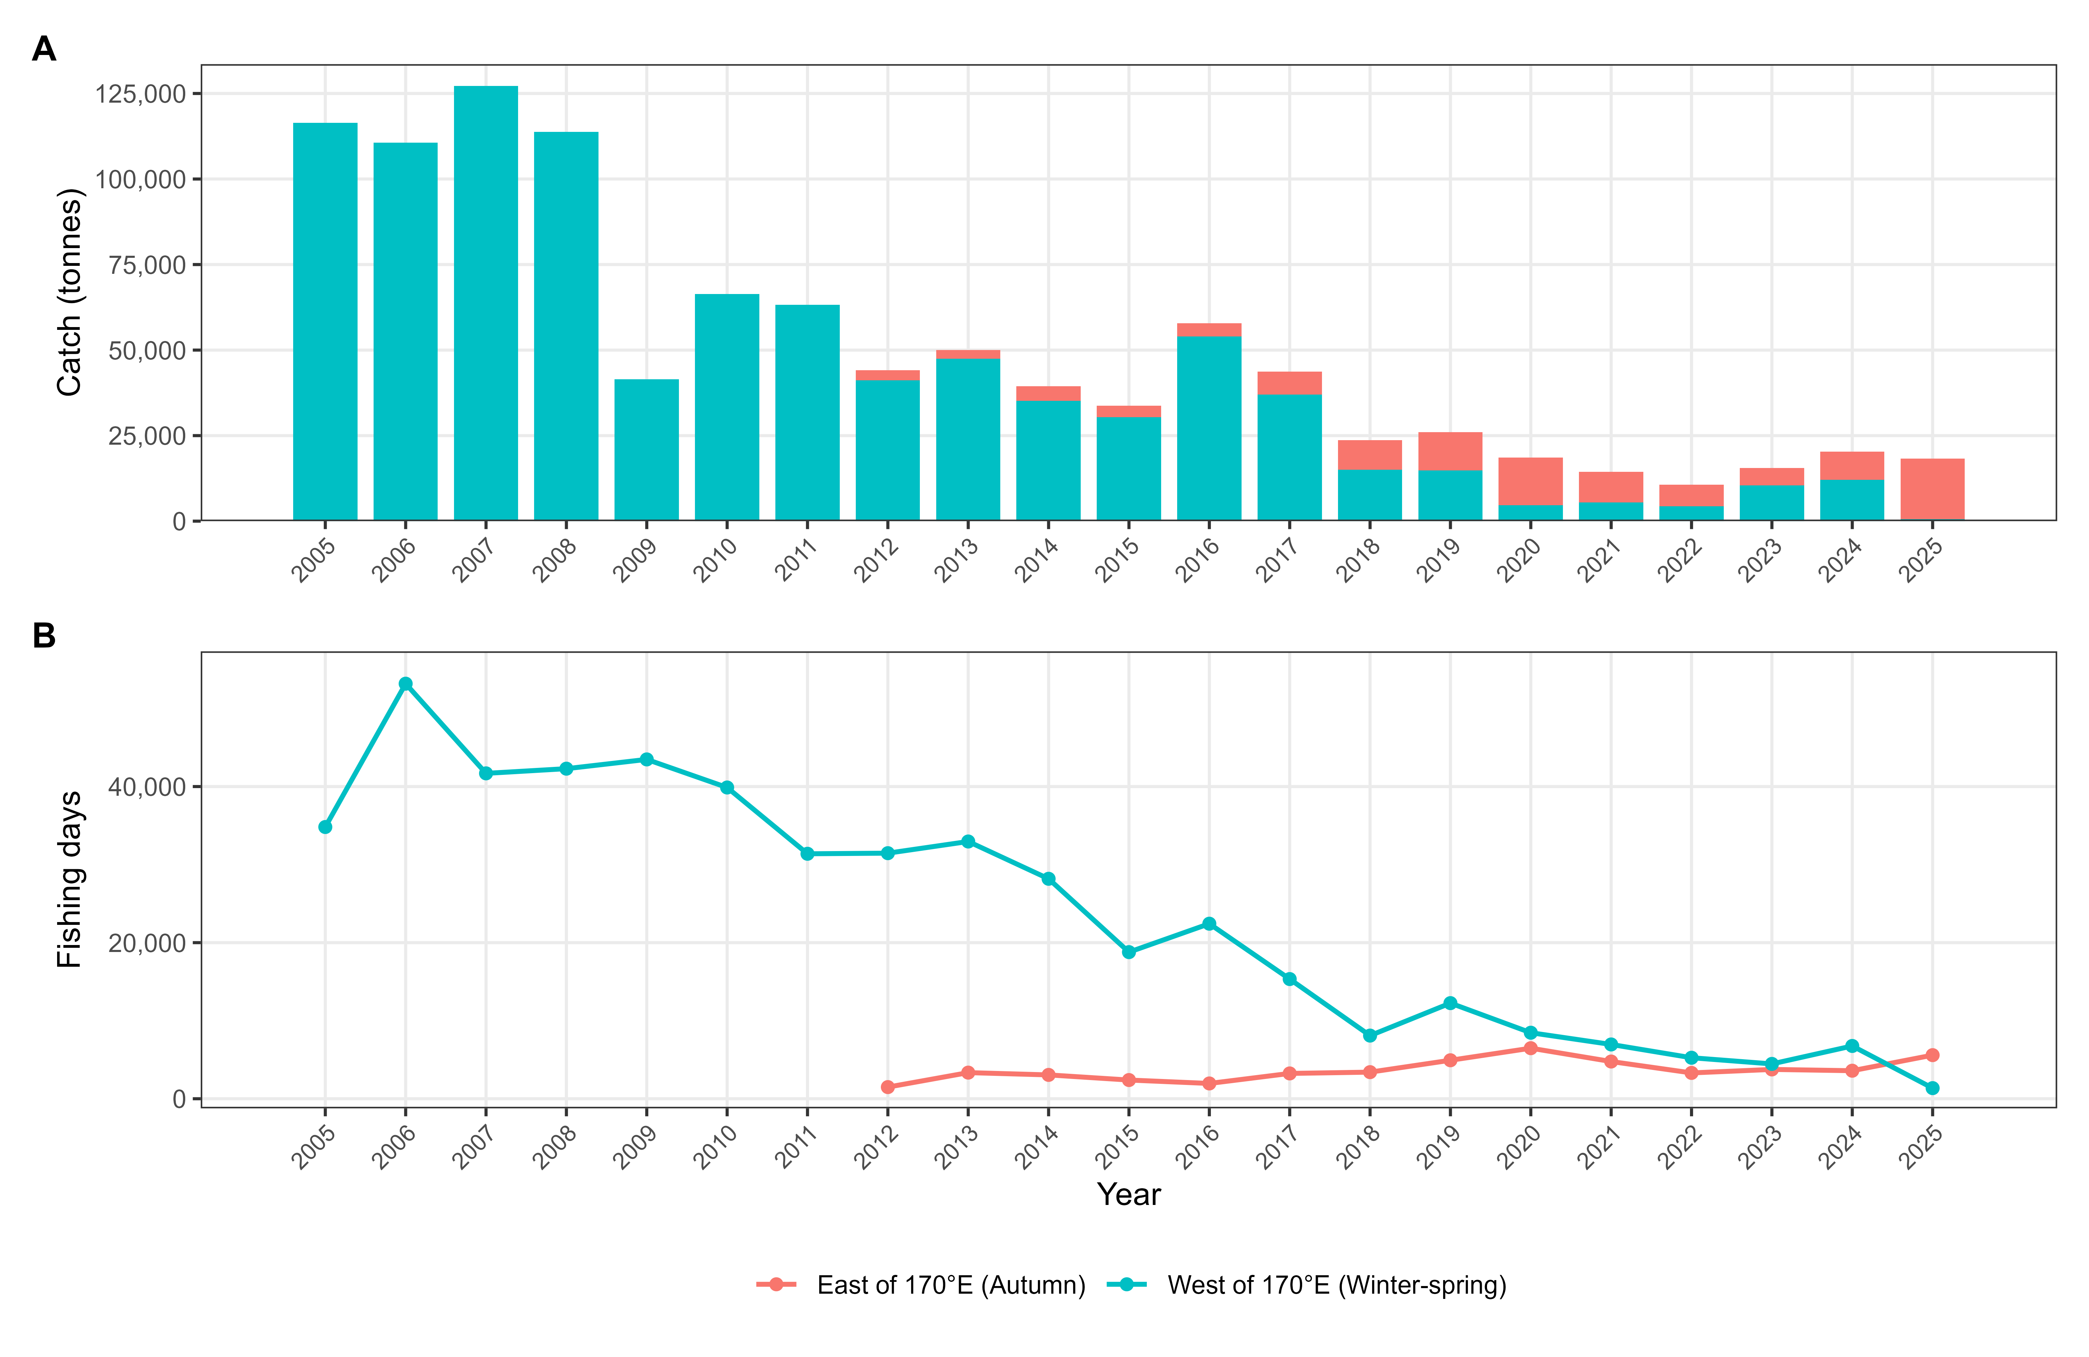
Fig. 1 Annual catch and fishing effort (fishing days) of neon flying squid in the Northwest Pacific Ocean based on NPFC-compiled data from all members, 2005–2025.

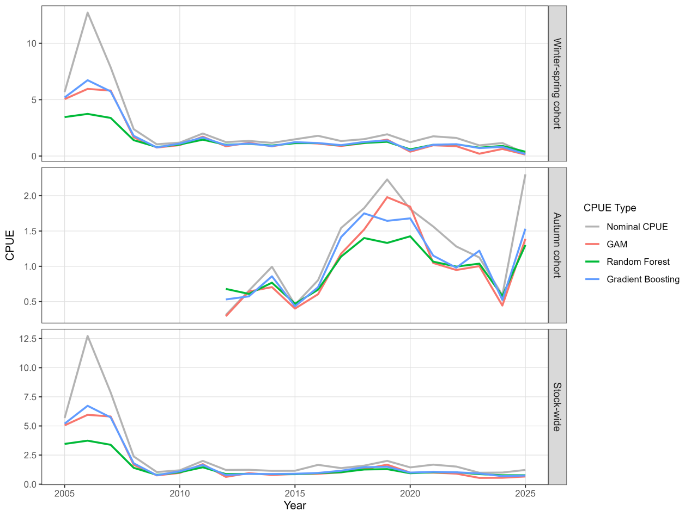
Fig. 2 Comparison of nominal and standardized CPUE indices for the winter-spring cohort, autumn cohort, and stock-wide of neon flying squid derived from three modeling approaches.
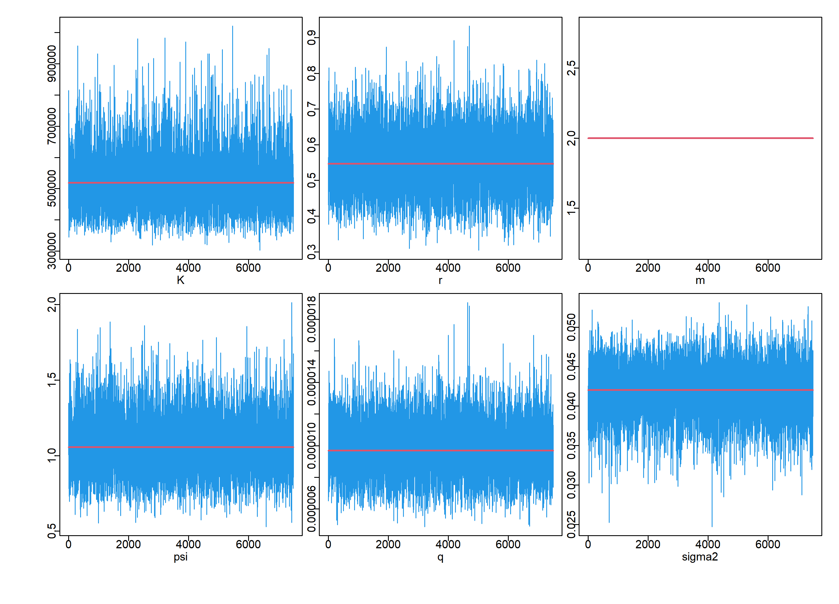
Fig. 3 MCMC convergence diagnostics for the stock-wide assessment using GAM-standardized CPUE.

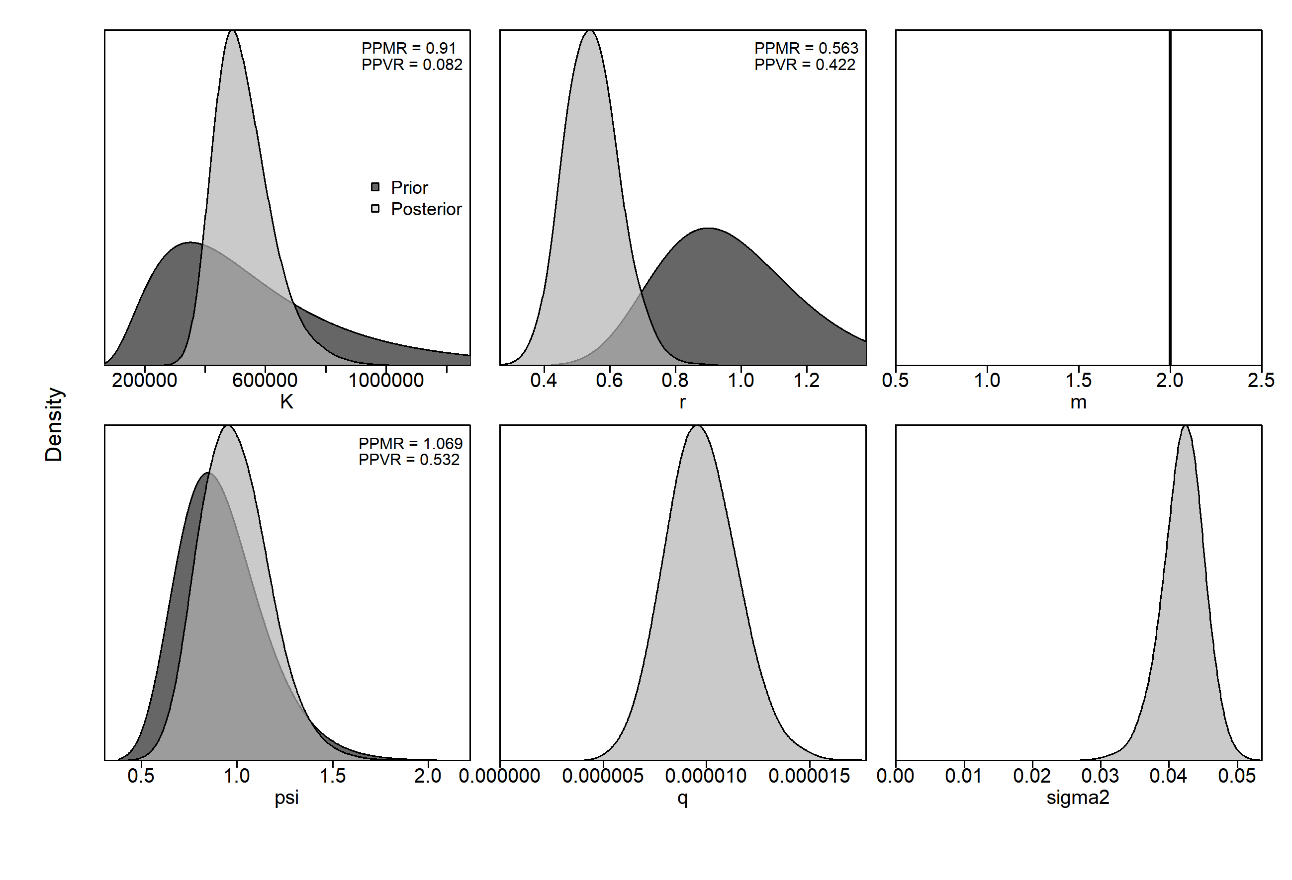
Fig. 4 Prior and posterior distributions of key parameters for the base-case scenario (stock-wide, GAM-standardized CPUE).

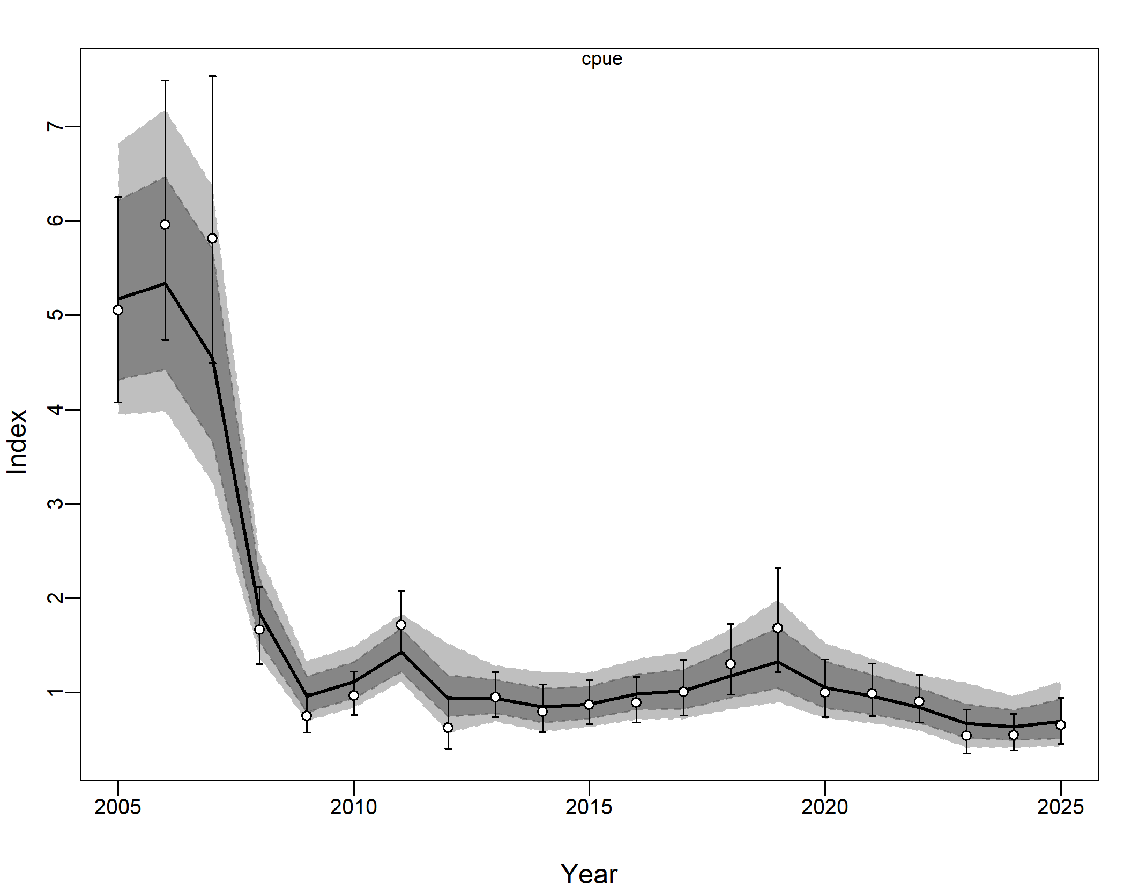
Fig. 5 Observed and predicted CPUE from the JABBA base-case model.

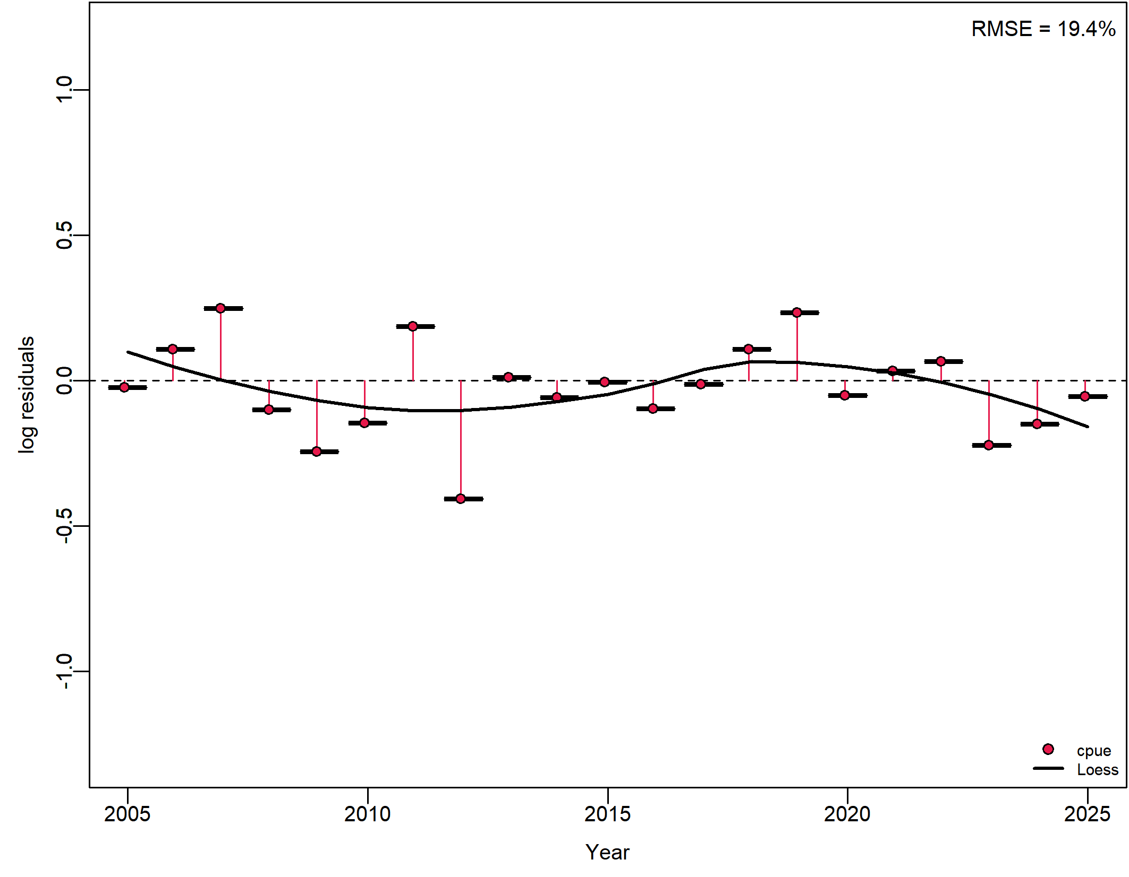
Fig. 6 Standardized residual diagnostics for the stock-wide assessment based on GAM-standardized CPUE.
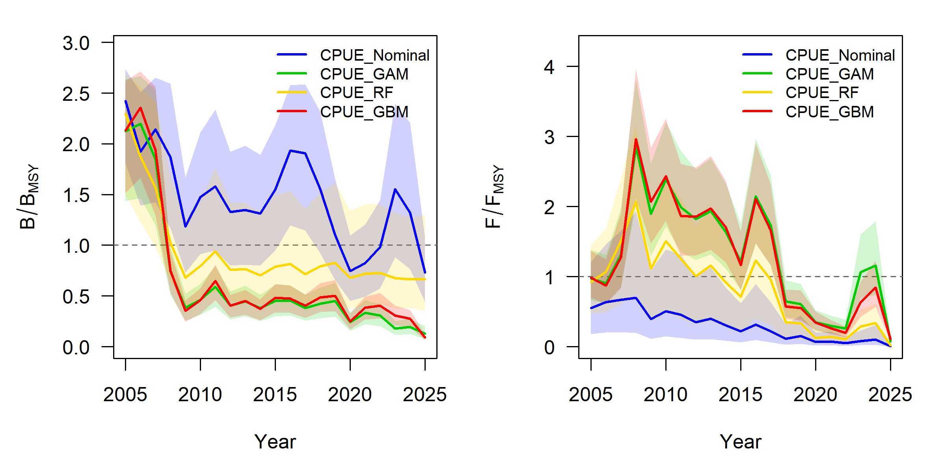
Fig. 7 Trajectories of B/B_{MSY} and F/F_{MSY} for the winter-spring cohort estimated from four abundance indices.
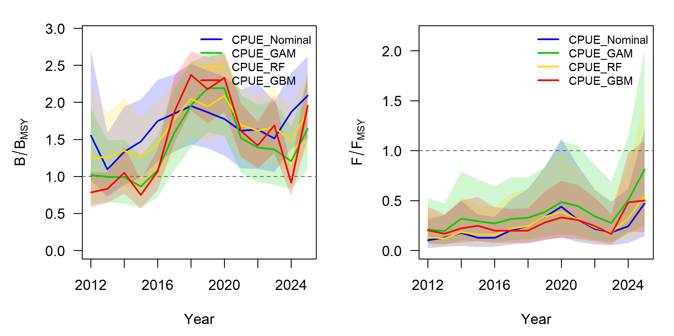
Fig. 8 Trajectories of B/B_{MSY} (left) and F/F_{MSY} (right) for the autumn cohort estimated from four abundance indices.
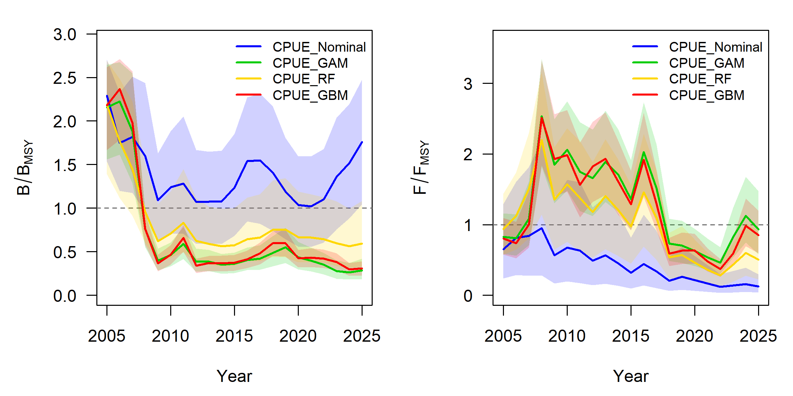
Fig. 9 Trajectories of B/B_{MSY} (left) and F/F_{MSY} (right) for the stock-wide population estimated from four abundance indices.
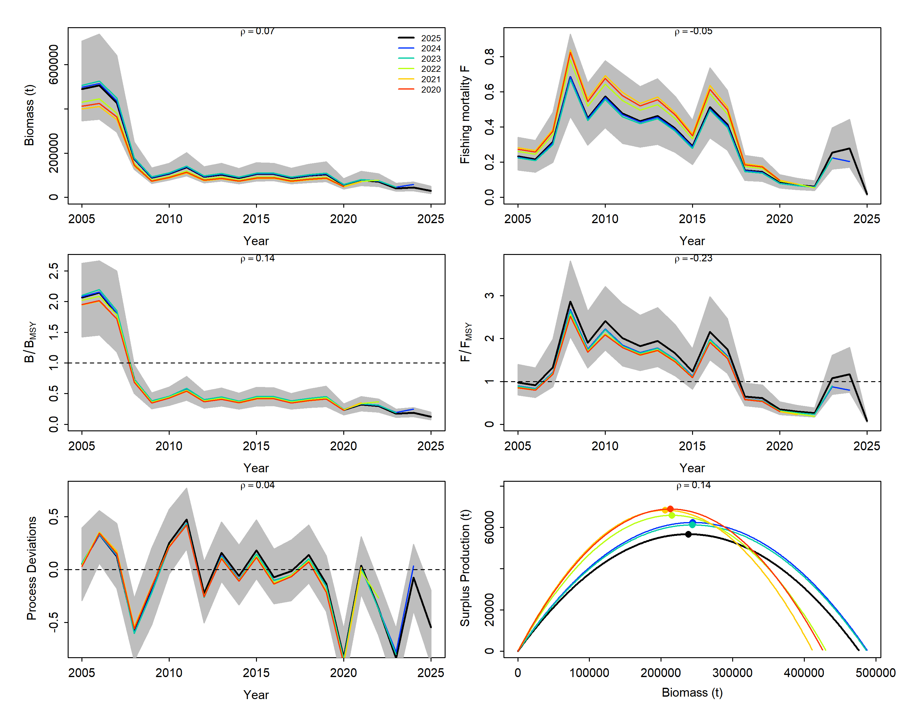
Fig. 10 Retrospective analysis of the GAM-based assessment for the winter–spring cohort.
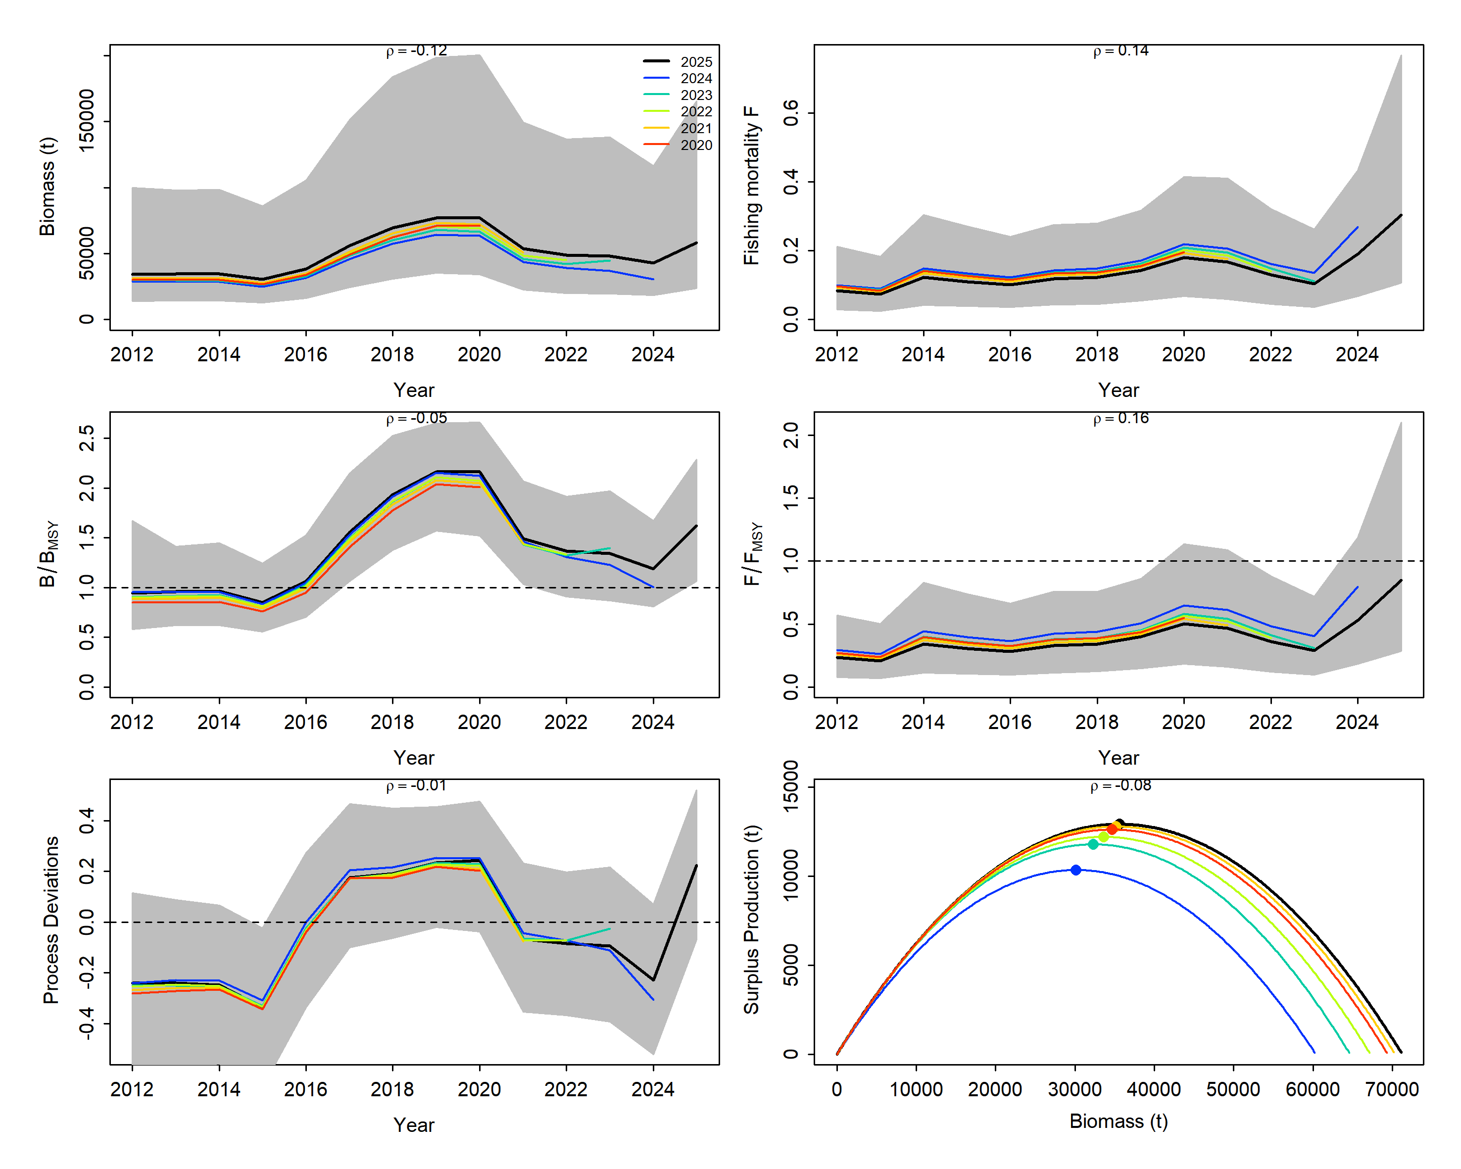
Fig. 11 Retrospective analysis of the GAM-based assessment for the autumn cohort.
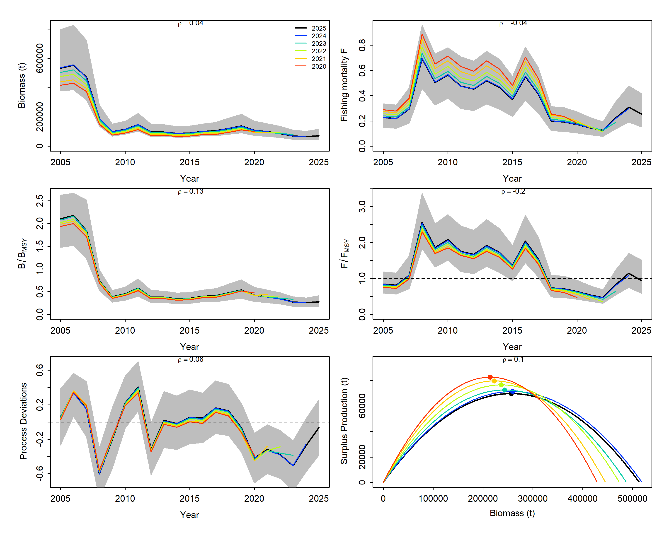
Fig. 12 Retrospective analysis of the GAM-based assessment for the stock-wide assessment.

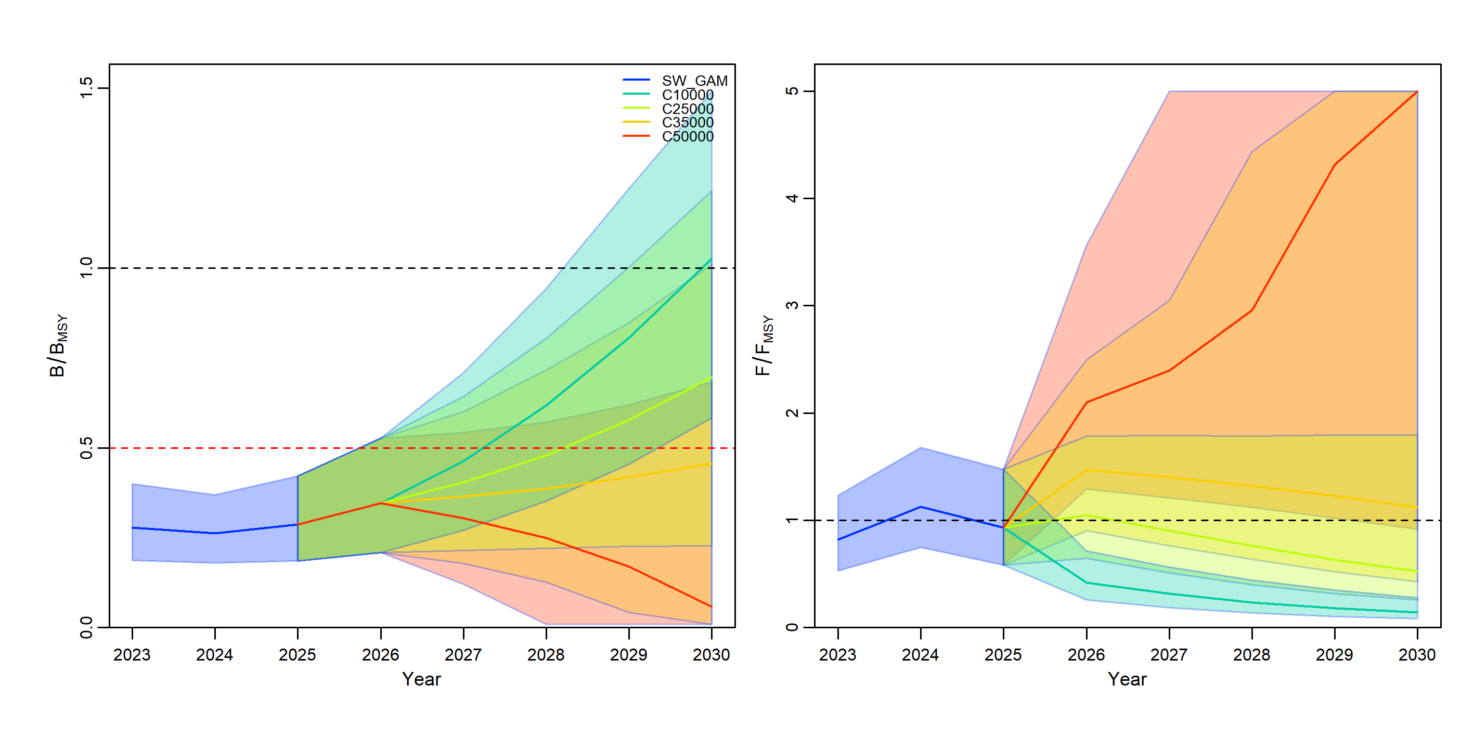
Fig. 13 Short-term projections under different catch scenarios for the stock-wide GAM base-case scenario.

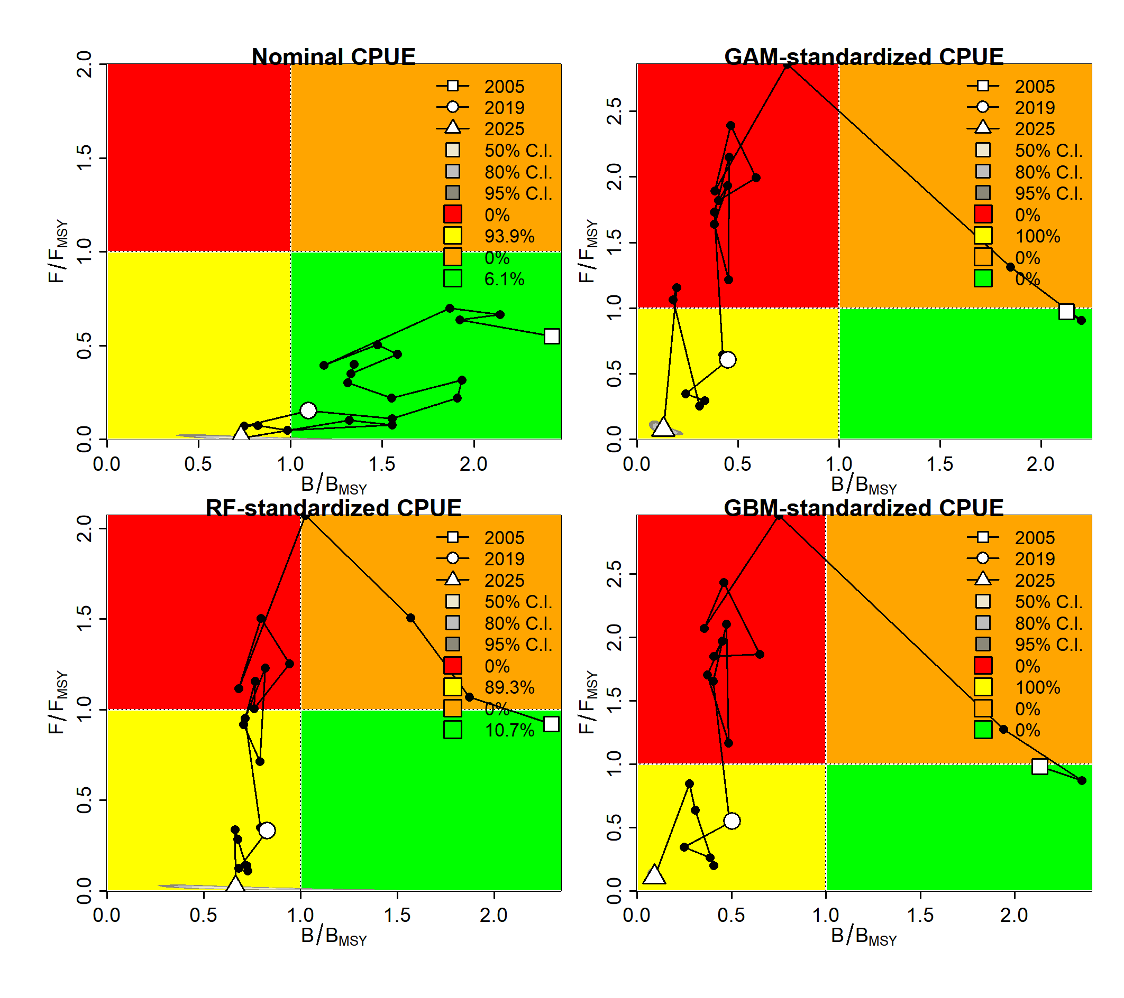
Fig. 14 Kobe plots showing stock status trajectories under different CPUE scenarios for the winter–spring cohort.
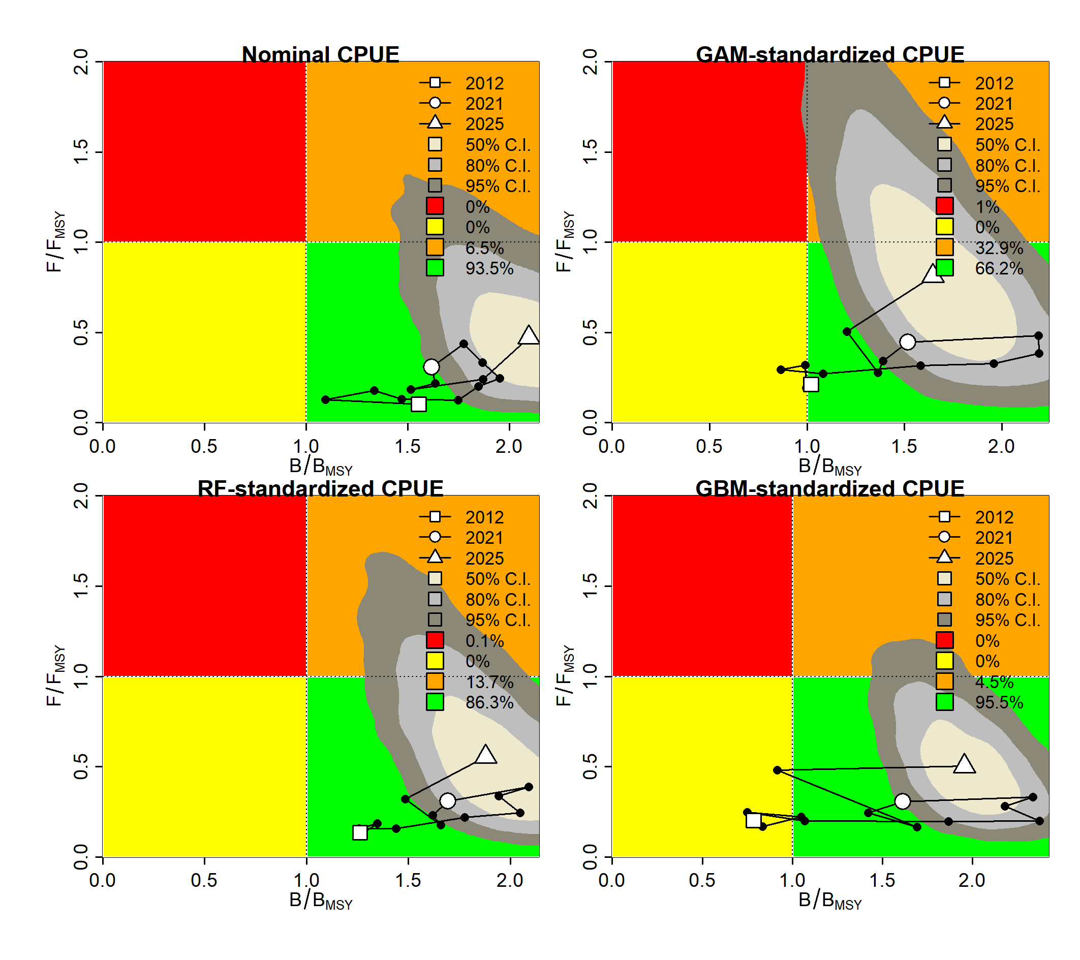
Fig. 15 Kobe plots showing stock status trajectories under different CPUE scenarios for the autumn cohort.
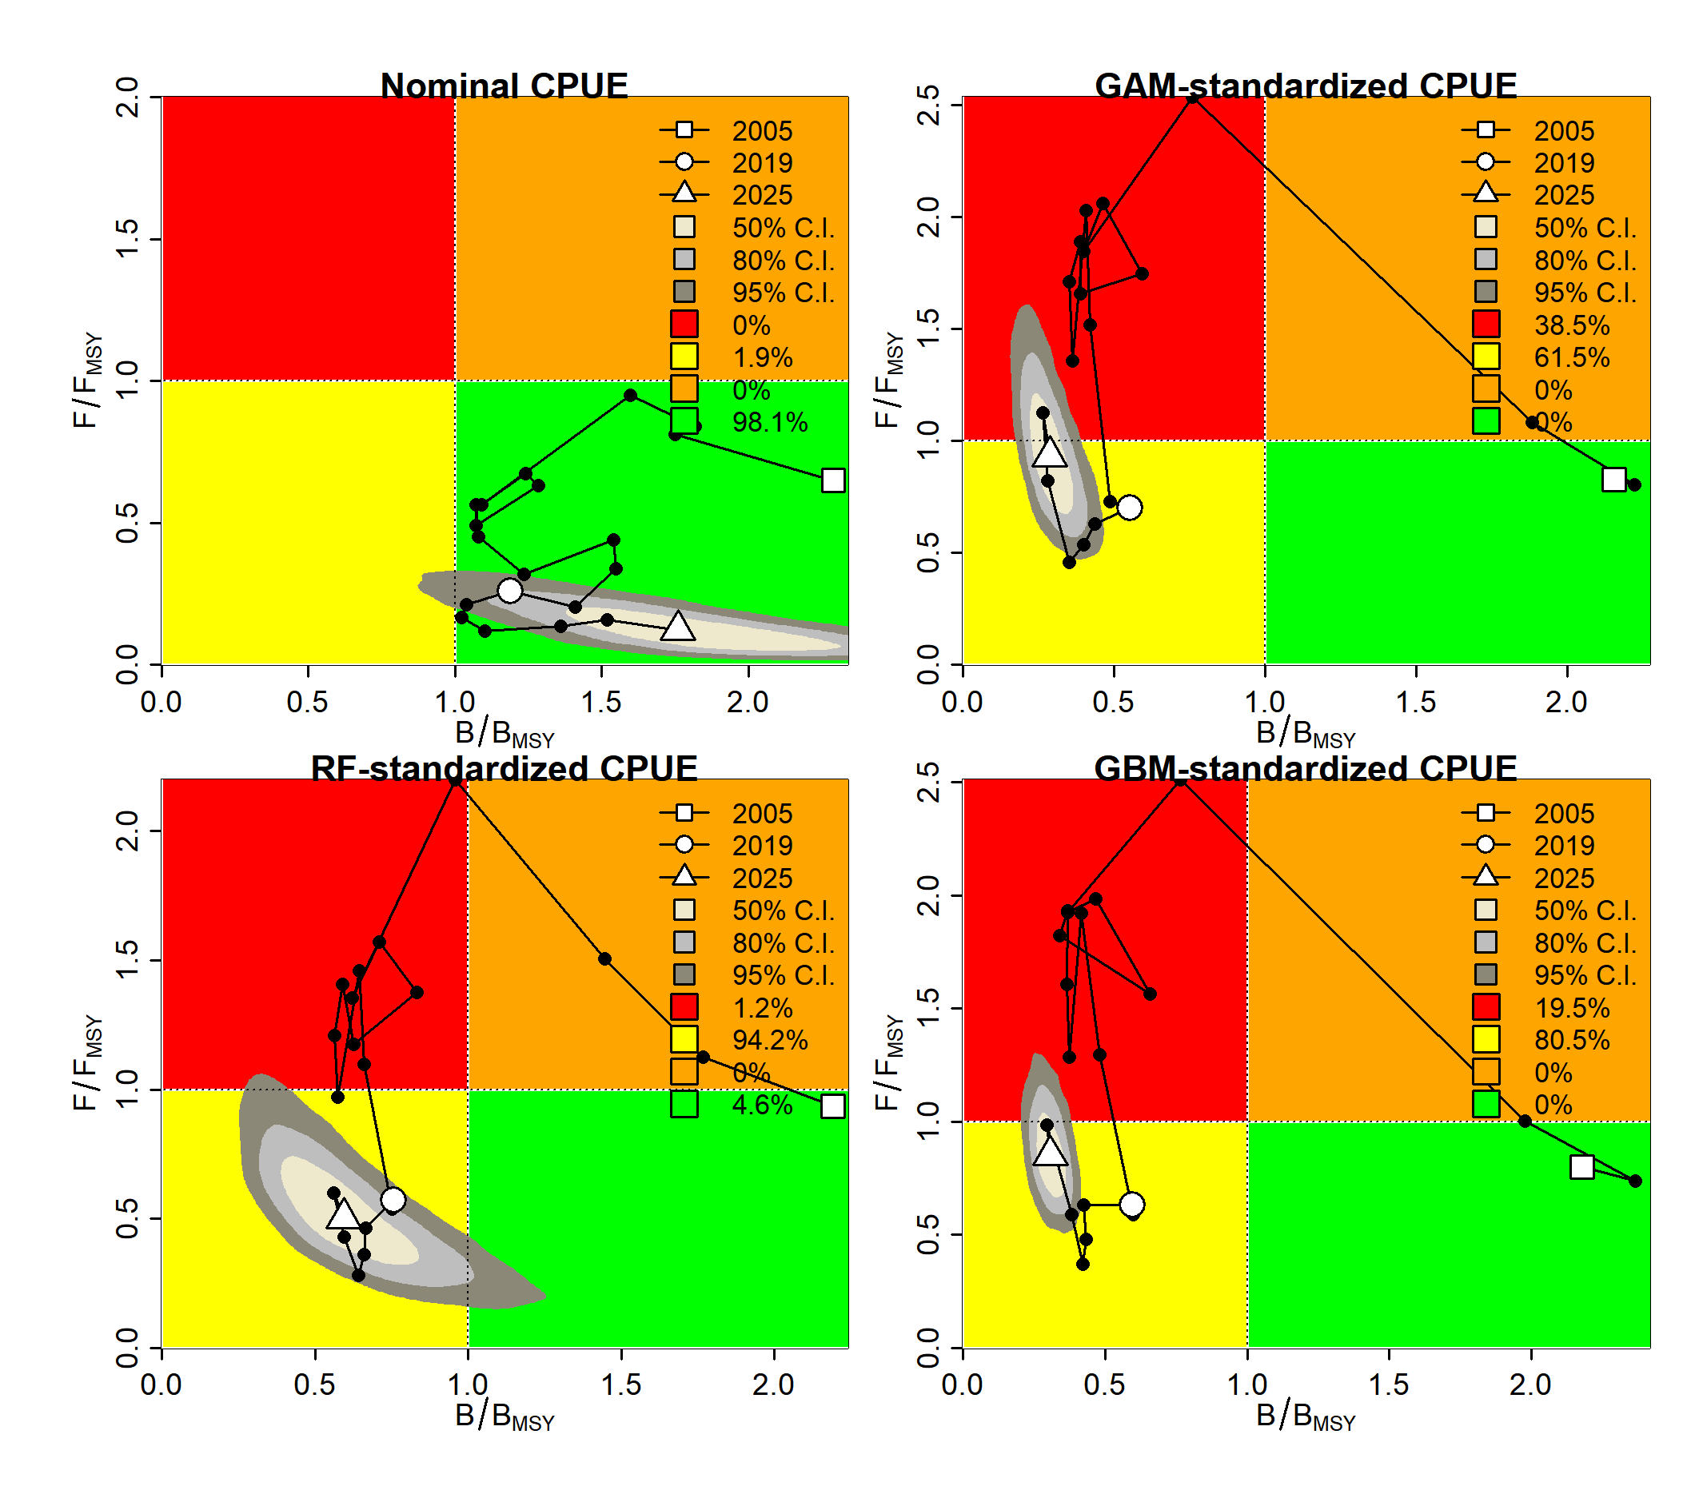
Fig. 16 Kobe plots showing stock status trajectories under different CPUE scenarios for the stock-wide population.

