NPFC-2026-SSC NFS04-WP06
Size composition of neon flying squid based on Chinese squid jigging survey in the Northwest Pacific Ocean
Junjie He, Bilin Liu, Jintao Wang
Summary
This report presents an updated analysis of the size composition, length-weight relationship, and sexual maturity of neon flying squid (Ommastrephes bartramii), based on squid jigging surveys conducted by the Chinese research vessel “Songhang” in the Northwest Pacific Ocean during the summer months (June to August) from 2021 to 2025. A total of 3,908 neon flying squid individuals were measured during the survey period. The results showed that the mantle length of the sampled neon flying squid ranged from 110 to 490 mm, with a unimodal distribution where the vast majority of individuals were concentrated between 180 and 250 mm. Most of these medium-sized individuals remained at immature stages (maturity stages 1 and 2), indicating that the summer aggregations in the surveyed high-seas fishing grounds were primarily composed of the winter-spring cohort.
Introduction
Neon flying squid (Ommastrephes bartramii) is a key pelagic species in the North Pacific Ocean, holding significant ecological importance within the marine food web and supporting highly valuable commercial fisheries (Jereb and Roper, 2010). Given its short lifespan and high sensitivity to oceanographic conditions, continuous monitoring of its biological characteristics is critical for sustainable fisheries management under the framework of the North Pacific Fisheries Commission. Fishery-independent efforts are vital for collecting crucial biological data to understand the demographic structure and spatial distribution of the stock in the high seas.
This report provides an updated analysis regarding the size composition of neon flying squid based on Chinese squid jigging surveys conducted by research vessel “Songhang” in the Northwest Pacific Ocean. The survey station activities conducted during the summer months (June to August) between 2021-2025 are summarized. Currently, mantle length has been widely used to evaluate population structure; however, utilizing size composition alone to differentiate between the winter-spring and autumn cohorts may present certain uncertainties for such short-lived species. Consequently, integrating the analysis of gonad development and sexual maturity stages offers valuable supplementary information, facilitating a clearer identification of spawning cohorts and a more comprehensive understanding of population dynamics.
Methods
Surveys for neon flying squid were systematically conducted by research vessel “Songhang” in the Northwest Pacific Ocean. The sampling operations were carried out from June to August between 2021 and 2025.The squid jigging stations were designed using a spatial stratified sampling scheme. The survey area in the high seas of the Northwest Pacific Ocean was divided into several geographic strata according to longitude and latitude gradients, and sampling stations were allocated within these strata. Table 1 summarizes the details of the survey efforts and biological sampling activities. Due to specific logistical reasons, the station data for 2021 were not available (NA). Spatially, the survey area in 2022 was bounded by 152.55–164.18°E and 36.01–45.15°N, and located within 156.68–164.02°E and 35.45–45.12°N in 2023. Subsequently, the survey footprint extended westward to 147.92°E in 2024, and further eastward to 168.12°E in 2025, achieving its broadest spatial coverage (Fig.1). Concurrently, the occurrence rate of neon flying squid varied across the years, ranging from 25.93% to 53.33%.
All specimens were frozen and brought back to the laboratory for further biological analysis, which includes the measurement of mantle length (1mm), body weight (g) and sexual maturity. Each squid specimen was dissected to determine its sex and evaluate its reproductive status. The sexual maturity of both male and female neon flying squid was assessed macroscopically based on the visual observation of the gonads and accessory reproductive organs. For this study, the maturity status was classified into five macroscopic stages (Stage 1 to Stage 5), adapting standard cephalopod grading criteria. The detailed descriptive characteristics and specific morphological criteria for each maturity stage are defined in Table 3.
The relationship between mantle length and body weight for neon flying squid was established using the power function
W = aL^{b}(Wang et al., 2023).
where W is body weight, L is mantle length, and a and b are parameters to be estimated.
Result and Discussion
From 2022 to 2025, the mantle length of neon flying squid ranged approximately from 110 to 490 mm. The size composition showed a unimodal distribution, with the highest frequency occurring around 220 mm. Most individuals were concentrated between 180 and 250 mm, indicating that medium-sized individuals dominated the samples. Individuals smaller than 150 mm or larger than 300 mm occurred at relatively low frequencies. The distribution was slightly right-skewed, with a long tail extending toward larger mantle length classes (Fig.2). Annual differences were observed in the mantle length composition of neon flying squid from 2022 to 2025. In 2022, the mantle length distribution showed a relatively broad and discontinuous pattern, with individuals distributed mainly in two size ranges: approximately 160–230 mm and 350–430 mm. This indicated that both winter-spring cohort and autumn cohort individuals were present in the 2022 samples (Fig.3). The overall length–weight relationship indicated that body weight increased with mantle length in neon flying squid. The total b value close to 3 suggested that the sampled population generally followed an isometric growth pattern. However, the annual variation in b values indicated differences in growth condition among years. The positive allometric growth observed in 2022 and 2025 (b = 3.415, b = 3.331) suggested that larger individuals were relatively heavier, whereas the negative allometric growth in 2023 and 2024 (b = 2.712, b = 2.817) may reflect lower body condition or a higher proportion of smaller and developing individuals. The result for 2022 should be interpreted with caution because of the relatively small sample size (Fig.4).
The mantle length distributions of female and male neon flying squid showed a similar unimodal pattern. Most individuals of both sexes were concentrated between 180 and 250 mm, with peak frequencies occurring around 210–230 mm. However, female individuals showed a slightly higher frequency at the modal length class and a longer right tail in the distribution. Individuals larger than 300 mm were mainly represented by females, whereas males were less frequent in the larger mantle length classes (Fig.5). The sex composition varied among maturity stages. At maturity stages 1 and 2, the proportions of females and males were relatively similar, with females accounting for 54.4% and 51.9%, respectively. However, the proportion of males increased with maturity stage. Males accounted for 64.5% at stage 3 and 87.5% at stage 4, and all individuals at stage 5 were males. This pattern suggests that males were more frequently represented in advanced maturity stages in the present samples. However, the high male proportion at stages 4 and 5 should be interpreted with caution, as these stages may have been represented by a limited number of individuals (Fig.6). Figure 7 showed that the distribution of maturity stages varied with mantle length. Individuals at maturity stages 1 and 2 were mainly distributed between 160 and 250 mm, whereas individuals at higher maturity stages were more frequently observed in larger mantle length classes. Overall, the results indicate that larger individuals tended to show more advanced gonadal development. Specifically, mature individuals were primarily found at larger sizes; however, the extremely high frequency observed at 350 mm should be interpreted cautiously due to the small sample size of individuals at maturity stage 5. Annual differences were observed in the mantle length composition and maturity stages. In 2023, individuals were mainly concentrated between 190 and 260 mm, with the highest frequency occurring around 220 mm. In 2024, the mantle length distribution shifted toward smaller size classes, mainly ranging from 160 to 240 mm. In 2025, most individuals were distributed between 170 and 230 mm, but a long right tail was observed, indicating the presence of a small number of large individuals. Most individuals from 2023 to 2025 were at maturity stages 1 and 2, while higher maturity stages were mainly observed in larger mantle length classes (Fig.8).
The dominance of individuals in the 180–250 mm mantle length range suggested that the sampled squid population was mainly composed of winter-spring cohort individuals with low sexual maturity stages during the survey period. The low proportion of large individuals (mantle length > 300 mm) may indicate that fully grown or mature individuals were less represented in the jigging samples. Previous studies suggested that the winter–spring cohort of neon flying squid generally begins to enter the feeding grounds in the Northwest Pacific in July, with abundance increasing toward August and peaking during August to October. Therefore, the July samples in this study may represent the early stage of feeding migration, which may account for the absence of large individuals(Gong et al., 2021; Wang et al., 2022).
The results of sexual maturity identification indicated an apparent sex-specific disparity among the large-sized neon flying squid. Although both sexes shared a broadly similar unimodal distribution with peak frequencies occurring around 210–230 mm, the female mantle length distribution displayed a relatively longer right tail. Individuals exceeding 300 mm in mantle length were mostly females, whereas males were less frequently observed in these larger size classes. The underlying mechanism for this divergence may be associated with differential energy allocation during the maturation process(Han et al., 2022). For females, continued somatic growth confers reproductive advantages, as a larger body size and expanded internal cavity volume can accommodate the production of oocytes, thereby enhancing potential fecundity. Conversely, males tend to reach early sexual maturity at a smaller size, potentially shifting their metabolic energy investment from somatic growth to spermatophore production earlier than females(Jereb and Roper, 2010; Rocha et al., 2001).
Overall, it is suggested that sexual maturity stage should be incorporated as a routine biological sampling item in future NPFC data collection for neon flying squid. Although mantle length is useful for describing population structure, using mantle length composition alone to distinguish the winter-spring and autumn cohorts may involve uncertainty, particularly for short-lived and fast-growing species. Sexual maturity provides direct information on reproductive development and can therefore serve as an important supplementary indicator for interpreting size composition. In the present study, most individuals were concentrated between 180 and 250 mm and remained at maturity stages 1 and 2, whereas higher maturity stages were more frequently observed in larger mantle length classes. Therefore, integrating maturity stage with size composition may improve the interpretation of biological status and potential cohort composition. In addition, standardized criteria for assessing sexual maturity stages of neon flying squid should be promoted under the NPFC framework. A standardized maturity-stage guideline for neon flying squid, including sex-specific morphological descriptions, diagnostic indicators, and reference illustrations or samples, would improve consistency in maturity determination.

References
Gong, C., Chen, X., Gao, F., Yu, W., 2021. The Change Characteristics of Potential Habitat and Fishing Season for Neon Flying Squid in the Northwest Pacific Ocean under Future Climate Change Scenarios. Marine and Coastal Fisheries 13, 450–462. https://doi.org/10.1002/mcf2.10170
Han, P., Li, J., Dan, Y., Liu, B., Chen, X., Fang, Z., 2022. Decadal Changes in the Annual Growth of Two Commercial Ommastrephid Species in the Pacific Ocean. Fishes 7, 280. https://doi.org/10.3390/fishes7050280
Jereb, P., Roper, C.F.E., 2010. Cephalopods of the world - an annotated and illustrated catalogue of cephalopod species known to date. Vol 2. Myopsid and oegopsid squids. FAO, Rome.
Rocha, F., Guerra, Á., González, Á.F., 2001. A review of reproductive strategies in cephalopods. Biological Reviews 76, 291–304. https://doi.org/10.1017/S1464793101005681
Wang, J., Cheng, Y., Lu, H., Chen, X., Lin, L., Zhang, J., 2022. Water Temperature at Different Depths Affects the Distribution of Neon Flying Squid (Ommastrephes bartramii) in the Northwest Pacific Ocean. Front. Mar. Sci. 8. https://doi.org/10.3389/fmars.2021.741620
Wang, Y., Han, P., Fang, Z., Chen, X., 2023. Climate-induced life cycle and growth variations of neon flying squid (Ommastrephes bartramii) in the North Pacific Ocean. Aquaculture and Fisheries 8, 211–220. https://doi.org/10.1016/j.aaf.2021.08.006

Table 1. Summary of squid jigging surveys for neon flying squid in the northwest Pacific Ocean between 2021-2025
Year | Month | No. of stations | No. of stations with NFS |  | Occurrance rate | No. of measured NFS
2021 | 6-8 | NA | NA | NA |  | NA
2022 | 6-8 | 15 | 8 | 53.33 |  | 72
2023 | 6-8 | 25 | 12 | 48.00 |  | 2546
2024 | 6-8 | 27 | 7 | 25.93 |  | 711
2025 | 6-8 | 39 | 11 | 28.21 |  | 579

Table 2. Criteria for identifying sexual maturity stages I–V in female and male squids
Stage | Female | Male
1 | Ovary small, whitish and translucent; oocytes not visible. Nidamental glands and oviducts small. | Testis small, whitish and translucent. Spermatophoric complex weakly developed; no spermatophores in Needham’s sac.
2 | Ovary enlarged, whitish and granular; small oocytes visible. Nidamental glands and oviducts developing. | Testis enlarged and whitish. Spermatophoric complex visible; sperm duct developing; no spermatophores present.
3 | Ovary markedly enlarged and pale yellow, with developing oocytes. Oviducts thickened, but mature eggs absent. | Testis greyish white and enlarged. Sperm duct convoluted; immature spermatophores or granular material may appear in Needham’s sac.
4 | Ovary mature, yellowish-green, with numerous uniform oocytes. Few mature eggs present in oviducts, occupying <10% of oviduct volume. | Testis mature and pale yellow. Mature spermatophores present, occupying <20% of Needham’s sac volume.
5 | Ovary similar to Stage IV. Oviducts swollen; mature eggs occupy 10%–60% of oviduct volume. | Needham’s sac enlarged; mature spermatophores neatly arranged, occupying 20%–50% of sac volume.

Table 3. Mantle length of neon flying squid in the northwest Pacific Ocean between 2021-2025
Year | n | ML range (mm) | Mean ML (mm) | Median ML (mm) | SD (mm)
2021 | NA | NA | NA | NA | NA
2022 | 73 | 160~460 | 326.99 | 376 | 103.03
2023 | 2547 | 122~495 | 232.19 | 228 | 29.86
2024 | 712 | 110~430 | 204.48 | 201 | 33.21
2025 | 580 | 160~460 | 219.93 | 200 | 56.51
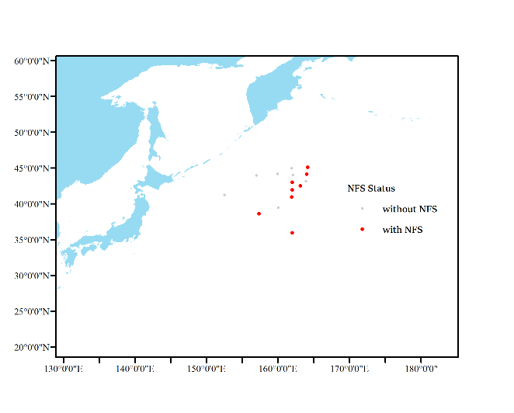  - 2022 | 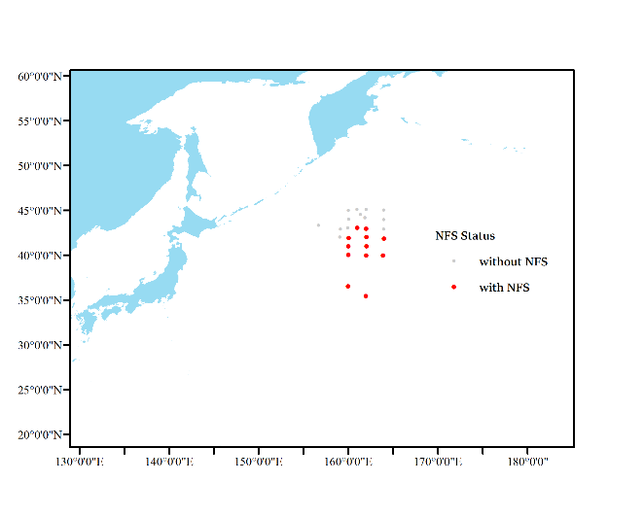  - 2023
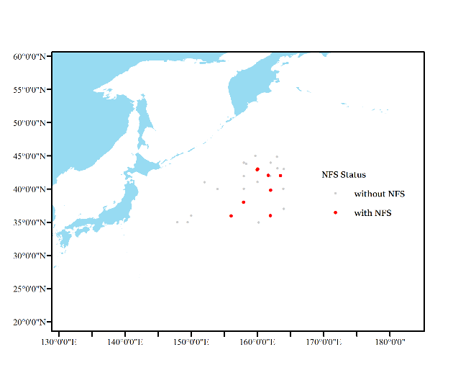  - 2024 | 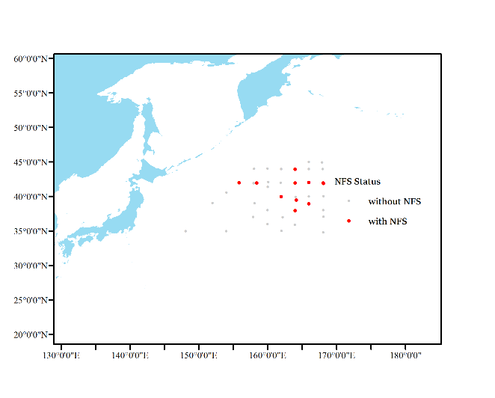  - 2025
Fig.1. Squid jigging stations by Chinese squid jigging surveys between 2022-2025

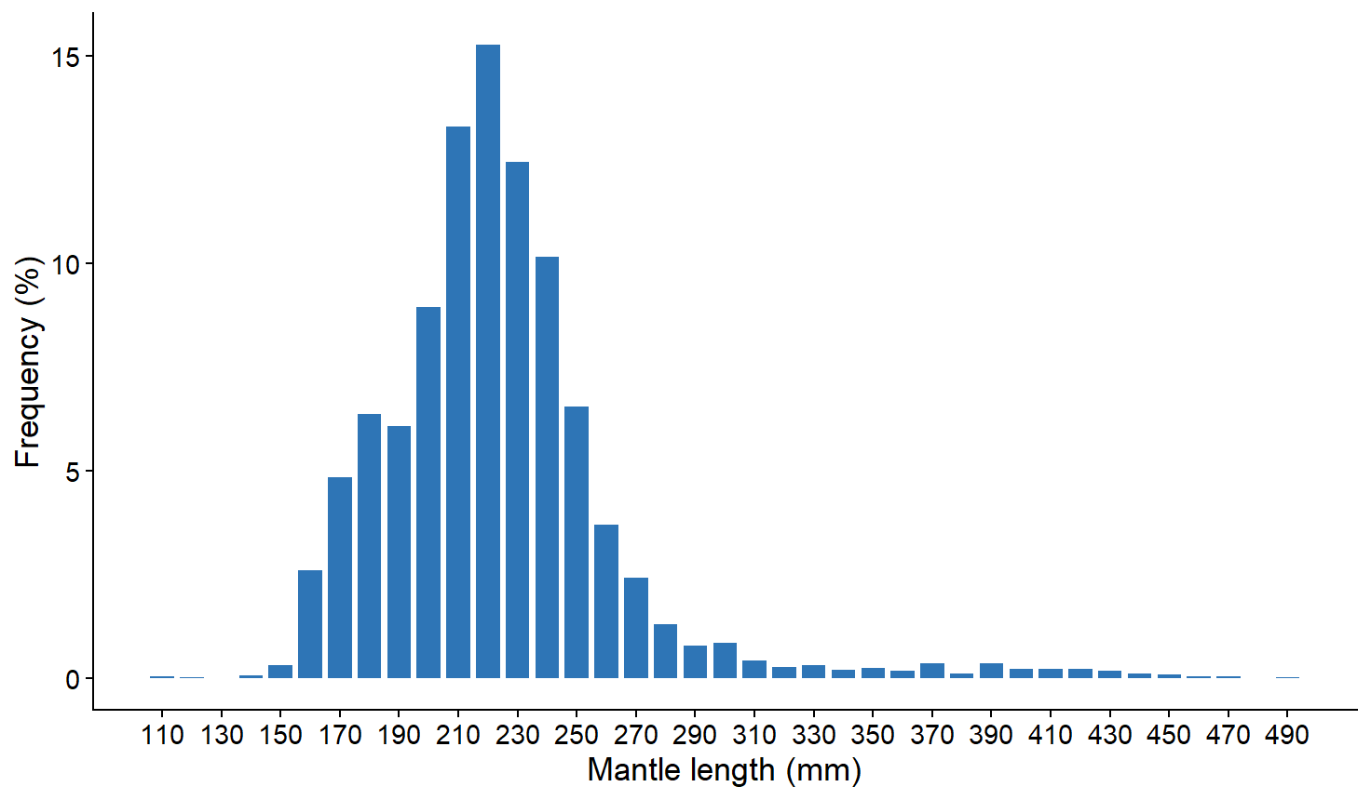
Fig.2. Overall mantle length composition of neon flying squid by Chinese squid jigging surveys in the Northwest Pacific Ocean from 2022 to 2025

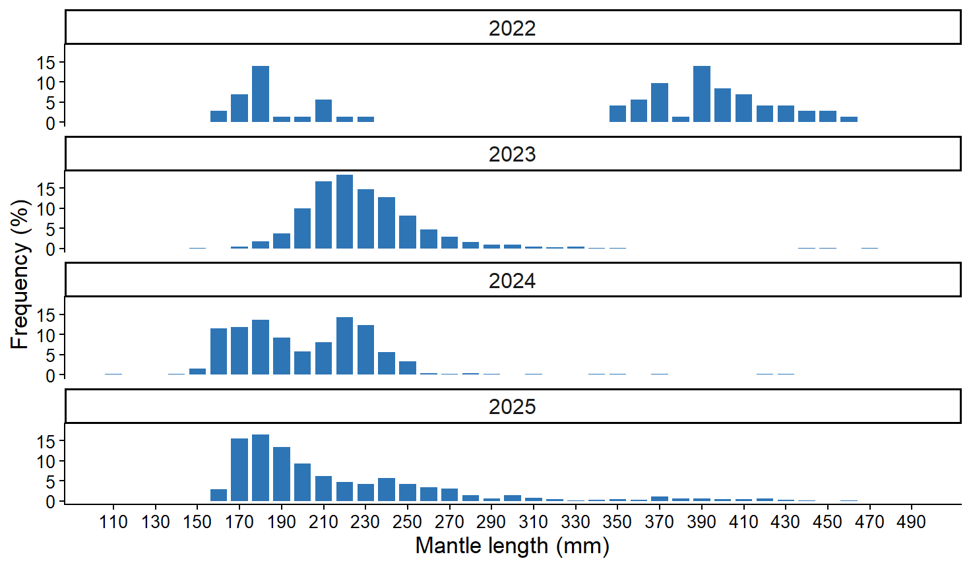
Fig.3. Annual mantle length composition of neon flying squid by Chinese squid jigging surveys in the Northwest Pacific Ocean from 2022 to 2025

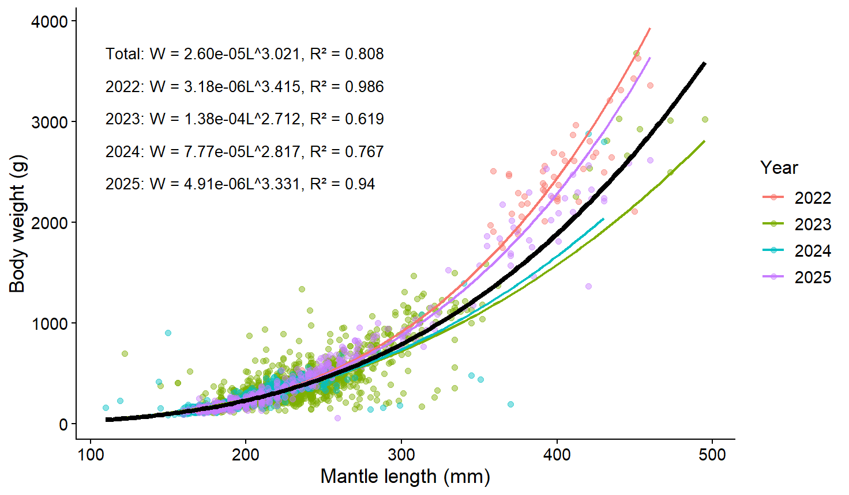
Fig. 4. Length–weight relationships of neon flying squid by year and for all years combined during 2022–2025.
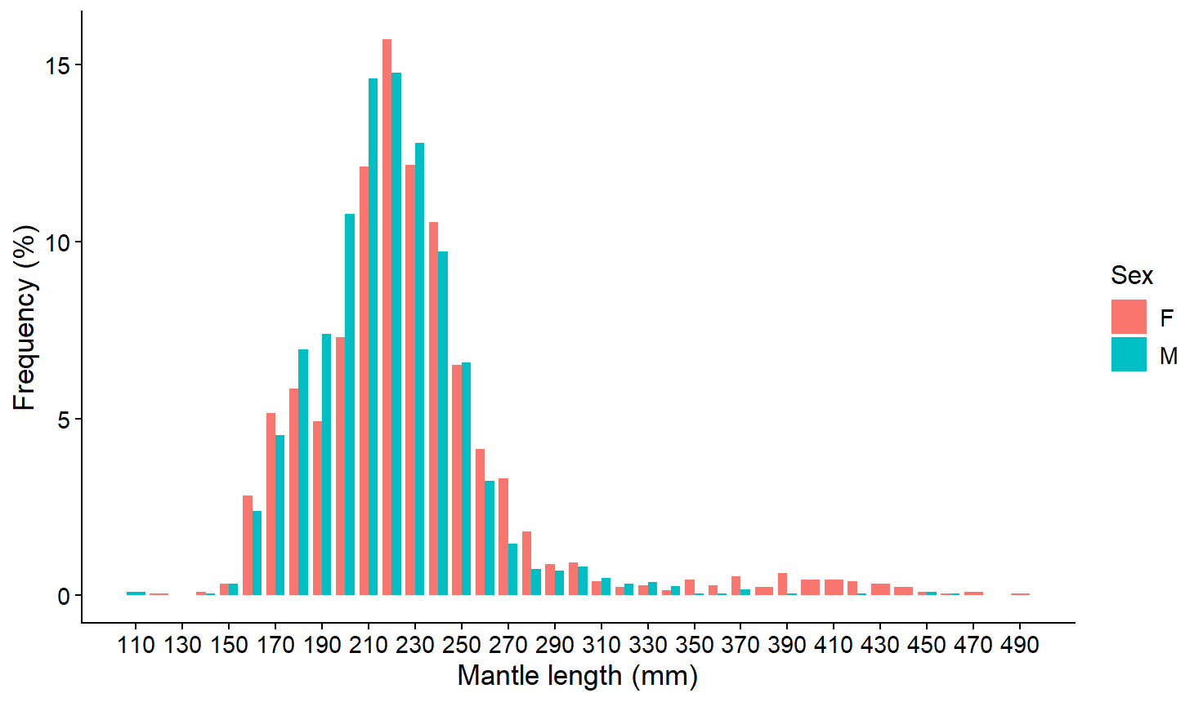
Fig.5 Mantle length composition of neon flying squid by Chinese squid jigging surveys by sex
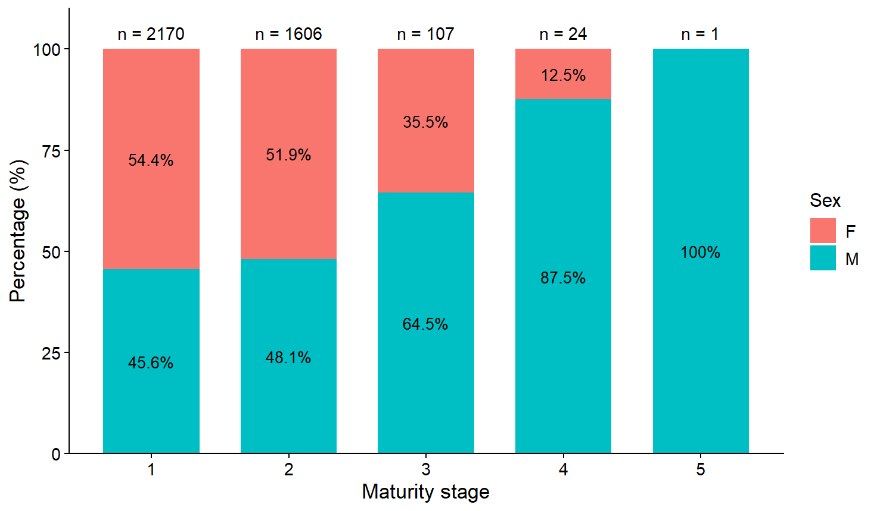
Fig. 6. Sex composition of neon flying squid at different sexual maturity stages in the Northwest Pacific Ocean from 2022 to 2025.

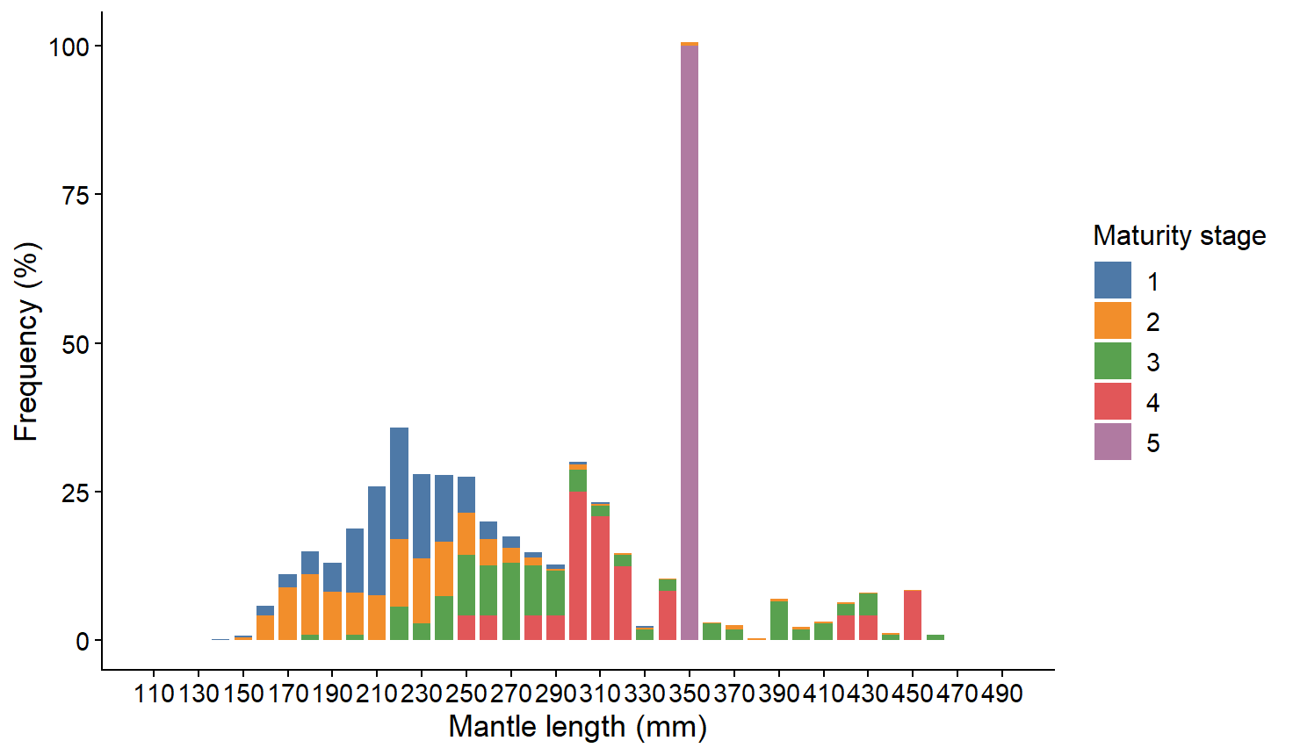
Fig.7. Mantle length composition of neon flying squid by sexual maturity
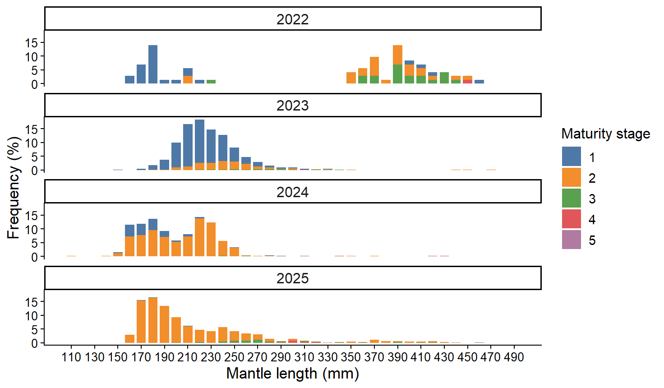
Fig.8. Annual mantle length composition of neon flying squid by sexual maturity

