NPFC-2026-SSC NFS04-WP05
Standardized CPUE Indices for Neon Flying Squid Using Chinese Squid-Jigging Fishery Data from 2005 to 2025

Shanghai Ocean University
Mingyan Song, Jintao Wang

Summary
This study updated the Chinese squid-jigging fishery data for neon flying squid from 2005 to 2025 and standardized CPUE separately for the winter–spring and autumn cohorts. Generalized additive models (GAM), random forest (RF), and gradient boosting machines (GBM) were fitted, and annual standardized CPUE indices were extracted using an expanded-grid approach. A Tweedie-GAM was also applied to evaluate the effects of zero-catch treatment and CPUE distributional assumptions on the standardization results. The standardized CPUE indices produced by the three methods showed highly consistent interannual trends across cohorts, with high pairwise Pearson correlations. CPUE for the winter–spring cohort was relatively high during 2005–2007, declined markedly in 2008, and subsequently remained at a relatively low level with minor fluctuations. CPUE for the autumn cohort increased markedly after 2017, reached relatively high levels in 2019–2020, subsequently declined, and showed a clear recovery in 2025. The Tweedie-GAM and the original GAM produced similar major interannual trends, indicating that the standardization results were generally robust. The updated annual indices provide basic information for subsequent stock assessment and fisheries management of neon flying squid.

1. Introduction
The neon flying squid (Ommastrephes bartramii, hereafter NFS) is a widely distributed and commercially important oceanic squid in the North Pacific Ocean (Murata, 1990). The population mainly comprises two seasonal cohorts, the winter–spring cohort and the autumn cohort, which differ in spawning season and spatiotemporal distribution (Yatsu et al., 1997, 1998). Fishery-dependent catch per unit effort (CPUE) is commonly used as an index of relative abundance, however, nominal CPUE may also be influenced by spatial, temporal, environmental, and fishing-related factors and therefore requires standardization. This study updates the Chinese squid-jigging fishery data through 2025. Based on the GAM, random forest (RF), and gradient boosting machine (GBM) analyses used in NPFC-2026-SSC NFS03-WP08, a Tweedie-GAM sensitivity analysis was added to evaluate the sensitivity of the estimated annual trends to alternative treatments of zero catches and assumptions regarding the CPUE distribution. An expanded-grid approach was also applied to improve the extraction of annual standardized CPUE indices. The updated indices are intended to support subsequent stock assessment and fisheries management of NFS. The corresponding NPFC CPUE standardization protocol checklist is provided in Appendix 1.

2. Materials and Methods
2.1. Fishery Data and Covariates
Fishery data from the Chinese squid-jigging fishery during 2005–2025 were provided by the China Squid Jigging Technology Group. The data were aggregated monthly at a spatial resolution of 1° × 1° and included year, month, longitude, latitude, catch, and fishing days. Based on the 170°E longitude boundary, the data were divided into two cohorts for separate analyses: the winter–spring cohort in waters west of 170°E during 2005–2025 and the autumn cohort in waters east of 170°E during 2012–2025. The annual spatial distributions of the fishing grids for the two cohorts are shown in Fig. 1. The stock-wide index was subsequently derived by combining the annual standardized CPUE indices of the two cohorts.
Explanatory variables included:
Spatial variables: Longitude (Lon), Latitude (Lat)
Temporal variables: Year, Month
Environmental variables: Sea surface temperature (SST, Temp_0), sea surface salinity (SSS, Sali_0), mixed layer depth (MLD), sea surface height (SSH)
The environmental data were obtained from the Copernicus Marine Service at an original spatial resolution of 0.083° × 0.083° and matched to the corresponding 1° × 1° fishery grids. These variables were selected according to their known ecological relevance and data availability.
Variance inflation factors (VIFs) and Spearman’s rank correlation coefficients were used to examine multicollinearity and relationships among the explanatory variables. All VIF values were below 10 (range: 1.56-5.17), indicating no serious multicollinearity among the predictors. Spearman correlations among the explanatory variables are shown in Fig. 2, and the complete VIF results are presented in Table 1.

2.2. CPUE standardization models
Nominal CPUE was calculated as the total catch divided by the total fishing days. The monthly spatial distributions of mean nominal CPUE for the winter–spring and autumn cohorts are shown in Fig. 3. To retain zero-catch observations, a constant (c) was added to all CPUE values for each cohort, where (c) was defined as 10% of the mean positive CPUE for that cohort (Campbell, 2004), and log(CPUE+c) was used as the response variable.
Three approaches were used for CPUE standardization: the generalized additive model (GAM), random forest (RF), and gradient boosting machine (GBM). The GAM was fitted using the mgcv package in R with a Gaussian error distribution, and the model structure was: log(CPUE + c) ~ s(Lon, Lat) + s(Temp_0) + s(Sali_0) + s(MLD) + s(SSH) + Year + Month, where s() denotes thin-plate regression splines.
RF and GBM used the same response variable, with the following model structure:
log(CPUE + c) ~ Lon + Lat + Temp_0 + Sali_0 + MLD + SSH + Year + Month. RF was implemented using the randomForest package, and GBM was implemented using the gbm package.
Models were fitted separately for the winter–spring and autumn cohorts. After the annual indices were extracted, the stock-wide index was calculated by combining the standardized CPUE indices of the two cohorts using fixed reference-area weights.

2.3. Model Evaluation and Diagnostics
Key hyperparameters for RF and GBM are summarized in Table 2. The fitting performance of GAM, RF, and GBM was evaluated using the root mean square error (RMSE) and coefficient of determination (R²), with lower RMSE and higher R² indicating better model performance (Table 3). Although the performance metrics differed among the three models, all models were retained and compared to assess the robustness of the annual standardized CPUE trends to differences in model structure.
Model diagnostics were conducted separately for the winter–spring and autumn cohorts, including normal Q–Q plots, histograms of residuals, and plots of residuals against fitted values. The diagnostic results showed no obvious systematic patterns or serious deviations in the residuals of the models (Figs. 4-5).

2.4. Extraction of Standardized CPUE and Uncertainty Calculation
To derive annual indices representing changes in stock abundance, an expanded-grid approach was used to calculate standardized CPUE separately for the winter–spring and autumn cohorts. This approach reduces the influence of annual changes in fishing-ground distribution by predicting CPUE over a common reference grid. For each cohort, a 1° × 1° reference grid was constructed based on combinations of month, longitude, and latitude, and only grid–month combinations observed in at least two years were retained. Environmental variables for each reference grid were set to the multi-year mean values for the corresponding grid and month, ensuring that predictions across years were based on the same spatial and environmental conditions.
For each year, the Year variable in the reference grid was set to the corresponding year, and predictions were generated for each grid using GAM, RF, and GBM. The predictions were then back-transformed to the original CPUE scale as follows: Standardized CPUE = exp (predicted value) − c. Within each month, the predicted CPUE values were weighted by grid-cell area to obtain the monthly standardized CPUE index. The monthly indices for all months with valid reference grids were then averaged to obtain the annual standardized CPUE index.
Uncertainty was estimated using model-specific approaches. For GAM, prediction standard errors were calculated using predict.gam; for RF, uncertainty was estimated from the standard deviation of predictions across the 500 trees; and for GBM, uncertainty in the annual indices was estimated through 200 bootstrap replicates stratified by year and month, with the model refitted and predictions recalculated in each replicate. The coefficient of variation was calculated as follows:
CV (%) = (standard deviation / standardized CPUE) × 100.
The 95% confidence intervals were also calculated for the annual indices. The GBM-based standardized CPUE indices for the winter–spring cohort, selected for presentation because of their reasonable uncertainty estimates (CV < 20%), are provided in Table 4 with full uncertainty metrics.

2.5 Sensitivity Analysis
To evaluate the effects of zero-catch treatment and CPUE distributional assumptions on the standardization results, a Tweedie-GAM was used for sensitivity analysis. Unlike the original GAM, which used (log(CPUE+c)) as the response variable, the Tweedie-GAM used raw CPUE directly as the response variable and assumed a Tweedie distribution with a log link function, allowing zero-catch observations and positive continuous CPUE values to be modeled simultaneously. The model structure was:
CPUE ~ s(Lon, Lat) + s(Temp_0) + s(Sali_0) + s(MLD) + s(SSH) + Year + Month.
The Tweedie-GAM was fitted separately for the winter–spring and autumn cohorts, and annual standardized CPUE indices were extracted using the same expanded-grid approach as that applied to the main models. The annual trends estimated by the Tweedie-GAM were compared with those from the original GAM to assess the sensitivity of the standardization results to alternative treatments of zero catches and assumptions regarding the error distribution.

3. Results

3.1. Model Performance and Consistency
Model performance is summarized in Table 3. Although the fitting performance differed among the models, all three models were retained to compare the effects of different model structures on the standardization results. Pairwise Pearson correlation coefficients among the annual standardized CPUE indices from the three models were high, ranging from 0.993 to 0.995 for the winter–spring cohort, from 0.942 to 0.988 for the autumn cohort, and from 0.994 to 0.995 for the stock-wide indices. These results indicate that the interannual trends estimated by the different models were generally consistent (Fig. 6).

3.2. Standardized CPUE Trends
Nominal CPUE and the annual standardized CPUE indices estimated by GAM, RF, and GBM are shown in Fig. 7. A detailed comparison between the nominal CPUE index and the standardized CPUE indices from the three models for the winter–spring cohort is presented in Table 5. The three models produced generally consistent interannual trends, which were also similar to the pattern of nominal CPUE, although the absolute values of the indices differed to some extent.
CPUE for the winter–spring cohort was relatively high during 2005–2007, declined markedly in 2008, and subsequently remained at a relatively low level with minor fluctuations. CPUE for the autumn cohort was relatively low during 2012–2016, increased markedly after 2017, and reached relatively high levels in 2019–2020. It then gradually declined before showing a clear recovery in 2025. The stock-wide index generally reflected the combined dynamics of the two cohorts.

3.3. Sensitivity Analysis
The annual standardized CPUE indices estimated by the original GAM and Tweedie-GAM are shown in Fig. 8. The two models produced generally consistent interannual trends for both the winter–spring and autumn cohorts, with similar high-value periods, low-value periods, and major turning points. The indices estimated by the Tweedie-GAM were higher than those estimated by the original GAM in most years, particularly during the early years of the winter–spring cohort, resulting in noticeable differences in index magnitude between the two models. Despite these differences in absolute index levels, the two methods led to consistent overall interpretations of the long-term trends, indicating that the inferred temporal patterns were generally robust to alternative treatments of zero catches and assumptions regarding the CPUE distribution.

4. Discussion
Using Chinese squid-jigging fishery data updated through 2025, this study applied GAM, RF, and GBM to update the standardized CPUE indices for neon flying squid in the North Pacific Ocean, and annual indices were extracted using an expanded-grid approach. The highly consistent interannual patterns produced by the three different modeling methods indicate that the resulting indices can provide a relatively robust representation of changes in relative abundance, thereby increasing their credibility as inputs for stock assessment. The autumn cohort index showed a recovery in 2025 following a recent decline, although its subsequent development should continue to be monitored.
The original GAM and Tweedie-GAM produced generally consistent major trends, indicating that alternative treatments of zero catches and assumptions regarding the CPUE distribution did not substantially alter the overall interpretation of stock dynamics. Retaining and presenting results from multiple models, rather than selecting a single index, provides a more explicit representation of model-based uncertainty in the CPUE standardization process. The annual standardized CPUE indices derived from Chinese fishery data can serve as important inputs for stock assessment and evaluation of stock status under the NPFC framework.

References
Murata M. 1990. Oceanic resources of squids. Marine Behaviour and Physiology, 18: 19-71.
Yatsu A, Midorikawa S, Shimada T, Uozumi Y. 1997. Age and growth of the neon flying squid, Ommastrephes bartrami, in the North Pacific Ocean. Fisheries Research, 29: 257-270.
Yatsu A, Tanaka H, Mori J. 1998. Population structure of the neon flying squid, Ommastrephes bartramii, in the North Pacific. Japan marine fishery resources research center, p 31-48.
Campbell R A. 2004. CPUE standardisation and the construction of indices of stock abundance in a spatially varying fishery using general linear models. Fisheries Research, 70: 209-227.

APPENDIX
Appendix 1. Checklist for the CPUE standardization protocol
1 | Provide a description of the type of data (logbook, observer, survey, etc.), and the "resolution" of the data (aggregated, set-by-set etc.). | Yes (Section 2.1)
2 | Identify potential explanatory variables (i.e., spatial, temporal, environmental, and fisheries variables) that may influence CPUE values. | Yes (Section 2.1)
3 | Plot annual/monthly spatial catch, effort and nominal CPUE distributions and determine temporal and spatial resolution for CPUE standardization. | Yes (Fig. 1, Fig. 3 )
4 | Make scatter plots (for continuous variables) and/or box plots (for categorical variables) and present correlation matrix if possible to evaluate correlations between each pair of those variables. | Yes (Table 1, Fig. 2)
5 | Describe selected explanatory variables based on (2)-(4) to develop full model for the CPUE standardization. | Yes (Section 2.1 and 2.2)
6 | Specify model type and software (packages) and fit the data to the assumed statistical models (i.e., GLM, GAM, Delta-lognormal GLM, Neural Networks, Regression Trees, Habitat based models, and Statistical habitat based models). | Yes (Section 2.2)
7 | Evaluate and select the best model(s) using methods such as likelihood ratio test, information criterions, cross validation etc. | Yes (Table 3)
8 | Provide diagnostic plots to support the chosen model is appropriate and assumption are met (QQ plot and residual plots along with predicted values and important explanatory variables, etc.). | Yes (Figs. 4-5)
9 | Extract yearly and, if needed, seasonally standardized CPUE and standard error by a method that is able to account for spatial heterogeneity of effort, such as least squares mean or expanded grid. Provide details on how the CPUE index was extracted. | Yes (Section 2.4)
10 | Calculate uncertainty (SD, CV, CI) for standardized CPUE for each year. Provide detailed explanation on how the uncertainty was calculated. | Yes (Table 4)
11 | Provide a table and a plot of nominal and standardized CPUEs over time. When the trends between nominal and standardized CPUE are largely different, explain the reasons (e.g. spatial shift of fishing efforts), whenever possible. | Yes (Fig. 7, Table 5)

Table 1. Variance Inflation Factor (VIF) and Spearman correlation coefficient among explanatory variables
Variable | VIF | Lon | Lat | SST | SSS | MLD | SSH | Year | Month
Lon | 2.63 |  | -0.023 | -0.317 | 0.244 | -0.143 | 0.348 | 0.406 | -0.558
Lat | 3.2 | 0.129 |  | -0.37 | -0.812 | -0.062 | -0.704 | 0.162 | 0.361
SST | 2.45 | <0.001 | <0.001 |  | 0.335 | -0.2 | 0.361 | -0.089 | 0.18
SSS | 3.88 | <0.001 | <0.001 | <0.001 |  | 0.153 | 0.812 | 0.054 | -0.43
MLD | 1.56 | <0.001 | <0.001 | <0.001 | <0.001 |  | 0.166 | 0.059 | 0.469
SSH | 5.17 | <0.001 | <0.001 | <0.001 | <0.001 | <0.001 |  | 0.231 | -0.297
Year | NA | <0.001 | <0.001 | <0.001 | <0.001 | <0.001 | <0.001 |  | -0.118
Month | NA | <0.001 | <0.001 | <0.001 | <0.001 | <0.001 | <0.001 | <0.001

Table 2. Model specifications for the Random Forest and Gradient Boosting Machine algorithms.
Model | Hyperparameter | Value
Random Forest (RF) | ntree | 500
 | importance | TRUE
 | Other parameters | Using default randomForest settings
Gradient Boosting Machine (GBM) | n.trees | 5,000
 | interaction.depth | 4
 | shrinkage | 0.01
 | distribution | gaussian
 | Other parameters | Using default gbm settings

Table 3. Performance metrics (RMSE, R²) of the GAM, RF, and GBM models for standardizing CPUE of the winter-spring cohort and autumn cohort of neon flying squid.
Stock | Model | RMSE | R²
winter-spring cohort | GAM | 0.7677 | 0.4146
 | RF | 0.3279 | 0.8932
 | GBM | 0.5541 | 0.6951
autumn cohort | GAM | 0.6592 | 0.4153
 | RF | 0.3178 | 0.8641
 | GBM | 0.3604 | 0.8252

Table 4. Standardized CPUE indices with uncertainty estimates for the winter-spring cohort of NFS based on GBM (2005-2025).
Year | Standardized CPUE | SE | CV (%) | 95% CI
2005 | 5.2 | 0.23 | 4.37 | 4.78–5.67
2006 | 6.73 | 1.02 | 15.1 | 5.07–9.01
2007 | 5.73 | 0.68 | 11.78 | 4.66–7.12
2008 | 1.79 | 0.12 | 6.63 | 1.56–2.03
2009 | 0.77 | 0.07 | 9.1 | 0.65–0.88
2010 | 1.1 | 0.06 | 5.04 | 0.99–1.21
2011 | 1.65 | 0.07 | 4.16 | 1.52–1.78
2012 | 0.96 | 0.04 | 4.53 | 0.88–1.05
2013 | 1.11 | 0.04 | 3.74 | 1.03–1.19
2014 | 0.88 | 0.05 | 5.43 | 0.80–0.98
2015 | 1.23 | 0.07 | 5.86 | 1.09–1.38
2016 | 1.16 | 0.07 | 5.93 | 1.05–1.32
2017 | 0.97 | 0.06 | 6.04 | 0.86–1.07
2018 | 1.25 | 0.09 | 7.05 | 1.09–1.42
2019 | 1.38 | 0.14 | 9.88 | 1.14–1.68
2020 | 0.5 | 0.05 | 9.77 | 0.42–0.60
2021 | 1 | 0.07 | 7.42 | 0.87–1.14
2022 | 1.05 | 0.09 | 8.97 | 0.88–1.24
2023 | 0.71 | 0.09 | 12.66 | 0.53–0.89
2024 | 0.81 | 0.07 | 8.92 | 0.69–0.94
2025 | 0.17 | 0.02 | 11.69 | 0.14–0.22

Table 5. CPUE indices for the winter-spring cohort: nominal and standardized by three models.
Year | Nominal_CPUE | GAM_Std_CPUE | RF_Std_CPUE | GBM_Std_CPUE
2005 | 5.68 | 5.05 | 3.46 | 5.2
2006 | 12.72 | 5.96 | 3.74 | 6.73
2007 | 7.87 | 5.81 | 3.38 | 5.73
2008 | 2.38 | 1.66 | 1.41 | 1.79
2009 | 1.04 | 0.75 | 0.8 | 0.77
2010 | 1.19 | 0.97 | 1.03 | 1.1
2011 | 2 | 1.72 | 1.45 | 1.65
2012 | 1.24 | 0.87 | 1 | 0.96
2013 | 1.34 | 1.17 | 1.08 | 1.11
2014 | 1.16 | 0.86 | 0.93 | 0.88
2015 | 1.48 | 1.21 | 1.14 | 1.23
2016 | 1.8 | 1.11 | 1.15 | 1.16
2017 | 1.33 | 0.89 | 0.95 | 0.97
2018 | 1.5 | 1.14 | 1.16 | 1.25
2019 | 1.93 | 1.45 | 1.27 | 1.38
2020 | 1.23 | 0.38 | 0.59 | 0.5
2021 | 1.75 | 0.95 | 1 | 1
2022 | 1.61 | 0.88 | 1.04 | 1.05
2023 | 0.95 | 0.21 | 0.74 | 0.71
2024 | 1.16 | 0.63 | 0.9 | 0.81
2025 | 0.24 | 0.13 | 0.38 | 0.17

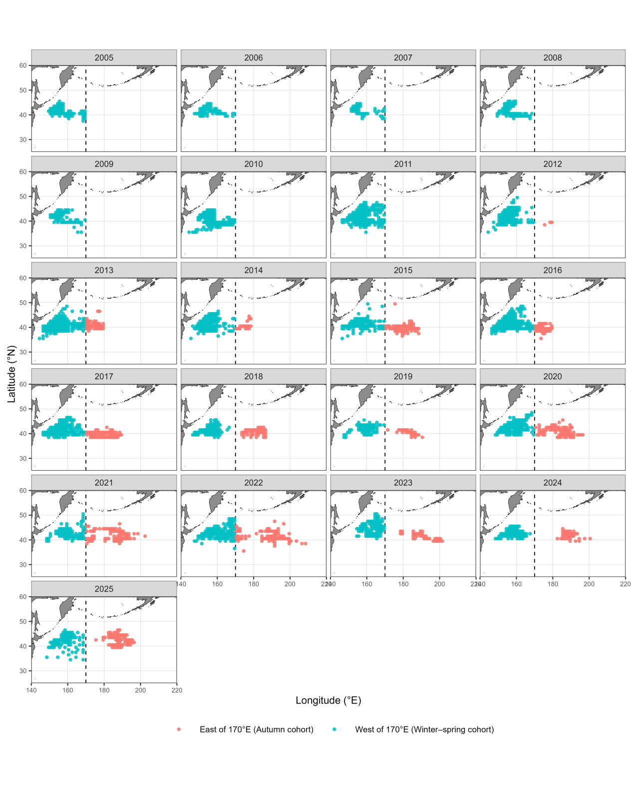
Fig. 1. Annual spatial distribution of Chinese squid-jigging fishing activity during 2005–2025.

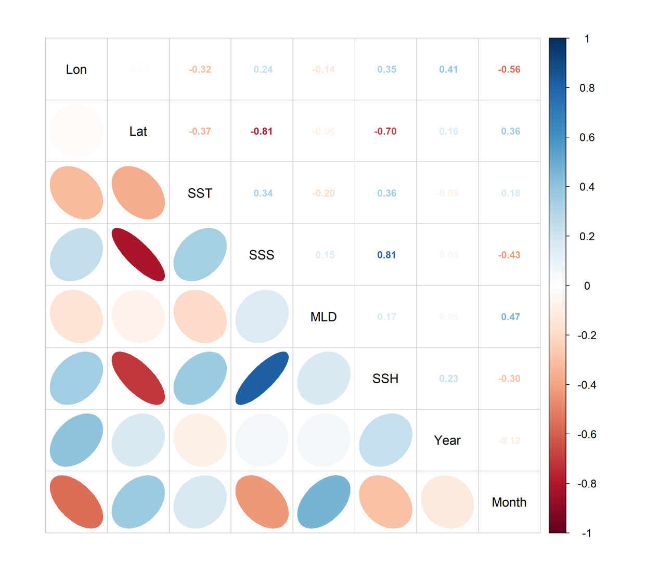
Fig. 2 Correlation matrix of explanatory variables used in the analysis.

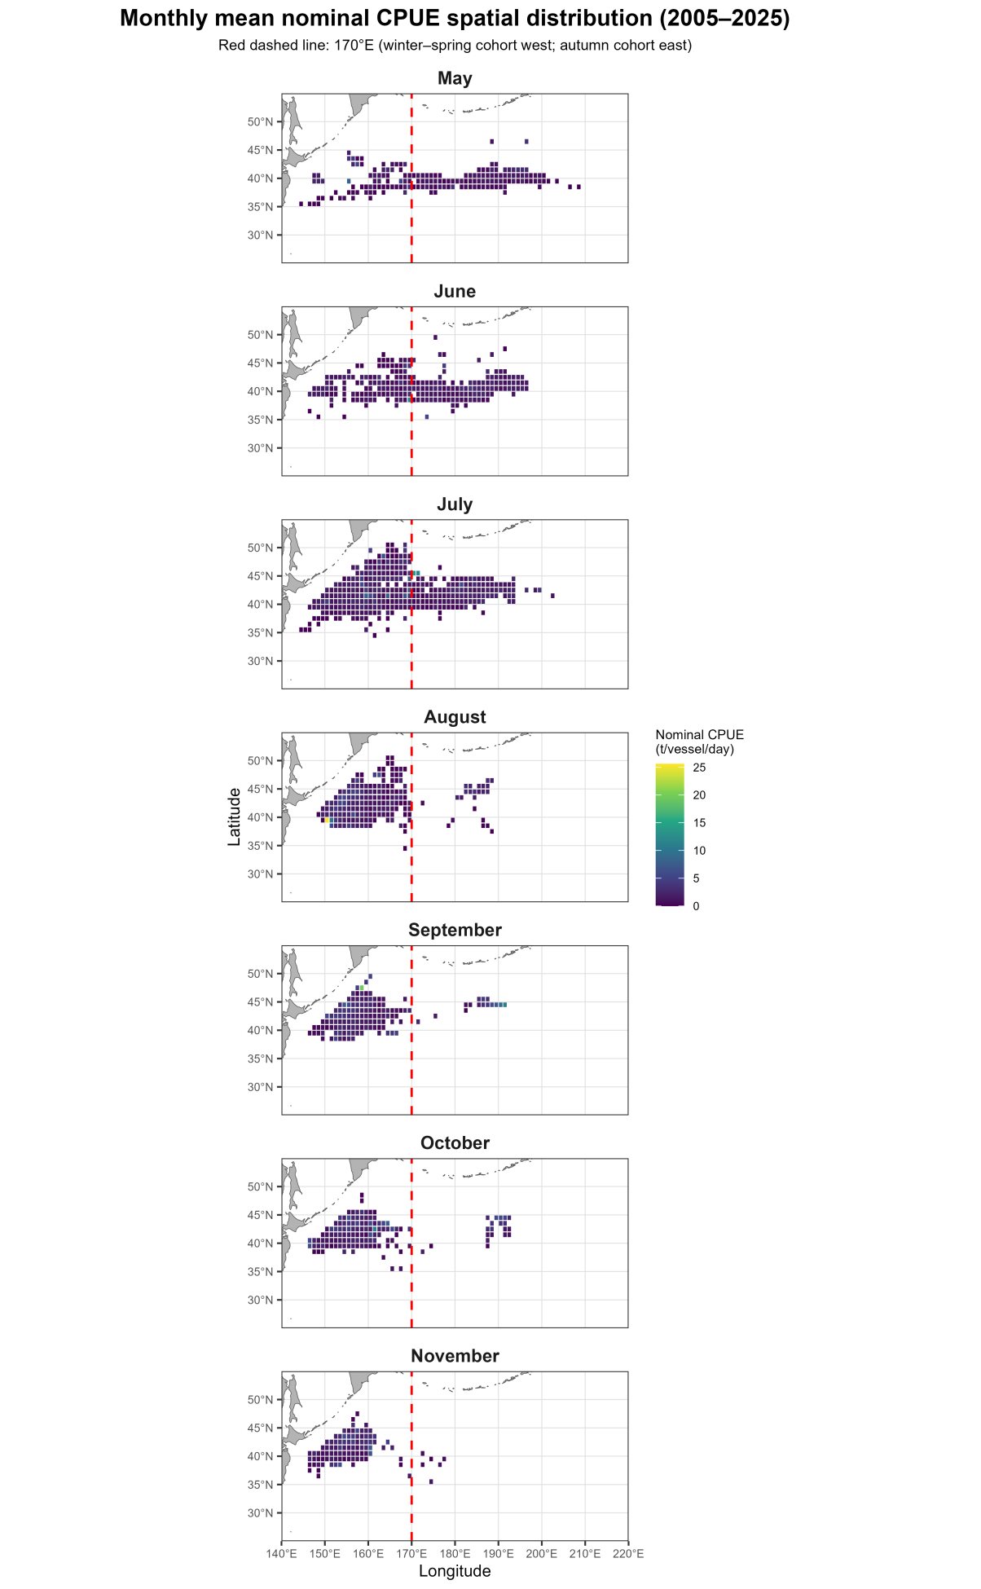
Fig. 3 Spatial distribution of mean nominal CPUE for the autumn cohort and the winter-spring cohort of neon flying squid by Chinese squid jigging fisheries.

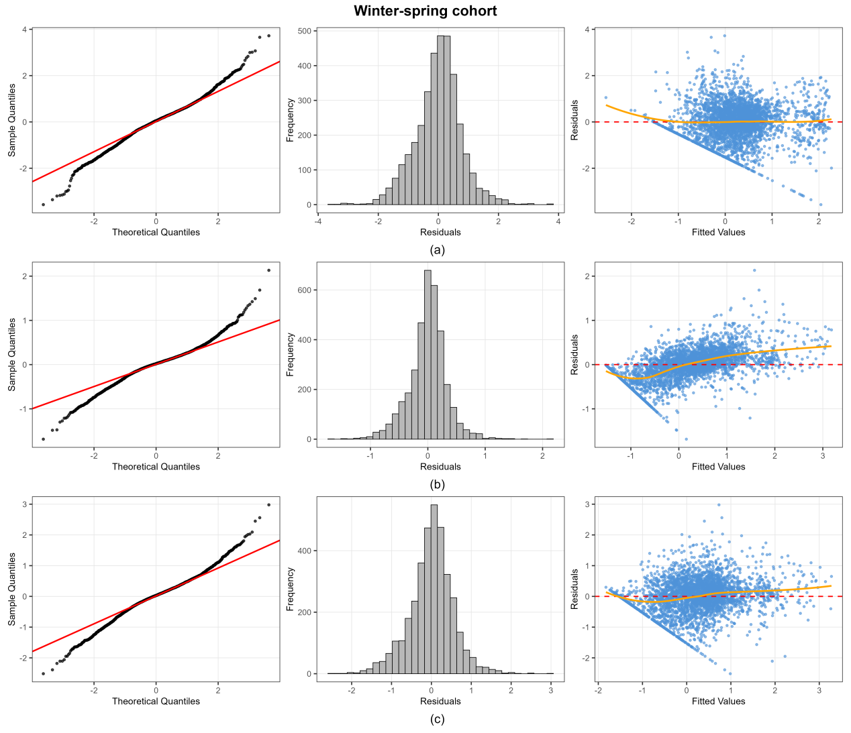
Fig. 4 Model diagnostic plots (Q-Q plot, histogram of residuals, and plot of residuals versus fitted values) for the winter-spring cohort: (a) GAM, (b) RF, (c) GBM.

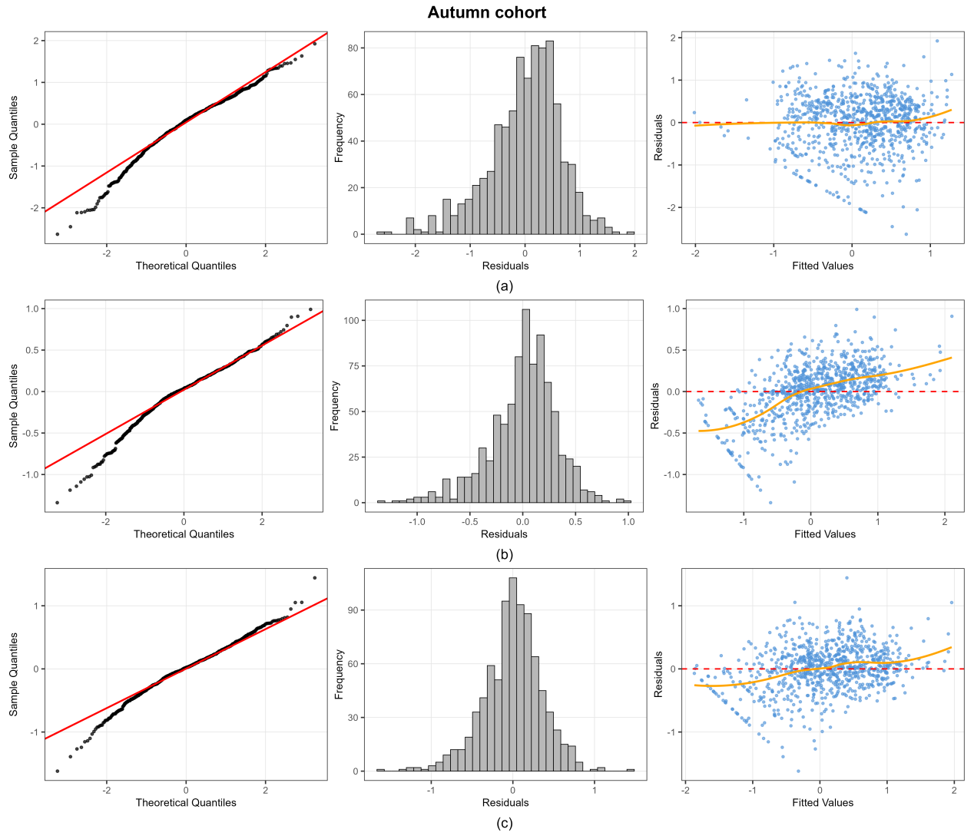

Fig. 5 Model diagnostic plots (Q-Q plot, histogram of residuals, and plot of residuals versus fitted values) for the autumn cohort: (a) GAM, (b) RF, (c) GBM.

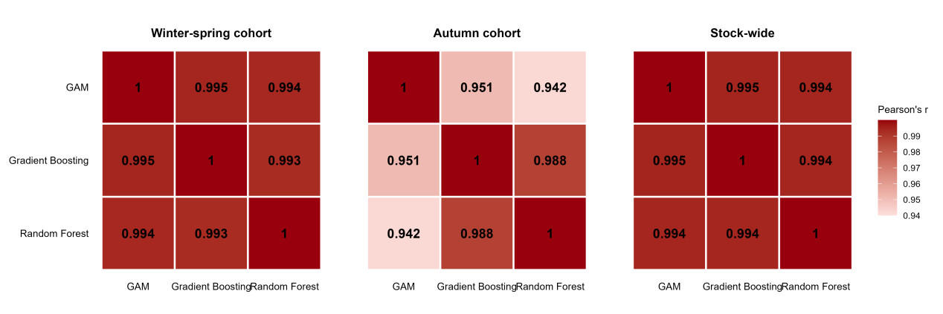
Fig. 6 Correlation matrices of standardized CPUE indices from the GAM, RF, and GBM models for the three stocks.

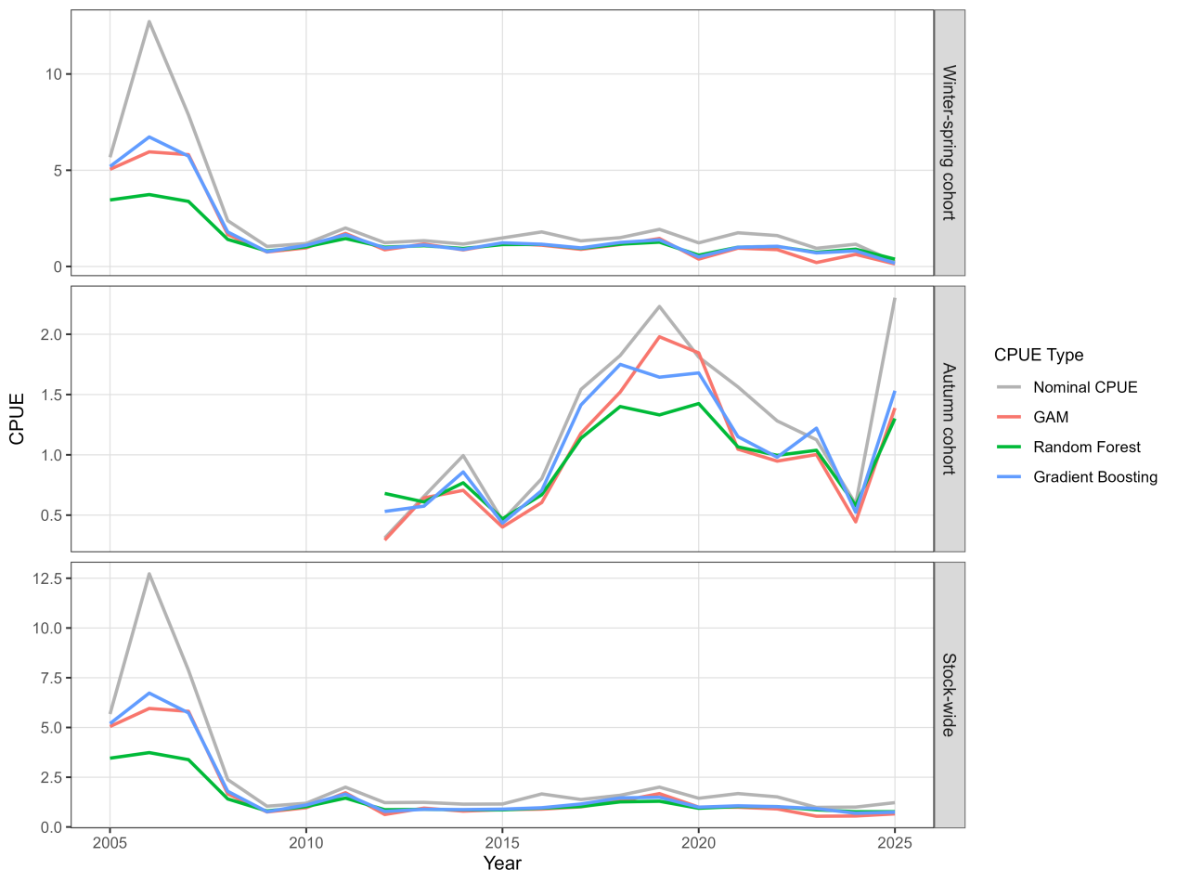
Fig. 7 Comparison of nominal and standardized CPUE indices for the winter-spring cohort, autumn cohort, and stock-wide of neon flying squid derived from three modeling approaches.

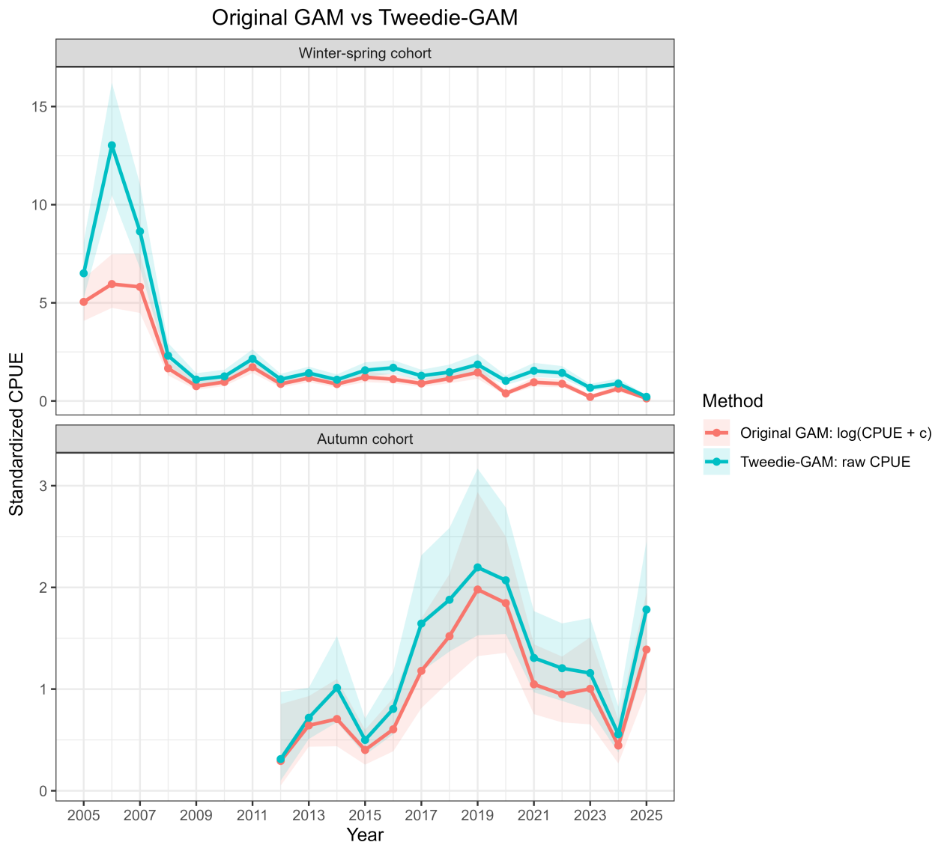
Fig. 8 Comparison of annual standardized CPUE indices estimated by the original GAM and Tweedie-GAM for the winter–spring and autumn cohorts.

