NPFC-2026-SSC JS01-WP06
Temporal Variation in Growth and Mortality of Japanese Sardine based on Chinese survey in the Northwest Pacific
Yufei Zhou, Zhengyan Jiang, Qiuyun Ma, Libin Dai, Bilin Liu, Siquan Tian
College of Marine Living Resource Sciences and Management, Shanghai Ocean University, China
(Corresponding author: Qiuyun Ma, qyma@shou.edu.cn)

Summary
Japanese sardine is an important small pelagic species in the Northwest Pacific and a key resource within the NPFC Convention Area. This study estimated growth and natural mortality parameters using survey data collected by RV Songhang from 2021 to 2025. Fork length distributions showed clear interannual variation, with fish sampled in 2024-2025 generally smaller than those collected in previous years. Length-weight relationships also varied among years, while the mixed-effects model indicated a common allometric exponent close to isometric growth (b = 2.94). Growth parameters estimated from length-frequency data exhibited noticeable temporal variability, with pooled estimates of the von Bertalanffy growth function of L∞ = 25.31 cm, k = 0.31 y⁻¹, and t₀ = −0.94 y. An age-length key (ALK) constructed from otolith readings identified three age groups (0+, 1+, and 2+), with age‑0 and age‑1 fish comprising the vast majority (50.9% and 43.9%, respectively) of the aged individuals. Natural mortality (M) estimated using eight empirical methods ranged from 0.23 to 1.41, and the annual geometric mean varied from 0.46 to 0.77, with pooled estimates at 0.63. These results highlight pronounced temporal variability in Japanese sardine life history, and we recommend that future stock assessments adopt our time‑varying, high‑seas survey‑based estimates for the stock, as they better reflect actual conditions in the Convention Area than fixed parameters.

Introduction
Growth and mortality are key life-history parameters in stock assessment, as they directly influence the estimation of population dynamics and management reference points. For highly variable small pelagic species, these parameters may vary over time due to environmental variability and recruitment fluctuations. Japanese sardine (Sardinops melanostictus) is widely distributed in the Northwest Pacific and occurs across both national waters and the high seas within the NPFC Convention Area. Understanding its biological characteristics across different regions is important for improving stock assessment.
This study provides estimates of growth and mortality parameters for Japanese sardine based on Chinese survey data in the Northwest Pacific, aiming to support stock assessment and management within the NPFC framework.

Materials and Methods
The data used in this study were collected from fishery resource surveys conducted by the research vessel (RV) “Songhang” in the Northwest Pacific Ocean from 2021 to 2025 (Table 1).
Fork length data were measured for all sampled individuals. The length-weight relationship was estimated using the standard power function:
$$W=aL^{b}$$
where W is body weight, L is fork length, and a and b are parameters to be estimated. Temporal variability in the length-weight relationship was evaluated by fitting the model separately for each year. In addition, a nonlinear mixed-effects model was fitted to the data to account for interannual variation. In this model, the allometric exponent (b) was treated as a fixed effect shared among years, while the coefficient (a) was modeled as a year-specific random effect, allowing differences in intercepts among years while assuming a common growth exponent.
Growth parameters were estimated using the von Bertalanffy growth function (VBGF):
$$L_{t}=L_{∞}(1-e^{-k(t-t_{0})})$$
where L_{t} is the length at age t, L∞ is the asymptotic length, k is the growth coefficient, and t₀ is the theoretical age at zero length. Due to the lack of direct age data, growth parameters were estimated based on length-frequency data using the ELEFAN I method implemented in FiSAT II.
In addition, otolith-based age determination was conducted for Japanese sardine collected during the 2025 survey. A total of 172 individuals with successfully assigned ages were used to construct an age-length key (ALK). Fish were classified into 5-mm fork length classes, and the proportion of each age group within each length class was calculated. The ALK was used to characterize the age composition across different size classes and to provide supplementary information on the growth structure of Japanese sardine in the Northwest Pacific.
Natural mortality (M) was estimated using multiple empirical methods based on life-history parameters (Table 2). These included Pauly (1980), Jensen (1996), Hoenig (1983), Gislason et al. (2010), and Charnov et al. (2013), among others. Required inputs such as growth parameters, mean environmental temperature, and maximum age were derived from survey data and relevant literature. To account for variability among estimation methods, the range of M values was examined, and the geometric mean was calculated to provide a representative estimate for each year.

Table 1. Sampling information of Japanese sardine from RV “Songhang” surveys (2021-2025)
Year | Survey stations | Sample size
2021 | 42 | 1001
2022 | 36 | 1301
2023 | 39 | 446
2024 | 46 | 405
2025 | 56 | 203

Table 2. Methods for estimating natural mortality (M) of Japanese sardine
 | Methods | Formula | Reference
M1 | Pauly | $$\ln{M}=-0.0152-0.279\ln{L_{∞}}+0.6543\ln{k}+0.463lnT$$ | Pauly, 1980
M2 | Gislason | $$ln⁡M=0.55-0.17ln⁡L_{∞}+ln⁡k$$ | Gislason et al., 2010
M3 | Charnov | $$M=k{\left(\frac{L}{L_{∞}}\right)}^{-1.5}$$ | Charnov et al., 2013
M4 | Bingyi  Zhan | $$M=-0.0021+\frac{2.5912}{t_{max}}$$ | Zhan, 1986
M5 | Jensen | $$M=1.5k$$ | Jensen, 1996
M6 | Alverson | $$M=\frac{3k}{e^{0.38 t_{max}k}-1}$$ | Alverson et al., 1975
M7 | Hoening | $$ln⁡M=1.44-0.9821ln⁡t_{max}$$ | Hoenig, 1983
M8 | Gislason | $$M=1.73 L^{-1.61}L_{∞}^{1.44}k$$ | Gislason et al., 2010

Results
The fork length distributions of Japanese sardine showed clear interannual variability (Fig. 1). In 2021 and 2022, the distributions were relatively broad, with dominant size classes mainly ranging from 120 to 180 mm. In 2023, the length distribution shifted toward larger individuals, with a clear peak around 140-160 mm and a wider spread. In contrast, the samples in 2024 and 2025 were generally smaller, with dominant fork lengths concentrated between 80 and 120 mm.
The fork length-weight relationships of Japanese sardine were well described (Fig. 2). The parameter a ranged from 7.67×10⁻⁷ to 4.90×10⁻⁴, while the exponent b ranged from 2.68 to 3.56. The fixed-effect estimate of the common allometric exponent was b = 2.94, yielding an overall relationship of a ranged from 1.03×10⁻⁵ to 1.62×10⁻⁵ (Fig. 3). The estimated exponent was close to 3, indicating an isometric growth pattern during the study period.

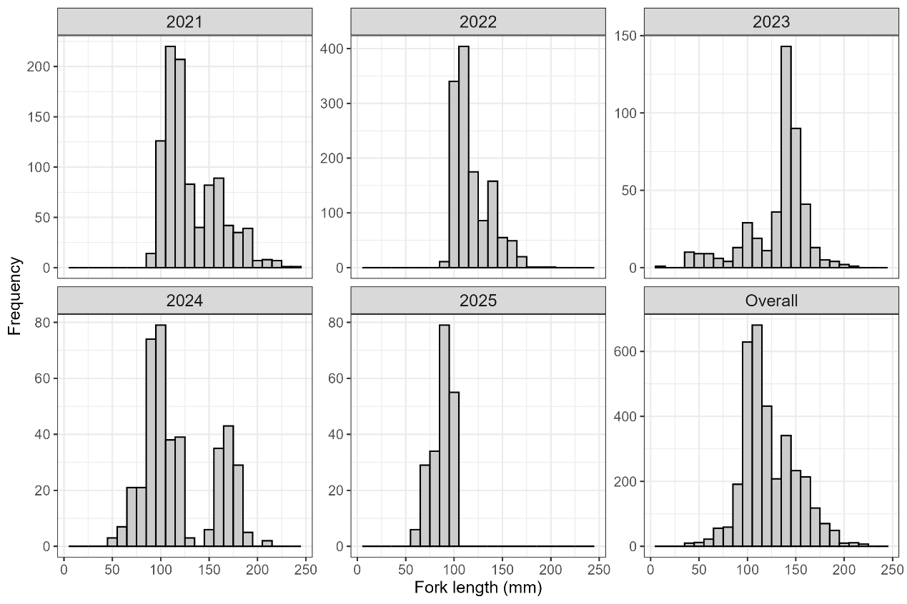
Figure 1. Fork length frequency distribution of Japanese sardine from 2021 to 2025

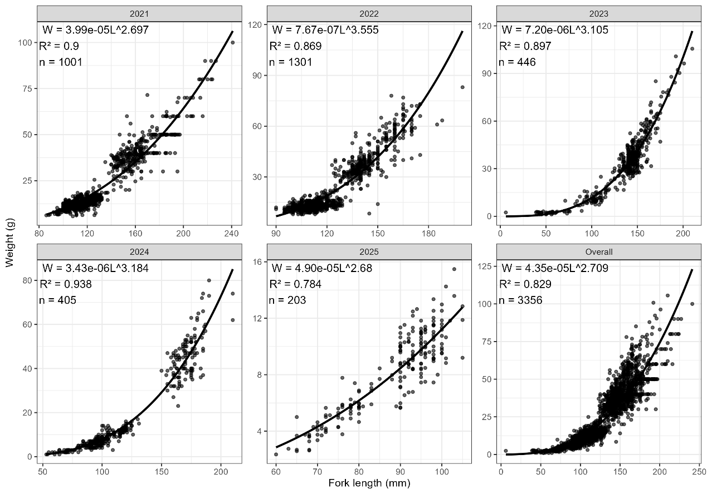
Figure 2. Fork length-weight relationship of Japanese sardine from 2021 to 2025

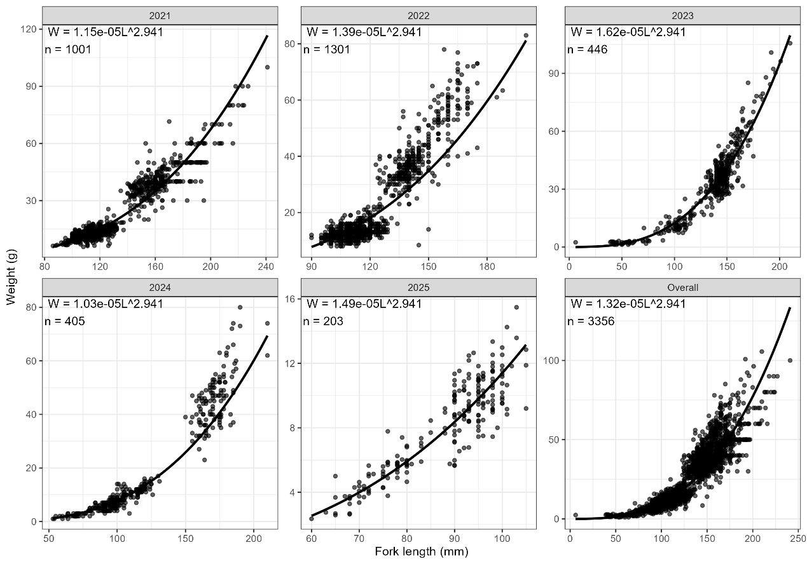
Figure 3. Mixed-effects model of fork length-weight relationship for Japanese sardine from 2021 to 2025

The growth parameters in the von Bertalanffy growth function were estimated based on length-frequency data. The estimated L∞ ranged from 11.02 to 25.20 cm, while the k ranged from 0.22 to 0.70 y⁻¹ (Table 3). The largest L∞ was estimated in 2021 (25.20 cm), whereas the highest k was observed in 2025 (0.70 y⁻¹). The estimated t₀ ranged from -1.39 to -0.51 y. The pooled data for 2021-2025 yielded estimates of L∞ = 25.31 cm, k = 0.31 y⁻¹, and t₀ = −0.94 y. These results suggest clear interannual variability in the growth parameters of Japanese sardine in the Northwest Pacific.
The ALK constructed from 173 aged individuals collected in 2025 showed the relationship between fork length and age composition (Fig. 4). Three age groups (0+, 1+, and 2+) were identified, with total counts of 88 (50.9%), 76 (43.9%), and 9 (5.2%), respectively. Age-0 fish were present in all length classes from 60 to 105 mm, with the highest count (27) in the 90-95 mm class. Age-1 fish also occurred in most classes, with peaks at 95-100 mm (n=27) and 100-105 mm (n=12). Age-2 fish were only observed in length classes ≥90 mm, with counts of 1, 4, and 4 in the 90-95, 95-100, and 100-105 mm classes, respectively; their highest proportion within a length class was 20% in the 100-105 mm class.

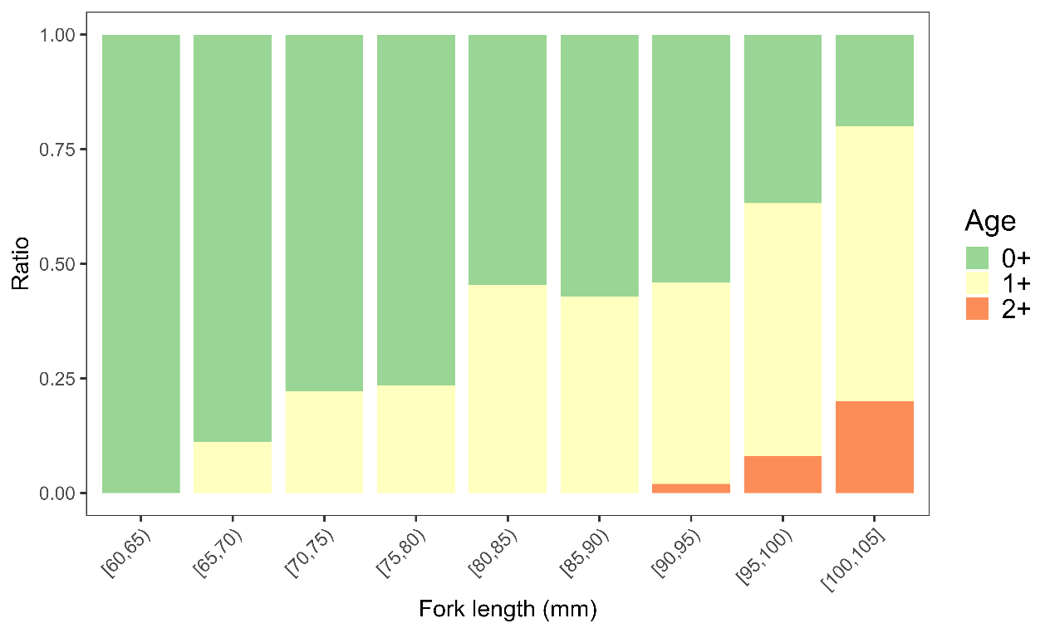
Figure 4. Age-length key (ALK) of Japanese sardine derived from 2025 survey samples

Natural mortality was estimated using eight empirical methods based on growth parameters, mean fork length, maximum age, and mean environmental temperature. The estimated M values varied considerably among methods and years, ranging from 0.23 to 1.41 (Table 4). The geometric mean of M ranged from 0.46 in 2023 to 0.77 in 2025, while the overall estimate for 2021-2025 was 0.63. Some estimators, such as Zhan and Hoenig, produced constant values across years because they depend mainly on maximum age, whereas methods incorporating growth parameters and body size showed stronger interannual variation.

Table 3. Growth parameters of Japanese sardine from 2021 to 2025
Year | t₀ (y) | L∞ (cm) | k (y⁻¹) | $\overline{L}$ (cm) | $\overline{T}$ (ºC)
2021 | -0.83 | 25.20 | 0.35 | 13.30 | 14.44
2022 | -0.76 | 21.00 | 0.40 | 12.00 | 15.10
2023 | -1.39 | 22.05 | 0.22 | 13.30 | 15.22
2024 | -1.17 | 22.05 | 0.26 | 11.90 | 15.68
2025 | -0.51 | 11.03 | 0.70 | 8.80 | 15.26
2021-2025 | -0.94 | 25.31 | 0.31 | 12.30 | 15.14

Table 4. Natural mortality estimates for Japanese sardine based on growth parameters from different sources used 8 methods
Methods | 2021 | 2022 | 2023 | 2024 | 2025 | 2021-2025
M1 | 0.69 | 0.81 | 0.54 | 0.62 | 1.41 | 0.65
M2 | 0.35 | 0.41 | 0.23 | 0.27 | 0.81 | 0.31
M3 | 0.91 | 0.93 | 0.47 | 0.66 | 0.98 | 0.92
M4 | 0.37 | 0.37 | 0.37 | 0.37 | 0.37 | 0.37
M5 | 0.52 | 0.60 | 0.33 | 0.39 | 1.05 | 0.46
M6 | 0.68 | 0.63 | 0.83 | 0.78 | 0.39 | 0.73
M7 | 0.62 | 0.62 | 0.62 | 0.62 | 0.62 | 0.62
M8 | 0.98 | 1.02 | 0.51 | 0.72 | 1.16 | 0.99
Range | 0.35-0.98 | 0.37-1.02 | 0.23-0.83 | 0.27-0.78 | 0.37-1.41 | 0.31-0.99
Geomean | 0.60 | 0.64 | 0.46 | 0.52 | 0.77 | 0.63

Discussion
This study provided preliminary estimates of growth parameters and natural mortality for Japanese sardine in the Northwest Pacific based on Chinese survey data. The results showed obvious variation among years, indicating the non-stationarity of life-history traits for Japanese sardine in the convention area.
Generally, the variation in growth and mortality may be related to changes in recruitment, population structure, and environmental conditions. As a typical small pelagic fish, Japanese sardine is highly variable in abundance and biological characteristics, and its growth and mortality parameters may change rapidly among years.
Therefore, fixed biological parameters may not fully represent the population dynamics of Japanese sardine. An additional consideration is that our samples were collected exclusively from the high seas, where fish may experience different environmental and ecological conditions compared to coastal areas within the same stock. Applying parameters derived from coastal surveys to the entire convention area could introduce uncertainty into assessment outputs. We therefore suggest that future assessments account for such spatial heterogeneity in environmental conditions and apply our survey‑derived, time‑varying estimates for the stock rather than relying solely on fixed or coastally‑derived parameters.

Acknowledgement
The document is supported by the National Natural Science Foundation of China (32202934), the National Key R&D Programs of China (2024YFD2400603), and Program on the Survey, Monitoring and Assessment of Global Fishery Resources (Comprehensive scientific survey of fisheries resources at the high seas) sponsored by the Ministry of Agriculture and Rural Affairs.

References
Alverson D L, Carney M J. A graphic review of the growth and decay of population cohorts[J]. ICES Journal of Marine Science, 1975, 36(2): 133-143.
Charnov E L, Gislason H, Pope J G. Evolutionary assembly rules for fish life histories[J]. Fish and Fisheries, 2013, 14.
Gislason H, Daan N, Rice J C, et al. Size, growth, temperature and the natural mortality of marine fish[J]. Fish and Fisheries, 2010, 11: 149-158.
Hoenig J M. Empirical use of longevity data to estimate mortality rates[J]. U.S. National Marine Fisheries Service Fishery Bulletin, 1983, 81: 898-903.
Jensen A L. Beverton and Holt life history invariants result from optimal trade-off of reproduction and survival[J]. Canadian Journal of Fisheries and Aquatic Sciences, 1996, 53(4): 820-822.
Pauly D. On the interrelationships between natural mortality, growth parameters, and mean environmental temperature in 175 fish stocks[J]. ICES Journal of Marine Science, 1980, 39(2): 175-192.
Zhan B Y, Lou D C, Zhong J S. An assessment of the filefish population and rational exploitation of the resource[J]. Journal of Fisheries of China, 1986, 10(4): 408-418.
Zhou Y F, Ma Q Y, Liu B L, et al. An overview of 2025 Chinese survey by fishery research vessel “Song Hang” in the NPFC convention area[R]. NPFC-2025-SC10-WP20. North Pacific Fisheries Commission, 2025.

