NPFC-2026-SSC JS01-WP05
Preliminary standardized fishery-independent index of Japanese Sardine (Sardinops melanostictus) based on the Chinese research vessel “Song hang” from 2021 to 2025
Zhengyan Jiang, Yufei Zhou, Qiuyun Ma, Libin Dai, Bilin Liu, Siquan Tian
College of Marine Living Resource Sciences and Management, Shanghai Ocean University, China
(Corresponding author: Qiuyun Ma, qyma@shou.edu.cn)

Summary
This study standardized the nominal index of Japanese sardine (Sardinops melanostictus) using trawl survey data collected by the RV Songhang in the Northwest Pacific from 2021 to 2025. Using the sdmTMB framework, generalized linear mixed models (GLMMs) incorporating different spatial and spatiotemporal random-effect structures were developed to evaluate Tweedie and delta-lognormal distributions for standardization. Model performance was assessed using Akaike’s Information Criterion (AIC), convergence diagnostics, and Hessian matrix evaluation. The Tweedie model with an independent and identically distributed (IID) was selected as the final model for standardization. The standardized abundance index showed a generally consistent temporal pattern with nominal index, with relatively higher values during 2021–2023 followed by a substantial decline in 2024 and reaching the lowest level in 2025. Among the environmental variables examined, chlorophyll-a concentration showed a significant positive relationship, whereas sea surface temperature and sea surface height exhibited negative effects. The results demonstrate that environmental variability and sampling effects should be considered when interpreting survey-based index trends and provide a preliminary standardized abundance index for monitoring Japanese sardine resources in the Northwest Pacific.

1. Background of the Japanese sardine fishery
The Japanese sardine (Sardinops melanostictus) is one of the key target species for China’s fishing operations in the northwestern Pacific, primarily harvested using purse seine fisheries, with a portion of the catch also taken by midwater trawls. According to the 2026 footprint, China’s catch of Japanese sardine has shown an increasing trend in recent years, reaching approximately 230,000 t in 2023, 260,000 t in 2024, and 300,000 in 2025.
Since 2021, the distant-water fisheries RV “Songhang” of Shanghai Ocean University has conducted comprehensive fishery resource surveys in the northwestern Pacific fishing grounds. Japanese sardine is one of the most important target species in these surveys, and multi-year investigations have generated extensive datasets, including biological samples, fishing ground information, and environmental data.
Temperature, chlorophyll-a concentration, and ocean currents have significant effects on the migration of adult Japanese sardine, and they also directly influence the survival of larvae and juveniles (Tameishi et al., 1996; Itoh et al., 2007; Nishikawa et al., 2008; Heath et al., 2002). Suitable ranges of temperature and salinity are conducive to higher spawning density (Oozeki et al., 2007). Variations in mixed layer depth affect phytoplankton abundance, which in turn influences food availability and survival of larval and juvenile Japanese sardine, thereby affecting recruitment (Nishikawa et al., 2013). In addition, sea surface height affects nutrient transport and plankton distribution, making it an important environmental factor determining the habitat distribution of Japanese sardine (Shi et al., 2023).

2. Method

2.1 The data
The fishery data used in this study were obtained from trawl surveys conducted by the research vessel “Songhang” in the Northwest Pacific from 2021 to 2025. The survey stations were arranged based on a 1° × 1° grid. For each operation, information on fishing location (longitude and latitude), fishing time, catch, and environmental variables was recorded.
Environmental variables included sea surface temperature (SST), salinity (SAL), chlorophyll-a concentration (CHL), mixed layer depth (MLD), sea surface height (SSH), dissolved oxygen (DO), eastward seawater velocity (ECV), and northward seawater velocity (NCV). SST, SAL, and CHL were measured in situ using a conductivity–temperature–depth (CTD) profiler onboard the RV Songhang, whereas the remaining variables were obtained from the Copernicus Marine Environment Monitoring Service (CMEMS) (https://marine.copernicus.eu/).
The original dataset consisted of 421 observations. After removing records with missing spatial information, environmental variables, or effort data, a total of 420 samples were retained for analysis. Among them, 280 samples had positive catches, accounting for 66.67% of the dataset (Tab.1 and Tab.2).
The survey area ranged approximately from 35-45°N,148-164°E, as shown in Fig. 1. All samples with spatial information were used for spatial modeling. The spatial distributions of nominal index and catch are presented in Fig. 2 and Fig. 3.

2.2 Associations between variables
The candidate explanatory variables included temporal variables (Year), spatial variables (Longitude), and environmental variables, including sea surface temperature (SST), sea surface height (SSH), chlorophyll-a concentration (CHL), mixed layer depth (MLD), salinity (SAL), eastward sea water velocity (ECV) and northward sea water velocity (NCV) (Tab.3).
Pearson correlation analysis and variance inflation factor (VIF) analysis were conducted to screen explanatory variables and assess multicollinearity. Variables with a Pearson correlation coefficient of |r| ≥ 0.7 or a VIF value > 5 were considered highly collinear and were not included simultaneously in the same model (Anderson-Cook, 2007; Dormann et al., 2013; Kindong et al., 2022).
Based on these criteria, Longitude, Year, SST, SSH, CHL, MLD, SAL, ECV, and NCV were retained for subsequent model development. The relationships between nominal index and the retained environmental variables were further examined using response curves derived from the fitted models (Fig.4 and Tab.4).

2.3 Model description and selection
Generalized linear mixed models (GLMMs) were fitted using the sdmTMB package, where spatial and spatiotemporal random-effect structures were considered among candidate models. Both Tweedie and delta-lognormal distributions were evaluated to develop alternative candidate models for standardization.
The full model included longitude, year, sea surface temperature (SST), sea surface height (SSH), chlorophyll-a concentration (CHL), mixed layer depth (MLD), salinity (SAL), eastward current velocity (ECV), and northward current velocity (NCV) as fixed effects. Year was treated as a categorical variable to estimate annual abundance indices, whereas the remaining environmental variables were included as continuous covariates.
The general form of the fitted model was (Anderson et al., 2024):
$$ŋ_{i}=X_{i}β+ω(s_{i})+δ(s_{i},t_{i})$$
where ŋ_{i} is the linear predictor, X_{i}β represents the fixed effects including Year, Longitude, SST, SSH, CHL, MLD, SAL, ECV, and NCV, ω(s_{i}) is the spatial random effect accounting for spatial autocorrelation, and δ(s_{i},t_{i}) is the spatiotemporal random effect accounting for spatiotemporal variation. The spatiotemporal random effect was modeled using either an independent and identically distributed (IID) process or a first-order autoregressive (AR1) process across years, with the optimal structure determined through model selection.
Spatial and spatiotemporal random effects were considered among candidate models to evaluate potential spatial dependence and temporal variation. Spatial random effects were incorporated and represented by a Gaussian random field. The spatial field was estimated using the stochastic partial differential equation (SPDE) approach (Lindgren et al., 2011). A spatial mesh was constructed based on the survey station coordinates.
A series of candidate models (fit1-fit57) was developed by progressively adding explanatory variables under both Tweedie and delta-lognormal distributions while considering alternative spatial structures. Model performance was evaluated using Akaike's Information Criterion (AIC) (Akaike, 1987), convergence diagnostics, and Hessian matrix evaluation. Models with non-positive-definite Hessian matrices or convergence failures were excluded from further consideration.

2.4 Yearly trend extraction
Annual standardized abundance indices were extracted from the selected Tweedie model using the predict() and get_index() functions implemented in the sdmTMB package (Anderson et al., 2024). The model was fitted within the generalized linear mixed model framework, including environmental covariates and year effects as fixed effects, with an independent spatiotemporal random effect to account for unexplained temporal variability among survey years.
The linear predictor of the model was expressed as:
$$\hat{ŋ_{i,t}}=X_{i,t}\hat{β}+\hat{δ_{i,t}}$$
where $\hat{ŋ_{i,t}}$represents the predicted linear predictor for survey station i in year t, X_{i,t} represents the matrix of fixed-effect covariates, $\hat{β}$ represents the estimated coefficients of fixed effects, and $\hat{δ_{i,t}}$ represents the estimated spatiotemporal random effect.
Because the Tweedie model was fitted using a log-link function, predicted values on the response scale were obtained by back-transforming the predicted linear predictor:
$$\hat{Y_{i,t}}=exp⁡(\hat{ŋ_{i,t}})$$
where $\hat{Y_{i,t}}$ represents the predicted density at location i in year t.
Standardized abundance index were then obtained using the get_index() function, which integrates predicted densities over the prediction domain and accounts for the spatial extent of the prediction area. The annual abundance index was calculated as:
$$I_{t}=\sum_{j=1}^{m}{\hat{D_{j,t}}}A_{j}$$
Where I_{t} represents the standardized abundance index in year t, $D_{j,t}$represents the predicted density in prediction grid cell j, A_{j} represents the area of prediction grid cell j, and m represents the total number of prediction cells.
To compare temporal trends between standardized abundance index and nominal index, both indices were standardized relative to their mean values during the survey period (2021–2025):
$$RI_{t}=\frac{I_{t}}{\overline{I}}$$
where RI_{t} represents the scaled index in year t, and $\overline{I}$ represents the mean annual abundance index from 2021 to 2025.
Nominal index was calculated as the arithmetic mean of observed catch values and swept area across all survey stations within each survey year:
$$I_{nom,t}=\frac{1}{n_{t}}\sum_{i=1}^{n_{t}}{X_{i,t}}$$
The uncertainty of standardized abundance indices was quantified using the standard errors estimated by get_index(). The coefficient of variation (CV) was calculated from the standard error of the log-transformed abundance index:
$${CV}_{t}=\sqrt{\exp\left({{SE}_{t}}^{2}\right)-1}$$
where SE_{t} represents the standard error of the log-scale abundance index provided by get_index().
The 95% confidence intervals were obtained from the lower and upper confidence limits estimated by get_index().

3. Result

3.1 Model selection and diagnostics
A total of 57 candidate generalized linear mixed models were fitted using combinations of Tweedie and delta-lognormal distributions with different spatial and spatiotemporal structures (Tab.5). The observed nominal index values showed highly skewed distributions among survey years, with a large proportion of zero or low catches and several extremely high catch observations (Fig. 5). This characteristic supported the use of the Tweedie distribution. Model performance was evaluated based on the Akaike Information Criterion (AIC), convergence diagnostics, and Hessian matrix evaluation. The results showed that the Tweedie model (fit5) had the lowest AIC value (1957.62) among all successfully converged models and retained more environmental variables than the other candidate models (Tab.6). It was therefore selected as the final model for nominal index standardization.
Parameter estimates of the selected model are presented in Tab.7. All estimated coefficients were biologically reasonable and associated with acceptable standard errors, indicating stable parameter estimation and successful model convergence.
Model diagnostics suggested that the selected model adequately described the observed data (Fig. 6). The residual histogram and Q–Q plot indicated that the residuals approximately followed a normal distribution, while the residual-versus-fitted plot showed no obvious systematic pattern. In addition, the observed-versus-predicted comparison showed acceptable agreement between model predictions and observations, indicating satisfactory predictive performance. Additional residual diagnostics were conducted to evaluate whether systematic patterns remained between model residuals and explanatory variables. Residuals showed no strong systematic trends across the observed ranges of SST, CHL, SSH, and longitude, suggesting that the selected model adequately captured the major relationships between nominal index and environmental variability.

3.2 Effects of explanatory variables
Observed nominal index exhibited substantial spatial variability in relation to environmental variables, with potential nonlinear responses particularly for SST and chlorophyll-a concentration (Fig. 7). Therefore, nonlinear effects of environmental variables were further evaluated by incorporating smooth terms in additional candidate models (fit55–fit57). However, only model fit56 achieved successful convergence, and the smooth terms provided limited improvement in model performance, suggesting weak nonlinear contributions of environmental variables. Consequently, linear environmental effects were retained in the final model to ensure model stability and interpretability.
The estimated effects of the selected explanatory variables on the standardized abundance index are presented in Fig. 8. The standardized abundance index decreased with increasing sea surface temperature (SST) and sea surface height (SSH) over the observed ranges. In contrast, chlorophyll-a concentration (CHL) showed a significant positive effect on the standardized abundance index, with the standardized abundance index increasing as CHL increased. The effect of longitude (LON) showed an increasing trend in the standardized abundance index from west to east, with relatively higher the standardized abundance index in the eastern part of the survey area.

3.3 Standardized abundance index
The standardized abundance index and nominal index values from 2021 to 2025 are presented in Fig. 9, and the corresponding estimates are summarized in Table 8. Compared with nominal index, the standardized abundance index represents a relative abundance estimate after accounting for the effects of environmental covariates, year effects, and spatiotemporal variability included in the model.
The standardized abundance index showed a generally consistent temporal pattern with nominal index. Both indices exhibited a pronounced decline after 2023 and reached their lowest levels in 2025. However, some differences were observed between the two indices during 2021–2023. The nominal index increased continuously from 2021 to 2023, whereas the standardized abundance index showed a slight decrease in 2022 followed by an increase in 2023.
The coefficients of variation (CV) of the standardized abundance index ranged from 0.21 to 0.80. The highest uncertainty was observed in 2025, which corresponded to the extremely low abundance level in that year. The relatively high CV indicated increased uncertainty in abundance estimation under conditions of very low stock abundance.

4.Discussion
The standardized abundance index obtained in this study showed a temporal trend generally consistent with that of the nominal index, indicating that the nominal index broadly reflected interannual changes in Japanese sardine abundance. By incorporating environmental covariates together with spatial and spatiotemporal random effects, the selected Tweedie model reduced these sources of variation and produced a standardized abundance index that is less affected by sampling conditions.
The coefficients of variation (CV) of the standardized abundance index estimates ranged from 0.21 to 0.80, indicating moderate to relatively high uncertainty in some annual abundance estimates. Several factors may have contributed to these relatively high CV values. First, the available time series covered only five survey years (2021–2025), providing limited information for estimating interannual variability. Second, although 420 observations were included in the analysis, only 280 records contained positive catches, reducing the effective sample size available for nominal index. Third, Japanese sardine exhibited pronounced spatial aggregation during the surveys, resulting in substantial variability among sampling stations.
Although the selected Tweedie model provided the best overall performance among the candidate models, several limitations remain. Only a limited number of environmental variables were included in the analysis, and potentially important factors such as mesoscale oceanographic features, prey availability, or biological interactions were not considered. Furthermore, environmental effects were assumed to be linear on the link scale, and possible nonlinear responses or interactions among explanatory variables were not investigated.
As additional survey years become available, future studies should evaluate more flexible model structures, incorporate additional ecological covariates, and further assess the robustness of indices. This study represents a preliminary attempt to standardize survey nominal index for Japanese sardine in the Northwest Pacific based on the currently available data collected by the RV Songhang. As the survey time series is extended and additional data become available, the standardized abundance index is expected to be further improved and provide a more reliable reference for long-term stock monitoring and future stock assessments.

5. References
Akaike H. Factor analysis and AIC[J]. Psychometrika, 1987, 52(3): 317-332.
Anderson S C, Ward E J, English P A, et al. sdmTMB: an R package for fast, flexible, and user-friendly generalized linear mixed effects models with spatial and spatiotemporal random fields[J]. Journal of Statistical Software, 2025, 115(2): 1-46.
Anderson-Cook C M. Generalized additive models: an introduction with R[J]. Journal of the American Statistical Association, 2007, 102(478): 760-761.
Dormann C F, Elith J, Bacher S, et al. Collinearity: a review of methods to deal with it and a simulation study evaluating their performance[J]. Ecography, 2013, 36(1): 27-46.
Heath M R, Zenitani H, Watanabe Y, et al. Modelling the dispersal of larval Japanese sardine, Sardinops melanostictus, by the Kuroshio Current in 1993 and 1994[J]. Fisheries Oceanography, 2002, 7: 335-346.
Itoh S, Kimura S. Transport and survival of larvae of pelagic fishes in Kuroshio system region estimated with Lagrangian drifters[J]. Fisheries Science, 2007, 73: 1295-1308.
Kindong R, Sarr O, Wang J Q, et al. Size distribution patterns of silky shark Carcharhinus falciformis shaped by environmental factors in the Pacific Ocean[J]. Science of the Total Environment, 2022, 850: 157927.
Lindgren F, Rue H, Lindstrom J. An explicit link between Gaussian fields and Gaussian Markov random fields: the stochastic partial differential equation approach[J]. Journal of the Royal Statistical Society, 2011, 73(4): 423-498.
Nishikawa H, Yasuda I, Komatsu K, et al. Winter mixed layer depth and spring bloom along the Kuroshio front: implications for the Japanese sardine stock[J]. Marine Ecology Progress Series, 2013, 487: 217-229.
Nishikawa H, Yasuda I. Japanese sardine (Sardinops melanostictus) mortality in relation to the winter mixed layer depth in the Kuroshio Extension region[J]. Fisheries Oceanography, 2008, 17(5): 411-420.
Oozeki Y, Takasuka A, Kubota H, et al. Characterizing spawning habitats of Japanese sardine (Sardinops melanostictus), Japanese anchovy (Engraulis japonicus), and Pacific round herring (Etrumeus teres) in the Northwestern Pacific[J]. CalCOFI Reports, 2007, 48.
Shi Y, Kang B, Fan W, et al. Spatio-temporal variations in the potential habitat distribution of Pacific sardine (Sardinops sagax) in the Northwest Pacific Ocean[J]. Fishes, 2023, 8: 86.
Tameishi H, Shinomiya H, Aoki I, et al. Understanding Japanese sardine migrations using acoustic and other aids[J]. ICES Journal of Marine Science, 1996, 53(2): 167-171. https://doi.org/10.1006/jmsc.1996.0018

Appendices
Tab.1 Summary of annual survey data and nominal index of Japanese sardine during 2021–2025
Year | Number of stations | Positive nominal index | Total catch(kg) | Mean nominal index(kg/m²)
2021 | 142 | 123 | 2285.33 | 155.03
2022 | 92 | 69 | 1690.54 | 186.07
2023 | 85 | 63 | 6423.43 | 230.14
2024 | 46 | 17 | 804.60 | 51.72
2025 | 56 | 9 | 4.61 | 0.32

Tab.2 Summary of data filtering procedures and sample sizes used for nominal index standardization
Filter Applied | Number of Records Remaining |  | Number of Records with JS Catch >0
Raw data |  | 421 | 281
Remove missing values |  | 420 | 280
After environmental matching |  | 420 | 280
Final modeling data |  | 420 | 280

Tab.3 Summary of candidate explanatory variables used in the nominal index standardization model
Category | Variable | Abbreviation | Range | Unit
Temporal | year | year | 2021-2025 | /
Spatial | longitude | lon | 147.97-168.20 | °E
Spatial | latitude | lat | 34.00-45.08 | °N
Environmental | Temperature | Temp | 7.99-27.28 | ℃
Environmental | chlorophyll-a | Chl-a | 0.07-5.11 | mg/m³
Environmental | dissolved oxygen | DO | 227.63-339.69 | μmol/L
Environmental | salinity | SAL | 32.21-34.82 | PSU
Environmental | mixed layer depth | MLD | 10.38-27.16 | m
Environmental | sea surface height | SSH | -0.29-1.28 | m
Environmental | eastward sea water velocity | U | -0.86-1.78 | m/s
Environmental | northward sea water velocity | V | -1.39-1.15 | m/s

Tab.4 Variance inflation factors (VIF) for explanatory variables
Variable | VIF
lon | 1.50
lat | 5.02
Temp | 1.84
Chl-a | 4.29
DO | 1.41
SAL | 3.32
MLD | 1.10
SSH | 2.34
ECV | 1.06
NCV | 1.03

Tab.5 Candidate sdmTMB models evaluated for nominal index standardization
Model | Family | spatial | spatiotemporal | Variables
fit1 | Tweedie | off | iid | Lon
fit2 | Tweedie | off | iid | Lon+factor(Year)
fit3 | Tweedie | off | iid | Lon+factor(Year)+SST
fit4 | Tweedie | off | iid | Lon+factor(Year)+SST+SSH
fit5 | Tweedie | off | iid | Lon+factor(Year)+SST+SSH+CHL
fit6 | Tweedie | off | iid | Lon+factor(Year)+SST+SSH+CHL+MLD
fit7 | Tweedie | off | iid | Lon+factor(Year)+SST+SSH+CHL+MLD+SAL
fit8 | Tweedie | off | iid | Lon+factor(Year)+SST+SSH+CHL+MLD+SAL+ECV
fit9 | Tweedie | off | iid | Lon+factor(Year)+SST+SSH+CHL+MLD+SAL+ECV+NCV
fit10 | Tweedie | on | iid | Lon
fit11 | Tweedie | on | iid | Lon+factor(Year)
fit12 | Tweedie | on | iid | Lon+factor(Year)+SST
fit13 | Tweedie | on | iid | Lon+factor(Year)+SST+SSH
fit14 | Tweedie | on | iid | Lon+factor(Year)+SST+SSH+CHL
fit15 | Tweedie | on | iid | Lon+factor(Year)+SST+SSH+CHL+MLD
fit16 | Tweedie | on | iid | Lon+factor(Year)+SST+SSH+CHL+MLD+SAL
fit17 | Tweedie | on | iid | Lon+factor(Year)+SST+SSH+CHL+MLD+SAL+ECV
fit18 | Tweedie | on | iid | Lon+factor(Year)+SST+SSH+CHL+MLD+SAL+ECV+NCV
fit19 | Tweedie | on | ar1 | Lon
fit20 | Tweedie | on | ar1 | Lon+factor(Year)
fit21 | Tweedie | on | ar1 | Lon+factor(Year)+SST
fit22 | Tweedie | on | ar1 | Lon+factor(Year)+SST+SSH
fit23 | Tweedie | on | ar1 | Lon+factor(Year)+SST+SSH+CHL
fit24 | Tweedie | on | ar1 | Lon+factor(Year)+SST+SSH+CHL+MLD
fit25 | Tweedie | on | ar1 | Lon+factor(Year)+SST+SSH+CHL+MLD+SAL
fit26 | Tweedie | on | ar1 | Lon+factor(Year)+SST+SSH+CHL+MLD+SAL+ECV
fit27 | Tweedie | on | ar1 | Lon+factor(Year)+SST+SSH+CHL+MLD+SAL+ECV+NCV
fit28 | delta_lognormal | off | iid | Lon
fit29 | delta_lognormal | off | iid | Lon+factor(Year)
fit30 | delta_lognormal | off | iid | Lon+factor(Year)+SST
fit31 | delta_lognormal | off | iid | Lon+factor(Year)+SST+SSH
fit32 | delta_lognormal | off | iid | Lon+factor(Year)+SST+SSH+CHL
fit33 | delta_lognormal | off | iid | Lon+factor(Year)+SST+SSH+CHL+MLD
fit34 | delta_lognormal | off | iid | Lon+factor(Year)+SST+SSH+CHL+MLD+SAL
fit35 | delta_lognormal | off | iid | Lon+factor(Year)+SST+SSH+CHL+MLD+SAL+ECV
fit36 | delta_lognormal | off | iid | Lon+factor(Year)+SST+SSH+CHL+MLD+SAL+ECV+NCV
fit37 | delta_lognormal | on | iid | Lon
fit38 | delta_lognormal | on | iid | Lon+factor(Year)
fit39 | delta_lognormal | on | iid | Lon+factor(Year)+SST
fit40 | delta_lognormal | on | iid | Lon+factor(Year)+SST+SSH
fit41 | delta_lognormal | on | iid | Lon+factor(Year)+SST+SSH+CHL
fit42 | delta_lognormal | on | iid | Lon+factor(Year)+SST+SSH+CHL+MLD
fit43 | delta_lognormal | on | iid | Lon+factor(Year)+SST+SSH+CHL+MLD+SAL
fit44 | delta_lognormal | on | iid | Lon+factor(Year)+SST+SSH+CHL+MLD+SAL+ECV
fit45 | delta_lognormal | on | iid | Lon+factor(Year)+SST+SSH+CHL+MLD+SAL+ECV+NCV
fit46 | delta_gamma() | on | ar1 | Lon
fit47 | delta_gamma() | on | ar1 | Lon+factor(Year)
fit48 | delta_gamma() | on | ar1 | Lon+factor(Year)+SST
fit49 | delta_gamma() | on | ar1 | Lon+factor(Year)+SST+SSH
fit50 | delta_gamma() | on | ar1 | Lon+factor(Year)+SST+SSH+CHL
fit51 | delta_gamma() | on | ar1 | Lon+factor(Year)+SST+SSH+CHL+MLD
fit52 | delta_gamma() | on | ar1 | Lon+factor(Year)+SST+SSH+CHL+MLD+SAL
fit53 | delta_gamma() | on | ar1 | Lon+factor(Year)+SST+SSH+CHL+MLD+SAL+ECV
fit54 | delta_gamma() | on | ar1 | Lon+factor(Year)+SST+SSH+CHL+MLD+SAL+ECV+NCV
fit55 | Tweedie | off | iid | Lon+factor(Year)+s(SST)+SSH+CHL
fit56 | Tweedie | off | iid | Lon+factor(Year)+s(SST)+s(SSH)+CHL
fit57 | Tweedie | off | iid | Lon+factor(Year)+s(SST)+(SSH)+s(CHL)+MLD+SAL

Tab.6 Model comparison based on AIC, convergence diagnostics, and model performance
Model |  | AIC | ΔAIC | R² | NRMSE
fit1 | √ | 2016.63 | 241.43 | 0.25 | 7.51
fit2 | √ | 1971.76 | 196.56 | 0.19 | 7.51
fit3 | √ | 1959.41 | 184.21 | 0.19 | 7.51
fit4 | √ | 1961.17 | 185.97 | 0.19 | 7.51
fit5 | √ | 1957.62 | 182.42 | 0.19 | 7.51
fit6 | √ | 1958.17 | 182.97 | 0.19 | 7.51
fit7 | √ | 1959.26 | 184.06 | 0.19 | 7.51
fit8 | √ | 1961.23 | 186.04 | 0.19 | 7.51
fit9 | √ | 1961.70 | 186.50 | 0.19 | 7.51
fit10 | △ | 2018.63 | 243.43 | 0.25 | 7.51
fit11 | √ | 1971.76 | 196.56 | 0.19 | 7.51
fit12 | √ | 1961.39 | 186.19 | 0.19 | 7.51
fit13 | √ | 1963.16 | 187.96 | 0.19 | 7.51
fit14 | √ | 1959.59 | 184.39 | 0.19 | 7.51
fit15 | √ | 1960.02 | 184.83 | 0.19 | 7.51
fit16 | × | 1961.26 | 186.06 | 0.19 | 7.51
fit17 | × | 1963.23 | 188.04 | 0.19 | 7.51
fit18 | × | 1963.70 | 188.50 | 0.19 | 7.51
fit19 | △ | 2020.05 | 244.85 | 0.24 | 7.51
fit20 | × | 2028.70 | 253.50 | 0.19 | 7.51
fit21 | △ | 1963.22 | 188.02 | 0.19 | 7.51
fit22 | × | 2040.77 | 265.57 | 0.20 | 7.51
fit23 | × | / | / | / | /
fit24 | × | 2037.61 | 262.41 | 0.20 | 7.51
fit25 | × | 2023.23 | 248.03 | 0.21 | 7.51
fit26 | × | 2071.19 | 296.00 | 0.16 | 7.51
fit27 | × | 2052.85 | 277.65 | 0.17 | 7.51
fit28 | × | 1920.99 | 145.79 | 0.01 | 7.42
fit29 | √ | 1829.58 | 54.38 | 0.04 | 7.38
fit30 | √ | 1830.34 | 55.14 | 0.32 | 6.67
fit31 | × | 1834.40 | 59.21 | 0.04 | 7.30
fit32 | △ | 1775.20 | 0.00 | 0.03 | 7.84
fit33 | △ | 1776.69 | 1.50 | 0.03 | 7.76
fit34 | △ | 1776.26 | 1.07 | 0.02 | 8.59
fit35 | △ | 1779.93 | 4.73 | 0.02 | 8.54
fit36 | △ | 1781.99 | 6.79 | 0.02 | 8.47
fit37 | × | 1919.16 | 143.96 | 0.01 | 7.43
fit38 | × | 1825.88 | 50.68 | 0.04 | 7.36
fit39 | × | 1833.59 | 58.39 | 0.33 | 6.61
fit40 | × | 1835.61 | 60.41 | 0.32 | 6.55
fit41 | △ | 1777.15 | 1.96 | 0.04 | 7.72
fit42 | × | 1778.30 | 3.10 | 0.05 | 7.68
fit43 | × | / | / | / | /
fit44 | × | 1781.55 | 6.35 | 0.04 | 8.26
fit45 | △ | 1783.83 | 8.63 | 0.04 | 8.09
fi46 | △ | 1988.11 | 212.91 | 0.51 | 6.63
fit47 | × | 1897.09 | 121.89 | 0.59 | 6.38
fit48 | × | 1867.98 | 92.78 | 0.85 | 5.36
fit49 | × | 1870.37 | 95.17 | 0.85 | 5.35
fit50 | △ | 1803.00 | 27.80 | 0.01 | 13.23
fit51 | △ | 1816.20 | 41.00 | 0.89 | 5.29
fit52 | △ | 1815.48 | 40.28 | 0.87 | 5.29
fit53 | △ | 1811.87 | 36.67 | 0.01 | 13.65
fit54 | △ | 1821.54 | 46.34 | 0.88 | 5.28
fit55 | × | / | / | / | /
fit56 | △ | 1961.62 | 186.42 | 0.19 | 7.51
fit57 | × | / | / | / | /
*Model diagnostics were assessed using the sanity() function in sdmTMB. Models were classified into three categories according to convergence and parameter estimation diagnostics. Pass (√) indicates that the model successfully converged, the Hessian matrix was positive definite, and all random-effect components were adequately estimated. Partial pass (△) indicates that the convergence diagnostics were satisfied, but one or more random-effect components (e.g., spatial or spatiotemporal random effects) were estimated to be negligible, suggesting limited contribution of those components to model performance. Fail (×) indicates that the model failed to converge and/or the Hessian matrix was not positive definite, implying that parameter estimates may be unreliable.

Tab.7 Parameter estimates and associated uncertainty for the selected Tweedie model
Variable | Estimate | SE | 95% CI | Significance
(Intercept) | -1.66 | 6.92 | (-15.2, 11.9)
Longitude | 0.023 | 0.043 | (-0.062, 0.107) | ns
year2022 | -0.142 | 0.526 | (-1.174, 0.890) | ns
year2023 | -1.660 | 0.612 | (-2.860, -0.463) | *
year2024 | -1.220 | 0.760 | (-2.710, 0.267) | ns
year2025 | -5.590 | 0.829 | (-7.210, -3.960) | ***
SST | -0.104 | 0.075 | (-0.252, 0.044) | ns
SSH | -0.448 | 0.797 | (-2.010, 1.110) | ns
CHL | 0.609 | 0.253 | (0.112, 1.110) | *
range | 69.1 | 13.0 | (47.7, 100.0)
phi | 2.87 | 0.326 | (2.30, 3.59)
sigma_E | 3.47 | 0.306 | (2.92, 4.13)
tweedie_p | 1.73 | 0.0167 | (1.70, 1.76)

Tab.8 Annual standardized abundance index and nominal index estimates for Japanese sardine
Year | Abundance index | nominal index | SE | CV | lwr | upr
2021 | 21001.67 | 155.03 | 0.27 | 0.27 | 12435.22 | 35469.42
2022 | 16944.89 | 187.07 | 0.33 | 0.34 | 8854.79 | 32426.44
2023 | 18058,78 | 230.14 | 0.20 | 0.21 | 12112.99 | 26923.12
2024 | 2257.32 | 51.72 | 0.27 | 0.28 | 1325.43 | 3844.39
2025 | 15.43 | 0.32 | 0.70 | 0.80 | 3.90 | 61.16

Fig.1 Spatial distribution of trawl survey stations in the Northwest Pacific during 2021–2025.

Fig.2 Spatial distribution of nominal index (kg m⁻²) of Japanese sardine during trawl surveys in the Northwest Pacific from 2021 to 2025.

Fig.3 Spatial distribution of nominal Catch (kg) of Japanese sardine during trawl surveys in the Northwest Pacific from 2021 to 2025.

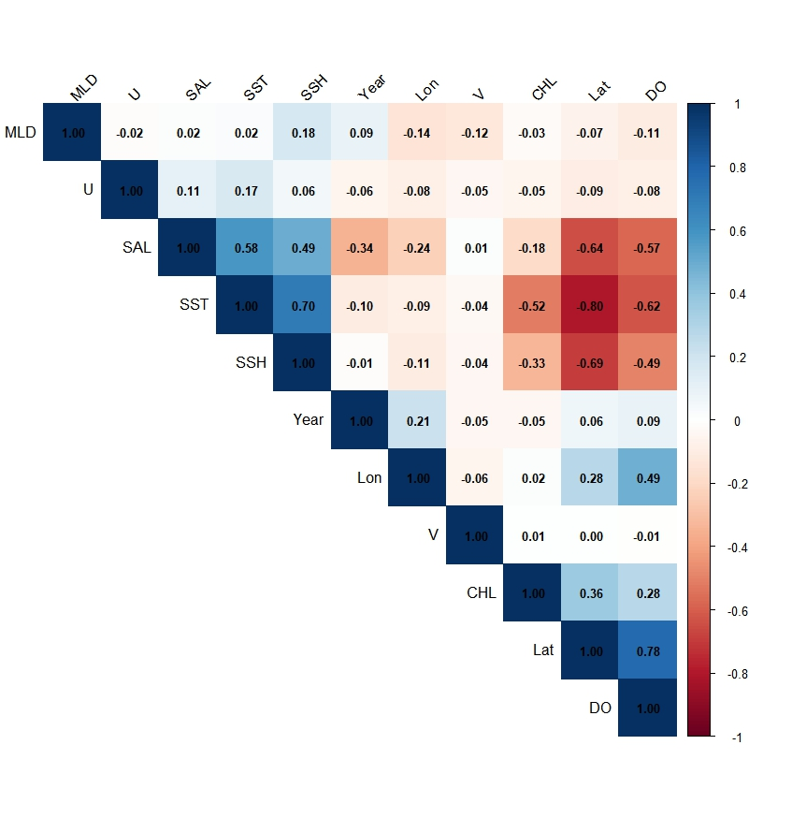
Fig.4 Pearson correlation matrix of candidate explanatory variables used in the nominal index standardization model.

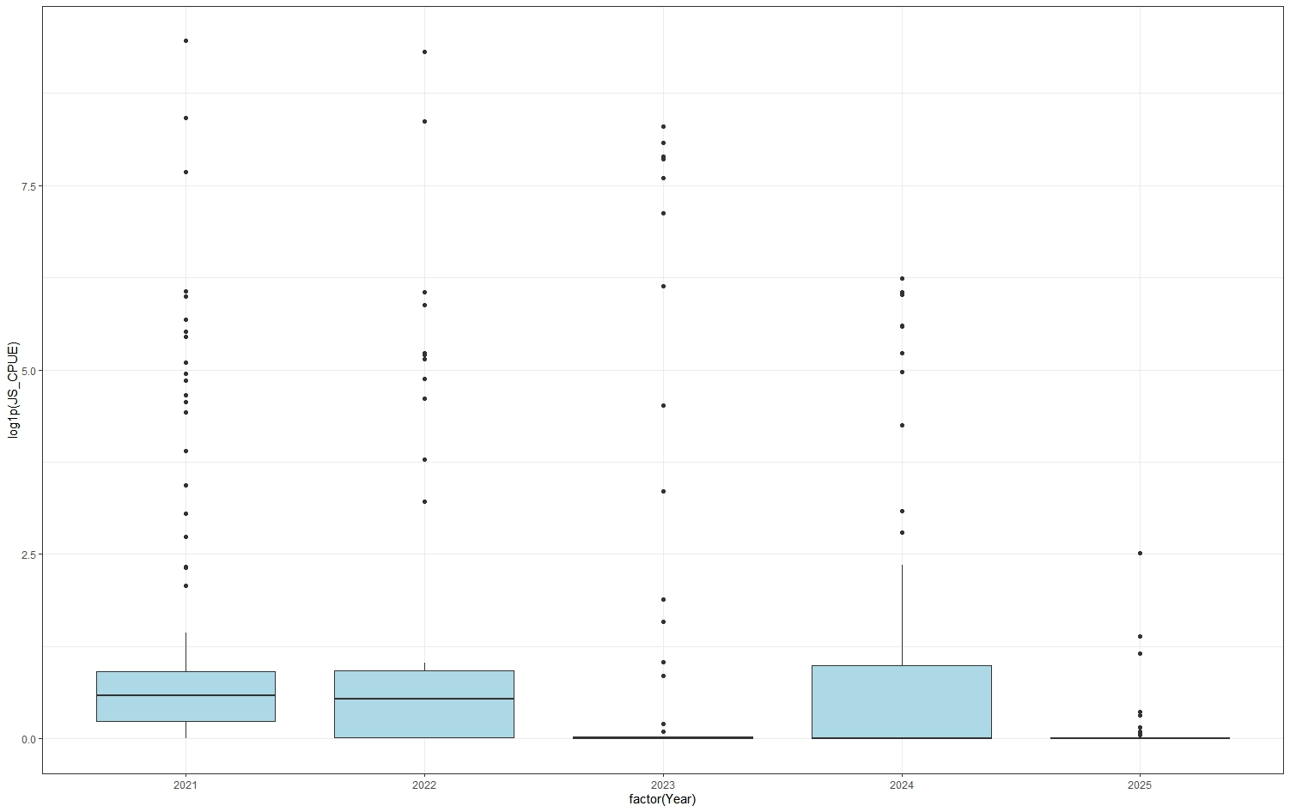
Fig.5 Annual distribution of observed Japanese sardine nominal index from 2021 to 2025.
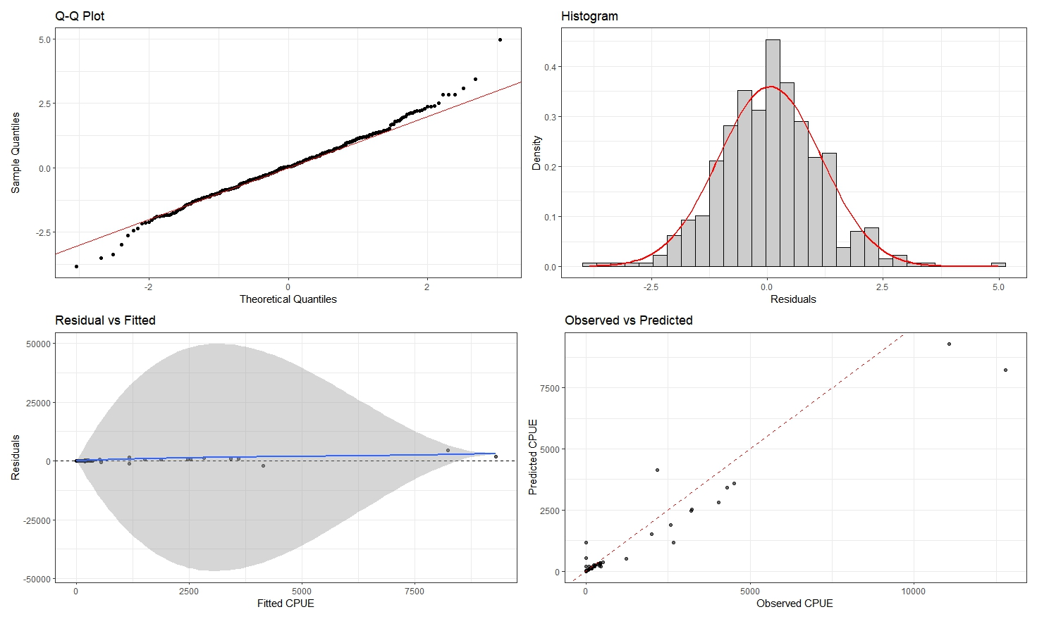
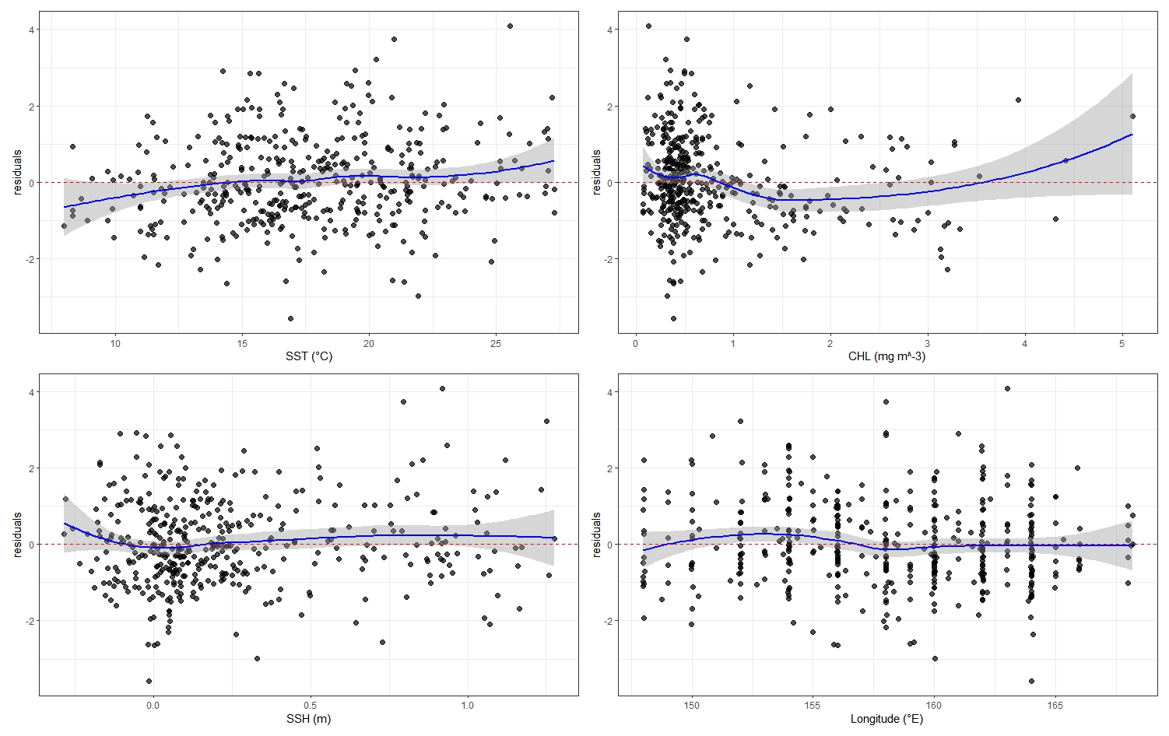
Fig.6 Diagnostic plots for the selected Tweedie model

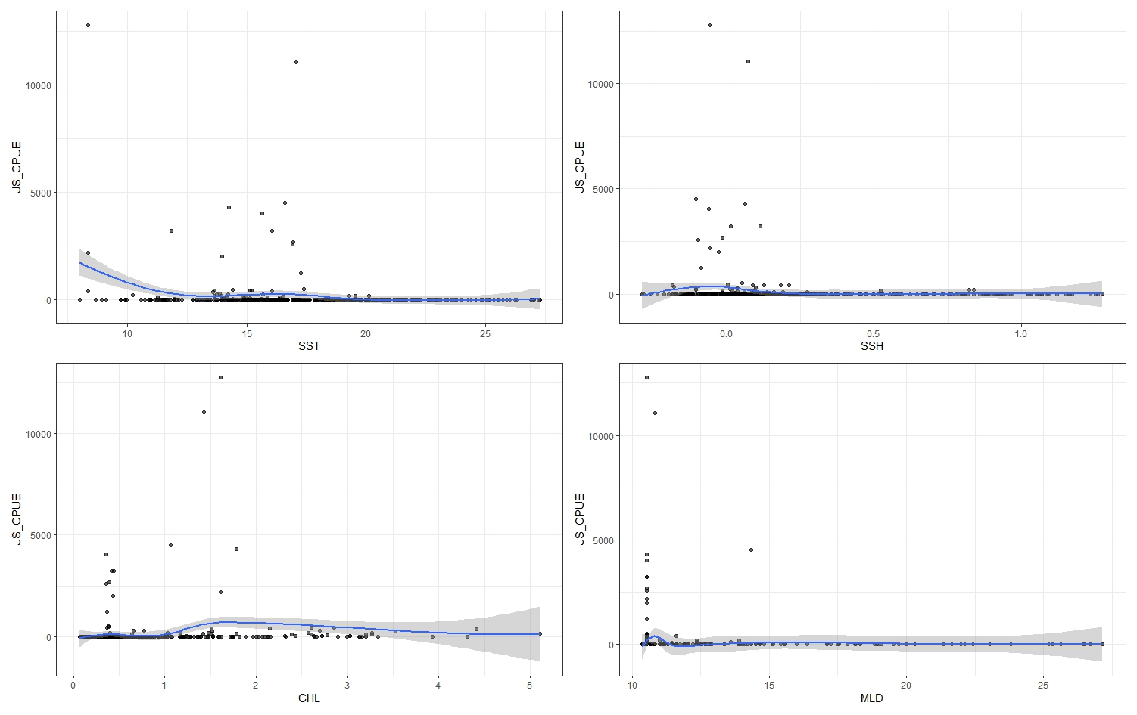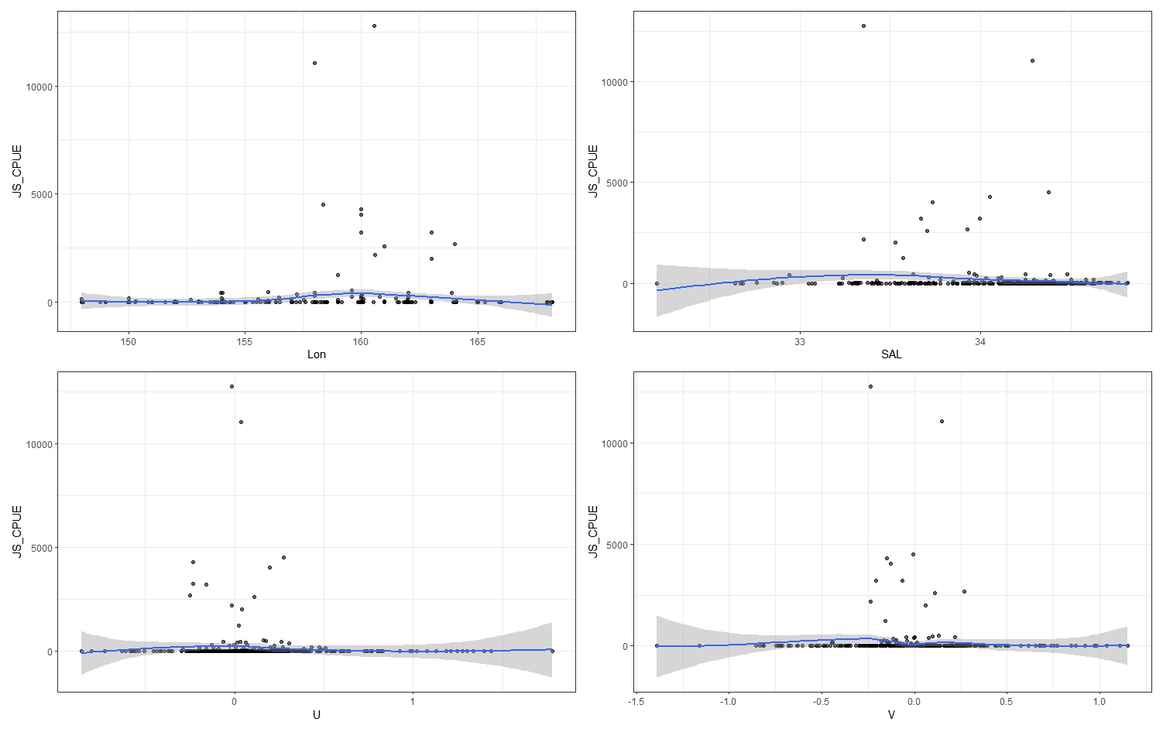
Fig.7 Relationships between observed nominal index and environmental variables.

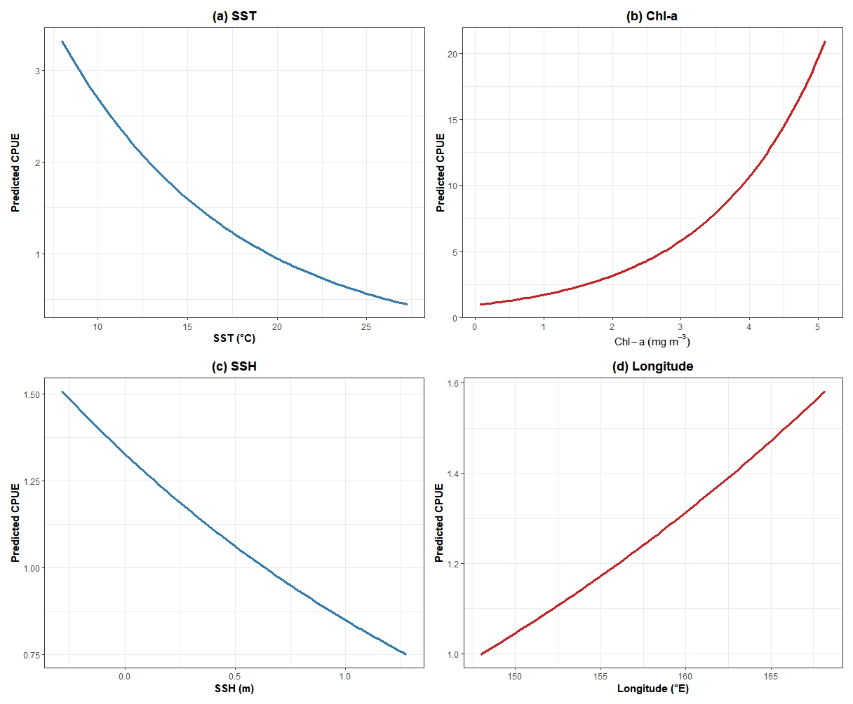
Fig.8 Estimated partial effects of environmental variables on standardized abundance index based on the selected Tweedie model.

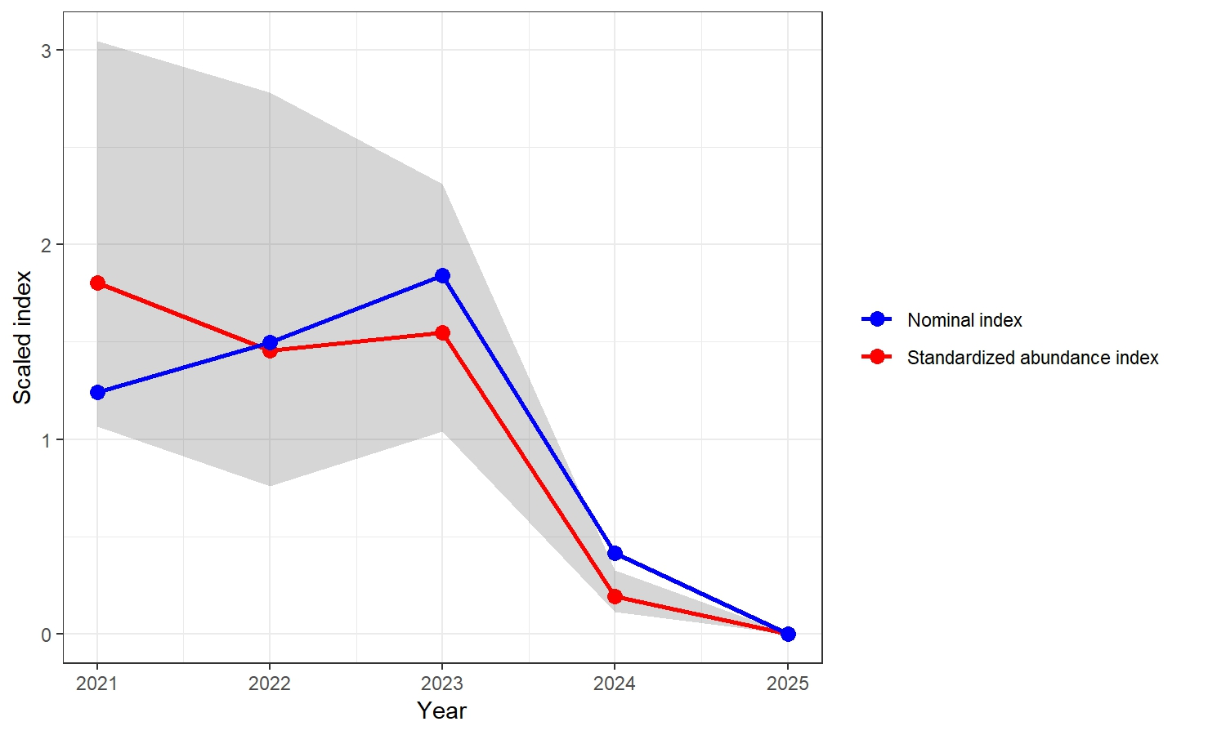
Fig.9 Annual nominal index and standardized abundance index indices of Japanese sardine during 2021–2025.

