NPFC-2026-SSC JS01-WP04

Distribution and migration, growth, and biological parameters for Japanese sardine Sardinops melanostictus from Japan

Akihiro MANABE, Sho FURUICHI, Yasuhiro KAMIMURA, Ryuji YUKAMI

Japan Fisheries Research and Education Agency, Japan

Summary
The stock of Japanese sardine (Sardinops melanostictus) in the northwestern Pacific Ocean has increased substantially since the 2010s, accompanied by changes in its biological characteristics. This document summarizes recent knowledge on the distribution, growth, natural mortality, and maturation of Japanese sardine based on Japanese domestic stock assessments and recent scientific studies.
Recent year-classes have exhibited considerable growth reductions, which have been suggested to result from density-dependent effect and changes in feeding conditions. Mean length and body weight-at-age have shown declining trends, and maturation characteristics are also known to vary with stock abundance. These findings indicate that the biological characteristics of Japanese sardine are dynamic and respond to changes in stock size and environmental conditions. Such characteristics play important factors for future stock assessments and fisheries management.

Introduction
The Japanese sardine (Sardinops melanostictus) in the northwestern Pacific has experienced a rapid increase in stock abundance since the 2010s as a result of strong recruitment. Concurrently various biological characteristics, including growth, maturation, distribution, and migration patterns have been observed (Yukami et al., 2017; Furuichi et al., 2026). Recently, density-dependent effect has been observed to decline growth, and the growth of the 2017–2018 year classes has been reported to be as slow as that observed during the high abundance period in the early 1980s (Kamimura et al., 2022). Furthermore, declines in zooplankton abundance in summer feeding grounds have been suggested to have intensified density-dependent effects on growth in recent years compared with the past high abundance period.
At the same time, the geographic distribution of Japanese sardine has expanded with increasing stock abundance. In recent years, the species has been observed east of 170E and beyond the International Date Line. This working paper reviews recent information on the distribution and migration patterns, growth, weight-at-age, natural mortality, and maturation of Japanese sardine in the northwestern Pacific Ocean, based on Japanese domestic stock assessment reports and recent studies.

Distribution and Migration
Japanese sardine in the northwestern Pacific is widely distributed from waters surrounding Japan to the offshore Kuroshio–Oyashio transition zone. Their distribution and migration patterns are largely determined by transport processes during the early life stages. Current understanding suggests the existence of two major recruitment pathways. The coastal recruitment group is transported to coastal nursery grounds around Japan, grows there, and recruits to coastal fisheries. The offshore recruitment group is transported eastward by the Kuroshio Current to the Kuroshio–Oyashio transition zone, where juveniles grow and migrate to subarctic feeding grounds off eastern Hokkaido and the Kuril Islands (Kawabata et al., 2011; Sakamoto et al., 2019). The distribution of age-0 fish belonging to the offshore recruitment group generally covers a broad area regardless of recruitment magnitude. However, Higashiguchi et al. (2026) reported that during recent years of high recruitment, Japanese sardine expanded their distribution farther offshore. Their study also discussed the relationship between the species’ distribution range and favorable thermal niche. It should be noted that the coastal and offshore recruitment groups do not represent independent populations; rather, they differ in their principal spawning periods and nursery grounds, and recruitment trends are not necessarily synchronized between the two groups.
For fish age-1 and older, Japanese sardine generally overwinter and spawn in waters around the Kuroshio Current. After spawning, some individuals remain in coastal waters around the Kuroshio region during summer and autumn or perform limited feeding migrations, whereas others migrate northward to feeding grounds. The level of these northward feeding migrations varies with stock abundance. During the period of high stock abundance in the 1980s, the species migrated throughout a subarctic region extending from waters off Sanriku and eastern Hokkaido to areas east of the Kuril Islands, reaching the Emperor Seamounts and even areas east of 180E (Ito, 1991; Kuroda, 1991). As stock abundance declined to below one million tons during the 1990s, the migration range contracted to the Oyashio region extending from northern Sanriku to eastern Hokkaido. When stock abundance declined to below 0.5 million tons during the 2000s, the migration range became further contracted to the Kuroshio Extension region off Joban and the southern margin of the Oyashio off southern Sanriku.
With the recent increase in stock abundance, the distribution range of Japanese sardine expanded substantially but temporarily. Japanese summer surveys have recorded age-1 and older fish as far east as approximately 170E since 2018, and the distribution further expanded into the east of 180E after 2021. Japanese autumn surveys have also documented occurrences of age-1 and older fish off the Kuril Islands since 2019. However, surveys conducted since 2024 have indicated that the distribution in offshore region is limited for age-1 and older fish, suggesting a possible contraction of the distribution range.

Growth
Growth of Japanese sardine in the northwestern Pacific is known to vary with stock abundance. Kamimura et al. (2022) compared growth curves of individual year classes during the period of large stock fluctuations in the 1970s and 1980s with those of year classes from 2011 to 2020 and presented the existence of substantial interannual variability in growth. In particular, the 2017–2018 year classes exhibited growth rates as low as those observed for the year classes that supported the high stock abundance period of the early 1980s. However, unlike the growth patterns observed during the 1980s, recent growth reductions may be subject to stronger density-dependent effects due to relatively limited zooplankton biomass in the summer feeding ground in recent years.
Mean scale-covered fork length (hereafter BL) at age for Japanese sardine caught in Japan was calculated using catch number at age at length data from the Japanese domestic stock assessment. The mean length-at-age was calculated as:
$$\overline{{BL}_{a,y}}=\frac{\sum{c_{BL,a,y}BL}}{\sum{c_{a,y}}}$$
where BL is the scale-covered fork length (cm), c is the catch number, a is age, and y is year.
Calculated mean lengths-at-age are presented in Table 1 and Figure 1. The mean length-at- age in 2023 and 2024 was less than 20 cm at age-5. This result is consistent with the findings of Kamimura et al. (2022), given that individuals from the 2018-year class, which was reported to exhibit particularly slow growth, reached age 5 in 2023.

Weight-at-Age
In the Japanese domestic stock assessment, mean weight-at-age is estimated annually as:
$$w_{a,y}=\frac{\sum{\left(α×{BL}^{β}×c_{BL,y,m,pref}×p_{BL,a,y,m,area}\right)}}{\sum{\left(c_{BL,y,m,pref}×p_{BL,a,y,m,area}\right)}}$$
where $α$ and $β$ are parameters of the length–weight relationship based on scale-covered fork length BL, $c_{BL,y,m,pref}$ is the catch number at a given length (cm) in prefecture pref during month m of year y, and $p_{BL,a,y,m,area}$ is the proportion of age-a fish at a given length in area area (i.e., Age-Length-Key).
In the Japanese domestic stock assessment, biological samples are collected annually from each prefecture, and prefecture-specific length–weight relationships are estimated. Using the estimated length–weight relationship, catch weight at length is calculated for each prefecture on a monthly basis. Monthly Age–length keys (ALKs) is used for two areas; east of Shizuoka and west of Mie prefecture. The ALKs convert catch weight at length into catch weight at age in each length class. These estimates are aggregated to obtain catch weight at age, and annual mean weight at age is calculated by dividing catch weight at age by catch numbers at age.
For the purpose of domestic stock assessment, catch weight at age and catch numbers at age estimated for Russian and Chinese fisheries are added to the Japanese estimates, and mean weight at age is then calculated for the entire stock. The calculated weight-at-age are presented in Table 2 and Figure 2.
Mean weight at age in 2024 was lower than that of 2014–2023 for fish aged two years and older, indicating a recent decline in body size. This pattern is consistent with the decrease in mean length-at-age shown in Figure 1. Likewise, figure 3 shows historical changes in mean weight-at-age by year class from 1975 to 2024. Mean weight-at-age was relatively low during the 1980s, when stock abundance was high. This pattern is consistent with the relationship between stock abundance and growth reported by Kamimura et al. (2022), suggesting that growth of Japanese sardine is influenced by stock density.

Natural mortality-at-Age
The Japanese domestic stock assessment estimates the natural mortality using the estimator by Tanaka (1960), which Tanaka model relates longevity to the natural mortality where M=2.5/longevity, hence greater the longevity, lower the natural mortality coefficient. The longevity of Japanese sardine is estimated as 7 years based on catch observation (Furuichi et al. 2026) and M is estimated to be 0.4/year. In the domestic stock assessment, neither age dependent nor time variable are considered.

Maturity-at-Age
Maturity-at-age currently used in the Japanese domestic stock assessment are presented in Table 3 and Figure 4. The maturity schedule of Japanese sardine is known to vary in response to density-dependent effects (Morimoto, 2010; Kamimura et al., 2022). During periods of high stock abundance, growth rates declined and maturation was delayed, however, during the period of low stock abundance after the late 1990s, maturation typically began at age-1, and most individuals were mature by age-2.
As shown in Table 3, the maturity schedule applied during the period of low stock abundance (1998–2015) assumes a maturity rate of 50% at age-1 and 100% at age-2 and older. For years since 2016, the age-specific maturity rates have been set at 20% for age-1 and 100% for age 2-and older, taking into account the recent increase in stock abundance. This maturity schedule is based on the assumption that spawning stock biomass since 2016 has been comparable to the levels observed during 1994–1997, when the stock temporarily recovered following the regime shift. However, mean weight-at-age has shown a declining trend since 2018, suggesting that maturity rates may also have decreased in recent years.
Previous studies have reported age-1 maturation during periods of low stock abundance. Surveys conducted in Tosa Bay, which is considered a spawning ground of the coastal recruitment group, found evidence of maturation begins at age 1 during 1999–2001 (Honda et al., 2002). Similar results were obtained from surveys conducted in the same area during 2008–2010, which also demonstrated maturation of age-1 fish (Yoneda et al., 2013).
In contrast, Yukami et al. (2017), based on analyses of samples collected during 2014–2016, assumed that the reproductive condition of the stock from 2016 onward was comparable to that observed during the temporary stock recovery period of 1994–1997. Furthermore, that study showed that within the same age-1 cohort, the proportion of mature fish was lower in the offshore recruitment group than in the coastal recruitment group, and discussed differences in maturation patterns between the two recruitment pathways.

Conclusion
Recent increases in the abundance of Japanese sardine in the northwestern Pacific have been accompanied by changes in biological characteristics, including reduced growth, expansion of the distribution range, and potential shifts in maturation patterns. Mean length-at-age and mean weight-at-age have both shown declining trends in recent years, consistent with the strong density-dependent growth effects reported by Kamimura et al. (2022).
This document also summarizes the natural mortality coefficient and maturity-at-age currently used in the Japanese domestic stock assessment. Both natural mortality (M) and maturity-at-age are key parameters that can substantially influence stock assessment results. Therefore, continued evaluation and refinement of these parameters remain important for improving the accuracy of future stock assessments.
References
Tanaka, S. (1960). Population Dynamics of aquatic organisms and fisheries resource management. Bull. Tokai Reg. Fish. Re. Lab. 28, 1-200. (in Japanese)
Ito, S. (1991) Nihon no maiwashi: Sono seikatsu to shigen [Japanese sardines in Japan: Its life history and resources]. In S. Matsushita (Ed.) Gyoyu to maiwashi [Fish oil and Japanese sardine] (pp.191-255). Koseisha-Koseikaku, Tokyo. [In Japanese]
Kuroda K. (1991) Studies on the Recruitment Process Focusing on the Early Life History of the Japanese Sardine, Sardinops melanostictus (SCHLEGEL). Bull. Natl. Res. Inst. Fish. Sci., 3, 25-278. [In Japanese]
Honda, H., M. Ishida, T. Mitani, S. Uehara, Y. Hirota, H. Sakaji, K. Nashida, and H. Morimoto. (2002) Recent trends in age structures and maturity conditions of the Japanese sardine, Sardinops melanostictus, spawning in Tosa Bay. Fisheries Science, 68:1, 210-213. https://doi.org/10.2331/fishsci.68.sup1_210
Morimoto, H. (2010) Temporal and spatial changes in the reproductive characteristics of female Japanese sardine Sardinops melanostictus and their effects on the population dyanmics. Bull. Jpn. Soc. Fish. Oceanogr. 74, 35-45.
Kawabata A., H. Nishida, K. Takagi, M. Takahashi, M. Nakagami, T. Suyama, Y. Ueno, M. Naya, and Y. Yamashita. (2011). Seasonal distribution and migration of age-0 and age-1 Japanese sardine in the northwestern Pacific Ocean. Stock Assessment Survey Report (FY2009) and Proceedings of the 59th Workshop on Pacific Saury and small pelagic fish resources. Tohoku National Fisheries Research Institute, Miyagi, 189-194.
Yoneda, M., H. Tanaka, S. Honda, H. Nishida, K. Nashida, K. Hirota, M. Ishida, S. Oshimo, S. Miyabe, H. Ito, and A. Shimizu. (2013). Sexual maturation, spawning period and batch fecundity of Japanese sardine Sardinops melanostictus in the coastal waters off western Japan in 2008-2010. Bull. Jpn. Soc. Fish. Oceanogr. 77:2, 59-67. https://doi.org/10.34423/jsfo.77.2_59
Yukami, R., C. Watanabe, Y. Kamimura, S. Furuichi, T. Akamine, and T. Kishida. (2017). Stock assessment and evaluation of the Pacific stock of Japanese sardine (fiscal year 2016). Marine fisheries stock assessment and evaluation for Japanese waters. Japan Fisheries Agency and Japan Fisheries Research and Education Agency, Tokyo, 1-38 pp, [in Japanese)]
https://abchan.fra.go.jp/wpt/wp-content/uploads/2023/08/details_2016_001.pdf
Sakamoto, T., K. Komatsu, K. Shirai, T. Higuchi, T. Ishimura, T. Setou, Y. Kamimura, C. Watanabe, and A. Kawabata (2019). Combining microvolume isotope analysis and numerical simulation to reproduce fish migration history. Methods Ecol. Evol., 10, 59-69.
Kamimura, Y., K. Tadokoro, S. Furuichi, and R. Yukami. (2022) Stronger density-dependent growth of Japanese sardine with lower food availability: Comparison of growth and zooplankton biomass between a historical and current stock-increase period in the western North Pacific. Fish. Res. 255, 106461.
https://doi.org/10.1016/j.fishres.2022.106461
Furuichi, S., R. Yukami, Y. Kamimura, S. Nishijima, S. Isu, Y. Izawa, K. Higashiguchi, and R. Watanabe (2026). Stock assessment and evaluation of the Pacific stock of Japanese sardine (fiscal year 2025). Marine fisheries stock assessment and evaluation for Japanese waters. Japan Fisheries Agency and Japan Fisheries Research and Education Agency, Tokyo, 1-76pp, [in Japanese)]
https://abchan.fra.go.jp/wpt/wp-content/uploads/2026/03/details_2025_01.pdf
Higashiguchi, K., S. Nishijima, Y. Kamimura, S. Furuichi, and R. Yukami (2026). Species-specific temporal shifts in distribution patterns of Japanese sardine and Japanese anchovy in the Western North Pacific in relation to the Pacific decadal oscillation. Fish. Oceanogr., 0:1-13. https://doi.org/10.1111/fog.70050

Table 1. Mean scale length (cm) at each age.
Year | Age_0 | Age_1 | Age_2 | Age_3 | Age_4 | Age_5
2014 | 12.2 | 15.5 | 19.2 | 20.5 | 21.1 | 22.1
2015 | 11.2 | 14.9 | 19.3 | 20.7 | 21.5 | 22.0
2016 | 11.5 | 15.6 | 18.7 | 20.8 | 21.3 | 22.2
2017 | 10.1 | 15.6 | 18.7 | 19.8 | 21.2 | 22.0
2018 | 11.1 | 15.1 | 18.5 | 19.9 | 20.4 | 21.8
2019 | 10.4 | 14.8 | 16.9 | 19.3 | 19.9 | 20.8
2020 | 10.7 | 15.2 | 16.5 | 18.3 | 20.3 | 21.7
2021 | 10.9 | 14.2 | 16.5 | 17.4 | 19.3 | 21.1
2022 | 12.6 | 14.3 | 16.1 | 17.2 | 18.8 | 20.9
2023 | 12.7 | 15.3 | 16.0 | 17.3 | 18.7 | 19.7
2024 | 11.9 | 15.5 | 16.0 | 16.8 | 17.9 | 19.3

Table 2. Mean weight at age of Japanese sardine from the Japanese domestic stock assessment of the Pacific stock of Japanese sardine.
Year | Age_0 | Age_1 | Age_2 | Age_3 | Age_4 | Age_5
2014 | 24.0 | 50.8 | 95.3 | 118.3 | 126.3 | 155.4
2015 | 18.4 | 41.3 | 95.9 | 127.0 | 131.5 | 142.2
2016 | 20.6 | 47.7 | 79.2 | 112.2 | 122.0 | 139.0
2017 | 13.8 | 50.5 | 91.5 | 107.6 | 130.1 | 143.0
2018 | 17.0 | 41.2 | 72.1 | 92.5 | 108.1 | 131.9
2019 | 15.6 | 40.4 | 56.6 | 84.9 | 100.7 | 118.5
2020 | 15.4 | 41.2 | 50.2 | 68.4 | 97.1 | 119.3
2021 | 13.9 | 36.9 | 49.0 | 58.0 | 84.0 | 110.5
2022 | 16.2 | 33.7 | 45.7 | 55.5 | 73.2 | 104.3
2023 | 15.1 | 40.1 | 46.2 | 60.4 | 77.5 | 94.4
2024 | 15.0 | 38.4 | 44.4 | 50.0 | 61.5 | 81.6

Table 3. Maturity at age of Japanese sardine in each year group.
Year group | Age_0 | Age_1 | Age_2 | Age_3 | Age_4 | Age_5+
1976-1993 | 0 | 0.1 | 1 | 1 | 1 | 1
1994-1997 | 0 | 0.2 | 1 | 1 | 1 | 1
1998-2015 | 0 | 0.5 | 1 | 1 | 1 | 1
2016-2024 | 0 | 0.2 | 1 | 1 | 1 | 1

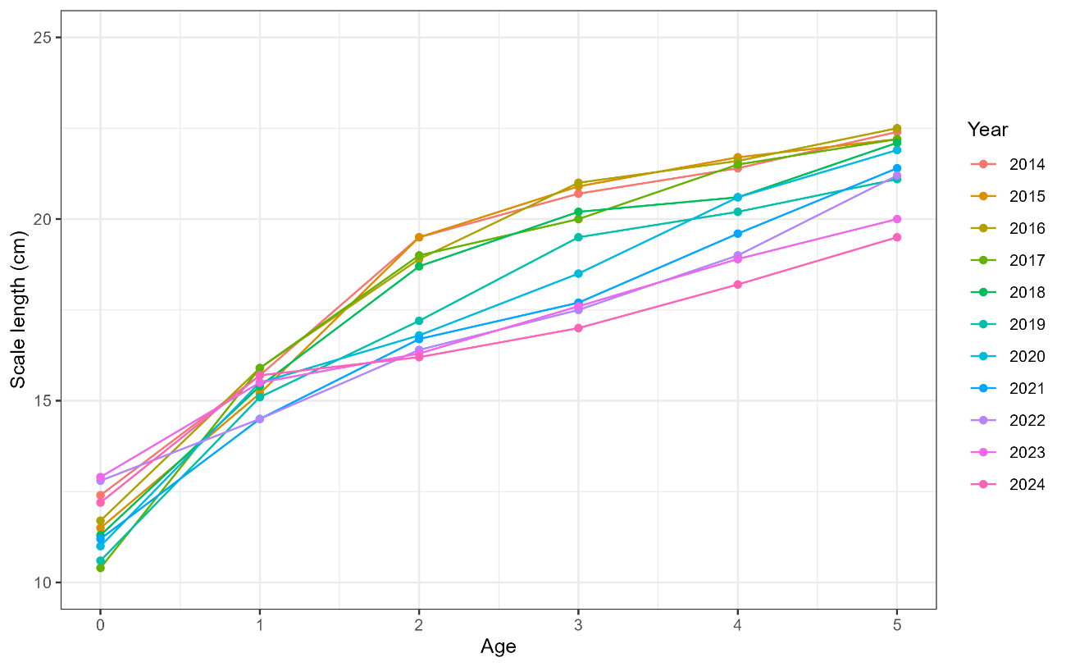
Figure 1. Mean scale covered body length (cm) at age from CY2014-CY2024.

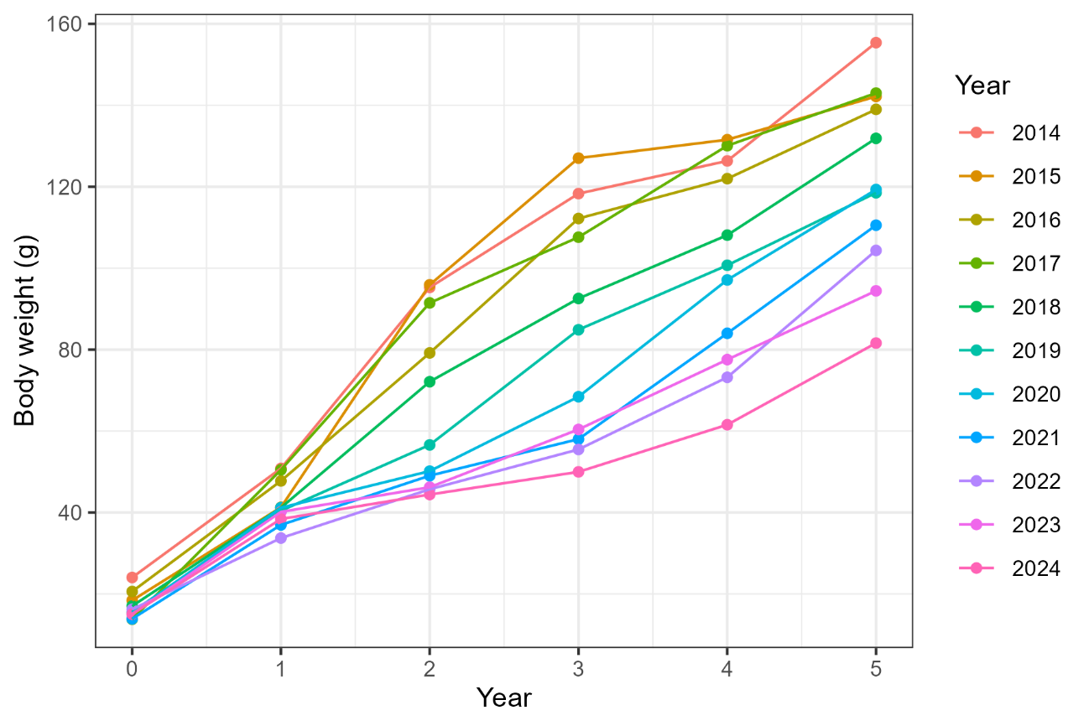
Figure 2. Mean body weight-at-age of Japanese sardine from the Japanese domestic stock assessment of the Pacific stock of Japanese sardine.

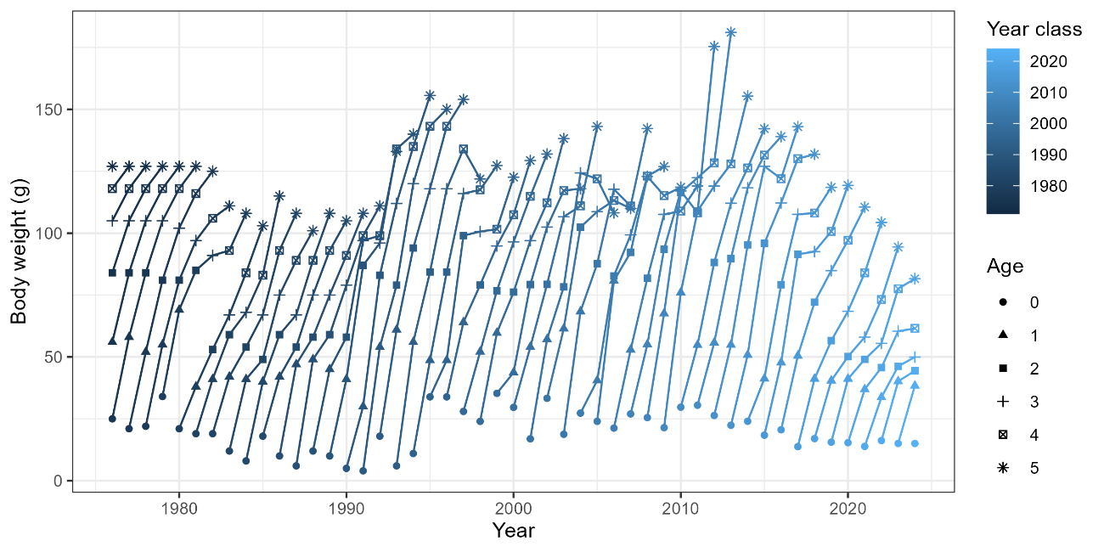
Figure 3. Mean body weight-at-age of Japanese sardine for each year-class from Japanese domestic stock assessment of the Pacific stock of Japanese sardine.

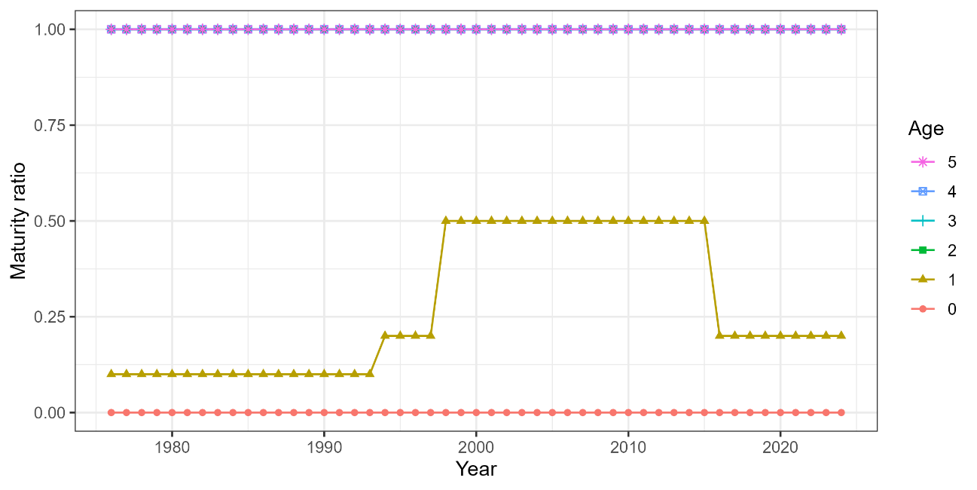
Figure 4. Maturity-at-age of Japanese sardine from the Japanese domestic stock assessment of the Pacific stock of Japanese sardine.

