NPFC-2026-SSC JS01-WP02
Standardized fishery independent indices for the Japanese Sardine (Sardinops melanostictus) caught in trawl surveys conducted by Russia in 2014-2025
Igor CHERNIENKO, Emiliya CHERNIENKO
Pacific branch of the Russian Federal Research Institute of Fisheries and Oceanography «VNIRO» («TINRO»)

1. Background of the Japanese sardine surveys
Annually TINRO carries out ecosystem surveys in waters off the Kuril Islands in the northwestern Pacific Ocean. Sardine is among the target species in these surveys. However, there was no standardization of a fishery-independent abundance index for the Japanese Sardine so far.

2. METHOD
2.1. The data
- Description of the data type and data "resolution"
The data used were derived from the ecosystem scientific bottom-trawl surveys conducted during 2014-2025 by the Pacific Branch of the Russian Federal Research Institute of Fisheries and Oceanography ("TINRO"). A total of 32 surveys were analyzed, with 2 to 4 cruises being carried out annually. The density index, expressed in specimens per square kilometer, was selected as the dependent variable. The density index was calculated as follows:
$$n_{i}=\frac{C_{i}}{1.852v_{i}t_{i}W_{i}}$$
where C_{i} is the catch at station i, (in the number of specimens), v_{i} is the speed in knots, t_{i} is the trawling duration in hours, and, W_{i} is the net mouth opening width in kilometers. The number of stations by year and survey is presented in Table 1. The spatial distribution of stations by year is shown in Figure 1.
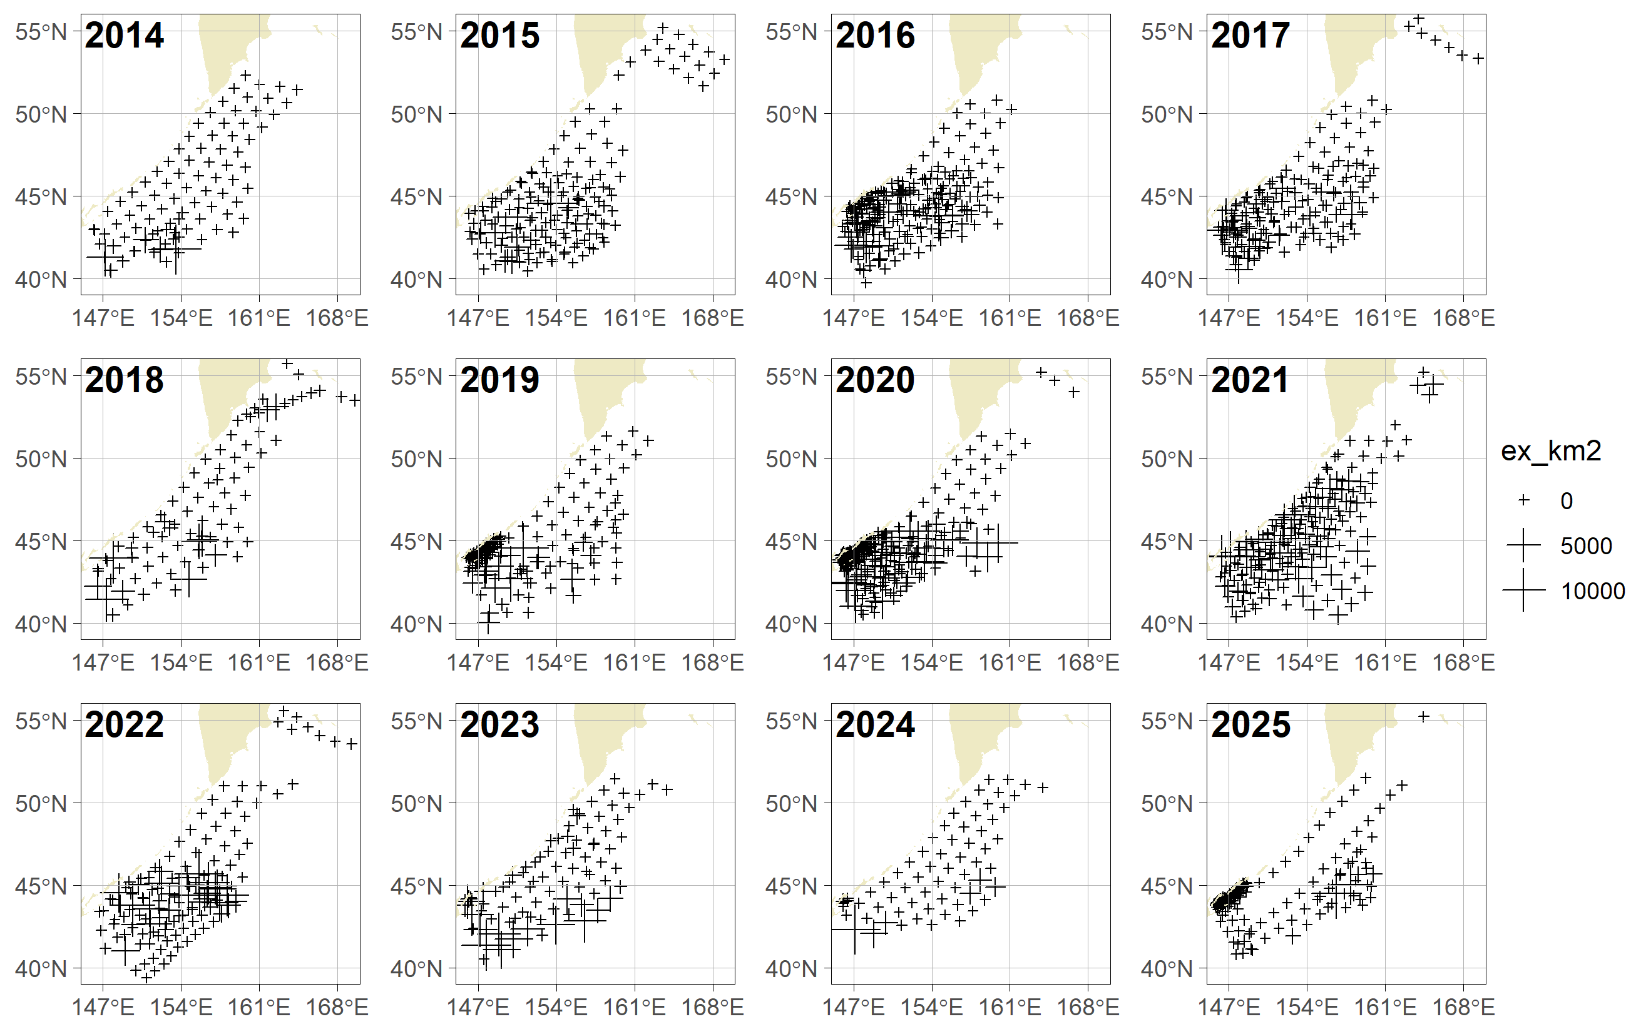
Fig. 1. Distribution of sampling stations and sardine abundance index (specimens/km²) by year

Table 1. Research Surveys used in the analysis
№ | Year | Vessel | Date |  | Coordinates |  | Stations count
№ | Year | Vessel | start | finish | start | finish | Stations count
1 | 2014 | RV PROFESSOR KAGANOVSKYI | 2014-06-02 | 2014-07-08 | 40°28,9ʹN 146°14ʹE | 52°17,3ʹN 164°23,5ʹE | 78
2 | 2014 | RV TINRO | 2014-09-01 | 2014-09-07 | 40°29,1ʹN 146°11,9ʹE | 43°35,3ʹN 153°48,5ʹE | 18
3 | 2015 | RV PROFESSOR KAGANOVSKYI | 2015-06-01 | 2015-07-01 | 41°0,7ʹN 146°15,4ʹE | 50°15,9ʹN 159°57,2ʹE | 61
4 | 2015 | RV PROFESSOR LEVANIDOV | 2015-06-06 | 2015-08-16 | 40°26,2ʹN 146°9,1ʹE | 55°10ʹN 169°1,7ʹE | 100
5 | 2016 | RV PROFESSOR KAGANOVSKYI | 2016-05-31 | 2016-07-16 | 40°29,5ʹN 146°1,1ʹE | 50°47,7ʹN 161°7,7ʹE | 88
6 | 2016 | RV TINRO | 2016-07-13 | 2016-09-17 | 39°44,7ʹN 146°32,6ʹE | 46°31ʹN 159°0,4ʹE | 138
7 | 2017 | RV PROFESSOR KAGANOVSKYI | 2017-06-01 | 2017-07-04 | 40°31ʹN 146°26,6ʹE | 50°46,6ʹN 161°4,6ʹE | 62
8 | 2017 | RV TINRO | 2017-08-11 | 2017-09-16 | 40°49,3ʹN 146°25,7ʹE | 55°44,1ʹN 169°19ʹE | 71
9 | 2017 | RV PROFESSOR KAGANOVSKYI | 2017-10-01 | 2017-10-10 | 41°16,3ʹN 146°5,7ʹE | 45°20,5ʹN 151°13ʹE | 32
10 | 2018 | RV PROFESSOR KAGANOVSKYI | 2018-05-31 | 2018-06-26 | 40°30,2ʹN 146°32ʹE | 51°34,1ʹN 162°29,3ʹE | 59
11 | 2018 | RV TINRO | 2018-08-19 | 2018-10-13 | 43°16,2ʹN 146°32,3ʹE | 55°3,5ʹN 164°30,9ʹE | 16
12 | 2018 | RV PROFESSOR LEVANIDOV | 2018-10-08 | 2018-10-13 | 52°28,6ʹN 160°11,7ʹE | 55°42,6ʹN 169°35,2ʹE | 12
13 | 2019 | RV PROFESSOR KAGANOVSKYI | 2019-01-16 | 2019-01-28 | 40°1,2ʹN 147°55ʹE | 47°15,4ʹN 159°25,1ʹE | 21
14 | 2019 | RV TINRO | 2019-03-24 | 2019-07-03 | 40°35,3ʹN 146°7,7ʹE | 51°36,4ʹN 162°12,1ʹE | 95
15 | 2019 | RV VLADIMIR SAFONOV | 2019-10-10 | 2019-11-24 | 42°43,9ʹN 145°57,2ʹE | 44°51,3ʹN 152°16ʹE | 40
16 | 2020 | RV PROFESSOR KAGANOVSKYI | 2020-03-28 | 2020-07-09 | 40°45,8ʹN 146°9,3ʹE | 51°27ʹN 162°22,9ʹE | 105
17 | 2020 | RV DMITRIY PESKOV | 2020-10-16 | 2020-10-29 | 43°37,4ʹN 145°45,4ʹE | 44°55,1ʹN 148°8,2ʹE | 46
18 | 2020 | RV VLADIMIR SAFONOV | 2020-09-22 | 2020-10-13 | 40°37,2ʹN 146°31ʹE | 45°9,5ʹN 154°18,1ʹE | 35
19 | 2020 | RV PROFESSOR KAGANOVSKYI | 2020-08-21 | 2020-10-04 | 40°30,7ʹN 146°22,3ʹE | 55°11ʹN 166°42,2ʹE | 51
20 | 2021 | RV TINRO | 2021-06-01 | 2021-07-18 | 40°29,3ʹN 146°45,5ʹE | 51°59,7ʹN 162°54,1ʹE | 65
21 | 2021 | RV TINRO | 2021-08-16 | 2021-10-02 | 40°22,2ʹN 146°13,9ʹE | 55°11,4ʹN 165°20,1ʹE | 86
22 | 2021 | RV PROFESSOR KAGANOVSKYI | 2021-12-02 | 2021-12-21 | 43°1,7ʹN 146°38,4ʹE | 50°4,1ʹN 156°30,8ʹE | 24
23 | 2022 | RV TINRO | 2022-05-31 | 2022-07-04 | 41°1,9ʹN 146°41,7ʹE | 51°6,7ʹN 163°59,1ʹE | 55
24 | 2022 | RV TINRO | 2022-08-31 | 2022-10-09 | 39°23ʹN 147°2,9ʹE | 55°33ʹN 163°11,7ʹE | 67
25 | 2022 | RV PROFESSOR KAGANOVSKYI | 2022-09-25 | 2022-10-08 | 53°33,1ʹN 163°54,8ʹE | 55°10,1ʹN 169°15,7ʹE | 6
26 | 2023 | RV TINRO | 2023-06-02 | 2023-07-07 | 41°5,3ʹN 146°28,2ʹE | 51°26,2ʹN 163°53,1ʹE | 64
27 | 2023 | RV DMITRIY PESKOV | 2023-08-27 | 2023-09-17 | 40°30,8ʹN 145°50ʹE | 49°35,6ʹN 157°18,8ʹE | 22
28 | 2024 | RV TINRO | 2024-06-03 | 2024-07-07 | 42°4,2ʹN 146°20,7ʹE | 51°23,5ʹN 163°56,1ʹE | 61
29 | 2024 | RV VLADIMIR SAFONOV | 2024-11-19 | 2024-11-25 | 43°42,8ʹN 146°2,3ʹE | 44°12,2ʹN 146°28,6ʹE | 7
30 | 2025 | RV TINRO | 2025-06-03 | 2025-07-02 | 41°4,9ʹN 146°26,2ʹE | 51°29,4ʹN 162°29,5ʹE | 48
32 | 2025 | RV TINRO | 2025-09-05 | 2025-10-25 | 40°49,1ʹN 146°14,6ʹE | 55°12ʹN 164°25,4ʹE | 32
28 | 2025 | RV DMITRIY PESKOV | 2025-09-11 | 2025-10-02 | 43°30,7ʹN 145°44,3ʹE | 45°9,6ʹN 148°40,1ʹE | 86

Table 2 presents the characteristics of the variables used for the abundance index standardization
Table 2 Variable characteristics
Variable | Designation | Units
Vessel | Ves | 5 categories
Sea surface temperature | SST | degrees Celsius
Depth | D | Meters

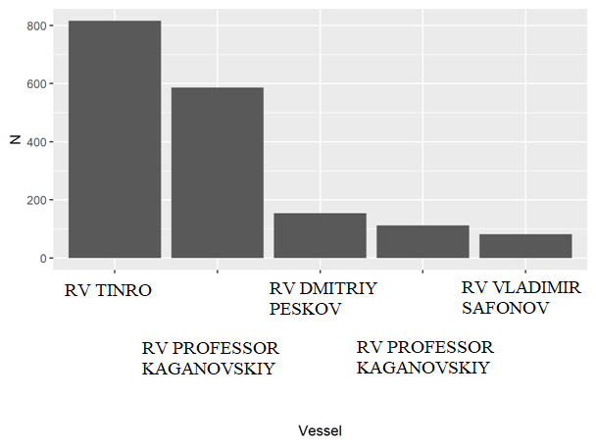
Fig. 2. Vessel frequency in the surveys.
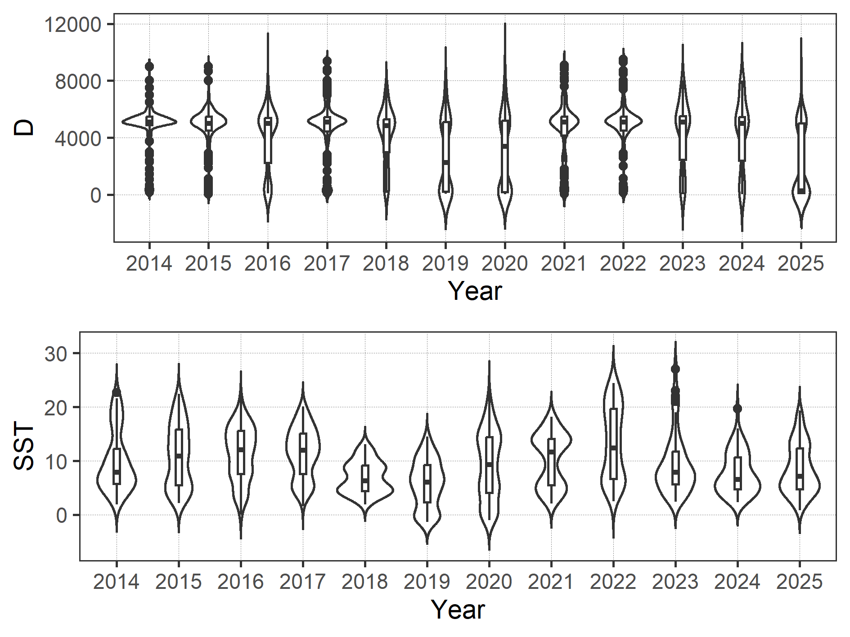
Fig. 3. Distribution of environmental variables
2.2 Full model description and model selection
The sdmTMB model (Anderson et al., 2024) was employed with the following parameter settings:
Options | Model | AIC | BIC
IID | ex_km2~1 | 10131,64 | 10164,45
IID | ex_km2~Ves | 10109,69 | 10164,37
IID | ex_km2~Ves+s(SST) | 9759,017 | 9824,632
IID | ex_km2~Ves+s(SST)+s(D) | 9757,039 | 9833,59
RW | ex_km2~1 | 10191,41 | 10224,22
RW | ex_km2~Ves | 10169,32 | 10224
RW | ex_km2~Ves+s(SST) | 9799,181 | 9864,797
RW | ex_km2~Ves+s(SST)+s(D) | 9789,556 | 9866,107
AR1 | ex_km2~1 | 10132,32 | 10170,6
AR1 | ex_km2~Ves | 10110,25 | 10170,4
AR1 | ex_km2~Ves+s(SST) | 9753,703 | 9824,786
AR1 | ex_km2~Ves+s(SST)+s(D) | 9751,66 | 9833,68

where s is a thin-plate spline.
The inclusion of the depth factor resulted in a slight decrease in AIC in all cases; however, the BIC has increased much stronger. With nearly equivalent BIC values, the AIC for the model with an autoregressive spatiotemporal component was somewhat lower than that for the model with independent dynamics. Random walk model exhibited the worst performance. Therefore, the model with an autoregressive spatiotemporal component and vessel and temperature factors was selected as the best-fitting model.

2.3 Yearly trend extraction
- The method for extracting yearly standardized indices and assessment of their uncertainties (e.g., standard error).
The method for deriving the annual standardized index was based on substituting into the best model a regular grid containing years, along with the most frequently occurring vessel, the R/V TINRO, and year-specific SST distributions for the median date of July 4 of each year. The median index values and standard deviations were obtained using methods implemented in the sdmTMB package (the delta method based on the precision matrix).

3. RESULT and 4. DISCUSSION
- Model selection results and interpretation of the selected model
The distribution of residuals from the selected model is shown in Figure 4. As can be seen, the residuals are in good agreement with a normal distribution.
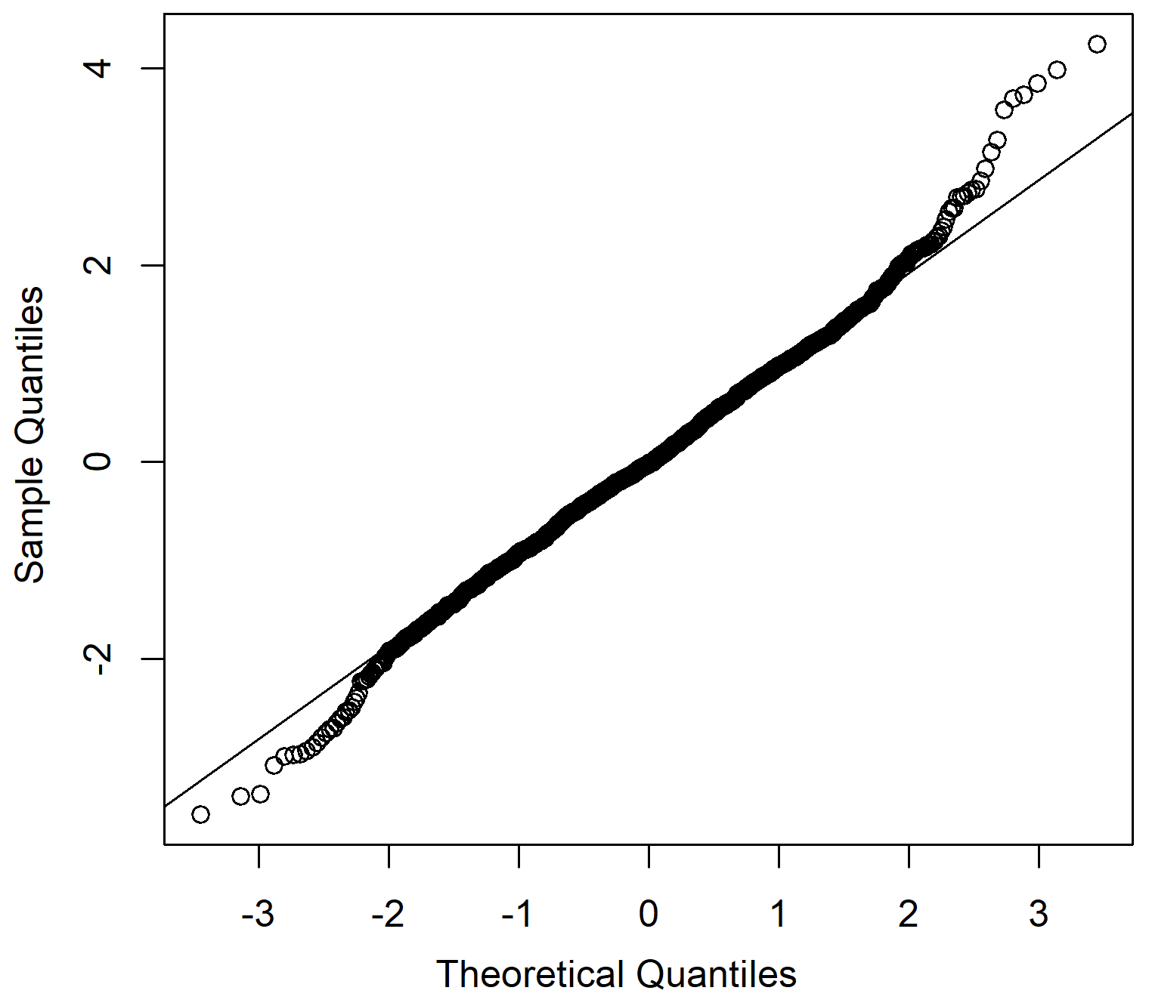
Fig. 4. Distribution of model residuals
Figure 5 shows the effect of the vessel factor variable, Figure 6 shows the effect of sea surface temperature (SST) on the response variable, and Figure 7 shows the contribution of SST to the response variable values. Table 3 presents the parameter estimates of the best model used for index standardization.

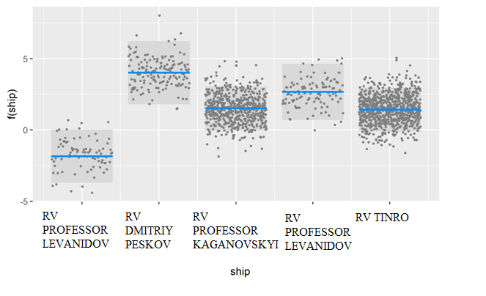
Fig. 5. Effect of the vessel factor on the response variable
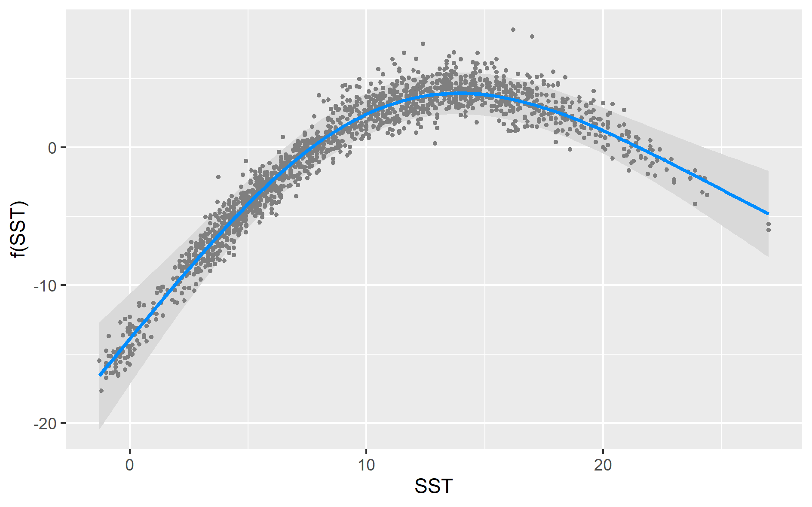
Fig. 6. Contribution of the sea surface temperature to the response variable

Table 3. Coefficient estimates for the best model
Term | mu | se | C.I. low | C.I. high
(Intercept) | -4,13 | 0,96 | -6,01 | -2,24
RV DMITRIY PESKOV | 5,85 | 1,08 | 3,74 | 7,97
RV PROFESSOR KAGANOVSKYI | 3,36 | 0,57 | 2,24 | 4,47
RV PROFESSOR LEVANIDOV | 4,51 | 0,94 | 2,67 | 6,36
RV ТИTINROНРО | 3,26 | 0,61 | 2,07 | 4,46
s(SST) | 2,97 | 1,07 | 0,87 | 5,07

The spatial distribution of the standardized index is shown in Figure 7.
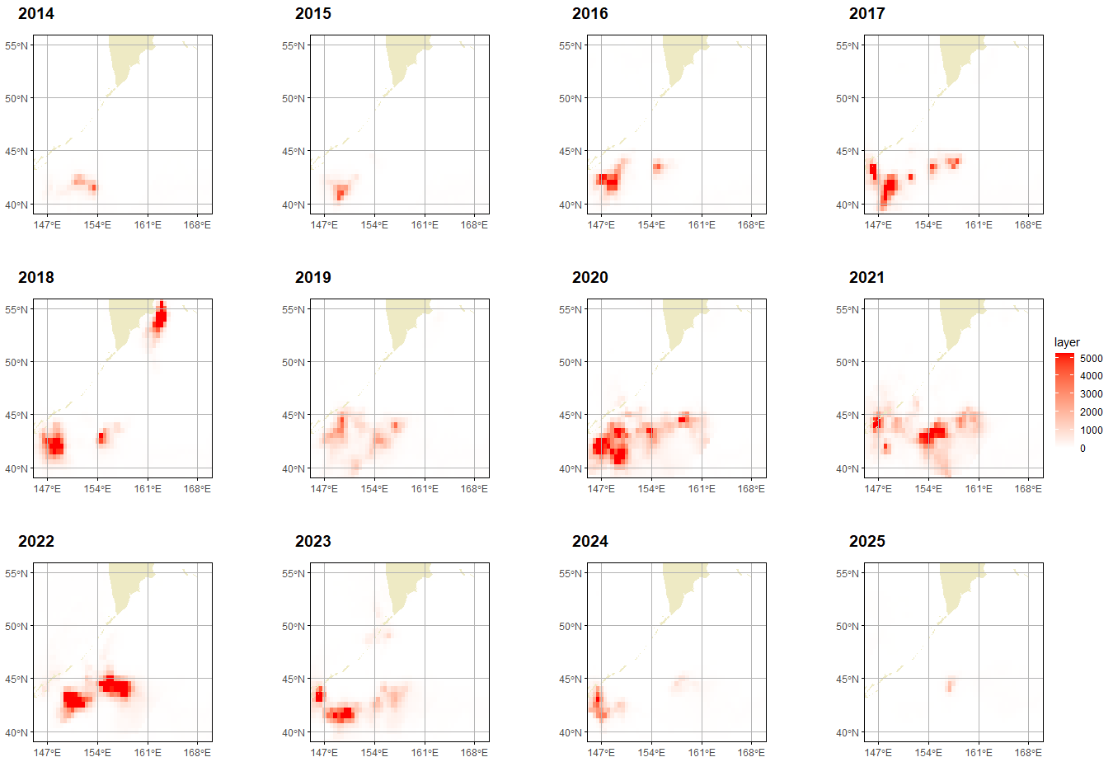
Fig. 7. Spatial distribution of standardized indices

Table 4 and Figure 8 present the nominal and standardized values of the fishery-independent abundance index.
Table 4. Standardized indices.
Год | Nominal | Standardized | C.I.Low | C.I.High | SE | CV
2014 | 260,81 | 68,44 | 22,88 | 204,71 | 0,56 | 0,61
2015 | 327,2 | 63,92 | 16,86 | 242,33 | 0,68 | 0,77
2016 | 637,79 | 153,74 | 82,85 | 285,29 | 0,32 | 0,32
2017 | 1195,02 | 331,64 | 155,28 | 708,31 | 0,39 | 0,40
2018 | 489,85 | 589,38 | 127,64 | 2721,49 | 0,78 | 0,92
2019 | 66,08 | 306,29 | 116,88 | 802,65 | 0,49 | 0,52
2020 | 689,48 | 738,10 | 279,08 | 1952,10 | 0,50 | 0,53
2021 | 972,71 | 601,20 | 314,15 | 1150,54 | 0,33 | 0,34
2022 | 789,55 | 633,69 | 288,65 | 1391,19 | 0,40 | 0,42
2023 | 441,16 | 455,78 | 190,50 | 1090,51 | 0,45 | 0,47
2024 | 237,78 | 173,33 | 41,82 | 718,32 | 0,73 | 0,83
2025 | 86,16 | 28,98 | 9,45 | 88,88 | 0,57 | 0,62
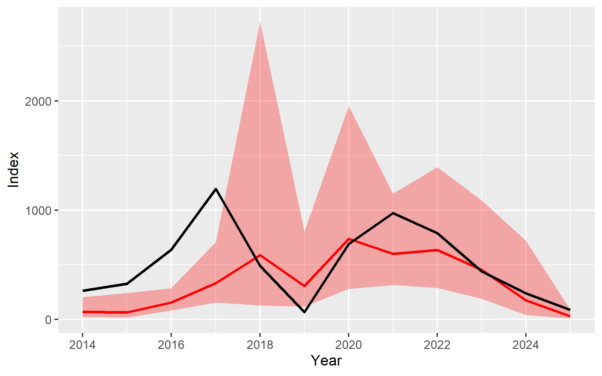
Fig. 8. Standardized and nominal fishery independent abundance indices for the Japanese Sardine
5. REFERENCES
Anderson, S. C., Ward, E. J., English, P. A., Barnett, L. A. K. & Thorson, J. T. sdmTMB: An R Package for Fast, Flexible, and User-Friendly Generalized Linear Mixed Effects Models with Spatial and Spatiotemporal Random Fields. Journal of Statistical Software 115, 1–46 (2025).
Burnham, K. P. & Anderson, D. R. Model selection and multimodel inference: a practical information-theoretic approach. (Springer, New York, NY, 2002).
Hijmans, R. (2025). raster: Geographic Data Analysis and Modeling. R package version 3.6-32. https://doi.org/10.32614/CRAN.package.raster
Hijmans, R. J. et al. terra: Spatial Data Analysis. (2026) R package version 1.9-34. https://doi.org/10.32614/CRAN.package.terra
Pebesma, E., & Bivand, R. (2023). Spatial Data Science: With Applications in R. Chapman and Hall/CRC. https://doi.org/10.1201/9780429459016
Pebesma, E., 2018. Simple Features for R: Standardized Support for Spatial Vector Data. The R Journal 10 (1), 439-446, https://doi.org/10.32614/RJ-2018-009
R Core Team (2026). R: A Language and Environment for Statistical Computing. R Foundation for Statistical Computing, Vienna, Austria. https://doi.org/10.32614/R.manuals

