NPFC-2026-SSC NFS03-WP10 (Rev. 1)
Stock assessment of Neon flying squid in the Northwest Pacific using JABBA model up to 2024
Mingyan Song, Xingwang Zhang, Libin Dai, Jintao Wang
Shanghai Ocean University

SUMMARY
This study provides an updated stock assessment for two seasonal cohorts (winter-spring and autumn) and the stock-wide population through 2024, using JABBA (Just Another Bayesian Biomass Assessment). Abundance indices were derived from the Chinese squid-jigging fishery, including nominal CPUE, GAM-standardized CPUE, and RF-standardized CPUE. Annual catch data were obtained from the official NPFC compilation “NPFC-2025-AR-Annual Summary Footprint - Squids”, aggregating reported catches from all members. A total of nine assessment scenarios were conducted, covering three stock units × three abundance indices. The scenario based on RF-standardized CPUE for the stock-wide population was designated as the base case. All models converged successfully, and residual diagnostics confirmed satisfactory model fit. Retrospective analysis showed negligible bias (Mohn’s ρ < 0.1). The results consistently indicated that in 2024, none of the stock units were overfished (B/B_{MSY} > 1) and overfishing was not occurring (F/F_{MSY} ≤ 1). Short-term projections further confirmed the stock’s resilience to catch levels within the recent historical range. These findings provide a scientific basis for considering the current exploitation of neon flying squid as sustainable under the NPFC management framework.

1. Introduction
The neon flying squid (Ommastrephes bartramii, hereafter referred to as NFS) holds significant development potential among contemporary marine biological resources and represents an economically important cephalopod species, widely distributed in the Pacific Ocean and its surrounding waters (Roper et al., 1984). Its population is structured into two main seasonal cohorts: the autumn cohort and the winter-spring cohort, with distinct spatial and temporal distributions. (Yatsu et al., 1997, 1998). The North Pacific Fishery Commission (NPFC) is the responsible international body for the management of squid fisheries, including the NFS, in the North Pacific. To support science-based management, the NPFC Scientific Committee established the Small Scientific Committee on Neon Flying Squid (SSC NFS) to conduct regular stock assessments of this species.
This report provides an updated stock assessment of NFS for the NPFC Scientific Committee, covering both seasonal cohorts and the stock-wide population through 2024. Abundance indices derived from the Chinese squid-jigging fishery are paired with annual catch data from the official NPFC compilation "NPFC-2025-AR-Annual Summary Footprint - Squids," which aggregates reported catches from all members, including China, Japan, Korea, Russia, Chinese Taipei, and Vanuatu. The temporal scope of the assessment reflects the availability of consistent fishery data across all contributing sources.

2. Materials and Methods

2.1. Input Data
Annual catch and fishing effort data of NFS were obtained from the official NPFC compilation “NPFC-2025-AR-Annual Summary Footprint-Squids”, aggregating reported catches from China, Japan, Korea, Russia, Chinese Taipei, and Vanuatu. This dataset represents the most comprehensive catch information available within the NPFC framework and is considered the best available data for total removals. (Fig. 1)
The time series covers 2005–2024 for the winter-spring cohort and stock-wide, and 2012–2024 for the autumn cohort, aligned with the availability of Chinese CPUE data. (Fig. 2)
Abundance indices were derived from the Chinese squid-jigging fishery. The companion CPUE standardization study produced four indices: nominal CPUE and three standardized series (GAM, RF, and GBM). All four indices are presented in Fig. 3 for reference. For the present stock assessment, three indices were selected as JABBA inputs: nominal CPUE, GAM-standardized CPUE, and RF-standardized CPUE. The GBM-standardized CPUE was not used, in order to streamline the number of scenarios while maintaining a robust representation of uncertainty across different modeling frameworks. Input standard errors (SE) from the standardization procedure were used to quantify observation uncertainty; for nominal CPUE, a conservative CV of 0.2 was assumed.

2.2. Stock assessment model
The stock assessment was conducted using the state-space Bayesian surplus production model, Just Another Bayesian Biomass Assessment (Winker et al., 2018), which is based on the generalized Pella-Tomlinson surplus production model form (Pella et al., 1969). The model accounts for both process error in population dynamics and observation error in the abundance indices. In this study, the Schaefer form (shape parameter m = 2) of the production function was applied.
SP=$\frac{r}{m-1}B\left[1-{\left(\frac{B}{K}\right)}^{m-1}\right]$ (1)
where SP is the surplus production, B is the exploitable biomass, r is the intrinsic rate of growth and K is the carrying capacity. This form assumes a symmetric production curve where the biomass at maximum sustainable yield (MSY) is B_{MSY}=K/2. The Schaefer model is widely applied in cephalopod stock assessments and provides a parsimonious and stable model for data-limited situations (Wang et al., 2016).
The observation equation was:
${\text{I}}_{\text{i}\text{，}\text{y}}$=${\text{q}}_{\text{i}}{\text{B}}_{\text{i}}{\text{e}}^{{\text{ε}}_{\text{y}\text{,}\text{i}}}$ (2)
where I_{i,y} is the abundance index from series i in year y, q_{i} is the catchability coefficient for that series, and ε_{y,i} is the observation error, assumed to follow a normal distribution: ${\text{ε}}_{\text{y,i}}\text{\sim }\text{N(}\text{0, }{\text{σ}}_{\text{ε,t}\text{,i}}^{\text{2}}\text{)}$.
A total of nine scenarios were defined: three stock units (winter-spring, autumn, stock-wide) × three abundance indices (nominal, GAM, RF).
The scenario based on the RF-standardized CPUE for the stock-wide population was considered the base case. The remaining eight scenarios were treated as sensitivity analyses to evaluate the influence of different abundance indices and stock separation assumptions.

2.3. Model parameterization and priors
Prior distributions for model parameters were set following the common practice of applying JABBA to short-lived squid stocks and previous assessments of NFS (Chen et al., 2008; Wang et al., 2016). The intrinsic growth rate (r) was bounded between 0.6 and 1.5 year⁻¹ based on previous studies (Ichii et al., 2006; Wang et al., 2016). A uniform prior for carrying capacity (K) was set from the maximum observed catch to ten times that value for each stock. Uninformative (diffuse) default priors were used for catchability (q) and initial depletion (psi). Process error variance was given a diffuse Inverse-Gamma(0.001,0.001) prior. A fixed coefficient of variation (CV = 0.1) was assumed for the catch observation error.

2.4. Model diagnostics
Model convergence was assessed through visual inspection of MCMC trace plots, while model goodness of fit was evaluated by comparing observed and predicted CPUE values and quantified using the root mean square error (RMSE) of standardized residuals.
Retrospective analysis was conducted for the base case scenario by sequentially removing the most recent 1–5 years of data, and Mohn’s ρ was calculated to quantify retrospective bias (Mohn，1999).

2.5. Model projection
Short-term projections for 2025–2029 were conducted using the forecasting module in JABBA. The projections were initialized from the base case scenario (stock-wide, RF-standardized CPUE). Three constant-catch scenarios were defined: Low: 10,000 t/yr, Medium: 35,000 t/yr, High: 60,000 t/yr. These scenarios bracket the range of recent historical catches. Productivity was assumed constant over the projection period.

3. Results

3.1. Model Performance and Consistency
Model convergence was assessed through visual inspection of MCMC trace plots. In the base-case scenario (stock-wide, RF-standardized CPUE), the trace plots for key parameters (e.g., carrying capacity K, intrinsic growth rate r) showed stable chains with good mixing and overlapping trajectories (Fig. 4). This pattern was consistent across all scenarios, confirming reliable model convergence. To complement the visual assessment, convergence was also evaluated quantitatively using the Geweke diagnostic. All key parameters had Geweke p-values > 0.05 (Table 1), providing statistical support for convergence.
The fit of the JABBA model to the abundance indices was evaluated by comparing observed and predicted CPUE values. A representative example using the stock-wide assessment with nominal CPUE is shown in Fig. 5. The observed CPUE values closely align with the model-predicted trajectory and its 95% credible interval, demonstrating satisfactory model fit. Diagnostic checks for the remaining scenarios yielded qualitatively similar results, confirming the robustness of all assessments.
Residual diagnostics confirmed the adequacy of model fits. Fig. 6 presents the standardized log-residuals for the stock-wide assessment using nominal CPUE. The residuals are randomly distributed around zero with no apparent temporal patterns, as indicated by the loess smoother remaining close to the zero line throughout the time series. The root mean square error (RMSE) of 31.8% indicates a good fit to the data. Similar random residual patterns were observed across all nine assessment scenarios.
Prior and posterior distributions of key parameters for the base-case scenario are shown in Fig. 7, confirming satisfactory model convergence. Specifically, the marginal posterior distribution of the intrinsic growth rate r showed little deviation from its prior, the posterior of the carrying capacity K was considerably narrower than its prior, and the median of the posterior for the initial depletion psi remained very close to its prior.

3.2. Stock status and reference points
Based on the estimated biological parameters, key fisheries management reference points were derived for each assessment scenario, including the maximum sustainable yield (MSY), the biomass that can produce MSY (B_{MSY}), and the corresponding fishing mortality rate (F_{MSY}). The status of the stock in the terminal assessment year relative to these reference points provides the basis for scientific management advice. Table 2-4 presents the median posterior estimates of these reference points and the terminal year status ratios for all nine assessment scenarios.

3.3. Biomass and fishing mortality trajectories
This section presents the temporal trajectories of relative biomass (B/B_{MSY}) and relative fishing mortality (F/F_{MSY}) for the winter-spring cohort, autumn cohort, and stock-wide NFS (Figs. 8-10). The three CPUE indices produced highly consistent trends for each stock unit, demonstrating the robustness of the assessment. Despite interannual fluctuations, B/B_{MSY} remained above 1.0 and F/F_{MSY} remained at or below 1.0 throughout all assessment periods for all three stock units. This historical pattern indicates that the stocks have not been overfished and overfishing has not occurred in the past.

3.4. Retrospective analysis
Retrospective analysis was conducted for the base case scenario (Fig. 11). The estimated biomass trajectories showed minimal systematic deviation, with Mohn’s ρ for terminal B/B_{MSY} estimated at 0.015. All Mohn’s ρ values were below 0.1, indicating negligible retrospective bias and confirming the stability of the model estimates over time.

3.5. Projection results
Results of the short-term projections are summarized in Table 5 and illustrated in Fig. 12. Under all scenarios, the stock remains above the biomass reference point (B/B_{MSY} > 1.0) with fishing pressure below the overfishing limit (F/F_{MSY} < 1.0) through 2029. The projected B/B_{MSY} values indicate a buffer above the B_{MSY} level, although the magnitude of the buffer decreases as the catch increases. Relative biomass shows a slight increase under the Low scenario (+0.0261), a modest decrease under the Medium scenario (−0.0691), and a more pronounced decrease under the High scenario (−0.1761). Correspondingly, relative fishing mortality rises with higher catch levels but remains sustainable (F/F_{MSY} < 1).

3.6. Stock status summary
The Kobe plots for the terminal assessment year (2024) are presented in Figs. 13-15, providing a visual summary of the stock status relative to MSY-based reference points. For all nine assessment scenarios (three stock units × three CPUE indices), the estimated stock status in 2024 falls within the green quadrant (B/B_{MSY} > 1, F/F_{MSY} < 1). This graphically confirms the conclusion drawn from the historical trajectories: neither the individual cohorts nor the combined stock were overfished, and overfishing was not occurring in 2024. These results provide direct scientific support for the sustainable management of NFS fisheries in the Northwest Pacific.

4. Discussion
This study presents an updated stock assessment of neon flying squid in the Northwest Pacific Ocean using the JABBA model, integrating NPFC-compiled catch data from multiple fishing entities and Chinese jigger-based CPUE series through 2024. All models achieved satisfactory convergence and passed residual diagnostics. Retrospective analysis confirmed the stability of the base case model, with Mohn’s ρ well below 0.1. All nine assessment scenarios, encompassing different cohorts and CPUE indices, successfully converged with satisfactory model diagnostics, confirming the reliability of the fits. Despite some variation in absolute biomass estimates, all scenarios converged on a consistent conclusion regarding stock status: the terminal year (2024) status for the winter-spring cohort, autumn cohort, and the stock-wide population was robustly positioned within the green quadrant of the Kobe plot. This indicates that the stocks were likely not overfished and overfishing was probably not occurring. The high consistency in resource trends derived from the three CPUE standardization methods further validates the robustness of the assessment. Additionally, short-term projections support the stock’s resilience to catch levels within the recent historical range. Overall, the current exploitation appears sustainable.
In summary, this assessment provides a robust scientific basis to consider the current exploitation of neon flying squid as sustainable under the NPFC management framework.

References
Roper C F E, Sweeney M J, Nauen C E. 1984. Cephalopods of the world: An annotated and illustrated catalogue of species of interest to fisheries. Rome: FAO, 1.
Yatsu A, Midorikawa S, Shimada T, Uozumi Y. 1997. Age and growth of the neon flying squid, Ommastrephes bartrami, in the North Pacific Ocean. Fisheries Research, 29: 257-270.
Yatsu A, Tanaka H, Mori J. 1998. Population structure ofthe neon flying squid, Ommastrephes bartramii, in the North Pacific. Japan marine fishery resources researchcenter, p 31-48.
Winker H, Carvalho F, Kapur, M. 2018. JABBA: Just Another Bayesian Biomass Assessment. Fisheries Research, 204: 275-288.
Pella, J J, Tomlinson P K. 1969. A generalized stock production model. Bulletin of the Inter-American Tropical Tuna Commission, 13: 421–458.
Wang, J T, Yu, W, Chen X J, Chen, Y. 2016. Stock assessment for the western winter-spring cohort of neon flying squid (Ommastrephes bartramii) using environmentally dependent surplus production models. Scientia Marina, 80(1): 69-78.
Ichii T, Mahapatra, K, Okamura, H et al. 2006. Stock assessment of the autumn cohort of neon flying squid (Ommastrephes bartramii) in the North Pacific based on past large-scale high seas driftnet fishery data. Fisheries Research, 78: 286–297.
Mohn, R. 1999. The retrospective problem in sequential population analysis: An investigation using cod fishery and simulated data. ICES J. Mar. Sci. 56, 473-488.

APPENDICES
Appendix1. Checklist for the Stock assessment protocol
1 | Identify the data that will be available to the stock assessment. | Yes (Section 2.1)
2 | Evaluate data quality and quantity and potential error sources (e.g., sampling errors, measurement errors, and associated statistical property (e.g., biased or random errors, statistical  distribution) to ensure that the best available information is used in the assessment. | Yes (Section 2.1)
3 | Select population models describing the dynamics of the stock and observational models linking population variables with the observed variables. | Yes (Section 2.2, Paragraph 1-4)
4 | Develop base case scenarios and alternative scenarios for sensitivity analyses. | Yes (Section 2.2, Paragraph 5-6)
5 | For each scenario, fit the model to the data, diagnostics of model convergence, plot and evaluate residual patterns, and evaluate biological implications of the estimated parameters. | Yes (Fig. 4-7,  Table 1)
6 | Develop retrospective analysis to verify whether any possible systematic inconsistencies exist among model estimates of biomass and fishing mortality. | Yes (Fig. 11)
7 | For each scenario, estimate and plot exploitable stock biomass and fishing mortality (and their relevant credibility distributions) over time. | Yes (Fig. 8-10)
8 | For each scenario, estimate biological reference points (e.g., MSY, B_{MSY}, F_{MSY}) and its associated uncertainty. | Yes (Table 2-4)
9 | Have the Kobe plot for each scenario. | Yes (Fig. 13-15)
10 | Develop alternative ABCs for the projection (e.g., 2-year projection). | Yes (Table 5,  Fig. 12)
11 | Include relevant ecosystem considerations regarding the stock for future assessment, including data and results from other scientific studies regarding potential impacts on the stock due to  climate change, non-stationary population and fisheries processes, predator-prey dynamics, or impacts of distribution and phenological changes on assessment data. | Not covered in this assessment.

Table 1. Geweke diagnostics for key parameters (base-case scenario).
Parameter | Geweke p-value
K | 0.375
r | 0.329
q | 0.532
ψ | 0.444
σ² | 0.081

Table 2. Median posterior estimates (95% credible intervals) of key quantities for the winter-spring cohort of NFS.
 | Nominal CPUE | GAM-standardized CPUE | RF-standardized CPUE
  Parameter
MSY | 134745.797  (61552.953-243457.352) | 162246.45  (85010.066-296240.46) | 141704.398  (79991.69-252352.985)
B_{MSY} | 324567.921  (143344.342-376834.704) | 319524.378  (191569.558-296240.46) | 330634.423  (159863.13-402731.082)
F_{MSY} | 0.496  (0.29-0.81) | 0.533  (0.33-0.881) | 0.522  (0.312-0.79)
B₂₀₂₄/B_{MSY} | 1.928  (1.363-2.416) | 1.904  (1.3-2.308) | 1.943  (1.505-2.36)
F₂₀₂₄/F_{MSY} | 0.047  (0.024-0.125) | 0.04  (0.02-0.088) | 0.045  (0.023-0.087)

Table 3. Median posterior estimates (95% credible intervals) of key quantities for the autumn cohort of NFS.
 | Nominal CPUE | GAM-standardized CPUE | RF-standardized CPUE
  Parameter
MSY | 15144.478  (8466.053-28395.321) | 18986.245  (9424.009-36807.89) | 13474.186  (7785.318-32821.931)
B_{MSY} | 32604.92  (19473-46966.984) | 39689.572  (22728.928-62281.902) | 27402.445  (15990.358-58877.192)
F_{MSY} | 0.474  (0.3-0.795) | 0.465  (0.293-0.739) | 0.489  (0.317-0.759)
B₂₀₂₄/B_{MSY} | 1.759  (1.227-2.249) | 1.703  (1.085-2.095) | 1.685  (0.908-2.123)
F₂₀₂₄/F_{MSY} | 0.268  (0.126-0.642) | 0.224  (0.102-0.63) | 0.312  (0.111-0.983)

Table 4. Median posterior estimates (95% credible intervals) of key quantities for the stock-wide of NFS.
 | Nominal CPUE | GAM-standardized CPUE | RF-standardized CPUE
  Parameter
MSY | 135747.458  (59318.724-248277.83) | 172127.678  (96554.92-292883.312) | 152516.984  (81554.216-263784.146)
B_{MSY} | 353316.316  (191860.167-396028.801) | 356398.115  (220986.801-416746.743) | 359598.269  (165858.236-399435.226)
F_{MSY} | 0.424  (0.263-0.723) | 0.521  (0.328-0.82) | 0.52  (0.324-0.783)
B₂₀₂₄/B_{MSY} | 1.899  (1.136-2.295) | 1.824  (1.174-2.217) | 1.929  (1.499-2.3)
F₂₀₂₄/F_{MSY} | 0.076  (0.038-0.278) | 0.063  (0.033-0.148) | 0.067  (0.035-0.138)

Table 5. Short-term (2025–2029) projections for the stock-wide under three alternative catch scenarios based on the RF-standardized assessment
Strategy | Annual catch (tons) | B₂₀₂₉/B_{MSY} | F₂₀₂₉/F_{MSY} | ΔB/B_{MSY} | Sustainability status
Low | 10000 | 1.955 | 0.0338 | +0.0261 | Sustainable
Medium | 35000 | 1.8598 | 0.1238 | –0.0691 | Sustainable
High | 60000 | 1.7528 | 0.2242 | –0.1761 | Sustainable

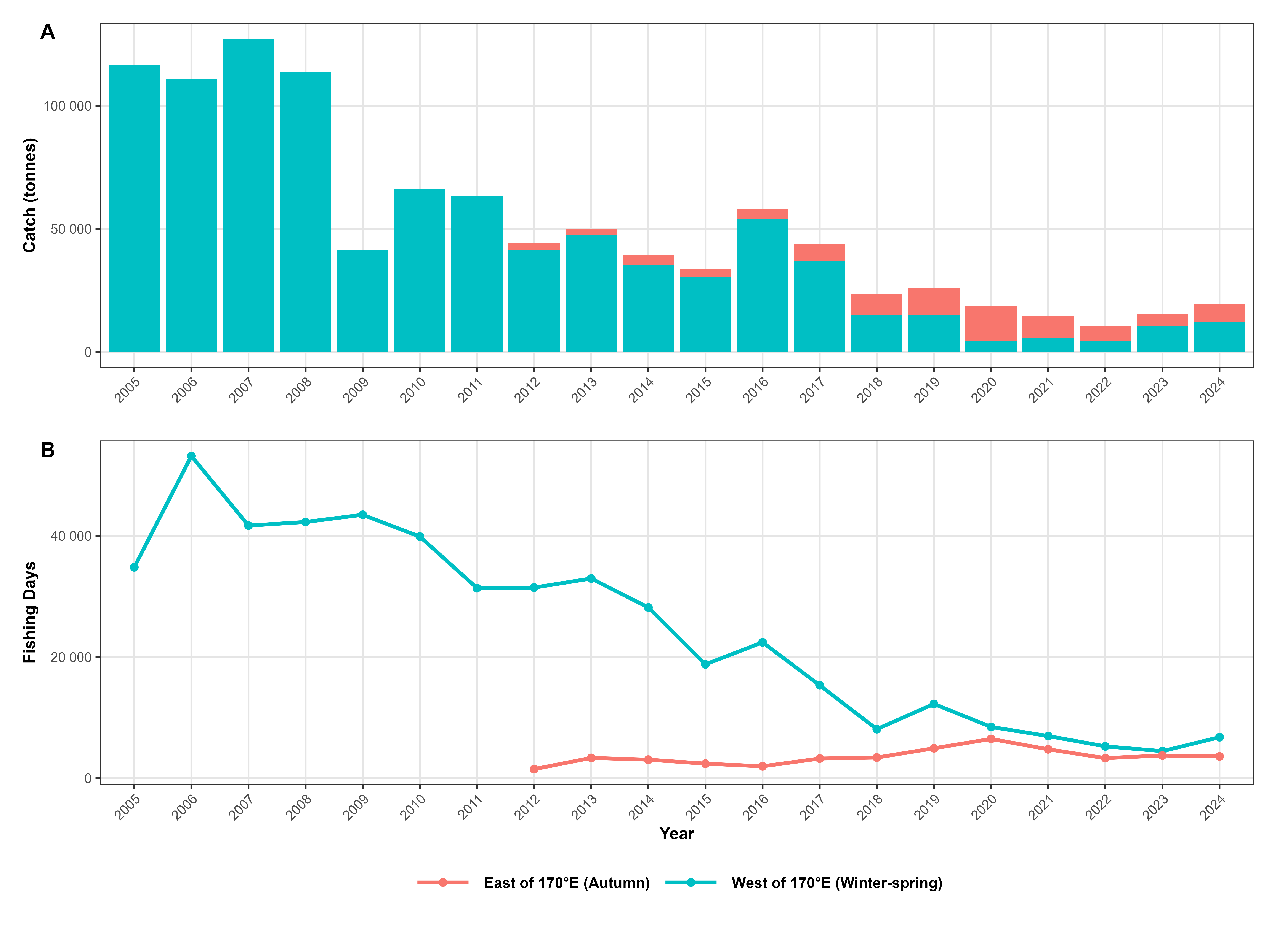
Fig. 1 Annual catch and fishing effort (fishing days) of neon flying squid in the Northwest Pacific Ocean based on NPFC-compiled data from all members, 2005–2024.

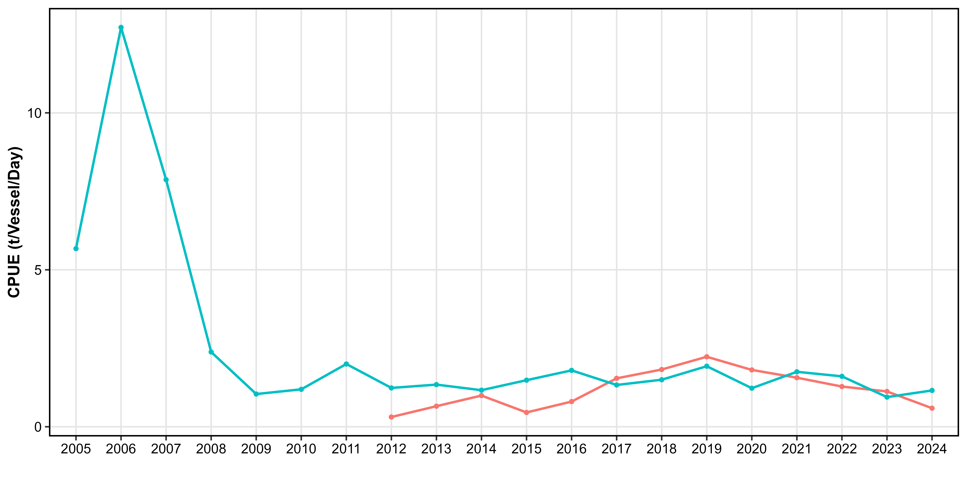
Fig. 2 Nominal CPUE (catch per vessel-day) indices for neon flying squid derived from the Chinese squid-jigging fishery in the Northwest Pacific Ocean, 2005–2024.

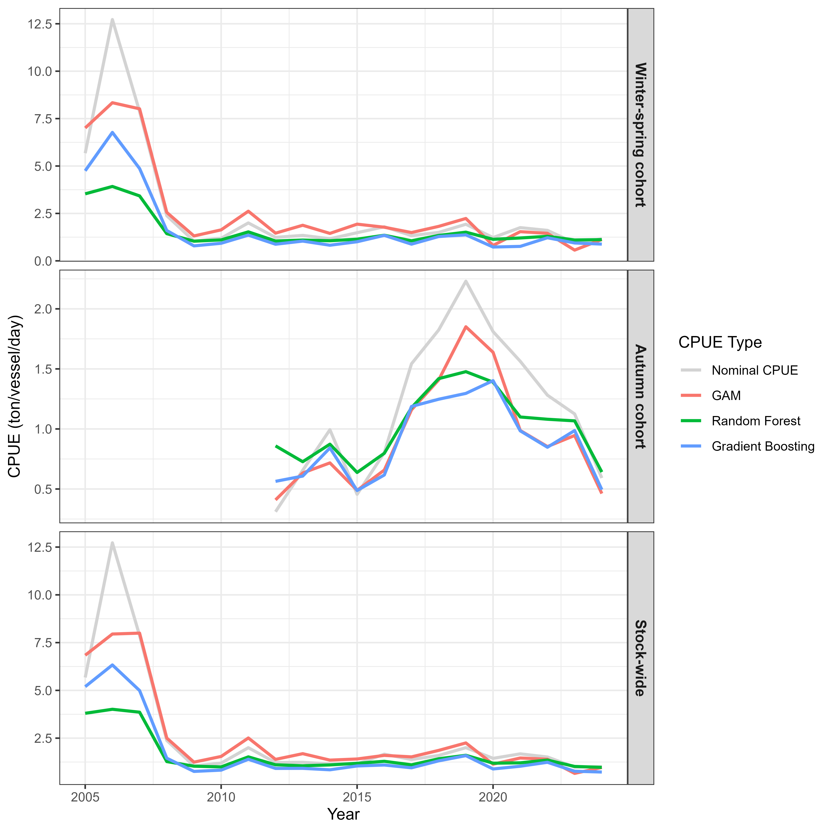
Fig. 3 Comparison of nominal and standardized CPUE indices for the winter-spring cohort, autumn cohort, and stock-wide of neon flying squid derived from three modeling approaches.

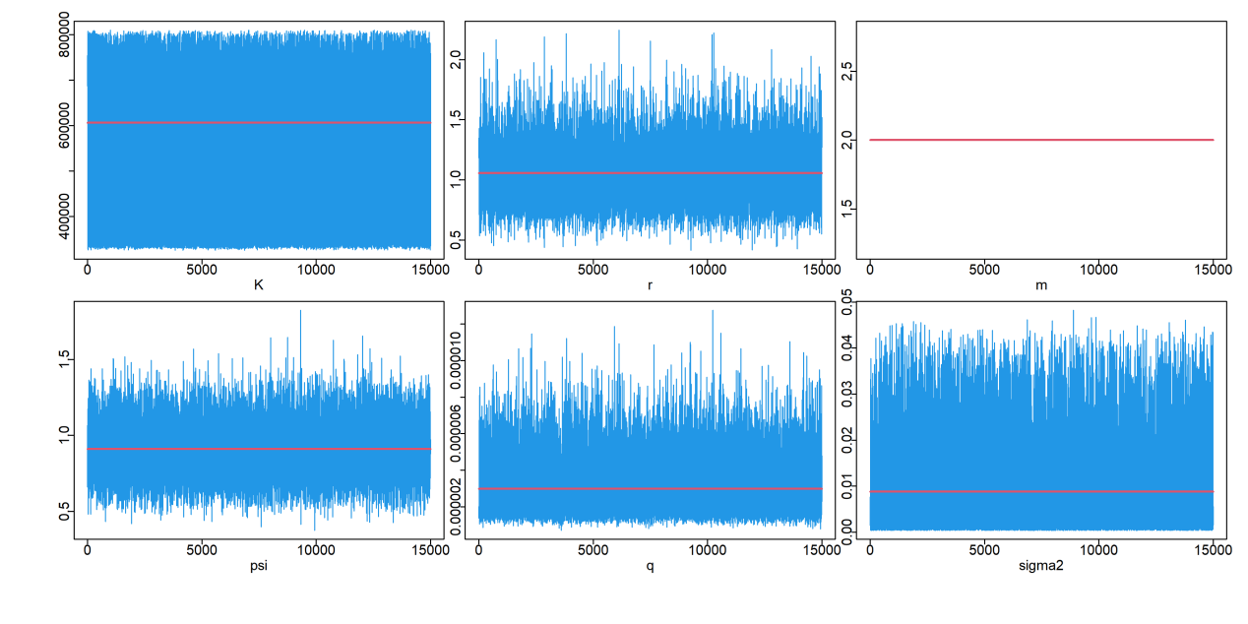
Fig. 4 MCMC convergence diagnostics for the stock-wide assessment using RF-standardized CPUE.

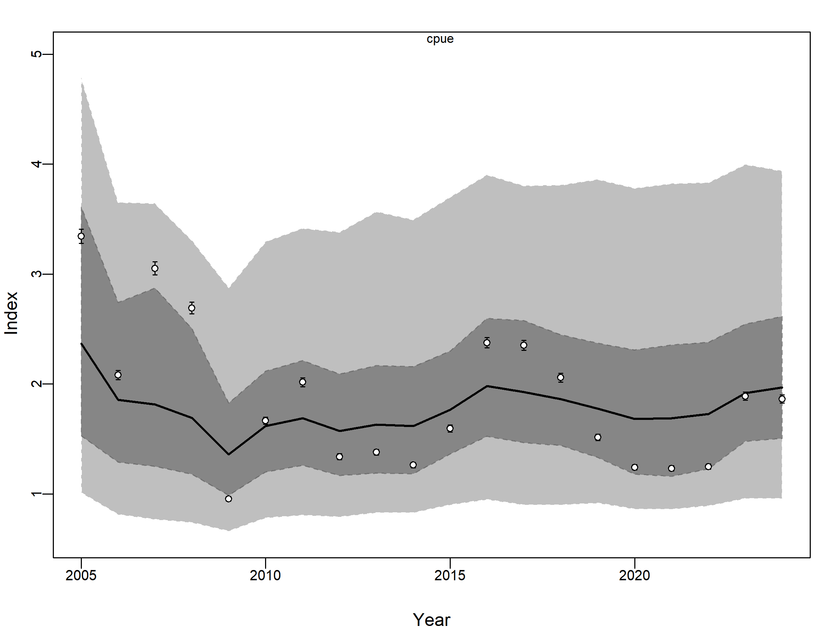
Fig. 5 Fit of the JABBA model to the nominal CPUE index for the stock-wide assessment.

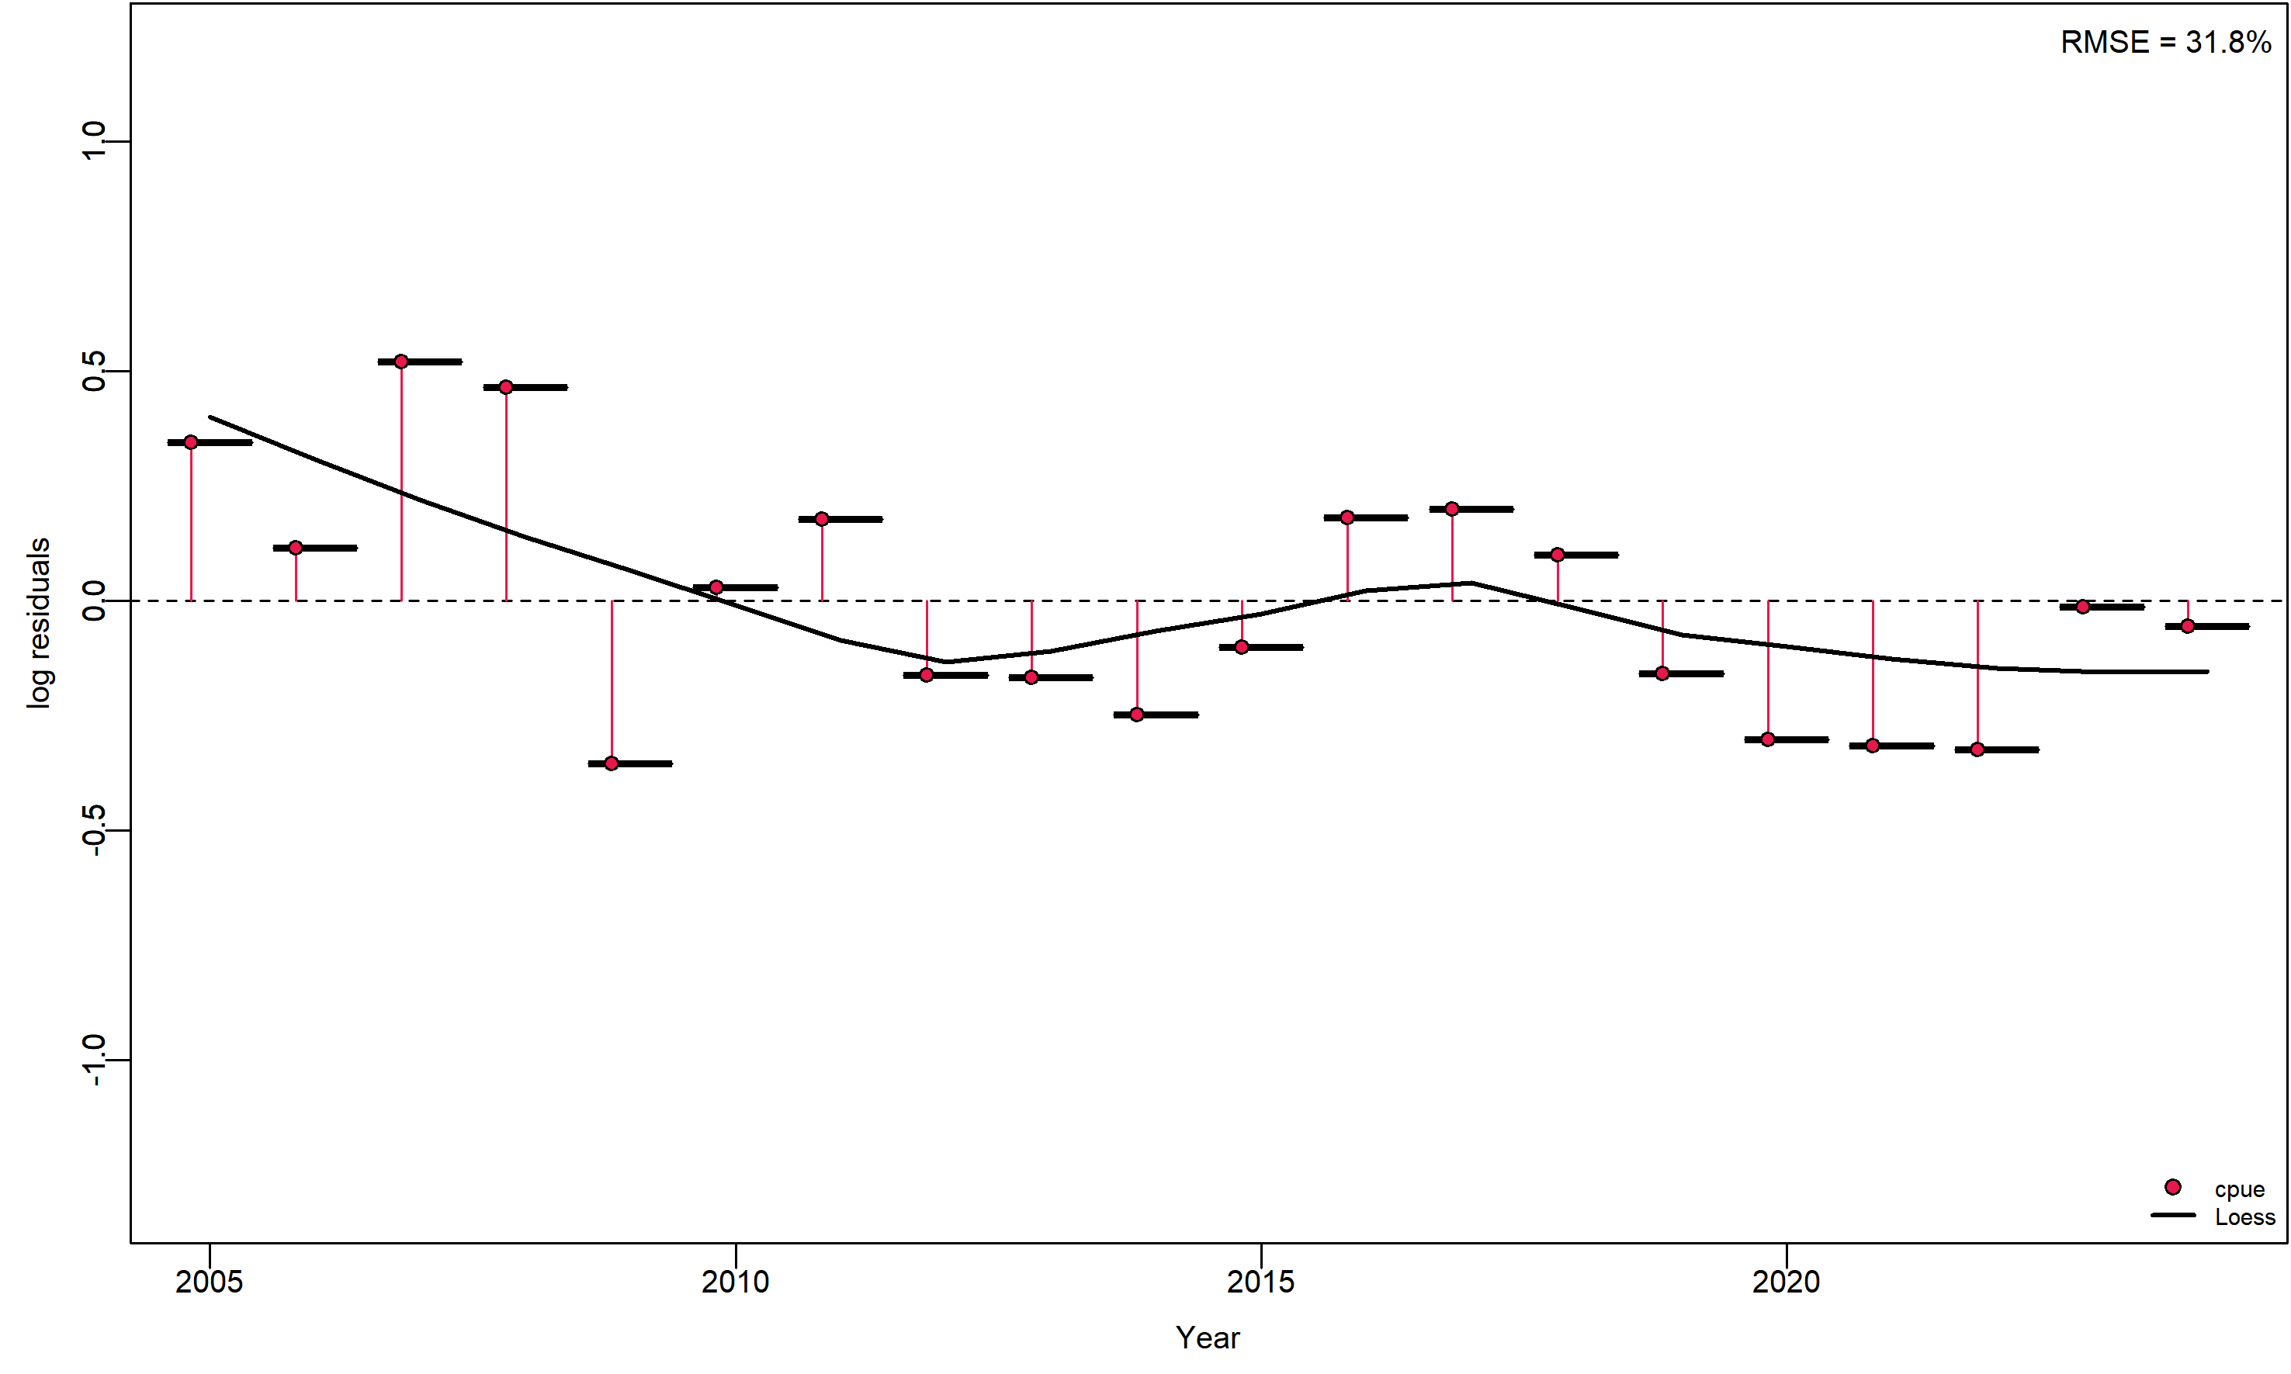
Fig. 6 Standardized residual diagnostics for the stock-wide assessment based on nominal CPUE.

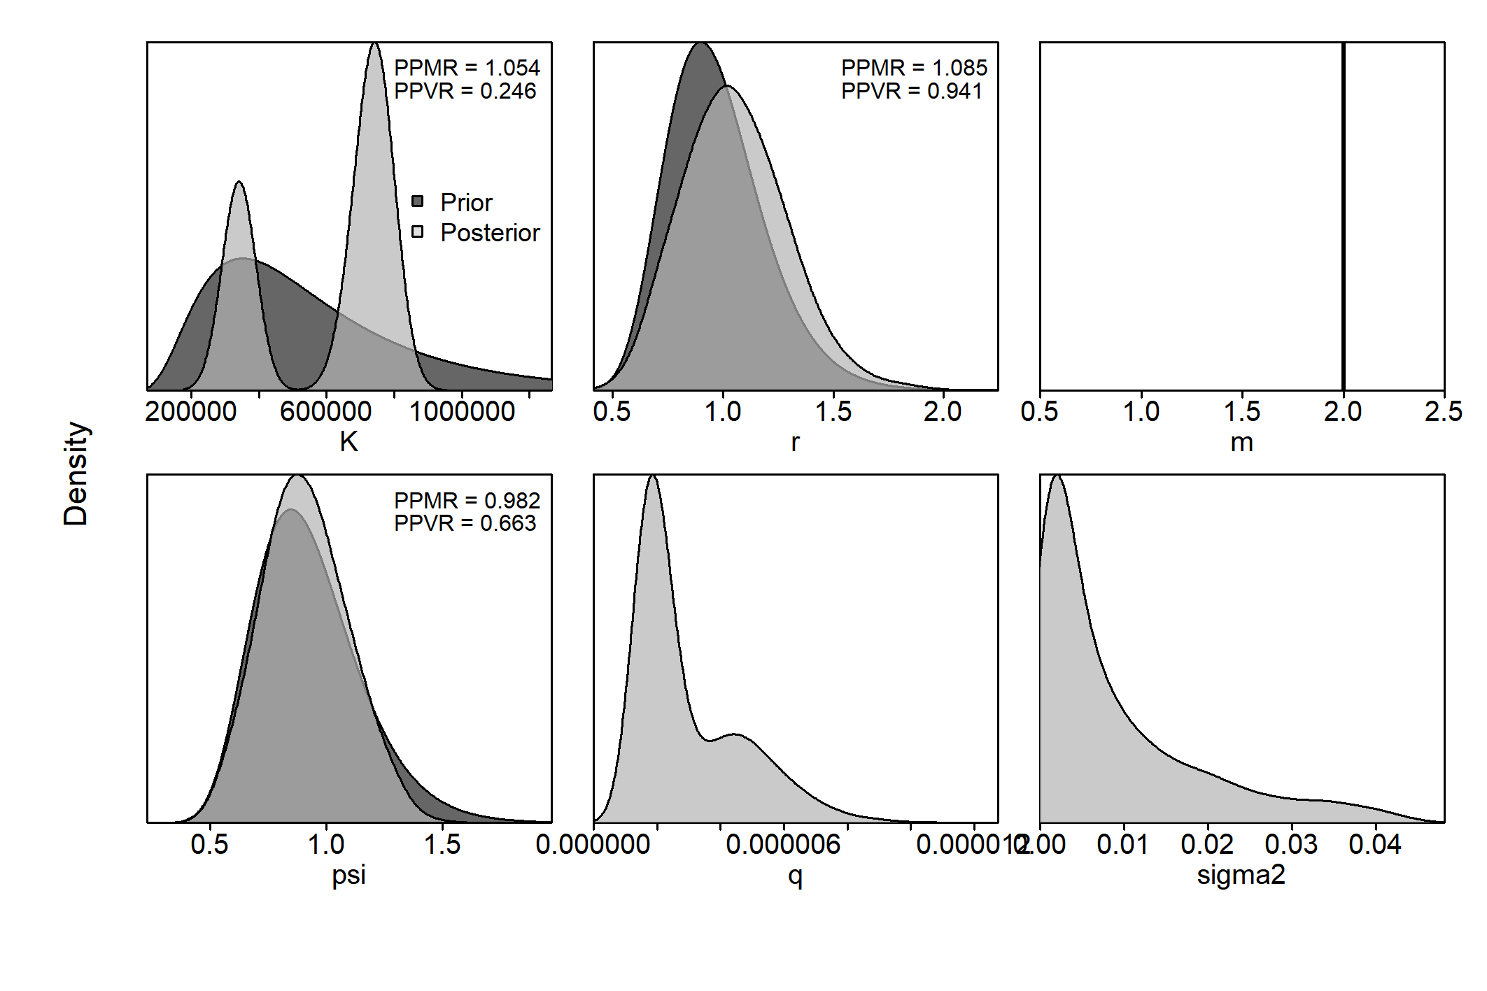
Fig. 7 Prior and posterior distributions of key parameters for the base-case scenario (stock-wide, RF-standardized CPUE).

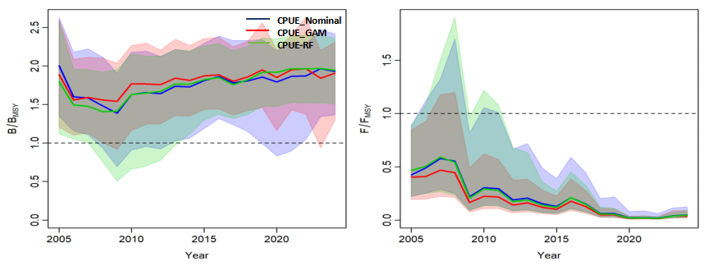
Fig. 8 Trajectories of B/B_{MSY} and F/F_{MSY} for the winter-spring cohort estimated from three abundance indices.
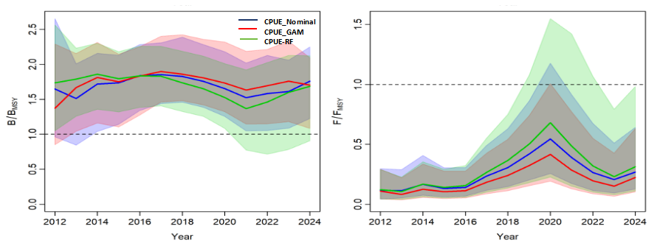
Fig. 9 Trajectories of B/B_{MSY} (left) and F/F_{MSY} (right) for the autumn cohort estimated from three abundance indices.

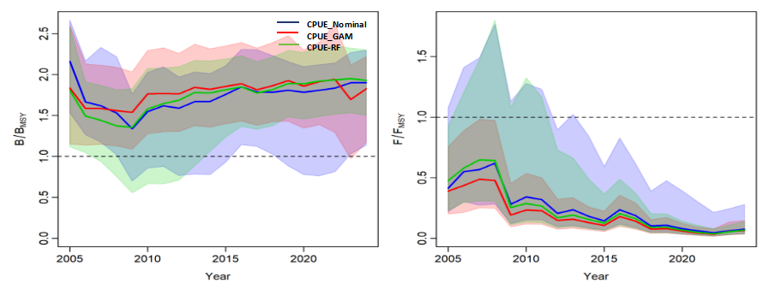
Fig. 10 Trajectories of B/B_{MSY} (left) and F/F_{MSY} (right) for the stock-wide population estimated from three abundance indices.

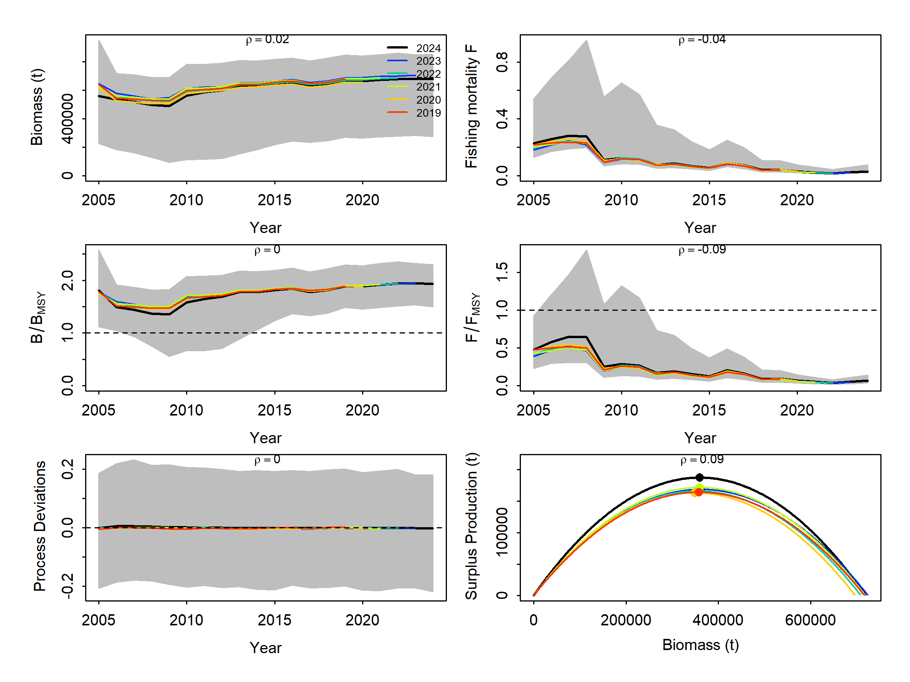
Fig. 11 Retrospective analysis for the stock-wide RF model.
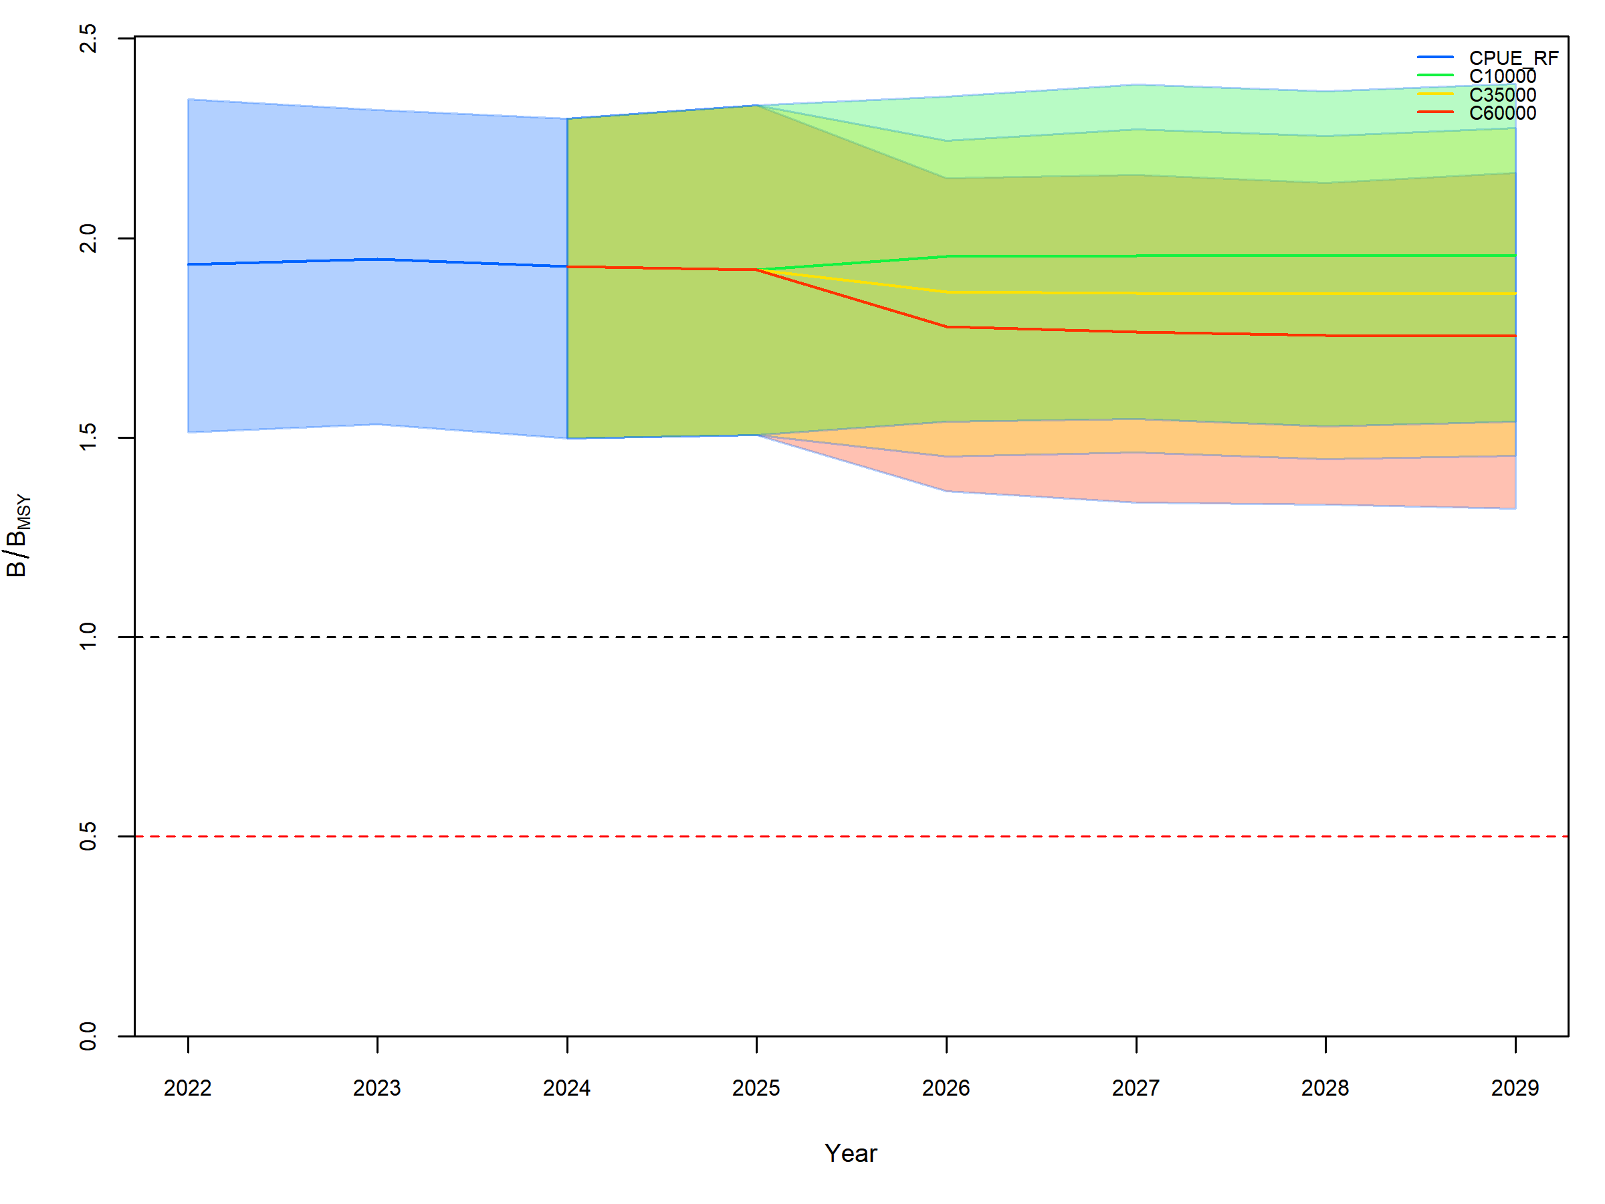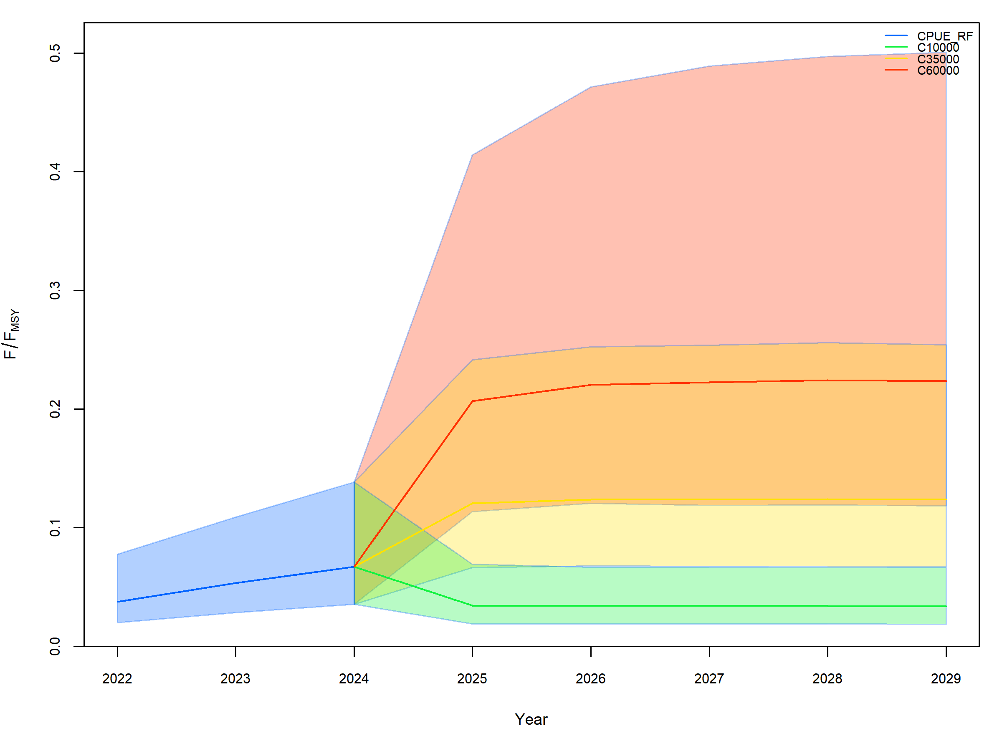
Fig. 12 Short-term (2025–2029) projections of B/B_{MSY} and F/F_{MSY} for the stock-wide population under three constant catch scenarios, based on the RF-standardized CPUE assessment.

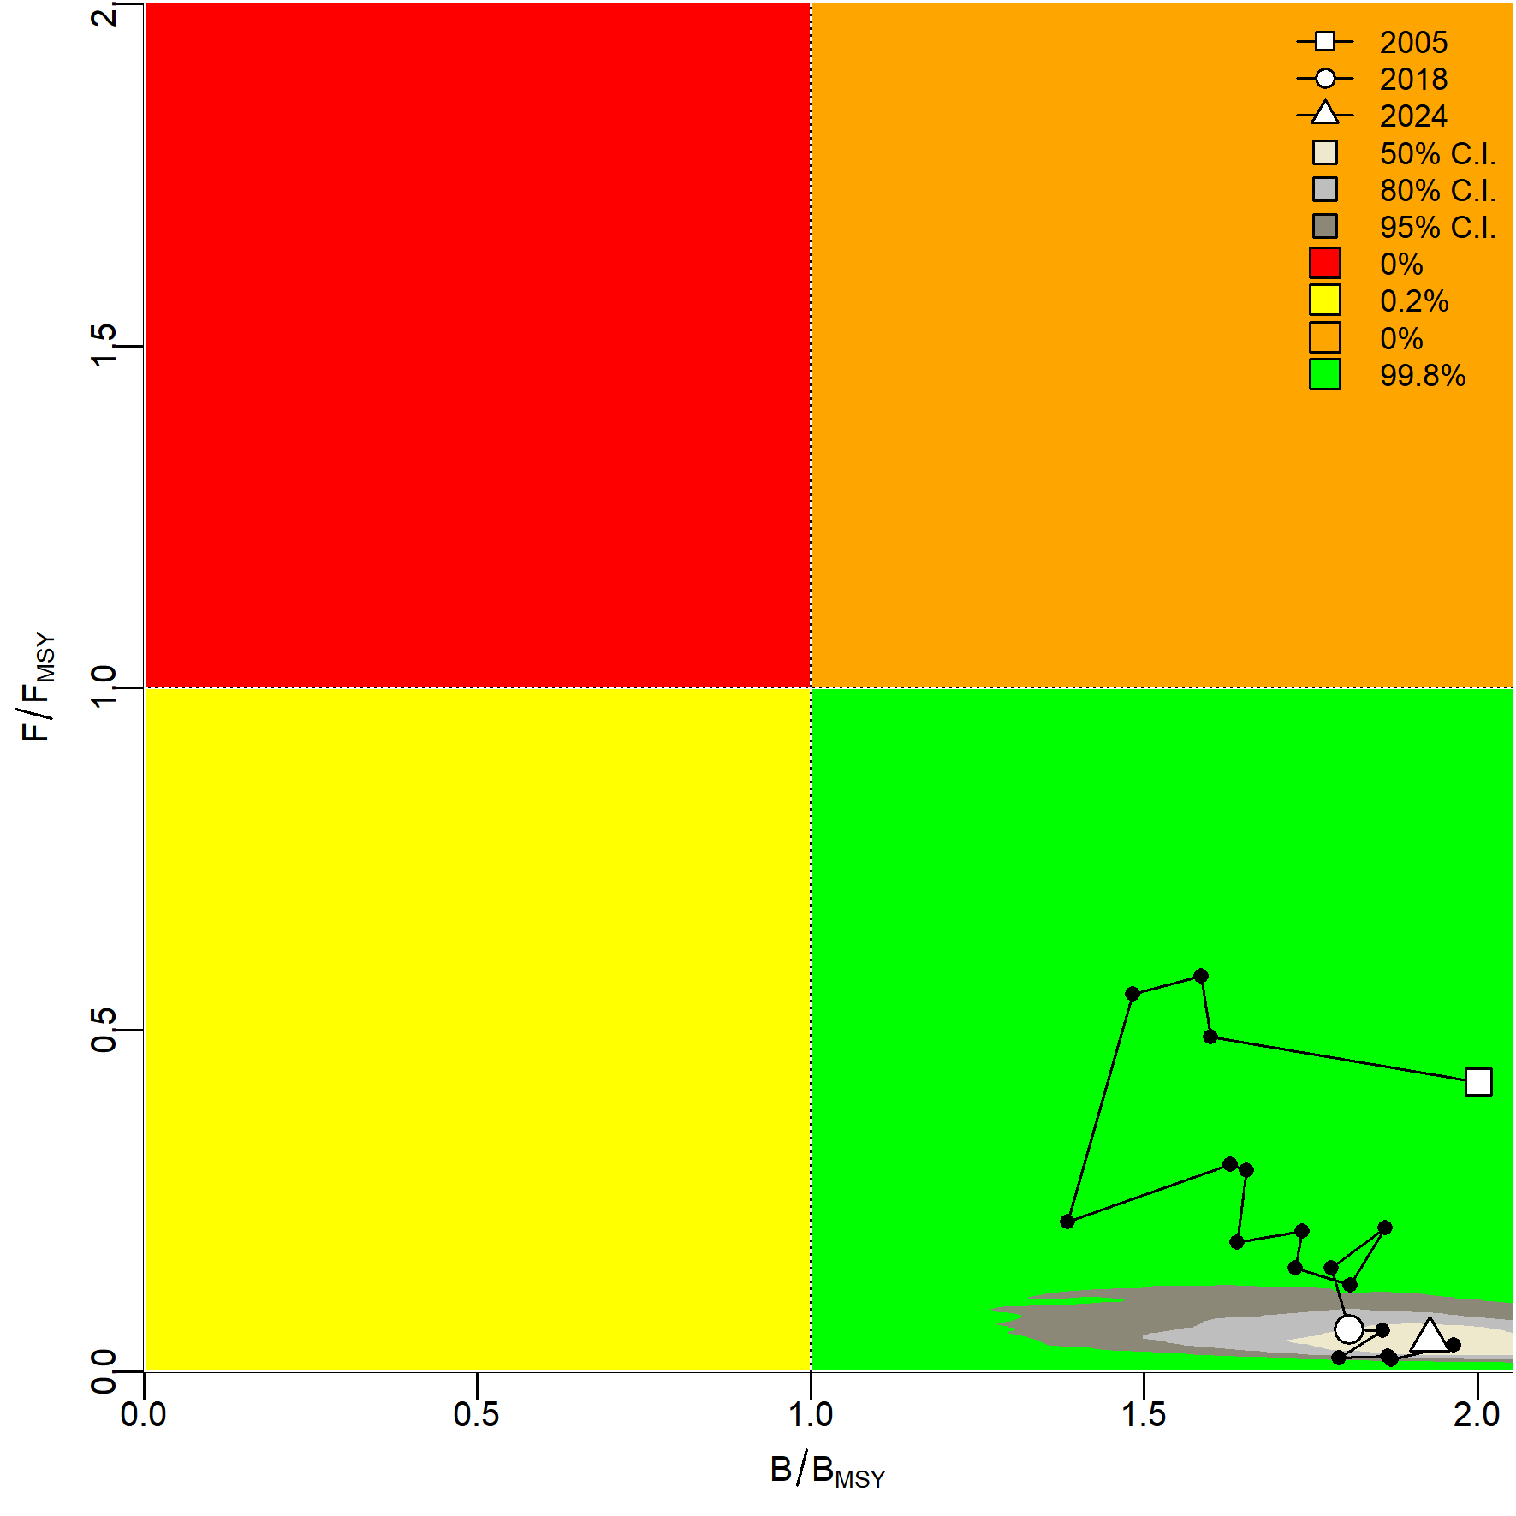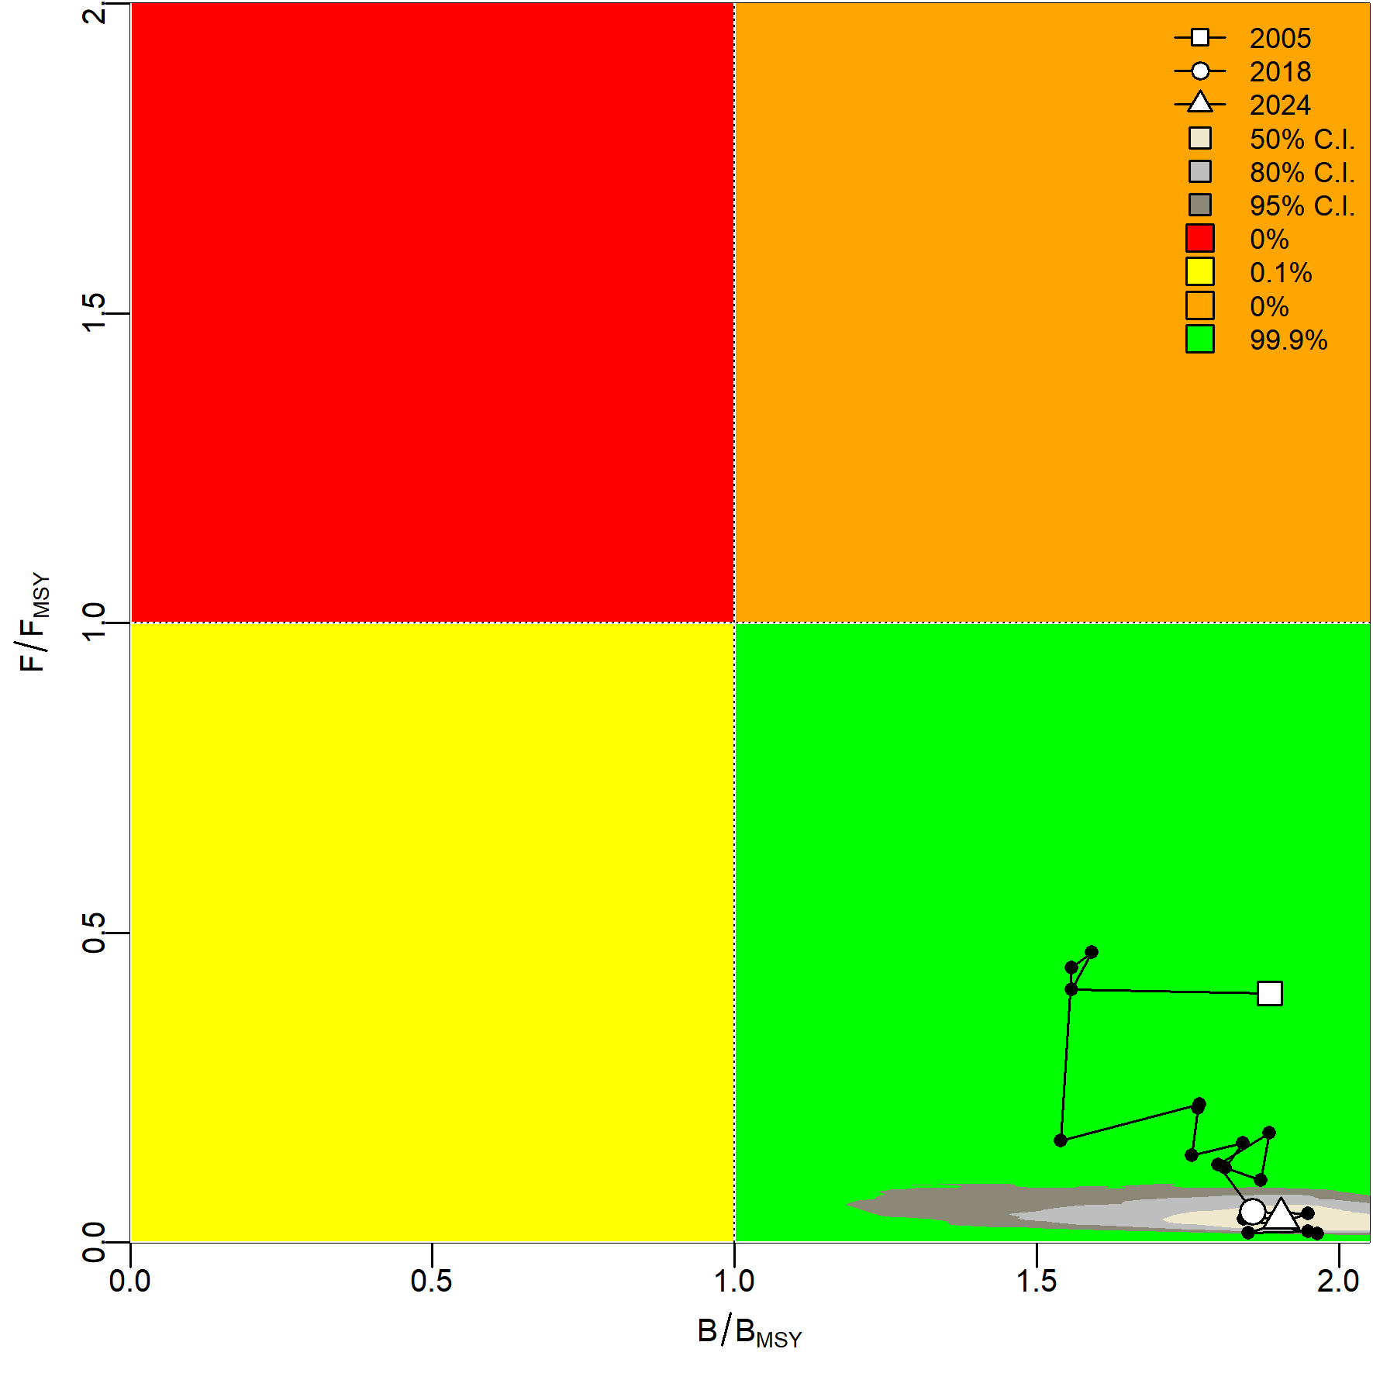
(a) (b)
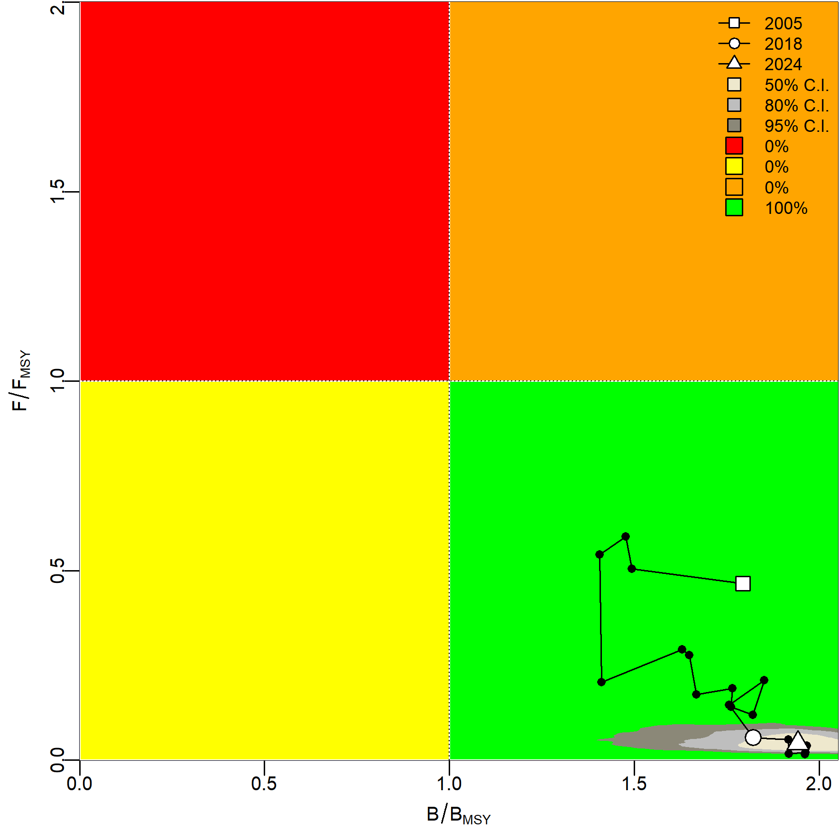
(c)
Fig. 13 Kobe phase plots for the winter-spring cohort under three abundance indices: (a) nominal CPUE, (b) GAM-standardized CPUE, and (c) RF-standardized CPUE.

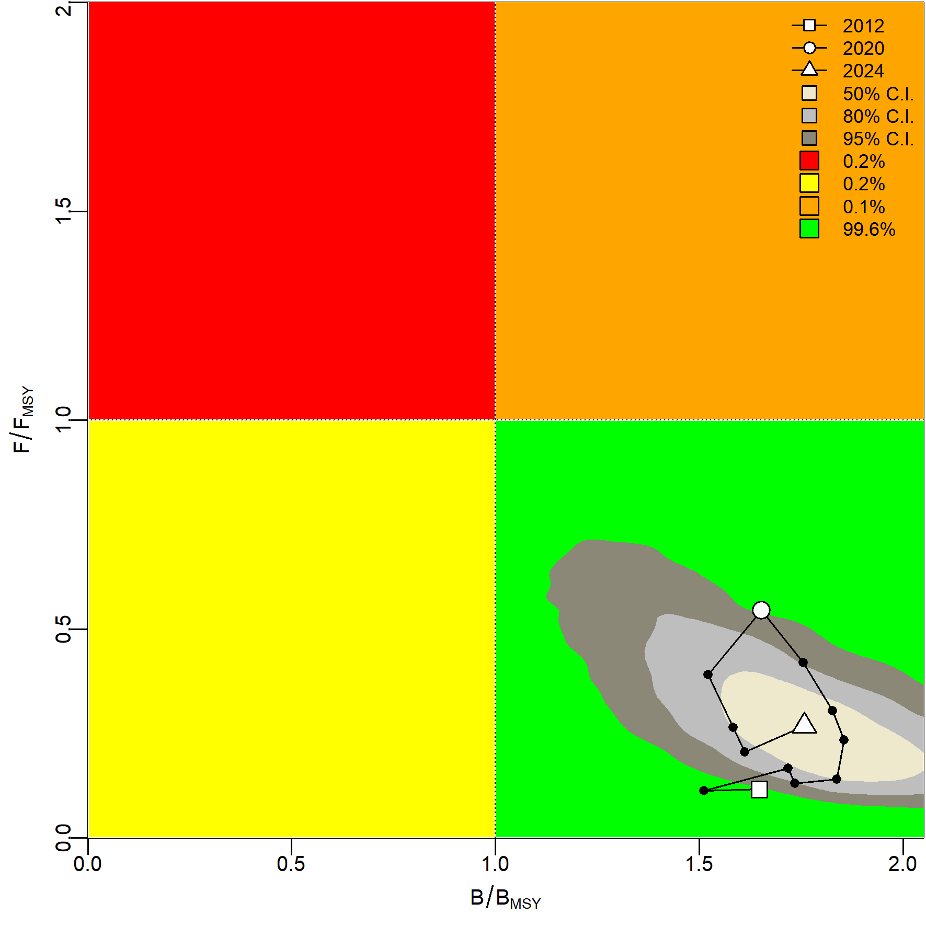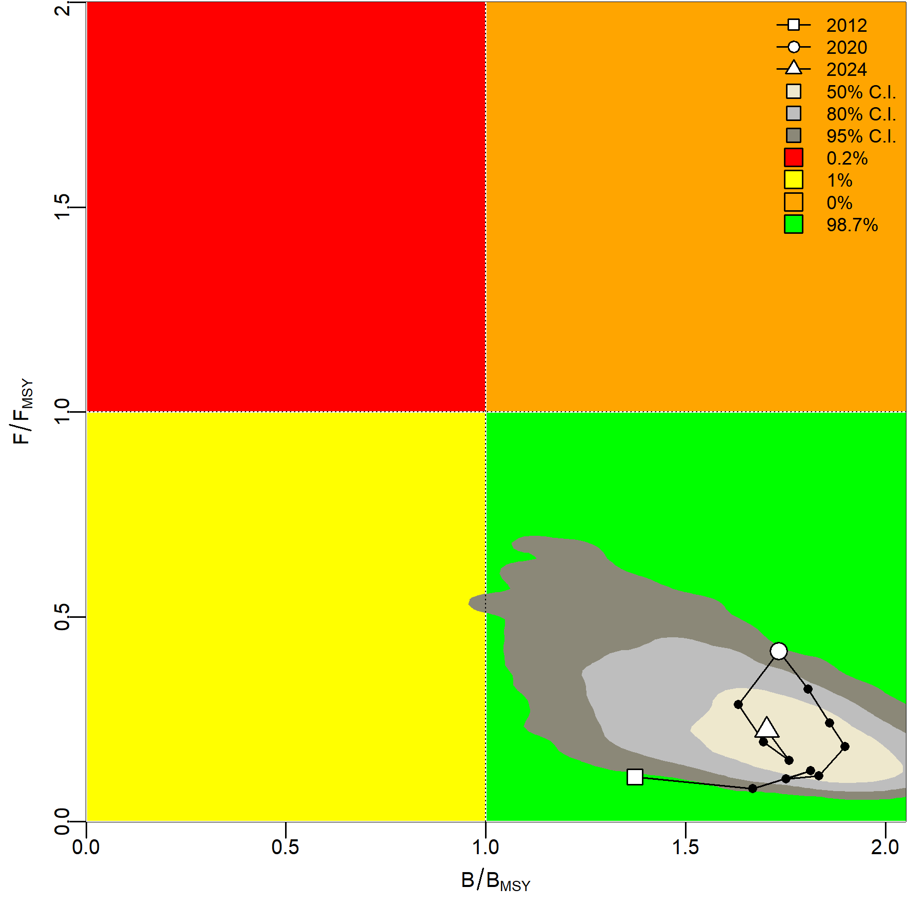
(a) (b)
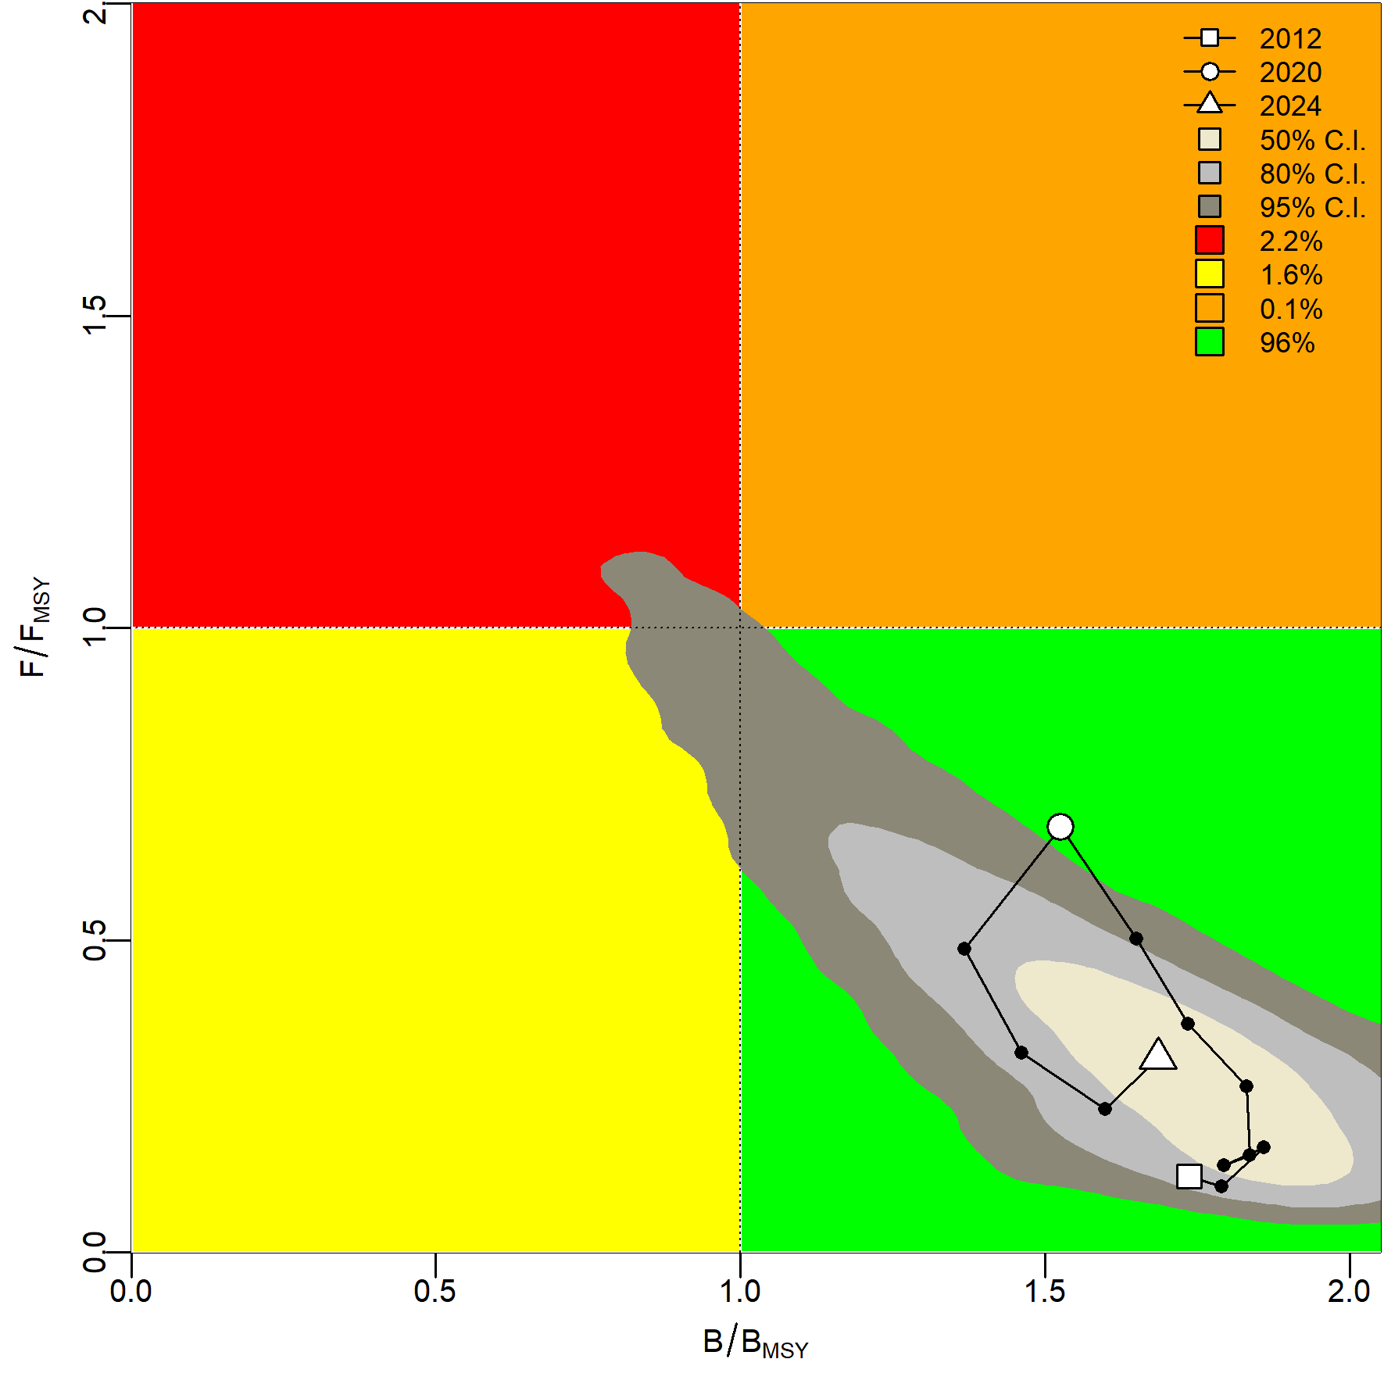
(c)
Fig. 14 Kobe phase plots for the autumn cohort under three abundance indices: (a) nominal CPUE, (b) GAM-standardized CPUE, and (c) RF-standardized CPUE.

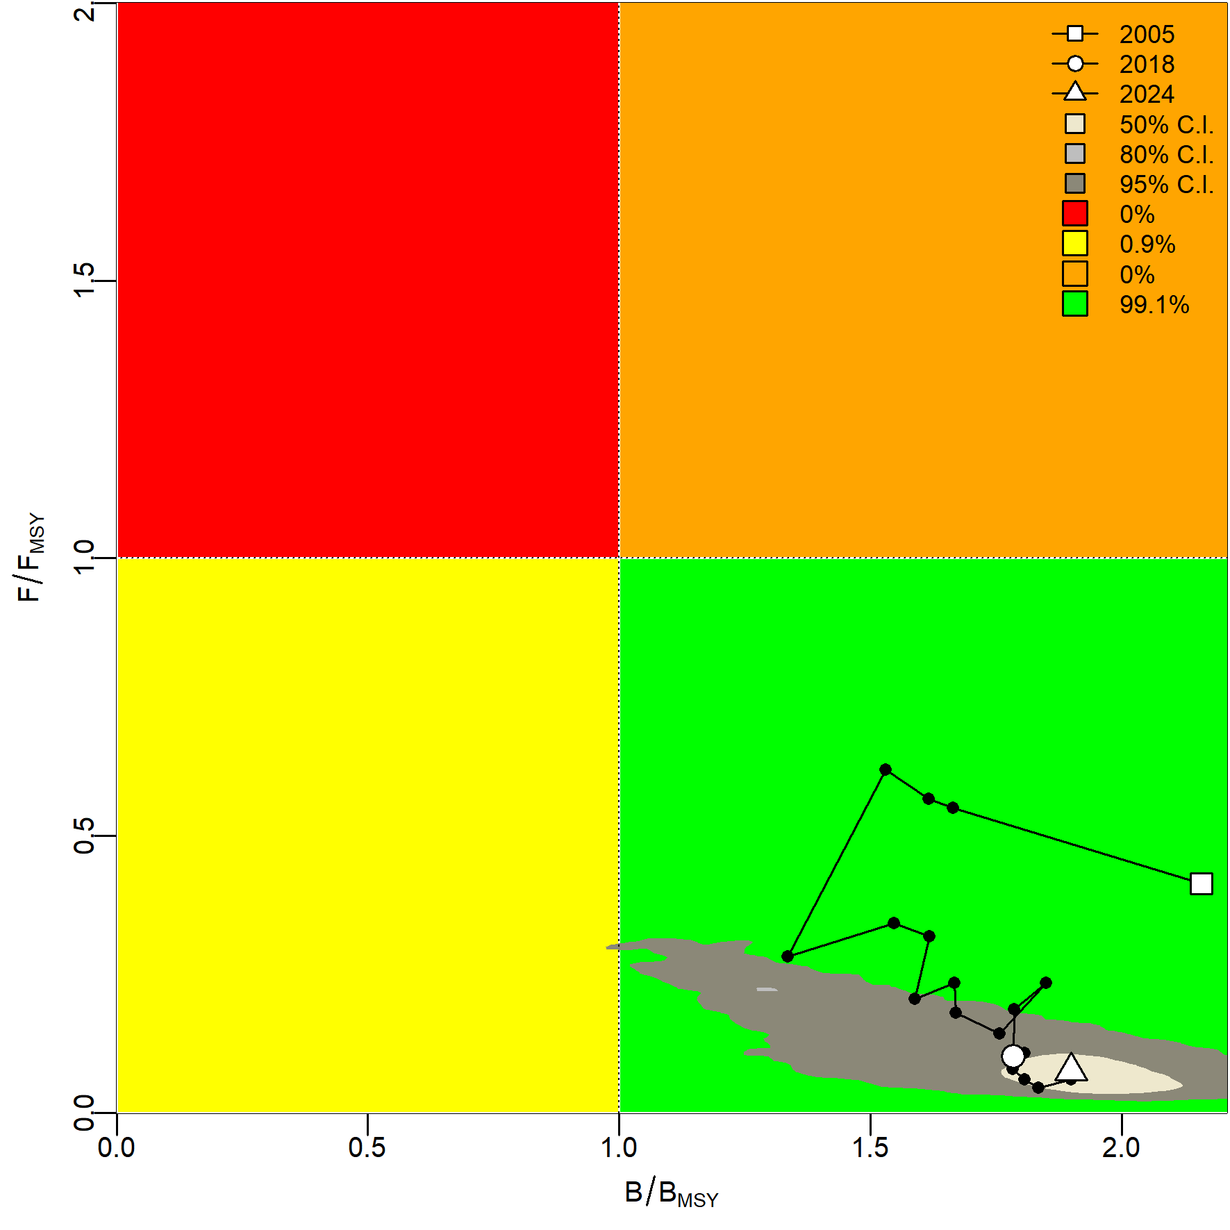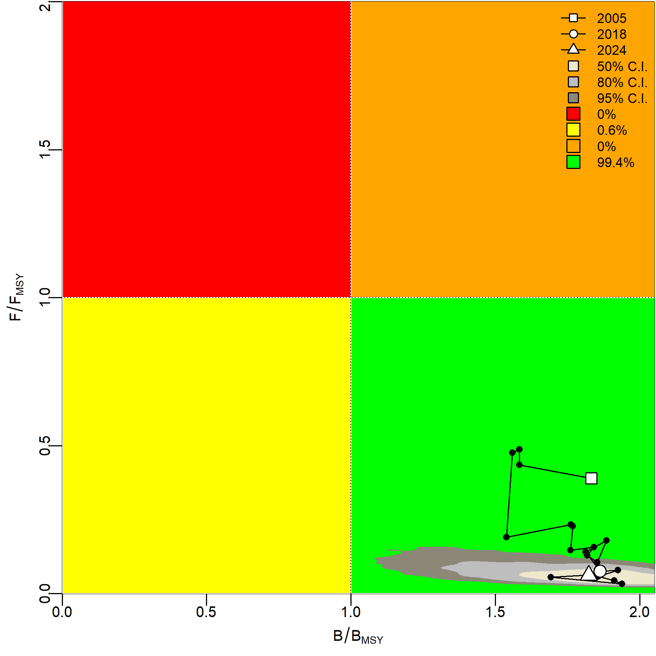
(a) (b)
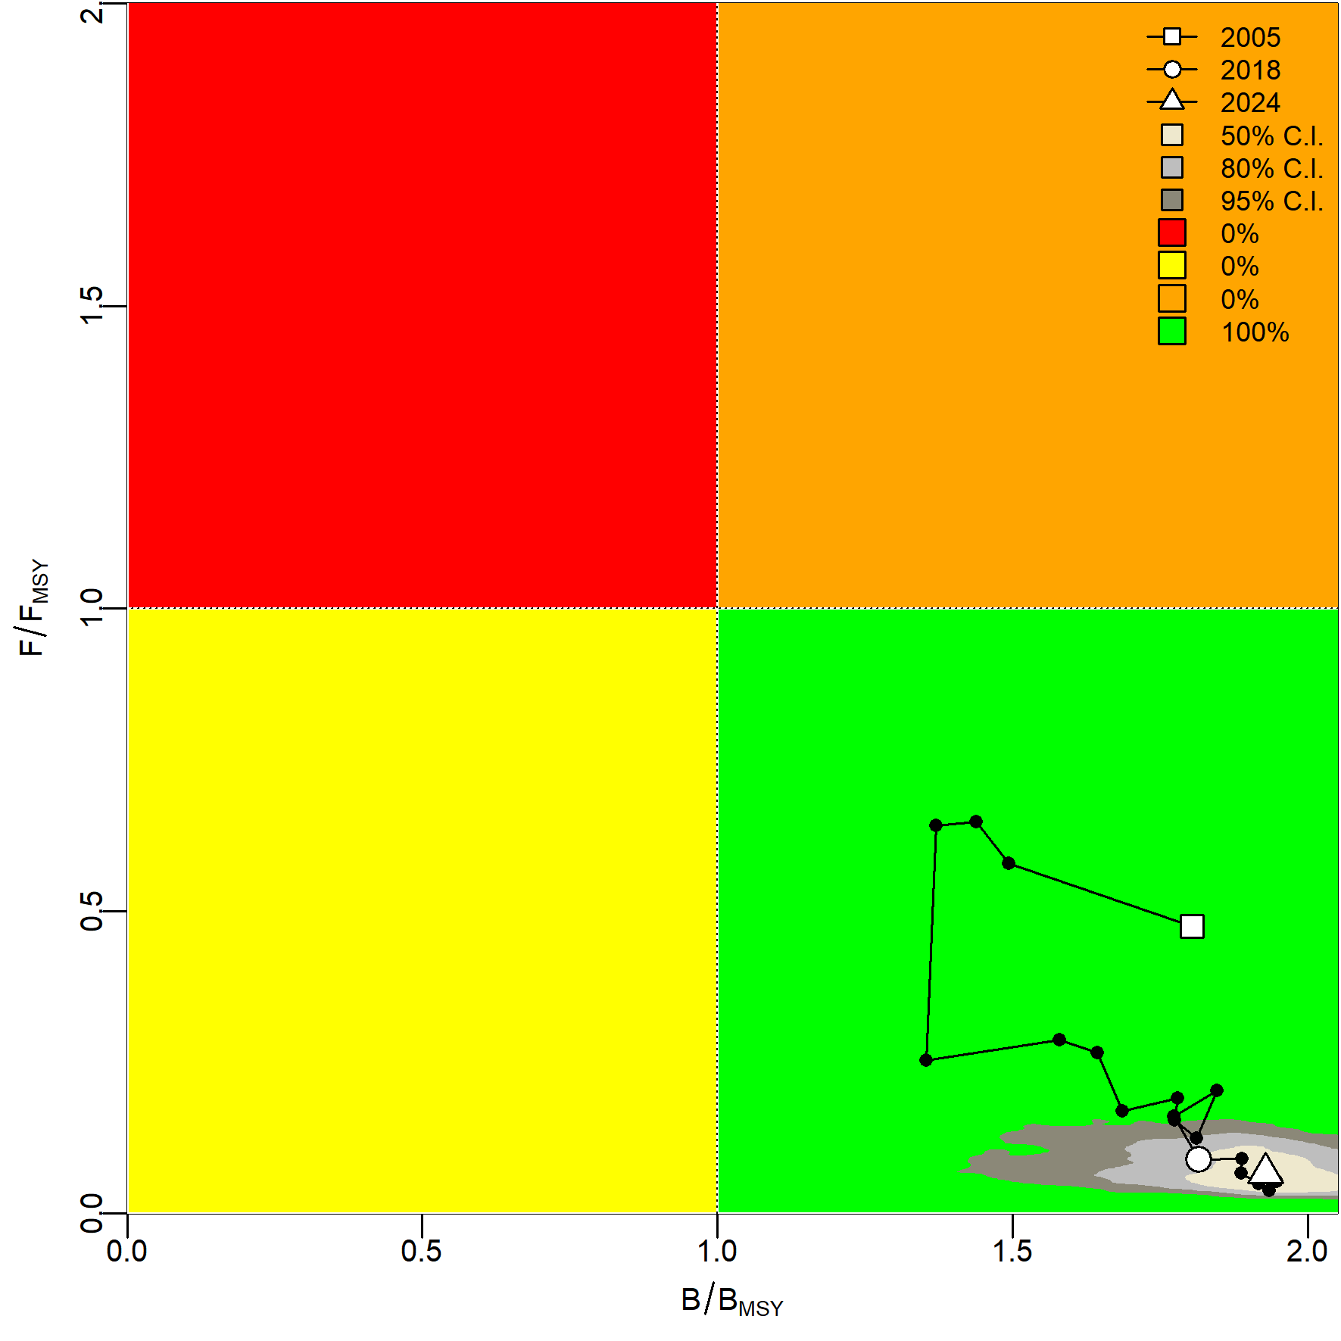
(c)
Fig. 15 Kobe phase plots for the stock-wide cohort under three abundance indices: (a) nominal CPUE, (b) GAM-standardized CPUE, and (c) RF-standardized CPUE.

