NPFC-2026-SSC NFS03-WP08 (Rev. 1)
CPUE standardization of Neon flying squid caught by the Chinese squid jigging fishery up to 2024 in the Northwest Pacific Ocean
Mingyan Song, Xingwang Zhang, Jintao Wang
Shanghai Ocean University

Summary
The neon flying squid (Ommastrephes bartramii) population in the Northwest Pacific Ocean comprises two main seasonal cohorts: the winter-spring cohort and the autumn cohort. We used three approaches including Generalized Additive Models (GAM), Random Forest (RF), and Gradient Boosting Machine (GBM) to standard the catch per unit effort (CPUE) for these two cohorts and for the combined stock during 2005–2024 of Chinese squid jigging fishery data. All models incorporated spatial, temporal, and environmental variables. Model performance metrics and residual diagnostics indicated acceptable fits for all models. The resulting standardized CPUE showed highly consistent interannual trends among the three methods for each cohort, as evidenced by high pairwise correlations (r > 0.94). Specifically, the standardized CPUE for the winter-spring cohort peaked during 2005–2007, declined thereafter, and has since remained at relatively low levels. In contrast, the index for the autumn cohort showed an increasing trend from 2012 onwards, reached its highest point around 2019–2020, and has exhibited a recent declining trend. The resulting standardized CPUE indices, validated through multi-model comparison, are provided to support future stock assessment and management of this species.

1. Introduction
The neon flying squid (Ommastrephes bartramii, hereafter referred to as NFS), one of the most abundant and economically important oceanic squid in the family Ommastrephidae, is widely distributed in the north Pacific Ocean (Murata, 1990). Its population is structured into two main seasonal cohorts with distinct spatial and temporal distributions: the winter-spring and autumn cohorts (Yatsu et al., 1997, 1998). Reliable abundance indices are crucial for stock assessment and management. However nominal CPUE from fishery-dependent data is often confounded by factors unrelated to abundance. This study aims to generate standardized CPUE indices for both cohorts and the combined stock (hereafter referred to as stock-wide) by removing the influence of spatial, temporal, and environmental factors using multiple statistical and machine learning models, providing updated inputs for stock assessment up to 2024. This study was conducted in accordance with the NPFC CPUE standardization protocol (revised July 2025); a compliance checklist is provided in Appendix 1.

2. Materials and Methods

2.1. Fishery Data
Commercial fishery data for NFS in the Northwest Pacific Ocean (2005–2024) were provided by the Chinese Squid Jigging Technology Working Group. The data included catch (metric tons), fishing effort (vessel-days), fishing position (longitude and latitude), fishing year and month for each fishing operation. According to the spatial distribution and seasonal characteristics of NFS, the data were divided into three stock units for separate analysis: the winter-spring cohort (west of 170°E, fishing period: May–November, 2005–2024), the autumn cohort (east of 170°E, fishing period: May–August, 2012–2024) and the stock-wide.
A spatial scale of 1°×1° (referred to as a fishing grid) was used in grouping the data. Nominal CPUE (ton/vessel/day) for each fishing grid was calculated as:
${\text{CPUE}}_{\text{i}}$=$\frac{{Catch}_{i}}{Fishing {days}_{i}}$ (1)
where ${\text{Catc}\text{h}}_{\text{i}}$ is the sum of catch for all the fishing vessels within a fishing grid, and $\text{Fis}\text{h}\text{ing} {\text{days}}_{\text{i}}$ is the sum of all fishing days of all fishing vessels within the fishing grid.
To enable log-transformation while accounting for grids with zero catch, a constant c was added to all CPUE values: c = 0.1 × mean (CPUE | CPUE > 0) (Campbell, 2004). The response variable for all subsequent models was therefore log(CPUE + c). The annual catch and fishing effort (vessel-days) of the Chinese squid jigging fishery is shown in Fig. 1, and the spatial distribution of monthly nominal CPUE is shown in Fig. 2.
Explanatory variables included:
Spatial variables: Longitude (Lon), Latitude (Lat)
Temporal variables: Year, Month
Environmental variables: Sea surface temperature (SST, Temp_0), sea surface salinity (SSS, Sali_0), mixed layer depth (MLD), sea surface height (SSH)
Environmental data were extracted from the Copernicus Marine Data Store at 0.083°×0.083° resolution and matched to corresponding 1°×1° fishing grids. These variables were selected based on established ecological relationships.
Variance Inflation Factor (VIF) and Spearman correlation coefficient among explanatory variables were calculated (Table 1) and correlations among variables were shown in the Fig. 3. All VIF values were below 10 (range: 1.58-5.22), indicating no severe multicollinearity among the predictor variables.

2.2. CPUE standardization models
Three modeling approaches were employed for CPUE standardization: Generalized Additive Model (GAM), Random Forest (RF), and Gradient Boosting Machine (GBM).
For the GAM, a Gaussian model was fitted using the mgcv package with the structure: log(CPUE + c) ~ s(Lon, Lat) + s(Temp_0) + s(Sali_0) + s(MLD) + s(SSH) + Year + Month, where s() denotes thin-plate regression splines.
For RF and GBM analyses, the model structure was: log(CPUE + c) ~ Lon + Lat + Temp_0 + Sali_0 + MLD + SSH + Year + Month. RF was implemented using the randomForest package and GBM using the gbm package. The constant c for log-transformation was calculated as 10% of the mean positive CPUE within each dataset.
Models were fitted separately for each cohort-specific analysis. For the stock-wide analysis, models were fitted to the pooled data from both cohorts, with the Stock factor included to account for baseline differences while estimating a common trend.

2.3. Model Evaluation and Diagnostics
Key hyperparameters for RF and GBM are summarized in Table 2. Model performance was evaluated using Root Mean Square Error (RMSE) and the coefficient of determination (R²), with lower RMSE and higher R² indicating better explanatory power (Table 3). While the RF model demonstrated relatively better performance metrics, results from all three models were retained and compared to illustrate the robustness of the derived trends—a key aspect of this multi-model approach. Diagnostic plots, including Normal Q-Q plots, histograms of residuals, and plots of residuals versus fitted values, were examined for all models. These diagnostics for the stock-wide models are presented in Fig. 4-6, confirming no major violations of model assumptions.

2.4. Extraction of Standardized CPUE and Uncertainty Calculation
To extract annual indices representing abundance trends, standardized CPUE was predicted for each year while holding other variables constant. Spatial and environmental variables were fixed at their overall mean values. The Month factor was fixed at May, the starting month of the fishing season for both cohorts. For the stock-wide analysis, the Stock factor was also fixed. Each fitted model was then used to predict log(CPUE + c) for each level of the Year factor under this common scenario. The resulting prediction represents the expected log(CPUE) for that year relative to others, assuming all other conditions were at the baseline state. The final standardized CPUE index for each year was obtained by back-transforming the prediction: Standardized CPUE = exp(predicted value).
Uncertainty was estimated using model-appropriate methods:
GAM: The standard error of the linear predictor from the predict.gam function.
RF: The standard deviation of predictions across all 500 individual trees in the ensemble.
GBM: The standard deviation of predictions from 200 bootstrap replicates of the model fitting process.
Coefficient of variation (CV, %) was calculated as CV = (standard deviation /Standardized CPUE) × 100. 95% confidence intervals were calculated on the log scale and back-transformed to the original scale. The GAM model standardized CPUE indices for the winter-spring cohort, selected for presentation due to their reasonable uncertainty estimates (CV < 20%) and longest time series (2005-2024), are provided in Table 4 with full uncertainty metrics.

3. Results

3.1. Model Performance and Consistency
Model performance metrics are summarized in Table 3. The RF models consistently yielded the highest R² values. Despite differences in absolute performance, the interannual trends produced by all three models were highly consistent for each stock unit. Pairwise Pearson correlation coefficients between the annual indices from the three models were high: ranging from 0.977 to 0.988 for the winter-spring cohort, 0.948 to 0.962 for the autumn cohort, and 0.984 to 0.992 for the stock-wide indices (visualized in the correlation heatmap, Fig. 8).

3.2. Standardized CPUE Trends
The final standardized CPUE indices from all three models are presented in Fig. 7, with a direct comparison between nominal and standardized indices for the winter-spring cohort provided in Table 5. The nominal CPUE showed consistent historical trends with all three standardized CPUE series. The index for the winter-spring cohort was high during 2005-2007, declined sharply, and has since fluctuated at relatively low levels. The autumn cohort index generally increased from the start of its series in 2012, peaked around 2019-2020, and has shown a recent declining trend. The stock-wide index reflects a composite of these dynamics.

4. Discussion
This study provides updated, multi-model standardized CPUE indices for neon flying squid in the Northwest Pacific. The high concordance among three fundamentally different modeling techniques strongly suggests that the derived indices reflect true interannual changes in relative abundance, enhancing their credibility for use in stock assessment. The observed trends align with known cohort-specific dynamics reported in the literature. The decision to present multiple model outputs, rather than a single index, explicitly characterizes and acknowledges model-based uncertainty in the standardization process. These indices, based on Chinese fishery data, serve as robust inputs for assessing the stock status under the NPFC framework.
We standardized CPUE in accordance with the standardization protocol (NPFC-2025-SSC NFS02-Final Report Annex D). The checklist is shown in Appendix 1.

References
Murata M. 1990. Oceanic resources of squids. Marine Behaviour and Physiology, 18: 19-71.
Yatsu A, Midorikawa S, Shimada T, Uozumi Y. 1997. Age and growth of the neon flying squid, Ommastrephes bartrami, in the North Pacific Ocean. Fisheries Research, 29: 257-270.
Yatsu A, Tanaka H, Mori J. 1998. Population structure ofthe neon flying squid, Ommastrephes bartramii, in the North Pacific. Japan marine fishery resources researchcenter, p 31-48.
Campbell R A. 2004. CPUE standardisation and the construction of indices of stock abundance in a spatially varying fishery using general linear models. Fisheries Research, 70: 209-227.

APPENDICES
Appendix1. Checklist for the CPUE standardization protocol
1 | Provide a description of the type of data (logbook, observer, survey, etc.), and the "resolution" of the data (aggregated, set-by-set etc.). | Yes (Section 2.1, Paragraph 1-2)
2 | Identify potential explanatory variables (i.e., spatial, temporal, environmental, and fisheries variables) that may influence CPUE values. | Yes (Section 2.1, Paragraph 4)
3 | Plot annual/monthly spatial catch, effort and nominal CPUE distributions and determine temporal and spatial resolution for CPUE standardization. | Yes (Fig. 1, Fig. 2 )
4 | Make scatter plots (for continuous variables) and/or box plots (for categorical variables) and present correlation matrix if possible to evaluate correlations between each pair of those variables. | Yes (Table 1, Fig. 3)
5 | Describe selected explanatory variables based on (2)-(4) to develop full model for the CPUE standardization. | Yes (Section 2.1 and 2.2)
6 | Specify model type and software (packages) and fit the data to the assumed statistical models (i.e., GLM, GAM, Delta-lognormal GLM, Neural Networks, Regression Trees, Habitat based models, and Statistical habitat based models). | Yes (Section 2.2)
7 | Evaluate and select the best model(s) using methods such as likelihood ratio test, information criterions, cross validation etc. | Yes (Table 3)
8 | Provide diagnostic plots to support the chosen model is appropriate and assumption are met (QQ plot and residual plots along with predicted values and important explanatory variables, etc.). | Yes (Fig. 4-6)
9 | Extract yearly and, if needed, seasonally standardized CPUE and standard error by a method that is able to account for spatial heterogeneity of effort, such as least squares mean or expanded grid. Provide details on how the CPUE index was extracted. | Yes (Section 2.4, Paragraph 1-2)
10 | Calculate uncertainty (SD, CV, CI) for standardized CPUE for each year. Provide detailed explanation on how the uncertainty was calculated. | Yes (Table 4)
11 | Provide a table and a plot of nominal and standardized CPUEs over time. When the trends between nominal and standardized CPUE are largely different, explain the reasons (e.g. spatial shift of fishing efforts), whenever possible. | Yes (Fig. 7, Table 5)

Table 1. Variance Inflation Factor (VIF) and Spearman correlation coefficient among explanatory variables
Variable | VIF | Lon | Lat | SST | SSS | MLD | SSH | Year | Month
Lon | 2.59 |  | -0.097 | -0.298 | 0.274 | -0.212 | 0.383 | 0.387 | -0.577
Lat | 3.18 | <0.001 |  | -0.457 | -0.79 | -0.078 | -0.733 | 0.168 | 0.292
SST | 2.48 | <0.001 | <0.001 |  | 0.398 | -0.158 | 0.434 | -0.111 | 0.131
SSS | 3.96 | <0.001 | <0.001 | <0.001 |  | 0.105 | 0.816 | 0.069 | -0.394
MLD | 1.58 | <0.001 | <0.001 | <0.001 | <0.001 |  | 0.153 | 0.032 | 0.632
SSH | 5.22 | <0.001 | <0.001 | <0.001 | <0.001 | <0.001 |  | 0.176 | -0.264
Year | NA | <0.001 | <0.001 | <0.001 | <0.001 | 0.037 | <0.001 |  | -0.131
Month | NA | <0.001 | <0.001 | <0.001 | <0.001 | <0.001 | <0.001 | <0.001

Table 2. Model specifications for the Random Forest and Gradient Boosting Machine algorithms.
Model | Hyperparameter | Value
Random Forest (RF) | ntree | 500
 | importance | TRUE
 | Other parameters | Using default randomForest settings
Gradient Boosting Machine (GBM) | n.trees | 5,000
 | interaction.depth | 4
 | shrinkage | 0.01
 | distribution | gaussian
 | Other parameters | Using default gbm settings

Table 3. Performance metrics (RMSE, R²) of the GAM, RF, and GBM models for standardizing CPUE of the winter-spring cohort, autumn cohort, and stock-wide of neon flying squid.
Stock | Model | RMSE | R²
winter-spring cohort | GAM | 0.7626 | 0.4001
 | RF | 0.3291 | 0.8883
 | GBM | 0.5506 | 0.6873
autumn cohort | GAM | 0.6543 | 0.4278
 | RF | 0.3295 | 0.8549
 | GBM | 0.3533 | 0.8331
stock-wide | GAM | 0.7792 | 0.3539
 | RF | 0.3176 | 0.8926
 | GBM | 0.5776 | 0.6450

Table 4. Standardized CPUE indices with uncertainty estimates for the winter-spring cohort of NFS based on GAM (2005-2024).
 | Standardized CPUE | SE | CV(%) | 95%CI
  Year
2005 | 7.47 | 1.30 | 17.46 | 5.30-10.52
2006 | 8.86 | 1.63 | 18.40 | 6.18-12.71
2007 | 8.56 | 1.64 | 19.10 | 5.89-12.45
2008 | 2.70 | 0.47 | 17.26 | 1.92-3.78
2009 | 1.40 | 0.25 | 17.71 | 0.99-1.98
2010 | 1.71 | 0.27 | 15.67 | 1.26-2.33
2011 | 2.75 | 0.44 | 15.89 | 2.01-3.75
2012 | 1.54 | 0.25 | 16.16 | 1.12-2.11
2013 | 2.00 | 0.32 | 16.18 | 1.44-2.71
2014 | 1.54 | 0.25 | 16.21 | 1.12-2.12
2015 | 2.04 | 0.34 | 16.76 | 1.47-2.84
2016 | 1.89 | 0.30 | 16.11 | 1.38-2.59
2017 | 1.58 | 0.25 | 16.13 | 1.15-2.17
2018 | 1.93 | 0.30 | 15.78 | 1.42-2.63
2019 | 2.39 | 0.45 | 18.88 | 1.65-3.46
2020 | 0.86 | 0.14 | 16.47 | 0.62-1.19
2021 | 1.65 | 0.28 | 16.91 | 1.19-2.30
2022 | 1.54 | 0.24 | 15.61 | 1.13-2.09
2023 | 0.60 | 0.09 | 15.61 | 0.44-0.80
2024 | 1.19 | 0.19 | 16.03 | 0.87-1.63

Table 5. CPUE indices for the winter-spring cohort: nominal and standardized by three models.
Year | Nominal_CPUE | GAM_Std_CPUE | RF_Std_CPUE | GBM_Std_CPUE
2005 | 5.68 | 7.01 | 3.53 | 4.75
2006 | 12.72 | 8.34 | 3.92 | 6.77
2007 | 7.87 | 8.02 | 3.42 | 4.87
2008 | 2.38 | 2.55 | 1.43 | 1.60
2009 | 1.04 | 1.31 | 1.04 | 0.79
2010 | 1.19 | 1.63 | 1.10 | 0.93
2011 | 2.00 | 2.62 | 1.53 | 1.35
2012 | 1.24 | 1.46 | 1.05 | 0.88
2013 | 1.34 | 1.88 | 1.10 | 1.04
2014 | 1.16 | 1.45 | 1.06 | 0.82
2015 | 1.48 | 1.93 | 1.14 | 1.01
2016 | 1.80 | 1.78 | 1.35 | 1.34
2017 | 1.33 | 1.49 | 1.06 | 0.88
2018 | 1.50 | 1.82 | 1.34 | 1.28
2019 | 1.93 | 2.23 | 1.51 | 1.37
2020 | 1.23 | 0.81 | 1.14 | 0.73
2021 | 1.75 | 1.54 | 1.21 | 0.76
2022 | 1.61 | 1.45 | 1.30 | 1.22
2023 | 0.95 | 0.57 | 1.10 | 0.94
2024 | 1.16 | 1.13 | 1.12 | 0.88

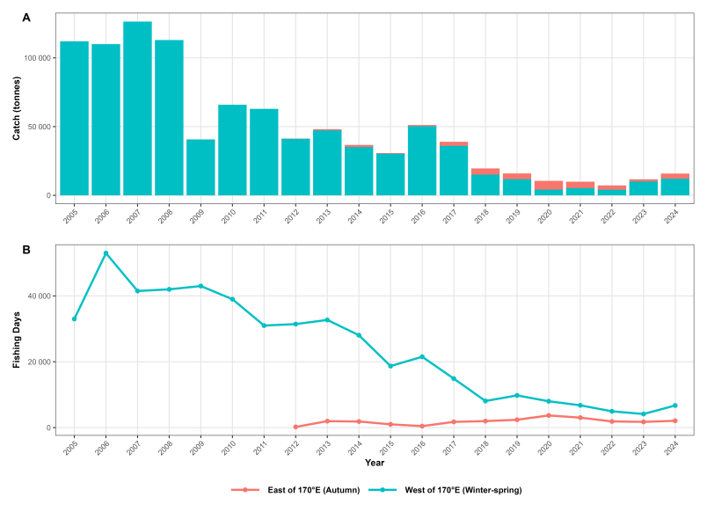
Fig. 1 Annual catch and fishing effort (i.e., vessel-days) of neon flying squid from the Chinese squid-jigging fishery in the Northwest Pacific Ocean, 2005-2024.

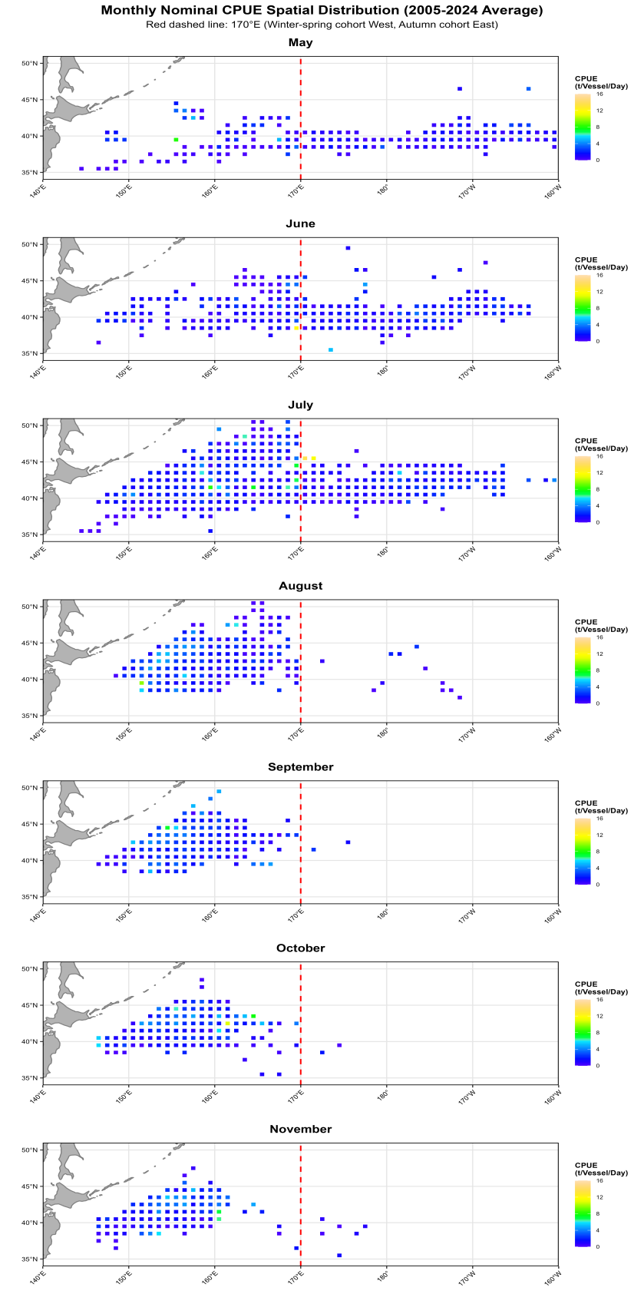
Fig. 2 Spatial distribution of mean nominal CPUE for the autumn cohort (May – August) and the winter-spring cohort (May – November) of neon flying squid by Chinese squid jigging fisheries.

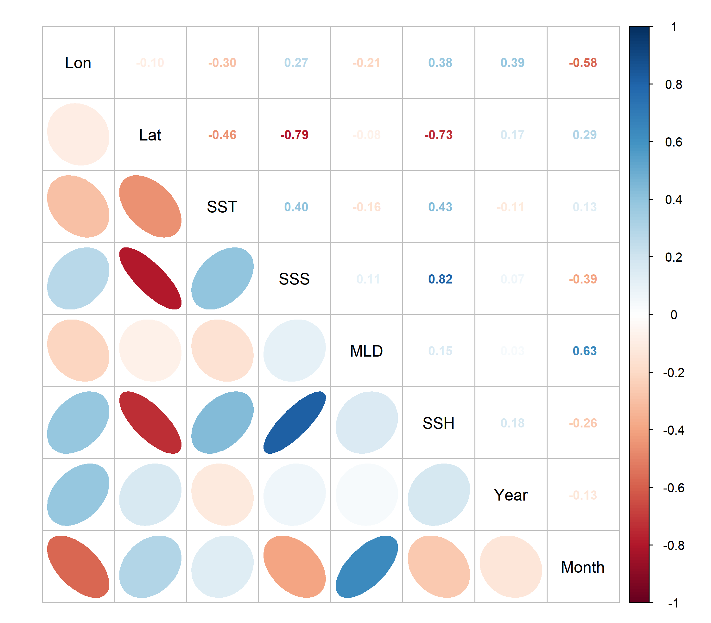
Fig. 3 Correlation matrix of explanatory variables used in the analysis.

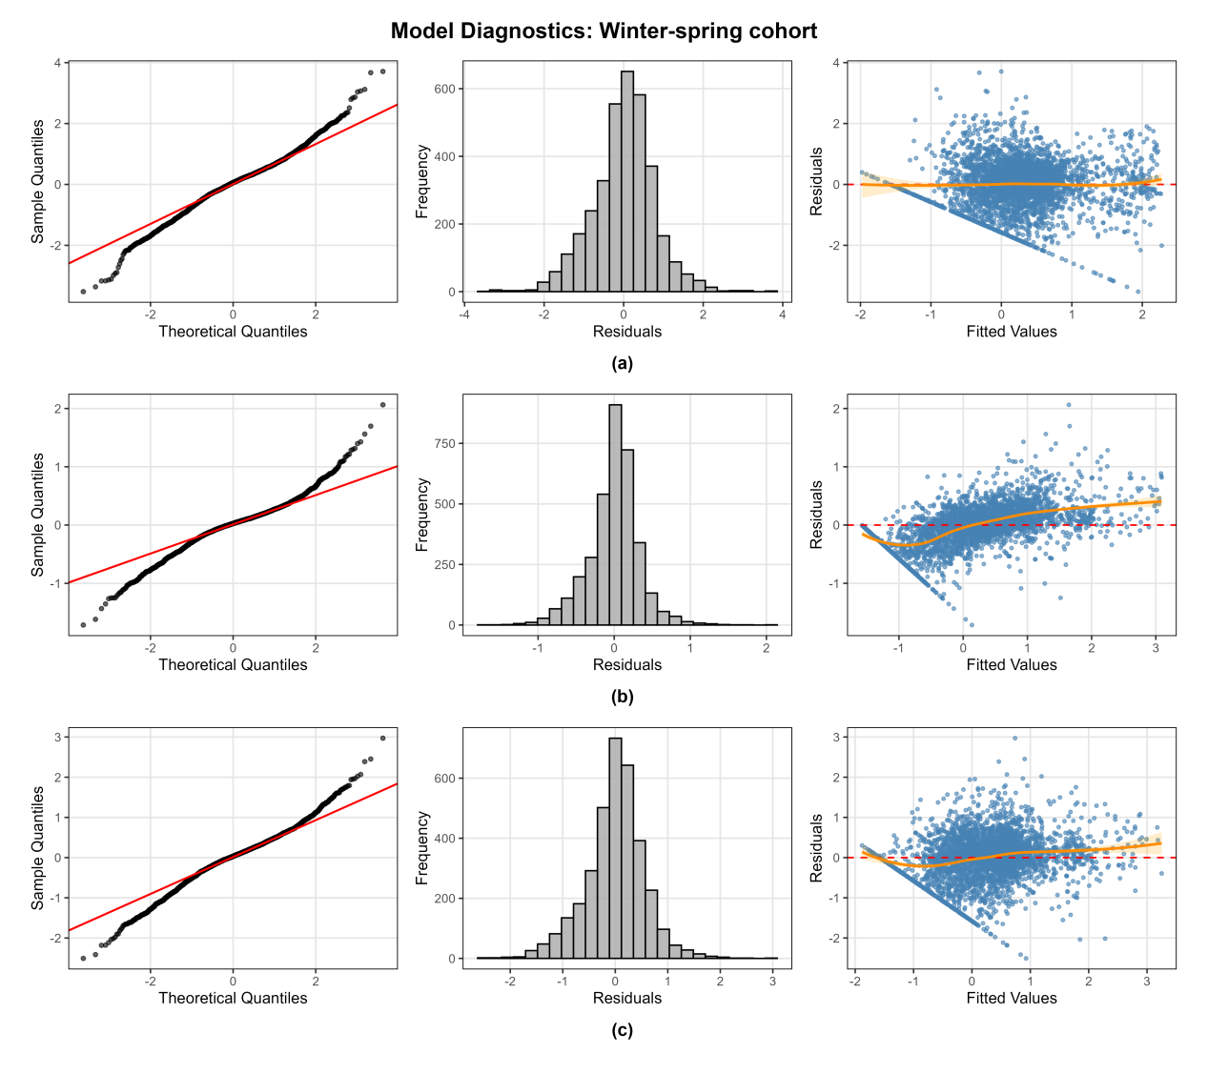
Fig. 4 Model diagnostic plots (Q-Q plot, histogram of residuals, and plot of residuals versus fitted values) for the winter-spring cohort: (a) GAM, (b) RF, (c) GBM.
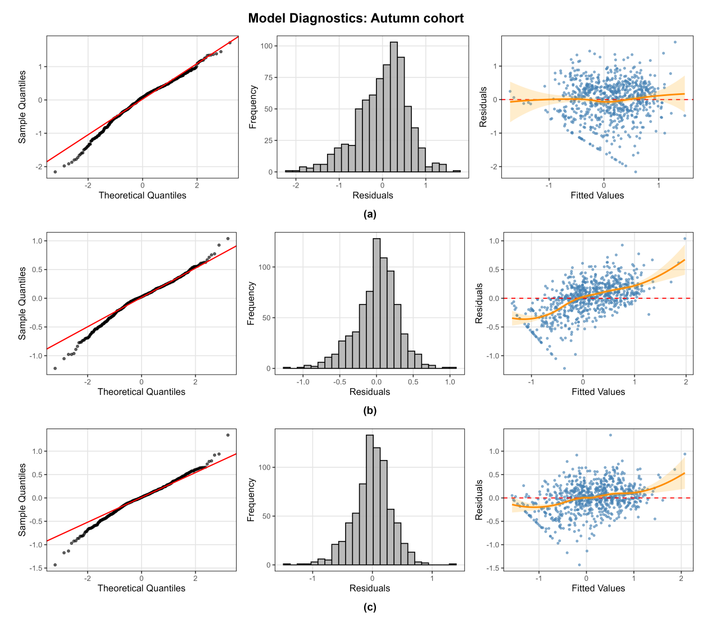
Fig. 5 Model diagnostic plots (Q-Q plot, histogram of residuals, and plot of residuals versus fitted values) for the autumn cohort: (a) GAM, (b) RF, (c) GBM.

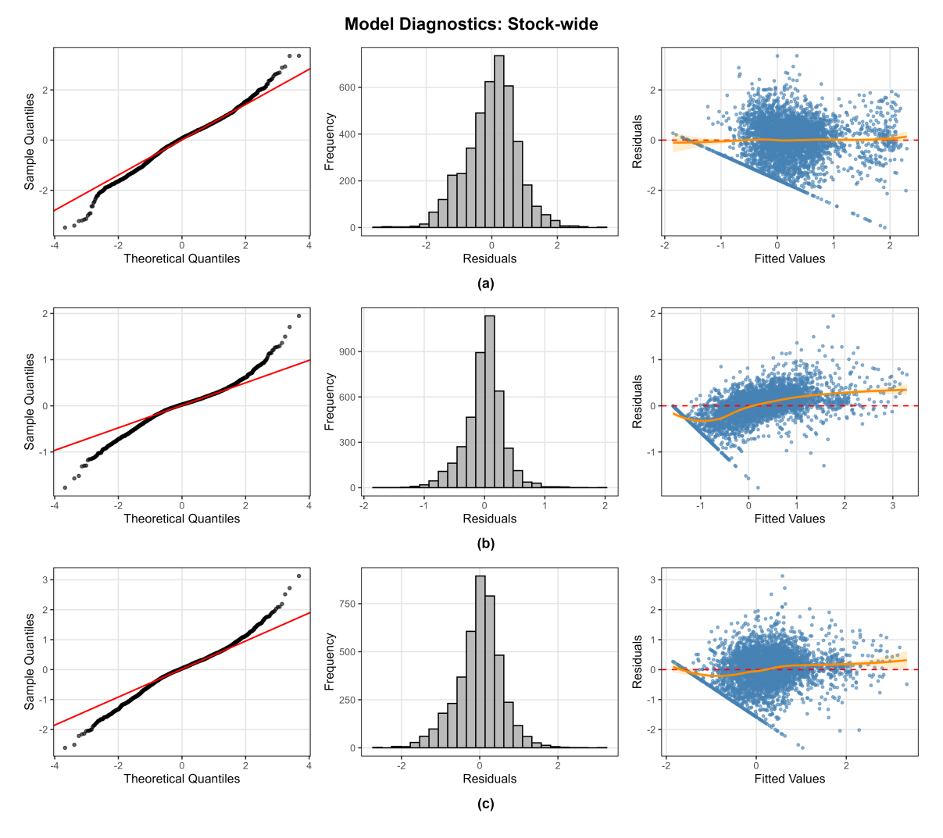
Fig. 6 Model diagnostic plots (Q-Q plot, histogram of residuals, and plot of residuals versus fitted values) for the stock-wide: (a) GAM, (b) RF, (c) GBM.
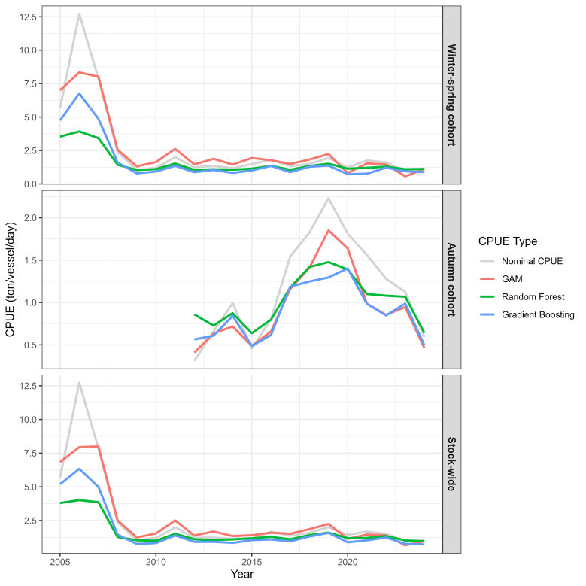
Fig. 7 Comparison of nominal and standardized CPUE indices for the winter-spring cohort, autumn cohort, and stock-wide of neon flying squid derived from three modeling approaches.

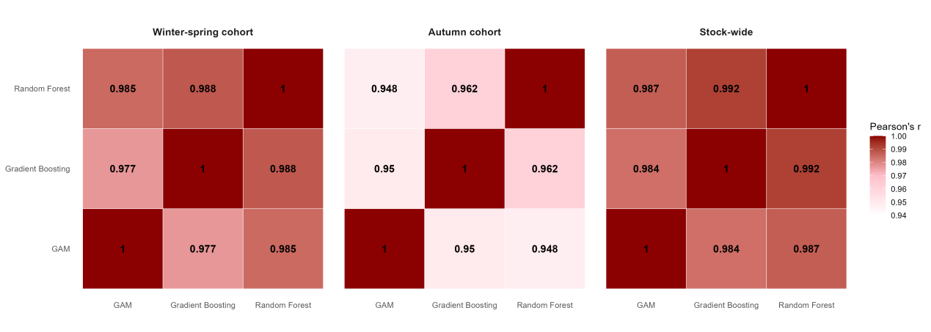
Fig. 8 Correlation matrices of standardized CPUE indices from the GAM, RF, and GBM models for the three stocks.

