NPFC-2026-SSC NFS03-WP09
Mantle length composition and length-weight relationships of neon flying squid by Chinese squid jigging vessels between 2011 and 2025
Junjie He, Bilin Liu, Jintao Wang
Shanghai Ocean University
Summary
This study analyzes the biological data of 10,061 neon flying squid (Ommastrephes bartramii) specimens collected by Chinese jigging vessels in the North Pacific Ocean from 2011 to 2025. The report focused on mantle length (ML) composition and length-weight (ML-BW) relationships to discern differences between regional cohorts and their long-term growth trajectories. The biological data of neon flying squid provided by Chinese squid fishing vessels are expected to provide complementary information for NFS stock assessment.
Methods
Samples of the neon flying squid specimens were randomly collected in the catches by Chinese squid jigging vessels since 2011. Then they were all transported to Shanghai Ocean University after the fishing vessel returned to the port. The biological information, including body weight (BW, unit: g) and mantle length (ML, unit: mm), was measured in the laboratory.
The neon flying squid was divided into two groups using 170°E as the boundary. Whereas the group distributed east of 170°E was predominantly associated with the autumn cohort, which is hereafter denoted as “E” in the following context, the group distributed west of 170°E were mainly associated with the winter–spring cohort, which is hereafter denoted as “W”. Mantle length data was aggregated into 10-mm length classes. For each year and group, mantle length distributions were calculated by normalizing the frequency of each length class to the total number of measured individuals within that year and region.
The relationship between mantle length and body weight was fitted with a power function：$W=a×L^{b}$ (King, 2007)
Results
Mantle length composition
Figure 1 illustrated the sampling distribution of neon flying squid between 2011 and 2025. The autumn cohort was distributed from 172°32′E to 159°14′W, while the winter-spring cohort ranged from 150°03′E to 167°44′E. Table 1 showed the groups, sampling time, number, mantle length range and mean mantle length based on the lab measurements. A total of 10,061 samples were measured since 2011. Most samples were captured between April to November. Clear regional differences in size composition were evident between the winter-spring cohort and the autumn cohort in the past years. In particular, the autumn cohort tended to exhibit higher proportions of larger mantle length classes, whereas the winter-spring cohort was generally characterized by a higher contribution of smaller and intermediate size classes. No samples from winter–spring cohort were collected in 2025 and a decrease in mantle length was observed. Overlap in mantle length composition was evident in 2023 and 2024 (Fig.2). No samples from the autumn cohort were collected in 2012, 2013, or 2018 and no samples from winter-spring cohort were collected in 2015. The winter-spring cohort primarily spans from 150 mm to 460 mm. In 2013, the cohort was highly concentrated in the smaller size class of 180 ~ 260 mm. By 2018, in the absence of the autumn cohort, the winter-spring cohort shifted toward larger sizes, peaking between 300 ~ 350 mm with several individuals exceeding 400mm. The autumn cohort generally represents larger individuals, ranging from 250mm to 480mm. In 2015, when the Western cohort was absent, the Eastern cohort dominated the high-length range of 300 ~ 480 mm, with a peak near 380 mm. In 2017, the distribution showed a very sharp peak at 300 mm, indicating a highly uniform size among the sampled population. (Fig.3).
Length-weight relationship
Figures 4 and 5 illustrated the length–weight relationships of neon flying squid of both cohorts in the North Pacific Ocean between 2011 and 2025. The majority of the sampled individuals are concentrated within a mantle length range of 200 mm to 450 mm, with corresponding body weights ranging from approximately 500g to 3000g. A noticeable steepening of the curve occurs once the mantle length exceeds 400 mm, indicating that biomass accumulation accelerates significantly in larger, more mature individuals. The growth parameter b is commonly used as an indicator of the adaptability of marine organisms to environmental changes. (Pauly, 1984)The b value for both cohorts were both slightly less than the isometric value of 3, exhibiting slight negative allometric growth. the winter–spring cohort was slightly lower than that for the autumn cohort.
Figures 6 and 7 compared the annual length-weight relationships of the both cohorts against the multi-year average. For the winter-spring cohort, significant inter-annual fluctuations were observed, especially in larger individuals. For instance, the curves for 2017, 2018 and 2023 fall below the average, suggesting that squid were 'slimmer' during these periods. Conversely, in 2013 and 2024, the cohort exhibited better condition factors. For the autumn cohort, the curves for 2016, 2017 and 2023 fall below average. The significant deviation of the 2017 growth curve from the long-term average may be attributed to an insufficient sample size, which limits the statistical robustness of the model for that year. Environmental factors like sea surface temperature and prey availability should be considered due to the increasing divergence of curves at larger mantle lengths.(Ichii et al., 2009; Wang et al., 2023)

Table 1. Data descriptions for mantle length composition of neon flying squid.
Year | Group | Month | n | ML range (mm) | Mean observed ML (mm)
2025 | W | / | / | / | /
2025 | E | 5～8 | 355 | 170～415 | 271.55
2024 | W | 6～9 | 330 | 32～428 | 194.70
2024 | E | 5～7 | 138 | 140～475 | 271.70
2023 | W | 4, 8～9 | 164 | 169～412 | 244.71
2023 | E | 4～8, 12 | 985 | 130～523 | 320.09
2018 | W | 10～11 | 612 | 28～467 | 318.86
2018 | E | / | / | / | /
2017 | W | 9～11 | 820 | 158～508 | 294.36
2017 | E | 9 | 20 | 226～428 | 308.40
2016 | W | 4～10 | 1944 | 124～548 | 269.25
2016 | E | 4～7, 10 | 172 | 218～455 | 327.14
2015 | W | / | / | / | /
2015 | E | 6～8 | 565 | 165～516 | 362.43
2014 | W | 7, 11 | 497 | 138～305 | 225.07
2014 | E | 6 | 195 | 174～457 | 374.78
2013 | W | 8 | 553 | 172～486 | 232.00
2013 | E | / | / | / | /
2012 | W | 8～10 | 895 | 97～380 | 256.52
2012 | E | / | / | / | /
2011 | W | 6～11 | 1631 | 165～464 | 267.38
2011 | E | 5～6 | 185 | 211～445 | 334.00

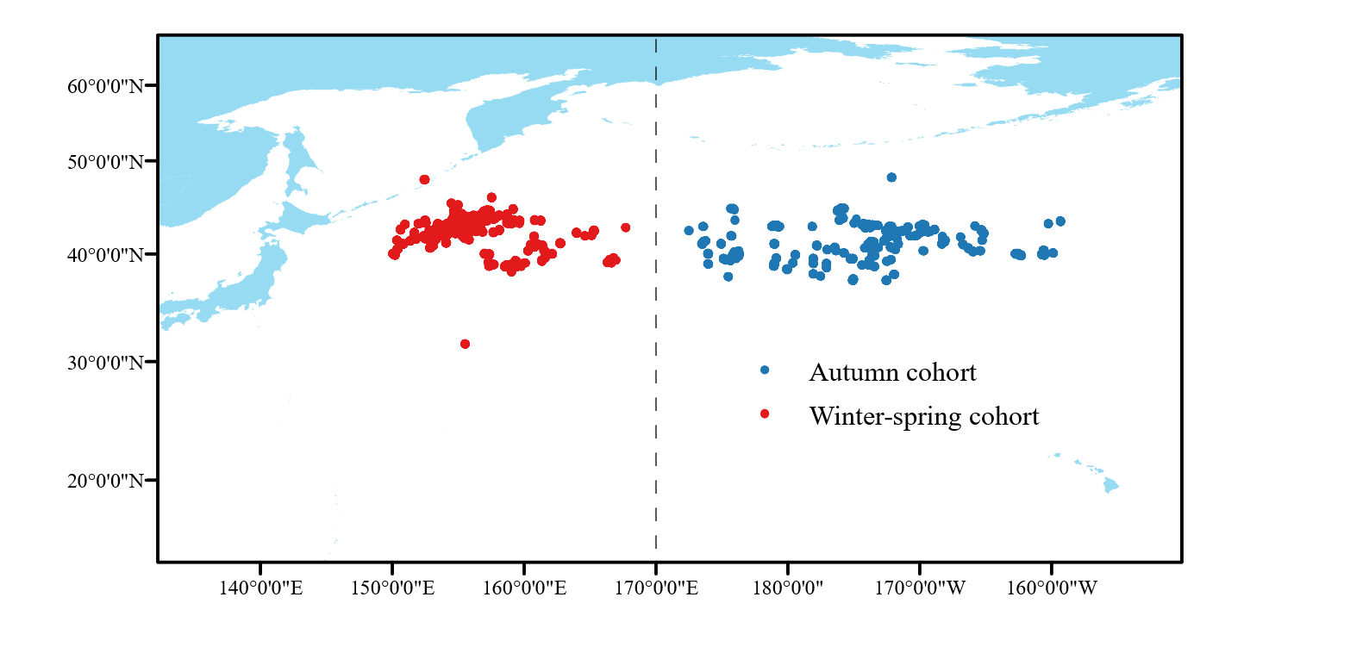
Figure 1. Distribution of neon flying squid sampling sites by Chinese squid jigging vessels from 2011 to 2025

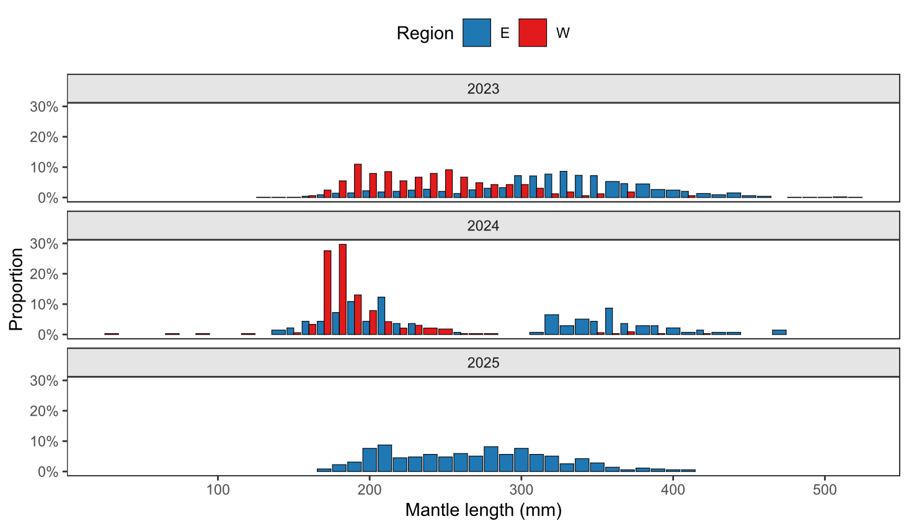
Figure 2. Mantle length composition of neon flying squid by squid jigging vessels from 2023 to 2025

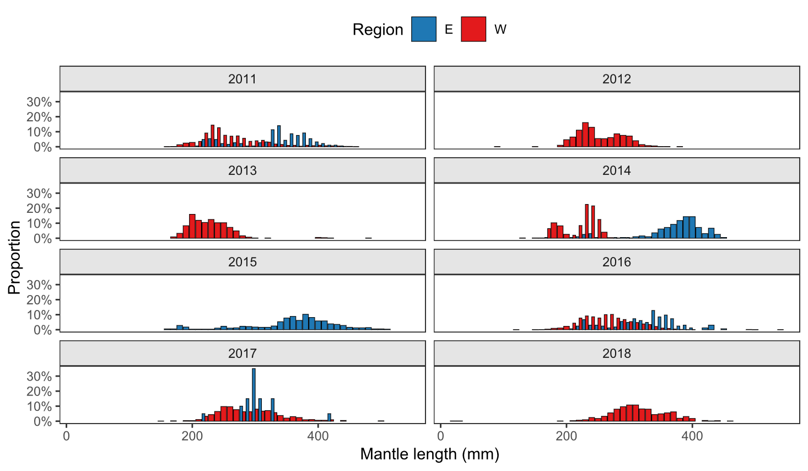
Figure 3. Mantle length composition of neon flying squid by squid jigging vessels from 2011 to 2018

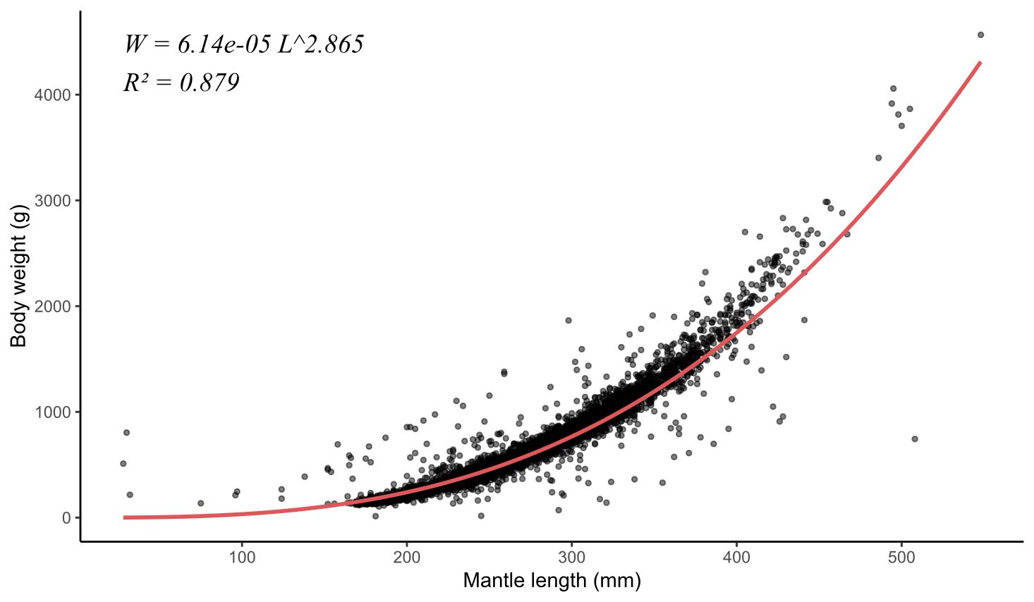
Figure 4. Overall length weight relationship of the winter-spring cohort from 2011 to 2025

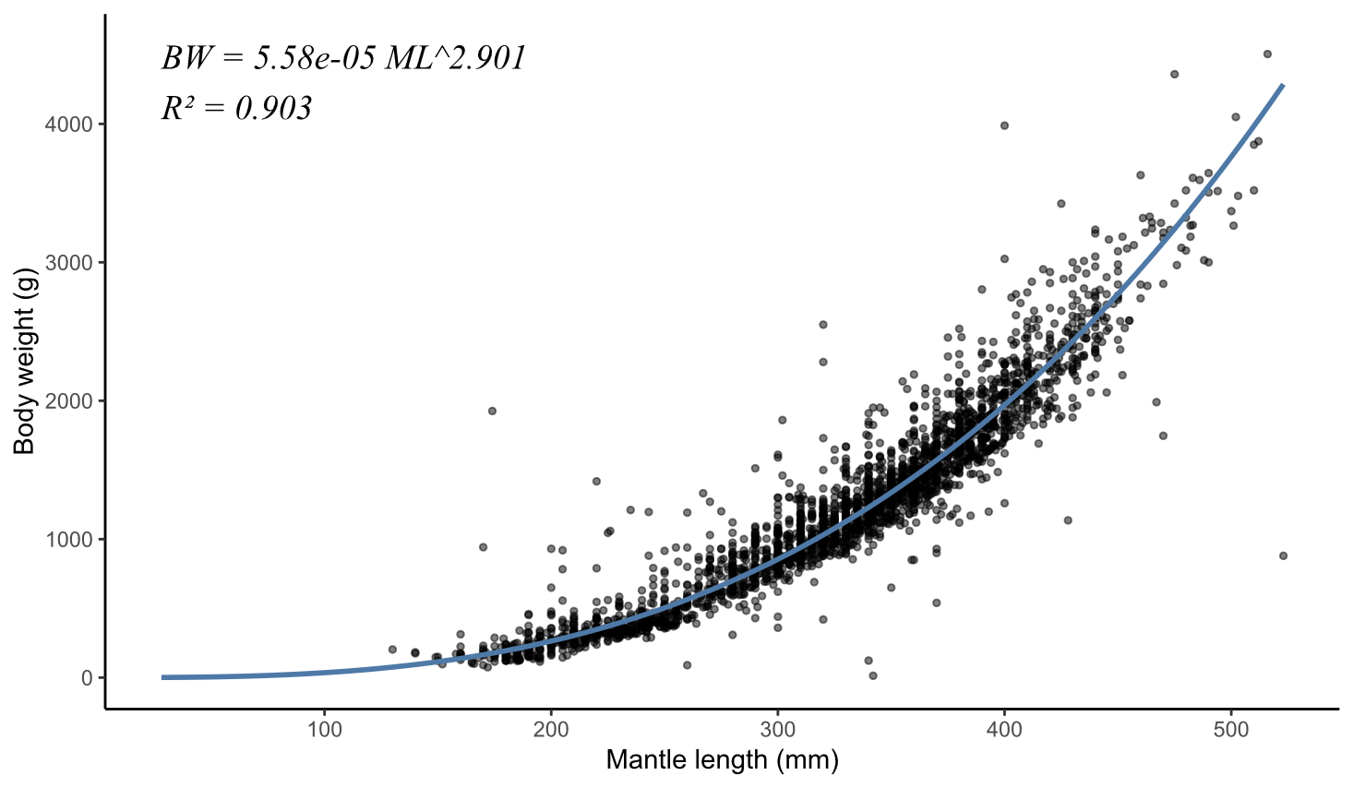
Figure 5. Overall length weight relationship of the autumn cohort from 2011 to 2025

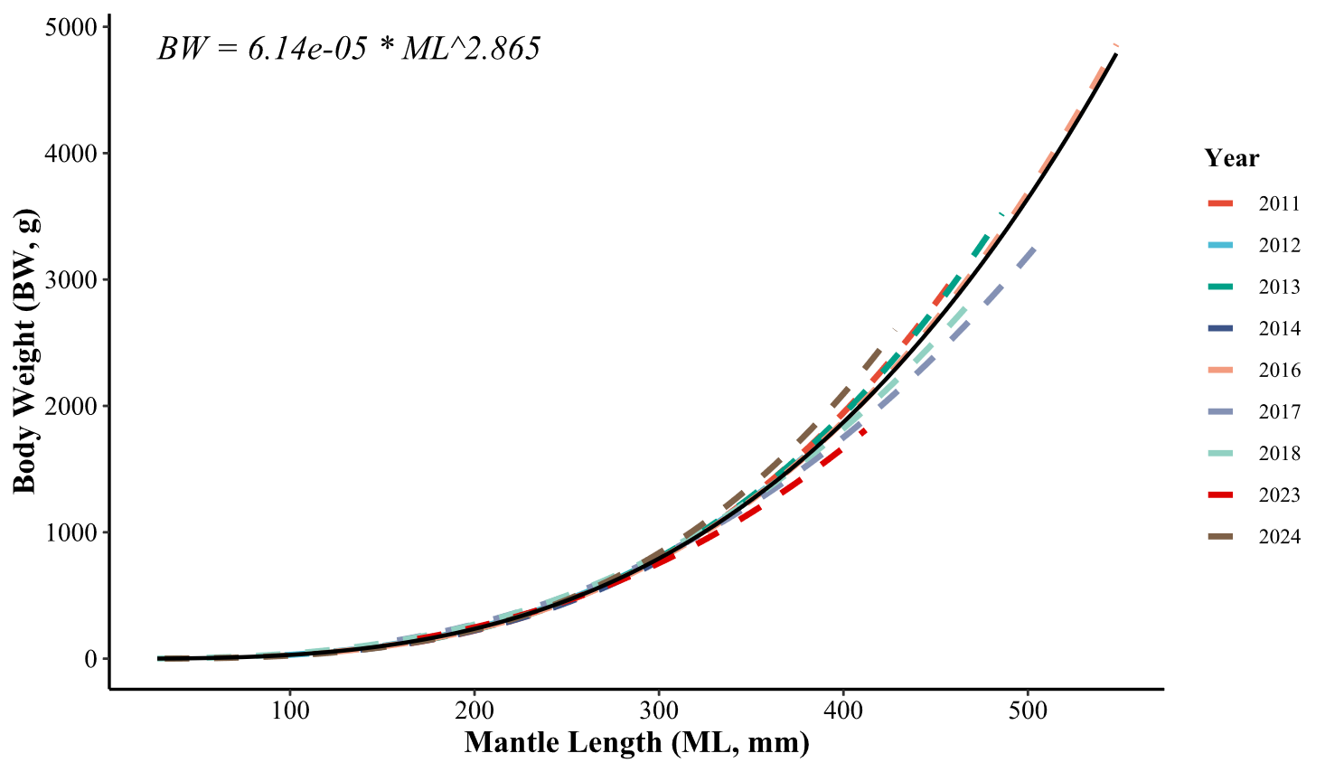
Figure 6. Comparison of Length weight relationship of winter-spring cohort between 2011 and 2025

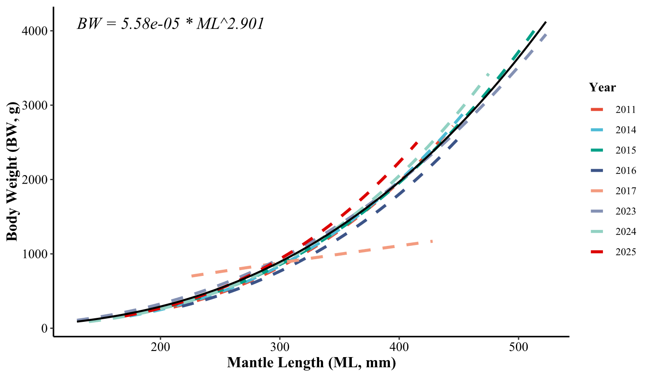
Figure 7. Comparison of Length weight relationship of autumn cohort between 2011 and 2025

Reference
Ichii, T., Mahapatra, K., Sakai, M., Okada, Y., 2009. Life history of the neon flying squid: effect of the oceanographic regime in the North Pacific Ocean. Marine Ecology Progress Series 378, 1–11. https://doi.org/10.3354/meps07873
King, M., 2007. Fisheries Biology, Assessment and Management. John Wiley & Sons.
Pauly, D., 1984. Fish Population Dynamics in Tropical Waters: A Manual for Use with Programmable Calculators. WorldFish.
Wang, Y., Han, P., Fang, Z., Chen, X., 2023. Climate-induced life cycle and growth variations of neon flying squid (Ommastrephes bartramii) in the North Pacific Ocean. Aquaculture and Fisheries 8, 211–220. https://doi.org/10.1016/j.aaf.2021.08.006

