NPFC-2025-SSC PS16-WP07 (Rev. 1)

Development of the Stock Synthesis model for Pacific saury in 2025
Quang C. Huynh¹
¹ Blue Matter Science

1 Abstract
This paper documents the continued development of the age-structured assessment model in 2025 for Pacific saury in the Northwestern Pacific Ocean (WNPO) with Stock Synthesis 3.30. The model fits the historical catch, standardized catch-per-unit-effort (CPUE), fishery-independent index of abundance, and length composition data provided during SSC PS 15. This document describes the methodology on model structure and parameterization of the current base case model, followed by diagnostic procedures to determine goodness of fit to the data, estimability and stability of parameter estimates using jitter analysis and comparison of MCMC with maximum likelihood estimation, and predictive ability for short-term forecasting with retrospective analysis and hindcast validation of future index predictions in the first projection year. Likelihood profiles inform alternative choices on natural mortality (M) and steepness for sensitivity analysis. A reduction in growth has improved the fit to the length composition and reduced the retrospective pattern compared to previous models. However, predictive performance remains difficult for this short-lived species. Sensitivity analyses indicates difficulty estimating MSY reference points with the current M value in the base model. Further evaluation is recommended with respect to the choice of M in the base case model, as the current value does not provide practical management advice.

2 Introduction
Pacific saury (Cololabis saira) is a commercially important fish in the Northwest Pacific Ocean, where harvest is managed by the North Pacific Fisheries Commission (NPFC). Currently, Pacific saury is assessed using Bayesian State-Space Production Models (BSSPM, Kitakado (2024)). This study documents the continued development of the age-structured population model using Stock Synthesis 3 (SS3; Methot and Wetzel (2013)).
In contrast to BSSPM, SS3 explicitly models individual cohorts in the population, seasonal spawning and recruitment, somatic growth, selectivity by size, and the inherently short life-span of the species. SS3 models can potentially be used for annual management advice as well as operating models in a management strategy evaluation (MSE) process. Initial model development is documented in Hsu et al. (2022), Hsu and Chang (2023), Dai (2024), and Jacobson (2024). The data, model results, and diagnostics are summarized in this paper to document the progress achieved in 2025, inform discussions, and provide recommendations for future work.

3 Methods
This paper uses a custom compilation of Stock Synthesis 3.30.24.01 with an adjustment for the correct calculation of time-varying growth in seasonal models (executable available from first author upon request). The latest SS3 version should be used once an official update by the SS3 developers is released.

3.1 Data
Fishery data (including total catch, catch-at-size, and standardized CPUE during 1994–2024) and survey data (including an age-aggregated index of abundance and survey length composition up to 2025) were provided by NPFC members during SSC PS 15 (Table 1, Figure 1). Fishery data were reported monthly and aggregated to quarter for the model. Size composition is reported at 1 cm bins. Catches prior to 1994 are obtained from FAO reports on an annual basis (NPFC 2025). Based on current practice with fishery exploitation in the second half of the year, pre-1994 catch is divided evenly between the 3rd and 4th quarters.

3.2 Model structure
Previous models used either an annual time step model (Hsu et al. 2022) or an annual time step model with seasons (Jacobson 2024). However, the annual model with seasons could not provide an appropriate temporal resolution to model the spawning behavior for the short lifespan of Pacific saury with only age 0 and 1+. Protracted spawning is reported for Pacific saury (NPFC 2024), but an annual model accommodates only one spawning event per year (during the first season). Thus, a seasonal model, where each independent time step is a quarter year, would be more appropriate for this species. Spawning biomass is calculated in each quarterly time step, but egg production and recruitment is estimated only for the 1st, 2nd, and 4th quarter (there is no recruitment in the 3rd quarter).
The age structure included 8 seasonal age classes. Biological parameters fixed in the base case model were identified from previous models (Table 2).
The first time step of the model is 1980, season 1. To accommodate the 2025 survey, the model final time step is year 2025, season 4 (time step 184). The 2024 catch is used as the provisional 2025 catch. The initial population abundance is estimated with an equilibrium catch assumption of average annual catch prior to 1980 (Hsu and Chang 2023). The initial equilibrium fishing mortality is estimated.
Recruitment deviations were estimated seasonally, excluding the 3rd quarter with zero recruitment, from the Beverton-Holt stock-recruit relationship with steepness fixed and unfished seasonal recruitment estimated (Table 3).

3.3 Index catchability
The survey index $I$ in time step $t$ was assumed to be proportional to vulnerable biomass $B$, where $I_{t}=qB_{t}$ by a catchability coefficient $q$.
For the CPUE series, a hyperstability parameter $β$ is estimated where the predicted value is a power function of vulnerable biomass, where ${\text{CPUE}}_{y}=qB_{y}^{\left(1+β\right)}$, where $β>0$ indicates hyperstability and $β<0$ indicates hyperdepletion in the CPUE.
For the Japanese early CPUE, a random walk in catchability is modeled, where ${\text{CPUE}}_{y}=q_{y}B_{y}$ and $log\left(q_{y}\right)=log\left(q_{y-1}\right)+ε_{y-1}$ with $ε_{y-1}∼N\left(0,σ^{2}\right)$, when the fishery was expanding.

3.4 Growth
The mean length at age is fixed in the model, where the variability in growth is estimated to best fit the length composition data.
Previous models showed a poor fit to the fishery length composition in recent years. Length-age data from the survey showed a declining trend in the mean length of age-1 animals through time, while there no obvious trend for age-0 (Figure 2). To incorporate this information in the model, the asymptotic length was time-varying using a smoothened trend for the survey age-1 mean length (Figure 3). Figure 4 compares the length-at-age at the beginning and end of the model.

3.5 Population scale
Initial model fits without information on population scale were not stable based on jitter analysis. Multiple fits with slightly different starting parameter values converged on spawning biomass estimates of different orders of magnitude (Figure 5). The estimates were at implausibly large magnitude, i.e., ${10}^{11}$ tonnes when historical annual catch is in hundreds of thousands of tonnes.
Best practice suggests that a catchability prior on a population index would provide more stability to the model (Thorson and Cope 2017). The biomass index derived from an area expansion of survey catch rates, predicted from the VAST spatiotemporal model, provided external information on population scale (Hashimoto et al. 2025a). Thus, a broad lognormal catchability prior with mean 1 (in normal space with lognormal bias correction) and standard deviation of 0.2 was used in the base model, which provided better performance when starting values were jittered (Figure 6).

3.6 Diagnostics
Several diagnostics were used to evaluate model performance with the ss3diags and r4ss R packages:
- Runs test of the residuals of the fit in the CPUE and survey index.
- MCMC to evaluate reliability of the maximum likelihood estimate. The No-U Turn sampler (NUTS) algorithm from the adnuts R package was used with 3 chains, each with 2,000 iterations and thin rate of 1. Evaluation of the Rhat, effective sample size, and Monte Carlo standard error of the MCMC chains did not reveal problems with convergence.
- Retrospective analysis to evaluate predictive ability of biomass and recruitment in the first projection year. The retrospective analysis removed 4 time steps (1 calendar year) for each peel of the data.
- Hindcast to evaluate predictive ability of the CPUE and index in the first projection year
- Likelihood profile of steepness and natural mortality to evaluate estimability of important productivity parameters

4 Results

4.1 Base case model
There is high seasonality in spawning stock biomass (SSB) through time, with lower biomass in recent years compared to the 2010s (Figure 7). This biomass trend is informed by the CPUE and indices (Figure 8). Selectivity estimates indicate that the fishery catches fish near the asymptotic length (near 30 cm, Figure 9).
Selectivity parameters were very similar when Bayesian MCMC and maximum likelihood estimation (MLE) approaches were used (Figure 10). There were some divergence between MCMC and MLE estimates of the unfished recruitment and survey catchability (Figure 11). The maximum likelihood estimate of the log survey catchability is -0.344 ($q=0.71$) and the posterior median is -0.61 ($q=0.54$). The discrepancy is a result of the strong correlation between the two parameters (Figure 12). For comparison, gear catchability has been estimated to be 0.179 although with high imprecision (Naya et al. 2010).
There are improved fits to the length composition, inferred by the trend in the mean lengths calculated from the observed and predicted proportions at length, with the decline in asymptotic length (Figure 13). The model previously could not fit the decline in fishery size composition in recent years when the growth was constant.
The retrospective analysis showed that the model was stable for most of the historical time series. However, the uncertainty is highest in the most recent year and for the first projection year (Figure 14).
At the end of the time series, there is a positive Mohn’s rho indicating that the terminal biomass is overly optimistic and the estimate will be revised downward in future assessments. This behaviour is likely explained by poor estimates of recent recruitment, which are uncertain in age-structured models because these cohorts have not completed their life cycle. However, recent recruitment estimates are important components for short-term forecasting of short-lived species.
This result is complemented by the hindcast which shows poor predictive skill in the CPUE, although the skill was better for the index of abundance (Figure 15).

4.2 Sensitivity scenarios
Sensitivity scenarios explored alternative choices for natural mortality (M) and steepness (h). The base case model used $M=2.18 {\text{year}}^{-1}$ and $h=0.82$ (identified as “Step22c” internally to track model development). Likelihood profiles indicated that lower values of both $M$ and $h$ were supported by the data (Figure 16).
Five models (one base and four sensitivity scenarios) were compared:
- Base with $M=2.18$ and $h=0.82$
- Same as base, but $h=0.6$
- Same as base, but $M=1$
- Both $h=0.6$ and $M=1$
- Same parameters as base, but fitted to joint CPUE instead of individual member CPUE
Overall, the fit to the joint CPUE had the most modest effect on biomass estimates (Figure 7). Alternative choices to natural mortality and steepness had the largest impact on stock size, impact of historical fishery on the stock, and yield curve (Figures 7, 17, and 18).
When $M=2.18$ is used, the fishery had little impact on historical stock dynamics. The estimated SSB is very similar to the hypothetical dynamic SSB0 time series if the fishery had not operated (Figures 17. The model attributes changes in biomass to natural variability.
There is difficulty in finding the optimum of the yield curve with high natural mortality (Figure 18), because additional mortality from fishery exploitation would have little impact on the age structure of the population. The yield curve also provides implausibly high seasonal catches compared to the catch history. In contrast, the alternative value of $M=1$ produces an optimum in the yield curve for MSY reference points which are more plausible relative to historical catches, and more likely attributes stock depletion to fishing mortality in the dynamic B0 comparison.
The lower steepness value modestly improved the residual pattern of seasonal recruitment around the stock-recruit relationship, although there is significant variation in general (Figures 19 and 20). Comparison of recruitment aggregated to calendar year is provided in Figure 21.

5 Discussion
Trends in biomass are consistent among the base and sensitivity scenarios, but uncertainty in natural mortality and steepness has important impacts on potential management advice and status determination. The two alternative values for M from meta-analysis and likelihood profiling provide very different interpretations of the yield curve. The high value of M in the base model is based on the meta-analysis and the short lifespan of Pacific saury (Nakayama et al. 2019; Hsu et al. 2022), but the value does not provide practical harvest advice in the yield curve.
This paper recommends further re-evaluation of the natural mortality parameter with consideration for lower values in the base model. Age-based natural mortality can also be considered in a sensitivity analysis (Nakayama et al. 2019). From an advice perspective, uncertainty about natural mortality may necessitate use of alternative reference points such as depletion and spawning potential ratio (SPR) as a proxy for MSY values. For example, 40% depletion is a typical proxy for the biomass at MSY when the yield curve is not well-defined.
For short-lived species, sub-annual time steps are frequently necessary to capture important population dynamics, e.g., growth, mortality, and seasonal spawning, in an age-structured model. As a result, advice based on an annual cycle remains challenging as short-term forecasting requires projection across multiple sub-annual time steps (in contrast, the projection is only for one annual time step in longer-lived species). In the current SS3 model, it is possible to annual catch advice can be calculated from a projection across 4 future time steps with assumptions about the seasonal exploitation pattern, e.g., fishing only in the 3rd and 4th season.
Future research on the potential causes on the decline in age 1 size can be informative for management purposes. For example, these declines are consistent with climate forecasts that propose a decline in growth from increases in sea surface temperature (SST) (Ito et al. 2013). Warming SST also suggests that larger fish will migrate further north away from fishing and survey areas. This hypothesis can be explored by modeling time-varying selectivity to describe decreased availability of the resource to the fishing gear. Comparison of recruitment estimates to oceanographic indices can establish any environmental-productivity relationships (Dai and Rooper 2023).
Future improvements to the model will incorporate updated research on fecundity-size relationships and seasonal spawning patterns (currently, the same maturity ogive is applied for seasons 1, 2 and 4) (Fuji et al. 2025). Changes in catchability of the Chinese Taipei CPUE series should also be explored with the change in registered fishing vessels after 2011 (Huang et al. 2025).

6 Tables
Table 1: Data sources for members’ CPUE and indices of abundance of Pacific saury, updated in 2025.
Data series | Source
Japan CPUE (pre 1994) | Oshima et al. (2018)
Japan CPUE (after 1994) | Hashimoto et al. (2025b)
Chinese Taipei CPUE | Huang et al. (2025)
Korea CPUE | Song (2025)
Russia CPUE | Kulik et al. (2025)
China CPUE | Hua et al. (2025)
Japan survey | Hashimoto et al. (2025a)
Joint CPUE | Hsu and Chang (2025)

Table 2: Biological parameters for the Pacific saury SS3 base case model. Rate parameters (natural mortality and growth rate) are in instantaneous units per year.
Parameter | Value | Reference
Natural mortality | 2.18 | Meta-analysis by Hsu et al. (2022)
Richard asymptotic length | 30.84 | Nakayama et al. (2019); NPFC (2024)
Growth rate K | 3.99 | Nakayama et al. (2019); NPFC (2024)
Richard power function | 0.0001 | Simplifies to Gompertz function
Length at age zero | 1.028 | Derived from Gompertz function
Length of 50% maturity | 25.8 | Hsu and Chang (2023); Suyama et al. (2006)
Length of 95% maturity | 30.2 | Hsu and Chang (2023); Suyama et al. (2006)
Length-weight a | 0.0015 | Fuji et al. (2019); Kosaka (2000)
Length-weight b | 3.33 | Fuji et al. (2019); Kosaka (2000)
Fecundity | Proportional to weight-at-age
Stock-recruit steepness | 0.82 | Hsu et al. (2024)
Recruitment variability | 0.6 | Fixed assumption

Table 3: Maximum likelihood estimates and parameter standard errors in the Pacific saury SS3 base case model. Recruitment deviations are not included here.
Number | Label | Value | SE
1 | lnSD_young_Fem_GP_1 | 0.14970 | 0.004375
2 | LnSD_old_Fem_GP_1 | 0.01059 | 0.002188
3 | SR_LN(R0) | 10.19000 | 0.100400
4 | InitF_seas_1_flt_7F7_JPN_early_1980-1993 | 1.96100 | 0.391100
5 | LnQ_base_S1_JPN_early_1980-1993(8) | -13.26000 | 0.877400
6 | LnQ_base_S2_JPN_1994+(9) | -10.51000 | 2.942000
7 | Q_power_S2_JPN_1994+(9) | -0.10680 | 0.239400
8 | LnQ_base_S3_CT(10) | -3.52200 | 3.568000
9 | Q_power_S3_CT(10) | -0.67910 | 0.284300
10 | LnQ_base_S4_KOR(11) | -6.31900 | 2.203000
11 | Q_power_S4_KOR(11) | -0.25000 | 0.199000
12 | LnQ_base_S5_RUS(12) | -4.63100 | 1.628000
13 | Q_power_S5_RUS(12) | -0.38780 | 0.131400
14 | LnQ_base_S6_CHN(13) | -2.68900 | 3.116000
15 | Q_power_S6_CHN(13) | -0.57800 | 0.276700
16 | LnQ_base_S7_JPN_Survey(14) | -0.34420 | 0.109900
17 | LnQ_base_S1_JPN_early_1980-1993(8)_dev_se | 0.73820 | 0.383500
18 | Size_inflection_F1_JPN_1994+(1) | 28.93000 | 0.439400
19 | Size_95%width_F1_JPN_1994+(1) | 5.96700 | 0.292700
20 | Size_inflection_F2_CT(2) | 27.77000 | 0.360400
21 | Size_95%width_F2_CT(2) | 4.01700 | 0.301900
22 | Size_inflection_F3_KOR(3) | 32.62000 | 0.425500
23 | Size_95%width_F3_KOR(3) | 4.77900 | 0.180100
24 | Size_inflection_F5_CHN(5) | 30.94000 | 0.692700
25 | Size_95%width_F5_CHN(5) | 5.96300 | 0.434700
26 | Size_inflection_F6_VAN(6) | 26.95000 | 0.263600
27 | Size_95%width_F6_VAN(6) | 2.80700 | 0.283500
28 | Size_inflection_S7_JPN_Survey(14) | 13.89000 | 0.192300
29 | Size_95%width_S7_JPN_Survey(14) | 0.94700 | 0.200700

7 Figures
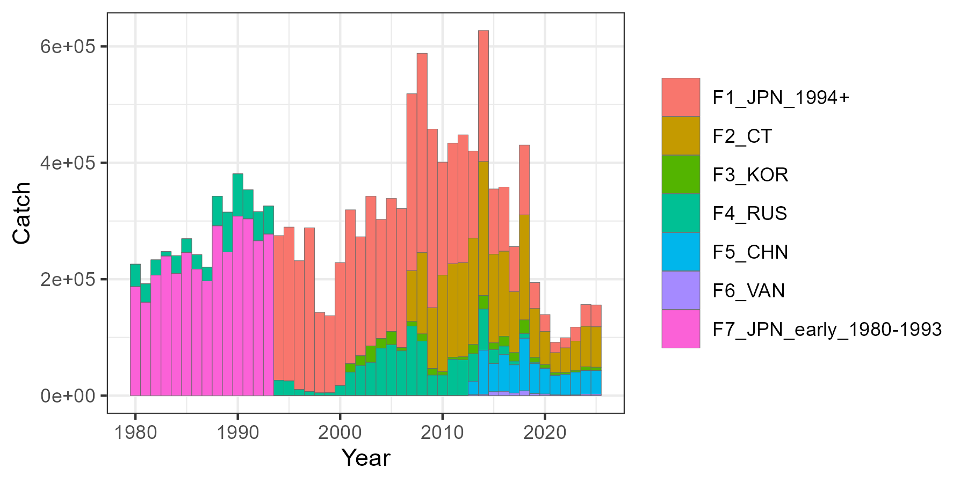
Figure 1: Annual historical catch (t) aggregated by Member and time period in the SS3 model. The 2025 catch is assumed to be identical to 2024 values.
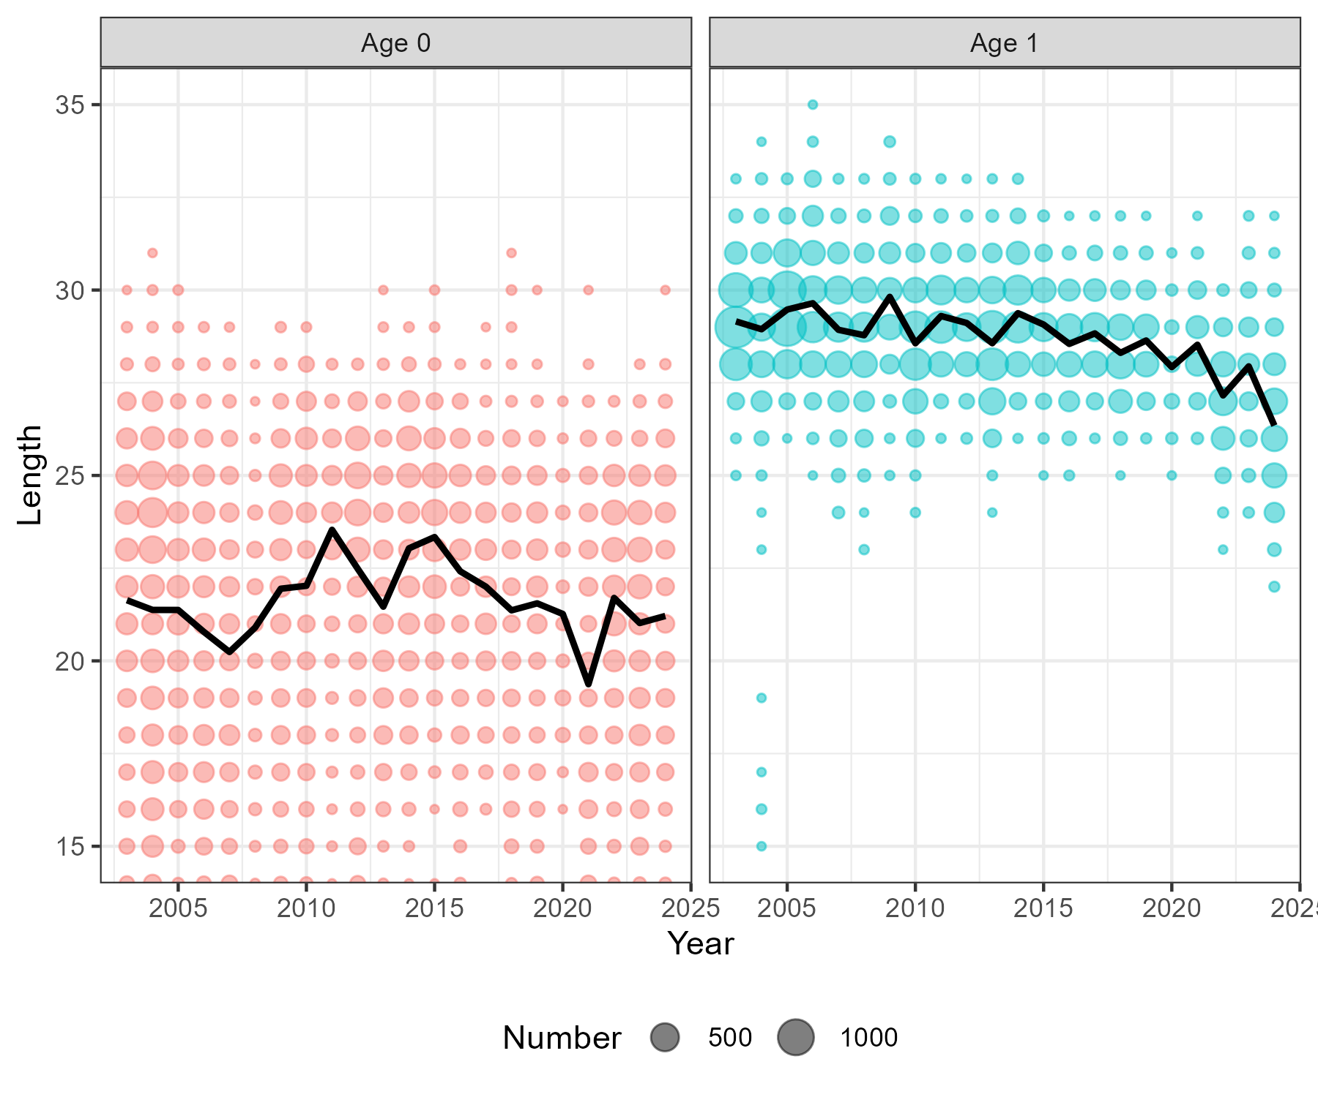
Figure 2: Numbers at age and length time series from the annual survey (coloured bubbles) with the mean size in black lines.
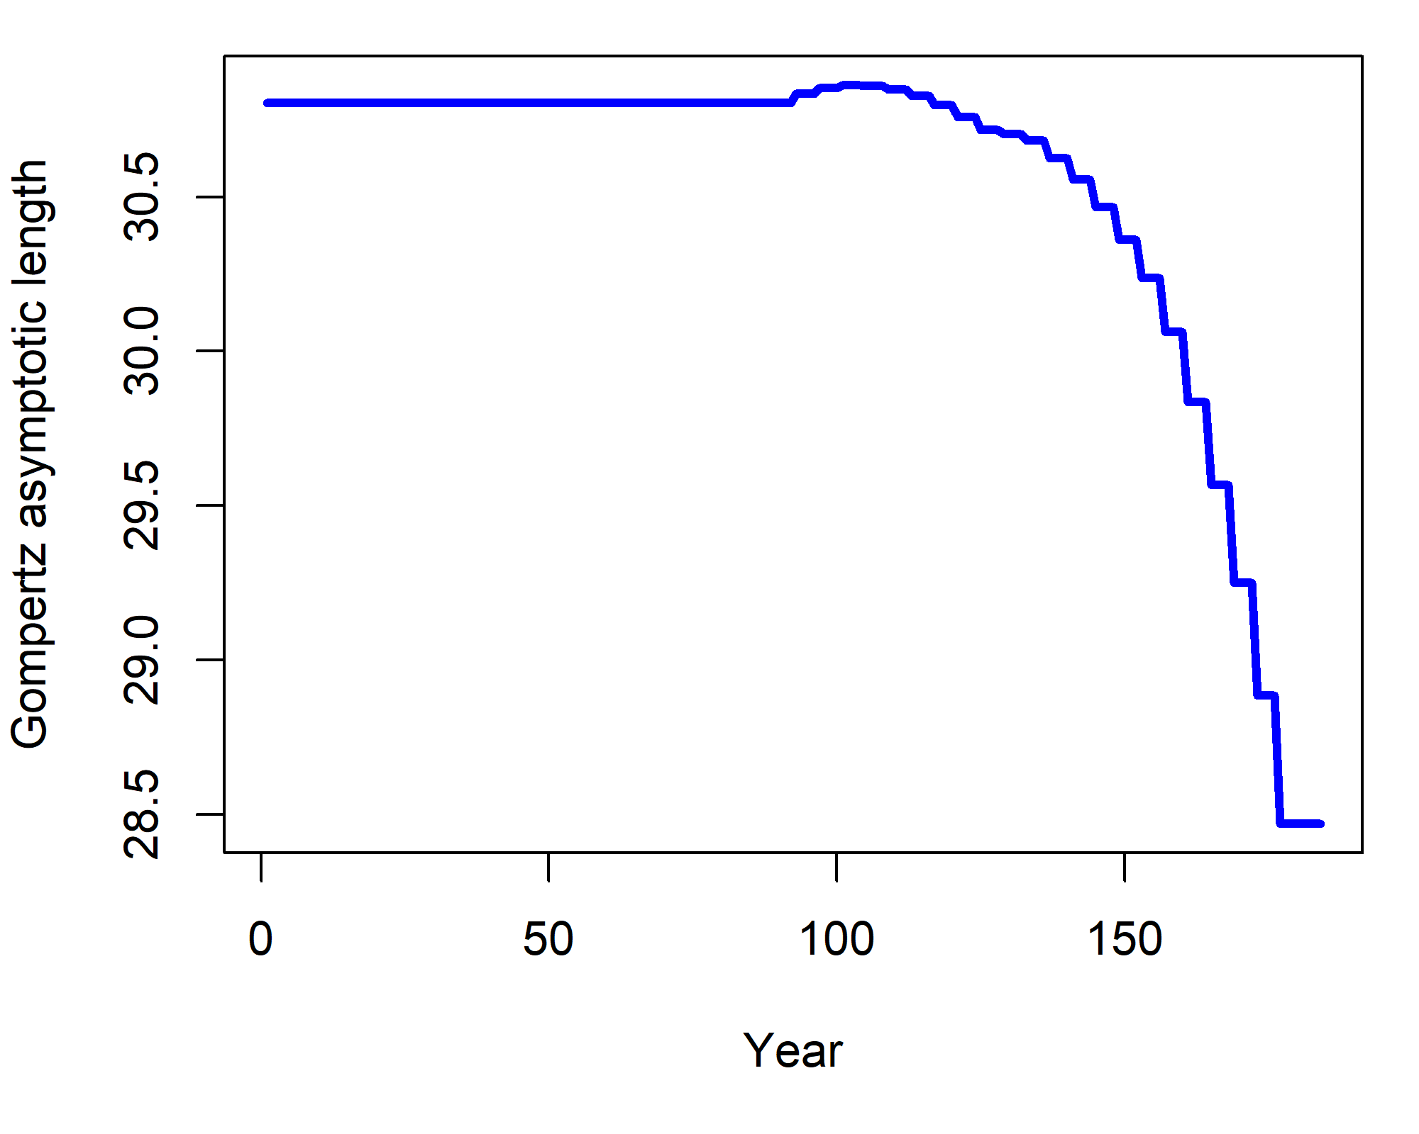
Figure 3: Time series of the asymptotic length in the base case model where the decrease is informed by a smoothed trend line from the empirical mean length of age 1 Pacific saury from the survey.
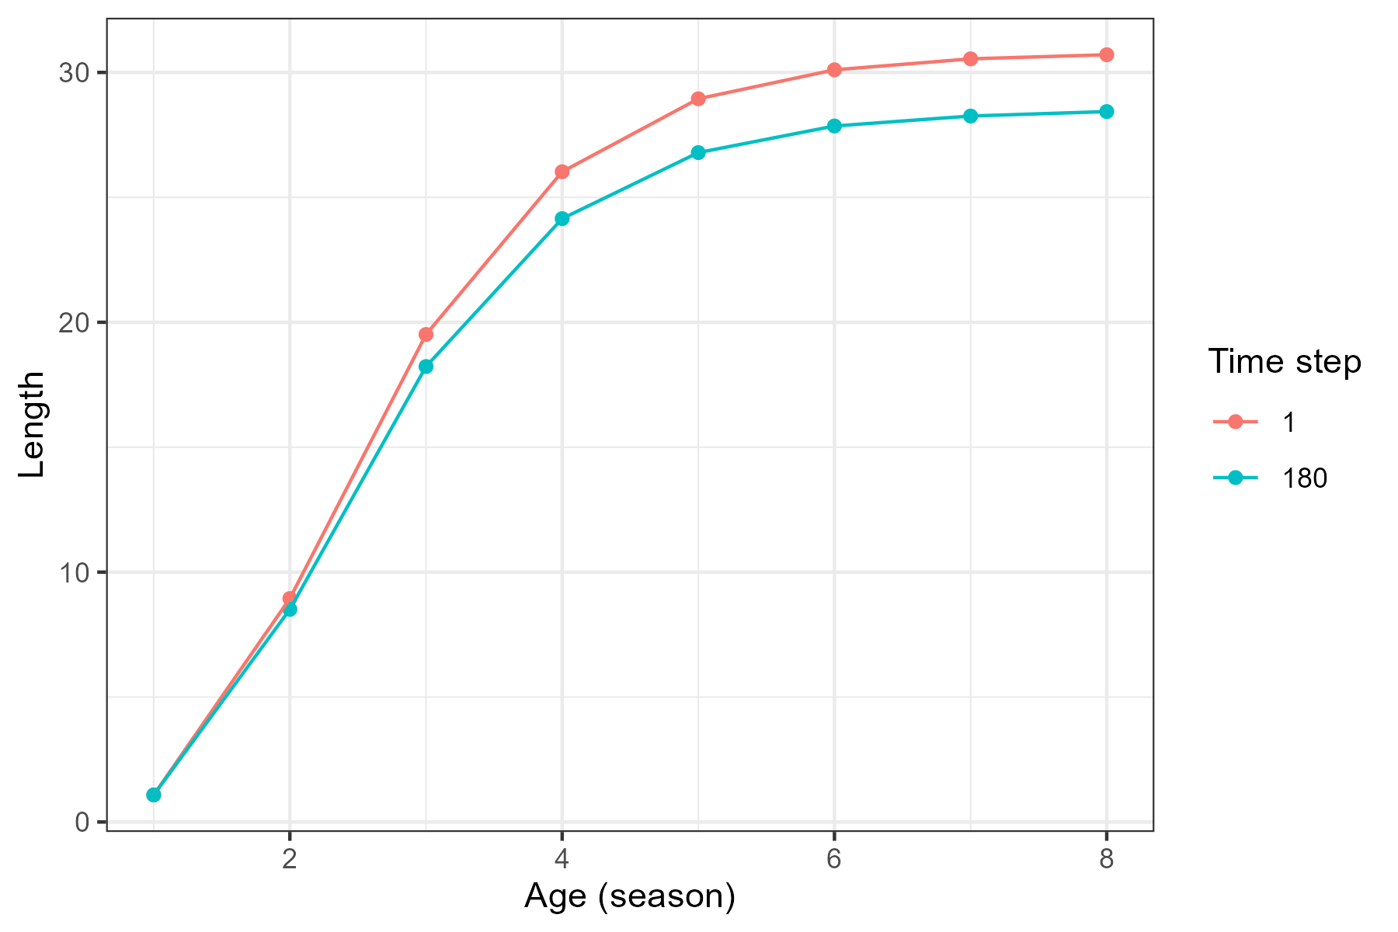
Figure 4: Comparison of the length at age at the beginning of the seasonal SS3 model (time step 1, corresponding to 1980) and end of the model (time step 180, corresponding to 2025) when asymptotic length is time-varying.
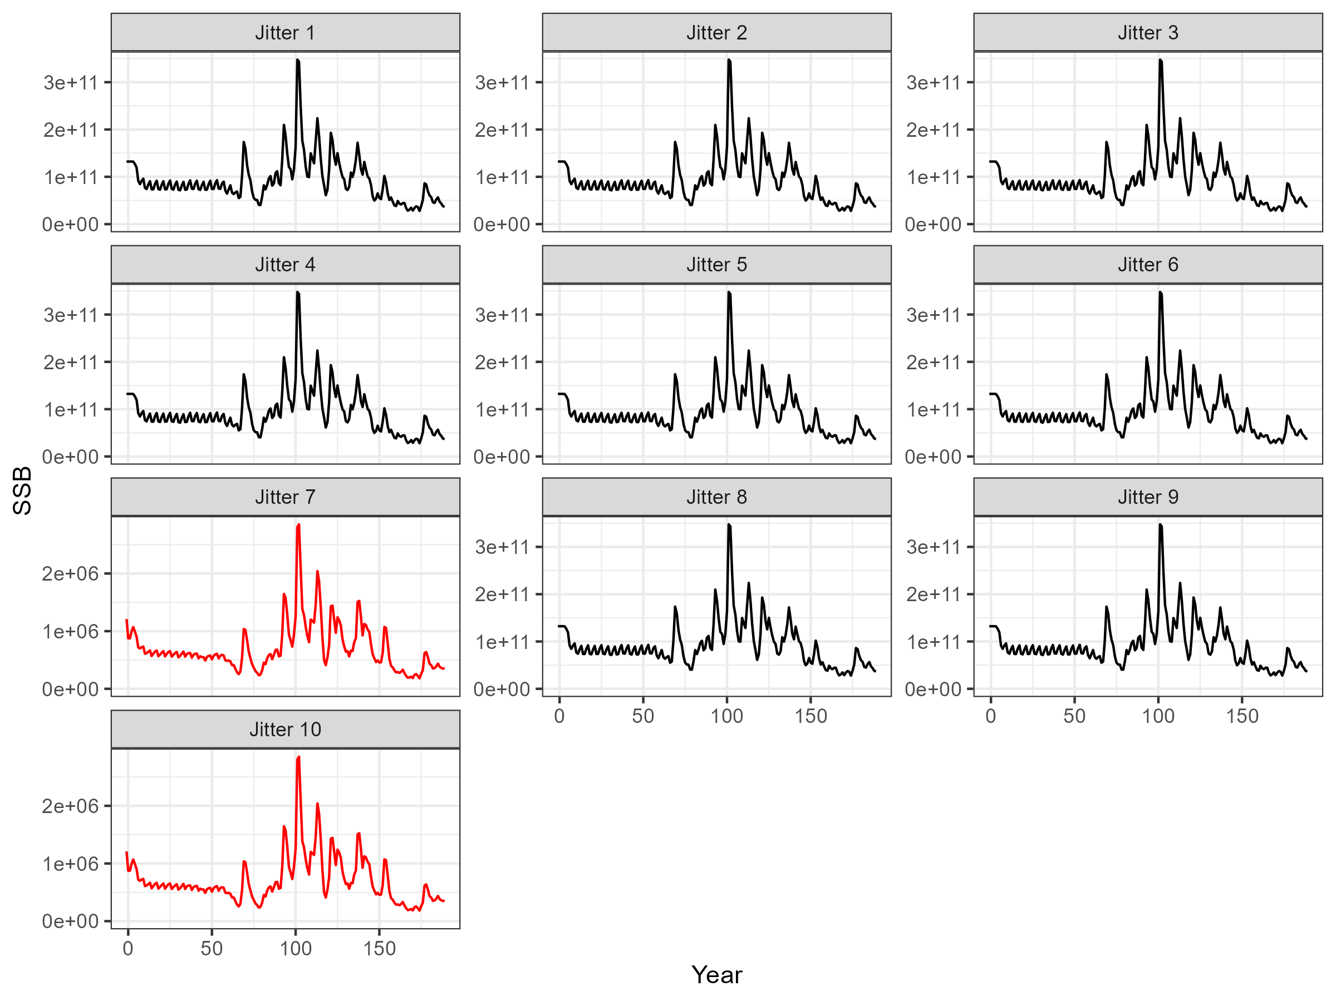
Figure 5: Jitter analysis to compare spawning stock biomass (SSB) estimates when there is no information on population scale provided to the model. The model frequently estimates biomass at implausibly large magnitude (black).
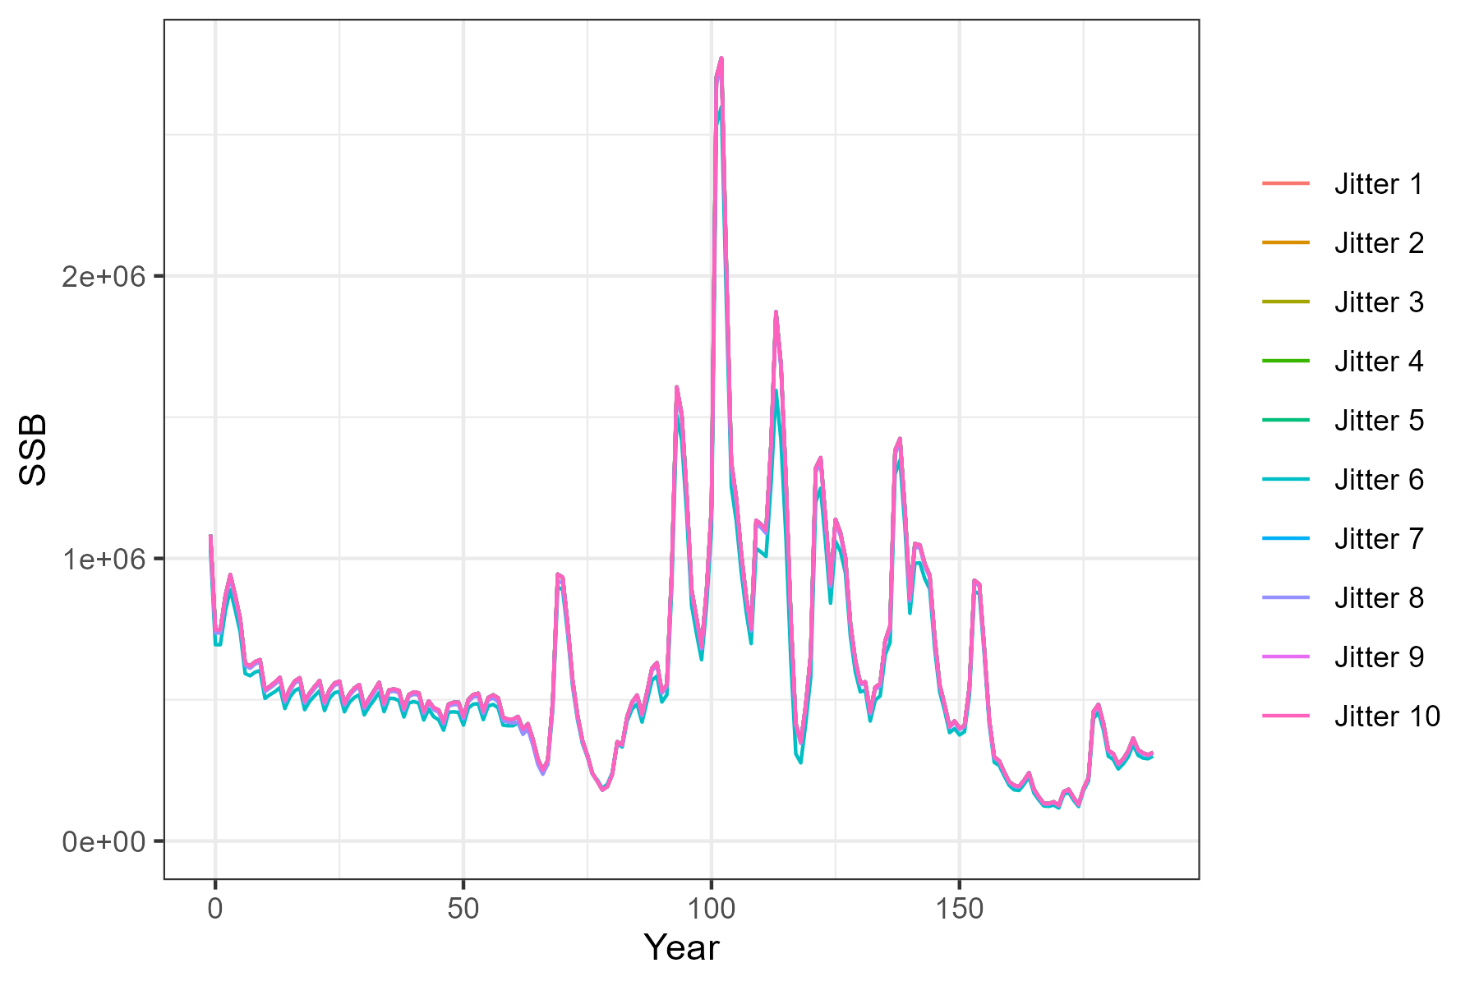
Figure 6: Jitter analysis to identify stability of spawning biomass estimates when a prior on catchability for the survey index of abundance is provided to the model.
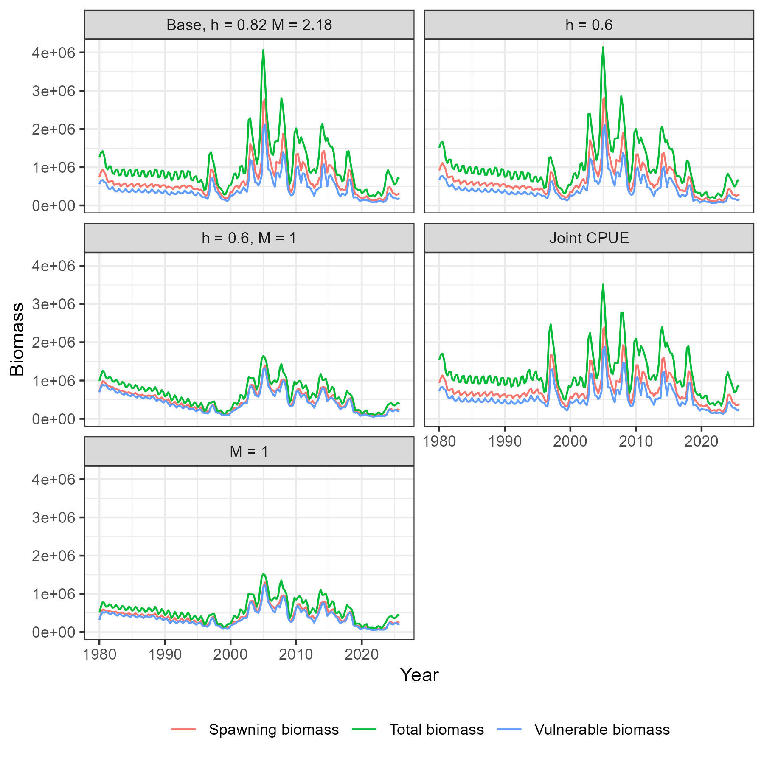
Figure 7: Comparison of total biomass, vulnerable biomass, and spawning biomass in the base and sensitivity models. The vulnerable biomass is calculated from the fleet with the lowest selectivity at size (Vanuatu).
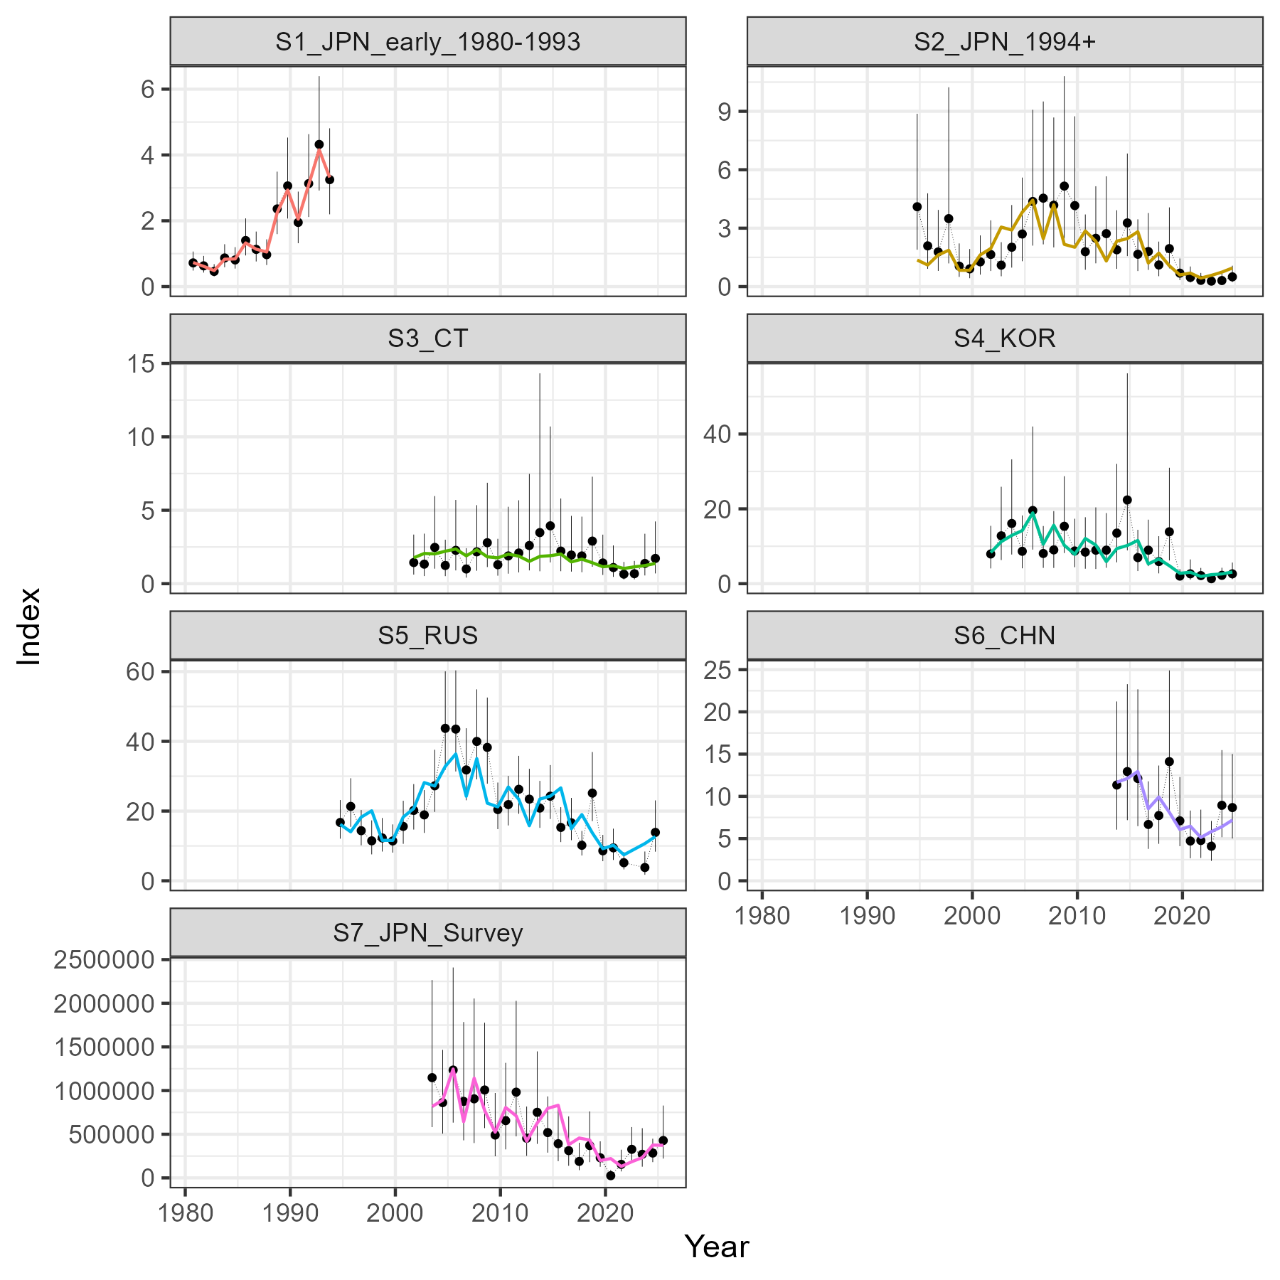
Figure 8: Fits to the CPUE and index of abundance in the base case model. Observed values in black and predicted values in coloured lines.
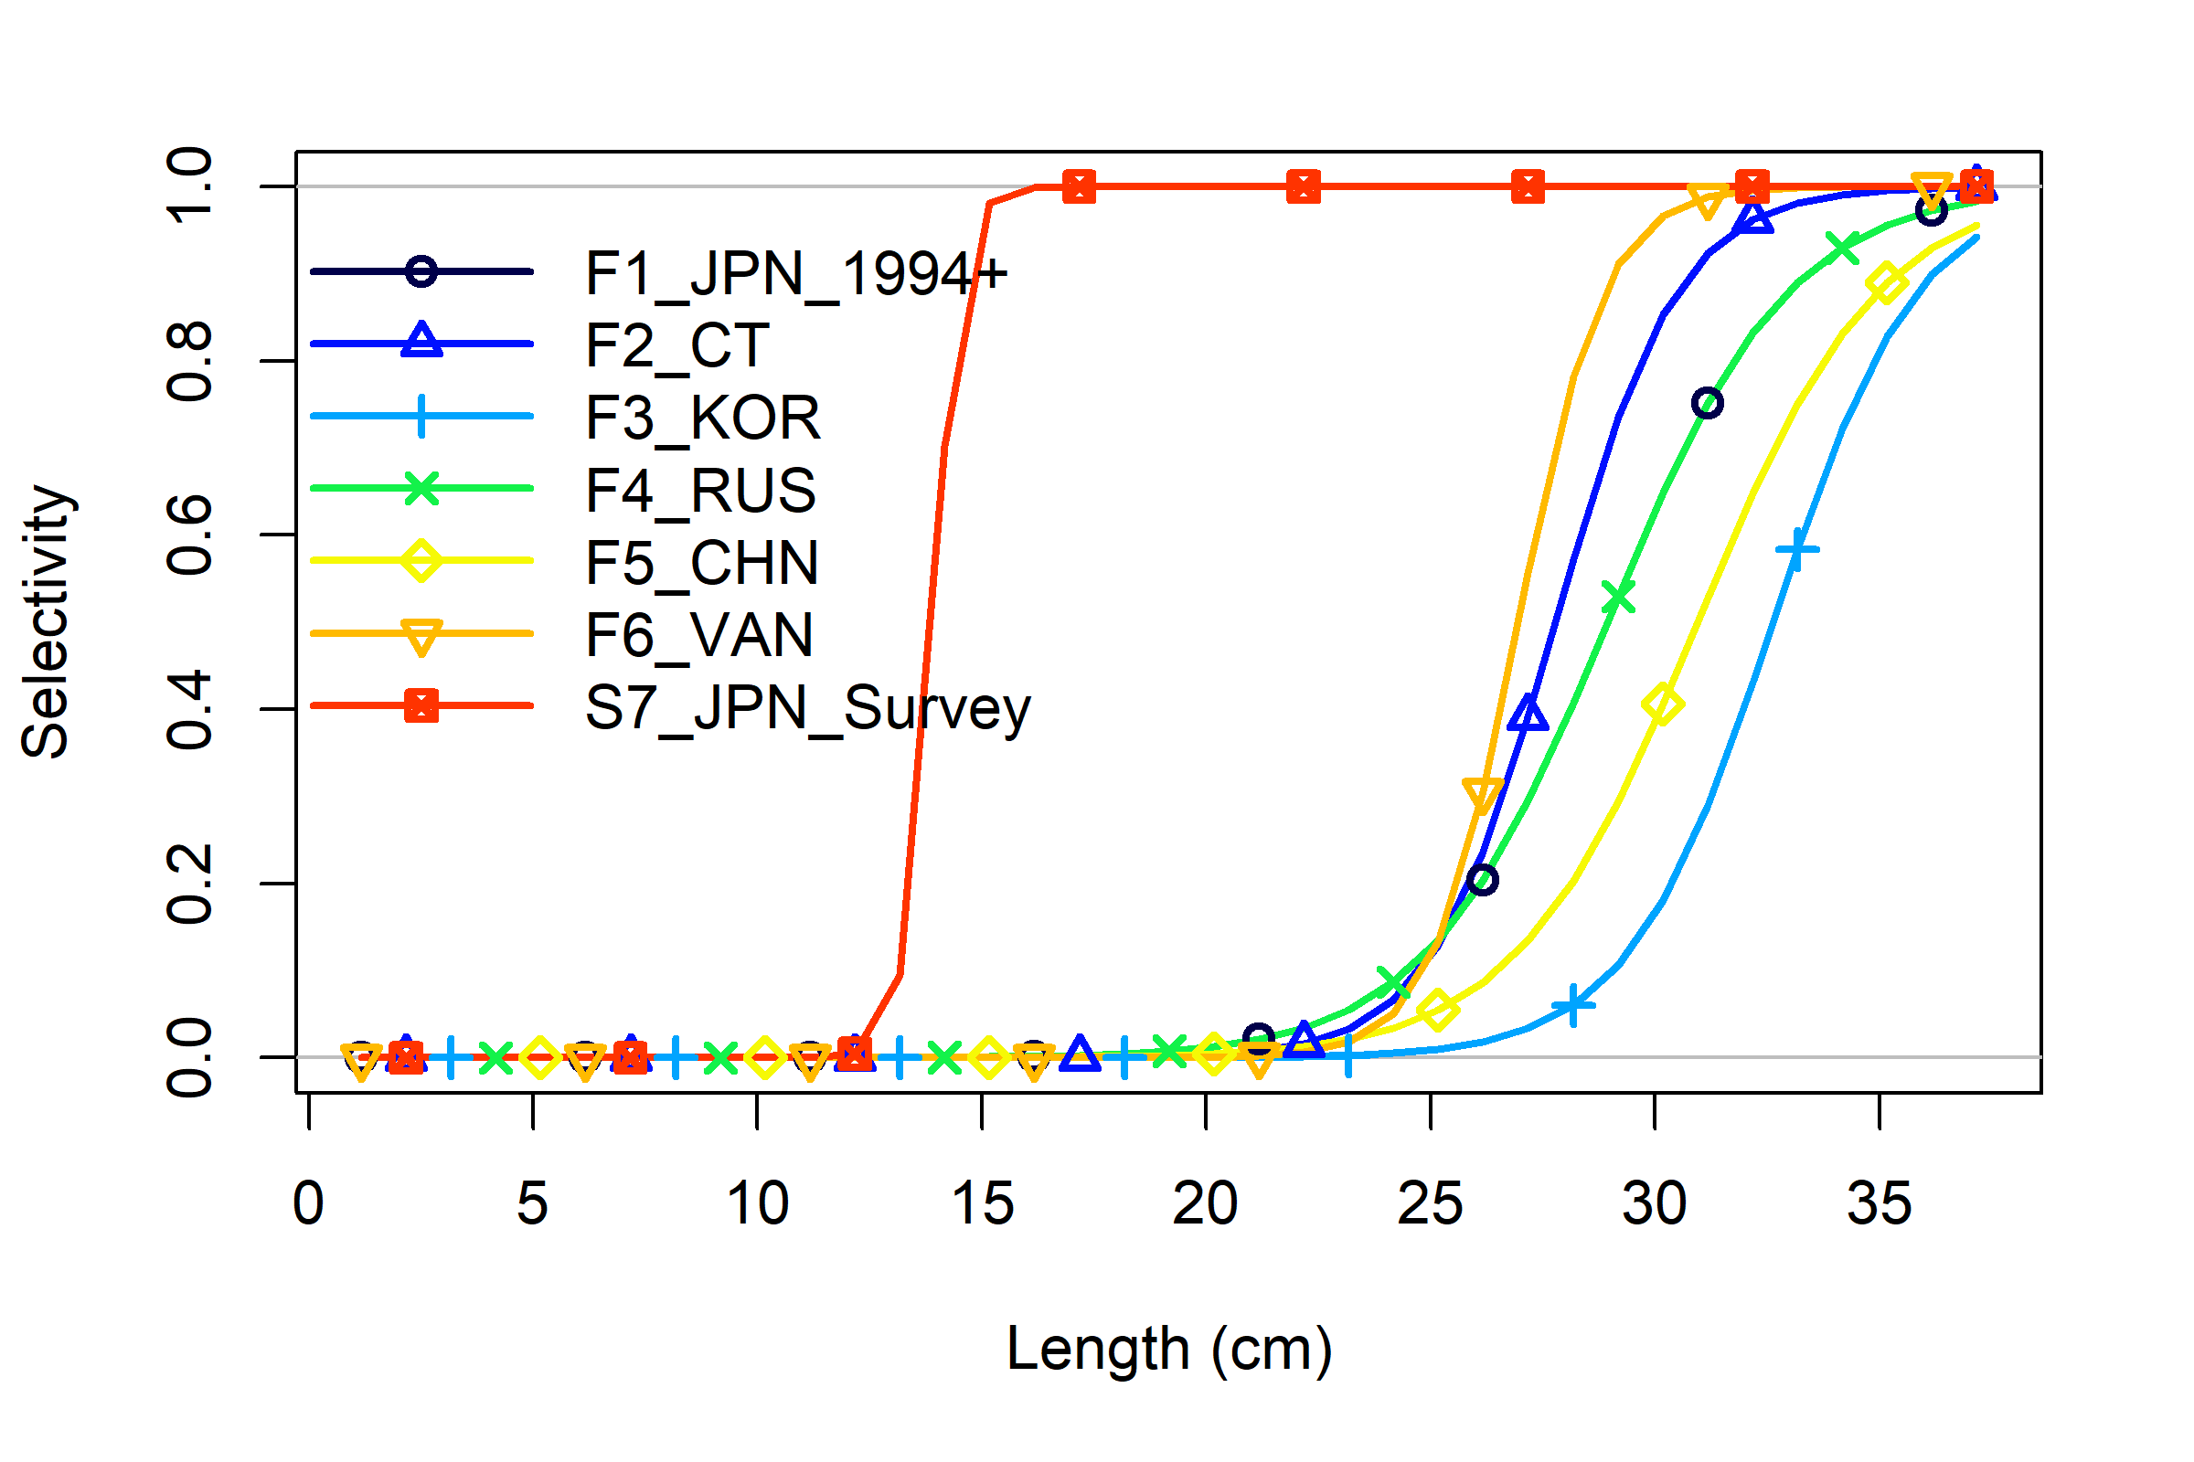
Figure 9: Selectivity at length for the fleets and survey in the base model.
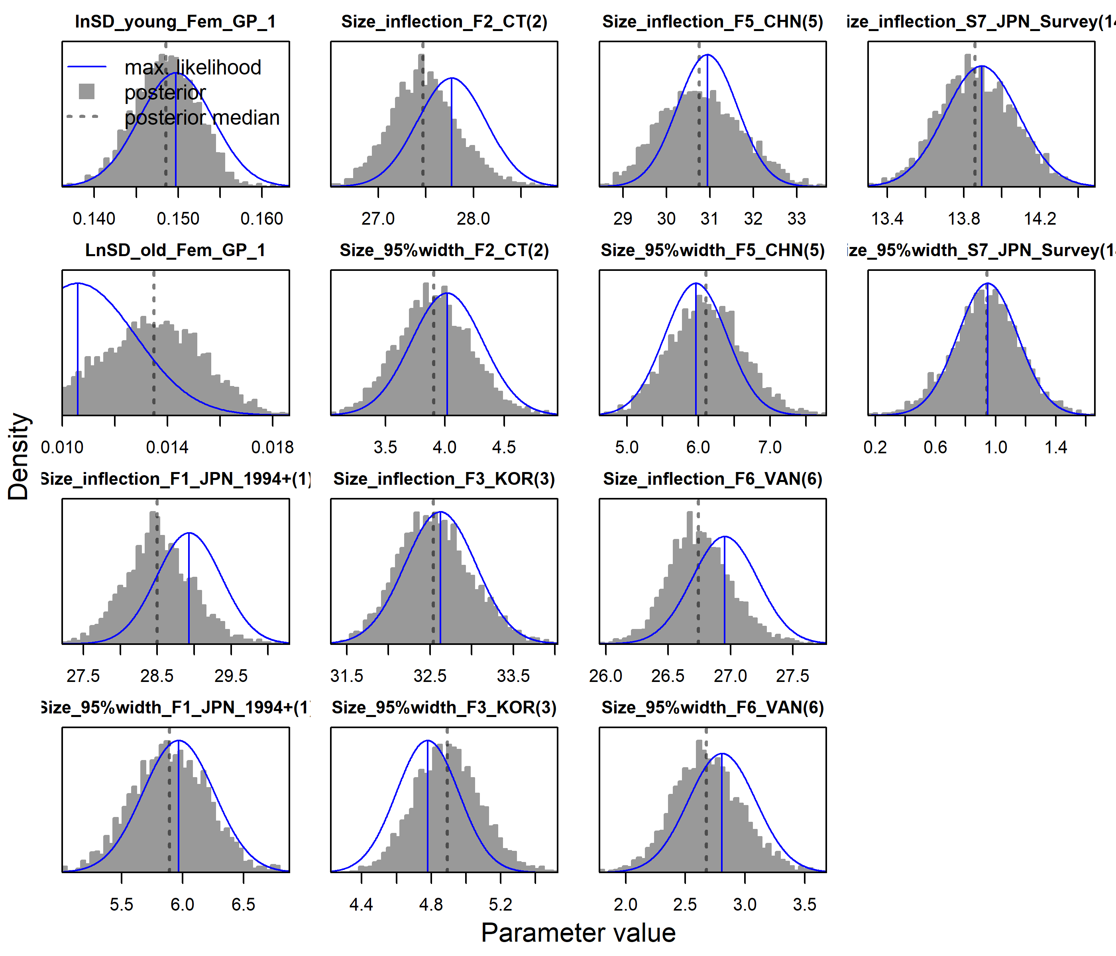
Figure 10: Comparison of model parameters and standard errors from Bayesian MCMC (grey) and the Hessian matrix (blue) at the maximum likelihood. Parameters include lognormal standard deviation for length at age, length of 50% selectivity, and width of logistic selectivity function.
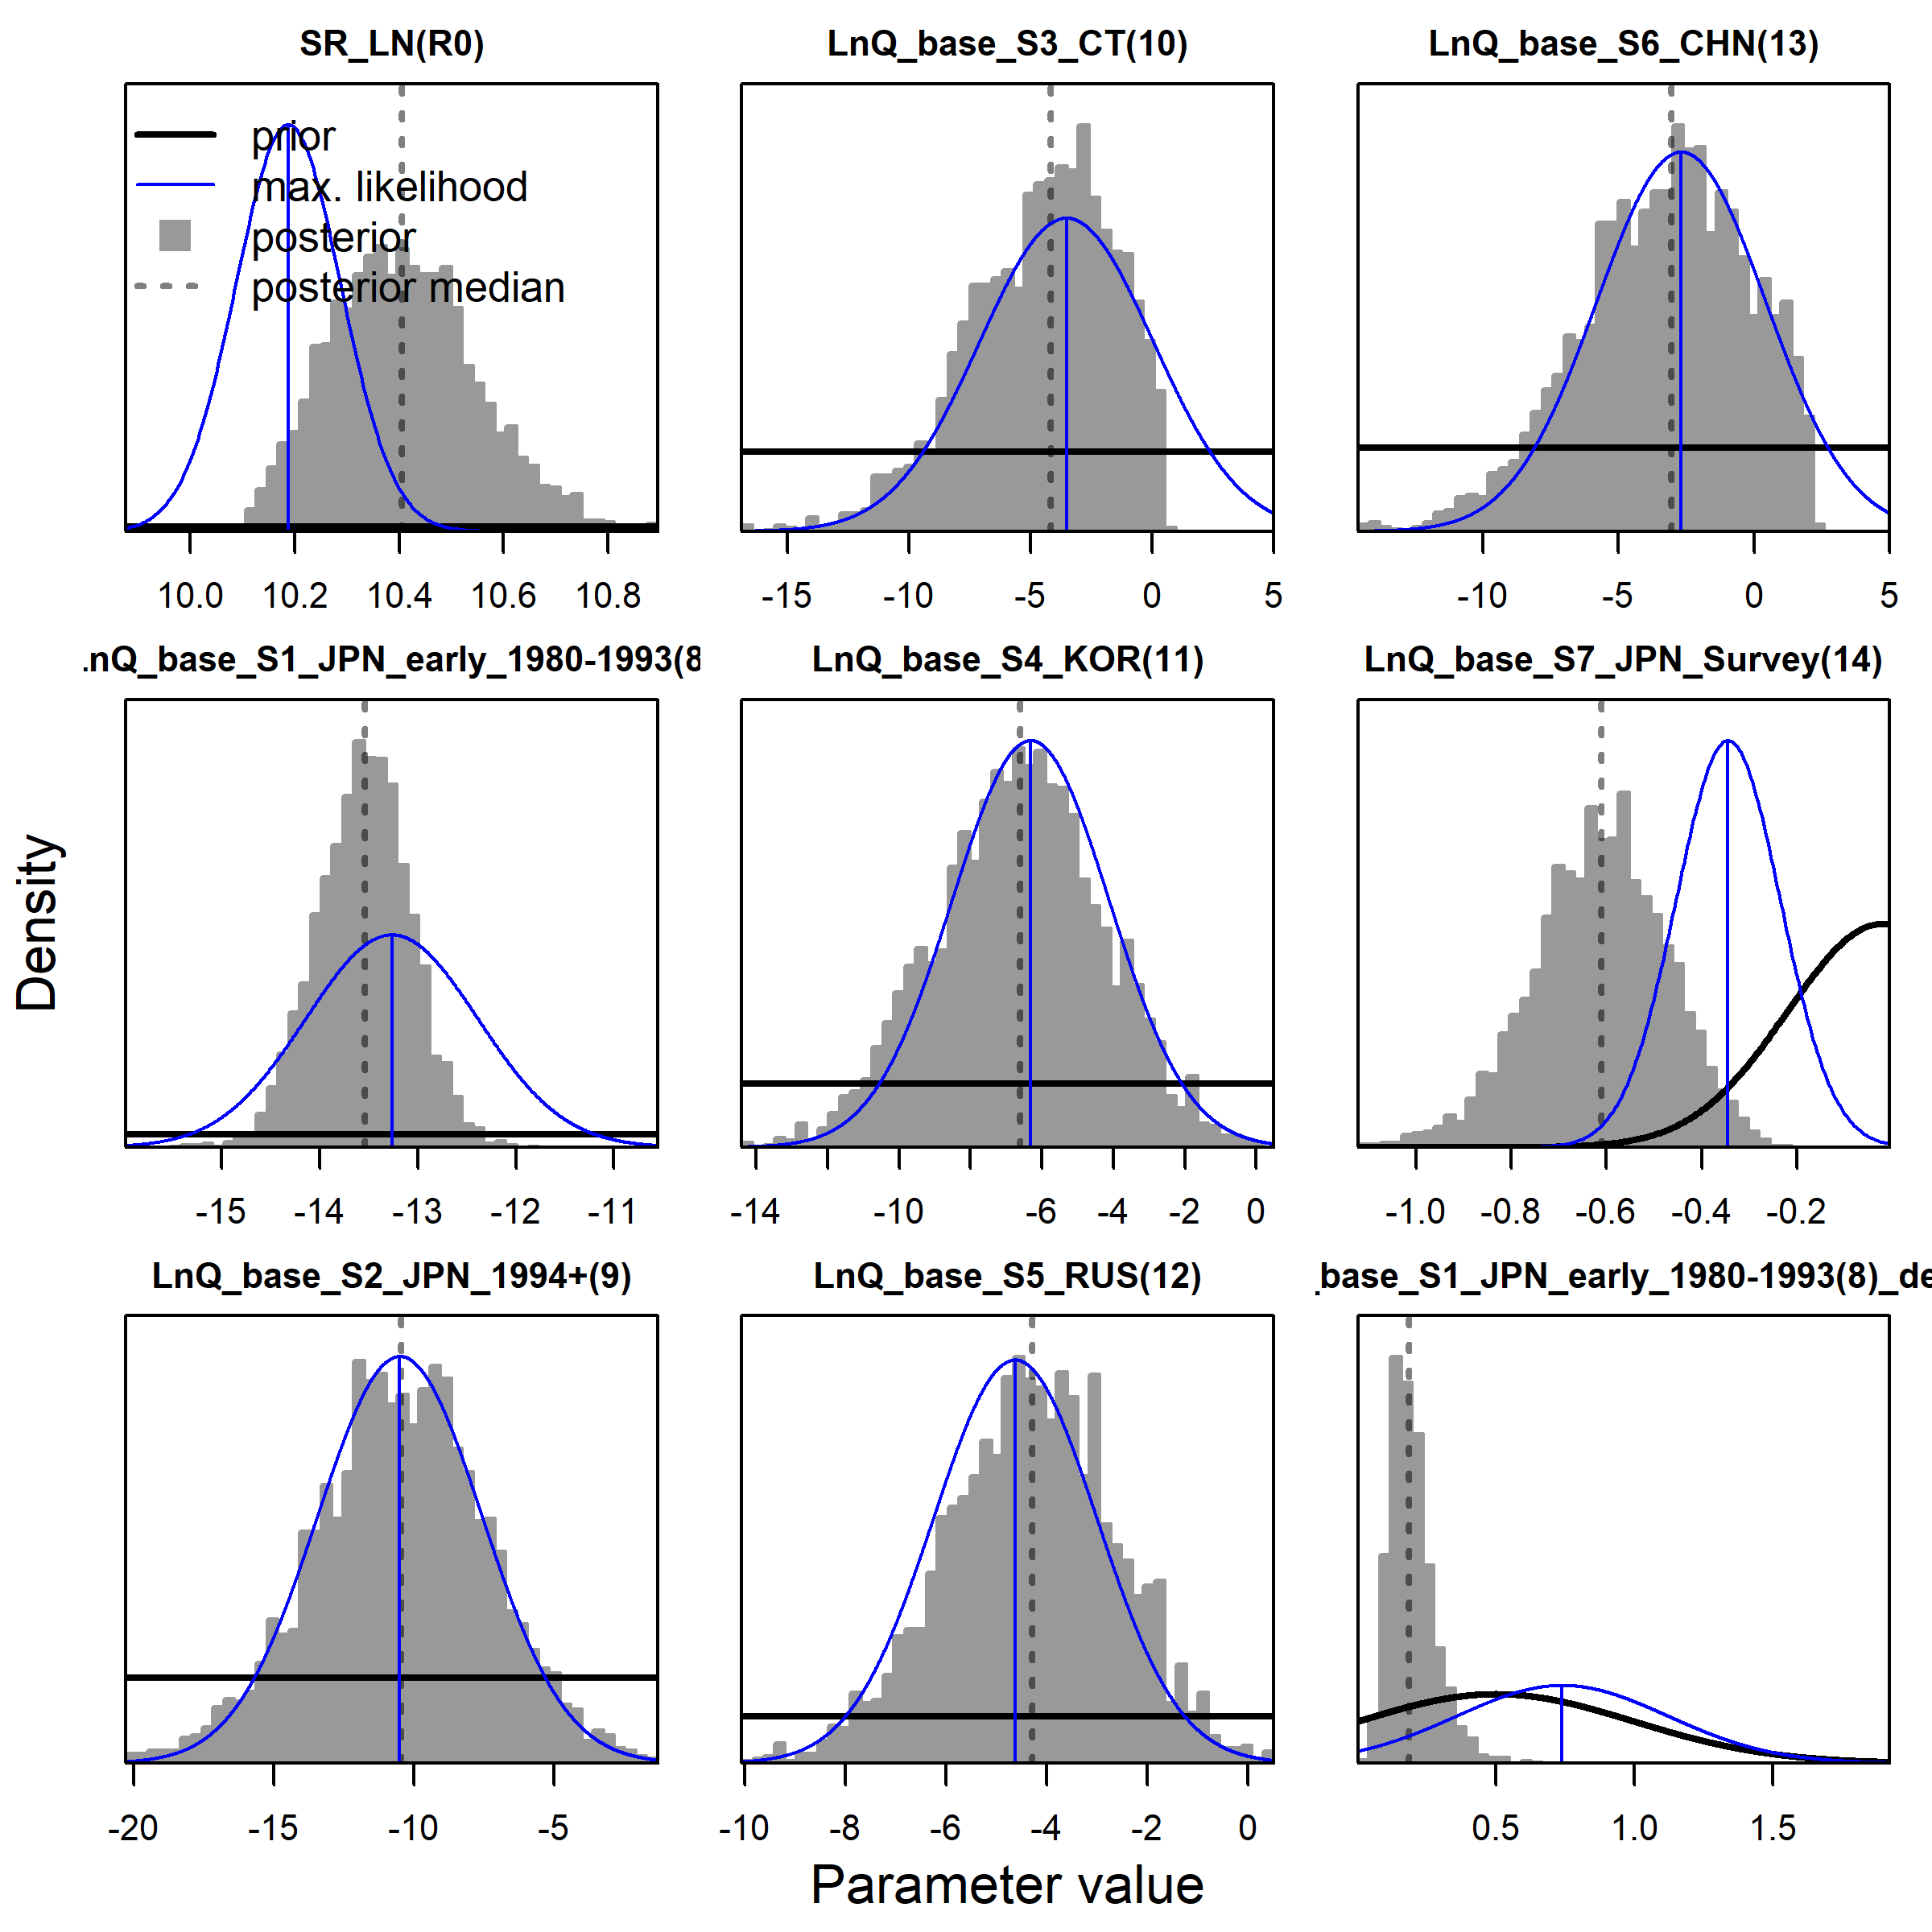
Figure 11: Comparison of model parameters and standard errors from Bayesian MCMC (grey) and the Hessian matrix (blue) at the maximum likelihood. Parameters include index catchability, hyperstability paramet, and unfished recruitment.
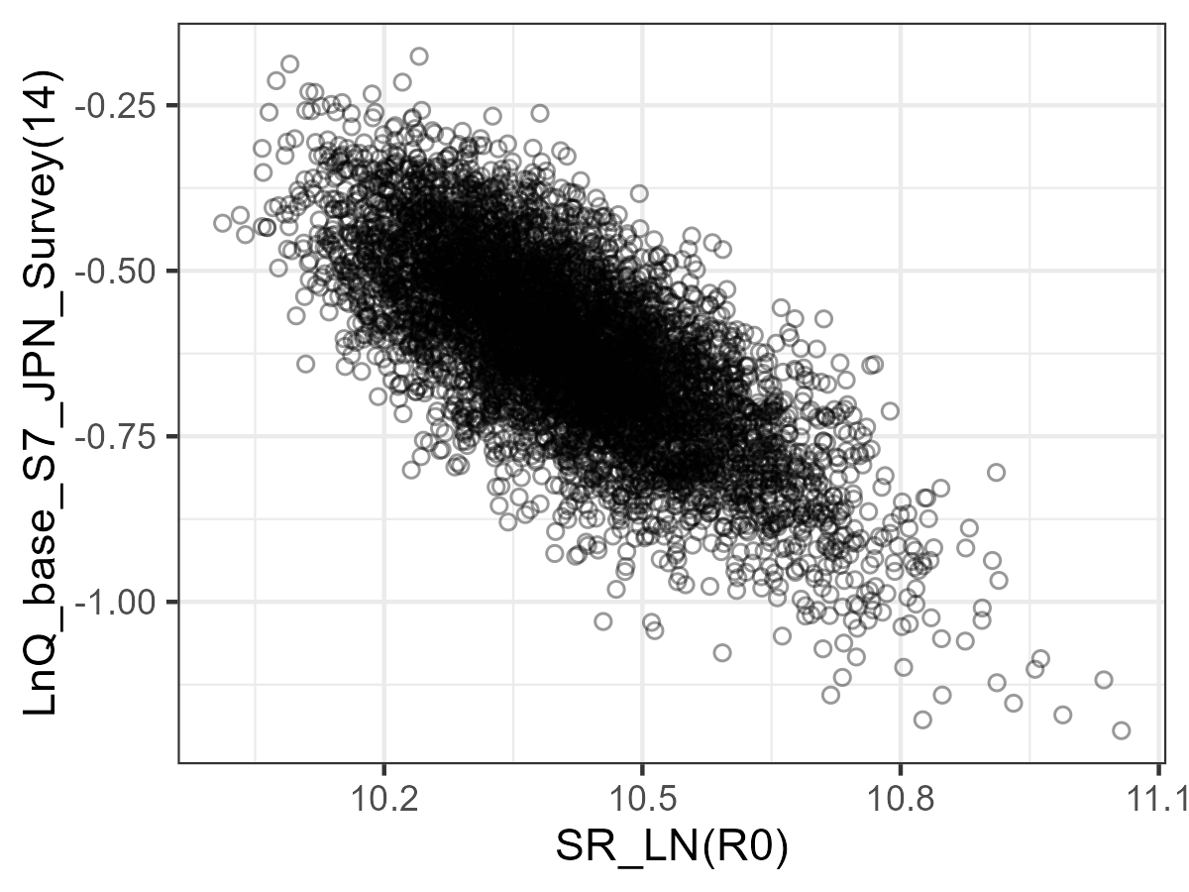
Figure 12: Joint posterior MCMC samples show the strong correlation between unfished recruitment and survey catchability (correlation = -0.726).
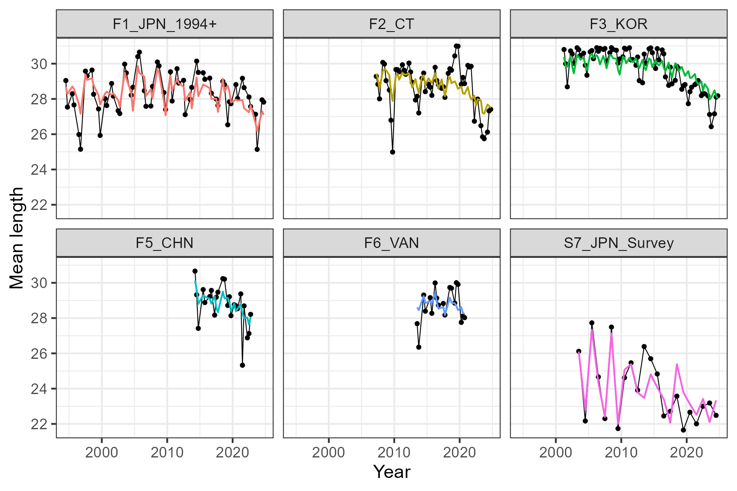
Figure 13: Observed (black) and predicted (colours) mean length time series, calculated from length composition in the model. Mean length is used as an indicator for goodness of fit in the length composition.
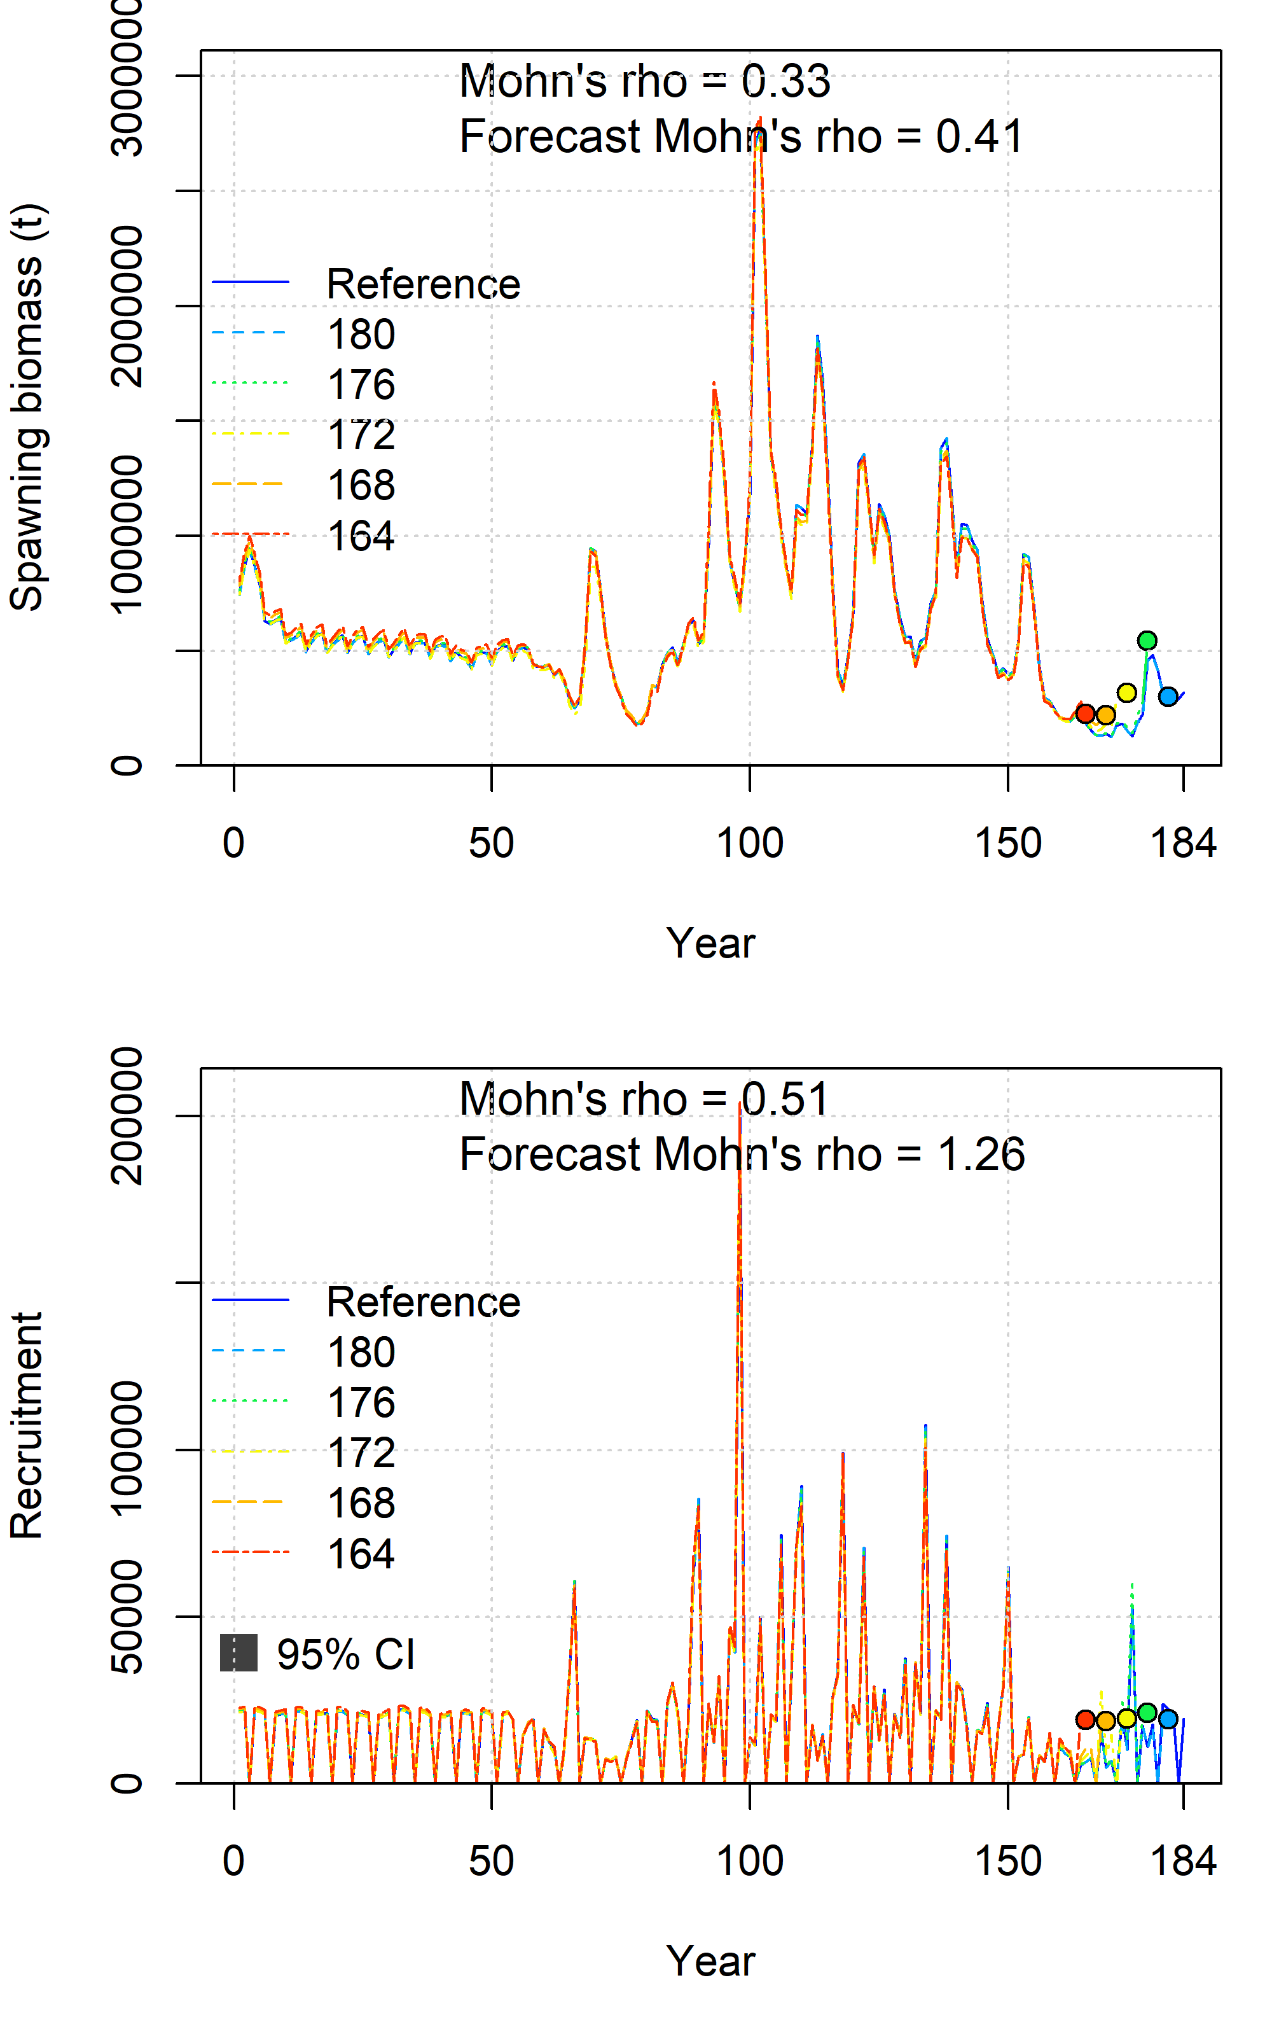
Figure 14: Retrospective analysis of spawning biomass and recruitment for the base model with Mohn’s rho. Coloured lines indicate the number of time steps removed at the end of the model, in intervals of 4 seasons. The reference time step is 184, corresponding to 2025, season 4. Coloured circles indicate the value estimated in the first projection year of the model.
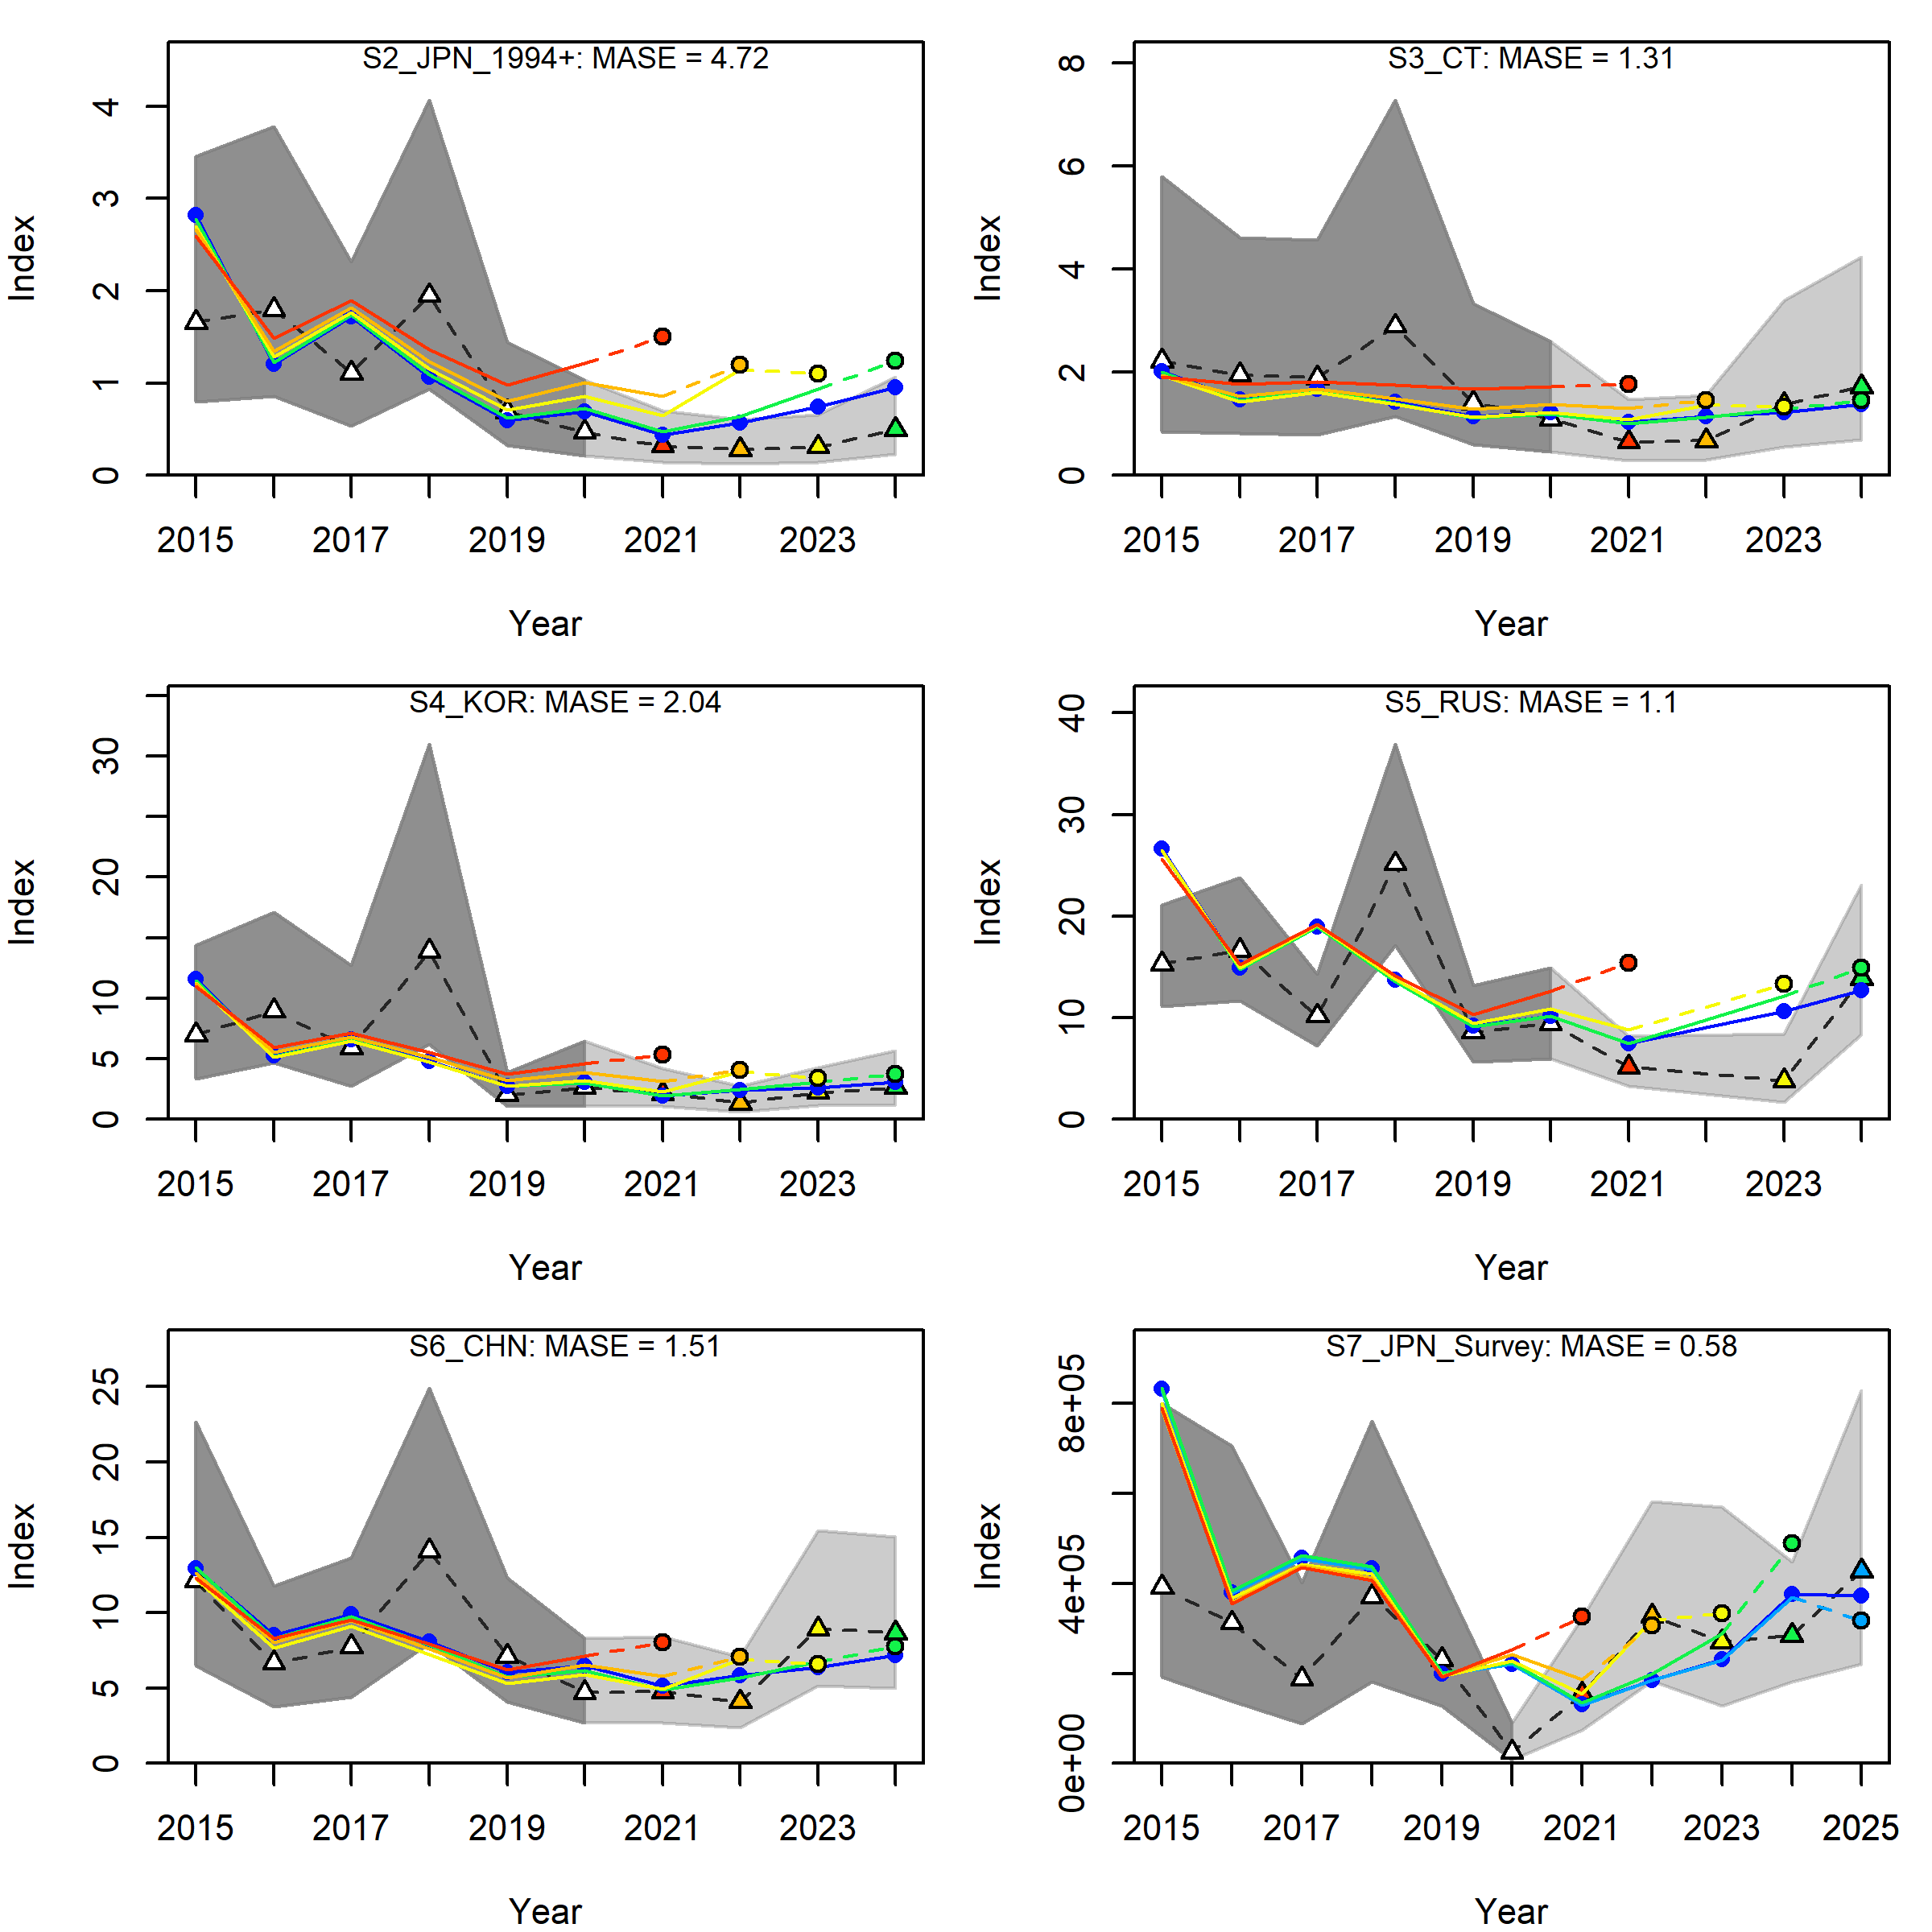
Figure 15: Hindcast analysis for one-step ahead predictions of indices of abundance in the retrospective models. White points and grey ribbons indicate historical data and confidence intervals, respectively. Coloured lines represent predicted values in the retrospective models and coloured points are the one-step ahead prediction in the first projection year. Good predictive skill is observed when the coloured points are closer to observed data point that are not used to fit the model. The mean absolute scaled error (MASE) < 1 can be used to support good predictive skill.
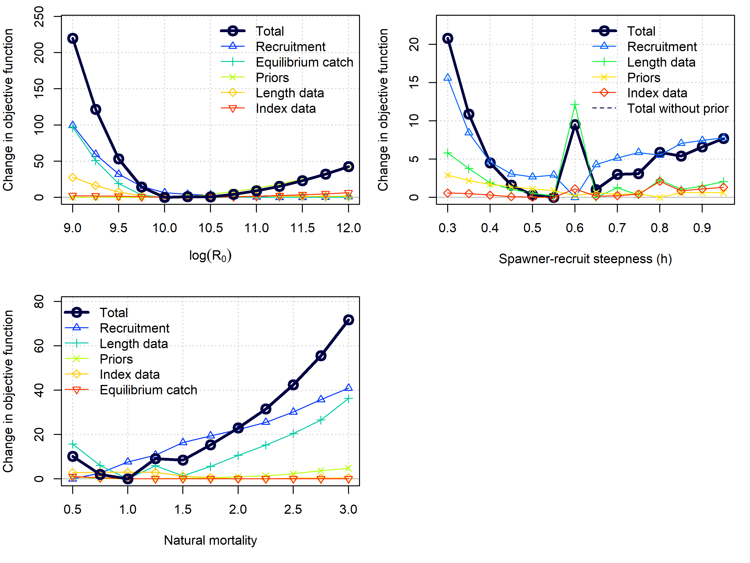
Figure 16: Profile of the objective function, including likelihood components of the data, recruitment penalty, and catchability prior, with respect to unfished recruitment (R0), steepness, and natural mortality. The profile for R0 on the right hand side is informed by the catchability prior, while steepness is weakly informed by the length data, and natural mortality is more strongly informed by the length data.
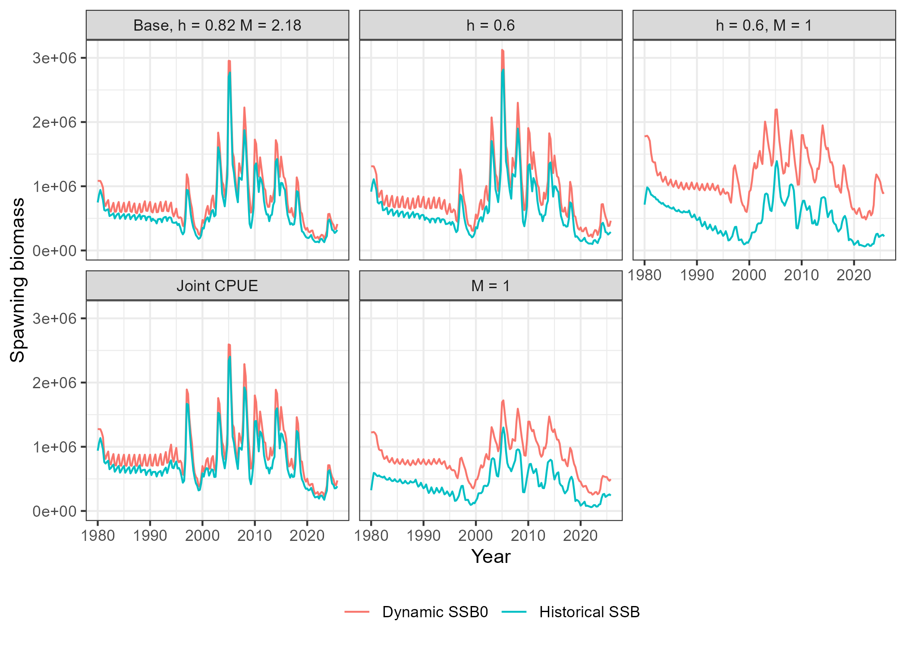
Figure 17: Comparison of spawning stock biomass (SSB) with the dynamic unfished value in the base and sensitivity models. The unfished value is the hypothetical biomass if the historical catch is zero. Differences in the hypothetical and realized value represents the impact of the fishery on the stock abundance.
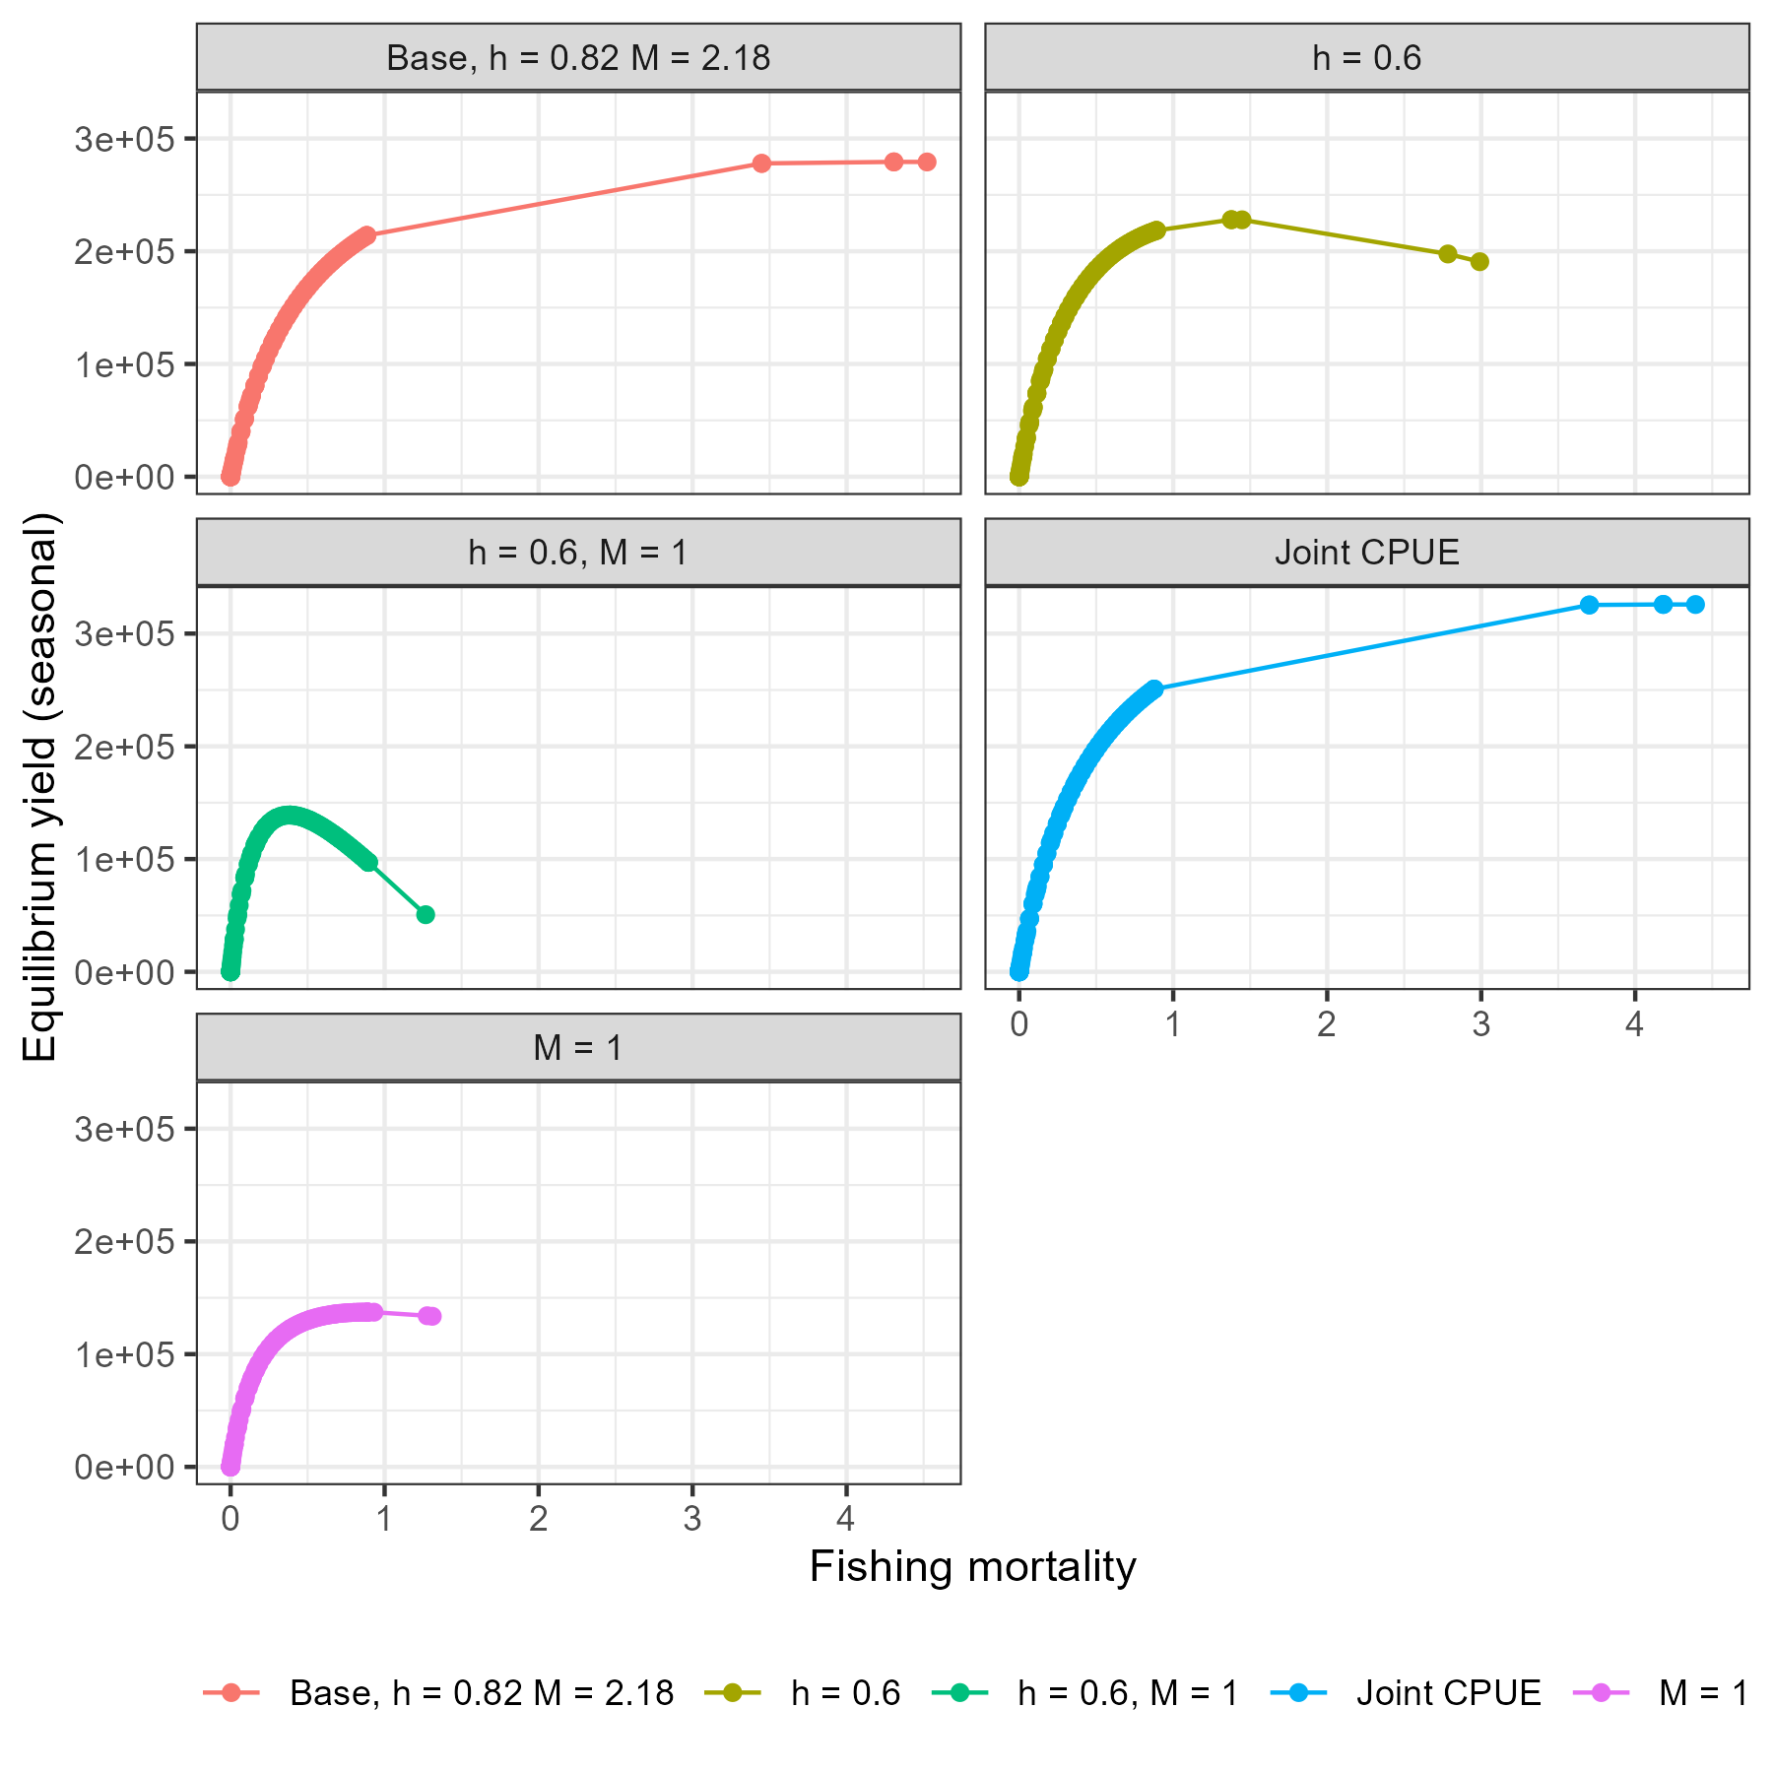
Figure 18: Equilibrium seasonal yield curve (t) with respect to instantaneous fishing mortality (per year) in the base and sensitivity models. Solid points are values calculated in SS3 and thin lines are interpolated values.
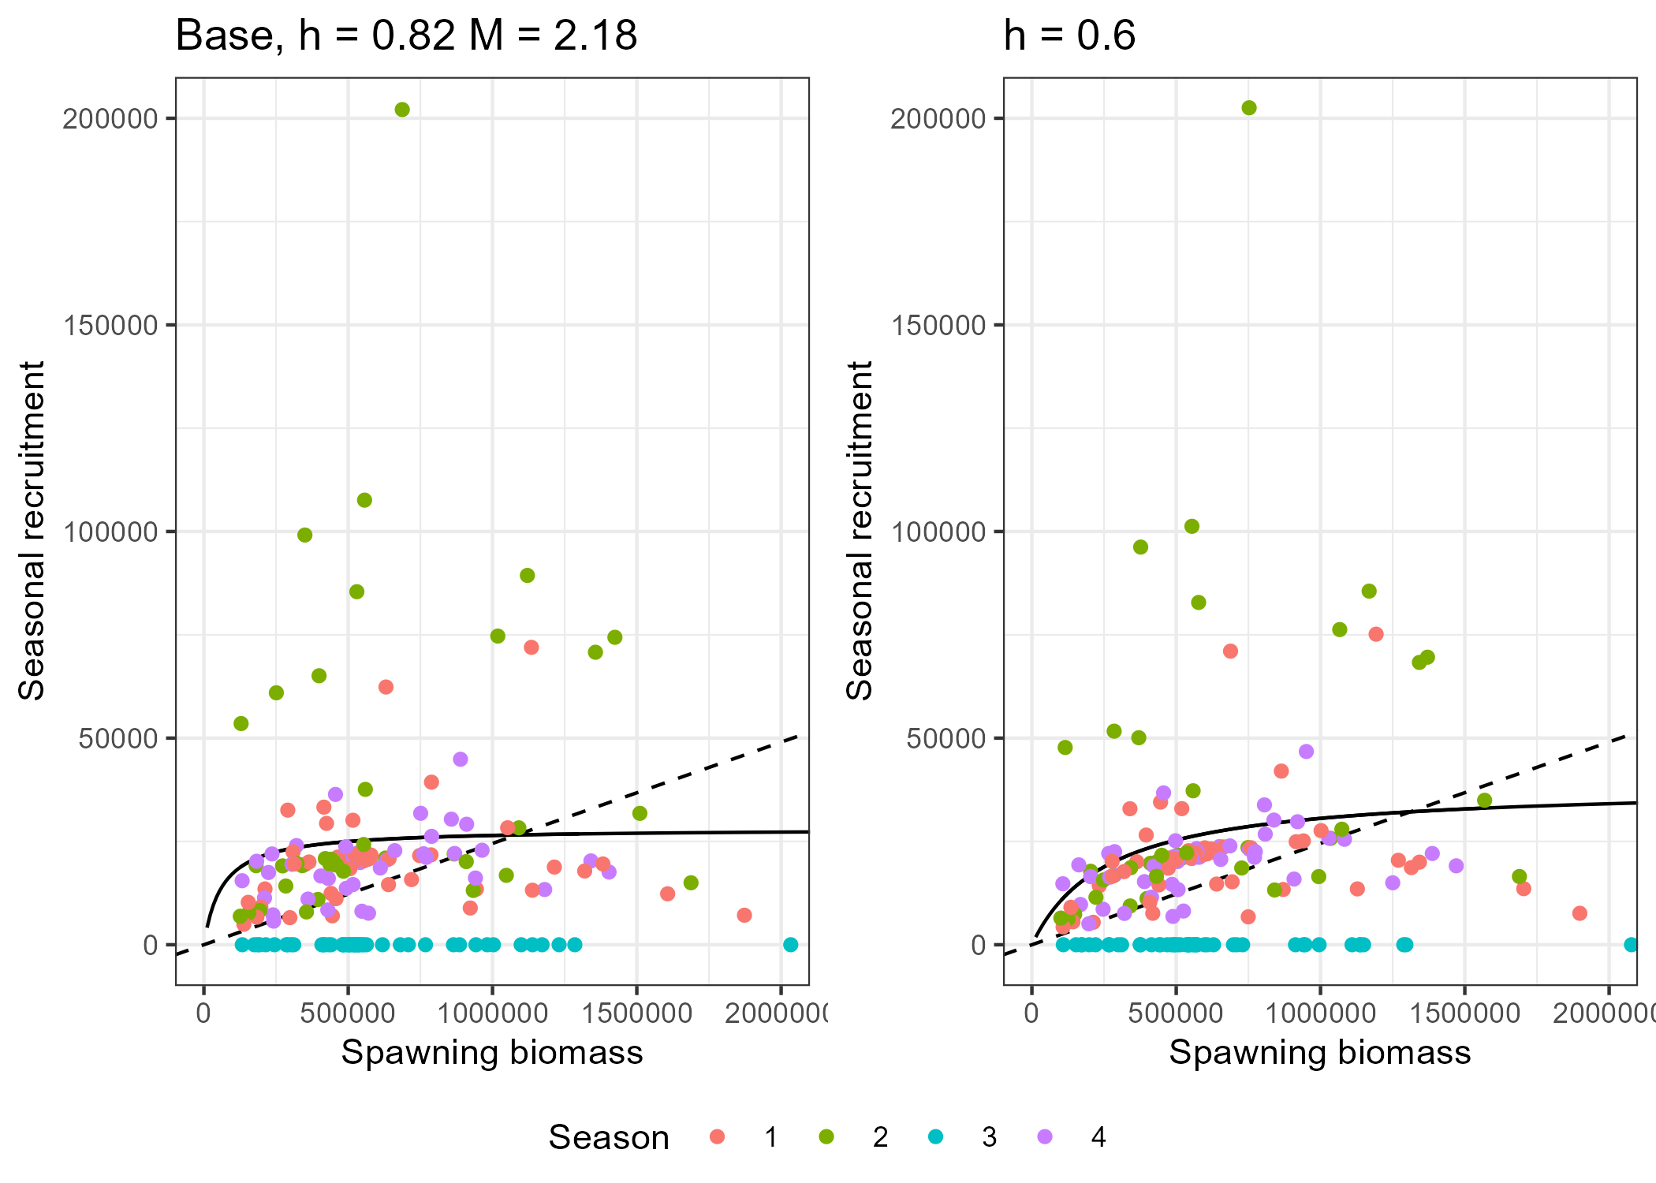
Figure 19: Comparison of stock-recruit relationships (SRR) that predict seasonal recruitment (units of millions of fish) in the base model (h = 0.82) and sensitivity model with h = 0.6. The dashed line is the replacement line calculated from fecundity and natural mortality to calculate the unfished reference points at the intersection with the SRR.
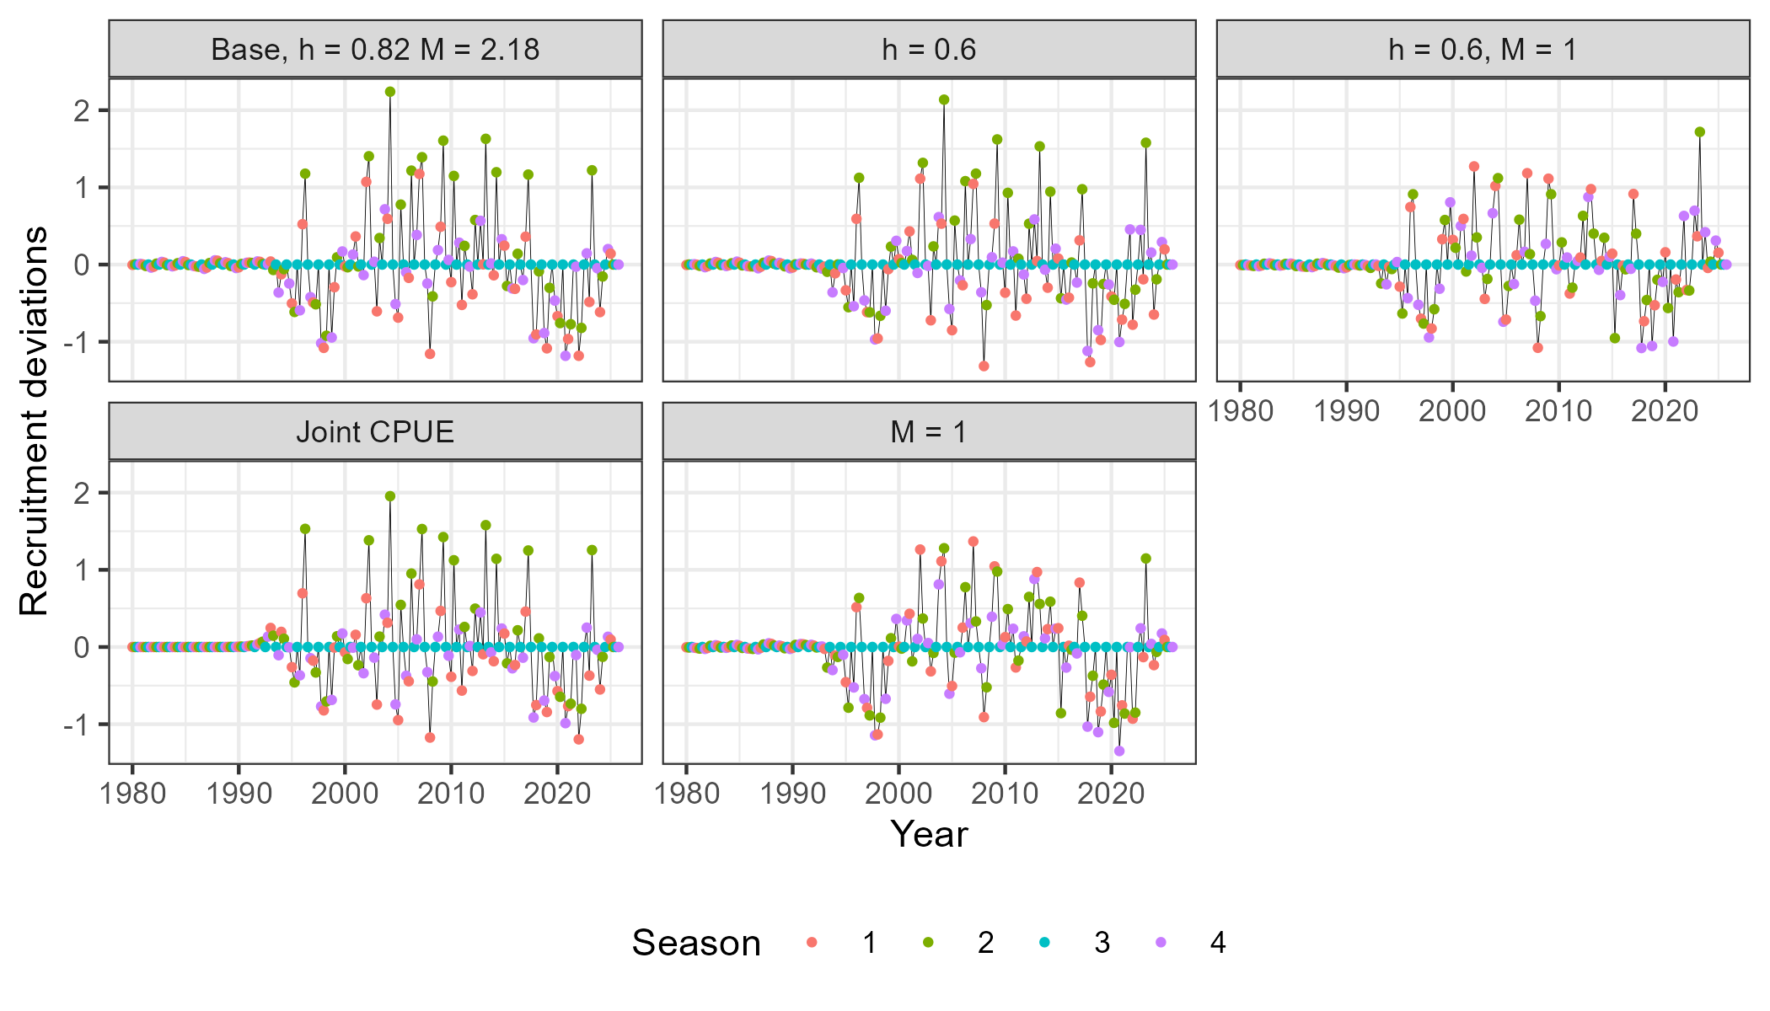
Figure 20: Log-recruitment deviations from the seasonal stock-recruit relationship estimated in the base and sensitivity models. Individual time steps are identified by year and season and aggregated by calendar year.
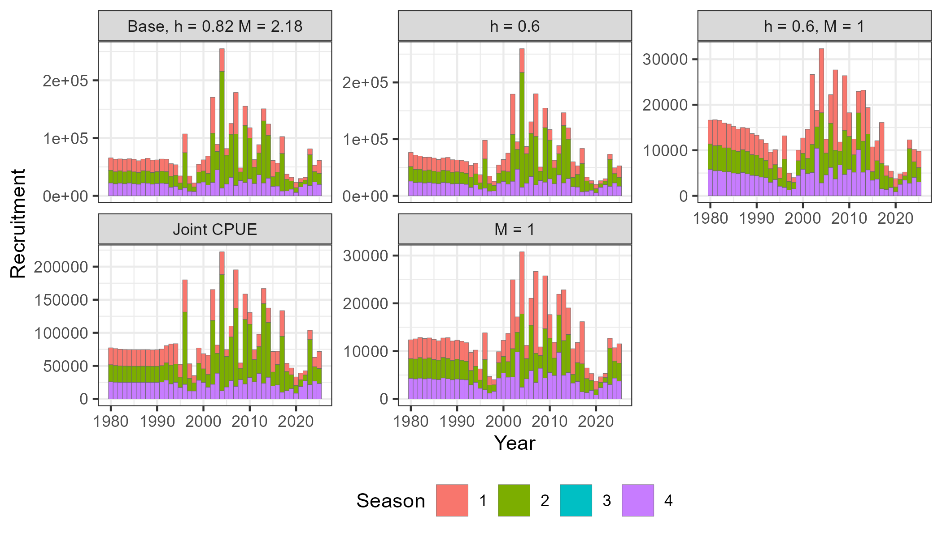
Figure 21: Comparison of recruitment (units of millions of fish) time series in the base and sensitivity models. Individual time steps are identified by year and season and aggregated by calendar year. The y-axis scales differs in each panel to evaluate temporal trends.

References
Dai, L. 2024. Working Group on New Stock Assessment Models for Pacific Saury – Progress Summary for 2024. NPFC-2024-SSC PS14-WP08.
Dai, L., and C. Rooper. 2023. Simulation of climate indices for process error in Pacific Saury. NPFC-2023-SSC PS12-WP03.
Fuji, T., S. Suyama, S. Nakayama, M. Hashimoto, and K. Oshima. 2019. A review of the biology for Pacific saury, Cololabis saira in the North Pacific Ocean. NPFC-2019-SSC PSSA05-WP13(Rev. 1).
Fuji, T., S. Suyama, S. Nakayama, and T. Kitakado. 2025. Seasonal variation in maturity ogive of Pacific saury. NPFC-2025-SSC PS16-IP02.
Hashimoto, M., S. Nakayama, T. Fuji, S. Suyama, H. Miyamoto, A. Tachibana, M. Naya, and S. Minamikawa. 2025a. Japanese survey biomass index of Pacific saury up to 2025 using VAST model. NPFC-2025-SSC PS15-WP01.
Hashimoto, M., M. Naya, S. Suyama, S. Nakayama, T. Fuji, H. Miyamoto, and S. Minamikawa. 2025b. Standardized CPUE of Pacific saury (Cololabis saira) caught by the Japanese stick-held dip net fishery up to 2024. NPFC-2025-SSC PS15-WP02.
Hsu, J., and Y.-J. Chang. 2023. Updated saury’s SS3 model for SSC PS 12. NPFC-2023-SSC PS12-IP08.
Hsu, J., and Y.-J. Chang. 2025. Joint CPUE standardization of the Pacific saury in the Northwest Pacific Ocean by using the spatio-temporal modelling approach. NPFC-2025-SSC PS15-WP10.
Hsu, J., Y.-J. Chang, J. Brodziak, M. Kai, and A. E. Punt. 2024. On the probable distribution of stock-recruitment resilience of Pacific saury (Cololabis saira) in the Northwest Pacific Ocean. ICES J. Mar. Sci. 81:748–759.
Hsu, J., Y.-J. Chang, C. Hsieh, W.-B. Huang, and T.-H. Chian. 2022. Preliminary stock assessment model in Stock Synthesis 3.30 for the Pacific saury in Northwestern Pacific Ocean. NPFC-2022-SSC PS09-WP12.
Hua, C., S. Tian, Y. Shi, and L. Dai. 2025. Standardized CPUE of Pacific saury (Cololabis saira) caught by the China’s stick-held dip net fishery up to 2024. NPFC-2025-SSC PS15-WP05.
Huang, W.-B., K. P. Ginting, Y.-J. Chang, and C.-h. Hsieh. 2025. Standardized CPUE of Pacific saury (Cololabis saira) caught by the Chinese Taipei stick-held dip net fishery up to 2024. NPFC-2025-SSC PS15-WP04.
Ito, S.-i., T. Okunishi, M. J. Kishi, and M. Wang. 2013. Modelling ecological responses of Pacific saury (Cololabis saira) to future climate change and its uncertainty. ICES J. Mar. Sci. 10:980–990.
Jacobson, L. 2024. SS3 Progress, Ideas and Plans. NPFC-2024-SSC PS14-IP10 (Rev.1).
Kitakado, T. 2024. 2024 update on Pacific saury stock assessment in the North Pacific Ocean using Bayesian state-space production models. NPFC-2024-SSC PS14-WP11.
Kosaka, S. 2000. Life history of the Pacific saury Cololabis saira in the northwest Pacific and considerations on resource fluctuations based on it. Bull. Tohoku Natl. Fish. Res. Inst.:1–96.
Kulik, V., A. Baitaliuk, and O. Katugin. 2025. Standardized CPUE of Pacific saury (Cololabis saira) caught by Russian vessels up to 2024. NPFC-2025-SSC PS15-WP08.
Methot, R. D., and C. R. Wetzel. 2013. Stock synthesis: A biological and statistical framework for fish stock assessment and fishery management. Fish. Res.:86–99.
Nakayama, S.-I., S. Suyama, T. Fuji, M. Hashimoto, and K. Oshima. 2019. A trial calculation of natural mortality estimators for Pacific saury. NPFC-2019-SSC PS05-WP18 (Rev.1).
Naya, M., Y. Ueno, T. Mouri, K. Oshima, T. Watanabe, K. Fujita, K. Itoh, K. Iwasaki, Y. Matsuo, Y. Itoh, and Y. Shimizu. 2010. Estimation of the fishing efficiency of a mid-water trawl for Pacific saury Cololabis saira using a high-frequency side-scan sonar. Nippon Suisan Gakkaishi:658–669.
NPFC. 2024. Summary of the idea exchange between the WGNSAM modelers and biologists in SSCPS. NPFC-2024-SSC PS14-WP05.
NPFC. 2025. Compiled data on Pacific saury catches in the NWPO. NPFC-2025-SSC PS15-WP07 (Rev.1).
Oshima, K., T. Fuji, and S. Suyama. 2018. Additional information regarding changes in the Japanese stick-held dip net for Pacific saury, especially in 1980s. NPFC-2018-TWG PSSA03-WP11.
Song, H. 2025. Standardized CPUE of Pacific saury (Cololabis saira) caught by the Korean’s stick-held dip net fishery up to 2024. NPFC-2025-SSC PS15-WP06.
Suyama, S., T. Morioka, M. Nakaya, M. Nakagami, and Y. Ueno. 2006. The Study of the Maturation Process of the Pacific Saury, Cololabis saira: The Role of the Rearing Experiments. Bull. Fish. Res. Agr.:173–180.
Thorson, J. T., and J. M. Cope. 2017. Uniform, uninformed or misinformed?: The lingering challenge of minimally informative priors in data-limited Bayesian stock assessments. Fish. Res.:164–172.

