NPFC-2025-SC10-IP01

NPFC Data Management Systems: Progress and Operational Guidelines

Abstract: This document provides an update on the progress and operational guidance for NPFC data management systems related to the Scientific Committee. It is intended for NPFC Members and highlights developments since the 9th Scientific Committee Meeting.

1. NPFC Website Overview
The NPFC website integrates the primary data and information management systems, which cover key areas such as the Members Home, Significant Dates/Events, Pacific Saury Weekly Catch Report, Chub Mackerel Monthly/Weekly Catch Report, GIS Maps, Collaboration, and Annual Reports.
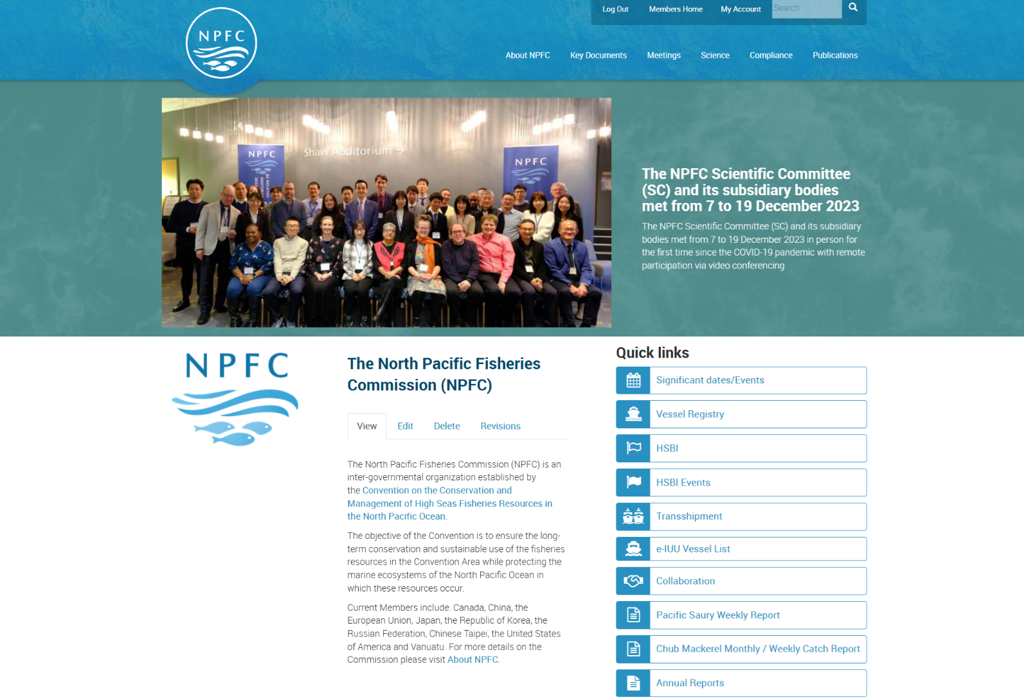

1.1. Members Home (https://www.npfc.int/members)
The Members Home section provides contact information for “Designated Representatives and Official Contacts” and “NPFC Committees and Working Groups”.
The Secretariat has recently updated the Member Account Management System, which now enables the generation of complete and up-to-date membership lists for each subsidiary body to support efficient communication among Members.
Key features include:
a. Regularly updated electronic contact lists with search functions filtered by Representative Role and Group (Member/CNCP, Observer, Secretariat Guest)
b. Group mailing functionality for relevant working groups.
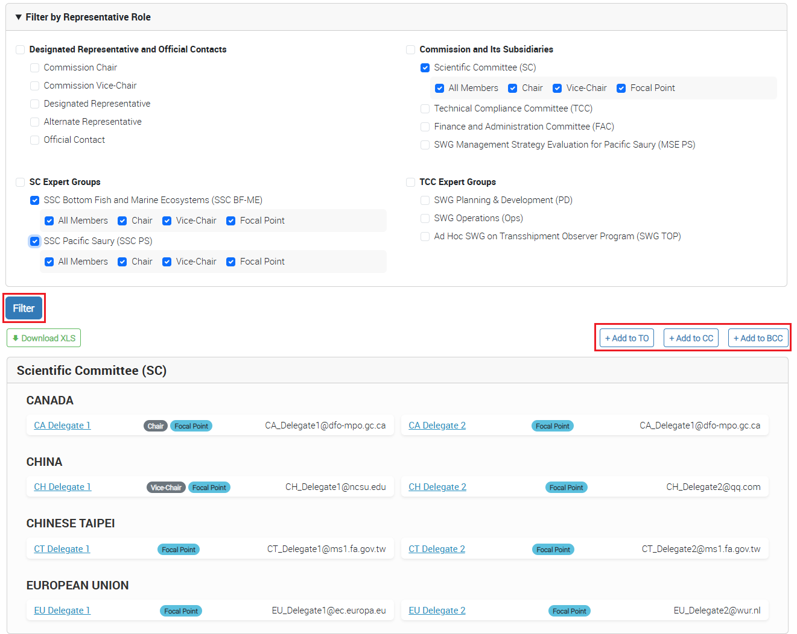
Further detailed guidelines for Group Administrators are available on the NPFC website under the System Manual section:
https://www.npfc.int/npfc-membership-account-managementmam-guideline-group-admins
1.2. Significant dates/events (https://www.npfc.int/significant-dates-calendar)
The Secretariat maintains the schedules for NPFC’s commission, committees, sub-committees, and working groups. The Secretariat has recently developed the event list which allows Members to access all the meetings and events ordered by from January to December to support visibility.
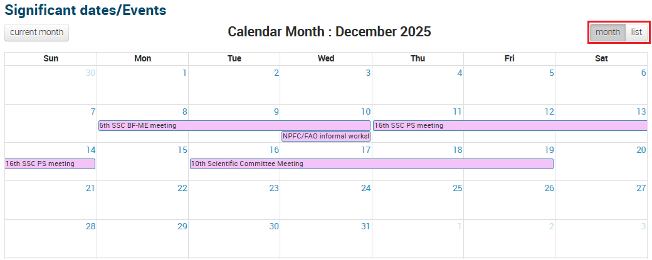

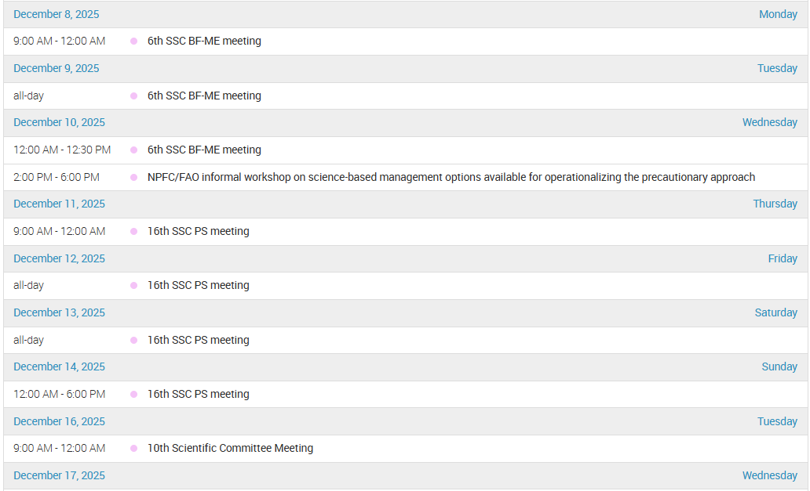

1.3. Pacific Saury Weekly Report (https://www.npfc.int/submissions/weekly-catch)
This section allows Members to view both individual and cumulative Pacific Saury weekly catch data. Aggregate catch data is also publicly accessible under the public domain area on the NPFC website (https://www.npfc.int/pacific-saury-cumulative-catch).
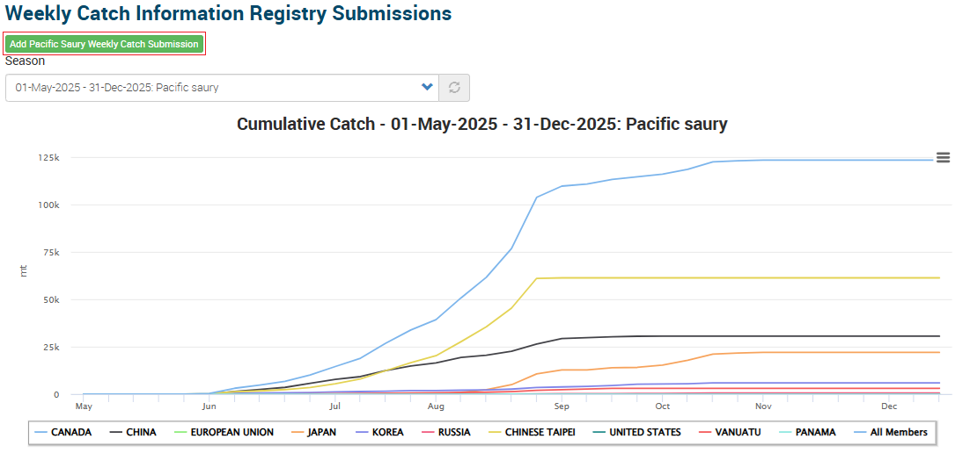
Designated Members (Catch Data Report Managers) are required to submit weekly catch data in metric tons through the data submission page (https://www.npfc.int/irs/add/psw_weekly_catch).
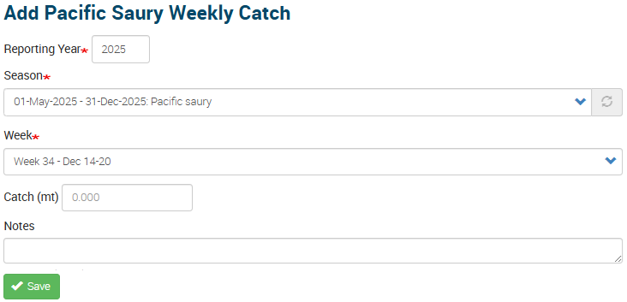

1.4 Chub Mackerel Monthly/Weekly Report (https://www.npfc.int/submissions/weekly-catch/MAS)
The Chub Mackerel Monthly/Weekly Report section has been developed since the Chub Mackerel CMM 2024-07 entered into force.
Members can access individual and aggregate Chub Mackerel catch data by different gear types (Purse Seiners/Trawlers). Cumulative catch data is posted on the public area of the NPFC website (https://www.npfc.int/pacific-saury-cumulative-catch).
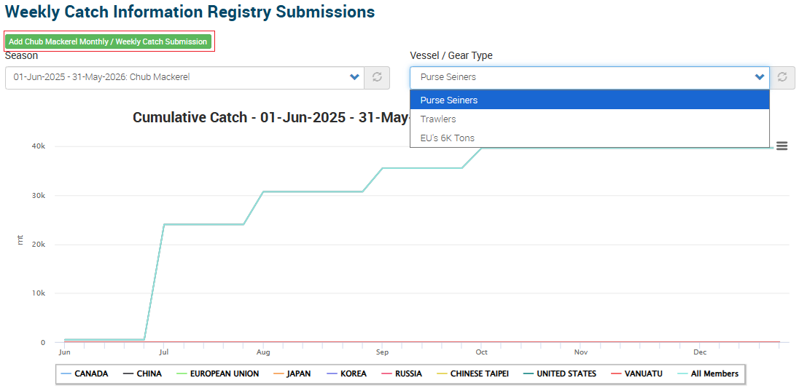
The system automatically transitions from monthly to weekly reporting once the catch data reaches 60% of the Total Allowable Catch (TAC).
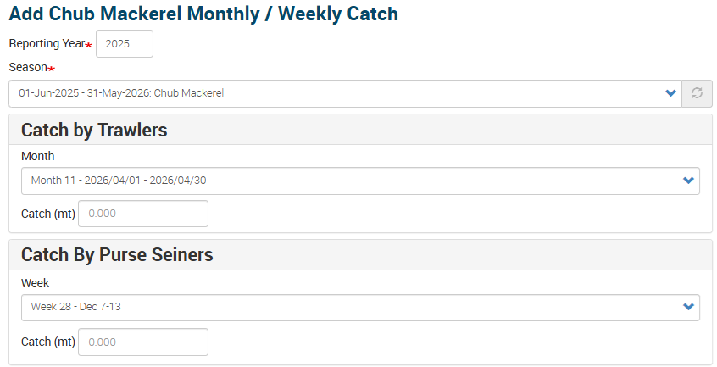
1.5 Collaboration (https://collaboration.npfc.int)
The NPFC Members, CNCP and Observers registered to the particular discussion groups (SC, SSC PS, TWG CMSA, SSC BF-ME, etc) can access the NPFC Collaboration groups. Access will be granted based on the user’s assigned Representative Roles and organizational requirements.
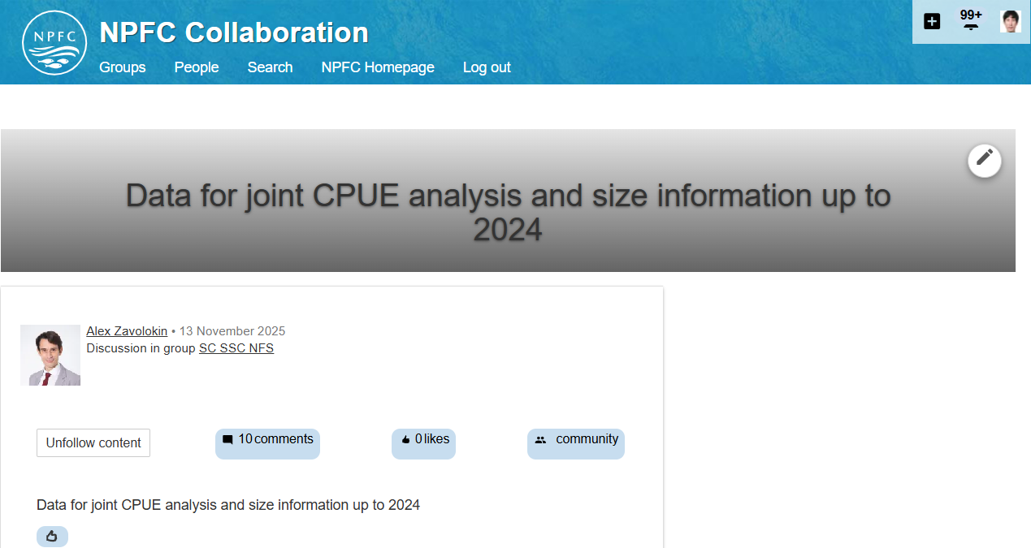
The updated Member Account Management System provides a synchronization function that links users’ Representative Roles to the corresponding NPFC Collaboration Groups. The Secretariat plans to synchronize the Collaboration Groups based on users’ Representative Roles, and Group Administrators are advised to review and align the Representative Roles of their group members to ensure accurate access to the appropriate Collaboration Groups.
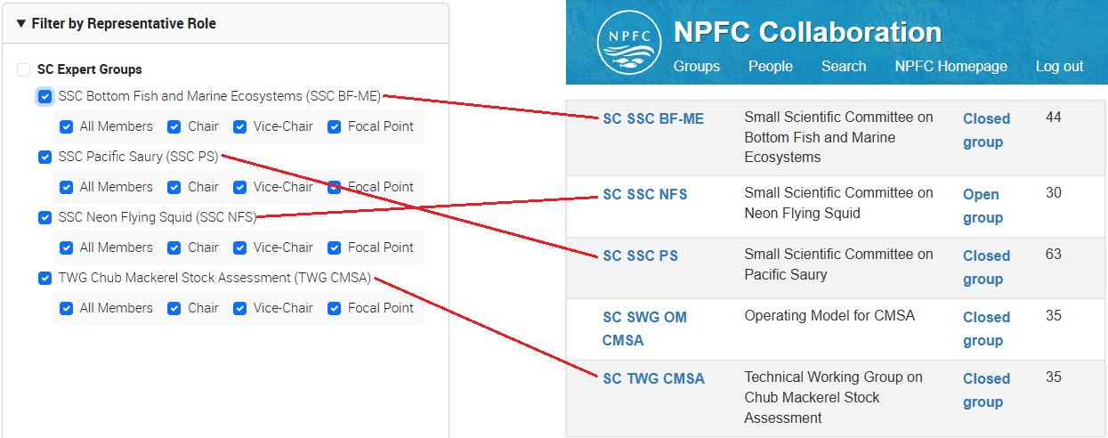

1.6 Annual Reports (https://www.npfc.int/annual-reports-members)
The NPFC Members can access Annual Reports section.
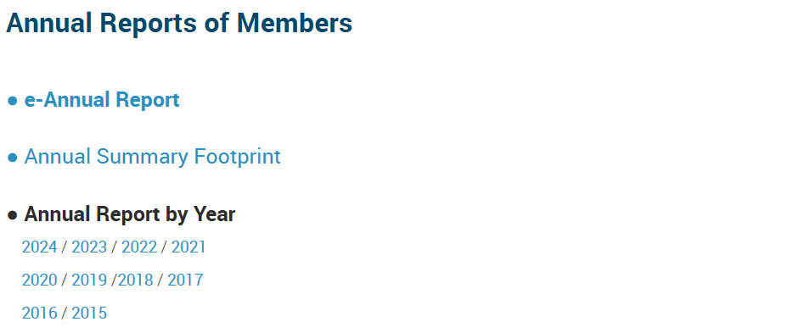
The Annual Reports section also has a link to the e-Annual Report where designated Members (Annual Report Managers) can enter their report for the calendar year. From 2021, the secretariat has requested Members to use the e-Annual Report.

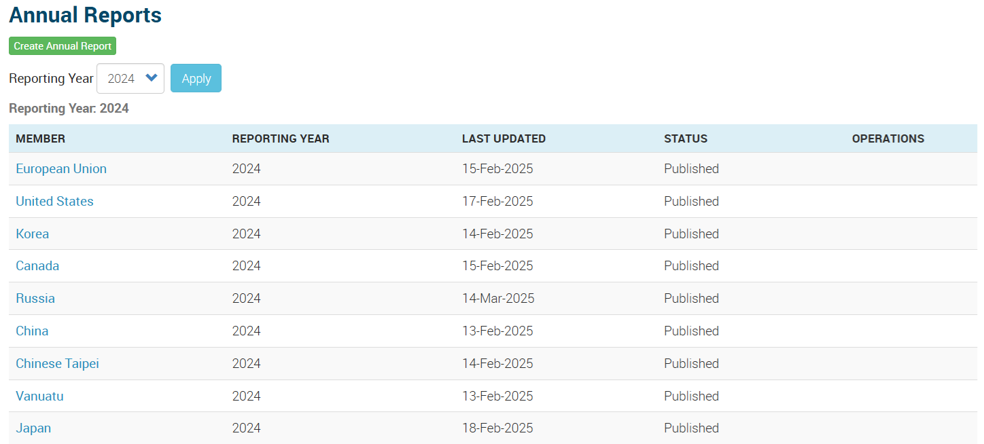

1.7. NPFC GIS Maps
1.7.1 Pacific Saury Map (https://www.npfc.int/science/gis/catch-effort/saury)
The Pacific Saury Map has recently been updated to include the Pacific Saury Catch and Effort data with sea surface temperature grid from 1994 to 2024.

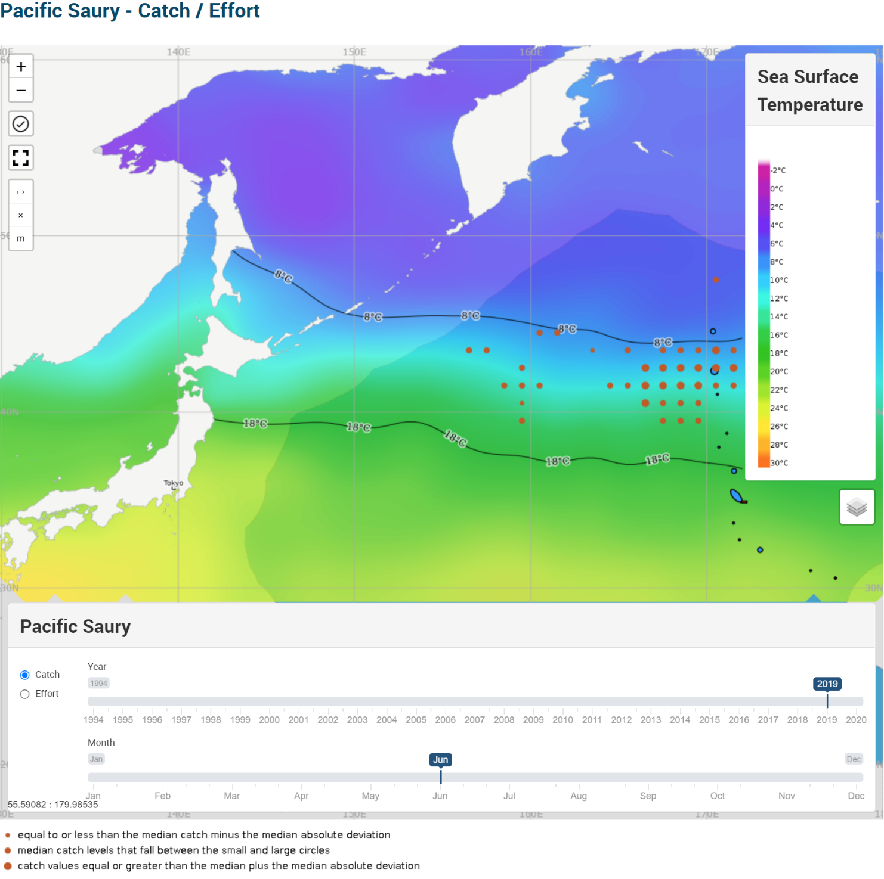

1.7.2 Bottom Fishing Map (https://www.npfc.int/science/gis/bottom_fishing)

The Secretariat developed the Bottom Fishing Map with combined, gear-specific footprints requested by the Small Scientific Committee on Bottom Fish and Marine Ecosystems (SSC BF-ME).
Members can filter the data by the number of sets and number of vessels with different gear types.
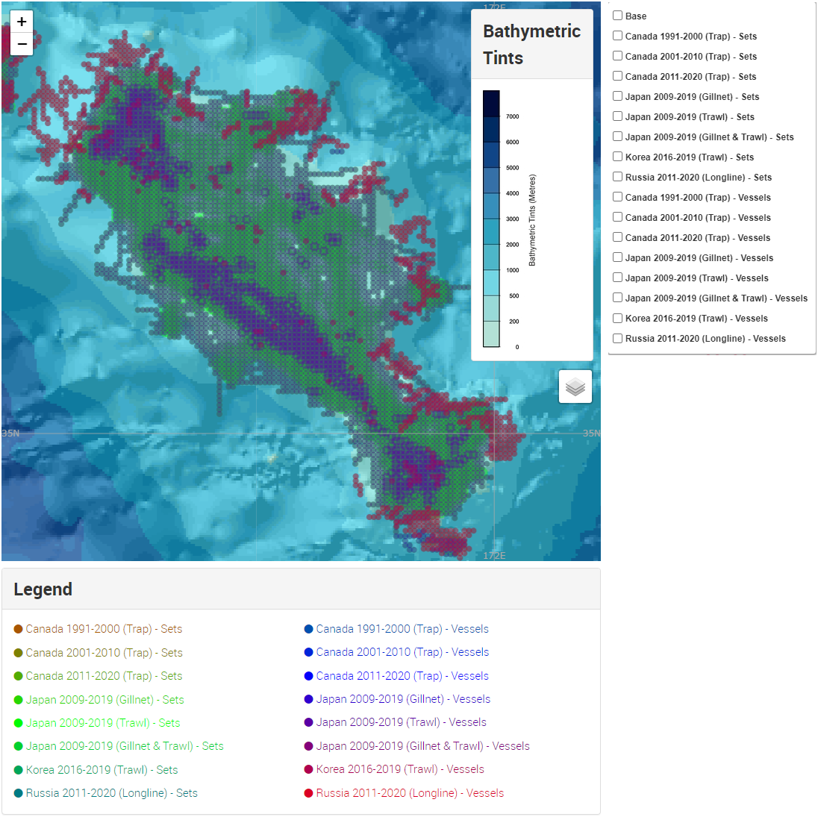
1.7.3 Neon Flying Squid Map Development
The Secretariat is developing the Neon Flying Squid (NFS) Map following the request from the SWG NFS for the Secretariat to map NFS catch and effort data. The structure of the map is designed to be similar to the Pacific Saury map, with additional functionality to filter data by Member and to display actual catch and effort information under the “Members Only” domain.

2. SC Database (Scientific Data Management System):
The Scientific Data Management System Development project is progressing as planned, with the prototype structure and standardized data templates developed based on input from SWG Data.
The system will cover seven core scientific data types
- Biological Estimates – Raw
- Biological Estimates – Age Composition
- Biological Estimates – Length Composition
- Biological Estimates – Maturity Ogive
- Catch and Effort – Processed
- Catch and Effort – CPUE
- Catch by Species – Ratio
and incorporate terminology standardization, automated validation rules, and a unified data submission workflow.
The prototype will undergo internal testing before Member training scheduled for January 2026, and full deployment is expected following the training and final refinements.

