NPFC-2025-SSC BFME06-WP09

Updated identification of potential VMEs on the Cobb-Eickelberg seamount chain based on predictive modelling that includes pennatulaceans as VME indicator taxa

Devon R Warawa, Christopher N Rooper, Ellen Kenchington, and Janelle MR Curtis
Fisheries and Oceans Canada

ABSTRACT
Areas likely to be vulnerable marine ecosystems (VMEs) (i.e. potential VMEs) can be identified using model predictions when no data from visual surveys exist, as outlined in the North Pacific Fisheries Commission’s (NPFC’s) framework for identifying data to identify VMEs (See Annex 2.3 in NPFC 2025a and NPFC 2025b). In this paper, we identify potential VMEs in the Cobb-Eickelberg seamount chain using predictive models of VME indicator taxa density, as in Warawa et al. (2023). To achieve this, we recalculated the regional VME indicator taxa density threshold in the Northeast Pacific Ocean to include pennatulaceans, which were recently added to the list of NPFC’s VME indicator taxa (NPFC 2024). The updated VME indicator taxa density threshold was 0.58 VME indicators per m² (compared to 0.6 VME indicators per m² in the original analysis). Our methods predict that potential VMEs are present on all seamounts in the Cobb-Eickelberg seamount chain. We invite feedback on our updated proposed method for identifying potential VMEs.

BACKGROUND
This working paper focuses on identifying areas where vulnerable marine ecosystems (VMEs) are likely to occur (henceforth potential VMEs) on seamounts along the Cobb-Eickelberg seamount chain in areas where visual data similar to that used by Warawa et al. (2023, 2025) are not available. The Cobb-Eickelberg seamount chain is important because of the Canadian sablefish fishery that occurs at these seamounts. The key steps in our methodology are to predict the distribution of VME indicator taxa density using species distribution models and apply an updated VME density threshold that includes pennatulaceans as VME indicator taxa (NPFC 2024) to our model predictions.

METHODS
Study area
Our study area, the Cobb-Eickelberg seamount chain, is located in the eastern part of the North Pacific Fisheries Commission’s (NPFC’s) Convention Area (CA), just outside of Canada’s exclusive economic zone (EEZ), approximately 450 km offshore Vancouver Island (Figure 1). This seamount chain is composed of 11 named seamounts and one ridge (Eickelberg Ridge) with Cobb Seamount having the shallowest pinnacle depth of 24 m (Parker & Tunnicliffe 1994). The Canadian commercial sablefish fishery has been active in the study area since the 1980s using mainly longline trap and some longline hook and line gear. Canada’s sablefish fishery is currently the only bottom fishery managed under the purview of the NPFC in the eastern part of its CA.

Figure 1. The Cobb-Eickelberg seamount chain study area in the eastern NPFC Convention Area, next to the Canadian EEZ (light grey). Black dots represent named seamounts and black outlines represent seamounts identified from geomorphic features in Harris et al. (2014).

Predictive models of VME indictor density
Due to the poor retention of corals and sponges in longline and trap Sablefish gear and limited visual data on the distribution and density of the NPFC’s VME indicator taxa on the Cobb-Eickelberg seamount chain (but see preliminary results from Rooper et al. 2023), there is limited data with which to identify VMEs (as in Warawa et al. 2025) in that area. Therefore, we used Warawa et al.’s (2023) approach to predict the density of NPFC VME indicator taxa and applied Warawa et al.’s (2025) updated VME indicator taxa density threshold to identify potential VMEs along that seamount chain.

Dependent data
We use the combined VME indicator taxa densities from 50m² transect segments (n=221, see Warawa et al. 2025) of the 2012 Cobb Seamount Survey AUV data (Curtis et al. 2015) as the dependent data in models of VME density in the Cobb-Eickelberg seamount chain. Abundances of all structure forming corals (including pennatulaceans), glass sponges, and demosponges were summed to calculate NPFC VME indicator taxa densities.

Environmental data
We considered the following environmental raster layers from Chu et al. (2019) for modelling VME indicator density based on prior knowledge of environmental conditions that strongly influence the density and distribution of corals and sponges: depth, calcite, dissolved oxygen, percent organic carbon, northness, silicate, slope, bottom temperature, topographic position index (TPI) at spatial scales of 1000, 500, and 100 meters, eastness, and sea surface temperature. We considered eastness and northness as proxies for other variables that were not available or were not well resolved over the seamounts along the Cobb-Eickelberg seamount chain, such as current velocity and shear stress. Environmental raster layers were downscaled to 100 m x 100m. We extracted model covariates from the environmental raster layers at the centroid locations of the AUV segments, using the terra R package (Hijmans 2022). We checked for high collinearity among the model covariates using Pearson’s correlations and Variance Inflation Factor (VIF) using the usdm R package (Naimi et al. 2014). We removed silicate, bottom temperature, calcite, sea surface temperature, TPI 100, and TPI 1000 covariates to limit VIF values to less than 10.

Model fitting and selection
We fit a generalized additive model (GAM) using the mgcv R package (Wood 2011). We modelled VME indicator taxa density using the Tweedie distribution with a log link, setting the power parameter p to 1.5. Predictions were limited to areas between 400 m and 1200 m depth to avoid extrapolating beyond the depth range of the observations of VME density (dependent data). We limited complexity by modelling all covariates using a low basis dimension (k=3) in order to avoid biologically unrealistic response curves. We completed backwards model selection, starting with the full model and removing covariates based on model out-of-sample predictive performance and marginal response curves. We favoured models with higher R² calculated by comparing test observations and predictions, and models with more realistic response curves that showed no large deviations in VME density predictions within extrapolated covariate space. We calculated marginal response curves following the evaluation strip method (Elith et al. 2005). During model selection, we removed the covariates dissolved oxygen, percent organic carbon, eastness, and TPI 500. The final model structure included only the covariates depth, northness and slope. Model validation was completed using the gam.check function from the mgcv R package to examine residuals. Figure 2 shows the predictive map produced by the final model.

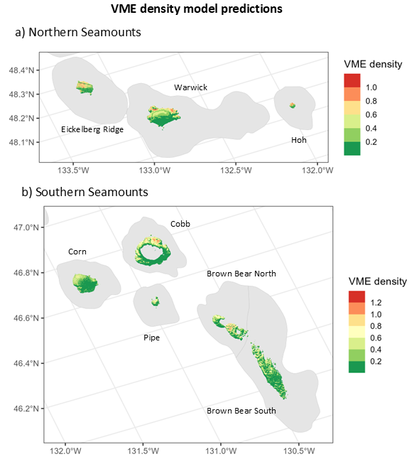

Figure 2. GAM-based VME density prediction map for the Cobb-Eickelberg seamount chain Northern Seamounts (a) and Southern Seamounts (b).Red represents predicted high density and green represents predicted low density. Grey shaded area represents seamount depths outside of the prediction area, which was limited to 400-1200m in depth.

Model evaluation
AUV segments were grouped into five roughly equal folds for cross-validation (CV; 44 or 45 AUV transect segments in each fold). The folds were spatially aggregated along each transect to reduce the amount of spatial autocorrelation between training and testing data. For each CV model, we made predictions at the test (hold-out) data locations. We pooled the test predictions from the CV models to calculate R² as the squared Pearson’s correlation between all test observation and test predictions. We opted to pool test predictions to calculate a single R² because of our small sample size and a high proportion of zero observations in one fold. Training data R² was 0.512 and testing data R² was 0.387.

Identifying Potential VMEs
We converted the VME indicator taxa density predictions to binary predictions of potential VME presence areas using the 0.58 VME indicator taxa colonies m⁻² threshold described in our updated methods for identifying VMEs (Warawa et al. 2025, see Figure 3 in the paper).

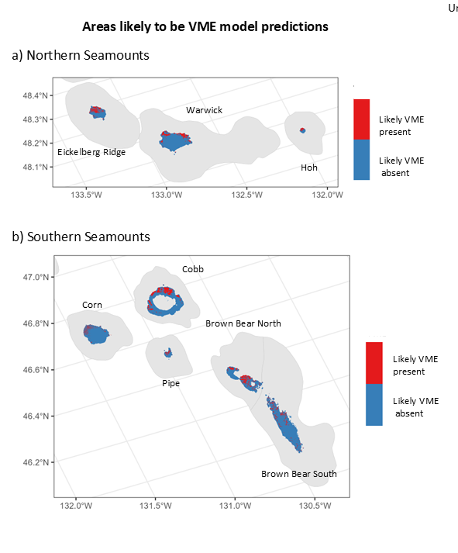
Figure 3. GAM-based VME presence prediction map for the Cobb-Eickelberg seamount chain Northern Seamounts (a) and Southern Seamounts. Potential VME presence (red) is determined by applying the VME density threshold (0.58) (see Warawa et al. 2025) to the VME density prediction model output. Grey shaded area represents depths outside of the prediction area, which was limited to 400-1200 m in depth.

DISCUSSION
Based on our predictive models of VME indicator taxa density, we hypothesize that there are high VME indicator taxa densities on all seamounts in the Cobb-Eickelberg seamount chain. Potential VMEs were predicted on all seamounts in the study area based on application of our updated VME indicator taxa density threshold of 0.58 VME indicator colonies m⁻² to our model predictions (Figure 3). According to the flow chart for identifying data to identify VMEs (NPFC 2025a; NPFC 2025b), areas identified as potential VMEs are high priority areas to undertake visual surveys to ground-truth predictions and confirm whether or not potential VMEs are indeed VMEs.

Next steps
- We invite feedback on our proposed methodology to identify areas where vulnerable marine ecosystems (VMEs) are likely to occur (i.e., potential VMEs). We will then revise our method as needed, apply it along the Cobb-Eickelberg seamount chain, and provide advice to the NPFC on the locations of these potential VMEs.

REFERENCES
Chu JWF, Nephin J, Georgian S, Knudby A, Rooper C, and Gale KSP. (2019). Modelling the environmental niche space and distributions of cold-water corals and sponges in the Canadian northeast Pacific Ocean. Deep-Sea Research Part I, 151:103063.

Curtis JMR, Du Preez C, Davies SC, Pegg J, Clarke ME, Fruh EL, Morgan K, Gauthier S, Gatien G, and Carolsfeld W. (2015). 2012 Expedition to Cobb Seamount: Survey methods, data collections, and species observations. Canadian Technical Report of Fisheries and Aquatic Sciences, 3124: xii + 145 p.

Elith J, Ferrier S, Huettmann F, and Leathwick J (2005). The evaluation strip: A new and robust method for plotting predicted responses from species distribution models. Ecol. Modell. 186(3): 280–289. doi:10.1016/j.ecolmodel.2004.12.007

Harris PT, Macmillan-Lawler M, Rupp J, & Baker EK (2014). Geomorphology of the oceans. Marine Geology, 352:4-24.

Hijmans R (2022). terra: Spatial Data Analysis. R package version 1.6-7, https://CRAN.R-project.org/package=terra

Naimi B, Hamm Na, Groen TA, Skidmore AK, Toxopeus AG (2014). Where is positional uncertainty a problem for species distribution modelling. Ecography, 37:191-203 Available at: https://doi.org/10.1111/j.1600-0587.2013.00205.x

North Pacific Fisheries Commission [NPFC] (2025a). Conservation and Management Measure (CMM) 2023-05 for Bottom Fisheries and Protection of Vulnerable Marine Ecosystems in the Northwestern Pacific Ocean. Available at: CMM 2025-05_For Bottom Fisheries and Protection of VMEs in the.pdf

North Pacific Fisheries Commission [NPFC] (2025b). Conservation and Management Measure (CMM) 2023-06 for Bottom Fisheries and Protection of Vulnerable Marine Ecosystems in the Northeastern Pacific Ocean. Available at: CMM 2025-06_For Bottom Fisheries and Protection of VMEs in the_0.pdf

North Pacific Fisheries Commission [NPFC] (2024). 8th Meeting Report. NPFC-2023-COM07-Final Report. 735 pp. (Available at www.npfc.int)

Parker T and Tunnicliffe V (1994) Dispersal strategies of the biota on an oceanic seamount: implications for ecology and biogeography. Biological Bulletin, 187:336–345.

Rooper CN, Goddard P, Wright C, Conrath C, Rand K, Lowe V. (2023). Joint Canada-USA International Seamount Survey update for 2023. NPFC-2023-SSC BFME04-IP02.

Warawa DR, Nephin J, Rooper CN, Dudas S, Knudby A, Chu JWF, Georgian S, Curtis JMR. (2023). Identifying potential VMEs on the Cobb-Eickelberg seamount chain based on predictive modelling. NPFC-2023-SSC BFME04-WP12.

Warawa DR, Rooper CN, Curtis JMR. (2025). Updated identification of VMEs on Cobb Seamount in the Northeast Pacific Ocean by including pennatulaceans as VME indicator taxa.
NPFC-2025-SSC BFME06-WP14.

Wood SN (2011). Fast stable restricted maximum likelihood and marginal likelihood estimation of semiparametric generalized linear models. Journal of the Royal Statistical Society (B) 73(1):3-36.

