NPFC-2025-SSC BFME06-WP03
  - Species Summary
NPFC Small Scientific Committee on Bottom Fish and Marine Ecosystems
2025-10-16

Blackspotted and Rougheye Rockfishes

(Sebastes melanostictus and Sebastes aleutianus)
Common names:
アラメヌケ, Aramenuke (Japan)
한볼락, Han Bollak (Korea)
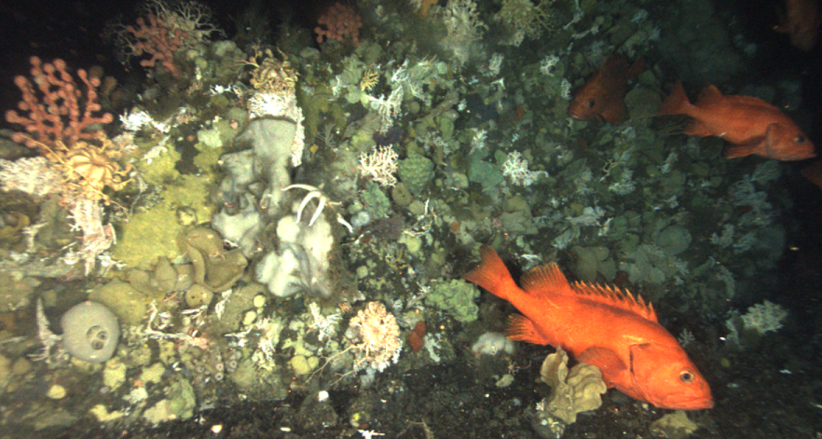
Figure 1. Blackspotted rockfish (Sebastes melanostictus).

Management

Active NPFC Management Measures
The following NPFC conservation and management measures (CMM) pertain to this species:
- CMM 2025-06 For Bottom Fisheries and Protection of VMEs in the NE Pacific Ocean
- CMM 2019-10 For Sablefish in the Northeastern Pacific Ocean
Available from https://www.npfc.int/active-conservation-and-management-measures

Management Summary
Blackspotted and rougheye rockfishes are captured in the longline trap fishery that targets sablefish (Anaplopoma fimbria) at seamounts in the eastern part of the NPFC Convention Area. The current management measure for blackspotted and rougheye rockfishes specifies both catch and effort limits. The allowable catch of blackspotted and rougheye rockfishes in the eastern portion of the Convention Area is based on a long-term mean of historical catches from seamounts by Canada. It allows for 2.3 mt to be landed each month for the 6 months of the fishing season (April to September). The fishery is also managed through input controls by only allowing a single vessel to fish in each month. The 1-3 Canadian vessels licensed to fish in the NPFC Convention Area are submitted to the NPFC Secretariat annually.
Current status of management measures
Convention.or.Management.Principle | Status | Comment.or.Consideration
Biological reference point(s) | Not accomplished | Not established
Stock status | Unknown | Status determination criteria not established
Catch limit | Known | Allowable catch of 2.3 mt per month (6 month season)
Harvest control rule | Not accomplished | Not established
Other | Known | Effort control (single vessel per month)

Assessment
No stock assessment is conducted for blackspotted and rougheye rockfishes in the NPFC Convention area.
It is unclear if the blackspotted and rougheye rockfish population on seamounts in the NPFC Convention Area is distinct from the population on the continental shelf of Canada. There is evidence of population structure in other regions, such as Alaska, where population trends and genetics indicate some structure on the order of ~1000 km (Shotwell and Hanselman 2019, Gharrett et al. 2007, Shotwell et al. 2014). This is about twice the distance from the continental shelf to the fished seamounts in the NPFC Convention Area, however there is potentially a large barrier to dispersal of deepwater between the shelf and the seamounts. There is no available tagging data to indicate whether the blackspotted and rougheye rockfishes at seamounts are connected to populations in domestic waters on the continental shelf. It is likely that the seamount populations are distinct stocks with distinct population trajectories.
Domestic stock assessments for blackspotted and rougheye rockfishes conducted in Canada assume there are two populations in domestic waters. These are assessed using a statistical catch at age model (DFO 2020). Assessments are also carried out in Alaska (Sullivan 2022, Spencer et al. 2022).

Data

Surveys
There is currently no survey conducted in the eastern NPFC Convention Area that captures or monitors blackspotted and rougheye rockfish populations.

Fishery
The Canadian high seas sablefish fishery typically operates at 1-4 seamounts in the commission area (Cobb, Eickleberg, Warwick and Brown Bear seamounts). Historically other seamounts have been fished for blackspotted and rougheye rockfishes both inside and outside Canada’s EEZ.
Fishing is conducted with longlined traps. Since 2014 a maximum of 3 vessels per year have been allowed to fish in NPFC waters. Historically the number of fishing vessels has averaged <3 per year (since 2008). The number of fishing days is the number of unique calendar days during which gear was set. The number of fishing days has averaged from about 25 to greater than 100, but in most years has averaged between 50 and 75 (Figure 2).
No Canadian vessels have chosen to fish for Sablefish in the Convention Area since 2020. This is likely due to a combination of economics (high fuel prices and the large distance to the seamounts), the availability of quota in the domestic fishery which is easier to access and hesitancy about the requirements under the implementation of the new NPFC AIS policy.
Both Canada and the U.S.A. have domestic fisheries that target blackspotted and rougheye rockfishes inside their EEZ’s. Blackspotted and rougheye rockfishes is also targeted in domestic trawl fisheries in Canada and the U.S.A.
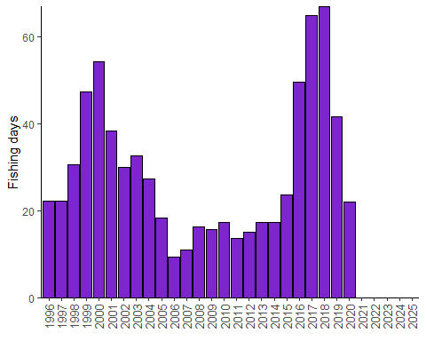
Figure 2. Fishing effort (in number of fishing days) for the Sablefish longline trap fishery conducted in NPFC waters (1996-present). Data are averaged across 3 years to comply with data privacy restrictions.
Output controls limit the landings of combined rougheye and blackspotted rockfish to 2.3 mt (in round weight). These measures have been in place since 2011.
Catches of blackspotted and rougheye rockfishes from NPFC region seamounts has ranged from an average of about 0.5 mt per year in 1996-2014 to about 4 mt in 2017 (Figure 3). Average annual catches were relatively low from 1996 to 2016 at NPFC seamounts and then increased in 2017-2018, with a decline to low levels in the last years. This increase in part probably reflects shifting sablefish effort due to closures of seamounts within Canada’s EEZ. An examination of coastwide shifts in the spatial pattern of fishing effort showed that fishing effort has become concentrated on Cobb Seamount, with increasing effort in shallower waters perhaps reflecting increased targeting of blackspotted and rougheye rockfishes relative to the past (Figure 4).
There has been no fishing effort at seamounts from 2021-2025 resulting in no catch.
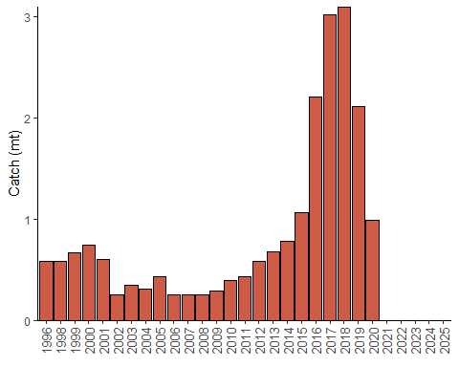
Figure 3. Landings of blackspotted and rougheye rockfishes in the Canadian Sablefish fishery in NPFC region (1996-present). Data are averaged across 3 years to comply with data privacy restrictions.
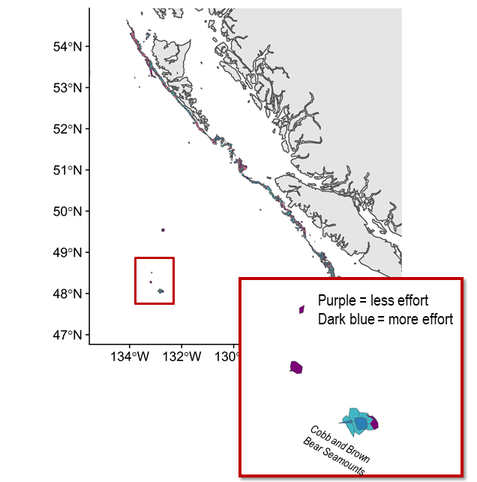
Figure 4. Relative change in spatial distribution of effort for Sablefish trap fishery from 2010-2017 to 2018-2019. Inset shows seamounts in the NPFC Convention Area.
Catch per unit of effort (mt/fishing days) for blackspotted and rougheye rockfishes has been increasing over the last 10 years (Figure 5), averaging 0.02 mt/fishing day (CV = 70%). CPUE was not calculated in 2025 due to the absence of fishing in the Convention Area, but has generally been increasing since 2012.
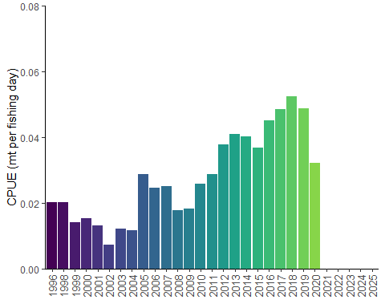
Figure 5. Catch per unit of effort for blackspotted and rougheye rockfishes in the Canadian Sablefish fishery in NPFC region. Data are averaged across 3 years to comply with data privacy restrictions.

Biological collections
No biological collections are taken from blackspotted and rougheye rockfishes captured in the NPFC Convention Area. Biological data are available from domestic fisheries and surveys in Canada.
Data availability from Members regarding blackspotted and rougheye rockfishes
Data | Source | Years | Comment
Catch | Canada | 1996-present | Catches from national waters and convention area
CPUE | Canada | 1996-present
Survey | None |  | Survey data are available from Canada and U.S.A. national waters
Age data | None |  | Data available from Canada and U.S.A. domestic fisheries and surveys
Length data | None |  | Data available from Canada and U.S.A. domestic fisheries and surveys
Maturity/fecundity | None |  | Data available from Canada and U.S.A. domestic fisheries and surveys

Special Comments
None

Biological Information

Distribution
Blackspotted and rougheye rockfishes are widely distributed throughout the Pacific Ocean from California to the Gulf of Alaska, westward to the Aleutian, and northward into the Bering Sea (Figure 6; Love et al. 2002). They are also found along the western margin of the Pacific Ocean from the Kuril Islands through the Kamchatka Peninsula and northward into the Bering Sea. Adult blackspotted and rougheye rockfishes occur in rocky habitat along the continental slope, shelf gullies, and in deep fjords, generally at depths from 150 to 450 m (Love et al. 2002). Juvenile blackspotted and rougheye rockfishes are found at shallower depths (250-300 m) at the continental shelf break. Until recently, these species were considered a single species (rougheye rockfish; Orr and Hawkins 2008).

Life history
Blackspotted and rougheye rockfishes are extremely long-lived, with maximum ages > 200 years. They mature late at about 20 years of age. These characteristics make them vulnerable to overfishing. The species are live-bearing, extruding larvae generally in the spring (February-June). Blackspotted and rougheye rockfishes are benthic feeders, consuming mostly shrimps, crabs and fishes (Yang and Nelson 2000).
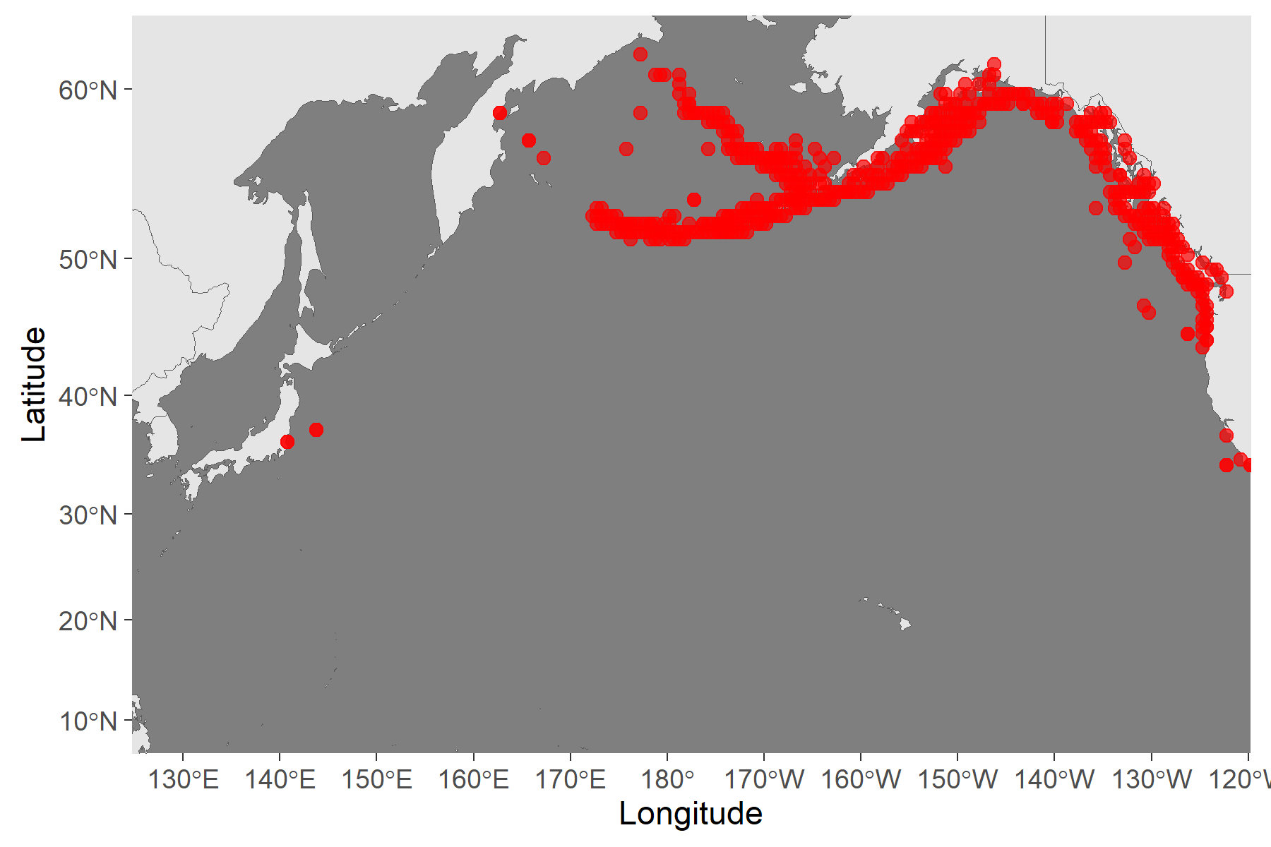
Figure 6. Map of distribution of blackspotted and rougheye rockfishes in the North Pacific.

Literature cited
DFO. 2020. Rougheye/Blackspotted Rockfish (Sebastes aleutianus/melanostictus) Stock Assessment for British Columbia in 2020. DFO Can. Sci. Advis. Sec. Sci. Advis. Rep. 2020/047.
Gharrett, A.J., A.P. Matala, E.L. Peterson, A.K. Gray, Z. Li, and J. Heifetz. 2007. Distribution and population genetic structure of sibling rougheye rockfish species. Pages 121-140 In J. Heifetz, J. DiCosimo, A.J. Gharrett, M.S. Love, V.M. O’Connell, and R.D. Stanley (eds.) 2007. Biology, assessment, and management of North Pacific rockfishes. Alaska Sea Grant College Publication AK-SG-07-01, University of Alaska Fairbanks.
Love, M.S., M. Yoklavich, and L. Thorsteinson. 2002.The Rockfishes of the North Pacific. University of California Press, Berkeley, California. 405 p.
Orr, J.W. and S. Hawkins. 2008. Species of the rougheye rockfish complex: resurrection of Sebastes melanostictus (Matsubara, 1934) and a redescription of Sebastes aleutianus (Jordan and Evermann, 1898) (Teleostei: Scorpaeniformes). Fish. Bull. 106(2):111-134
Shotwell, S.K., D.H Hanselman, P.J.F. Hulson, and J. Heifetz. 2014. Assessment of rougheye and blackspotted rockfish stock in the Gulf of Alaska. In Stock assessment and fishery evaluation report for the groundfish fisheries of the Gulf of Alaska. p.655-750. North Pacific Fishery Management Council, 605 W. 4th. Avenue, Suite 306, Anchorage, AK 9950-2252.
Sullivan J. 2022. Assessment of rougheye and blackspotted rockfish stock complex in the Gulf of Alaska. In Stock assessment and fishery evaluation report for the groundfish fisheries of the Gulf of Alaska. North Pacific Fishery Management Council, 605 W. 4th. Avenue, Suite 306, Anchorage, AK 9950-2252.
Spencer, P.D., J.N. Ianelli, and N. Laman. 2022. Assessment of the blackspotted and rougheye rockfish complex in the eastern Bering Sea/Aleutian Islands. In Stock assessment and fishery evaluation report BSAI. North Pacific Fishery Management Council, 605 W. 4th Ave, suite 306. Anchorage, AK 99501
Yang, M.S. and M.W. Nelson. 2000. Food habits of the commercially important groundfishes in the Gulf of Alaska in 1990, 1993, and 1996. NOAA Tech. Memo. NMFS-AFSC-112. 174 p.

