NPFC-2025-SC10-WP12

Final report of the Small Working Group on Data (SWG Data)

Executive summary
The Small Working Group on Data (SWG Data) met four times in 2025 (28 April, 4 June, and 12 August and 23 October 2025) via WebEx. The group, chaired by Karolina Molla Gazi (EU), advanced the development of the NPFC Scientific Committee (SC) database, including database architecture, user roles, confidentiality provisions, and harmonized templates. The SWG also reviewed the draft Conservation and Management Measure (CMM) on Minimum Data Standards, consolidating feedback from Members. Significant progress was achieved on defining data types, developing reference code lists, and outlining implementation steps.

Introduction
A database is a structured system for storing and managing large amounts of information in an organized and secure way. It ensures that all data are consistent, searchable, and easily accessible from a single location rather than scattered across multiple files and repositories. By maintaining standardized and up-to-date datasets, it promotes operational consistency, minimizes errors, and reduces redundant work. Built-in confidentiality controls (such as user roles and access permissions) enhance security, while documentation and tracking functions allow users to monitor modifications, imports, and exports. Overall, a database streamlines workflows, improves efficiency, and increases the overall quality and reliability of data management.
In the context of Regional Fisheries Management Organizations (RFMOs), a well-structured database is essential for effective scientific collaboration and credible stock assessment. RFMOs rely on data contributed by multiple Members, each with their own systems, formats, and standards. Without a common, centralized structure, data become fragmented, inconsistent, and difficult to integrate, eventually undermining the quality and comparability of analyses. A shared database provides a consistent framework for storing, managing, and accessing fisheries, and biological data, ensuring that all Members and expert groups work from the same verified and up-to-date information. This not only enhances transparency and reproducibility in stock assessments but also supports timely scientific advice by streamlining data preparation and reducing duplication of effort across working groups.
Confidentiality controls, such as user-based access levels, allow sensitive Member’s data to be stored securely while still enabling their use in joint analytical work, such as standardized CPUE analyses, stock assessment, and MSE development. In addition, version tracking and documentation features improve traceability and accountability, allowing scientists to follow the history of each dataset and the methods applied.

SC database development
The starting point of the work was figure 1, which illustrates the transition from the current to the proposed process for data sharing and scientific analysis among Members and subsidiary groups. At present, data are prepared using separate templates for each SC subgroup (e.g., SSC PS, SSC NFS, TWG CMSA, and other species) and submitted either by email or uploaded to the collaboration site. There is no systematic validation step, and data storage is fragmented between the collaboration site and the data warehouse. Data consolidation is carried out manually before being used for analysis. Under the proposed system, a common data template by data type will be used across all groups and submitted through a dedicated database interface. Validation will occur automatically during import, checking formats and allowed field values. Data will then be stored in a centralized database, where automated extraction queries will enable streamlined data consolidation and facilitate more efficient and consistent analyses.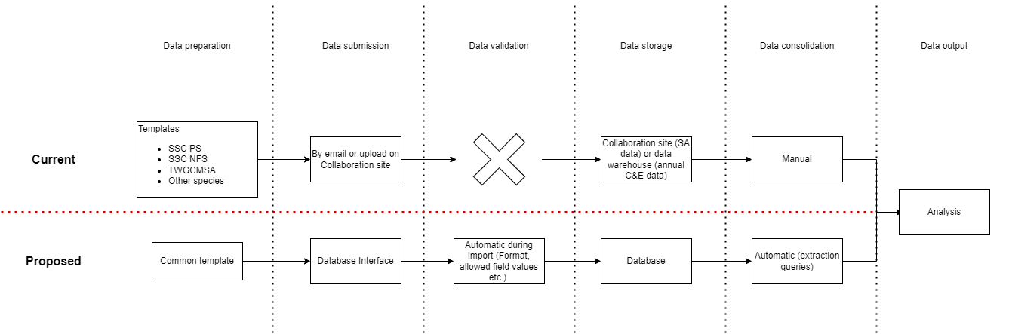
Figure 1: Current and proposed process for scientific data provision.
As a first step, the group discussed the types of data to be included in the database, based on a table of data categories previously compiled and circulated by the Secretariat (table 1).
Table 1: Data shared to support the NPFC stock assessments and scientific analyses.
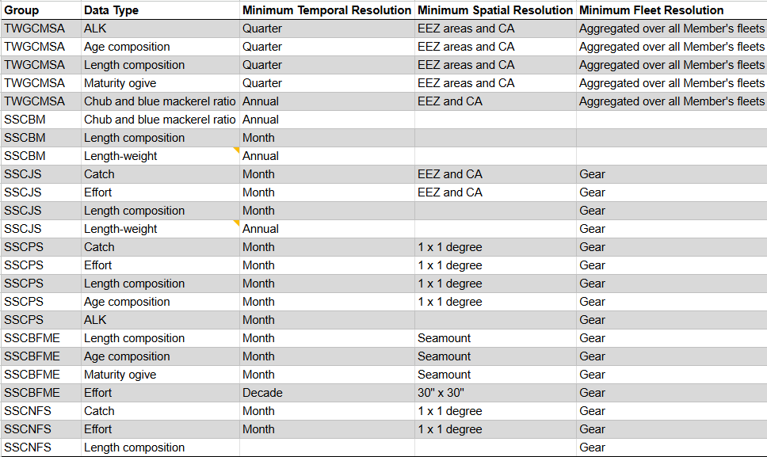
It was agreed that a clear distinction should be made between raw (unprocessed) data and processed or estimated data products, as these categories would require different templates and potentially separate storage tables. Figure 2 illustrates the relationship between raw, processed, and estimated data. On the left, raw data originate from logbooks and observer records on board, capturing catch, effort, and biological sampling information. These datasets are then transformed into processed data, such as monthly catch and effort summaries, annual footprint overviews, and biological ratios derived from sampling. Finally, these processed products feed into estimated data used for analyses, including Catch Per Unit Effort (CPUE) indices and aggregated biological estimates.
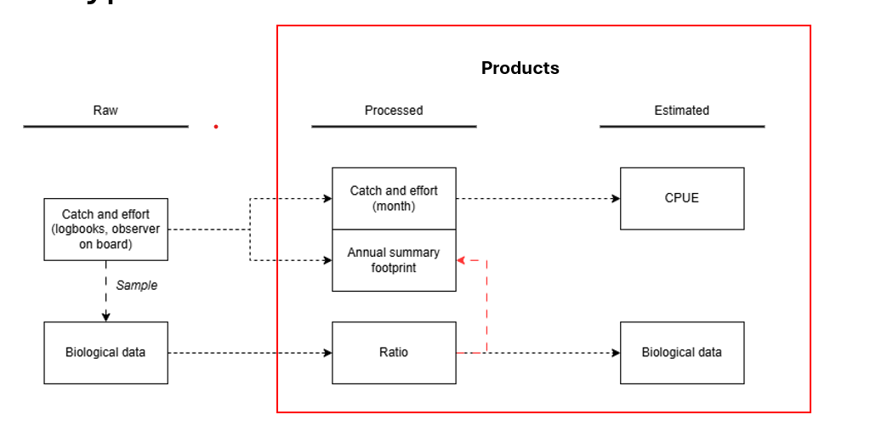
Figure 2: Schematic overview of the relationship between raw, processed, and estimated data types.
The Secretariat’s analyses identified the need to harmonize existing data templates among SC subsidiary groups that handle similar data, ensuring compatibility and consistency. It was acknowledged that certain specialized datasets, such as 30x30 effort data from bottom fisheries and VME visual survey data, may not be incorporated in the initial development phase but could be accommodated in future versions. It was also noted that raw data from bottom fishery observer programs are currently not shared directly with the Secretariat, but may be provided to specific expert groups for analytical purposes. The group also discussed the potential inclusion of hyperlinks within the database to relevant NPFC policies and protocols hosted on the NPFC website.
Table 2 shows the classification of different types of data according to their level of processing and analytical use.
Category | Examples
Raw data | Biological data
Processed data | Catch & effort (C&E), annual footprint, chub and blue mackerel ratio.
Estimated data | Standardized CPUE, ALK, length, age, maturity data
Table 2: Classification of different types of data.

Criteria for inclusion in the SC database
When determining which data types should be included, the primary criterion is whether the data are used directly and routinely in stock assessments or other scientific analyses that inform management decisions. These datasets form the foundation of the SC’s analytical work and must therefore be prioritized for inclusion. Additionally, data that may not currently be used in assessments but are commonly shared among Members because they provide valuable contextual or biological information could also be considered in the future.

User Roles and Confidentiality
User roles and confidentiality establish controlled access to data and system functions. Each user is assigned a specific role defining what actions they can perform, from uploading data to viewing restricted content. This role-based structure ensures data integrity, prevents unauthorized modifications, and maintains a clear audit trail of all activities. Confidentiality measures further protect sensitive or Member-specific data, allowing information to be shared securely while respecting data ownership and privacy agreements.
The access-control matrix in Annex 1 outlines user permissions following the standard CRUD model: Create, Read, Update, and Delete. These actions define what each user role can do within the various data domains, including Biological Estimates, Catch and Effort, and Ratio data. “Read” permissions allow users to view records, while “Create” and “Update” permissions enable them to add or modify data, generally restricted to information submitted by their own Member. “Delete” operations are implemented as soft deletes, meaning entries are archived rather than permanently removed, ensuring a complete audit trail. The use of the CRUD model provides a clear and consistent structure for managing data and maintaining transparency across user roles. The matrix also defines the roles within the system: Anonymous users have no access to Member-submitted data; Authenticated users can view publicly available reference information; Member Data Submitters can create, read, and update their own Member’s datasets; Species Data Analysts can read data for the species assigned to them; and the Secretariat has full CRUD permissions across all domains.
Table 3: Defined user roles and access rights.
Role | Description | Permissions | Notes
Anonymous User | A user who is not logged into the system. | Read access only to publicly available reference data (e.g., gear codes, species lists). | No access to any Member-submitted datasets.
Authenticated User | A registered user with an account but not associated with a Member for data submission. | Read-only access to non-sensitive reference data synchronised from MaM or public websites. | Cannot view or modify Member-level data.
Member Data Submitter | A user designated by a Member to upload, edit, and manage their own data submissions. | Full CRUD (Create, Read, Update, Delete*) for their own Member’s data in all required domains. | Delete operations are soft deletes (archive mode) to maintain an audit trail.
Species Data Analyst | A scientifically authorised user assigned specific species for analysis. | Read access to Member-submitted data for the species assigned to them. | No permission to create, update, or delete Member-submitted records.
Secretariat | Administrative users responsible for system oversight, coordination, and data governance. | Full CRUD across all data domains and Members. | Oversees system integrity, quality control, and administrative management.

Data templates & reference lists
It was agreed that each data type should correspond to a single harmonized template, to be developed in close coordination with the relevant subsidiary groups. The SWG Data coordinated with SSCs, TWGs, and SWGs to ensure data harmonization and requested a focal point to be nominated in order to review the templates developed under SWG Data. This process went smoothly and the SC’s subsidiary groups provided the necessary feedback which was incorporated to reflect their views.
This led to the creation of multiple templates capturing the different data types. For further information please refer to the collaboration site where they are stored. In addition, code reference lists in a database provide standardized sets of predefined values, such as species codes, gear types, or country identifiers, that ensure consistency and accuracy across datasets (table 3). They prevent discrepancies caused by variations in naming or formatting and make it easier to validate, compare, and integrate data from multiple sources.

Table 4: Illustrative example of reference lists.
Field | Description | Example(s)
SizeType | Measurement types and definitions | FL – Fork length; TL – Total length
NumbersUnit | Units for numbers of specimens | C – Count; K – Thousands; M – Millions
EffortUnits | Units for measuring fishing effort | kwd – Kilowatt-days; fd – Fishing days
Members | Codes and names of Members | CA – Canada; EU – European Union; JP – Japan
Species | Codes, names, and references | MAS – Scomber japonicus; SAP – Cololabis saira

Harmonizing and establishing definitions across all NPFC systems

During the meetings, the importance of adopting a common terminology to ensure consistency and comparability across the data submitted by Members was identified. Differences in terminology, such as variations in how effort, catch categories, or weight types are defined, can lead to misinterpretations and hinder the integration of datasets from different sources. Establishing standardized definitions and terms will make it possible to accurately compare, combine, and analyze data across Members. To that end, the SWG Data proposes to the SC that the following definitions are considered for adoption among all subsidiary bodies.

Table 5: Proposed definitions for weight and effort metrics.
Metric | Definition
Fishing days | Fishing days. Total time spent actively fishing (excludes transit, searching, or any other non-fishing activities) expressed in days.
Vessel days | Vessel days. Total days the vessel is at sea, including transit, searching and any other non-fishing activities.
Live weight | The weight of the whole fish as caught, prior to any processing (i.e. before gutting, heading, or removal of other parts).
Gutted weight | The weight of the fish after removal of internal organs (viscera), but before further processing such as heading, filleting, or skinning.

Coordination and Governance
It is important to establish a process for the inclusion of new codes in the official code lists is essential to ensure both flexibility and consistency in database management. A practical approach would be for each SC subsidiary group to propose new codes to the Secretariat whenever gaps or new needs are identified. The Subsidiary groups will bear the responsibility to verify the new proposed codes in terms of relevance, uniqueness, and alignment with the existing coding structure before formally integrating them into the master lists. This procedure ensures that the database can evolve to reflect emerging data requirements while maintaining a coherent and standardized system across all data submissions and analyses.

Deliverables and Timeline
Figure 3 illustrates the stepwise process for developing, testing, and releasing the SC database. The first draft of the templates was presented at SWG Data 03. These initial templates were then shared with Members and the SC subsidiary bodies for review under the Members Review Templates stage. Members provided feedback, which was compiled and circulated. Based on this input, the Prototype Development phase begins, during which the templates and database interface are further designed and adjusted.
Following prototype completion, Internal Testing will be conducted to verify functionality, consistency, and data handling. This stage may feed back into prototype development if issues or improvements are identified. It is expected that a manual will be developed at this phase to assist Members to populate the database. The process then moves to Training (expected in January 2026), where users are familiarized with the new system and templates, and finally to Release, marking the official deployment of the tested and approved database tools.
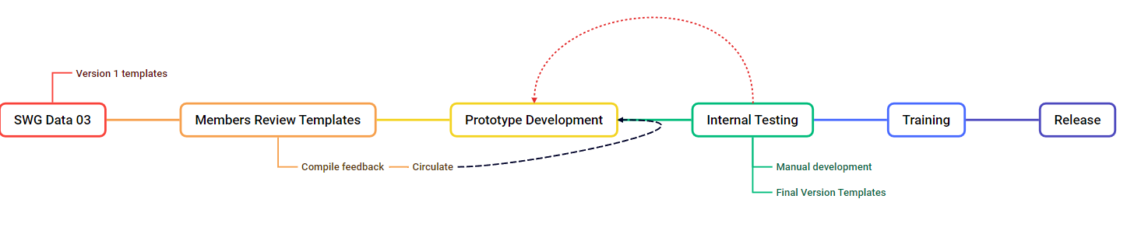
Figure 3: Process for developing, testing, and releasing the SC database.

Future developments
Further development of the database may include several enhancements to improve functionality, accessibility, and data transparency. These could involve the implementation of Data Dictionary tabs providing detailed field-level descriptions, and Charts tabs displaying Member submission coverage and other key visual summaries. Additional analytical charts and reports may also be developed to support more comprehensive data exploration. Technical improvements could include synchronization of data with the NPFC Data Warehouse to ensure consistency across systems, interface translation to support languages other than English, and interfaces for retrieving previous versions of updated records to enhance traceability. Together, these developments would strengthen usability and support broader participation and analytical capacity within the SC framework.

Review of the Draft CMM on Minimum Data Standards
The SWG Data was tasked with reviewing the EU-proposed draft CMM on Minimum Data Standards. Member feedback noted that many fields requested are not collected in logbooks, and detailed haul or tow data can only be realistically collected by observers. Fields for 'data source' (fisher or observer) and precise definitions of 'live weight' and 'fishing days' were recommended. A questionnaire was circulated after the second meeting to capture Members’ data collection practices, with responses due by 15 September 2025 for compilation before SC10.
Feedback to the CMM questionnaire was submitted by Canada, China, Chinese Taipei, Japan, Korea, Russia and the EU using the NPFC Minimum Standards Questionnaire templates. Each file included multiple annexes corresponding to data domains, such as general data collection, gear-specific information, and annual catch data. The responses were reviewed to determine which fields were completed, which were left blank, and where Members added written comments. All Members completed most annexes. The majority of fields contained “Yes”, showing that Members were collecting the information. Blank or “NA” cells were primarily associated with annexes that were not relevant to a Member’s fisheries. Only a small number of “No” or “Yes/No” entries were found. Across all submissions, approximately 70–75% of all cells contained “Yes”, about 10–15% contained “No” or “Yes/No”, and the remainder were blank or “NA”.

Annex summaries
Annex 1 – All Fishing Activities
All Members completed this annex, and almost all fields were marked “Yes”. A few fields were left blank or marked “NA” where specific identifiers or vessel categories did not apply. Several Members added comments clarifying that some identifiers (for example owner names or internal vessel codes) are not publicly shared or that the data exist in national systems but are not transmitted in this exact format. In addition, private and confidential information (such as the address of the master), it is not needed for scientific purposes.
Annex 2 – Trawl
This annex was completed by all Members with trawl fisheries. Most responses were “Yes”, confirming that trawl activity, catch, and sampling data are available. Blank or “NA” cells mainly appeared in submissions from Members without trawl operations. A small number of “No” responses were found in fields related to discarded weight. Comments commonly stated that the information in the logbooks focuses on main target species.
Annex 3 – Purse Seine
Annex 3 was completed by Members operating purse-seine fleets, including Japan, Korea, and Chinese Taipei. Nearly all fields were filled with “Yes”. Occasional “No” or “Yes/No” responses appeared in data-storage and reporting sections. Comments indicated that these data are collected through national observer programmes and stored within existing national institutes. Overall, this annex showed consistently high completeness and clear data structure across Members.
Annex 4 – Jigging
Only some Members operate jigging fisheries, and this annex was therefore partially completed. Where applicable, most fields contained “Yes”, but a few “No” entries were recorded. Comments referred to manual data entry still being used for part of the data flow and to ongoing efforts to move to digital reporting systems. The annex shows that the required information exists but that electronic data capture is still being expanded.
Annex 5 – Stick-Held Dip Net
Few Members use this gear, so most submissions marked this annex as “NA”. Where it was completed, nearly all fields were “Yes”. No explanatory comments were recorded. The annex was generally considered not relevant for most Members’ fisheries.
Annex 6 – Bottom Gear (Longline, Trap, Gillnet)
This annex was relevant only for Members with bottom-fishing operations. It was filled in by a small number of Members and marked “NA” by others. The completed sections contained a mixture of “Yes” and blank cells. Comments mainly stated that no vessels operate these gear types under NPFC authorization or that such activities occur only domestically. Where applicable, Members provided information indicating that data exist for these gears but are limited in spatial scope. It should be noted that the Annex for the trap gear was not included initially and it was proposed to be added by a Member, given that there are fisheries using this type of gear in NPFC.
Annex 7 – Annual Catch Data
All Members completed Annex 7, and almost every field was marked “Yes”. This annex showed the highest overall consistency. Only a few “NA” or blank cells appeared, mostly in optional metadata sections. The structure and completeness of this annex indicate that annual catch information is available for all Members in the format requested.

Completion by annex
All Members completed Annex 1 (All Fishing Activities) and Annex 7 (Annual Catch Data). Annexes 2–6 were completed to varying degrees, depending on whether the described gear types or activities occurred in that Member’s fisheries. Blank or “NA” cells mainly reflected non-applicability rather than lack of information. Comments were found in specific fields across the questionnaires. These were typically used to describe implementation status, applicability, or the type of national system used. Annex 2 provides a summary of the fields where responses differed from “Yes,” including the associated comments and their general content.

Recommendations to the Scientific Committee (SC10)
- The SWG Data suggests that the Scientific Committee consider adopting the common terminology discussed by the group regarding effort, gears, and the definitions of live and gutted weight.
- The SWG Data suggests that the Scientific Committee and its subsidiary bodies share information regarding the maturity scales and corresponding stages used at a national scale in order to develop the code list.
- The SWG Data suggests that the Scientific Committee endorses a 4-hour training workshop in January 2026 on the use of the database.
- The SWG Data suggests that the Scientific Committee considers continuing the SWG Data for one more year to finalize the development of the SC database.
- The SWG Data suggests that the Scientific Committee considers the future of the group and it’s scope beyond the development of the database.

  - ANNEX 1

NPFC Scientific Data Repository System Design Specification
NPFC

Exported on 03-Nov-2025

NPFC – NPFC Scientific Data Repository System Design Specification

Table of Contents

- Objectives 4
- User Operation 5
  - Exploring and Extracting Data 5
  - Loading Data 7
  - Updating Data 10
  - Scientific Analysis 11
  - Data Dictionary 11
- User Management and Authentication 13
- Access Control Matrix 15
- Data Structure 17
  - Entity Relationships Diagram 17
  - Data Updates and Revisioning 18
  - Delete (Archive) Operations 19
- Data Type: Biological Estimates - Raw 21
  - Data Entity Definition and Validation Rules 21
  - User Interface Wireframes 24
- Data Type: Biological Estimates - Age Composition 26
  - Data Entity Definition and Validation Rules 26
  - User Interface Wireframes 29
- Data Type: Biological Estimates - Length Composition 31
  - Data Entity Definition and Validation Rules 31
  - User Interface Wireframes 34
- Data Type: Biological Estimates - Maturity Ogive 36
  - Data Entity Definition and Validation Rules 36
  - User Interface Wireframes 38
- Data Type: Catch and Effort - Processed 40
  - Data Entity Definition and Validation Rules 40
  - User Interface Wireframes 42
- Data Type: Catch and Effort - CPUE 44
  - Data Entity Definition and Validation Rules 44
  - User Interface Wireframes 48
- Data Type: Catch by Species - Ratio 50
  - Data Entity Definition and Validation Rules 50
  - User Interface Wireframes 51
NPFC – NPFC Scientific Data Repository System Design Specification
- Data Warehouse Integration 53
  - Data Management Infrastructure Background 53
    - Data Warehouse Access Control 54
    - Scientific Data Synchronised to the Data Warehouse 54
- Prototype Implementation Plan 55
  - Future Development Items 55
- Ongoing, Maintenance and Capacity Requirements 57
  - Ongoing hosting and maintenance 57
  - Additional data types 57
  - Scientific reporting and analytical outputs 57
  - Secretariat capacity 57

Objectives
The aim of this web portal application is to establish a centralised repository of scientific datasets provided by NPFC Members. The repository is to enforce the use of standard data reporting templates for all Members and facilitate the extraction of data for analytical needs, with appropriate access controls.
Seven data types have been defined to be supported by the repository:
Biological Estimates - Raw
Biological Estimates - Age Composition
Biological Estimates - Length Composition
Biological Estimates - Maturity Ogive
Catch and Effort - Processes Catch and Effort - CPUE
Catch by Species - Ratio

User Operation

Exploring and Extracting Data
After logging into the portal, users will be presented with a landing page where they can navigate to explore the data of any of the supported data types.
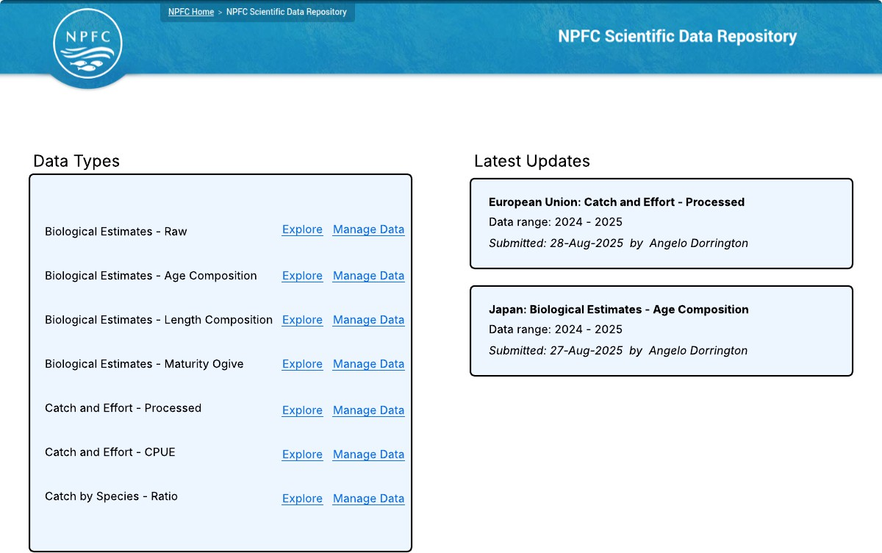

After selecting a data type the user will be presented with an ‘Explore Data’ page listing the 100 latest
records for that dataset, with pagination to allow exploring through more data records. The explore data page will allow for:
Filtering data by year (defaulting to current year)
Filtering data by submitting Member
Filtering data by species
Exporting data records into CSV format spreadsheets
The CSV export will respect the applied filters.
The CSV export will include all data columns for the data record, even where the ‘Explore Data’ tab shows only a subset of data columns due to the restricted screen space on a webpage.
An additional CSV export that includes the data revision history, i.e. one row per revision of a record.
Viewing a single record page - this is particularly useful for viewing all data fields of a particular record where the ‘Explore Data’ tab shows only a subset of data columns due to the restricted screen space on a webpage.

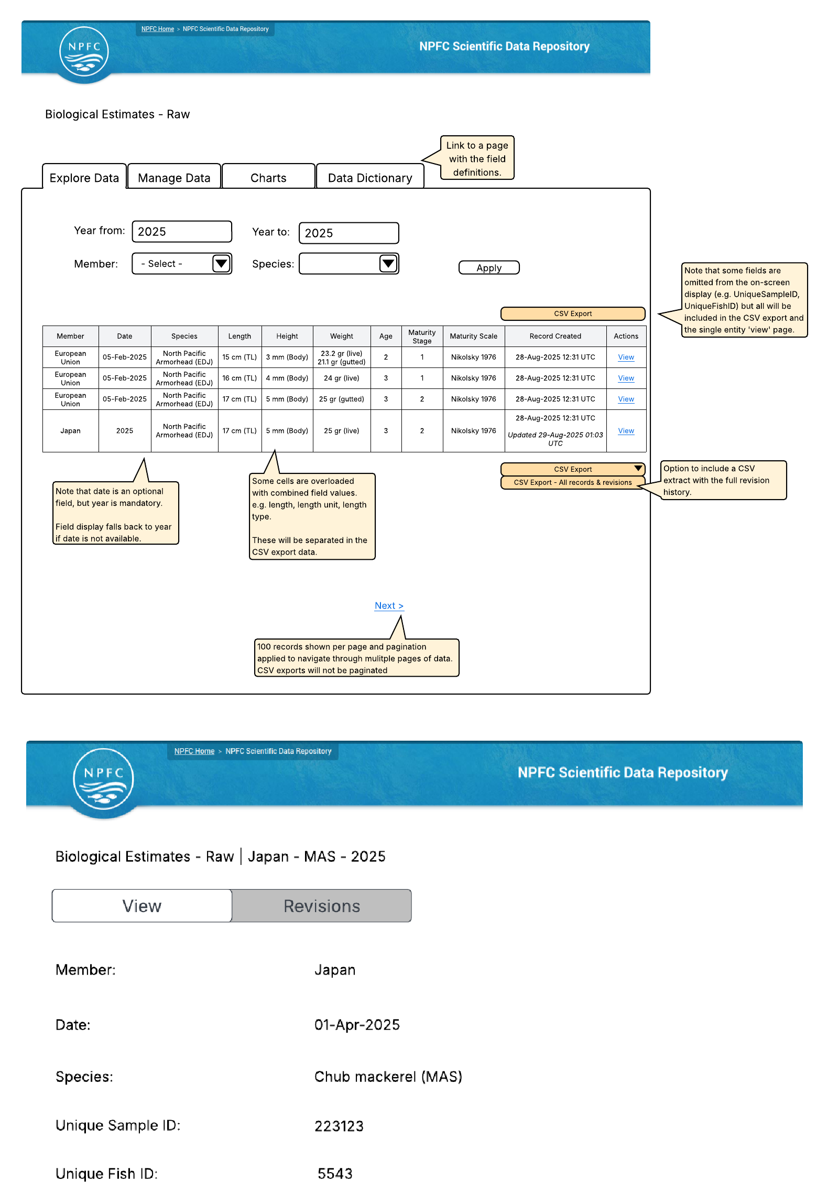

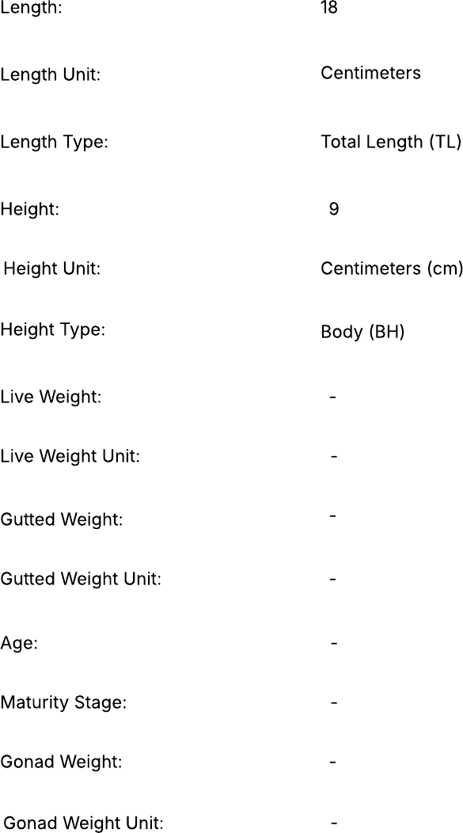

Loading Data
For each data type, users with sufficient access rights will be able to go to a ‘Manage Data’ tab.
From here users will be able to bulk-load data by uploading a CSV spreadsheet of data records they wish to submit.

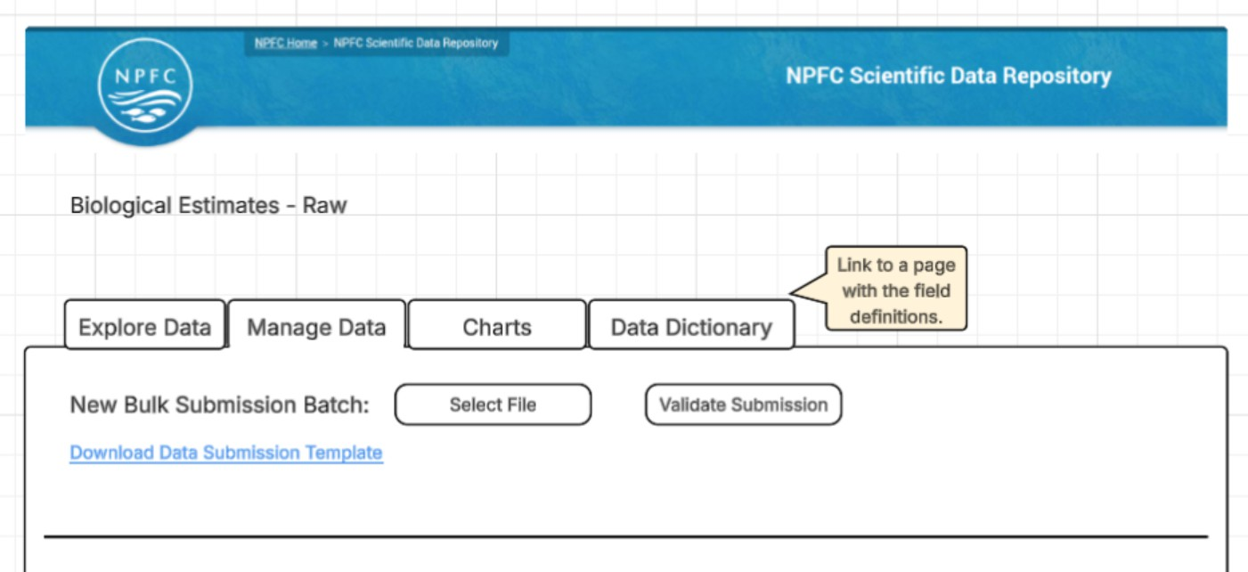

The uploaded spreadsheet will need to align with the template defined for that data type. An example template CSV file will be available for download, which will contain the correct column headers for data loading and some example records.
To further assist users to provide data in the correct format a ‘Data Dictionary’ tab will be available for each data type, which will contain detailed descriptions for each field.
After uploading a CSV file with data to load, the user will be taken to a validation / confirmation page.
If there are any validation errors that will restrict at least one row of data from being loaded then the user will be presented with information identifying which rows did not pass validation and they will not be able to proceed with the data load until they re-upload a file that successfully passes validation.
Examples of errors that will disallow the data batch to be loaded include:
Missing mandatory fields.
Fields with invalid options.
Numeric values outside of allowed ranges.
Multiple rows with identical composite key fields.

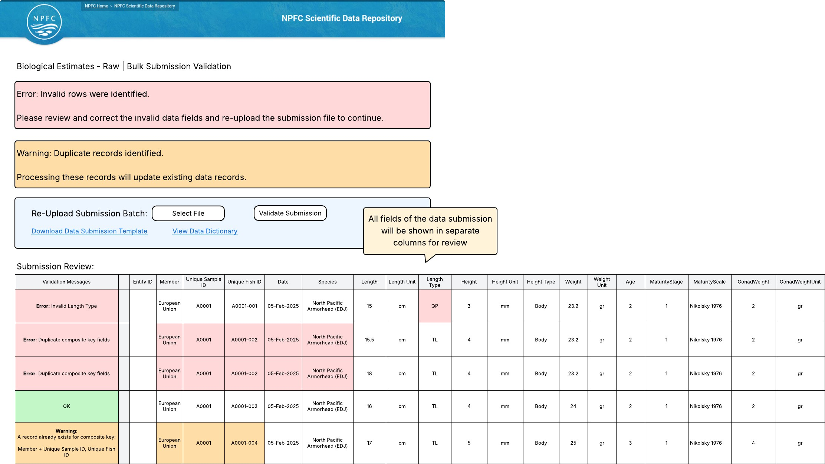
If there are no strict validation errors there may still be some data issues that trigger the presentation of warnings to the user, but do not stop them from continuing with the data load.
An example of a warning scenario is where composite key fields on a submitted data record match with an existing data record, identifying that the submitted record is a duplicate. In this scenario the user can choose to continue with the data load, which will result in the existing record being updated rather than a new record being created.
However, if a row is an exact match with a record already in the database, this row will simply be skipped and the existing row will be left untouched.
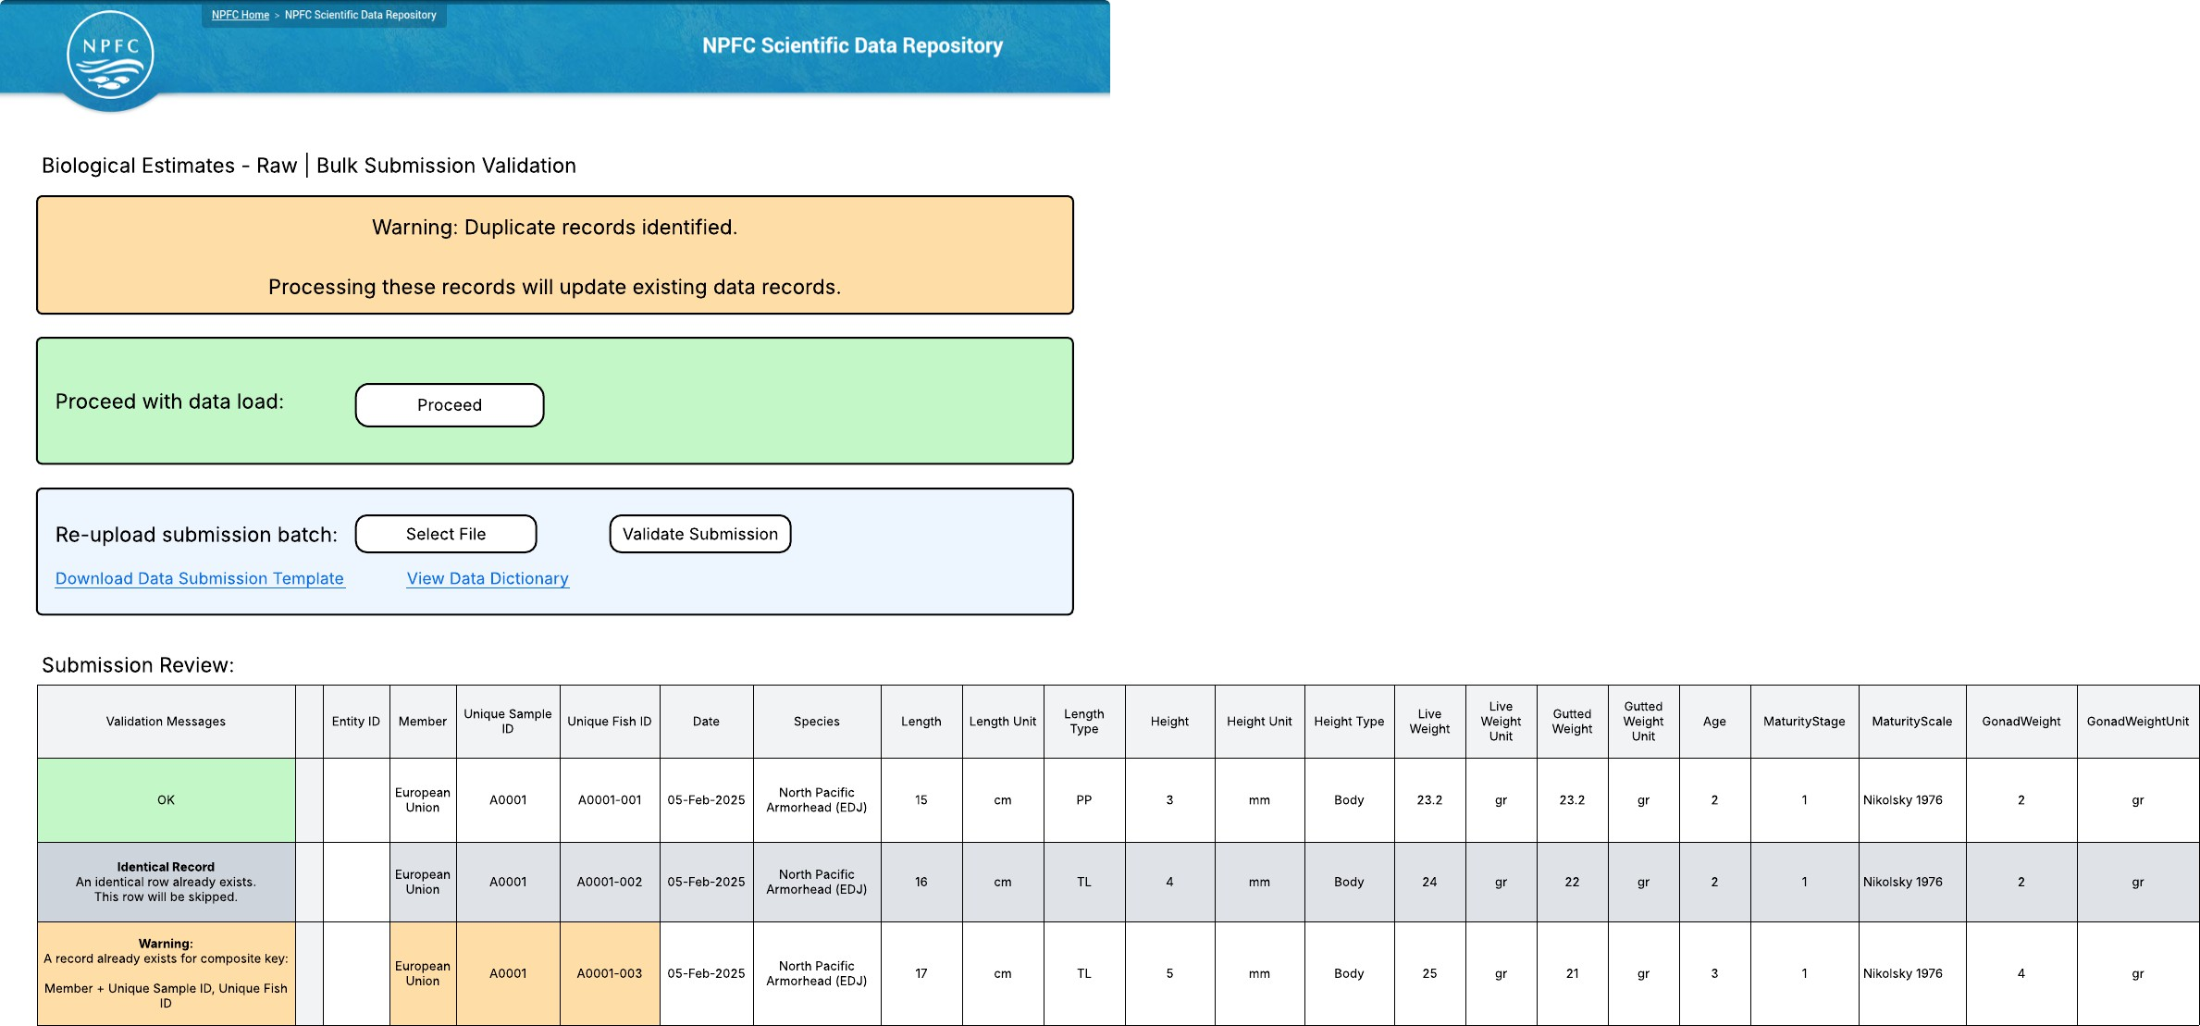

If there are no errors or warnings identified during the validation process, all rows will be marked with a green “Ok” message and the user can proceed with the loading operation.

Updating Data
If previously submitted data is found to be incorrect, or otherwise needs to be revised, it can be updated in several different ways.

Archive the old records and then submit new records.
The ‘Manage Data’ tab will provide data submitter users with the option to archive previously submitted
records, either based on selecting an upload batch or by selecting individual records.
Note that on the ‘Manage Data’ tab, users will only be presented with the rows that they have permission to
edit or archive, which in most cases will be the rows submitted by their own Member country.
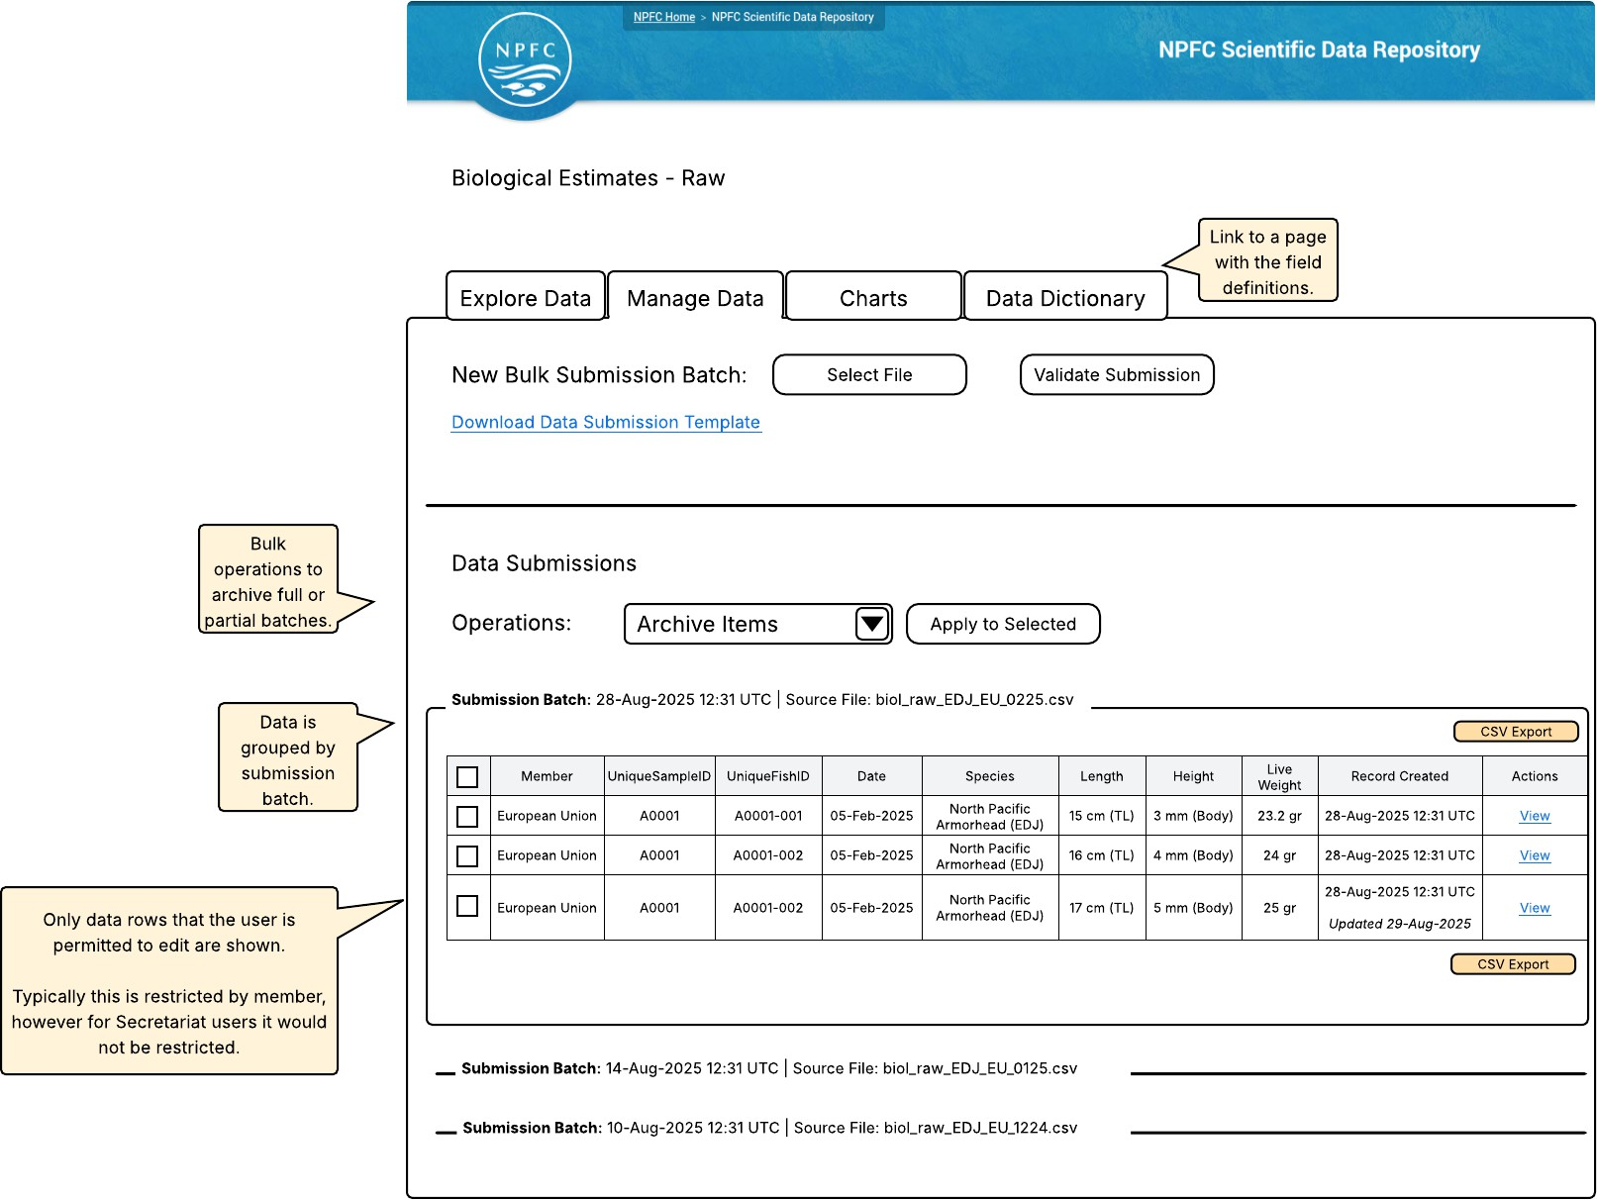
After the old records are archived, corrected records can be submitted.

Update operation during bulk CSV submission.
If a data row in a CSV bulk submission batch contains a value in the Entity ID field, it will be interpreted as intending to update the existing row identified by that Entity ID.
Similarly, if composite key values in a data row match that of an existing data record it will be identified as a duplicate and handled as an update operation.
The validation process will check that the user has sufficient permission to update the identified record and a warning will be presented to the user, requiring the user to confirm to proceed with the update.
If an existing record is updated, the database will maintain a revision history such that an audit trail of changes is maintained in the database. At this stage it is however not expected for the revision history to be available through the application user interface.

Scientific Analysis
It is expected that most data analysis will occur external to this application. The data repository portal will facilitate users with sufficient access rights to extract data from the repository in CSV format for external processing.
The data repository portal can however contain a ‘Charts’ tab for each data type. A first step may be for this tab will contain only a single chart, which will summarise the member submission coverage of the stored data using the Member, Year, Season and Date fields.
The Charts tab may be an area for future enhancement through the inclusion of other analytical outputs such as data driven charts.
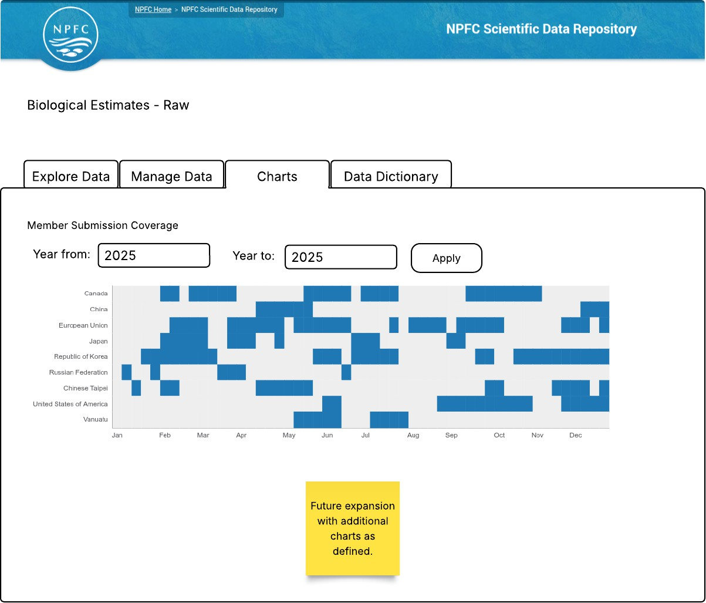

Data Dictionary
A Data Dictionary tab will be available for each data type and will present the definition of each data field included in that data type.

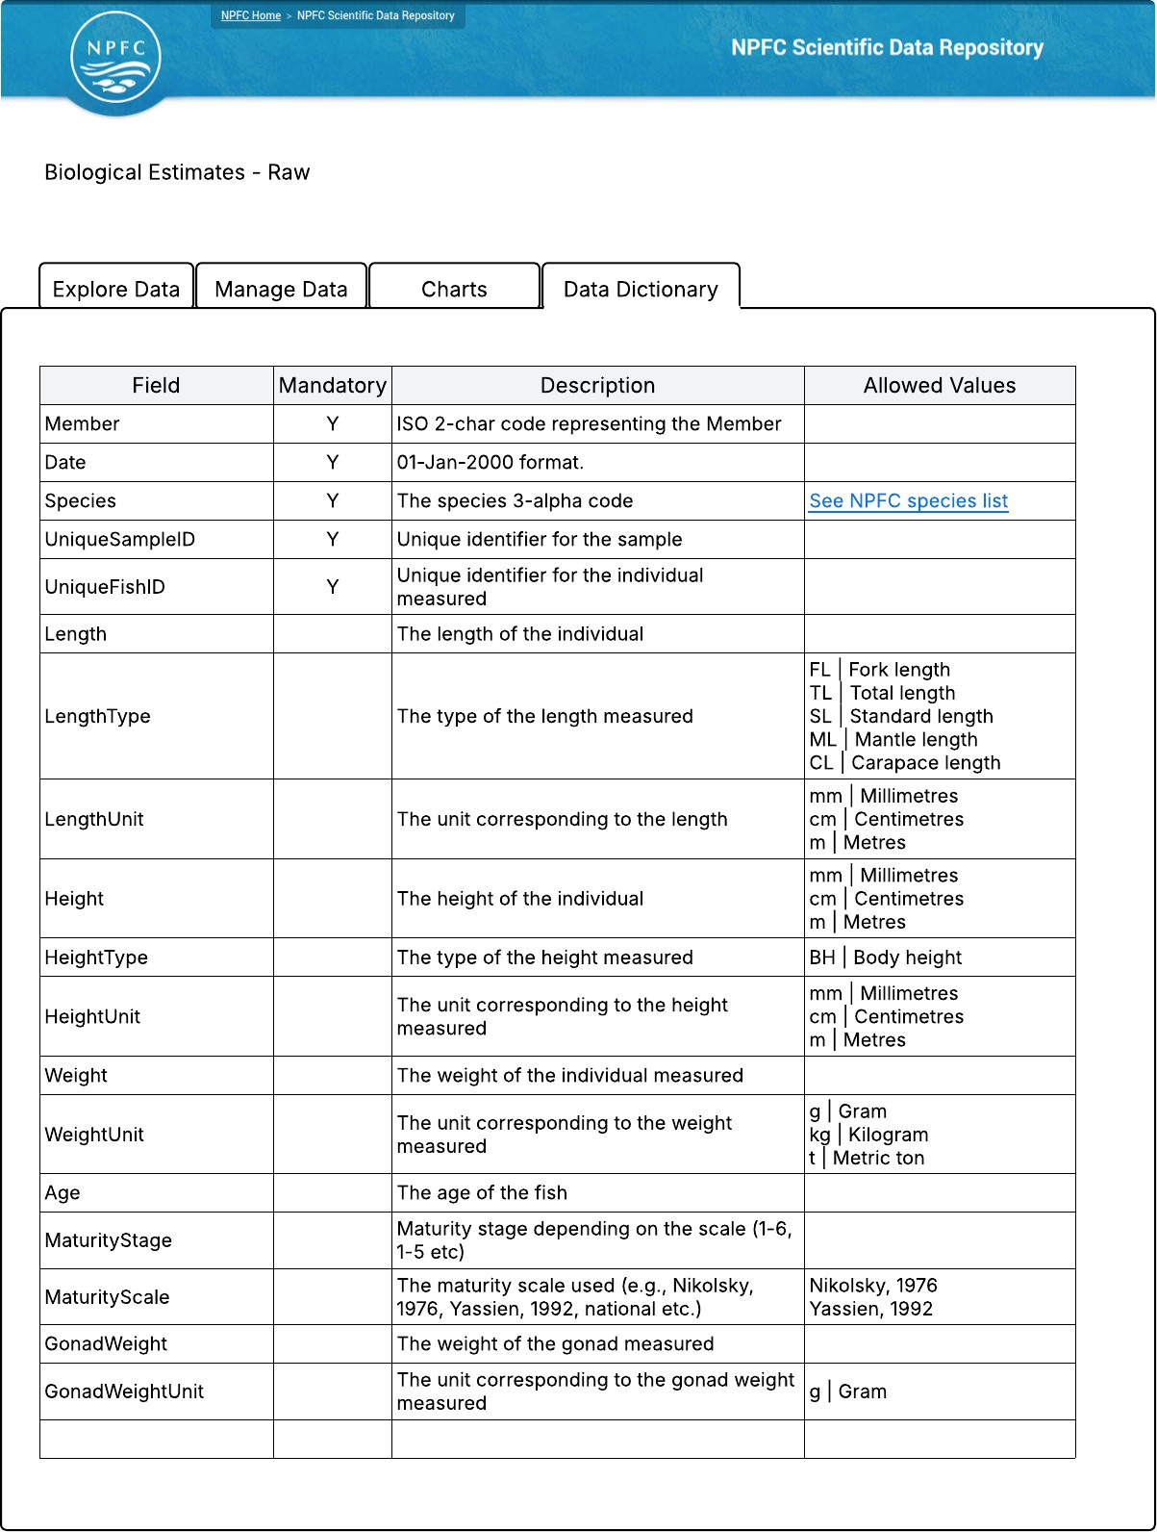

User Management and Authentication
The NPFC Scientific Data Repository will allow for the following roles. Access rules are defined within the Access Control Matrix (see page 15).
Member Data Submitter
Species Data Analyst
Secretariat
As per other NPFC web portals, user accounts will be managed through the NPFC Member Account Management (MaM) system, allowing users to access the system with a common set of credentials across different NPFC portals.
The NPFC MaM system will allow Group (Member) Admin users to delegate Member Data Submitter functional access to users within their group.
The Species Data Analyst functional role however will not be available for Group Admin users to assign themselves. This must be assigned by a NPFC User Admin. When a NPFC User Admin assigns the Species Data Analyst permission, they will also need to specify which species the user will be granted access. This is to be achieved by entering a comma separated list of species codes.
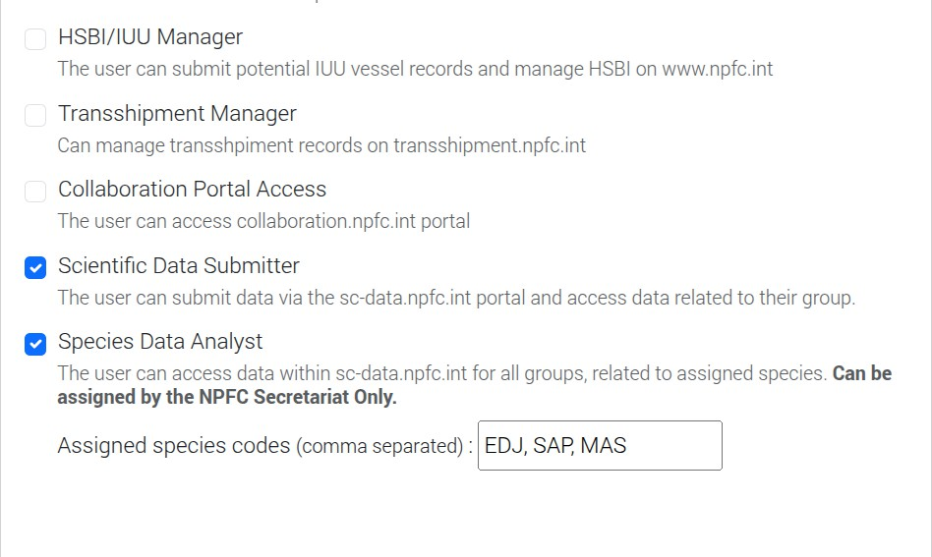

The following role mapping will be applied between the MaM system and the Scientific Data Repository.

MaM Group Security Access | SC Data Repository Role
Member : Scientific Data Submitter NEW  CNCP : Scientific Data Submitter NEW | Member Data Submitter

MaM Group Security Access | SC Data Repository Role
Member : Species Data Analyst NEW  CNCP : Species Data Analyst NEW  Secretariat Guests: Species Data Analyst NEW  (To be assigned with relevant species codes) | Species Data Analyst
Secretariat : Scientific Data Manager NEW | Secretariat

Access Control Matrix

 | Anonymous | Authenticated | Member Data Submitter | Species Data Analyst | Secretariat
Group (reference data synchronised from MaM) |  |  | R | R | R
Species  (reference data synchronised from website) |  |  | R | R | R
Gear Type  (reference data synchronised from website) |  |  | R | R | R
Biological Estimates - Raw |  |  | CRUD (where data references own Member only) | R (for assigned species only) | CRUD
Biological Estimates - Age Composition |  |  | CRUD (where data references own Member only) | R (for assigned species only) | CRUD
Biological Estimates - Length Composition |  |  | CRUD (where data references own Member only) | R (for assigned species only) | CRUD
Biological Estimates - Maturity Ogive |  |  | CRUD (where data references own Member only) | R (for assigned species only) | CRUD

 | Anonymous | Authenticated | Member Data Submitter | Species Data Analyst | Secretariat
Catch and Effort  - Processed |  |  | CRUD (where data references own Member only) | R (for assigned species only) | CRUD
Catch and Effort  - CPUE |  |  | CRUD (where data references own Member only) | R (for assigned species only) | CRUD
Catch by Species  - Ratio |  |  | CRUD (where data references own Member only) | R (for assigned species only) | CRUD
C = Create, R = Read, U = Update, D = Delete
All Delete operations are to be implemented as soft delete / archive operations. Operationally this will be equivalent to a delete, but allows for an audit trail of data changes to be maintained in the back-end database.

Data Structure

Entity Relationships Diagram
The below entity relationships diagram details the data entities to be included in this application.
The diagram includes three reference data entities. To ensure the consistency of reference data values used between different NPFC systems and datasets, the data for these three entities will be synchronised from the authoritative sources.

Dataset | Authoritative Source
Group  Note that Group is a broad term that encompasses Members, CNCPs, Observers, Secretariat. For the purposes of this application, Observer groups are not required and will not be synchronised into the scientific data repository application. | Member Account Management (MaM) System
Gear Type | NPFC Website
Species | NPFC Website

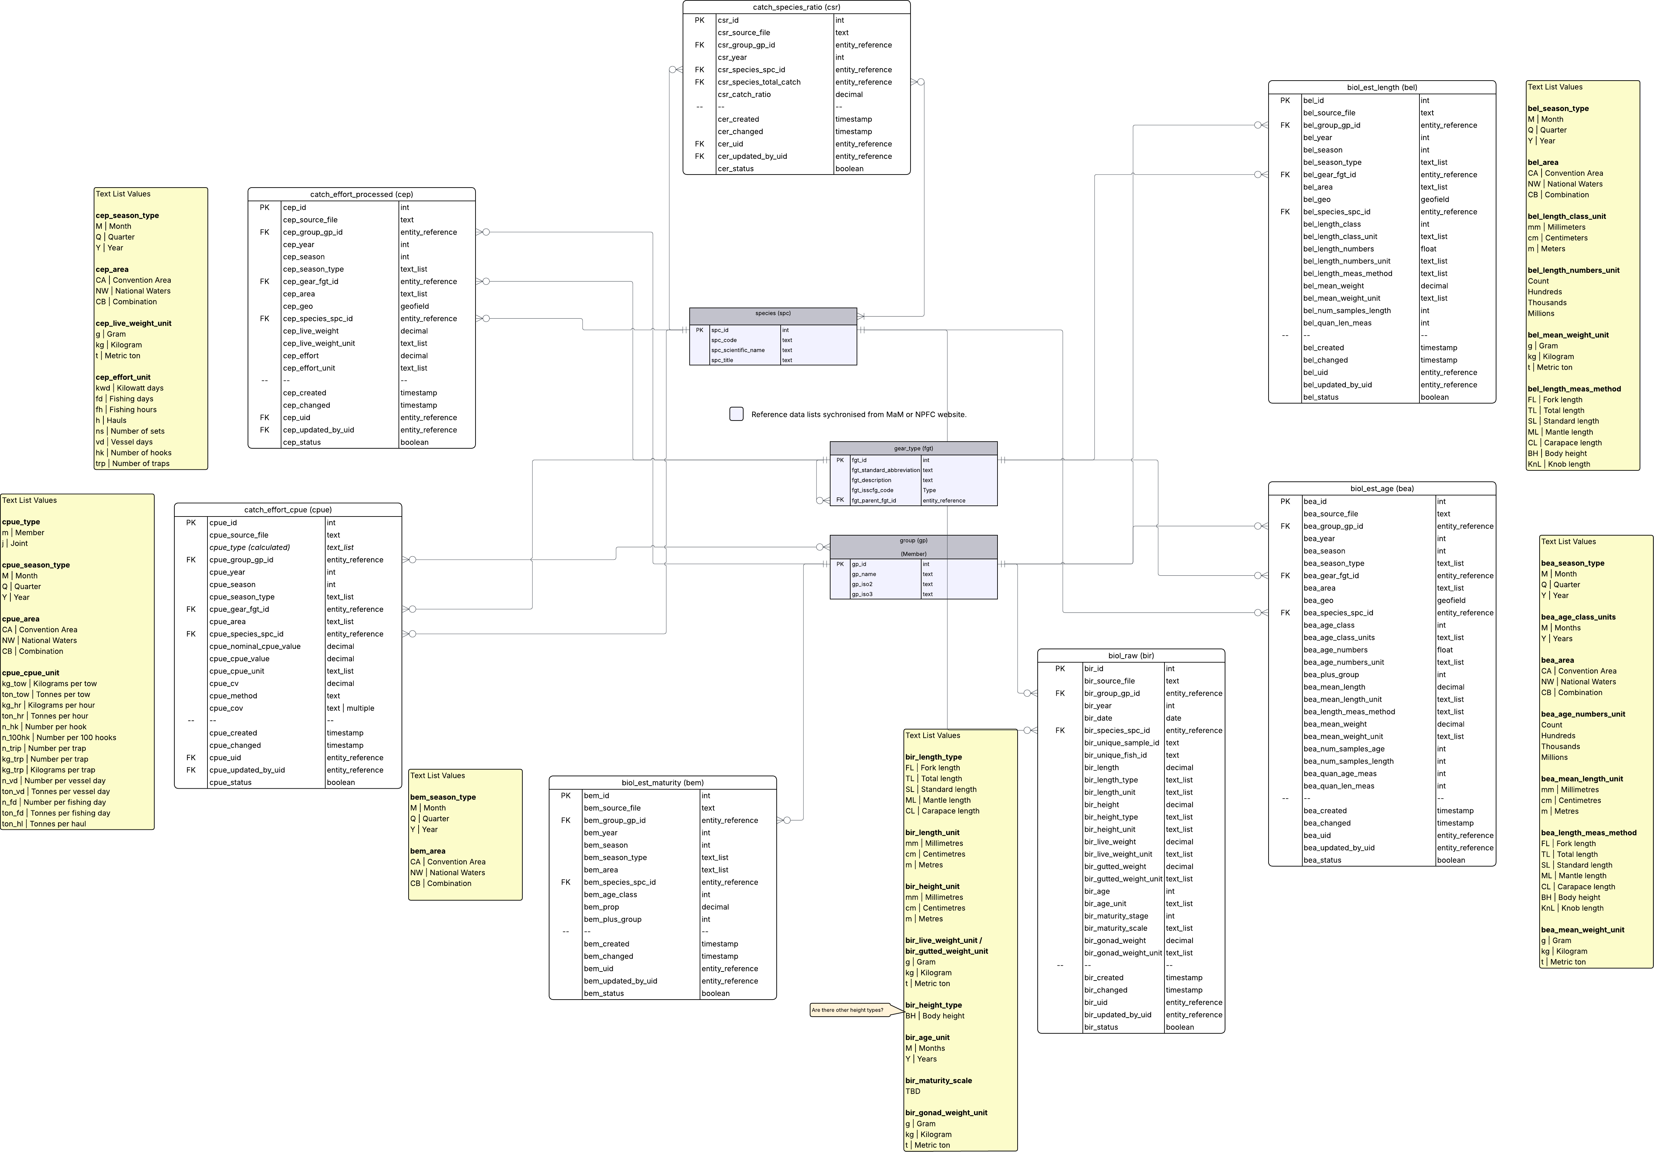

Data Updates and Revisioning
An update operation on a data record will occur:
- during a bulk data submission if the primary key Entity ID value is provided in a data row, identifying the row that is to be updated.
- during a bulk data submission if a provided data row contains a composite key that matches an existing record.
During the validation step of the data loading process, primary key or composite key matches will display as a warning, making the user aware that existing records will be updated but allowing them to review and continue.

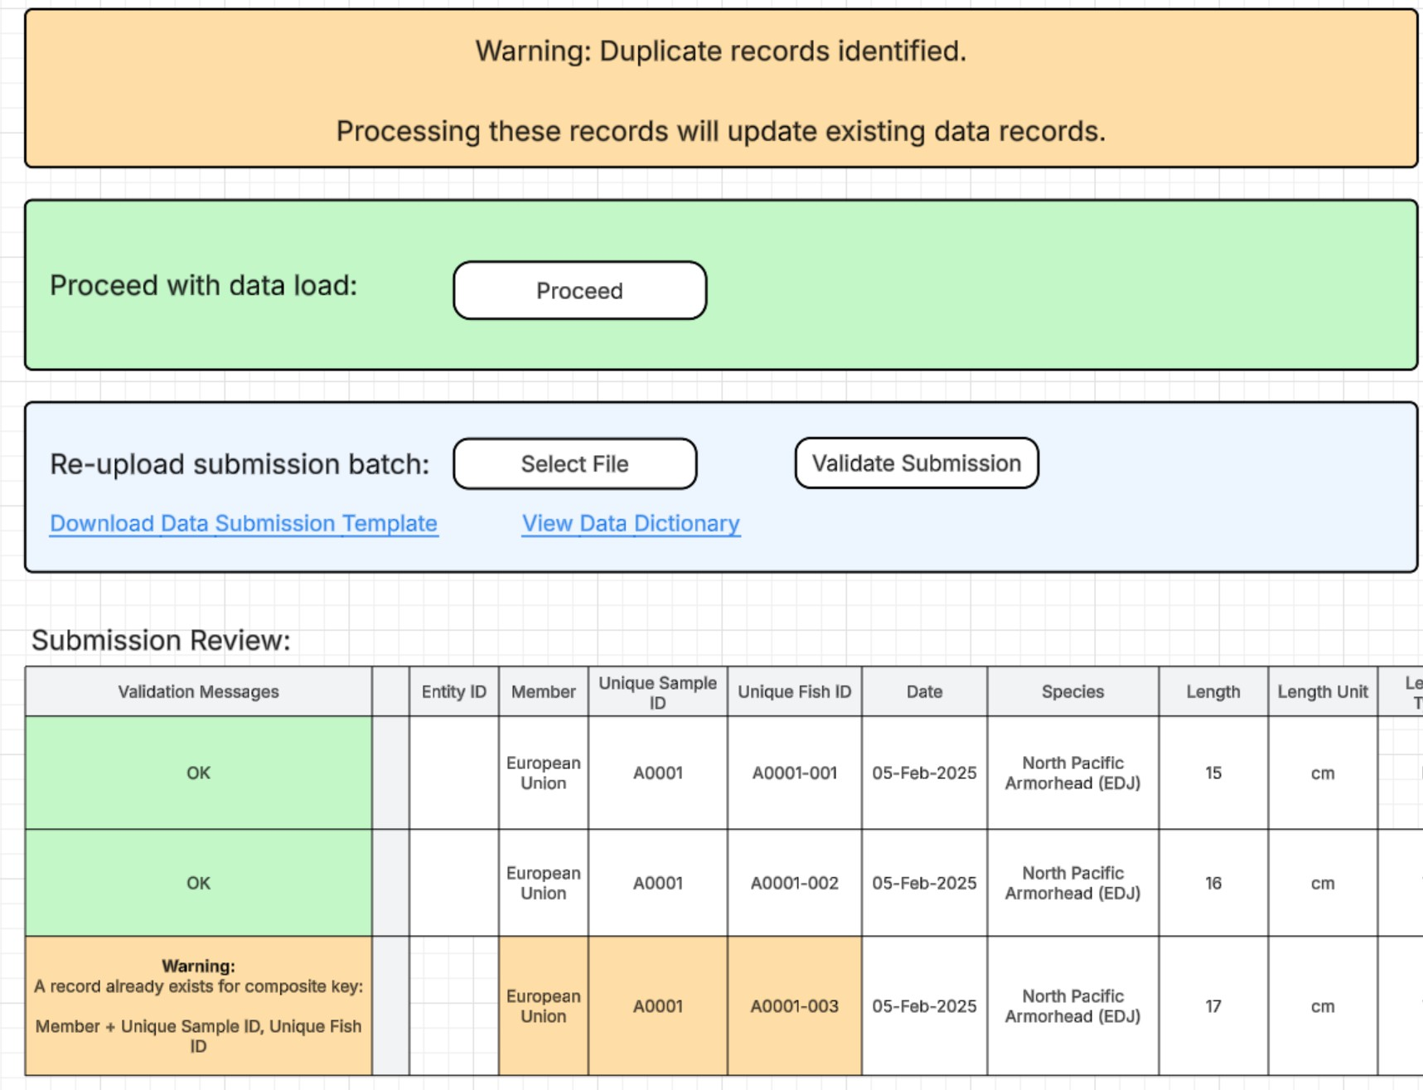
When an update operation occurs, the underlying database will maintain a revision history for that row. Each revision will also contain a timestamp and a reference to the user who performed that operation. This data revisioning strategy establishes an audit trail of data changes.

Delete (Archive) Operations
If data records have been loaded with mistakes, or a Member otherwise wishes to remove some data, this can be done from the Manage Data tab for the data type in question. Data Manager users will be able to select previously uploaded records either based on a whole submission batch or by selecting individual rows, and then select the ‘Archive Items’ bulk operation.
The archive operation will remove visibility of the selected records. Effectively this this akin to a delete, however the data will maintain in the database flagged as archived, which serves as an audit trail for the changes and allows for synchronisation of the archive operation to the data warehouse.

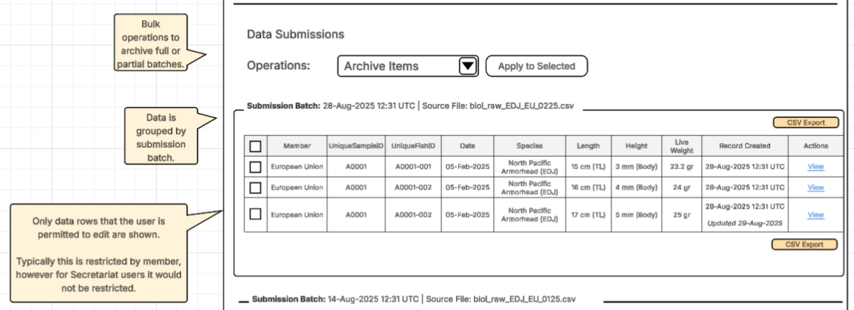
If a Member wishes to permanently purge (hard-delete) all of their records from the database, including the audit trail of changes, this would need to be handled as a special request to the Secretariat and performed as a manual task by the database maintainer.

Data Type: Biological Estimates - Raw

Data Entity Definition and Validation Rules

Field | Data Type | Label | Definition | Validation Rules
bir_id | int | Entity ID | Primary key identifying the data record. System generated. | PRIMARY KEY MANDATORY
bir_group_g p_id | entity_ref erence | Member | The Member who has submitted the data. | FOREIGN KEY MANDATORY  COMPOSITE KEY A
bir_date | date | Date | Date of the sample provided in format e.g. 01-Jan-2000 | MANDATORY  COMPOSITE KEY A
bir_species_ spc_id | entity_ref erence | Species | The species | MANDATORY  COMPOSITE KEY A
bir_unique_ sample_id | text | Unique Sample ID | Unique identifier for the sample | MANDATORY  COMPOSITE KEY A
bir_unique_f ish_id | text | Unique Fish ID | Unique identifier for the individual measured | MANDATORY  COMPOSITE KEY A
bir_length | decimal (8,2) | Length | The length of the individual | OPTIONAL  >0

Field | Data Type | Label | Definition | Validation Rules
bir_length_t ype | text_list | Length Type | The type of the length measured | OPTIONAL  Valid Options: FL | Fork length TL | Total length SL | Standard length  ML | Mantle length  CL | Carapace length
bir_length_u nit | text_list | Length Unit | The unit corresponding to the length | OPTIONAL  Valid Options: mm | Millimetres cm | Centimetres m | Metres
bir_height | decimal (8,2) | Height | The height of the individual | OPTIONAL  >0
bir_height_t ype | text_list | Height Type | The type of the height measured | OPTIONAL  Valid Options:  BH | Body height
bir_height_u nit | text_list | Height Unit | The unit corresponding to the height measured | OPTIONAL  Valid Options: mm | Millimetres cm | Centimetres m | Metres
bir_live_wei ght | decimal (8,3) | Live Weight | The "live" (ungutted, with head, tail, fins, gills and viscera intact.) weight of the individual measured | OPTIONAL  >0
bir_live_wei ght_unit | text_list | Live Weight Unit | The unit corresponding to the live weight measured | OPTIONAL  Valid Options:  g | Gram  kg | Kilogram t | Metric ton
bir_gutted_ weight | decimal (8,3) | Gutted Weight | The weight of the fish measured from which the viscera have been removed; head, tail, fins and skin remain. | OPTIONAL

Field | Data Type | Label | Definition | Validation Rules
bir_gutted_ weight_unit | text_list | Gutted Weight Unit | The unit corresponding to the gutted weight | OPTIONAL  Valid Options:  g | Gram  kg | Kilogram t | Metric ton
bir_age | int | Age | The age of the fish | OPTIONAL  >0
bir_age_unit | text_list | Age Unit | Unit of the age measurement, indicating the time increment used when reading growth structures. | OPTIONAL  Valid Options:  M | Months Y | Years
bir_maturity  _stage | int | Maturity State | Maturity stage depending on the scale (1-6, 1-5 etc) | OPTIONAL  TBD  >0
bir_maturity  _scale | text_list | Maturity Scale | The maturity scale used (e.g., Nikolsky, 1976, Yassien, 1992, national etc.) | OPTIONAL  Valid Options:  TBD
bir_gonad_ weight | decimal (8,3) | Gonad Weight | The weight of the gonad measured | OPTIONAL  >0
bir_gonad_ weight_unit | text_list | Gonad Weight Unit | The unit corresponding to the gonad weight measured | OPTIONAL  Valid Options:  g | Gram  kg | Kilogram t | Metric ton
COMPOSITE KEY A
bir_group_gp_id bir_unique_sample_id bir_unique_fish_id bir_date bir_species_spc_id

User Interface Wireframes
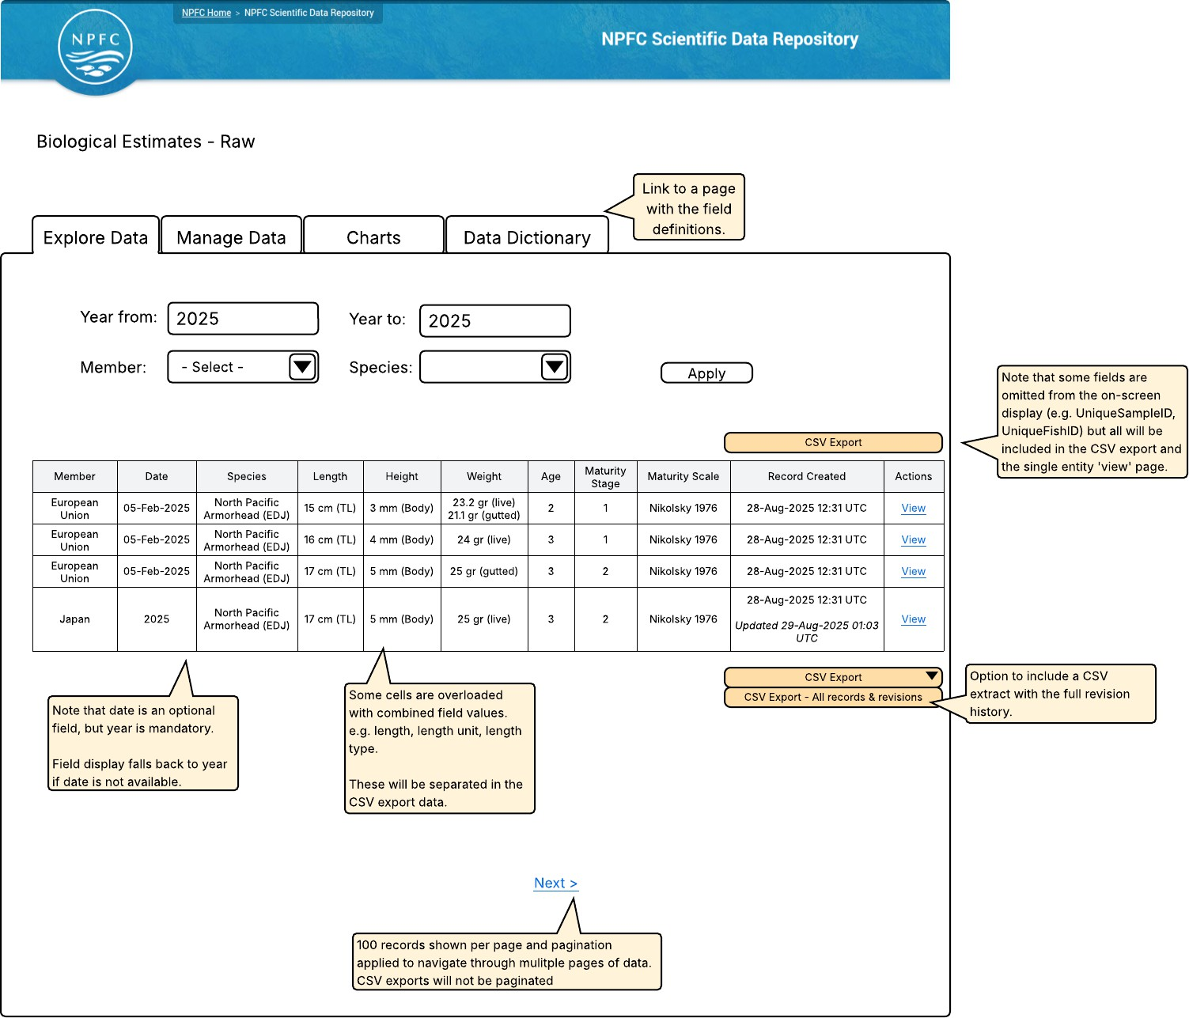

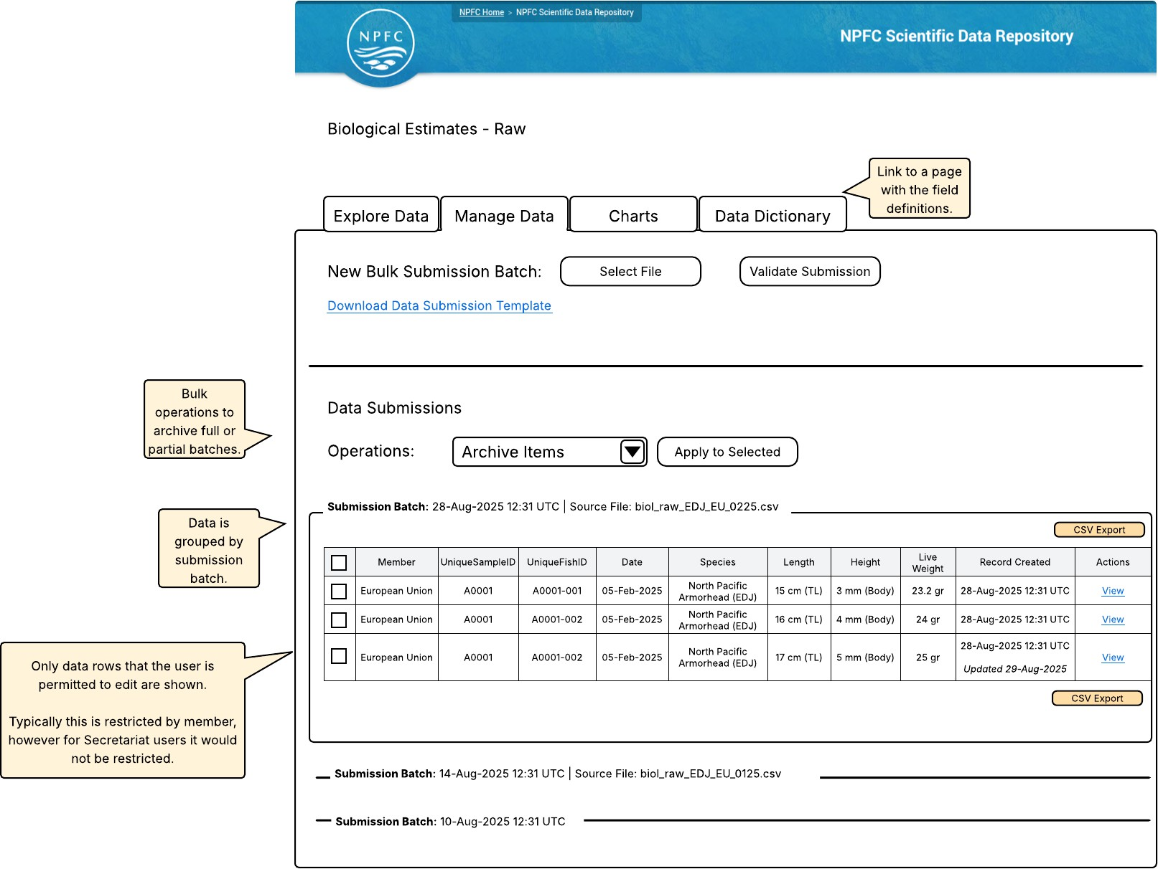

Data Type: Biological Estimates - Age Composition

Data Entity Definition and Validation Rules

Field | Data Type | Label | Definition | Validation Rules
bea_id | int | Entity ID | Primary key identifying the data record. System generated. | PRIMARY KEY MANDATORY
bea_grou p_gp_id | entity_r eferen ce | Member | The Member who has submitted the data. | FOREIGN KEY MANDATORY  COMPOSITE KEY A
bea_year | int | Year | The year of the data collection. | MANDATORY  4 digits  > 2000  COMPOSITE KEY A
bea_sea son | int | Season | The temporal aggregation level of the data. Can be the same as the year of the data collection | MANDATORY  If season_type is month, value must be between 1 and 12.  If season_type is quarter, value must be between 1 and 4.  If season_type is year, value must match the year field.  COMPOSITE KEY A
bea_sea son_type | text_lis t | Season Type | The type of temporal aggregation level. E.g., if the estimation is done on a quarter basis, then the SeasonType is Quarter | MANDATORY  Valid Options  M | Month Q | Quarter Y | Year  COMPOSITE KEY A
bea_gear  _fgt_id | entity_r eferen ce | Gear Type | The fishing gear type based on the ISSCFG list. | MANDATORY COMPOSITE KEY A

Field | Data Type | Label | Definition | Validation Rules
bea_area | text_lis t | Area | The area | MANDATORY  Valid Options  CA | Convention Area NW | National Waters CB | Combination  COMPOSITE KEY A
bea_geo | geofiel d | Latitude  / Longitud e | Decimal degree coordinates | ( MANDATORY COMPOSITE KEY A  ONLY if bea_gear_fgt_id references PS or NFS, otherwise optional.)
bea_spe cies_spc  _id | entity_r eferen ce | Species | The species | MANDATORY COMPOSITE KEY A
bea_age  _class | int | Age | The age class | MANDATORY COMPOSITE KEY A  Between 1 and 99
bea_age  _class_u nit | text_lis t | Age Class Unit | Unit of the age measurement, indicating the time increment used when reading growth structures. | MANDATORY COMPOSITE KEY A  Valid Options:  M | Month Y | Year
bea_age  _number s | float | Age Number s | The number of fish estimated in that age class | MANDATORY  >0
bea_age  _number s_unit | text_lis t | Age Number s Unit | Unit of the number of fish estimated in that age class | MANDATORY  Valid Options: Count Hundreds Thousands Millions
bea_plus  _group | int | Plus Group | The age where fish of a certain age and/or older are grouped at | OPTIONAL  >0

Field | Data Type | Label | Definition | Validation Rules
bea_mea n_length | decima l(8,2) | Mean Length | The mean length corresponding to the age class | OPTIONAL  >0
bea_mea n_length  _unit | text_lis t | Mean Length Unit | The mean length unit corresponding to the MeanLength | OPTIONAL  Valid Options:  mm | Millimetres cm | Centimetres m | Metres
bea_leng th_meas  _method | text_lis t | Length Measure ment Method | The measurement method of the fish. E.g., fork length, total length | OPTIONAL  Valid Options:  FL | Fork length TL | Total length  SL | Standard length ML | Mantle length CL | Carapace length BH | Body height  KnL | Knob length
bea_mea n_weight | decima l (8,3) | Mean Weight | The mean weight corresponding to the age class | OPTIONAL  >0
bea_mea n_weight  _unit | text_lis t | Mean Weight Unit | The mean weight unit corresponding to the Mean Weight | OPTIONAL  Valid Options:  g | Gram  kg | Kilogram t | Metric ton
bea_num  _sample s_age | int | Number of Age Samples | The number of age samples for the combination of fields defined by composite key A. | OPTIONAL  Between 1 and 9999
bea_num  _sample s_length | int | Number of Length Samples | The number of length samples for the combination of fields defined by composite key A. | OPTIONAL Between 1  and 9999
bea_qua n_age_m eas | int | Number of Fish Aged | The number of fish aged for the combination of fields defined by composite key A. | OPTIONAL Between 1  and 999999

Field | Data Type | Label | Definition | Validation Rules
bea_qua n_len_m eas | int | Number of Fish Length Measure d | The number of fish length measured for the combination of fields defined by composite key A.  Between 1 and 999999
COMPOSITE KEY A
bea_group_gp_id bea_year
bea_season
bea_season_type bea_gear_type
bea_area
bea_species_spc_id bea_age_class
bea_lat_lon (only included in composite key for PS and NFS)

User Interface Wireframes
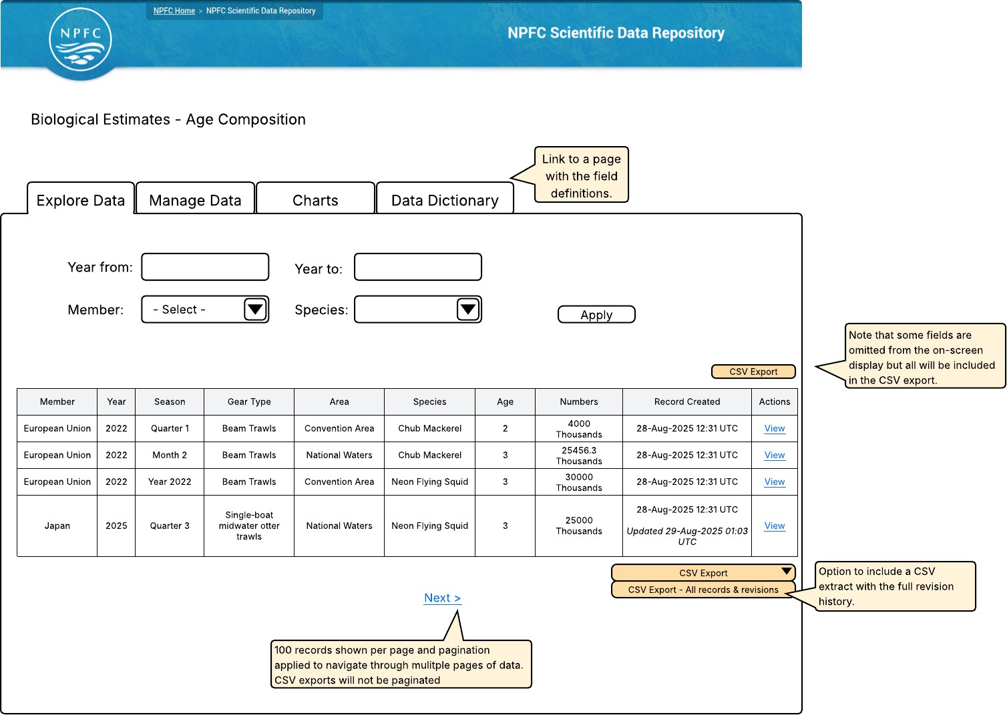

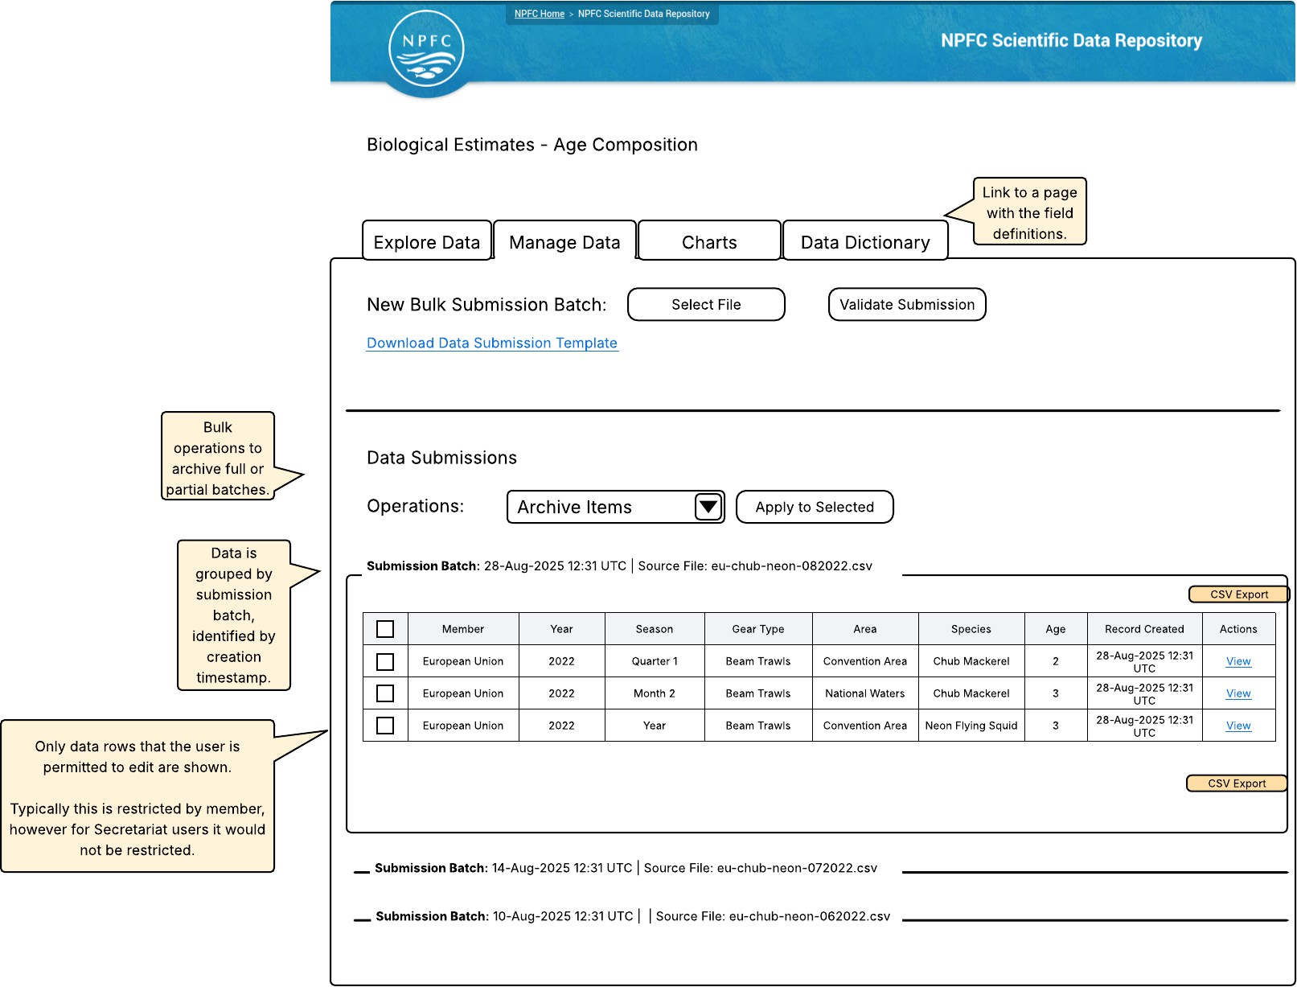

Data Type: Biological Estimates - Length Composition

Data Entity Definition and Validation Rules

Field | Data Type | Label | Definition | Validation Rules
bel_id | int | Entity ID | Primary key identifying the data record. System generated. | PRIMARY KEY MANDATORY
bel_gro up_gp_i d | entity_ referen ce | Membe r | The Member who has submitted the data. | FOREIGN KEY MANDATORY  COMPOSITE KEY A
bel_year | int | Year | The year of the data collection. | MANDATORY  4 digits  > 2000  COMPOSITE KEY A
bel_sea son | int | Season | The temporal aggregation level of the data. Can be the same as the year of the data collection | MANDATORY  If season_type is month, value must be between 1 and 12.  If season_type is quarter, value must be between 1 and 4.  If season_type is year, value must match the year field.  COMPOSITE KEY A
bel_sea son_typ e | text_lis t | Season Type | The type of temporal aggregation level. E.g., if the estimation is done on a quarter basis, then the SeasonType is Quarter | MANDATORY  Valid Options  M | Month Q | Quarter Y | Year  COMPOSITE KEY A
bel_gear  _fgt_id | entity_ referen ce | Gear Type | The fishing gear type based on the ISSCFG list. | MANDATORY COMPOSITE KEY A

Field | Data Type | Label | Definition | Validation Rules
bel_area | text_lis t | Area | The area | MANDATORY  Valid Options  CA | Convention Area NW | National Waters CB | Combination  COMPOSITE KEY A
bel_lat_l on | geofiel d | Latitude  / Longitu de | Decimal degree coordinates | ( MANDATORY if  bea_gear_fgt_id references PS or NFS, otherwise optional)
bel_spe cies_sp c_id | entity_ referen ce | Species | The species | MANDATORY COMPOSITE KEY A
bel_leng th_class | int | Length Class | The length class of the fish (usually following a common method for rounding to the nearest length class in cm if measured to the nearest mm) | MANDATORY  >0
bel_leng th_class  _unit | text_lis t | Length Class Unit | The length unit corresponding to that length class | MANDATORY  Valid Options:  mm | Millimeters cm | Centimeters m | Meters
bel_leng th_num bers | float | Number s | The number of fish estimated in that length class | MANDATORY  >0
bel_leng th_num bers_uni t | text_lis t | Number s Unit | Unit of the number of fish estimated in that length class | MANDATORY  Valid Options: Count Hundreds Thousands Millions

Field | Data Type | Label | Definition | Validation Rules
bel_leng th_mea s_meth od | text_lis t | Length Measur ement Method | The measurement method of the fish. E.g., fork length, total length | OPTIONAL  Valid Options:  FL | Fork length TL | Total length  SL | Standard length ML | Mantle length CL | Carapace length BH | Body height KnL | Knob length
bel_mea n_weigh t | decim al (8,3) | Mean Weight | The mean weight corresponding to the age class | OPTIONAL  >0
bel_mea n_weigh t_unit | text_lis t | Mean Weight Unit | The mean weight unit corresponding to the MeanWeight | OPTIONAL  Valid Options:  g | Gram  kg | Kilogram t | Metric ton
bel_num  _sample s_length | int | Number of Length Sample s | The number of age samples for the combination of Year*Season*SeasonType*Area*Fleet*Speci es | OPTIONAL  Between 1 and 9999
bel_qua n_len_m eas | int | Number of Fish Aged | The number of fish aged for the combination of Year*Season*SeasonType*Area*Fleet*Speci es | OPTIONAL Between 1  and 999999
COMPOSITE KEY A
bel_group_gp_id bel_year bel_season bel_season_type bel_gear_type bel_area bel_species_spc_id
bea_lat_lon (only included in composite key for PS and NFS)

User Interface Wireframes
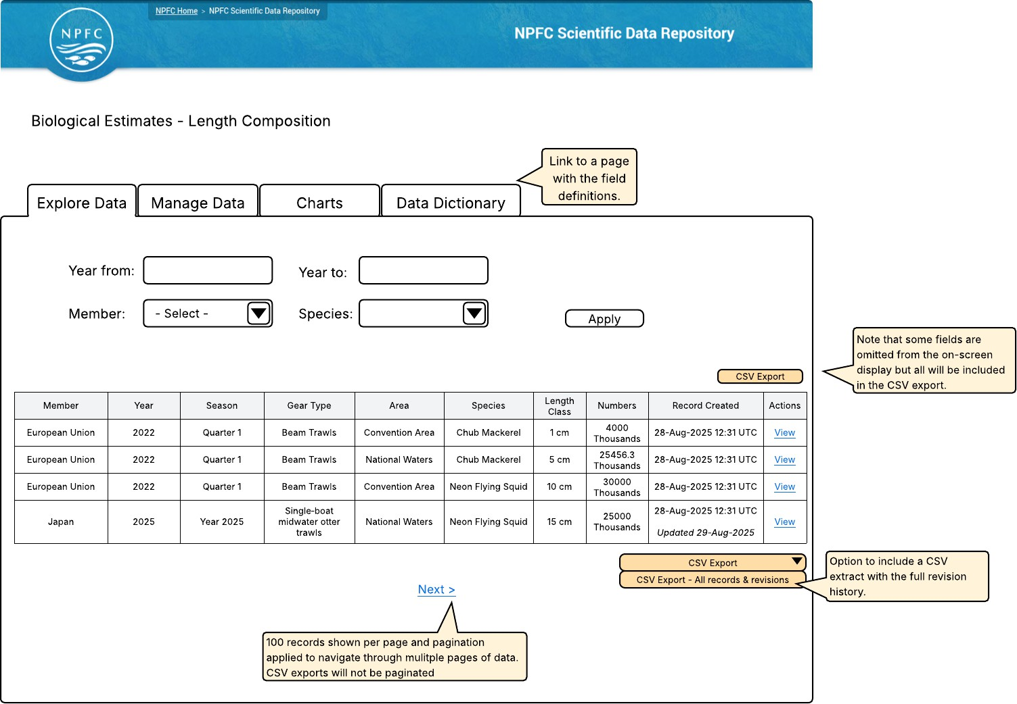

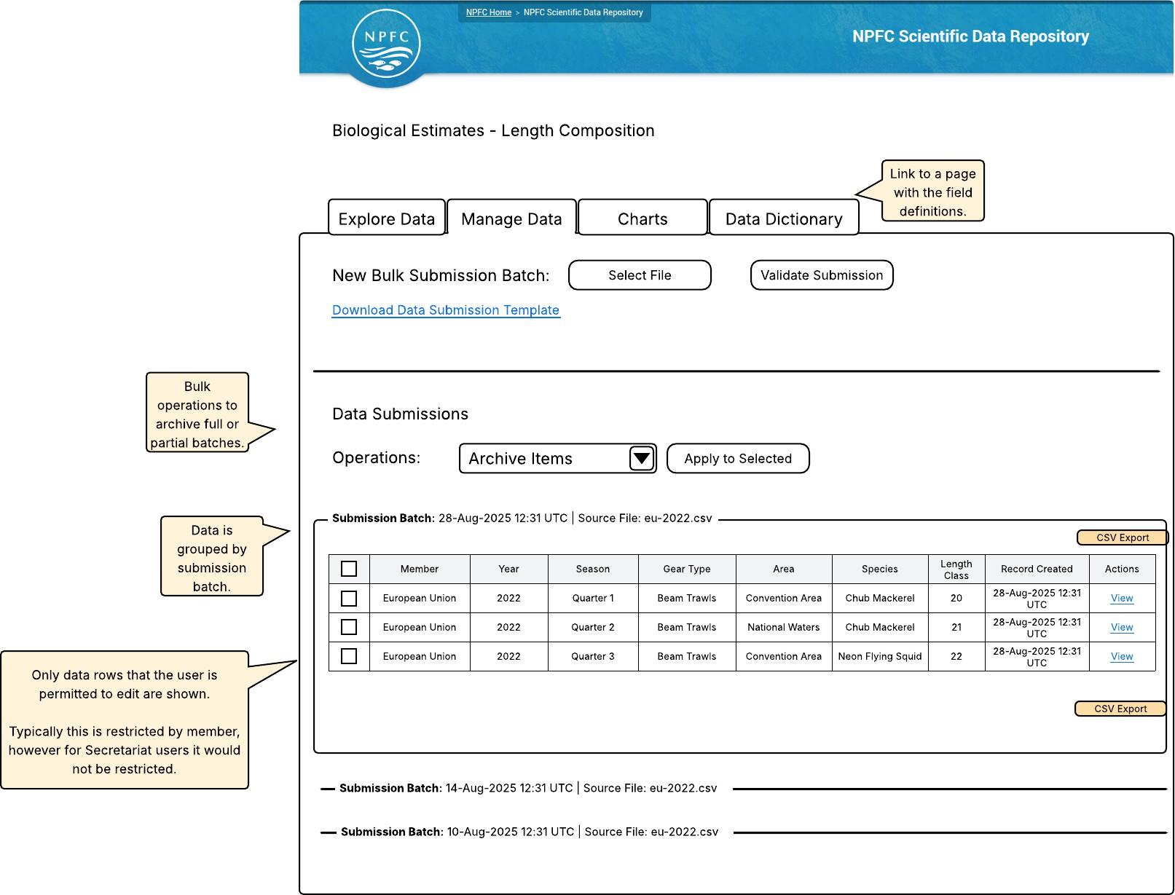

Data Type: Biological Estimates - Maturity Ogive

Data Entity Definition and Validation Rules

Field | Data Type | Label | Definition | Validation Rules
bem_id | int | Entity ID | Primary key identifying the data record. System generated. | PRIMARY KEY MANDATORY
bem_gro up_gp_id | entity_r eferenc e | Mem ber | The Member who has submitted the data. | FOREIGN KEY MANDATORY  COMPOSITE KEY A
bem_yea r | int | Year | The year of the data collection. | MANDATORY  4 digits  > 2000  COMPOSITE KEY A
bem_sea son | int | Seaso n | The temporal aggregation level of the data. Can be the same as the year of the data collection | MANDATORY  If season_type is month, value must be between 1 and 12.  If season_type is quarter, value must be between 1 and 4.  If season_type is year, value must match the year field.  COMPOSITE KEY A
bem_sea son_type | text_list | Seaso n Type | The type of temporal aggregation level. E.g., if the estimation is done on a quarter basis, then the SeasonType is Quarter | MANDATORY  Valid Options  M | Month Q | Quarter Y | Year  COMPOSITE KEY A

Field | Data Type | Label | Definition | Validation Rules
bem_are a | text_list | Area | The area | MANDATORY  Valid Options  CA | Convention Area NW | National Waters CB | Combination  COMPOSITE KEY A
bem_spe cies_spc  _id | entity_r eferenc e | Speci es | The species | MANDATORY COMPOSITE KEY A
bem_age  _class | int | Age | The age class | MANDATORY  1 to 9999
bem_pro p | decimal (8,3) | Propo rtion | The proportion of mature fish in that age class | MANDATORY  >0
bem_plu s_group | int | Plug Group | The age where fish of a certain age and/or older are grouped at | OPTIONAL  1 to 9999
COMPOSITE KEY A
bel_group_gp_id bel_year bel_season bel_season_type bel_area bel_species_spc_id

User Interface Wireframes
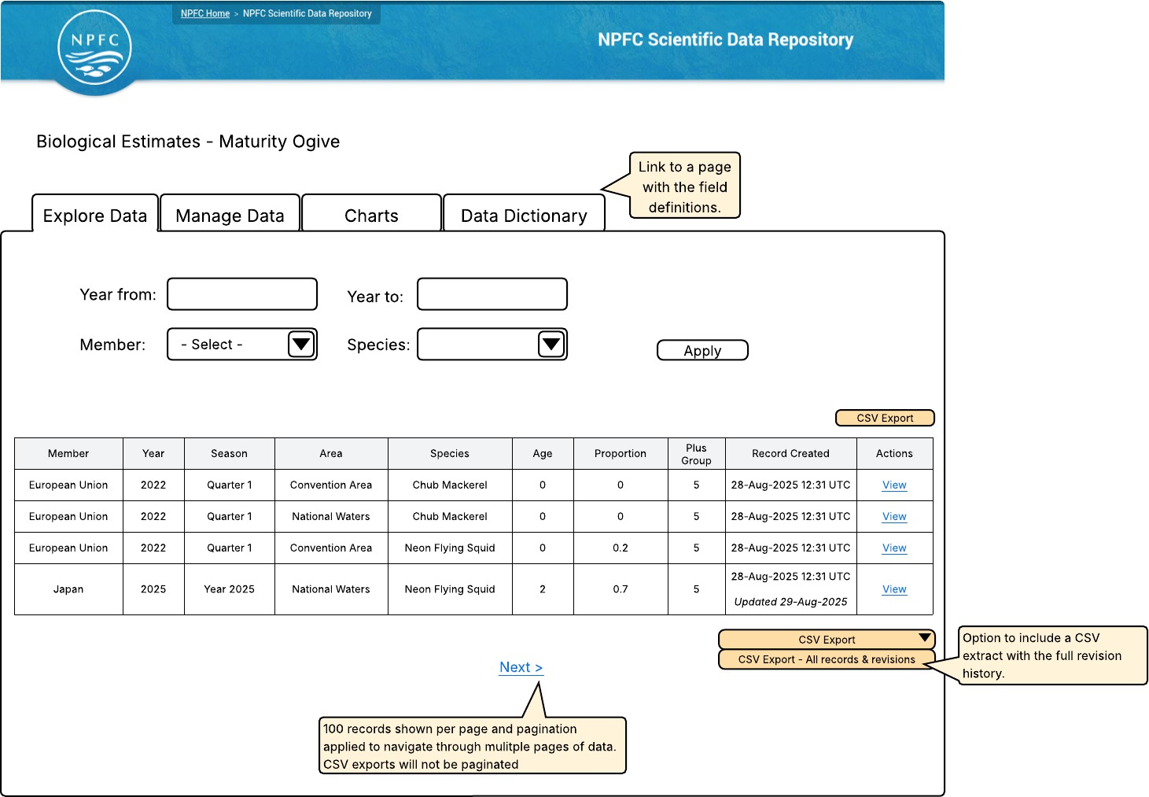

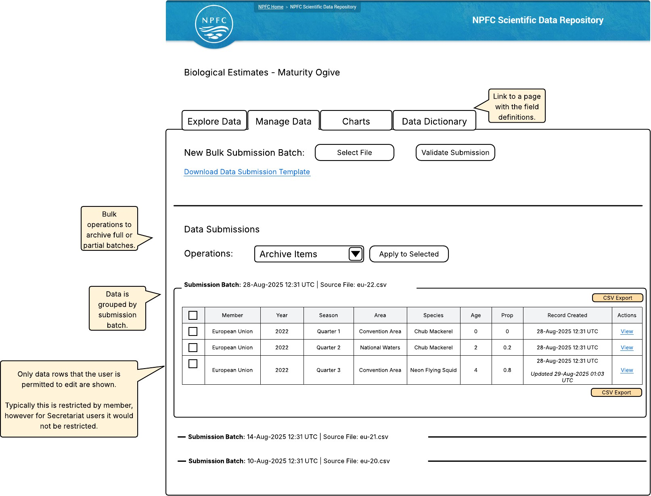

Data Type: Catch and Effort - Processed

Data Entity Definition and Validation Rules

Field | Data Type | Label | Definition | Validation Rules
cep_id | int | Entity ID | Primary key identifying the data record. System generated. | PRIMARY KEY MANDATORY
cep_gro up_gp_i d | entity_r eferenc e | Memb er | The Member who has submitted the data. | FOREIGN KEY MANDATORY COMPOSITE KEY A
cep_yea r | int | Year | The year of the data collection. | MANDATORY  4 digits  > 2000  COMPOSITE KEY A
cep_sea son | int | Seaso n | The temporal aggregation level of the data. Can be the same as the year of the data collection | MANDATORY  If season_type is month, value must be between 1 and 12.  If season_type is quarter, value must be between 1 and 4.  If season_type is year, value must match the year field.  COMPOSITE KEY A
cep_sea son_typ e | text_list | Seaso n Type | The type of temporal aggregation level. E.g., if the estimation is done on a quarter basis, then the SeasonType is Quarter | MANDATORY  Valid Options  M | Month Q | Quarter Y | Year  COMPOSITE KEY A
cep_gea r_fgt_id | entity_r eferenc e | Gear Type | The fishing gear type based on the ISSCFG list. | MANDATORY COMPOSITE KEY A

Field | Data Type | Label | Definition | Validation Rules
cep_are a | text_list | Area | The area | MANDATORY  Valid Options  CA | Convention Area NW | National Waters CB | Combination  COMPOSITE KEY A
cep_lat_ lon | geofiel d | Latitud e / Longit ude | Decimal degree coordinates | ( MANDATORY if  bea_gear_fgt_id references PS or NFS, otherwise optional.)
cep_spe cies_sp c_id | entity_r eferenc e | Specie s | The species | MANDATORY COMPOSITE KEY A
cep_live  _weight | decima l (8,3) | Live Weight | The species weight at the time of capture, before any processing such as gutting, filleting, or freezing. | MANDATORY COMPOSITE KEY A  > 0
cep_live  _weight  _unit | text_list | Live Weight Unit | The weight unit corresponding to the live weight | MANDATORY COMPOSITE KEY A  Valid Options:  g | Gram  kg | Kilogram t | Metric ton
cep_eff ort | decima l (8,2) | Effort | The total amount of fishing activity | MANDATORY  > 0
cep_eff ort_unit | text_list | Effort Unit | The effort units | MANDATORY  Valid Options:  kwd | Kilowatt days fd | Fishing days  fh | Fishing hours h | Hauls  ns | Number of sets vd | Vessel days  hk | Number of hooks trp | Number of traps
COMPOSITE KEY A
cep_group_gp_id

cep_year
cep_season
cep_season_type cep_gear_type
cep_area
cep_species_spc_id
cep_lat_lon (only included in composite key for PS and NFS)
cep_live_weight
cep_live_weight_unit

User Interface Wireframes
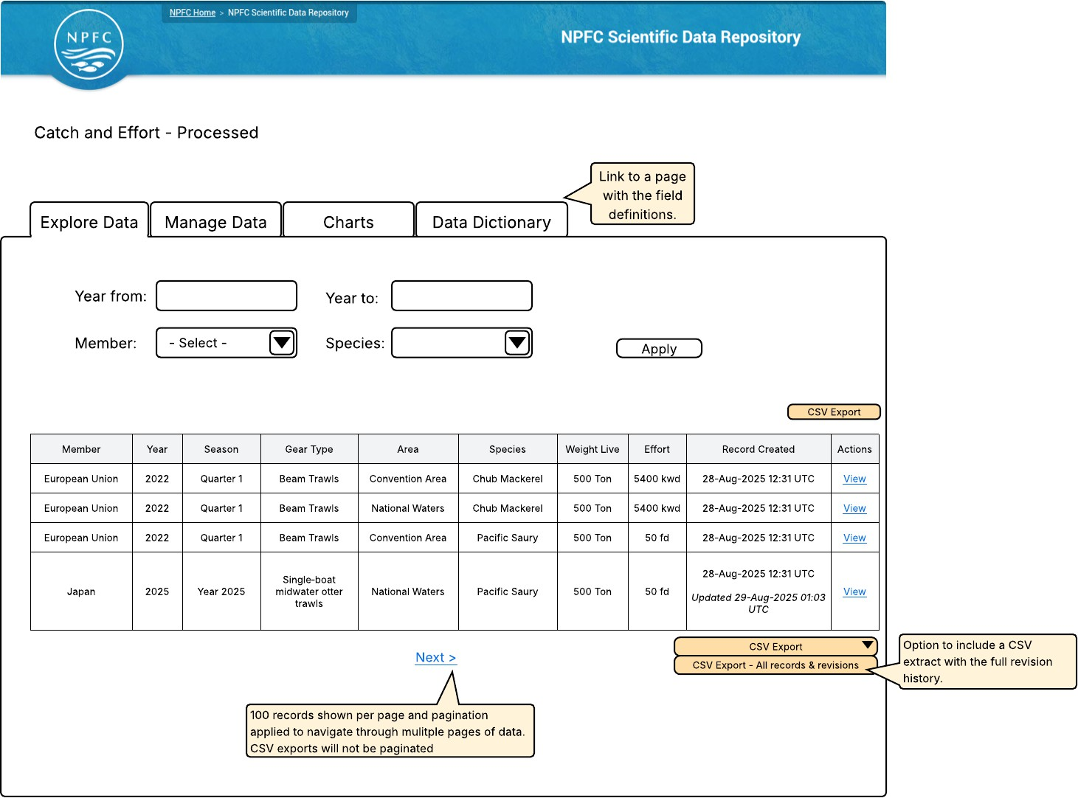

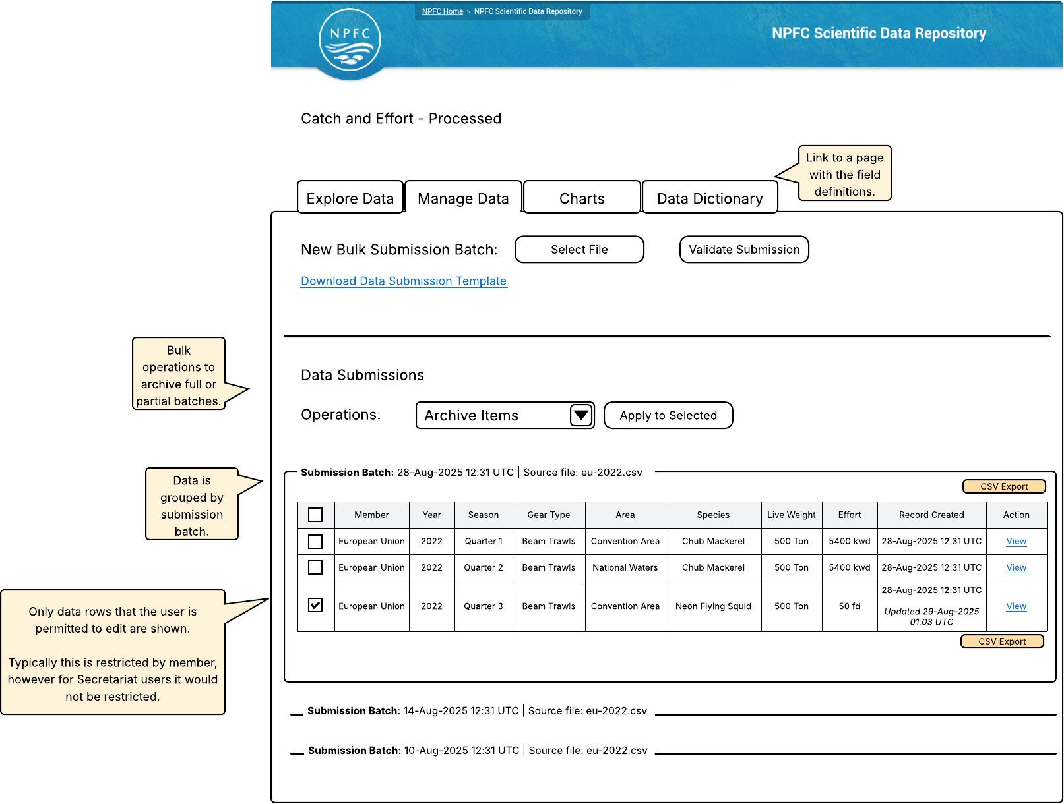

Data Type: Catch and Effort - CPUE

Data Entity Definition and Validation Rules11.1

Field | Data Type | Label | Definition | Validation Rules
cpue_id | int | Entity ID | Primary key identifying the data record. System generated. | PRIMARY KEY MANDATORY
cpue_type | text_list | CPUE Type | Member for single Member or Joint for multiple | Auto-calculated as M if one member is referenced or J if multiple members are referenced.
cpue_group_gp_id | entity_reference | Member | The Member who has submitted the data. | FOREIGN KEY MANDATORY  COMPOSITE KEY A  MULTI-VALUED
cpue_year | int | Year | The year of the data collection. | MANDATORY  COMPOSITE KEY A  4 digits  > 2000

Field | Data Type | Label | Definition | Validation Rules
cpue_season | int | Season | The temporal aggregation level of the data. Can be the same as the year of the data collection | MANDATORY  COMPOSITE KEY A  If season_type is month, value must be between 1 and  12.  If season_type is quarter, value must be between 1 and  4.  If season_type is year, value must match the year field.
cpue_season_type | text_list | Season Type | The type of temporal aggregation level.  E.g., if the estimation is done on a quarter basis, then the Season Type is Quarter | MANDATORY  COMPOSITE KEY A  Valid Options  M | Month Q | Quarter Y | Year
cpue_gear_fgt_id | entity_reference | Gear Type | The fishing gear type based on the ISSCFG list. | OPTIONAL
cpue_area | text_list | Area | The area | OPTIONAL  Valid Options  CA | Convention Area  NW | National Waters  CB | Combination
cpue_species_spc  _id | entity_reference | Species | The species | MANDATORY  COMPOSITE KEY A

Field | Data Type | Label | Definition | Validation Rules
cpue_nominal_cpu e_value | decimal (8.2) | Nominal Catch Per Unit of Effort | Catch per unit of effort calculated directly from raw data, without standardization for factors such as vessel, gear, or area. | OPTIONAL  >0
cpue_cpue_value | decimal (8.2) | Catch Per Unit of Effort | Catch per unit of effort (standardized) | MANDATORY  >0
cpue_cpue_unit | text_list | CPUE Unit | Unit of measurement for the CPUE | MANDATORY  Valid Options:  kg_tow | Kilograms per tow  ton_tow | Tonnes per tow kg_hr | Kilograms per hour  ton_hr | Tonnes per hour  n_hk | Number per hook n_100hk | Number per 100 hooks  n_trip | Number per trap  kg_trp | Number per trap  kg_trp | Kilograms per trap  n_vd | Number per vessel day ton_vd | Tonnes per vessel day n_fd | Number per fishing day ton_fd | Tonnes per fishing day ton_hl | Tonnes per haul  >0

Field | Data Type | Label | Definition | Validation Rules
cpue_cv | decimal (8,2) | Cooefficient of Variation | Coefficient of variation of the CPUE value (unitless 0 to 1) | OPTIONAL  >0
cpue_method | text | Method / Model Used | Method/model used (e.g., GLM, GAM,  delta lognormal) | OPTIONAL  >0
cpue_cov | text | Covariates | List of covariates used in the standardization separated by an underscore "_" | OPTIONAL MULTI-VALUED
COMPOSITE KEY A
cpue_group_gp_id cpue_year cpue_season cpue_season_type cpue_species_spc_id

User Interface Wireframes
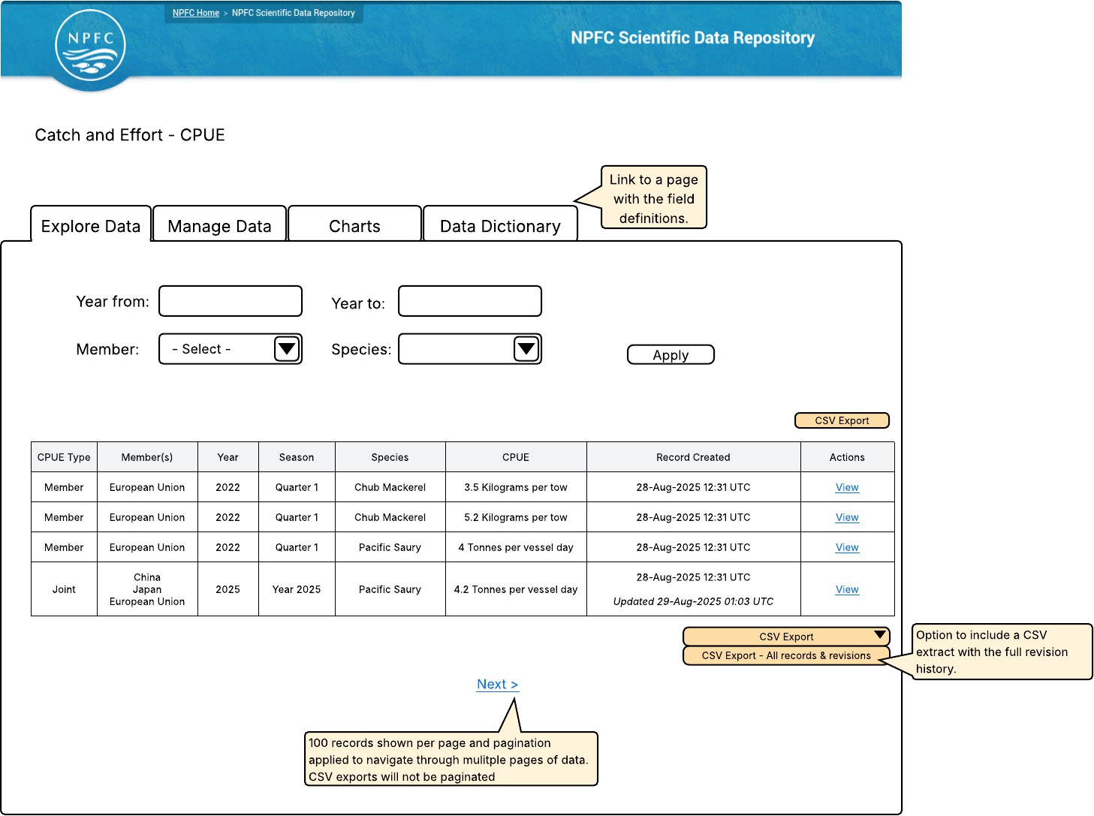

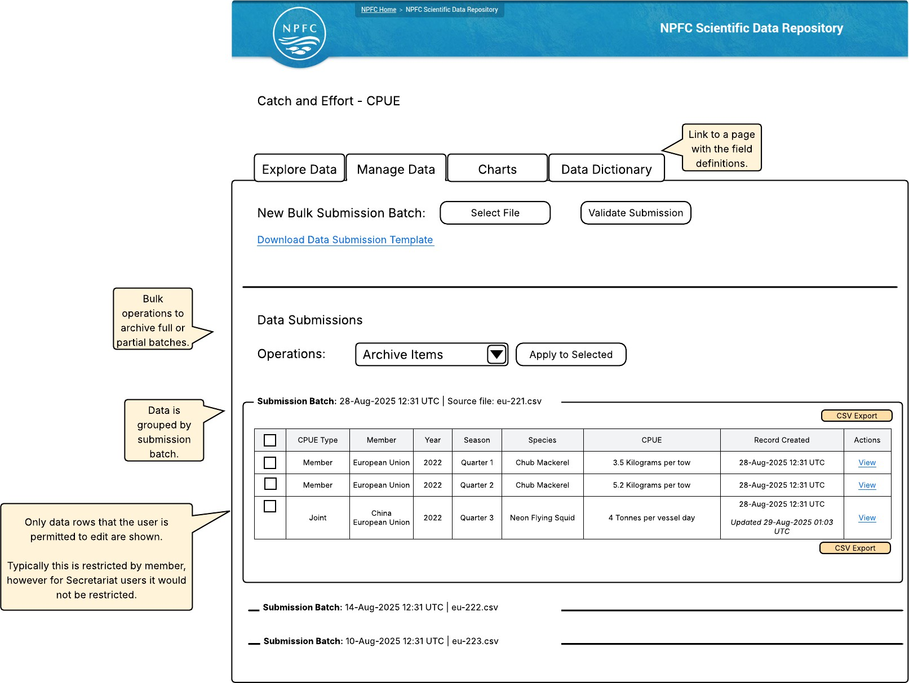

Data Type: Catch by Species - Ratio

Data Entity Definition and Validation Rules12.1

Field | Data Type | Label | Definition | Validation Rules
cbsr_id | int | Entity ID | Primary key identifying the data record. System generated. | PRIMARY KEY MANDATORY
cbsr_gro up_gp_id | entity_re ference | Memb er | The Member who has submitted the data. | FOREIGN KEY MANDATORY  COMPOSITE KEY A
cbsr_year | int | Year | The year of the data collection. | MANDATORY  COMPOSITE KEY A  4 digits  > 2000
cbsr_spe cies_spc_ id | entity_re ference | Specie s | The species | MANDATORY
cbsr_spe cies_total  _catch | entity_re ference | Specie s Total Catch | Species that comprise the total catch group used in the catch ratio calculation. The total catch group includes all species with misidentification issues relevant to and including the species code indicated in the "Species" field. | MANDATORY MULTI-VALUED
cbsr_catc h_ratio | decimal (4,3) | Catch Ratio | Ratio of the species catch to the total catch | MANDATORY  0 <= n <= 1
COMPOSITE KEY A
cbsr_group_gp_id cbsr_year cbsr_species_spc_id

User Interface Wireframes
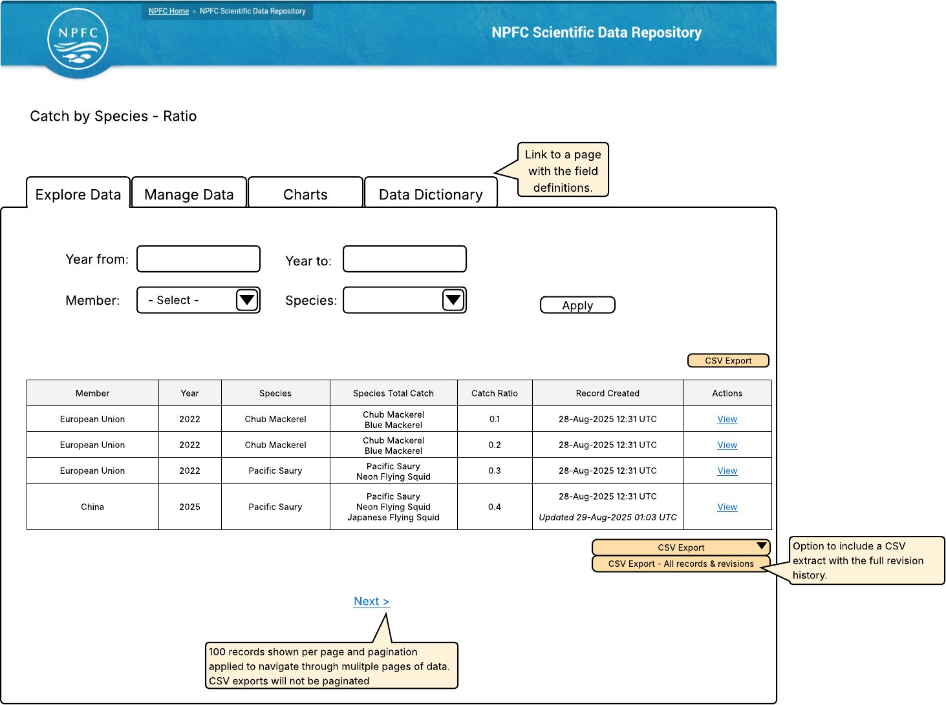

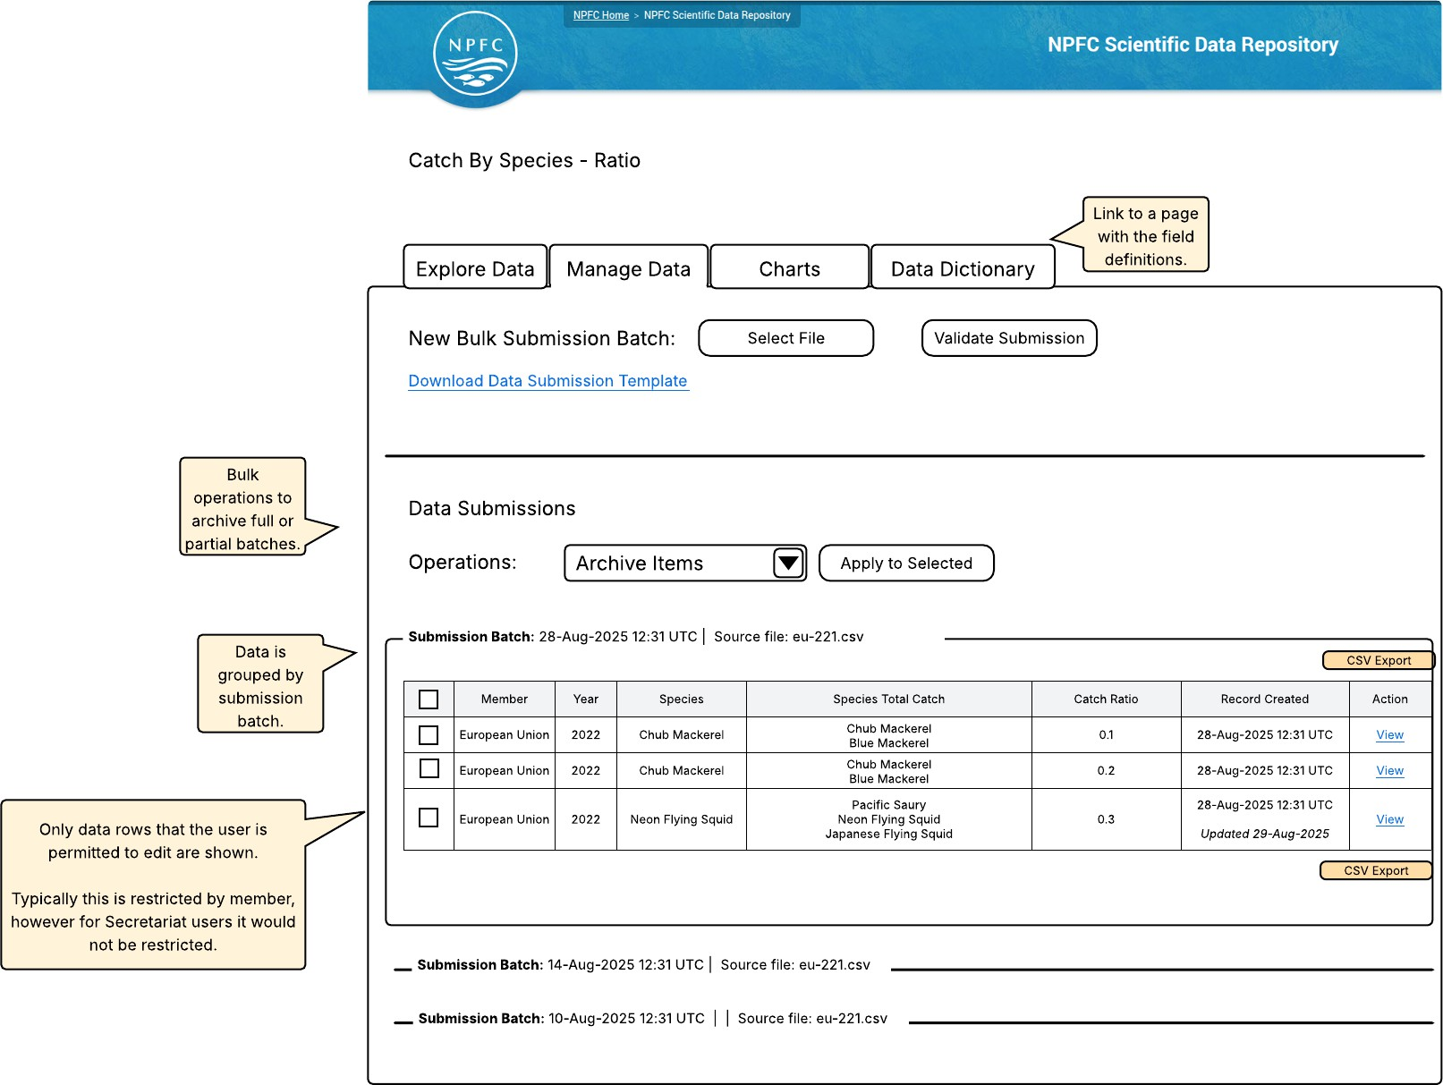

Data Warehouse Integration

Data Management Infrastructure Background
NPFC currently operates several data-driven information systems with associated databases.

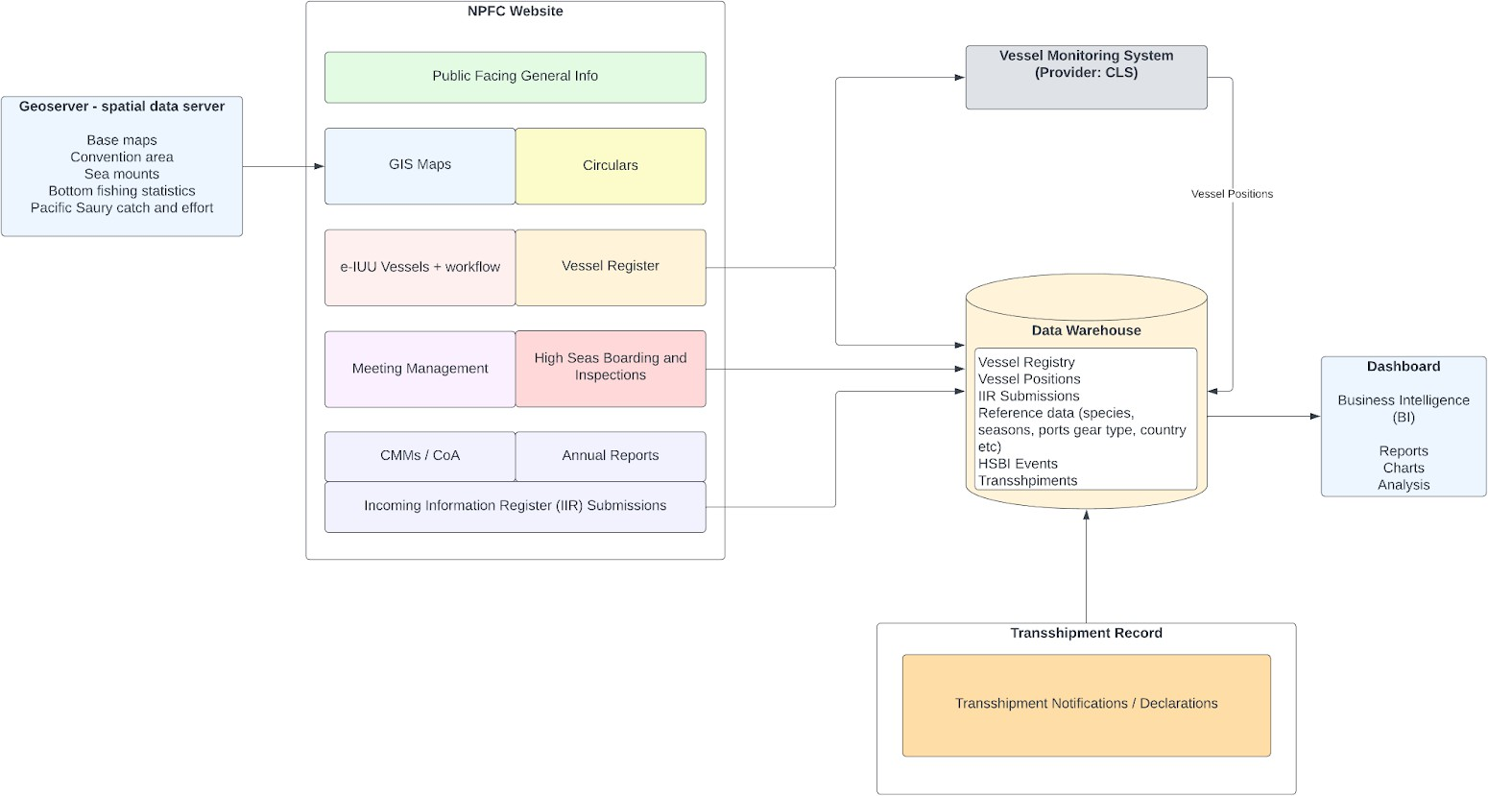
Operational applications such as the VMS, Transshipment Record and the NPFC website (containing Vessel Register etc) each contain a database that supports the operation of the application, data workflows and associated data access control rules.
A data warehouse (DWH) is also in place. The DWH ingests data from the various operational applications into a centralised relational database (PostresSQL with spatial data support). This centralised data repository aims to support data analysis and reporting in a number of ways:
Datasets are in one location so can be combined and cross referenced for deeper and easier analysis.
Application business logic is removed, leaving raw, finalised data for easier analysis.
All datasets can be queried using standard SQL (Structure Query Language) syntax.
A rudimentary dashboard-building application (Re-Dash) is connected to the data warehouse for data analysis and report building. Other analysis tools may be connected to the DWH as data analysis needs expand in the future.

Data Warehouse Access Control
An important aspect to consider in regard to the data warehouse is that it does not apply fine-grained access control rules.
Operational application modules will often apply complex row-level or even field-level access control business rules. A common scenario is for records submitted by one Member to not be visible to users of other Member states.
Within the data warehouse, these access rules are removed, leaving only a single role level. Authentication is still required, but there are no table-level, row-level or field-level restrictions. This simplicity makes the data warehouse extremely usable for broad analytical purposes, but must be restricted to Secretariat staff or Secretariat representatives (e.g. data analyst consultants) only.

Scientific Data Synchronised to the Data Warehouse
The NPFC Scientific Data Repository will act as an operational application to facilitate Members to load and update datasets, plus view data and extract data as CSV outputs. This operational application will apply row- level access control logic as defined in the Access Control Matrix.
Synchronisation processes will be put in place so that the scientific data entities included in the operational application are also synchronised into the NPFC data warehouse, and kept up to date as scientific data is added, updated or archived. This will allow for these datasets to be combined with other related datasets within the data warehouse for combined data analysis.
To facilitate this synchronisation, the Scientific Data Repository will have API based read-access enabled, with security authentication.

Prototype Implementation Plan
The below development schedule details the deliverables of three sprints of software development with the aim to achieve a functional Minimum Viable Product (MVP) within existing contractual budgets designated towards prototype implementation.

Sprint | Weeks | Key Deliverables / User Acceptance Testing Checklist
Sprint 1 - Project Initialisation | Weeks 1 - 3 | Preparation of project code repositories, UAT/Staging/Production hosting environments and domain name configuration.  Implementation of data structures as per ER diagram, with validation constraints rules and revisioning support.  Setup of web portal branding / theme based on previous NPFC web portals.  Sample data generation scripts to facilitate automated test development.  Implementation of landing page with navigation and latest updates list.  Implementation of Explore Data tabs with filters and pagination. Implementation of CSV Export functionality on Explore Data tabs.
Sprint 2 - Data loading, access control | Weeks 3 - 6 | Implementation of Manage Data tabs with CSV upload  Implementation of validation stage with error and warning display and row highlighting.  Implementation of bulk insert / update processing operations. Generation of data submission templates based on data definitions.  Listing of data submissions by batch on the Manage Data tab, with Archive Items bulk operation.  Implementation of roles and access control rules, with test coverage.
Sprint 3 - Integration points and deployment | Week 7 | Addition of roles to NPFC MaM, including species assignment option. Integration of Single Sign On (SSO).  Synchronisation of Member / CNCP groups from NPFC MaM.  Synchronisation of Species and Fishing Gear data from NFPC website.  Training / handover workshop Production deployment

Future Development Items
The following items are considered beyond the scope of the prototype (MVP) implementation, but may be considered for future enhancements.

Implementation of Data Dictionary tabs displaying field level descriptions. Implementation of Charts tabs with Member Submission Coverage chart. Additional charts / reports
Synchronisation of data into the NPFC Data Warehouse Interface translation for languages other than English
Interfaces to allow for the extraction of previous versions of updated data records.

Ongoing, Maintenance and Capacity Requirements
Post-implementation of the NPFC Scientific Data Repository portal there are a number of future considerations.

Ongoing hosting and maintenance
As with any online, web based application there will be a need for hosting, as well as maintenance such as application of software security updates.
It is proposed that this application will be developed using the Drupal content management framework. This framework is consistent with other NPFC data management systems, thus benefiting from some economies of scale for ongoing maintenance under the terms of NPFC’s existing application support retainer agreement.
An expectation for approximately 10 hours per quarter of software developer time needed towards hosting and security maintenance is recommended.

Additional data types
This application has been designed in a way that allows for each of the seven data types to be managed in a consistent manner. This allows for the possibility that additional datasets may be required in the future and can be accommodated without major application refactoring.

Scientific reporting and analytical outputs
The scope of this application so far does not include analytical outputs. A possible future development enhancement would be to include additional output formats such as data driven charts, dashboards and reports.

Secretariat capacity
It is recommended that the NPFC Secretariat maintain capacity to undertake the following tasks:

Support end-users
Provide guidance and assistance to Members on how to access and operate the application.
Maintaining help guides / documentation on system usage.

System business owner role
While contracted software developers can implement technical changes and enhancements to the software, the Secretariat is better placed to understand the subject matter of the data and act as a conduit between end-users and developers.
As the business owner of the application the Secretariat should maintain the analytical capacity to guide future change management processes in order to maintain data integrity and support the data collection and analytical needs of the Members. This tasking should be responsible for ensuring that future change requests to modify data entity definitions, validation rules or access control rules do not compromise historically collected data or breach NPFC data security policies.

  - ANNEX 2
Responses to Annex 1 of the CMM on Minimum Data Standards – All fishing activities

Field | Canada | China | Chinese Taipei | EU | Japan-JS | Japan-MA | Japan-JFS_NFS | Japan-PS | Korea | Russia
Address of master | Yes | No | Yes — We do not recommend providing such personal data. | No | Private information. Needed for scientific use? | Private information. Needed for scientific use? | Private information. Needed for scientific use? | Private information. Needed for scientific use? | Yes — The data field exists in the reporting system but is not a mandatory submission item. | No
Amount of fish onboard after unloading (mt) | No — This number should be zero according to licensing conditions, but I don't think it is recorded | No — For stock assessment purposes, these are likely unnecessary. | Yes | Yes | No | No | No | No | No — Domestic landings are managed by a different agency. | Yes
Amount of fish onboard at start of trip (mt) | No — This number should be zero according to licensing conditions, but I don't think it is recorded | No — For stock assessment purposes, these are likely unnecessary. | Yes | Yes | No | No | Yes | Yes — Usually, zero | No — Domestic landings are managed by a different agency. | Yes
Date and time of arrival | Yes | No | Yes — Providing the arrival date should be sufficient. Propose to delete 'time'. | Yes | No | No | No | No | Yes — The data field exists in the reporting system but is not a mandatory submission item. | Yes
Date and time of departure | Yes | No | Yes — Providing the departure date should be sufficient. Propose to delete 'time'. | Yes | No | No | No | No | Yes — The data field exists in the reporting system but is not a mandatory submission item. | Yes
Date and time of landing | Yes | No | Yes — If the master is required to submit Annex 1 at the end of a trip and, where applicable, after every transshipment at sea, then this annex should include additional fields for transshipment details. | Yes | No | No | No | No | No — Domestic landings are managed by a different agency. | Yes
External identification | Yes | No | Yes | Yes | Yes/No | Yes/No | Yes | Yes | Yes | Yes
Fishing permit or licence number(s) | Yes | No | Yes | Yes | Yes | Yes | Yes | Yes | Yes | Yes
International radio call sign | Yes | No | Yes | Yes | Yes | Yes | Yes/No | Yes | Yes | Yes
Name of master | Yes | Yes | Yes | Yes | Private information. Needed for scientific use? | Private information. Needed for scientific use? | Private information. Needed for scientific use? | Private information. Needed for scientific use? | Yes | Yes, See NPFC Vessel ID
Port of arrival | Yes | No | Yes | Yes | Yes | Yes | Yes | Yes | Yes — The data field exists in the reporting system but is not a mandatory submission item. | Yes
Port of landing (if different from port of arrival) | Yes | No | Yes | Yes | Yes | Yes | Yes | Yes | No — Domestic landings are managed by a different agency. | Yes
Registration number of vessel | Yes | No | Yes | Yes | Yes | Yes | Yes | Yes | Yes | Yes
Species (FAO 3-alpha code) | Yes | Yes | Yes | Yes | Almost Yes — S. melanostictus does not have a 3-alpha code in the ASFIS database | Almost Yes — CM and BM are not separated in the logbooks | Yes | Yes | Yes | Yes
Total amount of fish discarded (mt) | Yes | Yes | Yes | Yes — This is typically not considered reliable when it's coming from the logbooks | No | No | No | No — No discard of PS | Yes | Yes/No
Total amount of fish kept (mt) | Yes | Yes | Yes | Yes | Yes | Yes | No | No | Yes | Yes
Trip number this year | Yes | Yes — Regardless of the fishery, most Chinese fishing vessels typically complete only one fishing trip per year, as they transit across several oceans to conduct different fisheries. | Yes | Yes | Yes | Yes | Yes | Yes | No — This information could be derived or collected additionally if required. | Yes

Responses to Annex 2 of the CMM on Minimum Data Standards - Trawl

Field | Canada | China | Chinese Taipei | EU | Japan-JS | Japan-MA | Japan-JFS_NFS | Japan-PS | Korea | Russia
Bottom depth at start of fishing |  | No — Is this the water depth (seabed depth) or the depth of the footrope? |  | Yes |  | No |  |  |  | Yes
Estimated discards by species (FAO 3-alpha code) |  | Yes |  | Yes — This is typically not considered reliable when it's coming from the logbooks |  | No |  |  |  | Yes/No
Gear depth at start of fishing |  | No — Does this refer to the depth of the headline or the footrope? |  | Yes |  | No |  |  |  | Yes
Height of net opening |  | No — This data is only available for some fishing vessels and not every year, as it depends on whether the vessel is equipped with a net sonde to measure gear parameters. It is also not feasible to take such measurements for every single haul. |  | Yes |  | No |  |  |  | Yes/No
Incidental captures of species of concern or benthic taxa? (Yes/No/Unknown) |  | Yes |  | Yes |  | Unknown |  |  |  | Yes
Intended target species (FAO 3-alpha code) |  | Yes |  | Yes |  | Almost Yes — Blue and chub mackerel is not distinguished in logbooks |  |  |  | Yes
Mesh size |  | No — It's possible to include this in the future. |  | Yes |  | No |  |  |  | Yes
Tow end date and time (UTC) |  | Yes |  | Yes |  | No |  |  |  | Yes
Tow end position |  | Yes |  | Yes |  | No |  |  |  | Yes
Tow start date and time (UTC) |  | Yes |  | Yes |  | No |  |  |  | Yes
Tow start position |  | Yes |  | Yes |  | No |  |  |  | Yes
Type of trawl (S/D/T) |  | Yes — Do the terms "single" and "double" here refer to the number of vessels involved—as in single-boat trawling versus pair (double-boat) trawling? It's also worth noting that trawling is further categorized as either midwater or bottom trawling. |  | Yes |  | No |  |  |  | Yes
Width of net opening |  | No — This data is only available for some fishing vessels and not every year, as it depends on whether the vessel is equipped with a net sonde to measure gear parameters. It is also not feasible to take such measurements for every single haul. |  | Yes |  | No |  |  |  | Yes/No

Responses to Annex 3 of the CMM on Minimum Data Standards – Purse seine

Field | Canada | China | Chinese Taipei | EU | Japan-JS | Japan-MA | Japan-NFS | Japan-PS | Korea | Russia
Estimated discards by species (FAO 3-alpha code) |  | Yes |  |  | No | No |  |  |  | Yes/No — Observers are not required for Purse Seine (Pelagic) fisheries
Incidental captures of species of concern or benthic taxa? (Yes/No/Unknown) |  | Yes — Recording data for every haul is difficult. Please summarize it daily, based on the first net deployment and the last net retrieval. |  |  | Unknown | Unknown |  |  |  | Yes/No — Observers are not required for Purse Seine (Pelagic) fisheries
Intended target species (FAO 3-alpha code) |  | Yes |  |  | Almost Yes — S. melanostictus does not have a 3-alpha code in the ASFIS database | Almost Yes — Blue and chub mackerel is not distinguished in logbooks |  |  |  | Yes
Mesh size |  | No |  |  | No | No |  |  |  | No
Net height |  | No |  |  | No | No |  |  |  | No
Net length |  | No |  |  | No | No |  |  |  | No
Set end date and time (UTC) |  | Yes |  |  | No | No |  |  |  | Yes
Set start date and time (UTC) |  | Yes |  |  | No | No |  |  |  | Yes

Responses to Annex 4 of the CMM on Minimum Data Standards – Squid Jigging

Field | Canada | China | Chinese Taipei | EU | Japan-JS | Japan-MA | Japan-NFS | Japan-PS | Korea | Russia
Echo sounder used? (Yes/No) |  | Yes — It's available since 2024 | Yes |  |  |  | No |  | Yes
End position of drift |  | Yes — It's available since 2024 | Yes |  |  |  | No — Daily fishing position is available |  | Yes
Estimated discards by species (FAO 3-alpha code) |  | Yes — It's available since 2024 | Yes |  |  |  | No |  | Yes
Incidental captures of species of concern or benthic taxa? (Yes/No/Unknown) |  | Yes — It's available since 2024 | Yes |  |  |  | No |  | Yes
Maximum operating depth |  | Yes — It's available since 2024 | Yes |  |  |  | No |  | Yes — The data field exists in the reporting system but is not a mandatory submission item.
Number of crew |  | Yes — Does this number refer only to the crew members participating in handline fishing, or does it include the entire vessel crew? It's available since 2024 | Yes |  |  |  | No |  | Yes — The data field exists in the reporting system but is not a mandatory submission item.
Number of jigs per line |  | Yes — It's available since 2024 | Yes |  |  |  | No |  | Yes — The data field exists in the reporting system but is not a mandatory submission item.
Start position of drift |  | Yes — It's available since 2024 | Yes |  |  |  | No — Daily fishing position is available |  | Yes
Total deck light power (kW) |  | Yes — It's available since 2024 | Yes |  |  |  | No |  | Yes
Total hours fished |  | Yes — It's available since 2024 | Yes |  |  |  | No |  | Yes

Responses to Annex 5 of the CMM on Minimum Data Standards – Stick held dip net

Field | Canada | China | Chinese Taipei | EU | Japan-JS | Japan-MA | Japan-NFS | Japan-PS | Korea | Russia
Estimated discards by species (FAO 3-alpha code) |  | No — The CMM prohibits the discarding of Pacific saury; however, the discarding practices for other species remain unknown. | Yes |  |  |  |  | No | Yes | No
Haul end date and time (UTC) |  | No — Recording data for every haul is difficult. Please summarize it daily, based on the first net deployment and the last net retrieval. | No |  |  |  |  | No | Yes | Yes
Haul end position |  | No — Recording data for every haul is difficult. Please summarize it daily, based on the first net deployment and the last net retrieval. | No |  |  |  |  | No | Yes | Yes
Haul start date and time (UTC) |  | No — Recording data for every haul is difficult. Please summarize it daily, based on the first net deployment and the last net retrieval. | No — We would like to note that the time and position data of individual haul may not provide meaningful catch information. On the Taiwanese saury fishing vessels, once a haul is retrieved, the catch is immediately transferred to the processing cabin, where it undergoes a continuous workflow of sorting, packing, freezing, and storage. This process takes time to complete. During periods of high catch, the processing of one haul may not be finished before the next haul arrives, resulting in the mixing of successive catches. This makes it impossible to track the catch amount on a haul-by-haul basis. Therefore, collecting the haul start and end times and their positions is meaningless.  Instead, we propose recording "Number of hauls", as this is essential for estimating CPUE on a per-haul basis. |  |  |  |  | No | Yes | Yes
Haul start position |  | No — Recording data for every haul is difficult. Please summarize it daily, based on the first net deployment and the last net retrieval. | No |  |  |  |  | No | Yes | Yes
Incidental captures of species of concern or benthic taxa? (Yes/No/Unknown) |  | Unknown — Stick-Held Dip Net rarely catch bycatch species, with squid constituting a very small proportion. | Yes |  |  |  |  | Unknown | Yes | No
Mesh size |  | No | Yes |  |  |  |  | No | No — This requires additional collection. | No
Net height |  | No | Yes — We suggest revising the term 'Net height' to 'Operating depth' to reflect the actual deployment characteristics of the stick-held dip net. The term 'Net height' may be confusing, as it could be interpreted as the physical dimensions of the net, rather than its functional depth in the water column during fishing operations.  In addition, since there may be several hauls operating per night, the term 'Maximum operating depth' is more appropriate than 'Operating depth'. |  |  |  |  | No | No — This requires additional collection. | No
Net length |  | No | Yes |  |  |  |  | No | No — This requires additional collection. | No
Number of crew |  | Yes — For stock assessment purposes, these are likely unnecessary. | Yes |  |  |  |  | Yes | No — This requires additional collection. | Yes — In the NPFC register
Total deck light power (kW) |  | No | Yes |  |  |  |  | No | Yes | No
Total hours fished |  | No — Recording data for every haul is difficult. Please summarize it daily, based on the first net deployment and the last net retrieval. | Yes |  |  |  |  | No | Yes | Yes

