NPFC-2025-SC10-WP11

A literature review of studies relating environmental conditions to Japanese Sardine (Sardinops melanosticta) in the North Pacific Ocean

Chris Rooper¹, Dmitrii Antonenko², Jennifer Boldt¹,Jon Brodziak³, Janelle Curtis¹, Libin Dai⁴, Karolina Molla Gazi⁵, Zhengyan Jiang⁴, Don Kobayashi³, Vladimir Kulik², Quiyun Ma⁴, Shuya Nakatsuka⁶, Kazuhiro Oshima⁶, Alex Zavolokin⁷

¹Pacific Biological Station, DFO, Nanaimo, BC, Canada
²Pacific Branch, Russian Federal Research Institute of Fisheries and Oceanography, Vladivostok, Russia
³Pacific Islands Fisheries Science Center, NOAA, Honolulu, HA, USA
⁴Shanghai Ocean University, Shanghai, China
⁵Wageningen Marine Research, Wageningen University & Research, IJmuiden, The Netherlands
⁶Japan Fisheries Research and Education Agency, Yokohama, Japan
⁷North Pacific Fisheries Commission, Tokyo, Japan

Introduction
Japanese sardine (Sardinops melanostictus) are a commercially important small pelagic fish generally found in the western North Pacific Ocean. Typical of small pelagic species, the Japanese sardine has experienced “boom and bust” cycles with rapid population expansion followed by periods of low stock productivity. These cycles are thought to be related to environmental effects on recruitment and mortality. Recently, the species has been expanding its distribution into international waters of the western North Pacific and even crossing to the eastern Pacific as evidenced by recent (2022 and 2023) captures on the west coast of North America (Longo et al. 2025). This expansion has been of great interest to members of the North Pacific Fisheries Commission who commercially fish for this species in both domestic and international waters.

In 2024 (COM08) NPFC’s Commission tasked its Scientific Committee to consider climate change and its implications to their fisheries management. The Commission tasked the SC to identify relevant data availability and needs for including climate change in fisheries decisions, integrate analyses of climate change into its work plan, consider vulnerabilities and management implications of climate change on NPFC fisheries and discuss how best to incorporate climate change data into its work. In general, the Commission requested information on how climate changes will impact Japanese Sardine and what types of variables should the SC be monitoring to anticipate and mitigate those changes.

Thus, the objective of this review was to summarize the existing published literature that explores the relationship between Japanese sardine (JS) and the environment. We first identify existing literature using a standardized methodology for conducting literature reviews. Next we synthesized the data, identifying strengths and gaps in the existing literature. Finally, we attempt to synthesize some of the major impacts of the environment on Japanese sardine. This synthesis is expected to be useful in understanding the potential variability in the distribution and abundance of the stock in the context of future climate conditions and extremes. We also position this work to be a starting point for the North Pacific Fisheries Commission's efforts to include ecosystem information into management and to identify future research needs and stock assessment considerations for this species.

Methods

This systematic literature mapping exercise generally followed the spirit of the guidelines and standards of the Collaboration for Environmental Evidence for Evidence Synthesis in Environmental Management (CEE 2018) and the ROSES reporting standards (Haddaway et al. 2018). The most important deviations from the protocols were that calibrations among reviewers was not completed and methods were not published in advance, as would be typical. The specific methods and data collected were based on Boldt et al. (2023).

The literature review search was conducted the Aquatic Sciences and Fisheries Abstracts (ASFA) data base. The initial search terms used to identify articles are shown in Table 1. The initial search terms resulted in ~3000 records, however when filters were applied this was reduced to 238 records. Next each record was examined manually to determine whether it should be included in the database. This manual filtering removed records that did not actually include information on JS (most commonly these were manuscripts that examined oceanography and justified the importance of the study by the potential impacts on JS, but did not actually make the linkage using analyses). The manual filtering also removed any additional records that did not concern JS in the NW Pacific (e.g. removal of records for the western stock of JS). This resulted in 112 records. After final removal of 6 duplicate records, 106 reports, publications, abstracts or other material were examined.

Each coauthor was assigned a group from these 106 records which they read and summarized according to the format shown in Table 2. Key pieces of metadata collected from each record were the location of the research (which Member conducted the research), the language of the record, the source (peer-reviewed literature, unpublished report, abstract, thesis, etc.), the year the record was published, and the full citation of the work. The life stage(s) considered in the study were also noted, as well as the type of data used to conduct the study, any sampling gear that was used, roughly the duration of the study in years, any other species considered in the study, and a general description of the study type (distribution, life history, performance, migration, stock structure, stock assessment, ecosystem, or other).

Results

Most of the reports addressing the relationship between Japanese Sardine and the environment have been published as peer-reviewed journal articles (Figure 1). Most of the reports have also been published since 1993, with peak numbers in the late 2000s when the stock was at a sustained low level and in more recent years as the stock status has improved. A wide mix of gears have been used in these studies (Figure 2), with a fairly even distribution of studies addressing each life history stage (Figure 3).

The majority (n = 112) of studies of Japanese Sardine and environmental pressures have examined their relationship with temperature (Figure 4). The second most number of records addressed regional climate variables (n = 51) and the third most addressed currents and transport (n = 40). The highest number of studies have addressed the distribution or habitat use of Japanese Sardine, with others addressing growth and life history and recruitment.

In terms of the common effects on life history stages, most studies of life history found that temperature had a negative impact for the majority of studies across all life history stages. In the Japanese Sardine increasing temperature had a predominantly negative impact on egg distribution and temperature, with warmer temperatures associated with reduced spawning habitat (Watanabe et al. 1997) and lower egg density (Matsuoka and Konishi 2001, Ishida 2006). Considerable work has been done to examine the impact of temperature on the larval stage of Japanese Sardine. Importantly, a number of research papers have developed and explored the “Optimal Growth Hypothesis” for Japanese Sardine larvae (Takasuka et al. 2008 , Takasuda et al. 2007). This hypothesis purports that growth and survival through the larval stage occurs at lower temperature ranges (peaking at ~18 C), rather than higher temperatures. This hypothesis explains not only lower productivity stages in Japanese Sardine, but also the oscillation of the species with Japanese Anchovy. It also provides a mechanism for some of the observed correlations between larger adult populations and higher recruitment and lower temperature (Shimoyama et al. 2007, Noto et al 1999, Wada et al. 1995). Some of these studies have extended to the temperature effects on growth in juvenile stages and included additional environmental factors such as competitors (Watanabe 2009, Watanable et al. 2014, Takahashi et al. 2006, Wada et al. 1995, Plaza et al. 2008, Zentaini 1999) or food availability (Okunushi et al. 2012 , Kimura et al 2000. Kawasaki and Kumagai 1984) particularly in juvenile stages. In some cases temperature can have mixed effects on early life history stages, for example higher temperature can lead to lower growth in larval stages, but can also lead to earlier spawning which can convey some advantages to egg development and hatch (Kuroda et al. 2020, Kuroda 1991, Matsuoka 2001 Matsuoka and Manobe 2001).

Changing distribution, biology and spawn timing also appear to be driven by both environmental conditions and abundance. For example, higher temperature and lower stock biomass has been observed to result in higher body condition in adults (Koizumi et al 1993). Many researchers have noted that spawning occurs at fairly specific temperatures which can impact spawning distribution (Takasuka et al. 2021, Okinishi et al. 2009, Oezeki et al 2007) and that the distribution of spawning can be impacted by the number of spawners as well as temperature (Oozeki et al.2007)

Distributions of early life stages and adults were noted to be concentrated around oceanographic features, such as frontal areas with temperatures ~10 degrees C (Inagake and Hirono 1984). Species distributions have also been used to demonstrate the impacts of environmental factors such as winter mixing, SST and SLH on Japanese sardine catch and distribution (Sakurai 2007, Ignake and Hirano 1984, Sogrina et al 2021, Tameishi et al 1996, Shi et al. 2023, Kruchinin et al 2022). Transport of early life history stages from spawning to feeding grounds has also been implicated in survival and recruitment (Nishikawa and Yasuda 2008, Kawasaki and Omuri 1995, Suda and Kishida 2003, Itoh et al 2009).

Finally, regime change and larger-scale climate indicators have often been correlated or used in assessment of Japanese Sardine (e.g. Wada and Jacobson 1998, Kawabata et al. 2011, Ma et al. 2020) and cumulative impacts of fishing, temperature and regimes can all exhibit pressure on Japanese Sardine populations (Suda et al. 2008, Tian et al 2023, Lui et al 2025, Novikov et al 2020)

Conclusions

The existing literature shows that Japanese Sardine are impacted by their environment throughout all life history stages. The most commonly identified factor is temperature, but others such as system productivity, winter conditions, currents and competitors and predators have also been implicated in sardine dynamics. Based on the overwhelming negative impact of high temperatures on early life history stages of Japanese Sardine, it is likely that future climate change will have a negative impact on this species.

The literature highlights a few time series of environmental conditions that could be monitored to provide an indication of future conditions for Japanese Sardine. The list would include:

- Sea surface temperature in the Kuroshio transition zone (larval growth)

- PDO and other climate indicators (linked to overall abundance/productivity)

- Currents (successful transport to the larval feeding areas)

- Winter mixed layer depth (zooplankton production/composition)

- Spring primary production (larval growth survival)
  - Chlorophyll
  - Zooplankton biomass

- Sea surface salinity

A summary showing recent trends in some of these indicators is provided in Figure 6. In general, most of the important indicators (temperature in particular) are trending negative for Japanese Sardine or are neutral over the past 5 years.

Tables

Table 1. Search terms used to identify records from the ASFA literature database relevant to Japanese Sardine and their environment.
Search terms | Filters applied |  | Number of records
(japan* sardine OR Sardinops melanosticta OR Sardinops melanostictus) AND (oceanography OR environment OR temperature) | NOT (processing fishery products AND minced products AND storage effects AND food technology)NOT (PICES 13th Annual Meeting Book of Abstracts AND PICES 14th Annual Meeting Book of Abstracts AND Pittsburgh Post - Gazette AND Sunday Herald - Sun AND The Independent AND The Kingston Heritage EMC AND The Standard AND Times - Colonist AND Weekend Australian)NOT (INE, USA, California AND INE, Pacific, California Current AND ISE, Peru AND Seriola quinqueradiata AND ANW, Canada AND ASE, South Atlantic, Benguela Current AND California AND IN, Bering Sea AND ISE, Chile AND ISE, Pacific, Humboldt Current AND PN, Arctic AND United States--US AND A, Atlantic AND ANW, Canada, Nova Scotia, Halifax AND Arctic region AND ASW, Panama AND Gulf of Sakhalin AND Illex argentinus AND INE, Canada, British Columbia AND INE, USA, Alaska AND INE, USA, Alaska, Alaska Gulf, Alaskan Gyre AND INE, USA, Oregon AND INE, USA, Washington AND ISE, Mexico, Baja California Sur, Magdalena Bay AND ISEW, Southeast Asia) |  | 238

Table 2. Standard data collection format for the literature review of Japanese Sardine. Data types (column headers) and drivers or pressures are shown. For some data types a standard set of responses was allowed which is shown under the second column.
Data type (column header) | Data
ID
Citation
Year published
Language
Reviewer Name
Report type | book chapter, journal paper, conference proceedings, thesis, organization report, abstract only, other
Country of study
Study type | Distribution, life history, performance, migration, stock structure, stock assessment, ecosystem, other
Years of data | 1 year, < 5 years, > 5 years
Other species in this study
Life stage studied | Adult, Juvenile, Larval, Egg
Sampling gear used | bottom trawl, pelagic trawl, plankton net, hydroacoustics, commercial bottom trawl, commercial pelagic trawl, commercial seine net, tagging, other
Distribution_DataType | Genetics, otoliths, tagging, other
Distribution_DistributionHabitatUse | Abundance, biomass, catch, size, other
GrowthLifeHistory_MassOrSize | Climate (NAO, NPGO, etc), transport (currents, etc), temperature, salinity, oxygen, upwelling (magnitude or timing), phytoplankton (primary productivity), zooplankton (secondary productivity), predators, competitors, fisheries, other pressure, not linked to a pressure
GrowthLifeHistory_Condition | Climate (NAO, NPGO, etc), transport (currents, etc), temperature, salinity, oxygen, upwelling (magnitude or timing), phytoplankton (primary productivity), zooplankton (secondary productivity), predators, competitors, fisheries, other pressure, not linked to a pressure
GrowthLifeHistory_Foraging | Climate (NAO, NPGO, etc), transport (currents, etc), temperature, salinity, oxygen, upwelling (magnitude or timing), phytoplankton (primary productivity), zooplankton (secondary productivity), predators, competitors, fisheries, other pressure, not linked to a pressure
GrowthLifeHistory_Other | Climate (NAO, NPGO, etc), transport (currents, etc), temperature, salinity, oxygen, upwelling (magnitude or timing), phytoplankton (primary productivity), zooplankton (secondary productivity), predators, competitors, fisheries, other pressure, not linked to a pressure
Survival_Survival&Mortality | Climate (NAO, NPGO, etc), transport (currents, etc), temperature, salinity, oxygen, upwelling (magnitude or timing), phytoplankton (primary productivity), zooplankton (secondary productivity), predators, competitors, fisheries, other pressure, not linked to a pressure
Performance_Stress | Climate (NAO, NPGO, etc), transport (currents, etc), temperature, salinity, oxygen, upwelling (magnitude or timing), phytoplankton (primary productivity), zooplankton (secondary productivity), predators, competitors, fisheries, other pressure, not linked to a pressure
Performance_Energy | Climate (NAO, NPGO, etc), transport (currents, etc), temperature, salinity, oxygen, upwelling (magnitude or timing), phytoplankton (primary productivity), zooplankton (secondary productivity), predators, competitors, fisheries, other pressure, not linked to a pressure
Performance_Swimming | Climate (NAO, NPGO, etc), transport (currents, etc), temperature, salinity, oxygen, upwelling (magnitude or timing), phytoplankton (primary productivity), zooplankton (secondary productivity), predators, competitors, fisheries, other pressure, not linked to a pressure
Performance_Other | Climate (NAO, NPGO, etc), transport (currents, etc), temperature, salinity, oxygen, upwelling (magnitude or timing), phytoplankton (primary productivity), zooplankton (secondary productivity), predators, competitors, fisheries, other pressure, not linked to a pressure
Migration_Spawning | Climate (NAO, NPGO, etc), transport (currents, etc), temperature, salinity, oxygen, upwelling (magnitude or timing), phytoplankton (primary productivity), zooplankton (secondary productivity), predators, competitors, fisheries, other pressure, not linked to a pressure
Migration_Other | Climate (NAO, NPGO, etc), transport (currents, etc), temperature, salinity, oxygen, upwelling (magnitude or timing), phytoplankton (primary productivity), zooplankton (secondary productivity), predators, competitors, fisheries, other pressure, not linked to a pressure
Reproduction_Maturation | Climate (NAO, NPGO, etc), transport (currents, etc), temperature, salinity, oxygen, upwelling (magnitude or timing), phytoplankton (primary productivity), zooplankton (secondary productivity), predators, competitors, fisheries, other pressure, not linked to a pressure
Reproduction_Spawning | Climate (NAO, NPGO, etc), transport (currents, etc), temperature, salinity, oxygen, upwelling (magnitude or timing), phytoplankton (primary productivity), zooplankton (secondary productivity), predators, competitors, fisheries, other pressure, not linked to a pressure
Reproduction_EggAbundance | Climate (NAO, NPGO, etc), transport (currents, etc), temperature, salinity, oxygen, upwelling (magnitude or timing), phytoplankton (primary productivity), zooplankton (secondary productivity), predators, competitors, fisheries, other pressure, not linked to a pressure
Reproduction_EggSizeOrWeight | Climate (NAO, NPGO, etc), transport (currents, etc), temperature, salinity, oxygen, upwelling (magnitude or timing), phytoplankton (primary productivity), zooplankton (secondary productivity), predators, competitors, fisheries, other pressure, not linked to a pressure
Reproduction_Fecundity | Climate (NAO, NPGO, etc), transport (currents, etc), temperature, salinity, oxygen, upwelling (magnitude or timing), phytoplankton (primary productivity), zooplankton (secondary productivity), predators, competitors, fisheries, other pressure, not linked to a pressure
Reproduction_Other | Climate (NAO, NPGO, etc), transport (currents, etc), temperature, salinity, oxygen, upwelling (magnitude or timing), phytoplankton (primary productivity), zooplankton (secondary productivity), predators, competitors, fisheries, other pressure, not linked to a pressure
Productivity_BiomassOrAbundance | Climate (NAO, NPGO, etc), transport (currents, etc), temperature, salinity, oxygen, upwelling (magnitude or timing), phytoplankton (primary productivity), zooplankton (secondary productivity), predators, competitors, fisheries, other pressure, not linked to a pressure
Productivity_Recruitment | Climate (NAO, NPGO, etc), transport (currents, etc), temperature, salinity, oxygen, upwelling (magnitude or timing), phytoplankton (primary productivity), zooplankton (secondary productivity), predators, competitors, fisheries, other pressure, not linked to a pressure
Productivity_Other | Climate (NAO, NPGO, etc), transport (currents, etc), temperature, salinity, oxygen, upwelling (magnitude or timing), phytoplankton (primary productivity), zooplankton (secondary productivity), predators, competitors, fisheries, other pressure, not linked to a pressure
Impact of environment on sardine characteristic | Positive, Negative, Mixed, Not significant
Notes on relationship

Figures

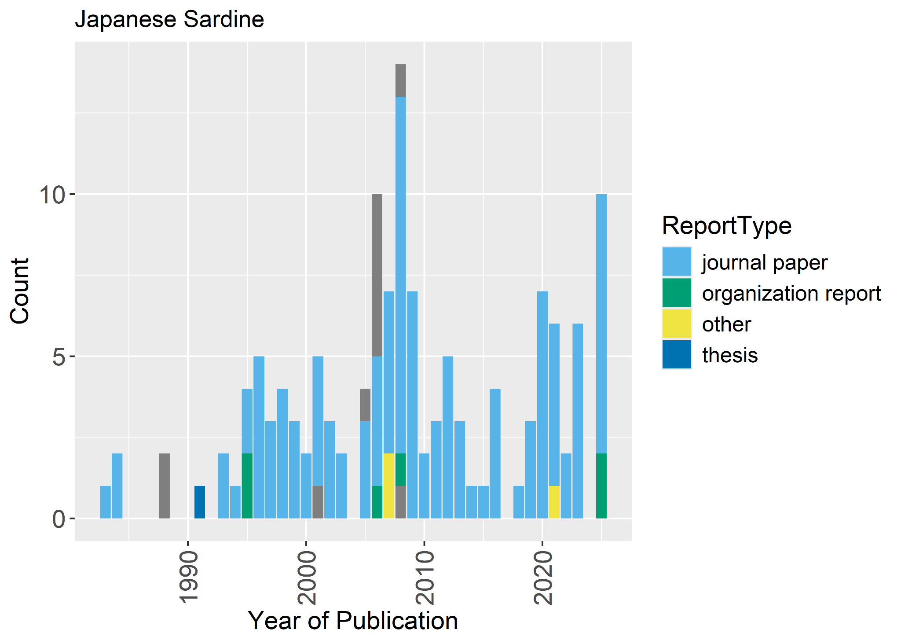

Figure 1. Type of report by year from the Japanese Sardine literature review.

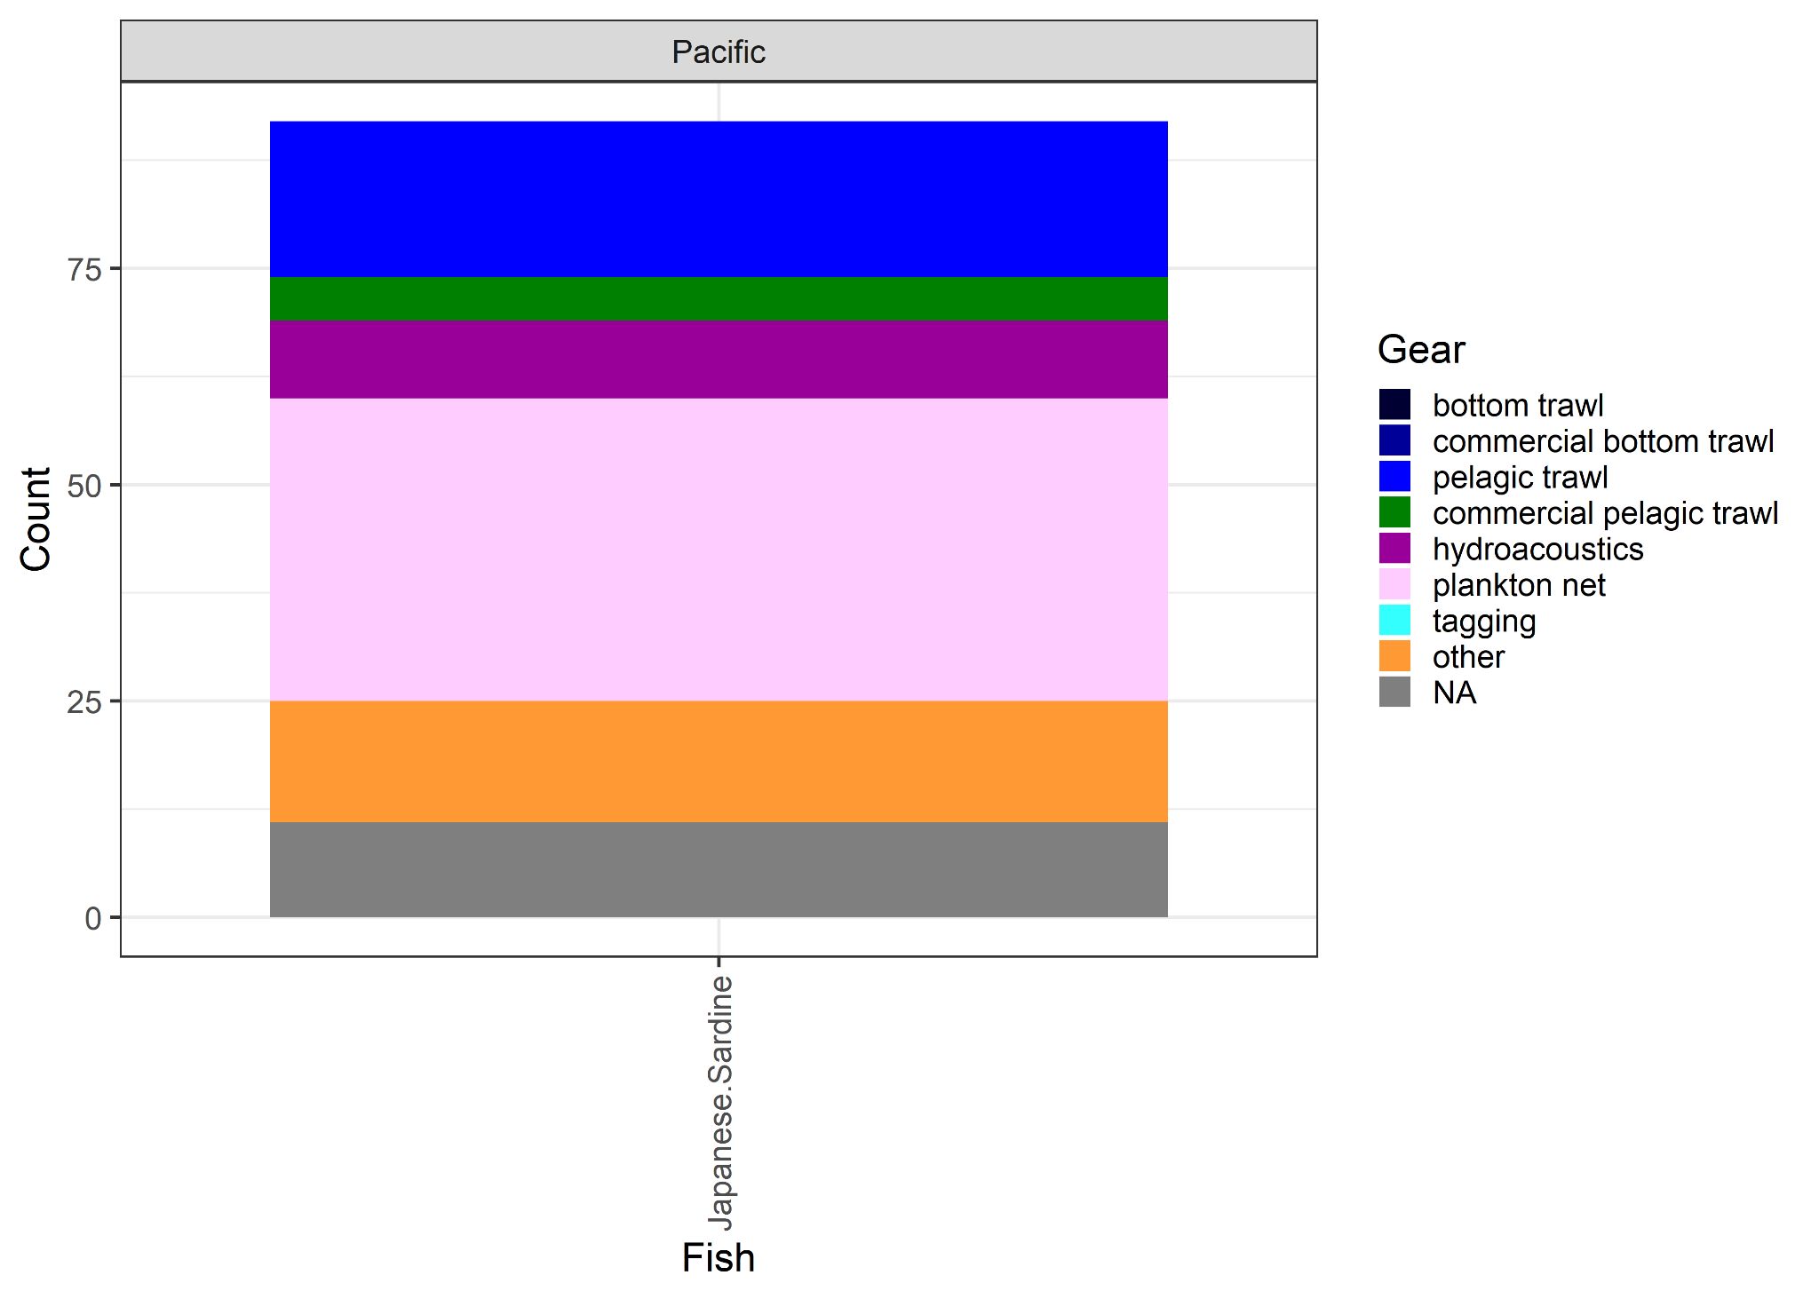

Figure 2. Type of gear used in studies of Japanese Sardine and the environment.
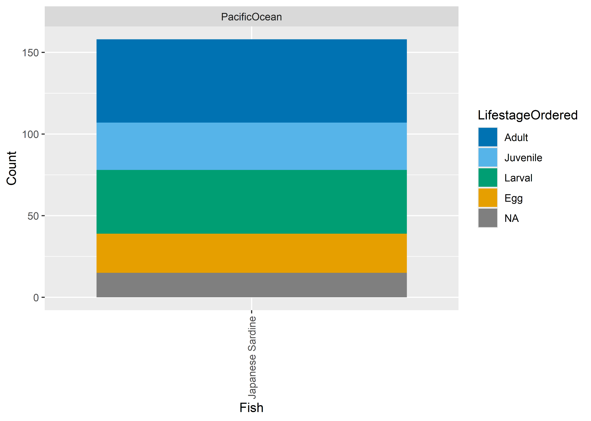

Figure 3. Life stages studied by researchers in the published literature on Japanese Sardine.
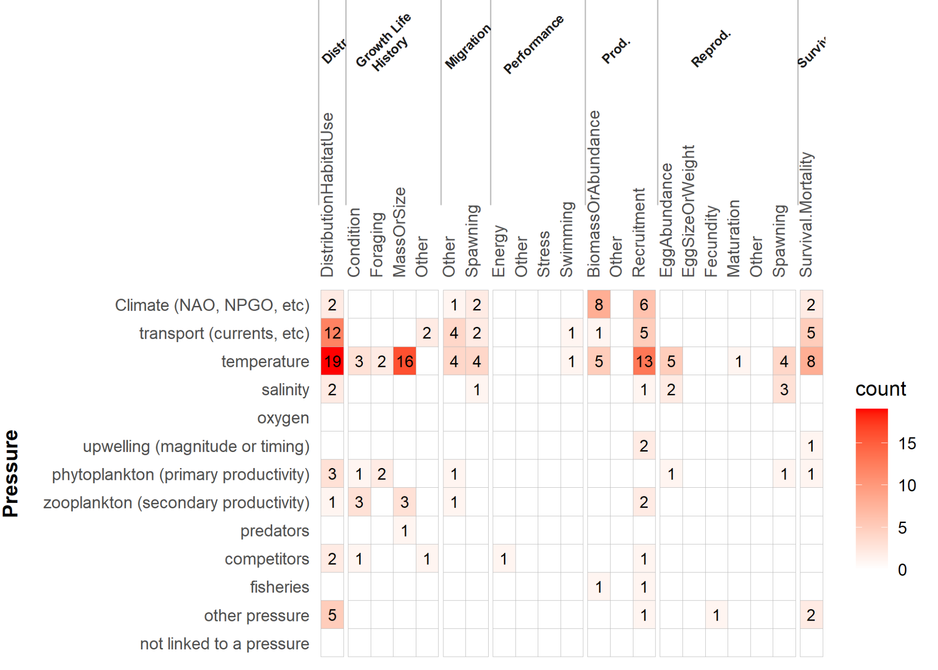

Figure 4. Summary of drivers (columns) and pressures (rows) and the number of records that studied each from the Japanese Sardine literature review.
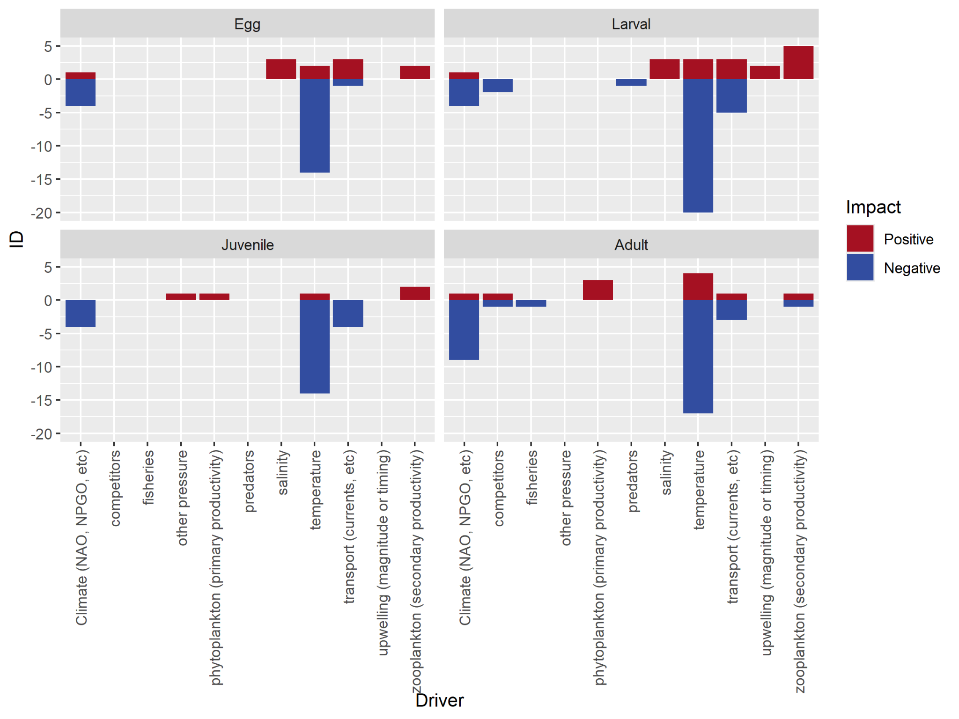

Figure 5. Summary of the effect of environmental drivers on life history stages for Japanese Sardine.
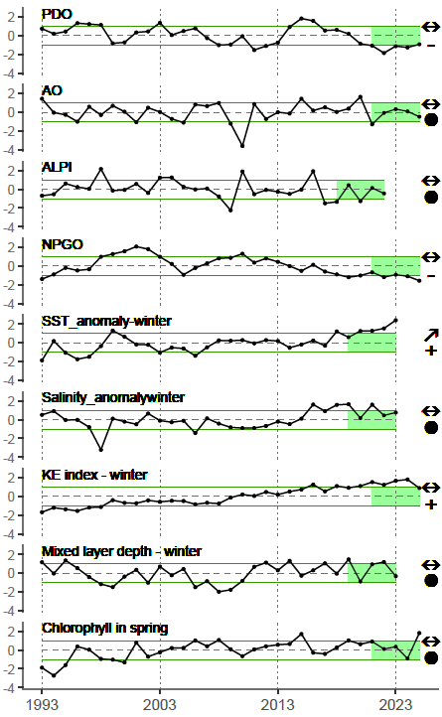

Figure 6. Trends in environmental indicators for Japanese Sardine since 1993.

References

CEE. 2018. Guidelines and standards for evidence synthesis in environmental management. Version 5.0. Edited by A.S. Pullin, G.K. Frampton, B. Livoreil and G. Petrokofsky. Available from http://www.environmentalevidence.org/information-for-authors.
Haddaway, N.R., Macura, B., Whaley, P., and Pullin, A.S. 2018. ROSES reporting standards for systematic evidence syntheses: pro forma, flow diagram and descriptive summary of the plan and conduct of environmental systematic reviews and systematic maps. Environ. Evid. 7:7. doi:10.1186/s13750-018-0121-7.
Inagake, D., Hirano, T. 1984. Horizontal distribution of the Japanese sardine in relation to oceanic front at the purse seine fishing grounds southeast of Hokkaido. Nippon Suisan Gakkaishi.
Ishida, M. 2006. Rapid decrease of egg production of Pacific stock of Japanese sardine, Sardinops melanostictus, and characteristics of persistent spawning ground in Tosa Bay, southwestern Japan. Bulletin of the Japanese Society of Fisheries Oceanography. https://agriknowledge.affrc.go.jp/RN/2010731234.pdf
Itoh, S., Yasuda, I., Nishikawa, H., Sasaki, H., Sasai, Y. 2009. Transport and environmental temperature variability of eggs and larvae of the Japanese anchovy (Engraulis japonicus) and Japanese sardine (Sardinops melanostictus) in the western North Pacific estimated via numerical particle-tracking experiments. Fisheries Oceanography. https://doi.org/10.1111/j.1365-2419.2009.00501.x
Kawabata, A., Yamaguchi, H., Kubota, S., Nakagami, M. 2011. Growth and fatness of 1975-2002 year classes of Japanese sardine in the Pacific waters around northern Japan. Fisheries Science. https://doi.org/10.1007/s12562-011-0326-y
Kawasaki, T., Kumagai, A. 1984. Food habits of the Far Eastern sardine and their implication in the fluctuation pattern of the sardine stocks. BULL. JAP. SOC. SCI. FISH./NISSUISHI..
Kawasaki, T., Omori, M. 1995. The impacts of climate change on Japanese fisheries. CLIMATE CHANGE AND NORTHERN FISH POPULATIONS.
Kimura, R., Watanabe, Y., Zenitani, H. 2000. Nutritional condition of first-feeding larvae of Japanese sardine in the coastal and oceanic waters along the Kuroshio Current. ICES Journal of Marine Science.
Koizumi, N., Matsumiya, Y., Wada, T. 1993. Statistical studies on biological indices of Japanese sardine. Nippon Suisan Gakkaishi.
Kruchinin O.N., Mizyurkin M.A., Zakharov E.A., Volotov V.M., Shabelsky D.L., Vakker N.L.. 2022. Fleet operations at fishing of japanese sardine and chub mackerel in the Kuril waters in the modern period of high abundance of these species.. Izvestiya Tikhookeanskogo nauchno-issledovatel'skogo rybokhozyajstvennogo tsentra/Transactions of the Pacific Research Fisheries Centre. https://doi.org/10.26428/1606-9919-2022-202-414-428
Kuroda, H., Saito, T., Kaga, T., Takasuka, A., Kamimura, Y., Furuichi, S., Nakanowatari, T. 2020. Unconventional Sea Surface Temperature Regime Around Japan in the 2000sâ€2010s: Potential Influences on Major Fisheries Resources. Frontiers in Marine Science. 10.3389/fmars.2020.574904
Kuroda, K. 1991. Studies on the recruitment process focusing on the early life history of the Japanese sardine, Sardinops melanostictus (Schlegel). Bulletin of the National Research Institute of Fisheries Science. https://agriknowledge.affrc.go.jp/RN/2010500436.pdf
Liu, D., Chen, X., Liu, B. 2025. The Impacts of Marine Heatwaves on Economic Fisheries in Adjacent Sea Regions Around Japan Under Global Warming. Fishes. https://doi.org/10.3390/fishes10070299
Longo, G., James, K., Hinton, K., Topping, J., Craig, M. 2025. Japanese Sardine (Sardinops melanosticta ) in the California Current large marine ecosystem 2024. NOAA Technical Memorandum NMFS
Ma, S., Tian, Y., Li, J., Yu, H., Cheng, J., Sun, P., Fu, C., Liu, Y., Watanabe, Y. 2020. Climate Variability Patterns and Their Ecological Effects on Ecosystems in the Northwestern North Pacific. Frontiers in Marine Science. https://doi.org/10.3389/fmars.2020.546882
Matsuoka, M. 2001. Influence of low temperature on hatching and survival rates at first-feeding stage in the Japanese sardine. Nippon Suisan Gakkaishi. https://doi.org/10.2331/suisan.67.894
Matsuoka, M. 2008. Studies on early development and spawning ecology in Japanese sardine Sardinops melanostictus. Bulletin of Fisheries Research Agency (Japan).
Matsuoka, M., Konishi, Y. 2001. Abundance and distributional changes of Japanese sardine eggs around Kyushu, Japan, from 1979 to 1995. Bulletin of the Japanese Society of Fisheries Oceanography. Tokyo. https://agriknowledge.affrc.go.jp/RN/2010631221.pdf
Nishikawa, H., Yasuda, I., Itoh, S., Komatsu, K., Sasaki, H., Sasai, Y., Oozeki, Y. 2013. Transport and survival of Japanese sardine (Sardinops melanostictus) eggs and larvae via particle-tracking experiments. Fisheries Oceanography. https://doi.org/10.1111/fog.12041
Noto, M., Yasuda, I. 1999. Population decline of the Japanese sardine, Sardinops melanostictus, in relation to sea surface temperature in the Kuroshio Extension. Canadian Journal of Fisheries and Aquatic Sciences.
Novikov, Y.V., Antonenko, D.V., Nikitin, A A. 2020. The influence of oceanological conditions on the location of pelagic fish fishing areas in the Pacific waters of the Kuril Islands during cold 2017 and warm 2018. Trudy VNIRO/Proceedings of VNIRO. https://doi.org/10.36038/2307-3497-2020-180-99-115
Okunishi, T., Yamanaka, Y., Ito, S. 2009. A simulation model for Japanese sardine (Sardinops melanostictus) migrations in the western North Pacific. Ecological Modelling. https://doi.org/10.1016/j.ecolmodel.2008.10.020
Okunishi, T., Yamanaka, Y., Ito, S-I. 2007. A migration model of Japanese sardine using artificial neural network. The Changing North Pacific: Previous Patterns, Future Projections and Ecosystem Impacts. S3_Okunishi.pdf
Oozeki, Y., Takasuka, A., Kubota, H., Barange, M. 2007. Characterizing spawning habitats of Japanese sardine (Sardinops melanostictus), Japanese anchovy (Engraulis japonicus), and Pacific round herring (Etrumeus teres) in the Northwestern Pacific. Reports of California Cooperative Oceanic Fisheries Investigations.
Plaza, G., Ishida, M., Aoyama, D. 2008. Temporal patterns of growth in larval cohorts of the Japanese sardine Sardinops melanostictus in a coastal nursery area. Journal of Fish Biology. https://doi.org/10.1111/j.1095-8649.2008.02002.x
Sakurai, Y. 2007. An overview of the Oyashio ecosystem. Deep Sea Research (Part II, Topical Studies in Oceanography). https://doi.org/10.1016/j.dsr2.2007.02.007
Shi, Y., Han, H., Tang, F., Zhang, S., Fan, W., Zhang, H., Wu, Z. 2023. Evaluation Performance of Three Standardization Models to Estimate Catch-per-Unit-Effort: A Case Study on Pacific Sardine (Sardinops sagax) in the Northwest Pacific Ocean. Fishes. https://doi.org/10.3390/fishes8120606
Shimoyama, S., Sakuramoto, K., Suzuki, N. 2007. Proposal for stock-recruitment relationship for Japanese sardine Sardinops melanostictus in North-western Pacific. Fisheries Science. https://doi.org/10.1111/j.1444-2906.2007.01433.x
Sogrina A.V., Emelin P.O., Sviderskiy V.A., Maligin E.U., Beliaev V.A. 2021. Distribution of pelagic fish in the Pacific waters of the Kuril Islands in September-October 2020. Trudy VNIRO/Proceedings of VNIRO. https://doi.org/10.36038/2307-3497-2021-185-152-157
Suda, M., Kishida, T. 2003. A spatial model of population dynamics of the early life stages of Japanese sardine, Sardinops melanostictus, off the Pacific coast of Japan. Fisheries Oceanography. https://doi.org/10.1046/j.1365-2419.2003.00224.x
Suda, M., Watanabe, C., Akamine, T. 2008. Two-species population dynamics model for Japanese sardine Sardinops melanostictus and chub mackerel Scomber japonicus off the Pacific coast of Japan. Fisheries Research (Amsterdam). https://doi.org/10.1016/j.fishres.2008.06.012
Takahashi, M., Checkley, D.M. Jr., Yatsu, A., Watanabe, Y. 2006. Growth of larval and early juvenile sardine (Sardinops spp.) and anchovy (Engraulis spp.) in the eastern and western North Pacific Ocean. PICES XV. Book of Abstracts. NA
Takasuka, A., Nishikawa, H., Furuichi, S., Yukami, R. 2021. Revisiting sardine recruitment hypotheses: Egg-production-based survival index improves understanding of recruitment mechanisms of fish under climate variability. Fish and Fisheries. 10.1111/faf.12564
Takasuka, A., Oozeki, Y., Aoki, I. 2007. Optimal growth temperature hypothesis: Why do anchovy flourish and sardine collapse or vice versa under the same ocean regime? Canadian Journal of Fisheries and Aquatic Sciences.
Takasuka, A., Oozeki, Y., Aoki, I., Kimura, R., Kubota, H., Sugisaki, H., Akamine, T. 2008. Growth effect on the otolith and somatic size relationship in Japanese anchovy and sardine larvae. Fisheries Science. https://doi.org/10.1111/j.1444-2906.2008.01519.x
Tameishi, H., Shinomiya, H., Aoki, I., Sugimoto, T. 1996. Understanding Japanese sardine migrations using acoustic and other aids. Proceedings of an ICES International Symposium held in Aberdeen, Scotland, 12-16 June 1995. Fisheries and Plankton Acoustics.
Tian, Y., Fu, C., Yatsu, A., Watanabe, Y., Liu, Y., Li, J., Liu, D., Pang, Y., Cheng, J., Ho, C.H., Ma, S. 2023. Long-term variability in the fish assemblage around Japan over the last century and early warning signals of regime shifts. Fish and Fisheries. https://doi.org/10.1111/faf.12754
Wada, T., Jacobson, L. D. 1998. Regimes and stock-recruitment relationships in Japanese sardine (Sardinops melanostictus), 1951-1995. Can. J. Fish. Aquat. Sci. https://doi.org/10.1139/cjfas-55-11-2455
Wada, T., Matsubara, T., Matsumiya, Y., Koizumi, N. 1995. Influence of environment on stock fluctuations of Japanese sardine, Sardinops melanostictus. Canadian special publication of fisheries and aquatic sciences. Ottawa ON.
Watanabe, Y. 2009. Recruitment Variability of Small Pelagic Fish Populations in the Kuroshio-Oyashio Transition Region of the Western North Pacific. Journal of Northwest Atlantic Fishery Science. https://doi.org/10.2960/J.v41.m635
Watanabe, Y. Ochiai, S.-i., Fukamichi, K. 2014. Larval growth rates differ in response to seasonal temperature variations among clupeoid species inhabiting the Pacific coastal waters of Japan. Fisheries Science. https://doi.org/10.1007/s12562-013-0684-8
Watanabe, Y., Zenitani, H., Kimura, R. 1997. Variations in spawning ground area and egg density of the Japanese sardine in Pacific coastal and oceanic waters. Fisheries Oceanography.
Zenitani, H. 1999. Size-specific changes in amount of lipid and daily growth rate of early larval sardine, Sardinops melanostictus, in the main Kuroshio Current and its offshore waters off eastern Japan. Marine Biology. https://doi.org/10.1007/s002270050580

Full list of Japanese Sardine records (n = 106)

Bulatov, O.A., Kotenev, B.N., Krovnin, A.S. 2016. On prospects of a new sardine epoch in the Northwest Pacific. Problems of Fisheries, 2016, vol. 17, 4; p. 385–405.
Furuichi, S., Niino, Y., Kamimura, Y., Yukami, R. 2020. Time-varying relationships between early growth rate and recruitment in Japanese sardine. Fisheries Research. 10.1016/j.fishres.2020.105723
Hayashi, A., Tsuruta, Y., Kawaguchi, K. 1994. Nutritional conditions of Japanese sardine larvae in the Kuroshio and its adjacent waters. Bulletin of the Japanese Society of Fisheries Oceanography. https://agriknowledge.affrc.go.jp/RN/2030561765.pdf
Heath, M., Zenitani, H., Watanabe, Y., Kimura, R., Ishida, M. 1998. Modelling the dispersal of larval Japanese sardine, Sardinops melanostictus, by the Kuroshio Current in 1993 and 1994. Fisheries Oceanography.
Inagake, D., Hirano, T. 1983. Vertical distribution of the Japanese sardine in relation to temperature and thermocline at the purse seine fishing grounds east of Japan. Nippon Suisan Gakkaishi.
Inagake, D., Hirano, T. 1984. Horizontal distribution of the Japanese sardine in relation to oceanic front at the purse seine fishing grounds southeast of Hokkaido. Nippon Suisan Gakkaishi.
Ishida, M. 2006. Rapid decrease of egg production of Pacific stock of Japanese sardine, Sardinops melanostictus, and characteristics of persistent spawning ground in Tosa Bay, southwestern Japan. Bulletin of the Japanese Society of Fisheries Oceanography. https://agriknowledge.affrc.go.jp/RN/2010731234.pdf
Ishida, Y., Yamada, A., Nagasawa, K. 2016. Future climate-related changes in fish species composition including chum salmon (Oncorhynchus keta) in northern Japanese waters, inferred from archaeological evidence. North Pacific Anadromous Fish Commission Bulletin. https://doi.org/10.23849/npafcb6/243.258
Ito, S.-I., Takasuka, A., Oozeki, Y., Yatsu, A., Noto, M., Kishi, M.J., Yamanaka, Y., Hashioka, T., Aita, M.N., Rose, K.A., Megrey, B.A., Werner, F.E., van der Lingen, C.D., Barange, M. 2006. A sardine growth model coupled with the NEMURO lower trophic level ecosystem model. PICES XV. Book of Abstracts. https://meetings.pices.int/publications/presentations/PICES_15
Itoh, S., Kimura, S. 2006. Biological transport and survival of larval pelagic fishes in the Kuroshio system region estimated with Lagrangian drifters. PICES XV. Book of Abstracts.
Itoh, S., Saruwatari, T., Nishikawa, H., Yasuda, I., Komatsu, K., Tsuda, A., Setou, T., Shimizu, M. 2011. Environmental variability and growth histories of larval Japanese sardine (Sardinops melanostictus) and Japanese anchovy (Engraulis japonicus) near the frontal area of the Kuroshio. Fisheries Oceanography. https://doi.org/10.1111/j.1365-2419.2011.00572.x
Itoh, S., Yasuda, I., Nishikawa, H., Sasaki, H., Sasai, Y. 2009. Transport and environmental temperature variability of eggs and larvae of the Japanese anchovy (Engraulis japonicus) and Japanese sardine (Sardinops melanostictus) in the western North Pacific estimated via numerical particle-tracking experiments. Fisheries Oceanography. https://doi.org/10.1111/j.1365-2419.2009.00501.x
Kasai, A., Kimura, S., Nakata, H., Okazaki, Y. 2000. Entrainment of Coastal Water into Cyclonic Eddies Caused by Frontal Disturbances of the Kuroshio Current: Its Role in Fish Recruitment. np. 24-28 Jan 2000.
Kasai, A., Sugimoto, T., Nakata, H. 1997. The dependence of yearly recruitment of Japanese sardine Sardinops melanostictus on survival in the Kuroshio-Oyashio transition region. Fisheries Science. Tokyo.
Kashiwai, M. 1995. Change in distribution of favourable water temperatures and migration of Japanese sardine (Sardinops melanostictus). Canadian special publication of fisheries and aquatic sciences /Publication speciale canadienne des sciences.
Kawabata, A., Yamaguchi, H., Kubota, S., Nakagami, M. 2011. Growth and fatness of 1975-2002 year classes of Japanese sardine in the Pacific waters around northern Japan. Fisheries Science. https://doi.org/10.1007/s12562-011-0326-y
Kawasaki, T. 1993. Recovery and collapse of the Far Eastern sardine. Fisheries Oceanography.
Kawasaki, T., Kumagai, A. 1984. Food habits of the Far Eastern sardine and their implication in the fluctuation pattern of the sardine stocks. BULL. JAP. SOC. SCI. FISH./NISSUISHI..
Kawasaki, T., Omori, M. 1995. The impacts of climate change on Japanese fisheries. CLIMATE CHANGE AND NORTHERN FISH POPULATIONS.
Kimura, R., Watanabe, Y., Zenitani, H. 2000. Nutritional condition of first-feeding larvae of Japanese sardine in the coastal and oceanic waters along the Kuroshio Current. ICES Journal of Marine Science.
Koizumi, N., Matsumiya, Y., Wada, T. 1993. Statistical studies on biological indices of Japanese sardine. Nippon Suisan Gakkaishi.
Komatsu, T., Sugimoto, T., Ishida, K., Itaya, K., Mishra, P., Miura, T. 2002. Importance of the Shatsky Rise Area in the Kuroshio Extension as an offshore nursery ground for Japanese anchovy (Engraulis japonicus) and sardine (Sardinops melanostictus). Fisheries Oceanography. https://doi.org/10.1046/j.1365-2419.2002.00218.x
Kruchinin O.N., Mizyurkin M.A., Zakharov E.A., Volotov V.M., Shabelsky D.L., Vakker N.L.. 2022. Fleet operations at fishing of japanese sardine and chub mackerel in the Kuril waters in the modern period of high abundance of these species.. Izvestiya Tikhookeanskogo nauchno-issledovatel'skogo rybokhozyajstvennogo tsentra/Transactions of the Pacific Research Fisheries Centre. https://doi.org/10.26428/1606-9919-2022-202-414-428
Kubota, H., Kaji, T., Saito, N., Takasuka, A., Oozeki, Y. 2006. Seasonal variability in feeding habits in the larval stage of three clupeoid species in Tosa Bay, southern Japan. PICES XV. Book of Abstracts.
Kuroda, H., Saito, T., Kaga, T., Takasuka, A., Kamimura, Y., Furuichi, S., Nakanowatari, T. 2020. Unconventional Sea Surface Temperature Regime Around Japan in the 2000sâ€2010s: Potential Influences on Major Fisheries Resources. Frontiers in Marine Science. 10.3389/fmars.2020.574904
Kuroda, K. 1988. Yearly changes of the main spawning grounds of the sardine, Sardinops melanostictus (T. et S.) in the waters along the Pacific coast of southern Japan. BULL. JAP. SOC. FISH. OCEANOGR./SUISAN KAIYO KENKYUKAIHO.. https://agriknowledge.affrc.go.jp/RN/2010410424.pdf
Kuroda, K. 1991. Studies on the recruitment process focusing on the early life history of the Japanese sardine, Sardinops melanostictus (Schlegel). Bulletin of the National Research Institute of Fisheries Science. https://agriknowledge.affrc.go.jp/RN/2010500436.pdf
Kurota, H., Szuwalski, C. S., Ichinokawa, M. 2020. Drivers of recruitment dynamics in Japanese major fisheries resources: Effects of environmental conditions and spawner abundance. Fisheries Research. 10.1016/j.fishres.2019.105353
Liu, D., Chen, X., Liu, B. 2025. The Impacts of Marine Heatwaves on Economic Fisheries in Adjacent Sea Regions Around Japan Under Global Warming. Fishes. https://doi.org/10.3390/fishes10070299
Lluch-Cota, S.E., Lluch-Belda, D., Lluch-Cota, D. 2006. Eastern North Pacific sardine spawning through climate, latitudinal, and inshore-offshore gradients. PICES XV. Book of Abstracts. https://meetings.pices.int/publications/book-of-abstracts/PICES_15_Book_of_Abstracts.pdf
Longo, G. et al.. 2025. Update on the presence of Japanese Sardine (Sardinops melanosticta) in the California Current large marine ecosystem.
Longo, G., James, K., Hinton, K., Topping, J., Craig, M. 2025. Japanese Sardine (Sardinops melanosticta ) in the California Current large marine ecosystem 2024. NOAA Technical Memorandum NMFS
Ma, S., Tian, Y. Fu, C., Yu, H., Li, J., Liu, Y., Cheng, J., Wan, R., Watanabe, Y. 2021. Climate-induced nonlinearity in pelagic communities and non-stationary relationships with physical drivers in the Kuroshio ecosystem. Fish and Fisheries. 10.1111/faf.12502
Ma, S., Tian, Y., Li, J., Yu, H., Cheng, J., Sun, P., Fu, C., Liu, Y., Watanabe, Y. 2020. Climate Variability Patterns and Their Ecological Effects on Ecosystems in the Northwestern North Pacific. Frontiers in Marine Science. https://doi.org/10.3389/fmars.2020.546882
Matsuoka, M. 2001. Influence of low temperature on hatching and survival rates at first-feeding stage in the Japanese sardine. Nippon Suisan Gakkaishi. https://doi.org/10.2331/suisan.67.894
Matsuoka, M. 2008. Studies on Early Development and Spawning Ecology in Japanese Sardine Sardinops melanostictus. Bulletin of Fisheries Research Agency (Japan). https://www.fra.go.jp/home/kenkyushokai/book/bulletin/files/bull22_matsuoka.pdf
Matsuoka, M. 2008. Studies on early development and spawning ecology in Japanese sardine Sardinops melanostictus. Bulletin of Fisheries Research Agency (Japan).
Matsuoka, M., Konishi, Y. 2001. Abundance and distributional changes of Japanese sardine eggs around Kyushu, Japan, from 1979 to 1995. Bulletin of the Japanese Society of Fisheries Oceanography. Tokyo. https://agriknowledge.affrc.go.jp/RN/2010631221.pdf
McFarlane, G.A., Smith, P.E., Baumgartner, T.R., Hunter, J.R. 2002. Climate Variability and Pacific Sardine Populations and Fisheries. American Fisheries Society Symposium. https://www.researchgate.net/profile/Gordon-Mcfarlane-2/publication/280019064_Climate_variability_and_Pacific_sardine_populations_and_fisheries/links/579e6b5208ae80bf6ea6d9d8/Climate-variability-and-Pacific-sardine-populations-and-fisheries.pdf
Miller, A.J., Alexander, M.A., Boer, G.J., Chai, F., et. al. 2003. Potential feedbacks between Pacific Ocean ecosystem and interdecadal climate variations. Bulletin of the American Meteorological Society.
Milovankin, P.G. 2022. Changes in the biomass of necton and macroplankton during the day (day/night) during the period of pre-airfield migrations of pacific salmon in the northwestern Pacific Ocean in 2004–2020.. Bull. No. 16 Study of Pacific Salmon in the Far East. https://doi.org/10.26428/losos_bull16-2022-79-87
Morimoto, H. 2010. Temporal and spatial changes in the reproductive characteristics of female Japanese sardine Sardinops melanostictus and their effects on the population dynamics. Bulletin of the Japanese Society of Fisheries Oceanography. http://jsfo.jp/contents/pdf/74-sp-35.pdf
Nagasawa, K., Ueno, Y. Sakai, J., Mori, J. 1998. Autumn distribution of epipelagic fishes and squids in the Okhotsk Sea and western North Pacific Ocean off the Kuril Islands and southeast Hokkaido. Bulletin of the National Research Institute of Far Seas Fisheries. Shimizu.
Nazarov, V., AIvanov, B.I., Chernykh, N.A. 2005. Changes of fish communities in estuaries of the Peter the Great Bay during the 20-21st centuries. PICES 14th Annual Meeting Book of Abstracts.
Nishikawa, H. 2019. Relationship between recruitment of Japanese sardine (Sardinops melanostictus) and environment of larval habitat in the low-stock period (1995-2010). Fisheries Oceanography. 10.1111/fog.12397
Nishikawa, H., Yasuda, I. 2005. Population decline of Japanese sardine and variation of mixed layer depth in the Kuroshio Extension. PICES 14th Annual Meeting Book of Abstracts. https://meetings.pices.int/publications/presentations/PICES_14#session9
Nishikawa, H., Yasuda, I. 2008. Japanese sardine (Sardinops melanostictus) mortality in relation to the winter mixed layer depth in the Kuroshio Extension region. Fisheries Oceanography. https://doi.org/10.1111/j.1365-2419.2008.00487.x
Nishikawa, H., Yasuda, I., Itoh, S., Komatsu, K., Sasaki, H., Sasai, Y., Oozeki, Y. 2013. Transport and survival of Japanese sardine (Sardinops melanostictus) eggs and larvae via particle-tracking experiments. Fisheries Oceanography. https://doi.org/10.1111/fog.12041
Noakes, D.J., Beamish, R.J. 2009. Synchrony of Marine Fish Catches and Climate and Ocean Regime Shifts in the North Pacific Ocean. Marine and Coastal Fisheries.
Noto, M., Yasuda, I. 1999. Population decline of the Japanese sardine, Sardinops melanostictus, in relation to sea surface temperature in the Kuroshio Extension. Canadian Journal of Fisheries and Aquatic Sciences.
Novikov, Y.V., Antonenko, D.V., Nikitin, A A. 2020. The influence of oceanological conditions on the location of pelagic fish fishing areas in the Pacific waters of the Kuril Islands during cold 2017 and warm 2018. Trudy VNIRO/Proceedings of VNIRO. https://doi.org/10.36038/2307-3497-2020-180-99-115
Okazaki, Y., Tadokoro, K., Kubota, H., Kamimura, Y., Hidaka, K. 2019. Dietary overlap and optimal prey environments of larval and juvenile sardine and anchovy in the mixed water region of the western North Pacific. Marine Ecology Progress Series. 10.3354/meps13124
Okunishi, T., Hashioka, T., Sumata, H., Ito, S-I., Yamanaka, Y. 2008. Theme Session Q: Simulation of the impact of climate change on migration pattern and growth of Japanese sardine. ICES Annual Conference & Meeting, 2008, 22-26 September, Halifax, Canada, Theme Sessions.
Okunishi, T., Ito, S.-I., Ambe, D., Takasuka, A., Kameda, T., Tadakoro, K., Setou, T., Komatsu, K., Kawabata, A., Kubota, H., Ichikawa, T., Sugisaki, H., Hashioka, T., Yamanaka, Y., Yoshie, N., Watanabe, T. 2012. A modeling approach to evaluate growth and movement for recruitment success of Japanese sardine (Sardinops melanostictus) in the western Pacific. Fisheries Oceanography. https://doi.org/10.1111/j.1365-2419.2011.00608.x
Okunishi, T., Ito, S.-i., Hashioka, T., Sakamoto, T.T., Yoshie, N., Sumata, H., Yara, Y., Okada, N., Yamanaka, Y. 2012. Impacts of climate change on growth, migration and recruitment success of Japanese sardine (Sardinops melanostictus) in the western North Pacific. Climatic Change. https://doi.org/10.1007/s10584-012-0484-7
Okunishi, T., Yamanaka, Y., Ito, S. 2009. A simulation model for Japanese sardine (Sardinops melanostictus) migrations in the western North Pacific. Ecological Modelling. https://doi.org/10.1016/j.ecolmodel.2008.10.020
Okunishi, T., Yamanaka, Y., Ito, S-I. 2007. A migration model of Japanese sardine using artificial neural network. The Changing North Pacific: Previous Patterns, Future Projections and Ecosystem Impacts. S3_Okunishi.pdf
Olson, D.B. 2001. Biophysical dynamics of western transition zones: a preliminary synthesis. Fisheries Oceanography. https://doi.org/10.1046/j.1365-2419.2001.00161.x
Oozeki, Y., Kubota, H. 2006. Decadal shifts of spawning grounds of small pelagic fishes off the Pacific coast of Japan. ICES Council Meeting documents.
Oozeki, Y., Takasuka, A., Kubota, H., Barange, M. 2007. Characterizing spawning habitats of Japanese sardine (Sardinops melanostictus), Japanese anchovy (Engraulis japonicus), and Pacific round herring (Etrumeus teres) in the Northwestern Pacific. Reports of California Cooperative Oceanic Fisheries Investigations.
Plaza, G., Ishida, M., Aoyama, D. 2008. Temporal patterns of growth in larval cohorts of the Japanese sardine Sardinops melanostictus in a coastal nursery area. Journal of Fish Biology. https://doi.org/10.1111/j.1095-8649.2008.02002.x
Polovina, J J. 1996. Decadal variation in the trans-Pacific migration of northern bluefin tuna (Thunnus thynnus) coherent with climate-induced change in prey abundance. Fisheries Oceanography.
Qiu, Y. 2015. Iron fertilisation by Asian dust influences North Pacific sardine regime shifts. Progress in Oceanography. https://doi.org/10.1016/j.pocean.2015.03.011
Ren, Q., Liu, M. 2020. Assessing Northwest Pacific Fishery Stocks Using Two New Methods: The Monte Carlo Catch-MSY (CMSY) and the Bayesian Schaefer Model (BSM). Frontiers in Marine Science. https://doi.org/10.3389/fmars.2020.00430
Sakurai, Y. 2007. An overview of the Oyashio ecosystem. Deep Sea Research (Part II, Topical Studies in Oceanography). https://doi.org/10.1016/j.dsr2.2007.02.007
Sakuramoto, K., Shimoyama, S., Suzuki, N. 2010. Relationships between environmental conditions and fluctuations in the recruitment of Japanese sardine, Sardinops melanostictus, in the northwestern Pacific. Bulletin of the Japanese Society of Fisheries Oceanography. https://agriknowledge.affrc.go.jp/RN/2010792844.pdf
Sarr, O., Kindong, R., Tian, S. 2021. Knowledge on the Biological and Fisheries Aspects of the Japanese Sardine, Sardinops melanostictus (Schlegel, 1846). Journal of Marine Science and Engineering. https://doi.org/10.3390/jmse9121403
Shi, Y., Kang, B., Fan, W., Xu, L., Zhang, S., Cui, X., Yang, D. 2023. Spatio-Temporal Variations in the Potential Habitat Distribution of Pacific Sardine (Sardinops sagax) in the Northwest Pacific Ocean. Fishes. https://doi.org/10.3390/fishes8020086
Shi, Y., Han, H., Tang, F., Zhang, S., Fan, W., Zhang, H., Wu, Z. 2023. Evaluation Performance of Three Standardization Models to Estimate Catch-per-Unit-Effort: A Case Study on Pacific Sardine (Sardinops sagax) in the Northwest Pacific Ocean. Fishes. https://doi.org/10.3390/fishes8120606
Shimoyama, S., Sakuramoto, K., Suzuki, N. 2007. Proposal for stock-recruitment relationship for Japanese sardine Sardinops melanostictus in North-western Pacific. Fisheries Science. https://doi.org/10.1111/j.1444-2906.2007.01433.x
Shoji, J., Maehara, T., Tanaka, M. 1999. Two spawning seasons of the Japanese sardine in Hiuchi-nada, the central Seto Inland Sea. Fisheries science. Tokyo. https://doi.org/10.2331/fishsci.65.784
Sogawa, S., Hidaka, K., Kamimura, Y., Takahashi, M., Saito, H., Okazaki, Y., Shimizu, Y., Setou, T. 2019. Environmental characteristics of spawning and nursery grounds of Japanese sardine and mackerels in the Kuroshio and Kuroshio Extension area. Fisheries Oceanography. 10.1111/fog.12423
Sogrina A.V., Emelin P.O., Sviderskiy V.A., Maligin E.U., Beliaev V.A. 2021. Distribution of pelagic fish in the Pacific waters of the Kuril Islands in September-October 2020. Trudy VNIRO/Proceedings of VNIRO. https://doi.org/10.36038/2307-3497-2021-185-152-157
Suda, M., Kishida, T. 2003. A spatial model of population dynamics of the early life stages of Japanese sardine, Sardinops melanostictus, off the Pacific coast of Japan. Fisheries Oceanography. https://doi.org/10.1046/j.1365-2419.2003.00224.x
Suda, M., Watanabe, C., Akamine, T. 2008. Two-species population dynamics model for Japanese sardine Sardinops melanostictus and chub mackerel Scomber japonicus off the Pacific coast of Japan. Fisheries Research (Amsterdam). https://doi.org/10.1016/j.fishres.2008.06.012
Takagi, K., Takahashi, M., Kinoshita, T., Yatsu, A., Honda, S., Nishida. 2013. Change in the horizontal distribution of juvenile Japanese sardine (Sardinops melanostictus) associated with the dynamics of the Kuroshio Extension in the western North Pacific. Bulletin of the Japanese Society of Fisheries Oceanography. https://www.jsfo.jp/contents/pdf/77-4/77-04-290.pdf
Takahashi, M., Checkley, D.M. Jr., Yatsu, A., Watanabe, Y. 2006. Growth of larval and early juvenile sardine (Sardinops spp.) and anchovy (Engraulis spp.) in the eastern and western North Pacific Ocean. PICES XV. Book of Abstracts. NA
Takahashi, M., Watanabe, Y., Yatsu, A., Nishida, H. 2009. Contrasting responses in larval and juvenile growth to a climate-ocean regime shift between anchovy and sardine. Canadian Journal of Fisheries and Aquatic Sciences/Journal Canadien des Sciences Halieutiques et Aquatiques.
Takasuka, A., Nishikawa, H., Furuichi, S., Yukami, R. 2021. Revisiting sardine recruitment hypotheses: Egg-production-based survival index improves understanding of recruitment mechanisms of fish under climate variability. Fish and Fisheries. 10.1111/faf.12564
Takasuka, A., Oozeki, Y., Aoki, I. 2007. Optimal growth temperature hypothesis: Why do anchovy flourish and sardine collapse or vice versa under the same ocean regime? Canadian Journal of Fisheries and Aquatic Sciences.
Takasuka, A., Oozeki, Y., Aoki, I., Kimura, R., Kubota, H., Sugisaki, H., Akamine, T. 2008. Growth effect on the otolith and somatic size relationship in Japanese anchovy and sardine larvae. Fisheries Science. https://doi.org/10.1111/j.1444-2906.2008.01519.x
Takasuka, A., Oozeki, Y., Kubota, H. 2008. Multi-species regime shifts reflected in spawning temperature optima of small pelagic fish in the western North Pacific. Marine Ecology Progress Series. 10.3354/meps07407
Takasuka, A., Oozeki, Y., Kubota, H., Lluch-Cota, S. E. 2008. Contrasting spawning temperature optima: Why are anchovy and sardine regime shifts synchronous across the North Pacific?. Progress in Oceanography. https://doi.org/10.1016/j.pocean.2008.03.008
Tameishi, H., Shinomiya, H., Aoki, I., Sugimoto, T. 1996. Understanding Japanese sardine migrations using acoustic and other aids. Proceedings of an ICES International Symposium held in Aberdeen, Scotland, 12-16 June 1995. Fisheries and Plankton Acoustics.
Tian, Y., Fu, C., Yatsu, A., Watanabe, Y., Liu, Y., Li, J., Liu, D., Pang, Y., Cheng, J., Ho, C.H., Ma, S. 2023. Long-term variability in the fish assemblage around Japan over the last century and early warning signals of regime shifts. Fish and Fisheries. https://doi.org/10.1111/faf.12754
Tomosada, A. 1988. Long term variation of sardine catch and temperature. Bulletin of the Tokai Regional Fisheries Research Laboratory. https://agriknowledge.affrc.go.jp/RN/2030411640.pdf
Valentina, K. 2025. Distribution of Summer Zooplankton in the Waters off the Kuril Islands (Northwest Pacific) in Relationship with Environmental Conditions. Biology. https://doi.org/10.3390/biology14070827
Velikanov, A.Y. 2016. Pacific sardine (Sardinops melanostictus) migrations to the shores of Sakhalin Island in the 20th-early 21st centuries. Journal of Ichthyology/Voprosy Ikhtiologii. https://doi.org/10.1134/S0032945216040147
Wada, T., Jacobson, L. D. 1998. Regimes and stock-recruitment relationships in Japanese sardine (Sardinops melanostictus), 1951-1995. Can. J. Fish. Aquat. Sci. https://doi.org/10.1139/cjfas-55-11-2455
Wada, T., Matsubara, T., Matsumiya, Y., Koizumi, N. 1995. Influence of environment on stock fluctuations of Japanese sardine, Sardinops melanostictus. Canadian special publication of fisheries and aquatic sciences. Ottawa ON.
Watanabe, A., Hashimoto, H.. 2005. Sudden increase and the factor in Japanese sardine catch in Hiuchi-Nada, the Central Seto Inland Sea, observed during a period of declining stock size. Bulletin of the Japanese Society of Fisheries Oceanography. https://agriknowledge.affrc.go.jp/RN/2010721888.pdf
Watanabe, Y. 2009. Recruitment Variability of Small Pelagic Fish Populations in the Kuroshio-Oyashio Transition Region of the Western North Pacific. Journal of Northwest Atlantic Fishery Science. https://doi.org/10.2960/J.v41.m635
Watanabe, Y. Ochiai, S.-i., Fukamichi, K. 2014. Larval growth rates differ in response to seasonal temperature variations among clupeoid species inhabiting the Pacific coastal waters of Japan. Fisheries Science. https://doi.org/10.1007/s12562-013-0684-8
Watanabe, Y., Nakamura, M. 1998. Growth trajectory of the larval Japanese sardine, Sardinops melanostictus, transported into the Pacific coastal waters off central Japan. Fishery Bulletin.
Watanabe, Y., Zenitani, H., Kimura, R. 1997. Variations in spawning ground area and egg density of the Japanese sardine in Pacific coastal and oceanic waters. Fisheries Oceanography.
Watanabe, Y., Zenitani, H., Kimura, R., Sato, C., Okumura, Y., Sugisaki, H., Oozeki, Y. 2002. Naupliar copepod concentrations in the spawning grounds of Japanese sardine, Sardinops melanostictus, along the Kuroshio Current. Fisheries Oceanography. https://onlinelibrary.wiley.com/doi/full/10.1046/j.1365-2419.1998.00059.x
Yamamoto, M., Katayama, S. 2012. Interspecific comparisons of feeding habit between Japanese anchovy Engraulis japonicus and Japanese sardine Sardinops melanostictus in eastern Hiuchi-nada, central Seto Inland Sea, Japan, in 1995. Bulletin of the Japanese Society of Fisheries Oceanography. https://www.jsfo.jp/contents/pdf/76-2/76-02-66.pdf
Yatsu, A., Aydin, K.Y., King, J.R., McFarlane, G.A., Chiba, S., Tadokoro, K., Kaeriyama, M., Watanabe, Y. 2008. Elucidating dynamic responses of North Pacific fish populations to climatic forcing: Influence of life-history strategy. Progress in Oceanography. https://doi.org/10.1016/j.pocean.2008.03.009
Yatsu, A., Kaeriyama, M. 2005. Linkages between coastal and open-ocean habitats and dynamics of Japanese stocks of chum salmon and Japanese sardine. Deep Sea Research (Part II, Topical Studies in Oceanography). https://doi.org/10.1016/j.dsr2.2004.12.019
Yatsu, A., Sassa, C., Moku, M., Kinoshita, T. 2005. Night-time vertical distribution and abundance of small epipelagic and mesopelagic fishes in the upper 100 m layer of the Kuroshio-Oyashio Transition Zone in Spring. Fisheries Science. https://doi.org/10.1111/j.1444-2906.2005.01094.x
Yongzheng, T., Yuanting, G., Zhang, H., Zhao, G., Tang, F. 2025. The Spatial Dynamics of Japanese Sardine (Sardinops sagax) Fishing Grounds in the Northwest Pacific: A Geostatistical Approach. Animals. https://doi.org/10.3390/ani15111597
Yoo, J.-T., Nakata, H. 2001. Implication of onshore-offshore shifts of the Kuroshio axis for coastal shirasu fishery in the Enshu-nada Sea. Bulletin of the Japanese Society of Fisheries Oceanography. Tokyo. https://www.jsfo.jp/contents/pdf/63-1219.pdf
Zenitani, H. 1999. Size-specific changes in amount of lipid and daily growth rate of early larval sardine, Sardinops melanostictus, in the main Kuroshio Current and its offshore waters off eastern Japan. Marine Biology. https://doi.org/10.1007/s002270050580
Zenitani, H. 2001. Studies on stock fluctuation and the ecological changes in eggs and larvae of the Japanese sardine along the Pacific coast of Japan. Bulletin of Fisheries and Environment of Inland Sea. https://agriknowledge.affrc.go.jp/RN/2030630378.pdf
Zhou, H., Yuan, D., Yang, L., Li, X., Dewar, W. 2018. Decadal Variability of the Meridional Geostrophic Transport in the Upper Tropical North Pacific Ocean. Journal of Climate. https://doi.org/10.1175/JCLI-D-17-0639.1
Zhu, Y., Minami, K., Iwahara, Y., Oda, K., Hidaka, K., Hoson, O., Morishita, K., Hirota, M., Tsuru, S., Shirakawa, H., Miyashita, K. 2021. Seasonal variation in fish school spatial distribution and abundance under the Kuroshio regular pattern and the large meander in Suzu coastal waters. PLoS One. https://doi.org/10.1371/journal.pone.0260629

