NPFC-2025-TWG CMSA11-WP10
Review of the maturity criterion using gonad index in Pacific stock chub mackerel

Sayoko Isu, Shota Nishijima, Akihiro Manabe, Yasuhiro Kamimura, Sho Furuichi, Kazunari Higashiguchi, Ryosuke Watanabe, Yuto Izawa and Ryuji Yukami
Fisheries Resources Institute, Japan Fisheries Research and Education Agency (FRA)

Summary
Japan have been using gonad index (KG) based maturity criterion for female chub mackerel of the Pacific stock with KG=3 as a sign of maturity. The present paper aimed to review the maturity criterion by estimating maturity probability curves based on KG and GSI using chub mackerel collected in 2013-2023, determining the maturity probability at KG=3, and comparing the annual changes in the threshold values for maturity based on KG and GSI. The review has found that KG=3 is a good indicator to extract only matured fish, however, its strict criterion labeled many individuals in early stages of yolk accumulation as immature. The 50% maturity KG showed a lower trend during 2019-2022 than during 2014-2018, whereas the 50% maturity GSI exhibited a relatively stable trend, hence GSI is considered a more appropriate maturity criterion. The 50% maturity GSI ranged from 1.6-1.8 in 2014-2023 and was 1.6 in the 2013-2023 integrated. This paper suggests that, in order to improve maturity-at-age (MAA) data for future stock assessment, it is more appropriate to use 50% maturity, notably GSI of 1.6 as the maturity criterion for stock assessment purpose, while noting KG=3 accurately designates maturation.

Introduction
In Japan, we examine the maturity status of female chub mackerel of the Pacific stock by histological observation of gonads and the gonad index KG. Histological observation provides precise information on maturity stages, but the sample size is limited due to very time- and cost- consuming. In contrast, the gonad index method is convenient, as it can be calculated from precise biological measurements and allows to collect the maturity status data from many samples. But we cannot distinguish mature fish in regressing or regenerating phase that generally appears in the late spawning season from immature fish by gonad index method.
Based on Watanabe and Yatsu (2006), we have used KG-based maturity criterion as a KG of 3. In this paper, chub mackerel samples were collected in the waters around Izu Islands, the main spawning ground from January to June and maturity criterion was calculated as follows. (1) Maturity stage of each sample was determined by histological observation, and KG was calculated. (2) From histological observation, the yolk accumulation stage fish (primary yolk stage, secondary yolk stage, tertiary yolk stage and later) were assumed as mature and unyoked stage fish were assumed as immature. (3) Proportion of mature and immature fish in each KG class (one unit) was determined for each year. (4) Almost all females were in the yolk accumulation stages in KG class 3 and above in all years, and therefore a KG of 3 was defined as the criterion for maturity. However, the maturity probability of KG=3 was unknown because it was calculated based on analysis of KG classes.
The GSI is also used as a gonad index in many cases and is more common than the KG. The denominator in both indices is a measure of body size, which is volume-based fork length cubed for KG and weight-based body weight for GSI. Therefore, the distribution of KG and GSI may show different annual changes during the years when body condition declines.
A density-dependent decline in growth and body condition was observed in this stock after the occurrence of the strong year class in 2013 (Kamimura et al. 2021). These changes in biological characteristics may have accompanied changes in gonadal development, necessitating a review of the maturity criterion. In reviewing the maturity criterion, we considered that it would be better to compare the annual changes of KG and GSI and adopt a more stable index.
The purpose of this paper is to review the maturity criterion by estimating maturity probability curves for KG and GSI using chub mackerels collected between 2013-2023, determining the maturity probability at KG=3, and comparing the annual changes in the threshold values for maturity based on KG and GSI.

Materials and methods
Chub mackerel samples were collected in the waters around the Izu Islands (Fig. 1) in January to June from 2013 to 2023 by commercial fishing vessels and research vessels with hook and line, dip net, and stick-held dip net fishing. Since the waters around the Izu Islands is considered as a major spawning ground and January to June as the spawning season, it is considered that samples represent the spawning stock. Fork length (FL) was measured to the nearest 0.1 cm and total body weight (BW) and gonad weight (GW) were measured to the nearest 0.1 g. Sex was determined by visual observation of the gonads.
For histological observation, 1661 females were used (Table 1). The ovaries were removed and fixed in 10% formalin. Sections (5-6㎛) were stained with PAS. Maturity stages were defined according to the most advanced type of oocyte, amount and type of oocytes undergoing atresia, more space between oocytes, interstitial tissue and muscle bundles present in ovary with reference to Takashima and Hanyu (1989) and Brown-Peterson et al. (2011). We classified individuals with few or no oocyte undergoing atresia into “perinucleolus”, “yolk vesicle”, “partially yolked” (i.e. primary yolk), “full yolked” (including secondary and tertiary yolk), “migratory nucleus” (MN) and “hydrated oocyte” (HO) according to the most advanced type of oocyte present. Individuals with some atretic vitellogenic oocytes were classified into two stages: “<50% yolked oocytes regressing” and “>=50% yolked oocytes regressing”. Individuals with some yolk vesicle oocytes undergoing atresia, individuals with some beta/gamma/delta atresia, and individuals with regressing features such as more space between oocytes, interstitial tissue and muscle bundles present were classified as “spent with unyolked oocytes”.
KG and GSI were calculated by using the following equations.
KG = (GW (g) / FL³ (cm)) × 10000
GSI = (GW (g) / (BW(g) - GW (g))) × 100
The maturity probability curves for KG and GSI were calculated as follows. It was assumed that individuals which started to accumulate yolk in oocytes would spawn during the spawning season of the year. Individuals which were in “perinucleolus” or “yolk vesicle” stages were assumed as ‘immature’, while individuals were in “partially yolked”, “full yolked”, “MN”, and “HO” stages were assumed as ‘mature‘. Maturity probability curves for each year and 2013-2023 data integrated version were estimated using a logistic regression model with GLMs with binomial distribution, where maturity status (i.e.’ immature’ or ‘mature’) were the response variables and KG or GSI were the explanatory variables. The estimated maturity probability curves were used to examine maturity probability at KG = 3 and the annual change in 50% maturity KG and GSI.
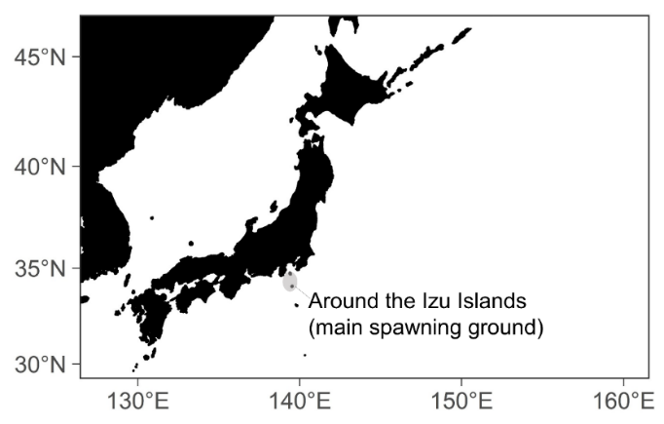
Fig. 1 Map of the main spawning ground for chub mackerel.

Table 1. Number of female chub mackerels by maturity stages based on histological observation from 2013 to 2023.
Results
Annual changes in KG and GSI distributions by maturity stages
The sample from 2013-2023 covered 72-205 individuals per year and covered throughout nearly all maturity stages (Table 1). The distributions of KG and GSI exhibited similar annual trends across all maturity stages (Fig. 2). The interannual distributions of KG and GSI were almost unchanged before the onset of yolk accumulation (“perinucleolus”, “yolke vesicle”) and the stages of yolk accumulation (“partially yolked”, “full yolked”), but a lower trend was observed in immediately prior to laying (“MN”, “HO”) since around 2019 for both KG and GSI. Median KG and GSI varied more in advanced maturity stages. Median KG ranged from 0.5-0.9 for “perinucleolus”, 1.4-1.9 for “yolk vesicle”, 2.2-2.8 for “partially yolked”, 4.1-6.5 for “full yolked”, 3.6-6.9 for “MN”, 6.4-12.7 for “HO”, 1.0-2.4 for “<50% yolked oocytes regressing”, 1.0-2.2 for “>=50 yolked oocytes regressing”, 0.9-1.5 for “spent with unyolked oocytes”. Median GSI ranged from 0.4-0.9 for “perinucleolus”, 1.2-1.6 for “yolk vesicle”, 1.7-2.6 for “partially yolked”, 3.6-5.6 for “full yolked”, 3.4-6.1 for “MN”, 6.0-12.1 for “HO”, 0.9-2.3 for “<50% yolked oocytes regressing”, 0.9-2.0 for “>=50% yolked oocytes regressing”, 0.9-1.5 for “spent with unyolked oocytes”.

Maturity probability at KG=3
The maturity probability at KG = 3 was 94% in 2014, 100% in 2015, 2016, 2018-2021 and 2023, 98% in 2017 and 2022, and 99% in the 2013-2023 data integrated version (Fig. 3). KG maturity probability curve for 2013 did not converge (Fig. 3).

50% maturity KG and GSI
The 50% maturity KG varied between 1.7 and 2.1 in 2014-2023 and showed a lower trend during 2019-2022 than during 2014-2018 (Figs 3, 5). It was 1.9 in the 2013-2023 integrated version.
The 50% maturity GSI varied between 1.6 and 1.8 in 2014-2023 and was 1.6 in the 2013-2023 integrated version (Figs. 4, 5). GSI maturity probability curves for 2013 and 2023 did not converge (Fig. 4).

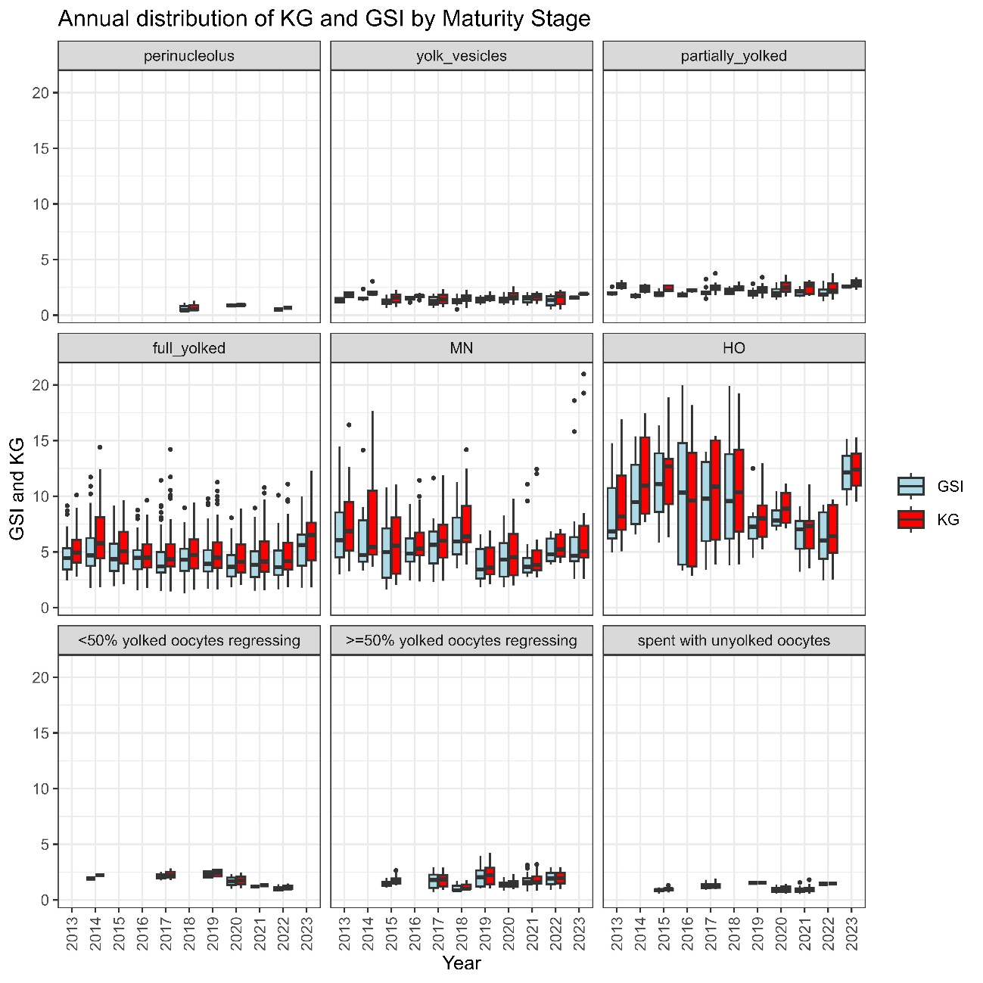
Fig.2 Box plots of KG and GSI by maturity stages from 2013 to 2023.

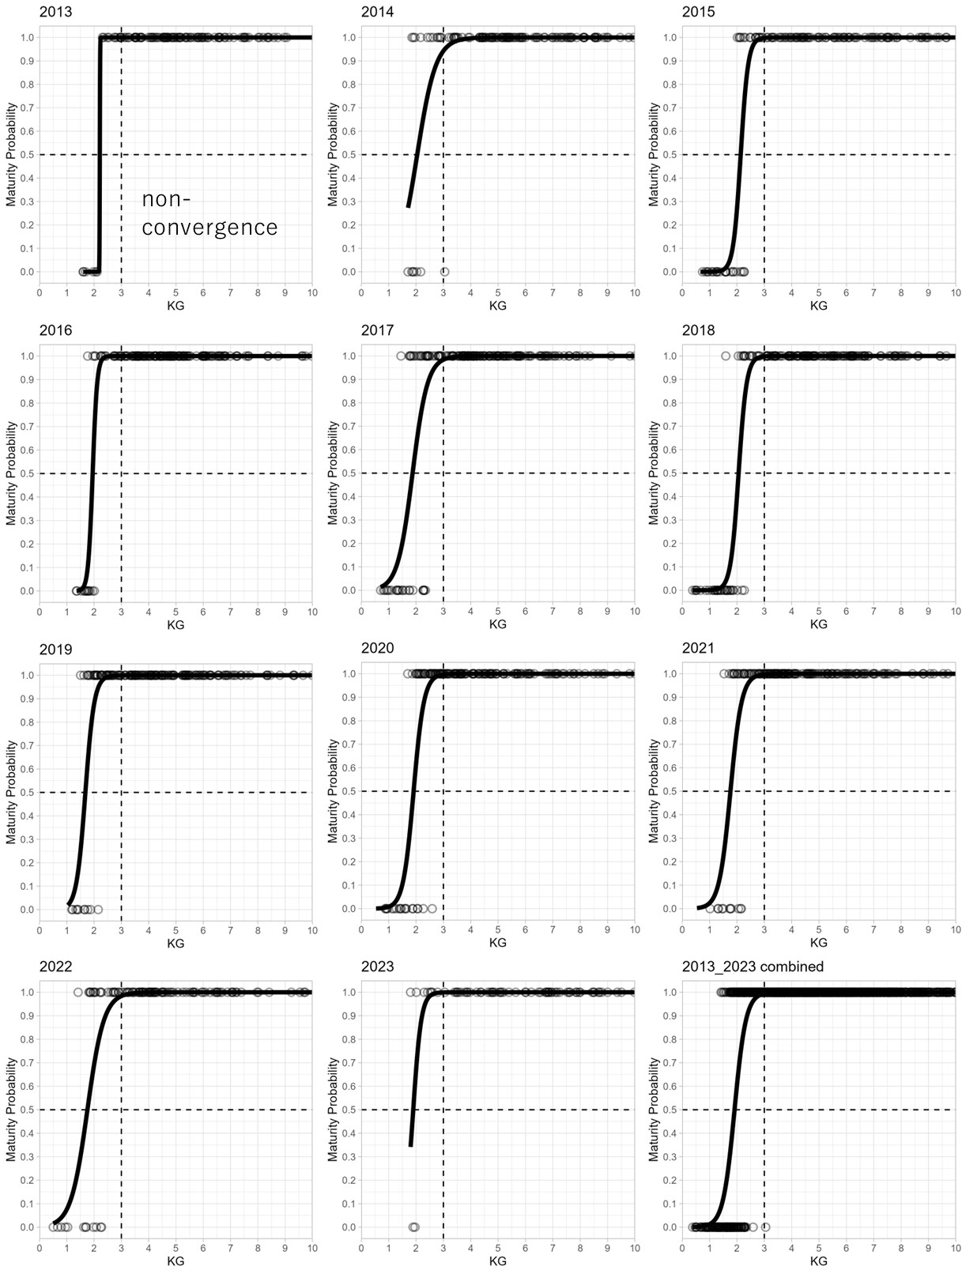
Fig.3 KG maturity probability curves for each year 2013~2023 and for the integrated version. The vertical dashed line at KG=3 is the maturity criterion estimated in Watanabe and Yatsu (2006).

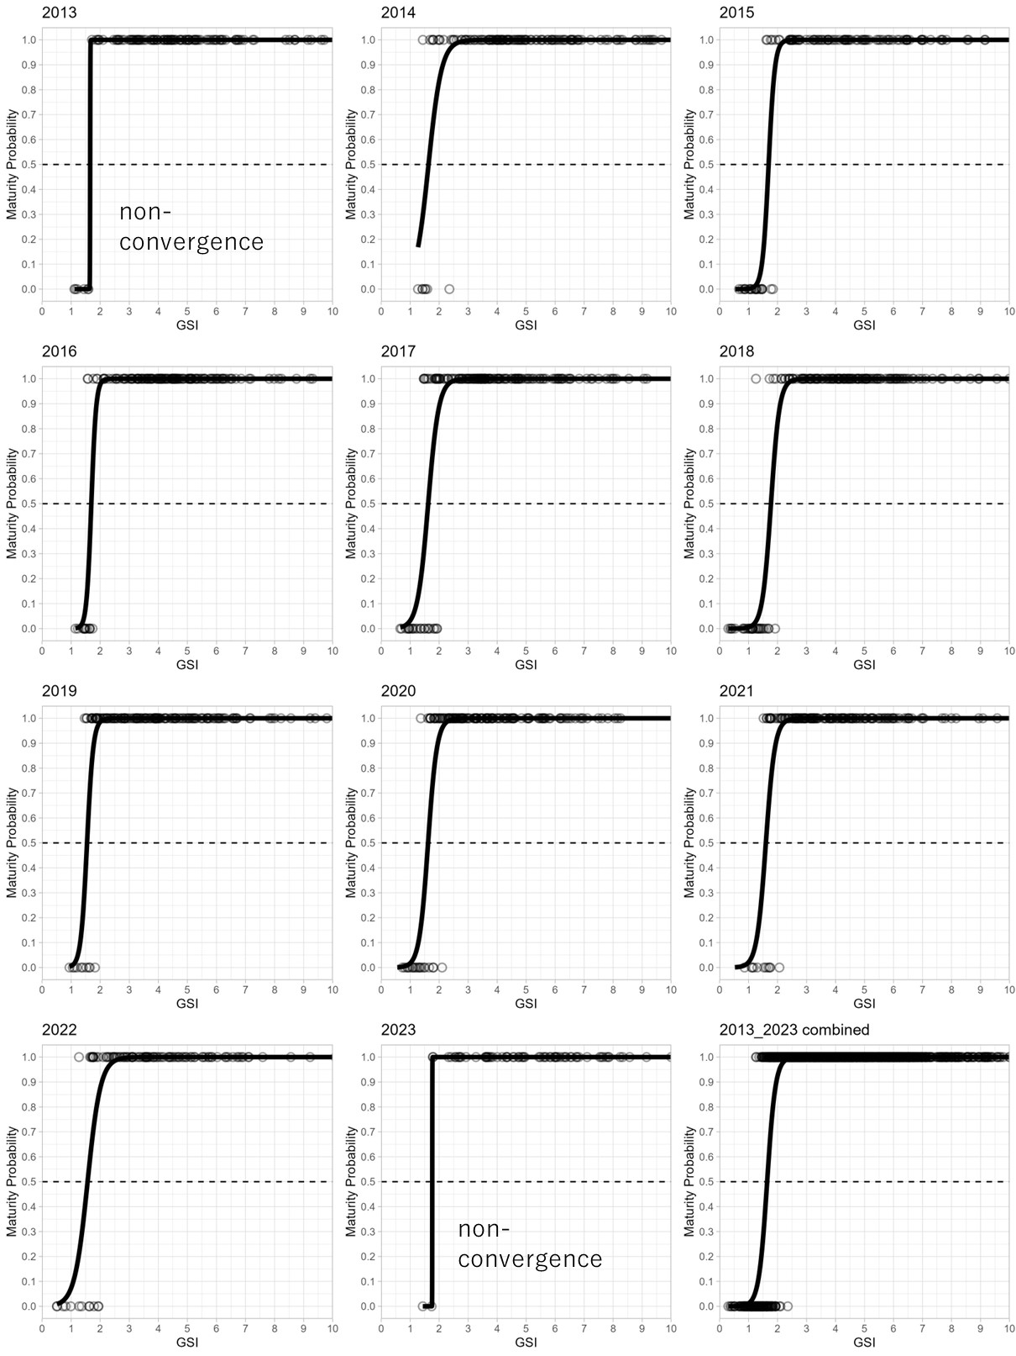
Fig.4 GSI maturity probability curves for each year 2013~2023 and for the integrated version.

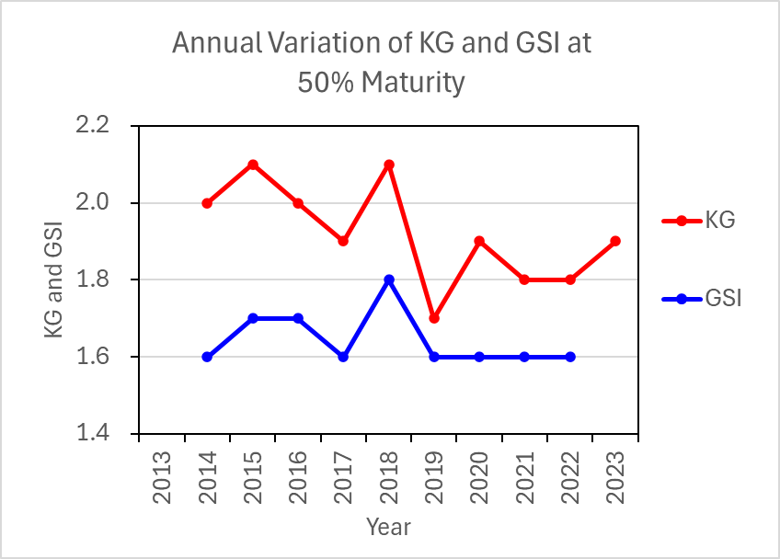
Fig.5 Annual change in 50% maturity KG and GSI from 2013-2023.

Discussion
Annual changes in KG and GSI distributions by maturity stages
The distribution of KG and GSI was almost unchanged before the onset of yolk accumulation and in the stages of yolk accumulation, but a lower trend was observed in immediately prior to laying since around 2019 (Fig. 2). Based on these annual changes in KG and GSI, the maturity criterion was reviewed as follows.

Maturity probability at KG=3
As the maturity probability was 94-100% for KG=3 in 2013-2023 (Fig. 3), KG=3 was a good indicator to extract only matured fish. However, as the median KG for early stages of yolk accumulation (“partially yolked”) ranged from 2.2 to 2.8 (Fig. 2), KG 3 is considered as a strict maturity criterion and would misidentify matured fish categorized in “partially yolked” stage. Therefore, it was considered more appropriate to use the 50% maturity criterion, where the probability of being a mature fish is equal to the probability of being an immature fish.

50% maturity KG and GSI
The 50% maturity KG showed a lower trend during 2019-2022 than during 2014-2018, whereas the 50% maturity GSI exhibited a relatively stable trend (Fig. 5). Isu et al. (in submission) describe a declining trend in body condition (Condition Factor =BW/FL³) in spawners around the waters the Izu Islands since around 2016. A decrease in body condition reflects a reduction in BW relative to FL³. Therefore, KG, whose denominator (i.e. FL³) depends solely on FL, tended to decrease with decreasing CF, while GSI, whose denominator (i.e. BW-GW) which is influenced by both FL and body condition, tended to be stable.
Since the 50% maturity GSI exhibits smaller annual variation than the 50% maturity KG (Fig. 5), it is considered that GSI is more appropriate maturity criterion to use across years with differing growth and body condition. The 50% maturity GSI ranged from 1.6-1.8 in 2014-2023 and was 1.6 in the 2013-2023 integrated version (Fig. 5). Therefore, it is considered appropriate to use a GSI of 1.6 as the maturity criterion, classifying individuals with GSI ≥ 1.6 as mature and those with GSI < 1.6 as immature.

Limits of the 50% maturation criterion
Individuals with GSI values below 1.6 were also observed in regressing and resting stages (“<50% yolked oocytes regressing”, “>=50% yolked oocytes regressing”, “spent with unyolked oocytes”) (Fig. 2). Therefore, even using the maturity criterion of a GSI of 1.6, it is impossible to correctly identify individuals after spawning with a GSI lower than 1.6 as mature. However, in estimating MAA, it is desirable to use samples from the peak of the spawning season (such as the peak period of the monthly proportion of mature individuals), before the emergence of post-spawning individuals, to avoid underestimating MAA, so the impact of the aforementioned problem can be evaded.

Conclusion
Maturity criterion is a fundamental component to calculate MAA. Considering the present dynamics of MAA of chub mackerel, it is important to review the criteria which were developed decades ago. The present study had reconfirmed that KG=3 is a good indicator to extract only matured fish and found to be strict but robust criterion. Considering the necessity to include ongoing matured fish at the time of sampling, more lenient maturity criterion may be useful to capture the dynamics of maturity at age and spawning dynamics. This paper suggests that, in order to improve MAA data for future stock assessment, it is more appropriate to use 50% maturity, notably GSI of 1.6 as the maturity criterion for stock assessment purpose, while noting KG=3 accurately designates maturation.

References
Brown-Peterson NJ, Wyanski DM, Saborido-Rey F, Macewicz BJ, Lowerre-Barbieri SK (2011) A standardized terminology for describing reproductive development in fishes. Mar Coast Fish 3:52–70. https://doi.org/https://doi.org/10.1080/19425120.2011.555724
Kamimura Y, Taga M, Yukami R, Watanabe C, Furuichi S (2021) Intra- And inter-specific density dependence of body condition, growth, and habitat temperature in chub mackerel (Scomber japonicus). ICES J Mar Sci 78:3254–3264. https://doi.org/10.1093/icesjms/fsab191
Takashima F, Hanyu I (1989) Reproductive biology of fish and shellfish, 1st edn. Midorishobo, Tokyo
Watanabe C, Yatsu A (2006) Long-term changes in maturity at age of chub mackerel (Scomber japonicus) in relation to population declines in the waters off northeastern Japan. Fish Res 78:323–332. https://doi.org/10.1016/j.fishres.2006.01.001

