NPFC-2025-TWG CMSA11-WP07

Sensitivity analyses of the 2025 chub mackerel stock assessment
in the Northwest Pacific Ocean

Shota Nishijima¹, Momoko Ichinokawa¹, Akihiro Manabe¹, Kazuhiro Oshima¹,
Shin-Ichiro Nakayama, and Joel Rice²

1: Fisheries Resources Institute, Japan Fisheries Research and Education Agency (FRA)
2: NPFC consultant
(Corresponding author: Shota Nishijima, nishijima_shota02@fra.go.jp)

Summary
We conducted sensitivity analyses to examine the impacts of observation uncertainty and model uncertainty in the 2025 stock assessment of chub mackerel in the Northwest Pacific. The analysis showed that the necessary assumptions of biological parameters to use 2024 fishing year abundance indices do not greatly affect stock abundance estimates. The analyses also show that models with the 2024 indices had higher prediction skill than models without the 2024 indices. We suggest using the most recent abundance indices in the stock assessment considering the robustness and predictability. Our results also suggest that process errors for age-1 and older fish and nonlinearity for age-0 and age-1 indices substantially change stock dynamics such as the strength of the 2013-year class, but these models exhibited bad model performance with respect to fit, prediction skill, and robustness. MSY-reference points were highly sensitive to the choices of data, biological parameters, and stock-recruitment relationship. This highlights the difficulty of using the MSY-reference points, and it may be appropriate to use more robust quantities based on historical SSB estimates as interim and empirical reference points, such as median or quartiles.

Introduction
The stock assessment of chub mackerel in the Northwestern Pacific is conducted by aggregating data from the TWG CMSA Members and using the state-space assessment model (SAM, Nielsen and Berg 2014). The TWG CMSA has agreed on the input data used for the base case stock assessment (NPFC-2025-TWG CMSA11-WP03) and the model settings for the base case generally follow the last year’s stock assessment despite minor revisions (NPFC-2025-TWG CMSA11-WP06). However, stock assessment and management involve many uncertainties, making it important to manage fisheries resources while considering these uncertainties.
The uncertainties related to fisheries resource management can be divided into five categories: (1) observation uncertainty, (2) process uncertainty, (3) model uncertainty, (4) estimation uncertainty, and (5) implementation uncertainty (Rosenberg and Restrepo 1994; Holland and Herrera 2009). Among these, implementation uncertainty refers to errors in management implementation, also known as management uncertainty, and it is sometimes considered separately from the other four (which are commonly called scientific uncertainty) (Privitera-Johnson and Punt 2020). Process uncertainty refers to the inherent variability in the natural biological processes affecting fish populations, such as growth rates, natural mortality, recruitment, and environmental influences. This type of uncertainty arises from the stochastic nature of these processes, which are not perfectly predictable. The CMSA includes variations in not only recruitment at age 0 but also other process errors for older ages, which are estimated in SAM (NPFC-2025-TWG CMSA11-WP06). Moreover, the variations in process errors are considered when conducting simulations and risk assessments for future projections (NPFC-2025-TWG CMSA11-WP09). Estimation uncertainty (the statistical uncertainty in the estimated parameters within a given model) and observation uncertainties in catch at age and abundance indices can be considered in SAM and the magnitudes were evaluated in the candidate base case document (NPFC-2025-TWG CMSA11-WP06).
In this working paper, we conduct sensitivity analyses to evaluate further uncertainty that was not covered in the candidate base case document (NPFC-2025-TWG CMSA11-WP06): uncertainty in input data (observation uncertainty) and model settings (model uncertainty). To analyze the level of observation uncertainty (i.e. the errors and inaccuracies in the data) we prepare several sensitivity scenarios to change input data or model settings from the candidate base cases. Through the sensitivity scenarios, the uncertainty due to the choice of the model structure and assumptions used in the assessment was assessed. Especially, we focus on the effect of different biological parameters of the 2024 fishing year (FY2024), because last year’s base case did not include the most recent abundance indices due to uncertainty of the biological parameters (NPFC-2024-SC09-WP20 (Rev. 1)). These sensitivity scenarios were compared by using performance measures (PMs) employed during the operating model development (NPFC-2022-TWG CMSA05-WP01), including recent spawning stock biomass (SSB), F reference points relative to current F, depletion statistics of SSB and other state variables. We also conducted hindcast cross validation in order to compare prediction skill among the models with different data sets in addition to a series of model diagnostics such as residual plots and retrospective analysis.

Methods

Sensitivity scenarios for observation uncertainty
SAM is a statistical catch-at-age model that considers not only the observation errors of abundance indices but also the observation errors of catch-at-age. However, it is unclear how robust the estimates are to changes in these data and biological parameters within. In the current stock assessment, the catch-at-age, weight-at-age, and maturity-at-age data up to FY2023 have been agreed upon within the TWG-CMSA. On the other hand, six abundance index time series—excluding the Chinese fishery CPUE—are available up to FY2024. Some of these indices are fitted to vulnerable stock biomass or spawning stock biomass (SSB), and thus, weight-at-age and maturity-at-age data for FY2024 are required. This allows the use of the 2024 abundance indices to compare against projected stock estimates that are forward projected from population dynamics up to FY2023. The catch-at-age data for 2024 are treated as missing, and the estimates of F-at-age and catch-at-age are complemented using a state-space model.
We applied a change-point analysis to historical spawner per recruit without fishing (SPR0), a measure of spawning potential using the R package ‘changepoint’ (Killick & Eckley, 2014). The result detected three different regimes of SPR0 and the last regime began in FY2016 (Fig. 1). Future projections last year were conducted using the average of weight-at-age and maturity-at-age from FY2016 to FY2022, which matches the results of change point analysis (maturity-at-age is constant since FY2016). Considering the continuity from last year and the result of change point analysis, we proposed using the FY2016-2023 average of weight- and maturity-at-age as those for FY2024 as a candidate base-case scenario (S02-Index24_1, NPFC-TWG CMSA11-WP06, Table 1). However, weight-at-age has been time-varying even since FY2016 and its average values differ depending on the beginning year for taking average (Fig. 2). We therefore considered three sensitivity scenarios in which the averaging period was revised to the most recent five years (FY2019-2023), three years (FY2021-2023), and one year (FY2023).
To fit the Russian CPUE in FY2024, the proportion of Russia's catch-at-age relative to the total catch-at-age from all Members is required (see NPFC-TWG CMSA11-WP06 for details). As a candidate for the base-case scenario, we considered using the average proportion over the most recent three years (FY2021-2023). To assess the sensitivity of this assumption, we also examined an alternative case using the most recent five years (FY2019-2023). As a result, we analyzed a total of eight sensitivity scenarios by combining four assumptions for weight-at-age with two assumptions for the proportion of Russia’s catch-at-age in 2024 (Scenarios S02-09 in Table 1).
We also investigated sensitivity to maturity-at-age and natural mortality. While Japan’s maturity-at-age was used as the base case (NPFC-TWG CMSA11-WP03, 06), it is suggested to use the average between China and Japan as a sensitivity scenario (NPFC-TWG CMSA11-WP03). Accordingly, we analyzed two sensitivity scenarios using the average maturity-at-age of China and Japan with the 2024 indices excluded and included (Scenarios S10-11 in Table 1). The average maturity-at-age for age 2 were slightly lower than the value of the base case maturity-at-age (Fig. 3). We also analyzed sensitivity scenarios in which age-common natural mortality M=0.5 for all ages, previously used as candidate (NPFC-TWG CMSA09-WP03), was used while the other input data and model settings were the same as the candidate base cases (Scenarios S12-13 in Table 1).

Scenarios for model uncertainty
We prepared three kinds of sensitivity scenarios to evaluate sensitivity to model structure (Table 1). The first two scenarios relate to the choice of stock-recruitment relationship. A Beverton-Holt (BH) stock-recruitment relationship was used in the candidate base cases as in last year’s stock assessment (NPFC-2025-TWG CMSA09-WP06). However, MSY-based reference points estimated by the BH curve were highly sensitive to data and model settings and exceeded the historical range of spawning stock biomass, i.e., SSB_{MSY} > max(SSB) (NPFC-2024-SC09-WP20 (Rev. 1)). We therefore tried to use a smooth hockey-stick (SHS) stock-recruitment relationship (Mesnil & Rochet, 2010). SHS is a differentiable hockey-stick model in which stock-recruitment parameters can be estimated within stock assessment models using automatic differentiation, such as SAM (Scenarios S12-13 in Table 1). The SHS model is expressed as:
$$R_{y}= 0.5a\left[B_{y}+\sqrt{b^{2}+\frac{γ^{2}}{4}}-\sqrt{{\left(B_{y}-b\right)}^{2}+\frac{γ^{2}}{4}}\right] ,$$
where a is the slope at the origin and b is the breakpoint, both of which are estimated parameters in SAM. The parameter γ controls the smoothness around the breakpoint and we set γ = 100 so that the model was converged.
The next two scenarios relate to process errors of numbers for age 1 and older (age 1+). The process error for age 1+ is a unique characteristic in CMSA and was introduced to the base case stock assessment of last year during the TWG CMSA09 meeting to improve the fit to abundance indices and reduce retrospective patterns (NPFC-2024-SC09-WP20 (Rev. 1)). Although we have continued to estimate the process errors for age 1+ in the candidate base case scenarios (NPFC-TWG CMSA11-WP06), the effect of process errors for age 1+ is worth investigating with respect to abundance estimates and model performance. In the two sensitivity scenarios, we fixed the standard deviation of process errors for age 1+ population numbers at 0.01 (Scenarios S14-15 in Table 1).
The last two scenarios relate to the nonlinear coefficients for abundance indices. In the candidate base cases, nonlinear coefficients were estimated for the three indices of 0-1 year-old fish from Japanese trawl surveys, based on model selection (NPFC-2025-TWG CMSA11-WP06). Here we analyzed scenarios with the nonlinear coefficients fixed at 1 (i.e. linear relationship between abundances and indices) (Scenarios S16-17 in Table 1) to inform the effect of nonlinearity for these abundance indices.

Model diagnostics and performance measures (PMs)
For all the scenarios mentioned above, we performed a complete set of model diagnostics similar to what was done in the candidate base cases (NPFC-2025-TWG CMSA11-WP06). For example, we checked for model convergence and calculated the AIC. However, since we cannot directly compare AIC among sensitivity scenarios with different observations (catch at age and abundance indices), it is not practical to include all diagnostic results for all scenarios in this document. Then, we introduce the results selectively for scenarios that showed substantial divergence from the candidate base cases. However, retrospective analysis is an important diagnostic, and therefore, we summarized the Mohn’s rho values in a table for all sensitivity scenarios.
To compare scenarios, we used PMs employed during OM development (Table 2). These PMs include state variables such as recent total biomass, SSB, recruitment, and exploitation rate, as well as current SPR/SPR0 and depletion statistics like the ratio of the most recent three-year average SSB (FY2021-2023) to the historical median SSB. Additionally, some of relative F reference points to current F were calculated, such as F_{MED}, F0.1, and F%SPR. Quantities related to the stock-recruitment relationship and MSY reference points were also estimated. These biological reference points were calculated using the average biological parameters (weight-at-age and maturity-at-age) of FY2016-2023 as default. Since the choice of biological parameters is known to be highly influential on biological reference points and future projection, however, we also computed the PMs of biological reference points using the whole-year average of biological parameters (FY1970-2023). Detailed calculation methods are shown in Annex D of NPFC-2022-TWG CMSA05-WP01.
We have newly added the historical median and the first and third quartiles of SSB during all stock assessment period (i.e. FY1970-2023) and the most recent three-year average of SSB to these historical quantities to the list of PMs (Table 2). The TWG CMSA has been requested by the Commission to calculate the probability that stock biomass will exceed an approximate MSY proxy in the future (NPFC Commission 2025). Due to the high uncertainty associated with the stock-recruitment relationship and biological parameters, we consider it difficult to establish MSY-based reference points at this time. Therefore, we included historical spawning stock biomass (SSB) quartiles and the median in the list, as they are considered more robust and may serve as provisional alternative reference points.

Hindcast cross validation
AIC comparisons cannot be made when abundance index datasets change. Additionally, retrospective analysis serves only as a method to assess the consistency of the model, not to evaluate prediction skill. For comparing predictive abilities when using different data and model structures, hindcast cross-validation (CV) has been conducted in some cases (Kell et al. 2016; Carvalho et al. 2021). This method evaluates model performance by assessing predictive power on observed values rather than unobserved, estimated values.
The spawning egg abundance index was used for evaluating predictive performance in this analysis because it correlates well with SSB (NPFC-2025-TWG CMSA11-WP06) and is a crucial indicator of population reproductive potential. To execute hindcast CV, the timeframes of any scenarios need to align. While some scenarios (e.g., S01-InitBase) shares the same final year for catch-at-age and index values, other scenarios (e.g., S02-Index24_1) use the latest abundance indices available one year ahead of catch-at-age data except the Chinese fishery CPUE. Therefore, while the former scenarios use catch-at-age and index values through FY2022 to predict the FY2024 spawning egg index value (using the first year of retrospective analysis), the latter scenarios use catch-at-age data up to FY2022 but the abundance indices up to FY 2023 to predict the 2024 spawning egg index value (also using the first year of retrospective analysis). In other words, in terms of lagged spawning egg index values, the former forecasts two years into the future, whereas the latter forecasts only one year into the future. Catch-at-age data from FY2023 onwards are treated as missing data, but SAM assumes F at age to follow a random walk, allowing it to predict SSB in FY2024 under this assumption, with the predicted spawning egg value obtained by multiplying the predicted SSB by the estimated proportionality constant. This process is repeated in the manner of retrospective analysis to obtain predictions of the egg abundance for seven years (FY2018-2024) across each scenario.
Predictive performance evaluation utilizes a robust statistical measure known as the mean absolute scaled error (MASE) (Carvalho et al. 2021):
$$MASE= \frac{\frac{1}{n}\sum_{y=2024-n+1}^{2024}{\left|I_{y}-{\hat{I}}_{y|y-h}\right|}}{\frac{1}{n}\sum_{y=2024-n+1}^{2024}{\left|I_{y}-I_{y-h}\right|}} ,$$ | (1)
where n is the total number of peels (7 years in this document), h is the time horizon of forecasting (2 years) , $I_{y}$ is the observed value of the spawning egg index in year y, and ${\hat{I}}_{y|y-h}$ is the predicted value of the spawning egg index in year y obtained by h-year-ahead forecasting. MASE means the mean absolute error (MAE) of forecasts scaled (divided) by MAE of naïve prediction by a random walk assumption ($I_{y}=I_{y-h}$). That is, MASE > 1 indicated that model forecasts are worse than the random walk prediction, while MASE = 0.5 indicates that the model forecasts are twice as accurate as the naïve benchmark prediction (Carvalho et al. 2021; Kell et al. 2021). We set the hindcasting horizon to h = 2 because the catch-at-age data through 2 years ago was used for all scenarios. This means that the denominator of eqn. (1) is the same among all scenarios and indicates the naïve prediction of a random walk of the spawning egg index two-year ahead.

Results

Overview of model diagnostics
In all 19 scenarios, the parameter estimation successfully converged, and the positive definite values of the Hessian matrix required to calculate the estimation error were obtained (Table 3). The final gradient values were also close to zero for all scenarios.

Performance measures (PMs) under the candidate base-case scenarios (S01 and S02)
The current spawning biomass (1.32–1.41 million tons in FY2023) was below the median of historical SSB (2.89 million tons) but remained above the first quartile (1.07 million tons) (Table 4). When biological parameters averaged over FY2016–2023 were used, the percent SPR under current fishing mortality (F) was estimated at approximately 16–17%, while %SPR at F_{MSY} was estimated at 67–68%. The current fishing pressure exceeded all calculated F reference points. The estimated steepness was 0.35–0.36, and SB_{MSY} was higher than the historical maximum SSB.
When the biological parameters were averaged over all years (FY1970-2023), all F reference points except F_{0.1} increased (Table 5). However, the current F still exceeded all F reference points except F_{MED}. Under this assumption, steepness increased to 0.50–0.51, and SB_{MSY} more than doubled, compared to the cases taking FY2016-2023 average.

Effects of using FY2024 indices
Changes in the FY2024 weight-at-age and the proportion of Russian catch （Scenarios S02-09）had little effect on the estimated stock biomass and the suite of PMs (Fig. 4, Table 4). The differences in AIC values were also small (less than 1) (Table 3).
The scenarios with the latest abundance indices showed lower MASE values in the hindcast cross validation than the corresponding scenarios without the latest indices (Table 3). For example, the MASE decreased from 0.94 for S01-InitBase to 0.73 for S02-Index24_1 by including FY2024 indices (Fig. 5). This suggests that using the newest information of abundance indices helps improve the prediction skill against the data of spawning egg abundance. Mohn’s rho values were also closer to zero for the scenarios with FY2024 indices than those without them (Tables 6-7).
The inclusion or exclusion of FY2024 abundance indices had little effect on the state variables, but it did influence the shape of the stock-recruitment relationship, resulting in changes to SSB0 and SSB_{MSY} estimates (Table 4). For example, under the S01-InitBase scenario, where biological parameters averaged over FY2016–2023 were used, SB_{MSY} was estimated at 1.915 million tons. In contrast, under the S02-Index24_1 scenario, it was estimated at 1.561 million tons. In addition, under last year’s base-case scenario (S28-ProcEst), SSB_{MSY} was estimated at 2.905 million tons, indicating a decrease in SSB_{MSY} due to the incorporation of the most recent data (Scientific Committee 2024). This suggests that SSB_{MSY} is sensitive to data revisions and updates. Furthermore, in the current stock assessment, SSB_{MSY} estimates in most scenarios (except for a few) still exceeded historical maximum SSB (Table 4).

Effects of maturity and natural mortality
The scenario in which the maturity-at-age was set as the average between Japan and China (S10–11) produced results that were nearly identical to those of the base-case candidates (Table 4, Figs 6-7). The model performance, as measured by AIC, MASE, and Mohn’s rho were also almost the same between these alternative scenarios and the candidate base cases (Tables 3, 6-7).
In contrast, the scenario assuming a constant natural mortality (M = 0.5) across ages (S12–13) showed slightly better predictive performance in terms of AIC and MASE than the base-case candidates with age-specific M (Table 3). Mohn’s rho for these alternative scenarios was almost identical to that for the base cases (Tables 6-7). In these scenarios with constant M, recruitment was estimated to be lower, whereas spawning biomass was estimated to be higher compared to the base-case candidates (Table 4, Figs 5-6). As a result, the historical median and quartiles of SSB were also higher, although the current level relative to them remained nearly the same as in the base-case candidates (Table 4). Compared to the scenarios with age-specific M, the scenarios with age-common M tended to produce higher F_{ref}/F_{current} and lower SSB_{MSY} estimates. Additionally, SSB_{MSY} was estimated to be below the historical maximum SSB (Table 4). These results suggest that MSY-based reference points are sensitive to assumptions about natural mortality, while historical medians and quartiles of SSB are more robust as benchmarks for evaluating current stock status.

Effects of using the smooth hockey stick (SHS) stock-recruitment model
Change in the stock-recruitment relationship from BH to SHS had a minor effects on the state variables (Table 4, Figs. 6-7) and model performance including AIC, MASE, and Mohn’s rho (Tables 3, 6-7). The SHS stock-recruitment relationships were estimated with smooth breakpoints at SSB = 1.02 million ton for S14-SHS and SSB = 0.94 million ton for S15-SHS_idx24 (Fig. 8). The likelihood profiling showed successful optimization of the estimated parameters, although the log-likelihood was relatively insensitive to changes in the breakpoint location, suggesting high uncertainty in the estimated value (Fig. 9).
Changes in the stock-recruitment relationship had a substantial impact on MSY-based reference points. When the SHS relationship was used, F_{MSY} was estimated to be higher and SSB_{MSY} to be lower compared to the estimates based on the BH relationship (Table 4). For simplicity in computation, the breakpoint in the SHS model was output as a deterministic SSB_{MSY}, consistent with the standard HS model. As a result, SSB_{MSY} was estimated within the range of historical SSB, but the SSB exceeded SSB_{MSY} only before 1980, and has remained below SSB_{MSY} since then (Fig. 8).

Effects of process errors and nonlinearity of abundance indices
The scenarios (S14-15) in which process errors for age-1 and older were turned off resulted in the largest change in the stock biomass pattern, followed by the scenarios (S18-19) in which the indices for age-0 and age-1 were assumed to follow a linear relationship (Figs. 6-7). In both of these scenarios, the 2013 year class was estimated to be larger than in the other scenarios.
However, these scenarios exhibited much poorer predictive performance than the others, as measured by AIC and hindcast cross-validation (Table 3, Fig. 5). They also showed poor fits when the indices for age-0 and age-1 were relatively high in recent years (Figs. 10-11). In the scenarios without process errors for age-1 and older, the QQ plot of one-step-ahead (OSA) residuals deviated substantially from the ideal line (Fig. 12), indicating that the residuals between predicted and observed values did not follow a normal distribution. Furthermore, in retrospective analysis, these scenarios showed particularly high Mohn’s rho values for both stock biomass and recruitment, indicating strong retrospective patterns (Table 3, Figs. 13-14).

Discussion
The sensitivity analysis conducted in this study revealed several key points for the stock assessment and management of chub mackerel in the Northwestern Pacific. First, the estimated stock biomass was highly robust to assumptions related to biological parameters when incorporating the most recent abundance indices. In general, the advantage of using the data up to the most recent year is significant by shortening time lag up to management implementation and increasing estimation robustness and forecasting skill of population dynamics (Le Pape et al., 2020; Nishijima et al., 2023). However, in CMSA, the effects of uncertainty due to the need for assumptions about biological parameters of the year of the most recent abundance indices have been concerned. The sensitivity analysis suggests that the impact of the uncertainty on the estimation is minimal if these parameters fall within the recent range of values. In our stock assessment, NPFC-2025-TWG CMSA-WP06 shows that using the most recent abundance indices in last year’s assessment would have reduced the extent of the downward revision observed in this year’s assessment. These findings suggest that incorporating recent abundance indices—along with using recent average values for biological parameters—can contribute to improving the stability and reliability of stock assessments while uncertainties regarding the assumptions about biological parameters are minimal.
Two key features of the current SAM configuration—the estimation of process errors for age-1 and older fish, and the estimation of nonlinearity in the indices for age-0 and age-1 fish—were found to have a substantial impact on stock biomass trends especially during the most recent decade. Process errors were shown to increase the estimated size of the 2013 year class after recruitment (age 0) (NPFC-2025-TWG CMSA11-WP06); when these errors and the nonlinearity were not estimated, the 2013 year class was estimated to be even larger at the time of age 0. However, model diagnostics consistently indicated poorer predictive performance and robustness in those scenarios. From a statistical measure such as AIC, it is considered more appropriate to estimate process errors for age-1+ fish and to assume nonlinearity in the indices for age-0 and age-1 fish. These findings raise important biological questions: (1) What specific factors—such as mortality or migration—underlie the process errors for age-1+ fish? and (2) Why do the survey indices from trawl surveys targeting age-0 and age-1 fish show a tendency toward hyperdepletion? These questions need to be addressed as mid- to long-term challenges. The stock biomass estimates derived from SAM were robust under scenarios other than those of process error and index nonlinearity.
As the third key point, the analysis revealed that MSY-based reference points are highly sensitive to model configurations and input data. For chub mackerel, which exhibit substantial variability in body weight and maturity-at-age, the SSB_{MSY} estimated under the BH stock–recruitment relationship can differ by more than a factor of two depending on whether recent biological parameters or long-term averages are used. SB_{MSY} estimates also changed significantly depending on whether the most recent (FY2024) abundance indices were included. For example, using the average biological parameters from FY2016–2023, SSB_{MSY} decreased from 1.92 million tons in Scenario S01-InitBase to 1.56 million tons in Scenario S02-Index24_1, an 18% reduction. On the other hand, statistics of historical median or quantiles of SSB were robust across almost all scenarios S01-19. Given the high sensitivity of MSY reference points to input data and biological parameters, using the historical median or quartiles of SSB would serve as a realistic basis for empirical reference points. However, it should be noted that the quartiles are consistently lower than SSB_{MSY} and should be considered merely as interim reference points rather than proxies for MSY. Specifically, the first, second (median), third quartiles correspond to 3.7–11.4%, 11.5–30.7%, and 23.2–76.8% of SSB_{MSY}, respectively, across all scenarios.
Interestingly, stock assessments since last year have shown that the inclusion of new data tends to slightly shift the shape of the stock–recruitment relationship and consistently leads to lower SSB_{MSY} estimates. This is likely because recent SSB levels have been relatively low, while recruitment has appeared above the fitted stock-recruitment curve, leading to an apparent strengthening of density dependence through a steeper slope in the stock–recruitment curve. Although SSB_{MSY} is currently estimated to be higher than the historical maximum, it is possible that stronger density dependence will be detected in the future, resulting in SSB_{MSY} estimates that fall within historical ranges.
In the case of the SHS relationship, SSB_{MSY} is represented as a deterministic breakpoint and is unlikely to be affected by biological parameters. As a result, SSB_{MSY} remained within the historical range. However, even in the SHS model, adding the FY2024 indices led to a decrease in SSB_{MSY} from 1.02 million tons to 0.94 million tons (a reduction of 8%), and the profile likelihood analysis indicated high uncertainty in the location of the breakpoint. Nevertheless, the SHS-based SSB_{MSY} show greater robustness against inclusion of SY2024 indices, compared to that from the BH model. If explicit use of MSY-based reference points is required, applying the SHS model could be a practical option.

References
Carvalho, F., Winker, H., Courtney, D., Kapur, M., Kell, L., Cardinale, M., Schirripa, M., Kitakado, T., Yemane, D., Piner, K.R., Maunder, M.N., Taylor, I., Wetzel, C.R., Doering, K., Johnson, K.F., and Methot, R.D. 2021. A cookbook for using model diagnostics in integrated stock assessments. Fish Res 240: 105959. Elsevier. doi:10.1016/J.FISHRES.2021.105959.
Holland, D.S., and Herrera, G.E. 2009. Uncertainty in the Management of Fisheries: Contradictory Implications and a New Approach. https://doi.org/10.1086/mre.24.3.42629656 24(3): 289–299. MRE Foundation, Inc. . doi:10.1086/MRE.24.3.42629656.
Hyndman, R.J., and Koehler, A.B. 2006. Another look at measures of forecast accuracy. Int J Forecast 22(4): 679–688. Elsevier. doi:10.1016/J.IJFORECAST.2006.03.001.
Manabe, A., Gazi, K. M., and Oshima, K. (2025) The data description for the base case stock assessment of chub mackerel Scomber japonicus in the northwestern Pacific Ocean for 2025 assessment. NPFC-2025-TWG CMSA11-WP03 (Rev. 1).
Kell, L.T., Kimoto, A., and Kitakado, T. 2016. Evaluation of the prediction skill of stock assessment using hindcasting. Fish Res 183: 119–127. Elsevier. doi:10.1016/J.FISHRES.2016.05.017.
Kell, L.T., Sharma, R., Kitakado, T., Winker, H., Mosqueira, I., Cardinale, M., and Fu, D. 2021. Validation of stock assessment methods: is it me or my model talking? ICES Journal of Marine Science 78(6): 2244–2255. Oxford Academic. doi:10.1093/ICESJMS/FSAB104.
Killick, R., & Eckley, I. A. (2014). changepoint: An R Package for Changepoint Analysis. Journal of Statistical Software, 58, 1-19. https://doi.org/10.18637/jss.v058.i03
Le Pape, O., Vermard, Y., Guitton, J., Brown, E. J., van de Wolfshaar, K., Lipcius, R. N., Støttrup, J. G., & Rose, K. A. (2020). The use and performance of survey-based pre-recruit abundance indices for possible inclusion in stock assessments of coastal-dependent species. ICES Journal of Marine Science, 77(5), 1953-1965. https://doi.org/10.1093/ICESJMS/FSAA051
Mesnil, B., & Rochet, M. J. (2010). A continuous hockey stick stock-recruit model for estimating MSY reference points. ICES Journal of Marine Science, 67, 1780-1784. https://doi.org/10.1093/icesjms/fsq055
Nielsen, A., and Berg, C. W. (2014). Estimation of time-varying selectivity in stock assessments using state-space models. Fisheries Research, 158, 96–101. https://doi.org/10.1016/j.fishres.2014.01.014
Nakayama, S., Nishijima, S., Ichinokawa, M., Manabe, A., Oshima, K., and Rice, J. (2025) Candidate base case scenarios for the 2025 chub mackerel stock assessment in the Northwest Pacific Ocean. NPFC-2025-TWG CMSA11-WP06.
Nishijima, S., Suzuki, S., Fukuta, R., and Okada, M. 2023. Modeling pulse dynamics of juvenile fish enables the short-term forecasting of population dynamics in Japanese pufferfish: a latent variable approach and hindcasting. Canadian Journal of Fisheries and Aquatic Sciences 80(6): 1017–1031. Canadian Science Publishing 1840 Woodward Drive, Suite 1, Ottawa, ON K2C 0P7.
Nishijima, S., Ichinokawa, M., Oshima, K., and Rice, J. (2025) Biological reference points and future projections in the 2025 stock assessment for the Northwestern Pacific chub mackerel. NPFC-2025-TWG CMSA11-WP09.
NPFC Commission. (2025) Meeting Report. NPFC-2025-COM09-Final Report. 771 pp. (Available at www.npfc.int)
NPFC 5th Meeting of the Technical Working Group on Chub Mackerel Stock Assessment (2024) 2nd Meeting of the Small Working Group on Operating Model for Chub Mackerel Stock AssessmentS. NPFC-2022-TWG CMSA05-WP01.
NPFC 9th Meeting of the Technical Working Group on Chub Mackerel Stock Assessment (2024) Stock Assessment of Chub Mackerel in the Northwest Pacific Ocean. NPFC-2024-SC09-WP20 (Rev. 1).
Privitera-Johnson, K.M., and Punt, A.E. 2020. A review of approaches to quantifying uncertainty in fisheries stock assessments. Fish Res 226: 105503. Elsevier. doi:10.1016/J.FISHRES.2020.105503.
Punt, A. E., Smith, A. D. M., Smith, D. C., Tuck, G. N., & Klaer, N. L. (2014). Selecting relative abundance proxies for BMSY and BMEY. ICES Journal of Marine Science, 71(3), 469-483. https://doi.org/10.1093/icesjms/fst162
Rosenberg, A.A., and Restrepo, V.R. 1994. Uncertainty and risk evaluation in stock assessment advice for U.S. marine fisheries. https://doi.org/10.1139/f94-271 51(12): 2715–2720. NRC Research Press Ottawa, Canada . doi:10.1139/F94-271.

Tables and Figures

Table 1
The list of base-case and sensitivity scenarios with descriptions, data used, and model settings.
Scenario | Description | Index duration | Biological parameters in 2024 | Russian catch proportion in 2024 | Nonlinearity for abundance indices | Stock-recruit | Maturity | Process error for or age 1+
S01-InitBase | Initial base-case candidate | Through 2023 | - | - | Estimate nonlinearity for ages 0 and 1 indices | Beverton-Holt | Japan | Estimated
S02-Index24_1 | Another candidate base case with indices of FY2024 (see right for details) | Through 2024 | 8 years ave (2016-2023) | 3 years ave (2021-2023) | Estimate nonlinearity for ages 0 and 1 indices | Beverton-Holt | Japan | Estimated
S03-Index24_2 | Use indices of FY2024 with a different assumption from S02 (see right for details) | Through 2024 | 5 years ave (2019-2023) | 3 years ave (2021-2023) | Estimate nonlinearity for ages 0 and 1 indices | Beverton-Holt | Japan | Estimated
S04-Index24_3 | Use indices of FY2024 with a different assumption from S02 (see right for details) | Through 2024 | 3 years ave (2021-2023) | 3 years ave (2021-2023) | Estimate nonlinearity for ages 0 and 1 indices | Beverton-Holt | Japan | Estimated
S05-Index24_4 | Use indices of FY2024 with a different assumption from S02 (see right for details) | Through 2024 | Latest year (2023) | 3 years ave (2021-2023) | Estimate nonlinearity for ages 0 and 1 indices | Beverton-Holt | Japan | Estimated
S06-Index24_5 | Use indices of FY2024 with a different assumption from S02 (see right for details) | Through 2024 | 8 years ave (2016-2023) | 5 years ave (2019-2023) | Estimate nonlinearity for ages 0 and 1 indices | Beverton-Holt | Japan | Estimated
S07-Index24_6 | Use indices of FY2024 with a different assumption from S02 (see right for details) | Through 2024 | 5 years ave (2019-2023) | 5 years ave (2019-2023) | Estimate nonlinearity for ages 0 and 1 indices | Beverton-Holt | Japan | Estimated
S08-Index24_7 | Use indices of FY2024 with a different assumption from S02 (see right for details) | Through 2024 | 3 years ave (2021-2023) | 5 years ave (2019-2023) | Estimate nonlinearity for ages 0 and 1 indices | Beverton-Holt | Japan | Estimated
S09-Index24_8 | Use indices of FY2024 with a different assumption from S02 (see right for details) | Through 2024 | Latest year (2023) | 5 years ave (2019-2023) | Estimate nonlinearity for ages 0 and 1 indices | Beverton-Holt | Japan | Estimated
S10-MAA_ChnJpn | Use average age of maturity between China and Japan | Through 2023 | - | - | Estimate nonlinearity for ages 0 and 1 indices | Beverton-Holt | Average of China and Japan | Estimated
S11-MAA_ChnJpn_idx24 | Use average age of maturity between China and Japan and indices of FY2024 | Through 2024 | 8 years ave (2016-2023) | 3 years ave (2021-2023) | Estimate nonlinearity for ages 0 and 1 indices | Beverton-Holt | Average of China and Japan | Estimated
S12-Mcom | Use age-common natural mortality (M=0.5) | Through 2025 | - | - | Estimate nonlinearity for ages 0 and 1 indices | Beverton-Holt | Japan | Estimated
S13-Mcom_idx24 | Use age-common natural mortality (M=0.5) and indices of FY2024 | Through 2026 | 8 years ave (2016-2023) | 3 years ave (2021-2023) | Estimate nonlinearity for ages 0 and 1 indices | Beverton-Holt | Japan | Estimated
S14-SHS | Use smooth hockey stick (SHS) | Through 2023 | - | - | Estimate nonlinearity for ages 0 and 1 indices | Smooth HS | Japan | Estimated
S15-SHS_idx24 | Use smooth hockey stick (SHS) and indices of FY2024 | Through 2024 | 8 years ave (2016-2023) | 3 years ave (2021-2023) | Estimate nonlinearity for ages 0 and 1 indices | Smooth HS | Japan | Estimated
S16-NoProcErr | Assume a very small process errors for numbers older than age 0 | Through 2023 | - | - | Estimate nonlinearity for ages 0 and 1 indices | Beverton-Holt | Japan | Fixed at SD=0.01
S17-NoProcErr_idx24 | Assume a very small process errors for numbers older than age 0 and use indices of FY2024 | Through 2024 | 8 years ave (2016-2023) | 3 years ave (2021-2023) | Estimate nonlinearity for ages 0 and 1 indices | Beverton-Holt | Japan | Fixed at SD=0.01
S18-Fix_b1 | Fix nonlinear coefficients at b=1 for all indices | Through 2023 | - | - | Assume linearity for all indices | Beverton-Holt | Japan | Estimated
S19-Fix_b1_idx24 | Fix nonlinear coefficients at b=1 for all indices and use indices of FY2024 | Through 2024 | 8 years ave (2016-2023) | 3 years ave (2021-2023) | Assume linearity for all indices | Beverton-Holt | Japan | Estimated

Table 2
Descriptions of performance measures (PM). The most recent three-year averages (FY2021-2023) of F-at-age are used for the PMs related to current F, F reference points, stock-recruitment relationship, and MSY. The biological parameters (maturity at age and weight at age) are assumed to be the average of 2016-2023 or 1970-2023.
PM | Description
TBy2023 | Total stock biomass in FY2023 (1,000 MT)
SSBy2023 | Spawning stock biomass in FY2023 (1,000 MT)
Ry2019 | The number of recruits in FY2019 (million)
Ry2020 | The number of recruits in FY2020 (million)
Ry2021 | The number of recruits in FY2021 (million)
Ry2022 | The number of recruits in FY2022 (million)
Ry2023 | The number of recruits in FY2023 (million)
AFy2019 | Weighted average of F-at-age by estimated catch-at-age in FY2019
AFy2020 | Weighted average of F-at-age by estimated catch-at-age in FY2020
AFy2021 | Weighted average of F-at-age by estimated catch-at-age in FY2021
AFy2022 | Weighted average of F-at-age by estimated catch-at-age in FY2022
AFy2023 | Weighted average of F-at-age by estimated catch-at-age in FY2023
Ey2019 | Exploitation rate (estimated catch divided by stock biomass) in FY2019
Ey2020 | Exploitation rate in FY2020
Ey2021 | Exploitation rate in FY2021
Ey2022 | Exploitation rate in FY2022
Ey2023 | Exploitation rate in FY2023
currentSPR/SPR0 | Ratio of spawners per recruit (SPR) in the average of FY2021-2023 to that without fishing
SSBmedian | Median spawning biomass from FY1970 to 2023
deple_median_last3 | Ratio of the average of spawning biomass in FY2020-2022 to its historical median
SSB_Q1 | The first quartile (25th percentile) of spawning biomass from FY1970 to 2023
Deple_Q1_last3 | Ratio of the average of spawning biomass in FY2020-2022 to its first quartile
SSB_Q3 | The third quartile (75th percentile) of spawning biomass from FY1970 to 2023
Deple_Q3_last3 | Ratio of the average of spawning biomass in FY2020-2022 to its third quartile
F_{MED}/Fcur | Ratio of F median to current F (average F in FY2020-2022)
F0.1/Fcur | Ratio of F0.1 to current F (average F in FY2020-2022)
FpSPR.30.SPR/Fcur | Ratio of F30%SPR to current F (average F in FY2020-2022)
FpSPR.40.SPR/Fcur | Ratio of F40%SPR to current F (average F in FY2020-2022)
FpSPR.50.SPR/Fcur | Ratio of F50%SPR to current F (average F in FY2020-2022)
FpSPR.60.SPR/Fcur | Ratio of F60%SPR to current F (average F in FY2020-2022)
FpSPR.70.SPR/Fcur | Ratio of F70%SPR to current F (average F in FY2020-2022)
Fmsy/Fcur | Ratio of F_{MSY} to current F (average F in FY2020-2022)
Bmsy | Deterministic MSY reference point for total biomass (1,000 MT)
SSBmsy | Deterministic MSY reference point for spawning stock biomass (1,000 MT)
H | Steepness
SSB0 | Virgin spawning stock biomass (1,000 MT)
SSBmsy/SB0 | Ratio of SB_{MSY} to SB0
FmsySPR | %SPR for F_{MSY}
B/Bmsy | Ratio of total biomass in FY2022 to B_{MSY}
SSB/SSBmsy | Ratio of spawning biomass in FY2022 to SSB_{MSY}
SSBmsy/SSBmax | Ratio of SSB_{MSY} to the historical maximum of spawning biomass

Table 3
Model diagnostics of all scenarios on convergence, positive definite of Hessian matrix (pdHess), the maximum of absolute final gradient (maxGrad), AIC, and mean absolute scaled error (MASE) for the standardized egg abundance (see the main text for details). Note that AIC cannot be compared between a scenario with the 2024 indices (scenario with “Index24” or “idx24”) and not, whereas MASE can be compared for any pairs of scenarios. “ü” means successful convergence for the column of “convergence” or positive definite can be obtained for the column of “pdHess”.
Scenario | convergence | pdHess | maxGrad | AIC | MASE
S01-InitBase | ✓ | ✓ | 0.00021 | 1172.22 | 0.94
S02-Index24_1 | ✓ | ✓ | 0.00065 | 1188.16 | 0.73
S03-Index24_2 | ✓ | ✓ | 0.00017 | 1188 | 0.73
S04-Index24_3 | ✓ | ✓ | 0.00129 | 1188.24 | 0.73
S05-Index24_4 | ✓ | ✓ | 0.00042 | 1188.94 | 0.73
S06-Index24_5 | ✓ | ✓ | 0.00136 | 1188.68 | 0.73
S07-Index_24_6 | ✓ | ✓ | 0.00141 | 1188.49 | 0.73
S08-Index_24_7 | ✓ | ✓ | 0.00041 | 1188.73 | 0.73
S09-Index24_8 | ✓ | ✓ | 0.00068 | 1189.48 | 0.73
S10-MAA_ChnJpn | ✓ | ✓ | 0.00031 | 1172.2 | 0.93
S11-MAA_ChnJpn_idx24 | ✓ | ✓ | 0.00232 | 1188.1 | 0.72
S12-Mcom | ✓ | ✓ | 0.00339 | 1171.16 | 0.9
S13-Mcom_idx24 | ✓ | ✓ | 0.00034 | 1187.09 | 0.72
S14-SHS | ✓ | ✓ | 0.00112 | 1171.98 | 0.95
S15-SHS_idx24 | ✓ | ✓ | 0.00124 | 1188.14 | 0.73
S16-NoProcErr | ✓ | ✓ | 0.00045 | 1204.6 | 1.22
S17-NoProcErr_idx24 | ✓ | ✓ | 0.00105 | 1223.3 | 0.97
S18-Fix_b1 | ✓ | ✓ | 0.00022 | 1209.36 | 1.99
S19-Fix_b1_idx24 | ✓ | ✓ | 0.00067 | 1224.22 | 1.26

Table 4
Performance measures for the base-case and sensitivity scenarios. The biological parameters are assumed to be the average of 2016-2023 to derive biological reference points.
PM | S01-InitBase | S02-Index24_1 | S03-Index24_2 | S04-Index24_3 | S05-Index24_4 | S06-Index24_5 | S07-Index_24_6 | S08-Index_24_7 | S09-Index24_8 | S10-MAA_ChnJpn | S11-MAA_ChnJpn_idx24 | S12-Mcom | S13-Mcom_idx24 | S14-SHS | S15-SHS_idx24 | S16-NoProcErr | S17-NoProcErr_idx24 | S18-Fix_b1 | S19-Fix_b1_idx24
TBy2023 | 1,433 | 1,375 | 1,381 | 1,369 | 1,347 | 1,372 | 1,378 | 1,366 | 1,344 | 1,440 | 1,388 | 1,364 | 1,291 | 1,443 | 1,384 | 1,621 | 1,413 | 1,337 | 1,211
SSBy2023 | 141 | 132 | 132 | 131 | 128 | 132 | 133 | 131 | 129 | 140 | 131 | 157 | 146 | 143 | 133 | 175 | 141 | 142 | 131
Ry2019 | 5,158 | 5,079 | 5,087 | 5,072 | 5,042 | 5,077 | 5,085 | 5,069 | 5,040 | 5,169 | 5,099 | 3,785 | 3,723 | 5,214 | 5,146 | 5,011 | 4,828 | 5,752 | 5,631
Ry2020 | 8,038 | 7,877 | 7,890 | 7,865 | 7,819 | 7,873 | 7,885 | 7,860 | 7,815 | 8,059 | 7,911 | 5,919 | 5,794 | 8,111 | 7,973 | 4,611 | 4,177 | 6,050 | 5,881
Ry2021 | 8,722 | 8,680 | 8,699 | 8,660 | 8,585 | 8,676 | 8,694 | 8,655 | 8,581 | 8,740 | 8,721 | 6,408 | 6,357 | 8,770 | 8,743 | 7,031 | 5,873 | 6,404 | 5,952
Ry2022 | 7,259 | 7,008 | 7,025 | 6,996 | 6,940 | 6,989 | 7,006 | 6,977 | 6,922 | 7,290 | 7,053 | 5,357 | 5,166 | 7,320 | 7,074 | 7,017 | 6,091 | 5,909 | 5,251
Ry2023 | 3,139 | 3,400 | 3,409 | 3,393 | 3,359 | 3,396 | 3,404 | 3,388 | 3,355 | 3,139 | 3,411 | 2,300 | 2,481 | 3,127 | 3,394 | 3,548 | 3,677 | 3,209 | 3,173
AFy2019 | 0.359 | 0.361 | 0.361 | 0.361 | 0.363 | 0.361 | 0.361 | 0.361 | 0.363 | 0.355 | 0.357 | 0.322 | 0.325 | 0.358 | 0.360 | 0.375 | 0.379 | 0.351 | 0.354
AFy2020 | 0.488 | 0.495 | 0.494 | 0.495 | 0.498 | 0.495 | 0.494 | 0.495 | 0.498 | 0.484 | 0.490 | 0.442 | 0.450 | 0.486 | 0.493 | 0.523 | 0.536 | 0.487 | 0.494
AFy2021 | 0.570 | 0.584 | 0.583 | 0.586 | 0.591 | 0.584 | 0.582 | 0.585 | 0.590 | 0.566 | 0.579 | 0.520 | 0.534 | 0.567 | 0.583 | 0.634 | 0.683 | 0.593 | 0.613
AFy2022 | 0.483 | 0.513 | 0.510 | 0.515 | 0.524 | 0.512 | 0.510 | 0.515 | 0.523 | 0.478 | 0.505 | 0.436 | 0.464 | 0.481 | 0.511 | 0.487 | 0.579 | 0.515 | 0.556
AFy2023 | 0.325 | 0.355 | 0.353 | 0.357 | 0.366 | 0.355 | 0.353 | 0.357 | 0.366 | 0.322 | 0.349 | 0.293 | 0.321 | 0.323 | 0.353 | 0.300 | 0.370 | 0.351 | 0.391
Ey2019 | 0.144 | 0.145 | 0.145 | 0.145 | 0.146 | 0.145 | 0.145 | 0.145 | 0.146 | 0.143 | 0.144 | 0.144 | 0.145 | 0.143 | 0.144 | 0.158 | 0.161 | 0.140 | 0.142
Ey2020 | 0.195 | 0.198 | 0.198 | 0.198 | 0.199 | 0.198 | 0.198 | 0.198 | 0.199 | 0.194 | 0.197 | 0.202 | 0.205 | 0.194 | 0.197 | 0.240 | 0.249 | 0.211 | 0.215
Ey2021 | 0.199 | 0.202 | 0.202 | 0.202 | 0.204 | 0.202 | 0.202 | 0.202 | 0.204 | 0.199 | 0.201 | 0.217 | 0.221 | 0.198 | 0.201 | 0.251 | 0.278 | 0.233 | 0.242
Ey2022 | 0.152 | 0.160 | 0.159 | 0.160 | 0.163 | 0.160 | 0.159 | 0.160 | 0.163 | 0.151 | 0.158 | 0.168 | 0.177 | 0.151 | 0.159 | 0.171 | 0.206 | 0.179 | 0.196
Ey2023 | 0.122 | 0.129 | 0.128 | 0.130 | 0.133 | 0.129 | 0.128 | 0.130 | 0.133 | 0.122 | 0.127 | 0.127 | 0.136 | 0.121 | 0.128 | 0.118 | 0.141 | 0.139 | 0.153
currentSPR/SPR0 | 0.174 | 0.162 | 0.163 | 0.161 | 0.157 | 0.163 | 0.164 | 0.161 | 0.158 | 0.172 | 0.161 | 0.220 | 0.205 | 0.176 | 0.164 | 0.153 | 0.120 | 0.155 | 0.140
SSBmedian | 289 | 289 | 289 | 289 | 289 | 289 | 289 | 289 | 289 | 289 | 289 | 317 | 317 | 288 | 288 | 312 | 306 | 303 | 301
deple_median_last3 | 0.912 | 0.892 | 0.894 | 0.890 | 0.884 | 0.892 | 0.895 | 0.891 | 0.885 | 0.906 | 0.888 | 0.913 | 0.894 | 0.918 | 0.899 | 0.849 | 0.798 | 0.878 | 0.859
SSB_Q1 | 107 | 107 | 107 | 107 | 107 | 107 | 107 | 107 | 107 | 107 | 107 | 113 | 113 | 107 | 107 | 100 | 99 | 106 | 106
deple_Q1_last3 | 2.463 | 2.404 | 2.412 | 2.399 | 2.379 | 2.406 | 2.414 | 2.401 | 2.381 | 2.448 | 2.395 | 2.569 | 2.503 | 2.477 | 2.420 | 2.655 | 2.457 | 2.502 | 2.438
SSB_Q3 | 721 | 724 | 724 | 724 | 724 | 724 | 724 | 724 | 724 | 720 | 723 | 779 | 782 | 720 | 722 | 630 | 629 | 722 | 722
deple_Q3_last3 | 0.365 | 0.356 | 0.357 | 0.356 | 0.353 | 0.356 | 0.357 | 0.356 | 0.353 | 0.363 | 0.355 | 0.372 | 0.362 | 0.368 | 0.359 | 0.420 | 0.389 | 0.368 | 0.358
Fmed/  Fcur | 0.312 | 0.310 | 0.312 | 0.309 | 0.303 | 0.310 | 0.312 | 0.309 | 0.304 | 0.306 | 0.305 | 0.266 | 0.272 | 0.325 | 0.320 | 0.366 | 0.318 | 0.305 | 0.292
F0.1/Fcur | 0.902 | 0.838 | 0.856 | 0.817 | 0.836 | 0.839 | 0.857 | 0.818 | 0.837 | 0.914 | 0.853 | 1.128 | 1.052 | 0.907 | 0.842 | 0.874 | 0.741 | 0.882 | 0.814
FpSPR.30.SPR/Fcur | 0.613 | 0.580 | 0.582 | 0.577 | 0.567 | 0.581 | 0.583 | 0.578 | 0.568 | 0.609 | 0.579 | 0.751 | 0.708 | 0.617 | 0.583 | 0.561 | 0.478 | 0.566 | 0.530
FpSPR.40.SPR/Fcur | 0.435 | 0.412 | 0.414 | 0.410 | 0.403 | 0.413 | 0.414 | 0.410 | 0.403 | 0.434 | 0.412 | 0.539 | 0.509 | 0.438 | 0.414 | 0.400 | 0.342 | 0.405 | 0.379
FpSPR.50.SPR/Fcur | 0.311 | 0.295 | 0.296 | 0.293 | 0.288 | 0.295 | 0.296 | 0.294 | 0.289 | 0.311 | 0.295 | 0.389 | 0.367 | 0.313 | 0.296 | 0.288 | 0.246 | 0.291 | 0.273
FpSPR.60.SPR/Fcur | 0.219 | 0.207 | 0.208 | 0.206 | 0.203 | 0.207 | 0.208 | 0.206 | 0.203 | 0.219 | 0.208 | 0.275 | 0.260 | 0.220 | 0.208 | 0.203 | 0.174 | 0.205 | 0.192
FpSPR.70.SPR/Fcur | 0.147 | 0.139 | 0.139 | 0.138 | 0.136 | 0.139 | 0.140 | 0.138 | 0.136 | 0.147 | 0.139 | 0.186 | 0.175 | 0.147 | 0.139 | 0.136 | 0.117 | 0.138 | 0.129
Fmsy/Fcur | 0.160 | 0.161 | 0.162 | 0.160 | 0.157 | 0.161 | 0.162 | 0.160 | 0.157 | 0.158 | 0.160 | 0.155 | 0.158 | 0.325¹ | 0.320¹ | 0.159 | 0.142 | 0.147 | 0.141
Bmsy | 6,551 | 5,417 | 5,420 | 5,414 | 5,407 | 5,427 | 5,429 | 5,423 | 5,418 | 6,485 | 5,371 | 4,490 | 3,838 | 4,379¹ | 4,105¹ | 9,436 | 7,712 | 8,188 | 7,179
SSBmsy | 1,915 | 1,561 | 1,562 | 1,561 | 1,560 | 1,564 | 1,565 | 1,564 | 1,563 | 1,877 | 1,533 | 1,371 | 1,156 | 1,021¹ | 940¹ | 2,721 | 2,202 | 2,413 | 2,105
h | 0.354 | 0.364 | 0.364 | 0.364 | 0.363 | 0.363 | 0.364 | 0.363 | 0.363 | 0.352 | 0.362 | 0.315 | 0.325 | 0.510 | 0.523² | 0.365² | 0.373 | 0.349 | 0.353
SSB0 | 4,680 | 3,863 | 3,865 | 3,860 | 3,856 | 3,870 | 3,872 | 3,867 | 3,864 | 4,580 | 3,786 | 3,194 | 2,725 | 2,086 | 1,969¹ | 6,756¹ | 5,522 | 5,873 | 5,148
SSBmsy/  SSB0 | 0.409 | 0.404 | 0.404 | 0.404 | 0.405 | 0.404 | 0.404 | 0.404 | 0.405 | 0.410 | 0.405 | 0.429 | 0.424 | 0.490 | 0.477¹ | 0.403¹ | 0.399 | 0.411 | 0.409
FmsySPR | 0.679 | 0.665 | 0.665 | 0.665 | 0.666 | 0.665 | 0.665 | 0.665 | 0.666 | 0.682 | 0.667 | 0.739 | 0.724 | 0.490 | 0.477¹ | 0.663¹ | 0.652 | 0.685 | 0.680
B/Bmsy | 0.219 | 0.254 | 0.255 | 0.253 | 0.249 | 0.253 | 0.254 | 0.252 | 0.248 | 0.222 | 0.259 | 0.304 | 0.336 | 0.329 | 0.337¹ | 0.172¹ | 0.183 | 0.163 | 0.169
SSB/  SSBmsy | 0.074 | 0.084 | 0.085 | 0.084 | 0.082 | 0.084 | 0.085 | 0.084 | 0.082 | 0.074 | 0.085 | 0.115 | 0.127 | 0.140 | 0.141¹ | 0.064¹ | 0.064 | 0.059 | 0.062
SSBmsy/  SSBmax | 1.373 | 1.116 | 1.117 | 1.116 | 1.115 | 1.119 | 1.119 | 1.118 | 1.118 | 1.346 | 1.095 | 0.900 | 0.757 | 0.731 | 0.671¹ | 2.017¹ | 1.627 | 1.740 | 1.517
1: The MSY reference points and SSB0 for the smooth hockey-stick (SHS) relationship were obtained assuming the standard hockey stick relationship for simplicity.
2: Steepness for the SHS relationship is calculated using $h=b/SSB0$, where b is the breakpoint, according to Punt et al. (2014).

Table 5
Performance measures related to biological reference point using the average biological parameters of 1970-2023.
PM | S01-InitBase | S02-Index24_1 | S03-Index24_2 | S04-Index24_3 | S05-Index24_4 | S06-Index24_5 | S07-Index_24_6 | S08-Index_24_7 | S09-Index24_8 | S10-MAA_ChnJpn | S11-MAA_ChnJpn_idx24 | S12-Mcom | S13-Mcom_idx24 | S14-SHS | S15-SHS_idx24 | S16-NoProcErr | S17-NoProcErr_idx24 | S18-Fix_b1 | S19-Fix_b1_idx24
currentSPR/SPR0 | 0.291 | 0.278 | 0.279 | 0.277 | 0.273 | 0.279 | 0.280 | 0.278 | 0.273 | 0.293 | 0.281 | 0.344 | 0.328 | 0.293 | 0.280 | 0.261 | 0.222 | 0.266 | 0.249
Fmed/Fcur | 1.091 | 1.067 | 1.071 | 1.061 | 1.042 | 1.068 | 1.073 | 1.062 | 1.044 | 1.097 | 1.078 | 1.113 | 1.098 | 1.124 | 1.096 | 1.134 | 0.964 | 1.005 | 0.949
F0.1/Fcur | 0.902 | 0.838 | 0.856 | 0.817 | 0.836 | 0.839 | 0.857 | 0.818 | 0.837 | 0.914 | 0.853 | 1.128 | 1.052 | 0.907 | 0.842 | 0.874 | 0.741 | 0.882 | 0.814
FpSPR.30.SPR/Fcur | 0.964 | 0.911 | 0.915 | 0.906 | 0.890 | 0.912 | 0.917 | 0.907 | 0.891 | 0.970 | 0.921 | 1.187 | 1.118 | 0.971 | 0.917 | 0.849 | 0.715 | 0.865 | 0.806
FpSPR.40.SPR/Fcur | 0.644 | 0.609 | 0.612 | 0.606 | 0.595 | 0.610 | 0.613 | 0.607 | 0.596 | 0.649 | 0.616 | 0.809 | 0.762 | 0.649 | 0.613 | 0.576 | 0.488 | 0.586 | 0.547
FpSPR.50.SPR/Fcur | 0.440 | 0.416 | 0.418 | 0.414 | 0.407 | 0.417 | 0.419 | 0.415 | 0.408 | 0.444 | 0.422 | 0.560 | 0.528 | 0.443 | 0.419 | 0.398 | 0.338 | 0.404 | 0.378
FpSPR.60.SPR/Fcur | 0.299 | 0.282 | 0.284 | 0.281 | 0.276 | 0.283 | 0.284 | 0.281 | 0.277 | 0.301 | 0.286 | 0.384 | 0.362 | 0.300 | 0.284 | 0.272 | 0.232 | 0.276 | 0.258
FpSPR.70.SPR/Fcur | 0.194 | 0.184 | 0.185 | 0.183 | 0.180 | 0.184 | 0.185 | 0.183 | 0.180 | 0.196 | 0.186 | 0.252 | 0.238 | 0.196 | 0.185 | 0.178 | 0.152 | 0.181 | 0.169
Fmsy/Fcur | 0.422 | 0.415 | 0.417 | 0.413 | 0.404 | 0.415 | 0.417 | 0.413 | 0.405 | 0.426 | 0.421 | 0.474 | 0.466 | 1.124 | 1.095 | 0.399 | 0.350 | 0.382 | 0.362
Bmsy | 11,882 | 9,597 | 9,600 | 9,593 | 9,592 | 9,619 | 9,620 | 9,614 | 9,616 | 11,848 | 9,575 | 9,403 | 7,758 | 4,476 | 4,196 | 16,638 | 13,365 | 15,002 | 13,031
SSBmsy | 4,158 | 3,317 | 3,317 | 3,316 | 3,318 | 3,325 | 3,325 | 3,324 | 3,327 | 4,138 | 3,302 | 3,544 | 2,890 | 1,021 | 940 | 5,760 | 4,586 | 5,288 | 4,574
h | 0.501 | 0.512 | 0.512 | 0.512 | 0.511 | 0.512 | 0.512 | 0.512 | 0.511 | 0.502 | 0.513 | 0.470 | 0.481 | 0.734 | 0.740 | 0.513 | 0.522 | 0.496 | 0.500
SSB0 | 11,892 | 9,613 | 9,616 | 9,609 | 9,609 | 9,634 | 9,636 | 9,630 | 9,632 | 11,845 | 9,580 | 9,678 | 7,993 | 3,832 | 3,618 | 16,772 | 13,507 | 15,084 | 13,114
SSBmsy/  SSB0 | 0.350 | 0.345 | 0.345 | 0.345 | 0.345 | 0.345 | 0.345 | 0.345 | 0.345 | 0.349 | 0.345 | 0.366 | 0.362 | 0.266 | 0.260 | 0.343 | 0.340 | 0.351 | 0.349
FmsySPR | 0.511 | 0.501 | 0.501 | 0.501 | 0.502 | 0.501 | 0.501 | 0.501 | 0.502 | 0.511 | 0.500 | 0.545 | 0.534 | 0.266 | 0.260 | 0.499 | 0.491 | 0.515 | 0.511
B/Bmsy | 0.121 | 0.143 | 0.144 | 0.143 | 0.140 | 0.143 | 0.143 | 0.142 | 0.140 | 0.122 | 0.145 | 0.145 | 0.166 | 0.322 | 0.330 | 0.097 | 0.106 | 0.089 | 0.093
SSB/  SSBmsy | 0.034 | 0.040 | 0.040 | 0.039 | 0.039 | 0.040 | 0.040 | 0.039 | 0.039 | 0.034 | 0.040 | 0.044 | 0.051 | 0.140 | 0.141 | 0.030 | 0.031 | 0.027 | 0.029
SSBmsy/  SSBmax | 2.982 | 2.371 | 2.372 | 2.370 | 2.372 | 2.377 | 2.377 | 2.377 | 2.379 | 2.967 | 2.360 | 2.327 | 1.892 | 0.731 | 0.671 | 4.270 | 3.390 | 3.814 | 3.297

Table 6
Mohn’s rho in the five-year retrospective analysis for all scenarios (N: total number, B: total biomass, SSB: spawning stock biomass, R: recruitment, F: mean F).
Scenario | N | B | SSB | R | F
S01-InitBase | 0.35 | 0.33 | 0.13 | 0.32 | -0.22
S02-Index24_1 | 0.3 | 0.26 | 0.05 | 0.27 | -0.17
S03-Index24_2 | 0.3 | 0.26 | 0.05 | 0.27 | -0.16
S04-Index24_3 | 0.3 | 0.26 | 0.05 | 0.28 | -0.17
S05-Index24_4 | 0.31 | 0.27 | 0.05 | 0.28 | -0.17
S06-Index24_5 | 0.3 | 0.26 | 0.05 | 0.28 | -0.16
S07-Index_24_6 | 0.3 | 0.26 | 0.05 | 0.27 | -0.16
S08-Index_24_7 | 0.3 | 0.26 | 0.05 | 0.28 | -0.17
S09-Index24_8 | 0.31 | 0.27 | 0.05 | 0.28 | -0.17
S10-MAA_ChnJpn | 0.36 | 0.33 | 0.14 | 0.32 | -0.22
S11-MAA_ChnJpn_idx24 | 0.3 | 0.26 | 0.05 | 0.28 | -0.17
S12-Mcom | 0.36 | 0.32 | 0.11 | 0.31 | -0.21
S13-Mcom_idx24 | 0.3 | 0.26 | 0.04 | 0.28 | -0.16
S14-SHS | 0.36 | 0.33 | 0.13 | 0.33 | -0.22
S15-SHS_idx24 | 0.31 | 0.27 | 0.05 | 0.28 | -0.17
S16-NoProcErr | 1.19 | 0.98 | 0.41 | 1.39 | -0.36
S17-NoProcErr_idx24 | 1.14 | 0.9 | 0.25 | 1.38 | -0.32
S18-Fix_b1 | 3.4 | 2.61 | 0.58 | 4.13 | -0.52
S19-Fix_b1_idx24 | 2.33 | 1.75 | 0.3 | 2.83 | -0.38

Table 7
Mohn’s rho in the five-year retrospective-forecasting analysis for all scenarios (N: total number, B: total biomass, SSB: spawning stock biomass, R: recruitment, F: mean F).
Scenario | N | B | SSB | R | F
S01-InitBase | 0.51 | 0.57 | 0.62 | 0.39 | -0.19
S02-Index24_1 | 0.42 | 0.45 | 0.29 | 0.27 | -0.16
S03-Index24_2 | 0.42 | 0.45 | 0.29 | 0.27 | -0.16
S04-Index24_3 | 0.42 | 0.45 | 0.3 | 0.27 | -0.17
S05-Index24_4 | 0.43 | 0.46 | 0.3 | 0.28 | -0.18
S06-Index24_5 | 0.42 | 0.45 | 0.29 | 0.27 | -0.16
S07-Index_24_6 | 0.42 | 0.45 | 0.29 | 0.27 | -0.16
S08-Index_24_7 | 0.42 | 0.45 | 0.29 | 0.27 | -0.17
S09-Index24_8 | 0.43 | 0.46 | 0.3 | 0.28 | -0.18
S10-MAA_ChnJpn | 0.5 | 0.56 | 0.61 | 0.37 | -0.2
S11-MAA_ChnJpn_idx24 | 0.42 | 0.46 | 0.29 | 0.27 | -0.16
S12-Mcom | 0.53 | 0.59 | 0.57 | 0.35 | -0.18
S13-Mcom_idx24 | 0.46 | 0.48 | 0.28 | 0.27 | -0.16
S14-SHS | 0.56 | 0.6 | 0.63 | 0.47 | -0.2
S15-SHS_idx24 | 0.43 | 0.46 | 0.3 | 0.28 | -0.16
S16-NoProcErr | 1.19 | 1.2 | 1.08 | 1.03 | -0.34
S17-NoProcErr_idx24 | 1.29 | 1.21 | 0.77 | 1.25 | -0.32
S18-Fix_b1 | 3.49 | 3.43 | 1.78 | 2.34 | -0.51
S19-Fix_b1_idx24 | 3.08 | 2.7 | 0.84 | 2.92 | -0.39

Figure 1
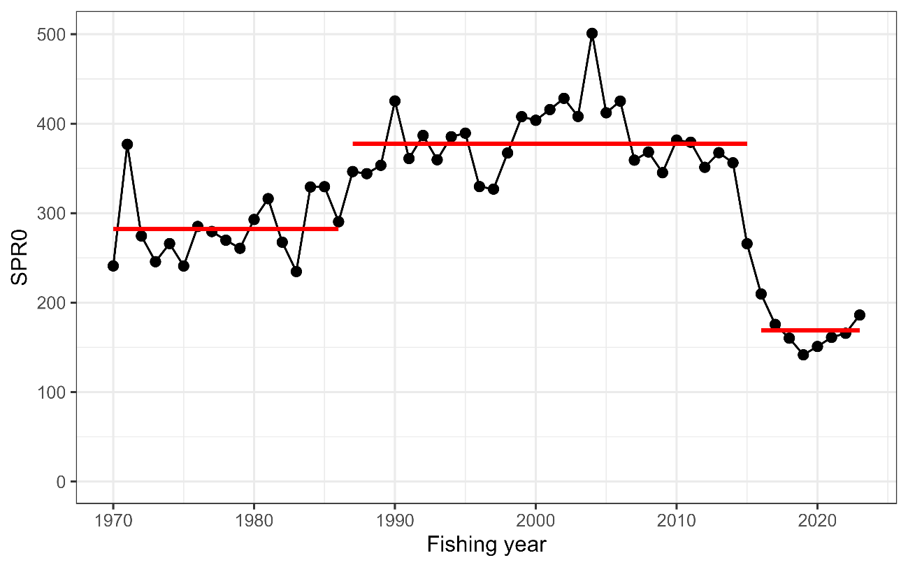
Historical SPR0 (black circles) and its regimes (red lines) detected by the change point analysis.

Figure 2
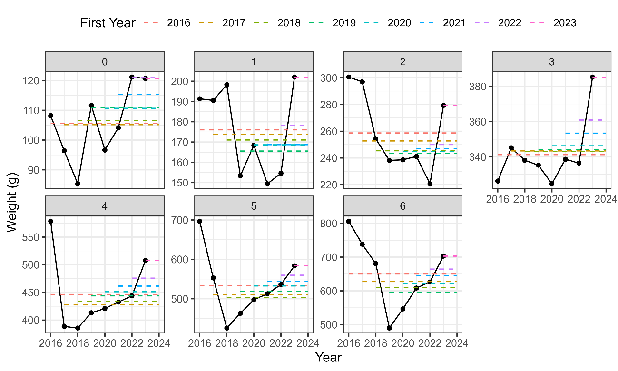
Body weight from age 0 to 6+ in FY2-16-2023 (black circles) and its averages having different beginning years (horizontal-colored lines).

Figure 3
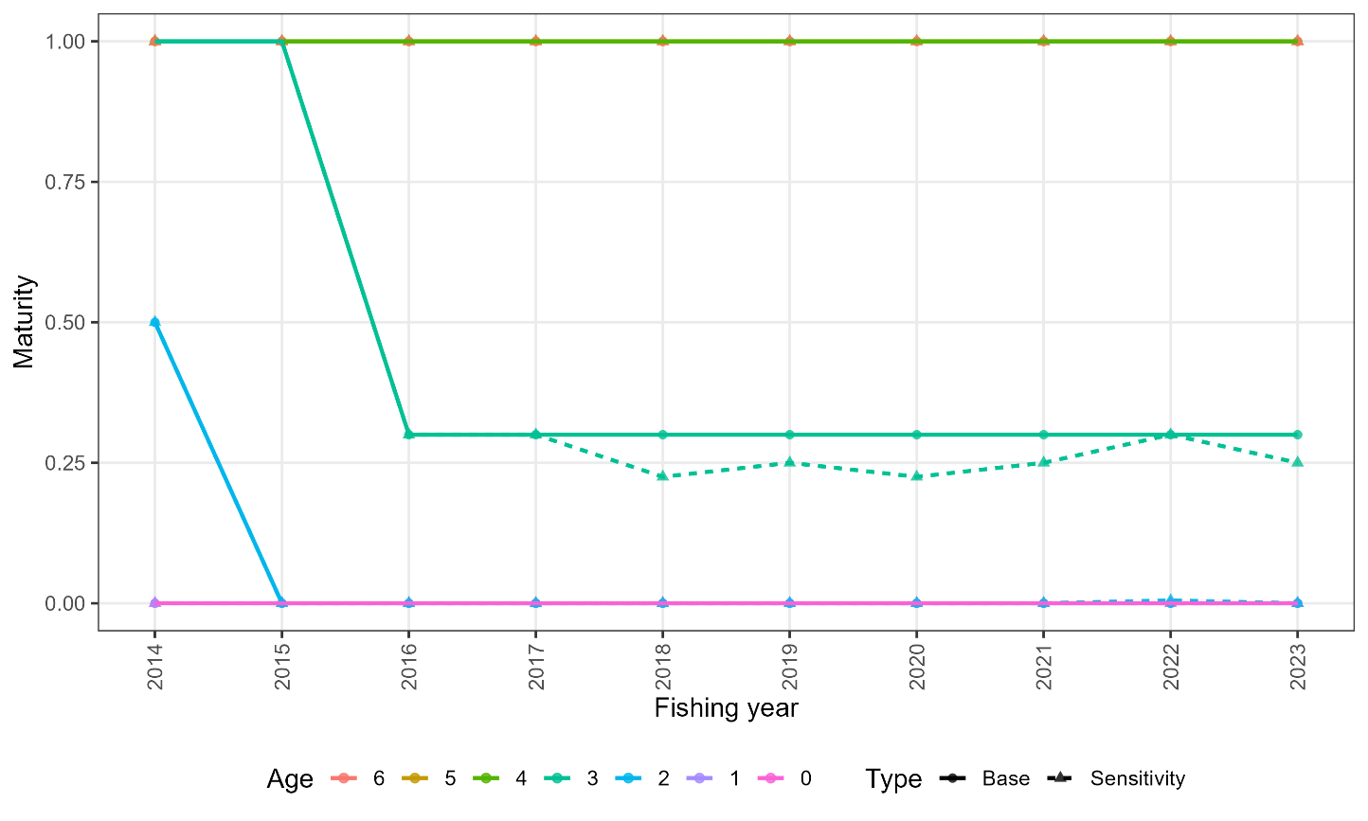
Maturity by age in FY2014-FY2023 for the base case and a sensitivity scenario. This figure is extracted from Fig. 8 in NPFC-TWG CMSA11-WP03.

Figure 4
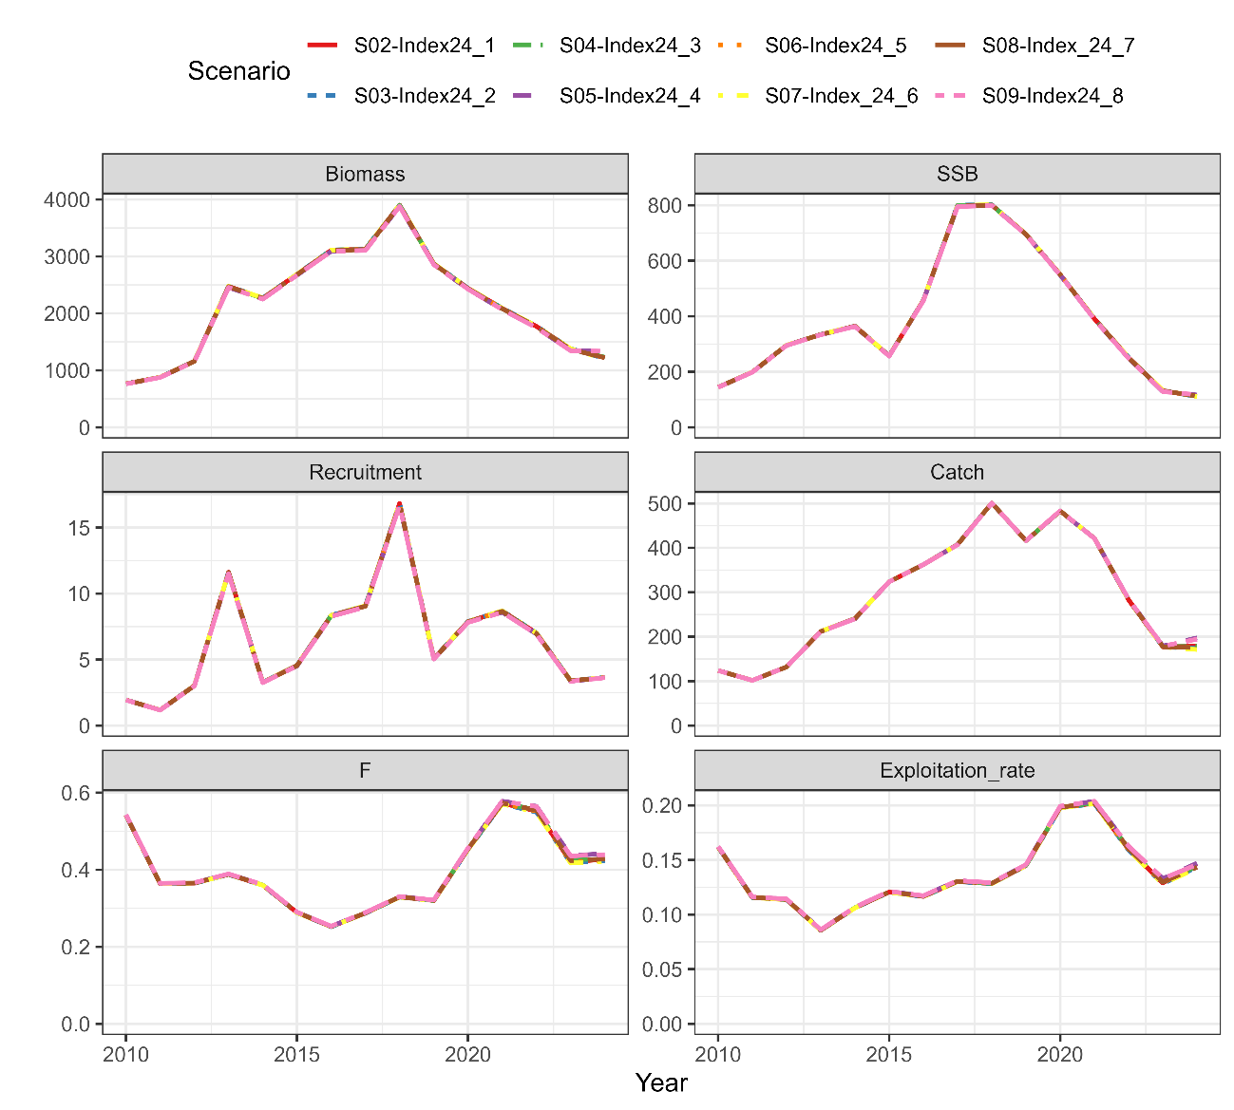
Recent estimates of total biomass (1,000 MT), SSB (1,000 MT), recruitment (billion), catch (1,000 MT), mean F, and exploitation rate (catch divided by total biomass) for the scenarios with different assumptions in FY2024.

Figure 5
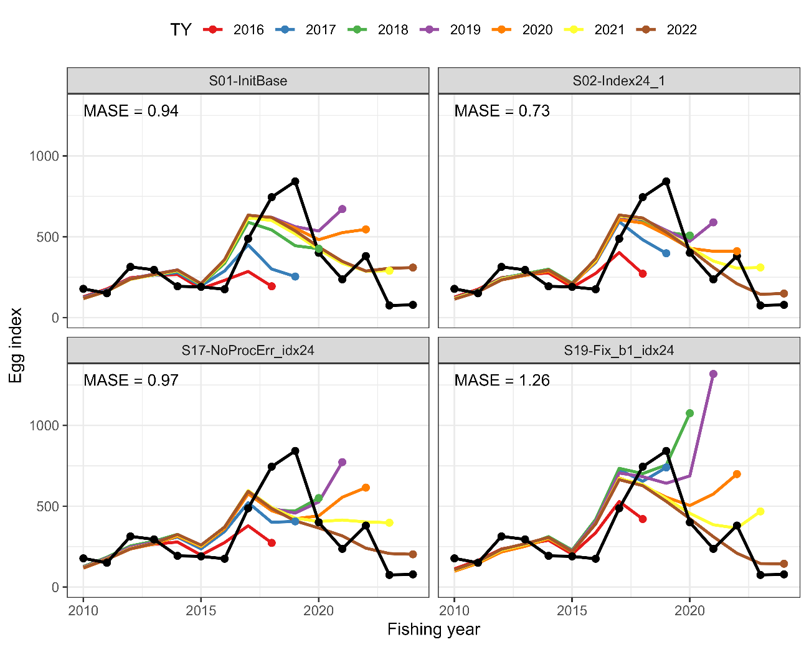
Results of hindcast CV to compare the prediction skill against the standardized spawning egg index for Scenarios S01-InitBase (upper left), S02-Index24_1 (upper right), S17-NoProcErr_idx24 (bottom left), and S19-Fix_b1_idx24 (bottom right. The terminal years (TY) for catch-at-age data are shown on the top. MASE scores are shown in the upper right corners of each panel.

Figure 6
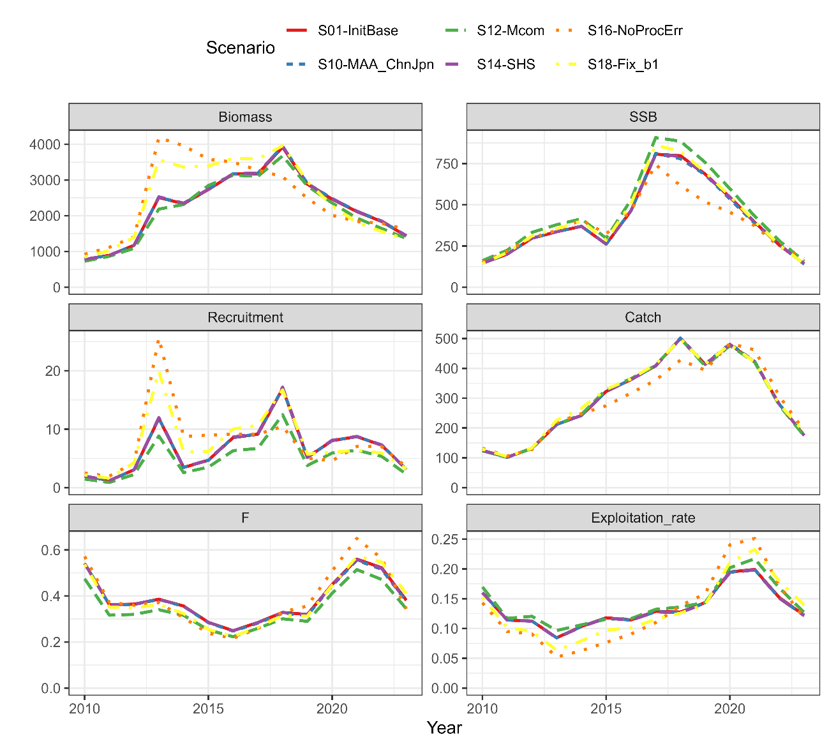
Same as Fig. 4 except for the scenarios using the abundance indices through FY2023.

Figure 7
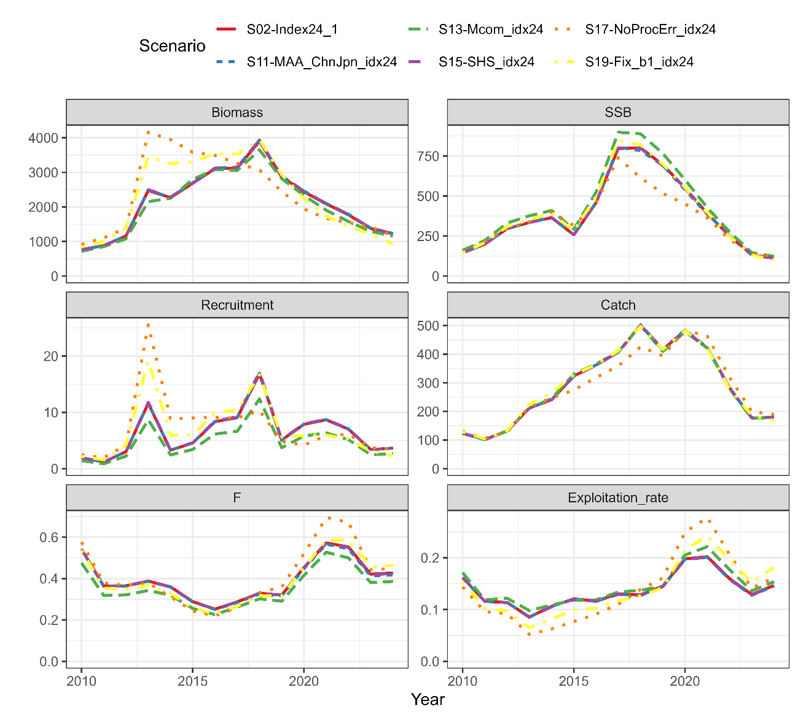
Same as Fig. 4 except for the scenarios using the abundance indices through FY2024.

Figure 8
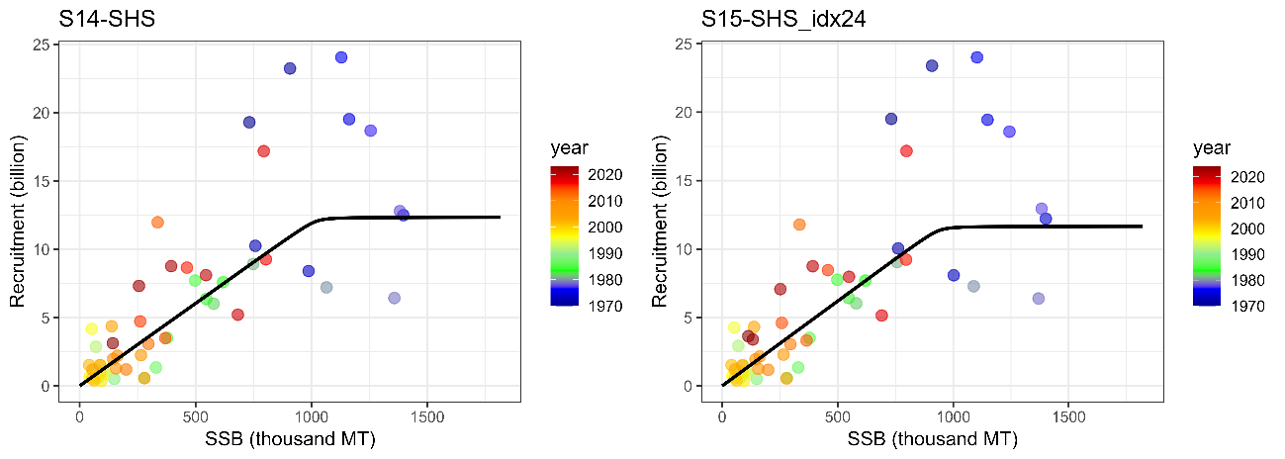
Smooth hockey-stick (SHS) stock-recruitment relationship estimated for Scenarios S14-SHS (left) and S15-SHS_idx24 (right).

Figure 9
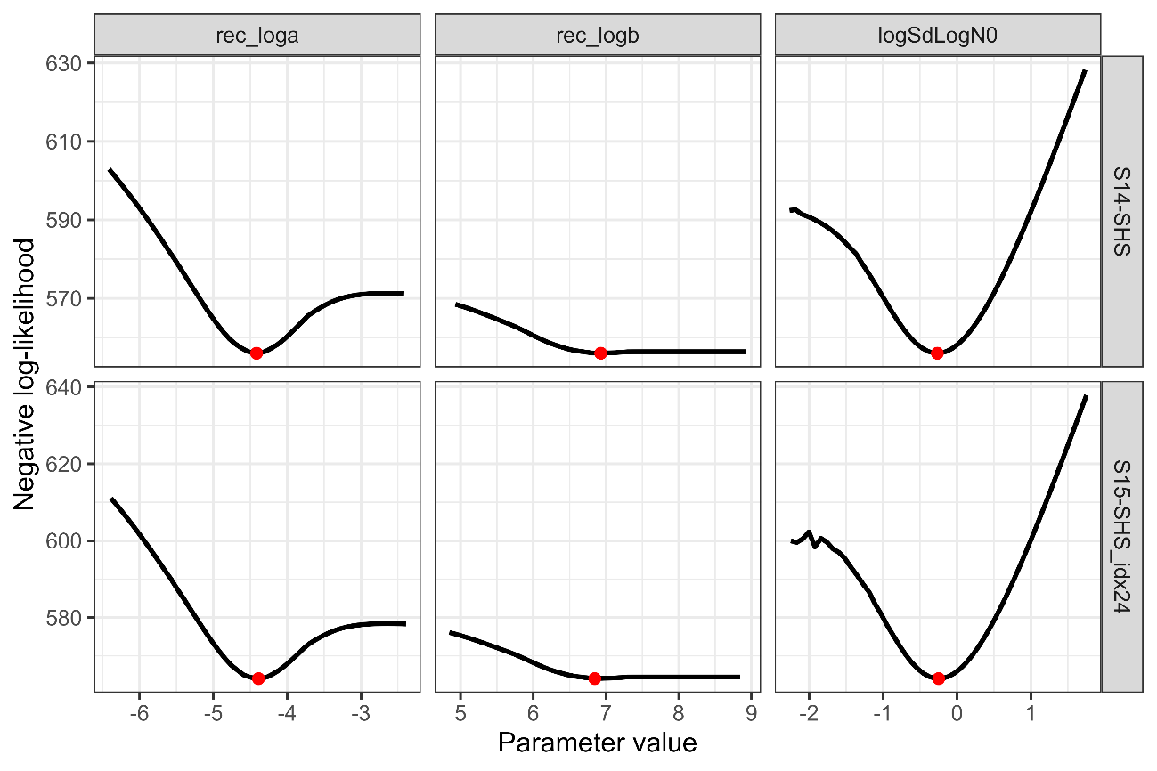
Changes in negative log-likelihoods by varying parameters related to the stock-recruitment relationship (α, β, ω₀ in log space) for Scenarios S14-SHS and S15-SHS_idx24.

Figure 10
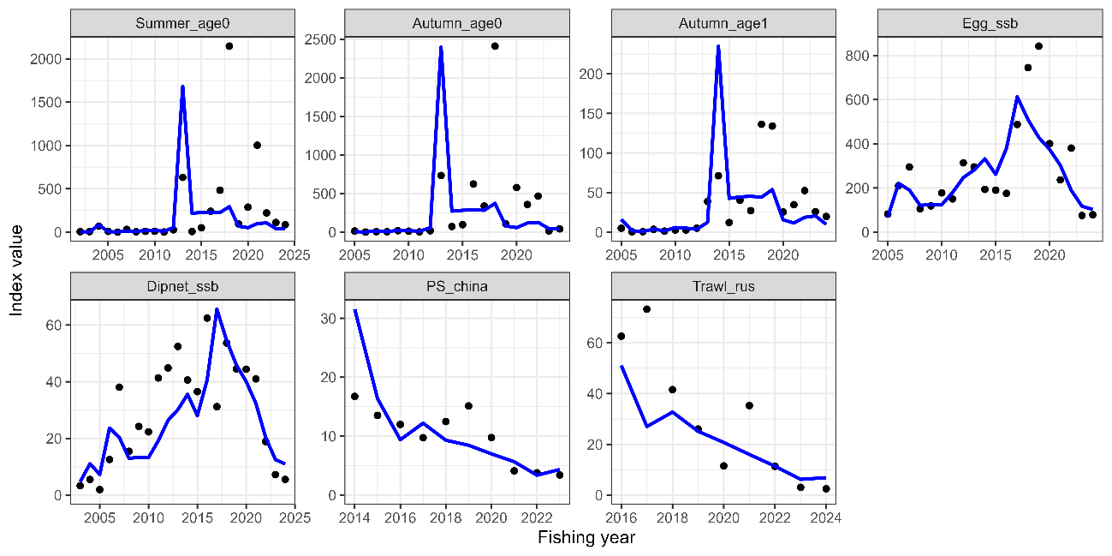
Temporal trends of abundance indices used (dots) and their predicted values (lines) under Scenario S17-NoProcErr_idx24.

Figure 11
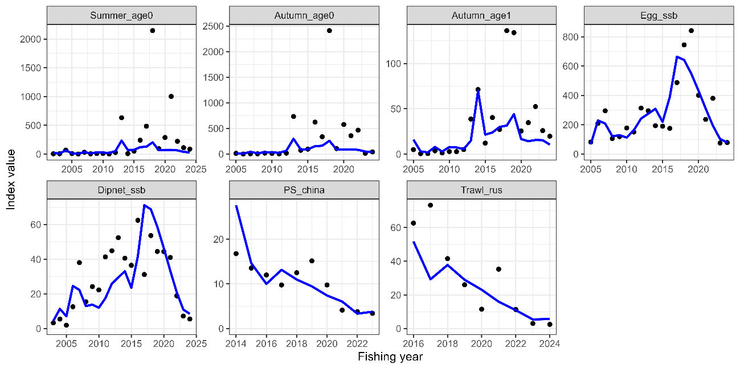
Same as Fig. 8 except that it is Scenario S19-Fix_b1_idx24.

Figure 12
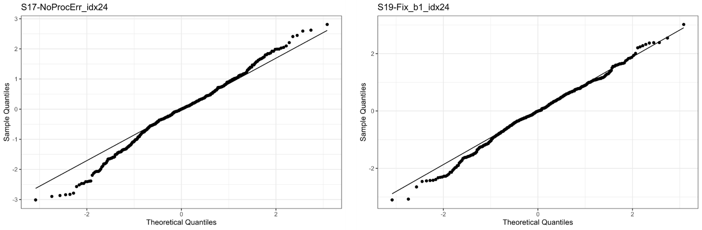
QQ plots based on OSA residuals for Scenarios S17-NoProcErr_idx24 and S19-Fix_b1_idx24.

Figure 13
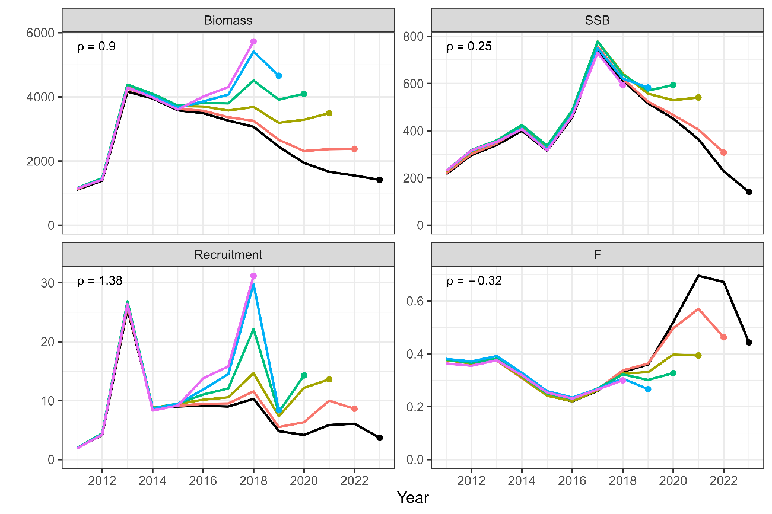
Retrospective patterns for total biomass (top left), SSB (top right), recruitment (bottom left), and mean F (bottom right) for Scenario S17-NoProcErr_idx24. Black Lines represent models with all data, and colored lines represent models with the most recent data trimmed. Mohn's rho is shown in the upper left corner. The dots indicate the terminal year for the calculation of Mohn’s rho.

Figure 14
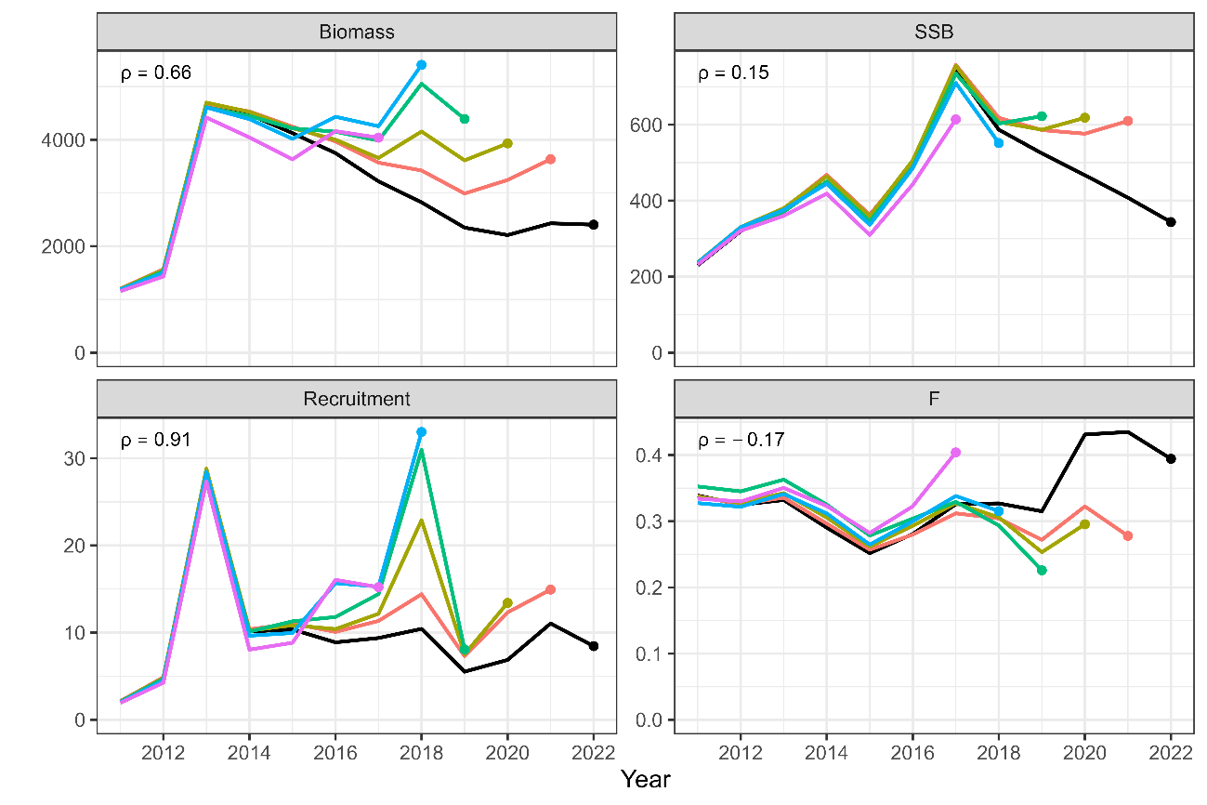
Same as Fig. 11 except that is Scenario S19-Fix_b1_idx24.

