NPFC-2025-SSC PS15-WP04

Standardized CPUE of Pacific saury (Cololabis saira) caught by the Chinese Taipei stick-held dip net fishery up to 2024

Wen-Bin Huang1, Kevin Pranata Ginting1, Yi-Jay Chang2, and Chih-hao Hsieh2
¹ Department of Natural Resources and Environmental Studies,
National Dong Hwa University, Hualien 974.
E-mail: bruce@gms.ndhu.edu.tw
² Institute of Oceanography, National Taiwan University, Taipei 106.

SUMMARY
Catch and effort data of Pacific saury for the Chinese Taipei saury fishery in the Northwestern Pacific Ocean were collected from 2001-2024. Standardization of the catch per unit effort (CPUE) of saury was conducted using a generalized linear model (GLM) with two approaches: one used the 2001-2024 data (non-divided period approach) and the other divided the data into two periods (two-divided period approach). Most of the main explanatory variables and interaction terms used in the modeling analyses were statistically significant in both approaches. The exhibit trends of the standardized CPUEs derived from both approaches were uniform. The standardized CPUE from 2001 to 2011 exhibited an oscillation with a slight increase, followed by a sharp increase until 2014, a steep decline until 2017, a dramatic increase in 2018, a sharp decline until 2021, and a moderate rise from 2022 to 2024. We recommend using the standardized CPUE series from the two-divided period approach as basic input data for stock assessments, same as last year. Besides, we also provided the standardized CPUE series derived from the non-divided period approach for reference.

- INTRODUCTION
Pacific saury (Cololabis saira Brevoort, 1856) is a commercially important fish in the Northwestern Pacific Ocean (NWPO) (Hubbs and Wisner, 1980). Most Pacific saury are caught by the stick-held dip net fishery and only a small proportion of catches are acquired through the use of other gear, such as gill nets and set-nets (TWG PSSA01, 2017). Results of saury stock assessments in the 14th Meeting of the Small Scientific Committee on Pacific Saury (SSC PS14) of the North Pacific Fisheries Commission (NPFC) in late 2024 indicated that the saury stock declined with high inter-annual variability from a high biomass level in the mid-2000’s after a period of high productivity to the current low biomass levels (SSC PS14, 2024). The results also indicated that average biomass (B) was below B_{MSY} during 2022-2024 (median average B/B_{MSY} during 2022-2024 = 0.345) and average F was above F_{MSY} (average F/F_{MSY} during 2021-2023 = 1.008). Biomass may have increased modestly during 2022-2024 based on the abundance indices and higher recruitment that may be evident in the Japanese fishery size composition. In addition, the results of the SSCPS 14 assessment indicated that based on CPUE, survey data, and model results, the condition of the Pacific saury stock and fishery improved in recent years although biomass remains below B_{MSY}. Harvest rates decreased while biomass and catch increased during 2020–2024. The improvement could be due at least in part to reductions in catch since 2020 and potentially due to unidentified environmental variability.
The Chinese Taipei saury fishery is a far-sea fishery that commenced in 1967 with fishing grounds located mainly on the high seas (Huang, 2007; 2010). Inter-annual variations of monthly fishing ground locations of the Chinese Taipei stick-held dip net fishery from 2001 to 2024 is shown in Fig. 1. The catch of the Chinese Taipei saury fishery increased dramatically from about 40,000 mt in 2001 to about 230,000 mt, the highest historical level, in 2014 (Huang et al., 2017). However, the current catch in 2024 was about 69,000 mt, which is about 30 % and 138 % of the catch from the highest historical level and the previous year (2023: ~50,000 mt), respectively.
The standardization of catch per unit effort (CPUE) of Pacific saury for various fleets operating in the NWPO was conducted for use as basic input data in stock assessments (TWG PSSA01, 2017). The stock assessments were based on the assumption of a single North Pacific-wide stock of Pacific saury since there was no evidence of genetic structuring groups in this population (Chow et al., 2009). Generalized linear models (GLMs) are the most commonly used approach for standardizing catch and effort data, assuming that the expected value of a transformed response variable is related to a linear combination of exploratory variables (Maunder and Punt, 2004). Generalized additive models (GAMs) are a semi-parametric extension of GLMs with the underlying assumption that the response variable is related to smooth additive functions of the explanatory variables (Maunder and Punt, 2004). The standardized CPUEs for saury, derived from both the GLM and the GAM for the Chinese Taipei stick-held dip net fishery, showed nearly identical results (Huang et al., 2019). The protocol for CPUE standardization on Pacific saury was first adopted at the 1st Pacific Saury Stock Assessment Workshop in 2016 (WS PSSA01, 2016) and was newly revised at the SSC PS13 meeting in 2024 (SSC PS13, 2024). The Chinese Taipei's standardized CPUE series, estimated according to the CPUE standardization protocol, has been accepted as an input for stock assessment from the TWG PSSA02 meeting in 2017 through the SSC PS13 meeting in 2024 (TWG PSSA02, 2017; SSC PS13, 2024).
In the SSC PS12 meeting, a discrepancy was noted between the stock assessment model results and Chinese Taipei’s standardized CPUE index (SSC PS12, 2023). In response, Chinese Taipei reviewed its fishery operations and found that between 2012 and 2019, 59 older vessels representing ~55% of the registered saury fishing vessels were replaced with 6 to 10 new fishing vessels replaced each year, except in 2015 with 3 replacements (Fig. 2). These new vessels differed in size, shape, and technical capabilities, likely affecting fishing efficiency. To account for this, and following the approach adopted in the 2024 assessment, the CPUE data were again divided into two periods: 2001–2011 and 2012–2024 (SSC PS13, 2024). A similar approach was taken for the Japanese Pacific saury fishery to reflect changes in fishing efficiency due to fleet modernization (Kidokoro et al., 2017; TWG PSSA02, 2017).
This study aimed to update the standardized CPUE of Pacific saury by the Chinese Taipei stick-held dip net fishery up to 2024. In this year's analysis, we employ the GLM with two approaches: one is the two-divided period approach using the 2001-2011 and 2012-2024 data as last year, and the other one is the non-divided period approach using the 2001-2024 data for reference.

- Materials & methods

2.1. Fishery data and water temperature
Data, collected from the Chinese Taipei saury fishery, included daily catch (weight of Pacific saury), fishing effort (number of hauls), and sea surface water temperature reported daily by each vessel from 2001-2024. A thermometer equipped beneath the bottom of each vessel measured sea surface water temperature as fishing was underway. These data were obtained from the Overseas Fisheries Development Council (OFDC) which compiled data from logbooks. CPUE is expressed as the weight of fish in metric tons per haul (mt/haul).
In the two-divided period approach, the dataset was divided into two periods: 2001-2011 and 2012-2024, containing 63,026 and 78,886 records, respectively. In the non-divided period approach, the 2001-2024 dataset contained 141,912 catch-effort records.

  - Full model descriptions and model selection
A GLM was used to standardize CPUE for the above two approaches. Six items in four groups of possible explanatory variables were considered for CPUE standardization, including year (Year) and month (Month) for the temporal variable, latitude and longitude (Area) for the spatial variable, gross registered tonnage (Grt) for the fishing vessel size variable, and sea surface water temperature (Sst) for the environmental variable. Before fitting the GLM, the Spearman correlation coefficients among explanatory variables were calculated. In addition, the variance inflation factor (VIF) was used to measure the amount of multi-collinearity among the independent variables in models.
The full model of GLM including interactions was expressed as follows:
ln(CPUE) = Year +Month +Area +Sst +Grt +two-way IAs +IC + ε
where Year is a categorical variable from 2001 - 2024 (24 years), Month is a categorical variable with 6 calendar months from June to November, Sst is a categorical variable with an interval of 1 ºC, Grt is a categorical variable with 4 levels: <800 t, 800 t, 900 t, and > 1,000 t, Area is a categorical variable with 4 regions based on bathymetric contours, two-way IAs are two-way interaction terms, IC is an intercept, and ε is an error term with ε~N(0, σ²).
A summary of used explanatory variables in the GLM analyses by these two approaches is shown in Table 1. Month data from May and December were incorporated into June and November, respectively, because the data from May and December were limited. The definition of the 4 Area regions was modified based on Huang et al. (2007), which examined the geographical distribution of Pacific saury in the NWPO. The 4 regions used in our analyses are the continental shelf and slope area (CSS), abyssal plain area 1 (AP1), abyssal plain area 2 (AP2), and the abyssal mountain area (AM) (Fig. 3).
In Chinese Taipei’s saury fisheries, no fishing operation in June occurred in some years and spatial allocation of fishing efforts has varied across years (Fig. 1). Therefore, re-stratification was conducted for the explanatory variables other than year used in two-way interactions (Month.int, Area.int and Sst.int), to ensure that there were no empty strata (Hashimoto et al., 2023) (Table 1).
Model assumptions followed the assumptions for GLM. Lognormal error distribution was assumed in the standardization. A forward stepwise approach was employed for the model selection. The improvement of each model that adds an additional predictor was examined using the changes in deviance explained and the proportions of deviance explained relative to the total explained deviance. In addition, since the maximum likelihood was employed for the parameter estimation, the Bayesian information criterion (BIC) was used to conduct objective model selection. Various diagnostic plots, including the distribution of residuals and the quantile-quantile plots (Q-Q plots), were used to assess the assumption of error distribution in the models and model fits for standardizing the nominal CPUE of Pacific saury in the NWPO.

  - Yearly trend extraction
The standardized CPUE was estimated using the best GLM. If the best model includes area and the size of spatial strata differs or the best model includes interactions between time and area, then standardized CPUE should be calculated with area weighting for each time step. An expanded data was generated, which was composed of combinations of explanatory variable categories, and then predicted annual values of ln(CPUE) for area i (ln(CPUE)_{y,i}). Annual standardized CPUEs were calculated as the area-weighted mean of (CPUE)_{y,i}:
CPUE_{y} = Σ_{i} [exp(ln(CPUE)_{y,i}) × (A_{i} / ΣA)],
where A_{i} indicates the size of area i. Coefficients of variation and 95 % confidential intervals were calculated by bootstrap resampled residuals with 1000 replications. The checklist for the CPUE standardization protocol is shown in Appendix I.

- Results & discussion
Chinese Taipei stick held dip-net fishery operated mainly in the high seas of the NWPO during 2001-2024 and high fishing efforts aggregated in the southeastern portion of the boundary between the exclusive economic zones and high seas (Fig. 4a). However, high CPUEs of Pacific saury appeared to be distributed mainly in the waters between 145-155 °E and 36-47 °N, and to a lesser degree between 160-164 °E and 36-40 °N (Fig. 4b).
Examination results of the GLMs by the two-divided period approach and the non-divided period approach are shown as described below. All Spearman’s correlation coefficients between each pair of variables used in the model were significant (p < 0.001) for both the two-divided period approach (Table 2a) and the non-divided period approach (Table 2b). All variance inflation factors (VIFs) were less than 10 in Table 2 for these 2 approaches, indicating that there was no serious multi-collinearity among the independent variables in models (Kleinbaum et al., 1988).
Most of the main explanatory variables and interaction terms used in the modeling analyses were statistically significant in the GLM for both the two-divided period approach (Table 3a) and the non-divided period approach (Table 3b). In the two-divided period approach, the BIC and deviance explained (%) in the best GLM are 142,436 and 24.7 % for the 2001-2011 period and 167,880 and 49.7 % for the 2012-2024 period, respectively (Table 3a). In the non-divided period approach, the BIC and deviance explained (%) in the best GLM are 309,894 and 40.0 % for the 2001-2024 period, respectively (Table 3b). Analysis of deviance for the best models of GLM is shown in Tables 4a & 4b for the two-divided period approach and the non-divided period approach, respectively. The Q-Q plot, histogram of residuals, and residual plots across years for the best GLMs indicated that the residual distributions from the GLM analyses appeared normal for the best models and confirmed the assumption of lognormal error distribution for the models used to standardize the CPUE for both the two-divided period approach (Fig. 5a) and the non-divided period approach (Fig. 5b).
The exhibit trends of the standardized CPUEs derived from both approaches were uniform (Fig. 6). The standardized CPUE from 2001 to 2011 exhibited an oscillation with a slight increase, followed by a sharp increase until 2014, a steep decline until 2017, a dramatic increase in 2018, a sharp decline until 2021, and a moderate rise from 2022 to 2024.
We recommend using the standardized CPUE series derived from the two-divided period approach as basic input data for stock assessments, same as last year (Table 5). Besides, we also provided the standardized CPUE series derived from the non-divided period approach in Table 5 for reference.

- References
Chow S, Suzuki N, Brodeur RD, Ueno Y (2009) Little population structuring and recent evolution of the Pacific saury (Cololabis saira) as indicated by mitochondrial and nuclear DNA sequence data. J Exp Mar Biol Ecol 369:17-21.
Hashimoto M, Naya M, Suyama S, Nakayama SI, Fuji T, Miyamoto H, and Kubota H (2023) Standardized CPUE of Pacific saury (Cololabis saira) caught by the Japanese stick-held dip net fishery up to 2022. NPFC-2023-SSC PS11-WP06. 17 pp.
Huang WB (2007) Body length, weight, and condition factor of Pacific saury (Cololabis saira) from the landed size-classes of Taiwanese catch in comparison with Japanese statistics. J Fish Soc Taiwan 34(4): 361-368.
Huang WB (2010) Comparisons of monthly and geographical variations in abundance and size composition of Pacific saury between the high-seas and coastal fishing grounds in the Northwestern Pacific. Fish Sci 76(1): 21-31.
Huang WB, Chang YJ, Hsieh CH (2017) Summary of CPUE standardization report from Chinese Taipei. NPFC-2017-TWG PSSA01-WP04. 4 pp.
Huang WB, Chang YJ, Hsieh CH (2019) CPUE standardization of Pacific saury (Cololabis saira) for the Chinese Taipei’s stick-held dip net fishery in the Northwestern Pacific Ocean from 2001-2018. NPFC-2019-SSC PS05-WP02. 13 pp.
Huang WB, Lo NCH, Chiu TS, Chen CS (2007) Geographical distribution and abundance of Pacific saury fishing stock in the Northwestern Pacific in relation to sea temperature. Zool Stud 46(6): 705-716.
Hubbs CL, Wisner RL (1980) Revision of the sauries (Pisces, Scomberesocidae) with descriptions of two new genera and one new species. Fish Bull US 77:521-566.
Kidokoro H, Naya M, Abo J, Suyama S, Iwasaki (2017) Update of Japanese standardized CPUE of stick-held dipnet fishery for Pacific saury and its modification corresponding to the changing status of the fishery. NPFC-2017-TWG PSSA02-WP06. 5pp.
Kleinbaum DG, Kupper LL, Muller KE (1988) Applied regression analysis and other multivariable methods. 2nd edition. Boston: PWS-Kent. 718 pp.
Maunder MN, Punt AE (2004) Standardizing catch and effort data: A review of recent approaches. Fish Res 70: 141-159.
SSC PS06 (2020) Report on 6th Meeting of the Small Scientific Committee on Pacific Saury. NPFC-2020-SSC PS06-Final Report. 69 pp.
SSC PS12 (2023) Report on 12th Meeting of the Small Scientific Committee on Pacific Saury. NPFC-2023-SSC PS12-Final Report. 62 pp.
SSC PS13 (2024) Report on 13th Meeting of the Small Scientific Committee on Pacific Saury. NPFC-2024-SSC PS13-Final Report. 35 pp.
SSC PS14 (2024) Report on 14th Meeting of the Small Scientific Committee on Pacific Saury. NPFC-2024-SSC PS14-Final Report. 61 pp.
TWG PSSA01 (2017) Report on the 1st Meeting of the Technical Working Group on Pacific Saury Stock Assessment. NPFC-2017-TWG PSSA01-Final Report. 121 pp.
TWG PSSA02 (2017) Report on 2nd Meeting of the Technical Working Group on Pacific Saury Stock Assessment. NPFC-2017-TWG PSSA02-Final Report. 25 pp.
WS PSSA01 (2016) Report on the 1st Pacific Saury Stock Assessment Workshop. NPFC-2016-WS PSSA01-Final Report. 21 pp.

Table 1. Summary of explanatory variables used in the GLM analyses for Pacific saury CPUE standardization by the two-divided period approach (a) and the non-divided period approach (b).
- Two-divided period approach
Variables | Cases | 2001-2011 |  |  | 2012-2024 |  | Note
Variables | Cases | Number of categories | Detail |  | Number of categories | Detail | Note
Year | Year | 11 | 2001-2011 |  | 13 | 2012-2024
Month | Month | 6 | Jun, Jul, Aug, Sep, Oct, Nov |  | same as 2001-2011
 | Month.int | 5 | Jun+Jul, Aug, Sep, Oct, Nov |  | 6 | Jun, Jul, Aug, Sep, Oct, Nov | for interaction terms
Area | Area | 4 | I(CSS), II(AP1), III(AP2), IV(AM) |  | same as 2001-2011 |  | see Fig. 3
 | Area.int | 2 | I+II, III+IV |  | 3 | I+II, III, IV | for interaction terms
Vessel tonnage | Grt | 3 | 700≦Grt<800, 800≦Grt<900, 900≦Grt<1000 |  | 4 | 700≦Grt<800, 800≦Grt<900, 900≦Grt<1000, 1000≦Grt<1400
Sea surface temperature | Sst | 11 | Sst(8)< 9°C,  9°C≦Sst(9)<10°C,…, 18°C≦Sst(18) |  | 14 | Sst(8)< 9°C,  9°C≦Sst(9)<10°C,…, 21°C≦Sst(21)
 | Sst.int | 8 | Sst(9)< 10°C,  10°C≦Sst<11°C,…, 16°C≦Sst(16) |  | 11 | Sst(9)< 10°C,  10°C≦Sst<11°C,…, 19°C≦Sst(19) | for interaction terms

- Non-divided period approach
Variables | Cases | 2001-2024 |  |  | Note
Variables | Cases | Number of categories |  | Detail | Note
Year | Year | 24 |  | 2001–2024
Month | Month | 6 |  | June–November
Fishing area | Area | 4 |  | CSS(I), AP1(II), AP2(III), AM(IV) | see Fig. 3
Vessel tonnage | Grt | 4 |  | Grt < 800, 800≦Grt <900,  900≦Grt <1000, 1000≦Grt<1400
Sea surface temperature | Sst | 13 |  | Sst(8) < 9°C, 9°C≦Sst(9)< 10°C ,…, 19°C≦Sst(19)<20°C, 20°C≦Sst(20) | at intervals of 1 °C

Table 2. Spearman correlation coefficient and variance inflation factor (VIF) among explanatory variables by the two-divided period approach (a) and the non-divided period approach (b).
- Two-divided period approach
2001-2011 | Coefficient \ p value |  |  |  |  |  |  | VIF
2001-2011 | Year | Month | Grt | Long. | Lat. | SST |  | VIF
Year |  | <0.001 | <0.001 | <0.001 | <0.001 | <0.001 |  | 1.13
Month | 0.03 |  | <0.001 | <0.001 | <0.001 | <0.001 |  | 1.77
Grt | 0.07 | 0.04 |  | <0.001 | 0.14 | 0.63 |  | 1.01
Long. | 0.05 | -0.64 | -0.01 |  | <0.001 | 0.02 |  | 2.97
Lat. | -0.13 | -0.35 | -0.01 | 0.68 |  | <0.001 |  | 2.01
SST | 0.22 | 0.01 | 0.00 | -0.01 | -0.05 |  |  | 1.05

2012-2024 | Coefficient \ p value |  |  |  |  |  |  | VIF
2012-2024 | Year | Month | Grt | Long. | Lat. | SST |  | VIF
Year |  | <0.001 | <0.001 | <0.001 | <0.001 | <0.001 |  | 1.86
Month | -0.04 |  | <0.001 | <0.001 | <0.001 | <0.001 |  | 3.13
Grt | 0.49 | 0.07 |  | <0.001 | <0.001 | <0.001 |  | 1.34
Long. | 0.39 | -0.77 | 0.14 |  | <0.001 | <0.001 |  | 3.87
Lat. | 0.09 | -0.52 | 0.05 | 0.55 |  | <0.001 |  | 1.61
SST | 0.22 | 0.29 | 0.15 | -0.19 | -0.35 |  |  | 1.26
Spearman correlation coefficients are under the slope line; p values are above the slope line.
- Non-divided period approach
2001-2024 | Coefficient \ p value |  |  |  |  |  |  | VIF
2001-2024 | Year | Month | Grt | Long. | Lat. | SST |  | VIF
Year |  | <0.001 | <0.001 | <0.001 | <0.001 | <0.001 |  | 1.95
Month | 0.05 |  | <0.001 | <0.001 | <0.001 | <0.001 |  | 2.24
Grt | 0.56 | 0.09 |  | <0.001 | <0.001 | <0.001 |  | 1.48
Long. | 0.32 | -0.68 | 0.18 |  | <0.001 | <0.001 |  | 3.11
Lat. | -0.07 | -0.45 | -0.01 | 0.55 |  | <0.001 |  | 1.65
SST | 0.33 | 0.20 | 0.21 | -0.09 | -0.27 |  |  | 1.22
Spearman correlation coefficients are under the slope line; p values are above the slope line.

Table 3. Results of model selection using a GLM Approach for Pacific saury CPUE standardization by the two-divided period approach (a) and the non-divided period approach (b).
- Two-divided period approach
No. | Data 2001-2011 | BIC | Explained deviance (%)
1 | ln(CPUE) ~ IC + Month | 151829 | 10.7
2 | ln(CPUE) ~ IC + Month + Year | 147378 | 16.9
3 | ln(CPUE) ~ IC + Month + Year + Area | 146642 | 17.9
4 | ln(CPUE) ~ IC + Month + Year + Area + Grt | 146148 | 18.6
5 | ln(CPUE) ~ IC + Month + Year + Area + Grt + Sst | 146126 | 18.8
6 | ln(CPUE) ~ IC + Month + Year + Area + Grt + Sst + Year:Month | 143037 | 23.3
7 | ln(CPUE) ~ IC + Month + Year + Area + Grt + Sst + Year:Month + Year:Area | 142564 | 24.0
8 | ln(CPUE) ~ IC + Month + Year + Area + Grt + Sst + Year:Month + Year:Area + Month:Area | 142489 | 24.2
9 | ln(CPUE) ~ IC + Month + Year + Area + Grt + Sst + Year: Month + Year:Area + Month:Area + Year:Sst | 142436 | 24.7

No. | Data 2012-2024 | BIC | Explained deviance (%)
1 | ln(CPUE) ~ IC + Year | 196905 | 25.0
2 | ln(CPUE) ~ IC + Year + Month | 181753 | 38.2
3 | ln(CPUE) ~ IC + Year + Month + Grt | 179169 | 40.2
4 | ln(CPUE) ~ IC + Year + Month + Grt + Sst | 178520 | 40.8
5 | ln(CPUE) ~ IC + Year + Month + Grt + Sst + Area | 178046 | 41.2
6 | ln(CPUE) ~ IC + Year + Month + Grt + Sst + Area + Year:Month | 169461 | 47.7
7 | ln(CPUE) ~ IC + Year + Month + Grt + Sst +Area + Year:Month + Month:Area | 168891 | 48.1
8 | ln(CPUE) ~ IC + Year + Month + Grt + Sst +Area + Year:Month + Month:Area + Year:Sst | 168566 | 48.7
9 | ln(CPUE) ~ IC + Year + Month + Grt + Sst +Area + Year:Month + Month:Area + Year:Sst + Month:Sst | 168292 | 49.0
10 | ln(CPUE) ~ IC + Year + Month + Grt + Sst +Area + Year:Month + Month:Area + Year:Sst + Month:Sst + Year:Grt | 168030 | 49.5
11 | ln(CPUE) ~ IC + Year + Month + Grt + Sst +Area + Year:Month + Month:Area + Year:Sst + Month:Sst + Year:Grt + Year:Area | 167880 | 49.7

- Non-divided period approach
No. | Data 2001-2024 | BIC | Explained deviance (%)
1 | ln(CPUE) ~ IC + Year | 350294 | 18.0
2 | ln(CPUE) ~ IC + Year + Month | 328742 | 29.6
3 | ln(CPUE) ~ IC + Year + Month + Grt | 326423 | 30.7
4 | ln(CPUE) ~ IC + Year + Month + Grt + Area | 325080 | 31.4
5 | ln(CPUE) ~ IC + Year + Month + Grt + Area + Sst | 324414 | 31.8
6 | ln(CPUE) ~ IC + Year + Month + Grt + Area + Sst + Year: Month | 312516 | 37.9
7 | ln(CPUE) ~ IC + Year + Month + Grt + Area + Sst + Year: Month + Year:Area | 310946 | 38.8
8 | ln(CPUE) ~ IC + Year + Month + Grt + Area + Sst + Year: Month + Year:Area + Year: Grt | 310058 | 39.5
9 | ln(CPUE) ~ IC + Year + Month + Grt + Area + Sst + Year: Month + Year:Area + Year: Grt + Month: Area | 309945 | 39.6
10 | ln(CPUE) ~ IC + Year + Month + Grt + Area + Sst + Year: Month + Year:Area + Year: Grt + Month:Area + Month: Sst | 309894 | 40.0

Table 4. Analysis of deviance table of the GLM approach for Pacific saury CPUE standardization by the two-divided period approach (a) and the non-divided period approach (b).
- Two-divided period approach
2001-2011: ln(CPUE) ~ IC + Month + Year + Area + Grt + Sst + Year:Month + Year:Area + Month:Area + Year:Sst + ε
 | SS | df | F | Pr (>F) | Signif. codes
Month | 4908 | 5 | 1785.37 | < 0.001 | ***
Year | 2862 | 10 | 520.63 | < 0.001 | ***
Area | 463 | 3 | 280.46 | < 0.001 | ***
Grt | 307 | 2 | 279.24 | < 0.001 | ***
Sst | 79 | 10 | 14.29 | < 0.001 | ***
Year:Month | 2081 | 47 | 80.55 | < 0.001 | ***
Year:Area | 325 | 10 | 59.12 | < 0.001 | ***
Month:Area | 72 | 5 | 26.22 | < 0.001 | ***
Year:Sst | 225 | 30 | 13.63 | < 0.001 | ***
2012-2024: ln(CPUE) ~ IC + Year + Month + Grt + Sst + Area + Year:Month + Month:Area
+ Year:Sst +Month:Sst + Year:Grt + Year:Area + ε
 | SS | df | F | Pr (>F) | Signif. codes
Year | 18671 | 12 | 3262.89 | < 0.001 | ***
Month | 9808 | 5 | 4113.55 | < 0.001 | ***
Grt | 1506 | 3 | 1052.60 | < 0.001 | ***
Sst | 448 | 13 | 72.24 | < 0.001 | ***
Area | 283 | 3 | 198.04 | < 0.001 | ***
Year:Month | 4869 | 59 | 173.06 | < 0.001 | ***
Month:Area | 334 | 8 | 87.43 | < 0.001 | ***
Year:Sst | 435 | 47 | 19.40 | < 0.001 | ***
Month:Sst | 240 | 20 | 25.15 | < 0.001 | ***
Year:Grt | 310 | 34 | 19.12 | < 0.001 | ***
Year:Area | 195 | 23 | 17.80 | < 0.001 | ***
***, < 0.001; **, < 0.01; *, < 0.05

- Non-divided period approach
2001-2024: ln(CPUE) ~ IC + Year + Month + Grt + Area + Sst+ Year:Month + Year:Area + Year:Grt + Month:Area + Month:Sst + ε
 | SS | Df | F | Pr (>F) | Signif. codes
Year | 21550 | 23 | 1844.13 | < 0.001 | ***
Month | 13845 | 5 | 5462.78 | < 0.001 | ***
Grt | 1385 | 3 | 910.48 | < 0.001 | ***
Area | 800 | 3 | 526.33 | < 0.001 | ***
Sst | 465 | 12 | 76.53 | < 0.001 | ***
Year:Month | 7247 | 111 | 128.81 | < 0.001 | ***
Year:Area | 1129 | 51 | 43.69 | < 0.001 | ***
Year:Grt | 828 | 56 | 29.18 | < 0.001 | ***
Month:Area | 149 | 14 | 21.00 | < 0.001 | ***
Month:Sst | 388 | 60 | 12.75 | < 0.001 | ***
***, < 0.001; **, < 0.01; *, < 0.05

Table 5. Nominal CPUEs, standardized CPUEs (Std-CPUE), and summary statistics using the GLM by the two-divided period approach and the non-divided period approach for the Chinese Taipei saury fishing vessels in the Northwestern Pacific Ocean from 2001-2024.
Year | Nominal CPUE (mt/haul) | Two-divided period approach |  |  |  |  |  | Non-divided period approach
Year | Nominal CPUE (mt/haul) | Std-CPUE  (2001-2011) | Std-CPUE  (2012-2024) | CV(%) | 95% CI |  |  | Std-CPUE  (2001-2024) | CV(%) | 95% CI
2001 | 2.38 | 1.44 |  | 0.03 | [1.38 | 1.51] |  | 1.47 | 0.03 | [1.42 | 1.53]
2002 | 2.12 | 1.33 |  | 0.08 | [1.21 | 1.53] |  | 1.60 | 0.03 | [1.55 | 1.67]
2003 | 2.62 | 2.47 |  | 0.05 | [2.39 | 2.58] |  | 2.77 | 0.07 | [2.66 | 2.92]
2004 | 1.92 | 1.24 |  | 0.05 | [1.15 | 1.35] |  | 1.41 | 0.02 | [1.38 | 1.46]
2005 | 2.27 | 2.27 |  | 0.07 | [2.14 | 2.43] |  | 2.52 | 0.05 | [2.45 | 2.63]
2006 | 1.83 | 1.00 |  | 0.05 | [0.93 | 1.11] |  | 1.21 | 0.01 | [1.18 | 1.24]
2007 | 2.65 | 2.17 |  | 0.06 | [2.07 | 2.29] |  | 2.40 | 0.04 | [2.33 | 2.49]
2008 | 3.34 | 2.79 |  | 0.06 | [2.69 | 2.92] |  | 2.93 | 0.04 | [2.87 | 3.04]
2009 | 1.90 | 1.29 |  | 0.04 | [1.23 | 1.39] |  | 1.56 | 0.02 | [1.52 | 1.61]
2010 | 2.31 | 1.89 |  | 0.12 | [1.72 | 2.20] |  | 1.93 | 0.02 | [1.89 | 1.99]
2011 | 2.90 | 2.09 |  | 0.11 | [1.94 | 2.36] |  | 2.51 | 0.03 | [2.46 | 2.59]
2012 | 3.27 |  | 2.60 | 0.14 | [2.41 | 2.94] |  | 2.46 | 0.03 | [2.41 | 2.54]
2013 | 3.69 |  | 3.48 | 0.33 | [3.05 | 4.39] |  | 2.93 | 0.04 | [2.87 | 3.03]
2014 | 4.32 |  | 3.94 | 0.11 | [3.74 | 4.20] |  | 3.91 | 0.05 | [3.83 | 4.04]
2015 | 4.08 |  | 2.22 | 0.09 | [2.08 | 2.45] |  | 2.26 | 0.05 | [2.19 | 2.37]
2016 | 3.63 |  | 1.95 | 0.04 | [1.88 | 2.05] |  | 2.28 | 0.03 | [2.23 | 2.36]
2017 | 2.37 |  | 1.89 | 0.05 | [1.82 | 2.00] |  | 1.95 | 0.03 | [1.90 | 2.02]
2018 | 4.21 |  | 2.90 | 0.07 | [2.79 | 3.06] |  | 3.36 | 0.05 | [3.28 | 3.48]
2019 | 2.09 |  | 1.41 | 0.04 | [1.34 | 1.52] |  | 1.38 | 0.02 | [1.35 | 1.42]
2020 | 1.83 |  | 1.10 | 0.04 | [1.04 | 1.17] |  | 1.09 | 0.01 | [1.06 | 1.12]
2021 | 1.05 |  | 0.65 | 0.02 | [0.62 | 0.69] |  | 0.67 | 0.01 | [0.66 | 0.69]
2022 | 0.98 |  | 0.68 | 0.02 | [0.65 | 0.73] |  | 0.70 | 0.01 | [0.69 | 0.73]
2023 | 1.49 |  | 1.38 | 0.06 | [1.28 | 1.53] |  | 1.27 | 0.03 | [1.23 | 1.34]
2024 | 2.11 |  | 1.72 | 0.06 | [1.61 | 1.87] |  | 1.67 | 0.04 | [1.60 | 1.75]

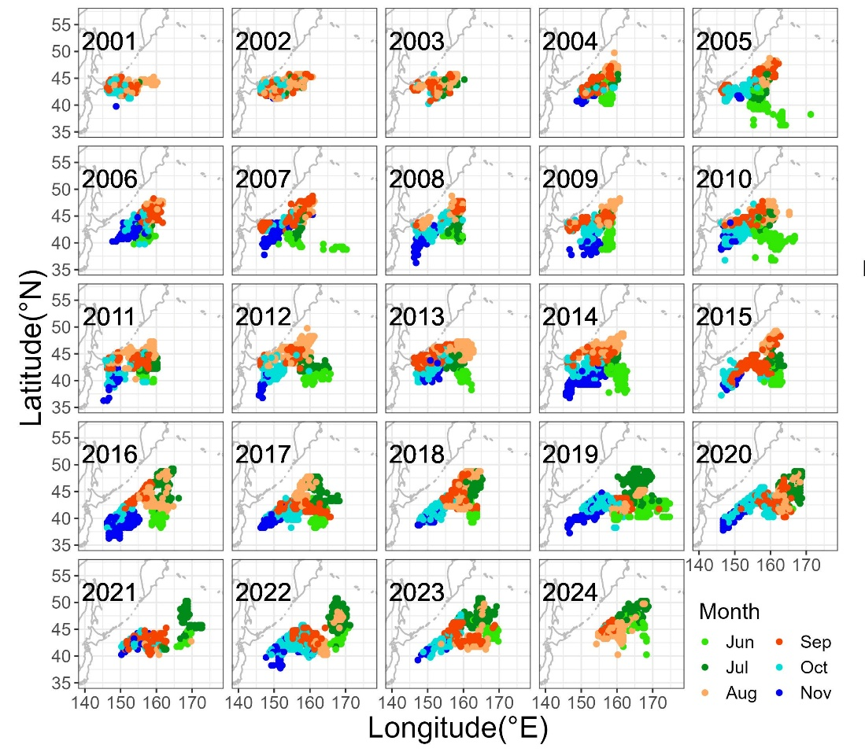
Fig. 1. Annual changes in monthly fishing grounds of Chinese Taipei stick-held dip net fishery for Pacific saury from 2001 to 2024.

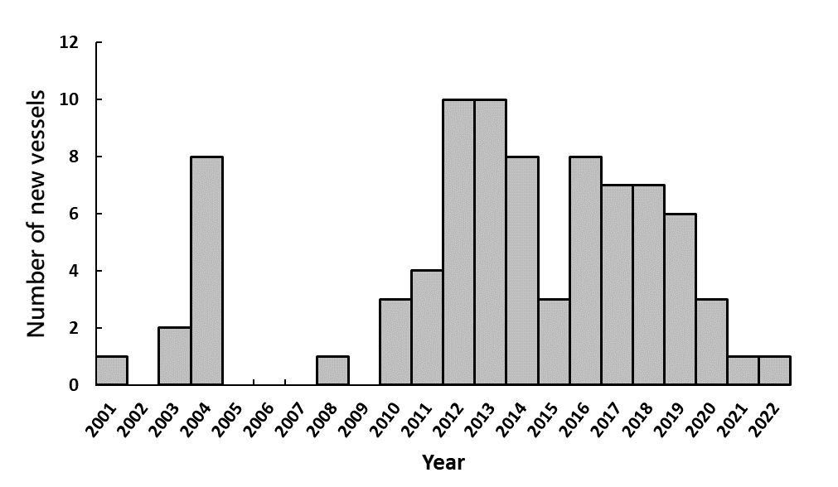
Fig. 2. Annual number of replacements with new fishing vessels for Chinese Taipei stick-held dip net fishery on Pacific saury from 2001 to 2022.

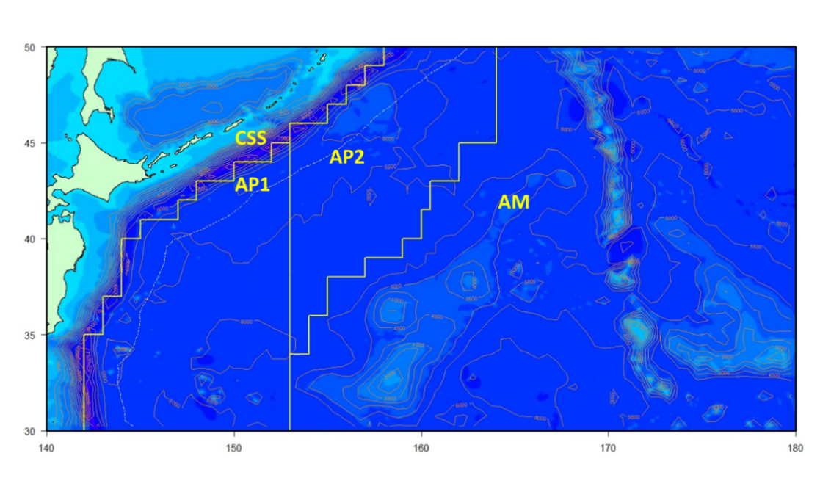
Fig. 3. Definition of four geographic regions based on bathymetric contours and Pacific saury aggregations (modified from Huang et al. (2007)). CSS, continental shelf and slop area; AP1, abyssal plain area 1; AP2, abyssal plain area 2; and AM, abyssal mountain area.

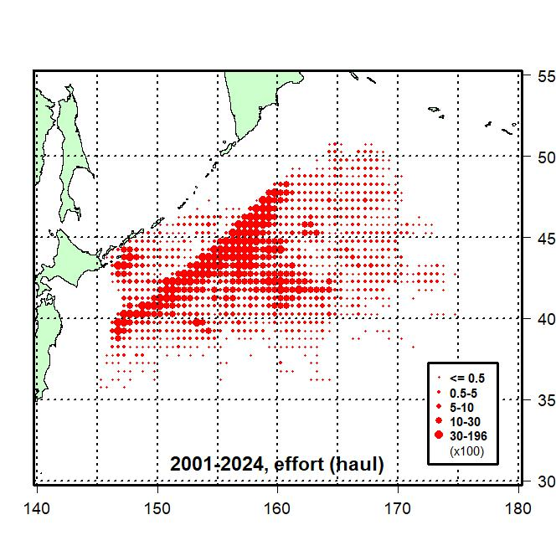  (a) | 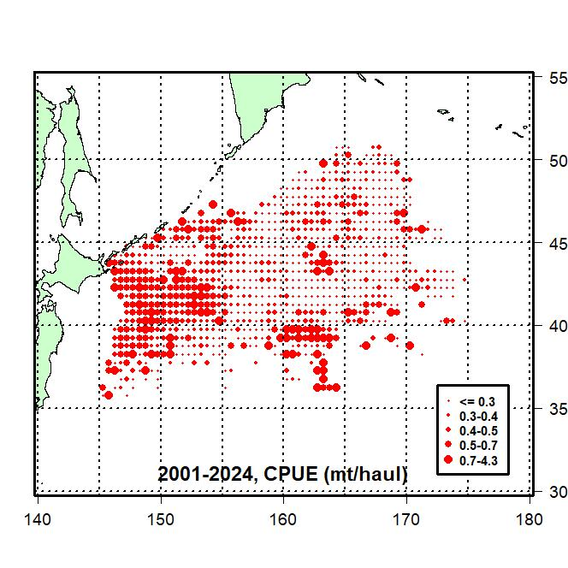  (b)
Fig. 4. Distributions of fishing efforts (10² hauls) (a) and nominal CPUEs (mt/haul) (b) for the Chinese Taipei saury fishing fleets in the Northwestern Pacific Ocean from 2001-2024.

- Two-divided period approach
2001-2011
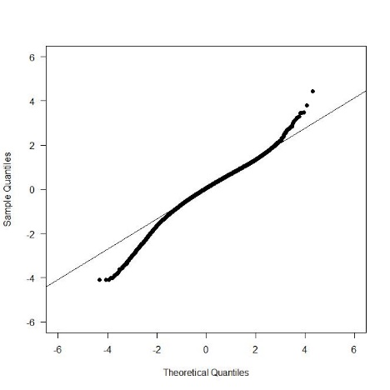 | 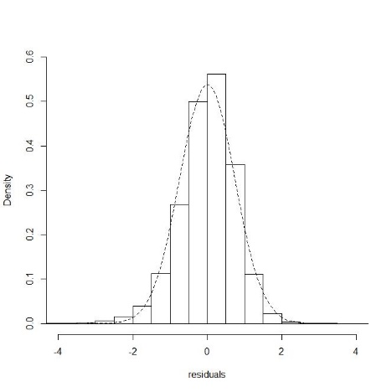 | 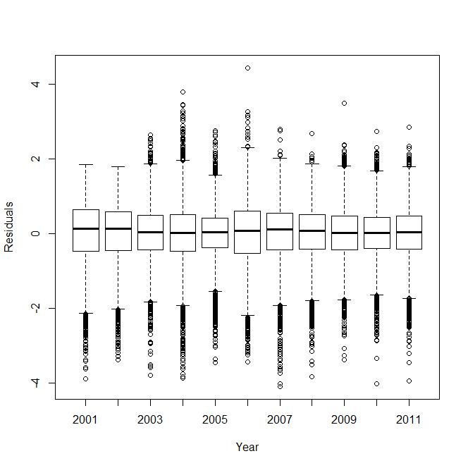
2012-2024
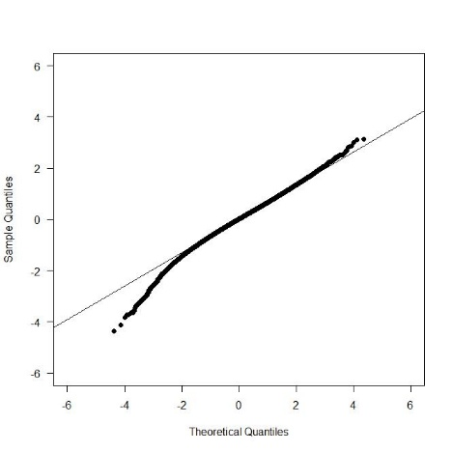 | 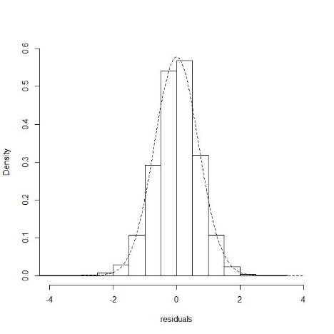 | 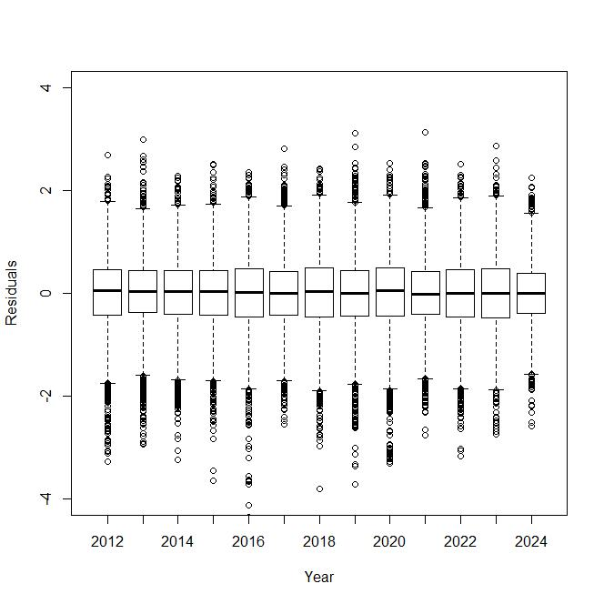

- Non-divided period approach
2001-2024
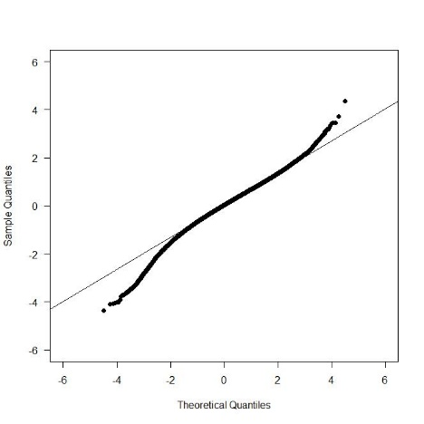 | 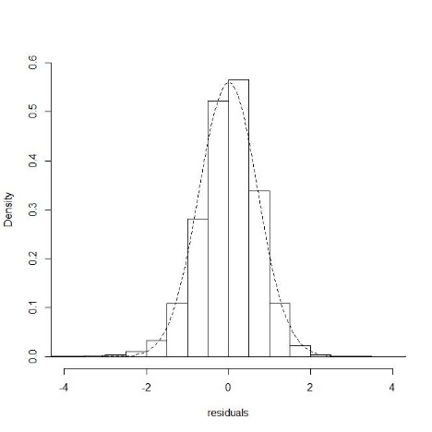 | 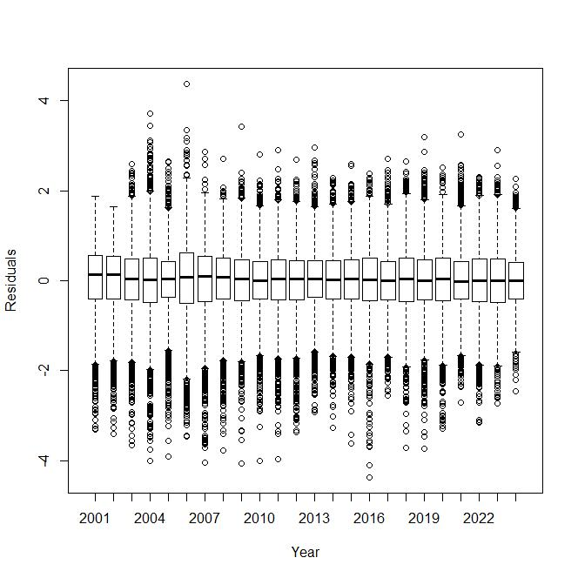
Fig. 5. Q-Q plots, histograms of residuals, and residual plots across years for the best model form the GLM by the two-divided period approach (a) and the non-divided period approach (b).

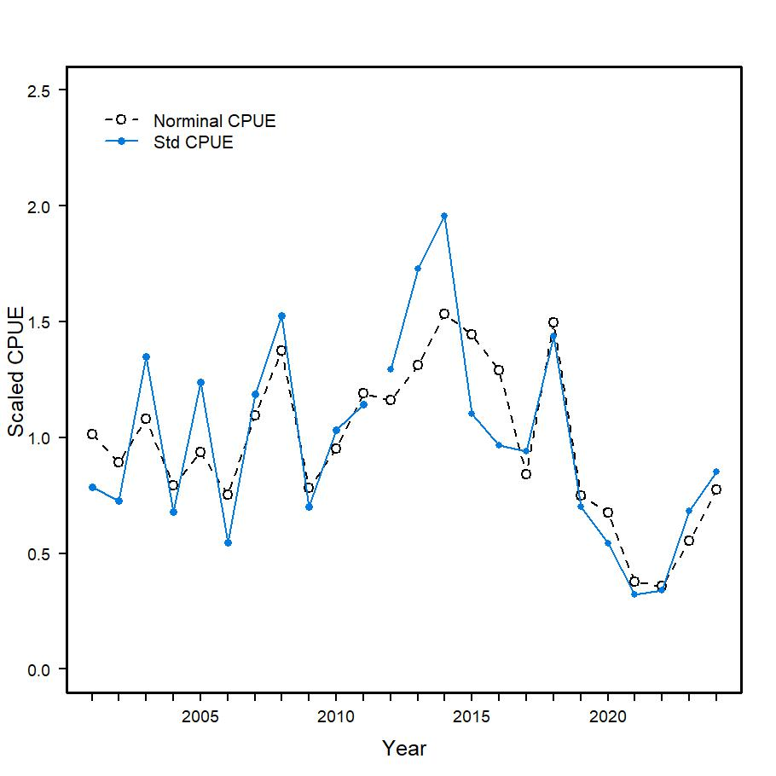
- Two-divided period approach
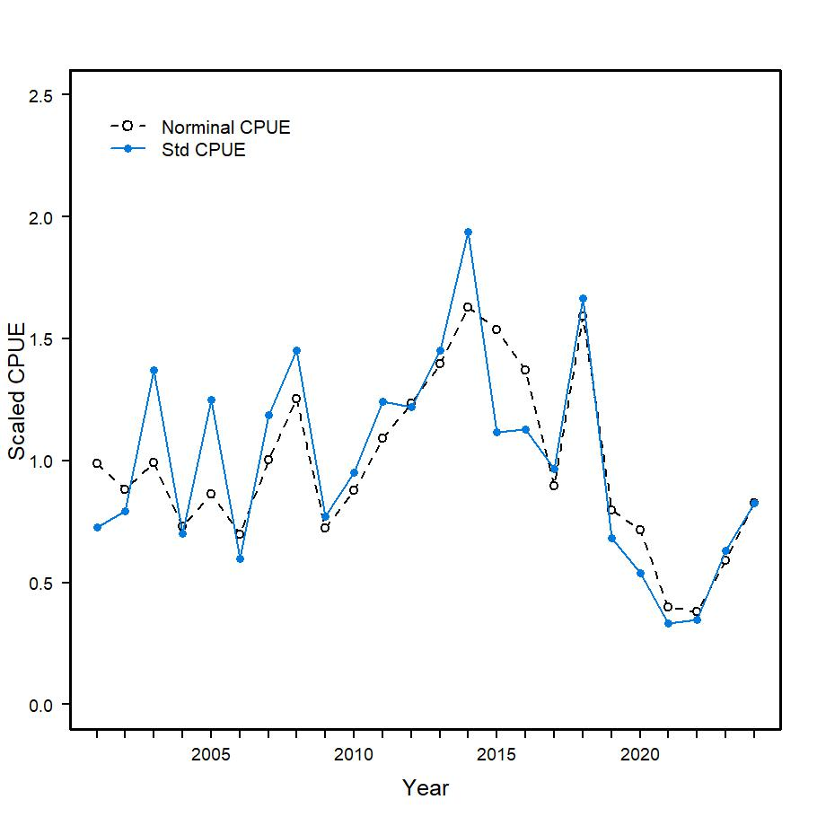
- Non-divided period approach
Fig. 6. A scaled nominal CPUE series (dashed line) and scaled standardized CPUE series (solid line) are presented for the best model from the GLM by the two-divided period approach (a) and the non-divided period approach (b).

AppendICES

Appendix I. Checklist for the CPUE standardization protocol (revised in August 2024)
No. | Step-by-step protocols | yes/no | Note
1 | Conduct a thorough literature review to identify key factors (i.e., spatial, temporal, environmental, and fisheries variables) that may influence CPUE values; | yes | Tian et al. 2003, 2004  Huang et al. 2007, 2010  Tseng et al. 2011, 2013  TWG PSSA, 2018, 2019
2 | Determine temporal and spatial scales for data grouping for CPUE standardization; | yes | See 2.1 Fishery data and water temperature, p.3 & 2.2. Full model descriptions and model selection, p.3-4
3 | Plot spatio-temporal distributions of fishing efforts and catch to evaluate spatio-temporal patterns of fishing effort and catch; | yes | See Fig.4, p.16
4 | Calculate correlation matrix to evaluate correlations between each pair of those variables; | yes | See Table 2, p.9
5 | Identify potential explanatory variables based on steps 1-4 as well as interaction terms to develop a full model for the CPUE standardization; | yes | See 2.2. Full model descriptions and model selection, 2nd par., p.4
6 | Fit candidate statistical models to the data (e.g., GLM, GAM, Delta-lognormal GLM, Neural Networks, Regression Trees, Habitat based models, and Statistical habitat based models); | yes | See Tables 3 & 4, p.10-13
7 | Evaluate the models using methods such as likelihood ratio, AIC/BIC and cross validation; | yes | See 2.2. Full model descriptions and model selection, last par., p.4
8 | Evaluate if distributional assumptions are satisfied and if there is a significant spatial/temporal pattern of residuals in CPUE standardization modeling; | yes | See Fig.5, p.17
9 | Extract yearly standardized CPUE and standard error by a method that is able to account for spatial heterogeneity of effort, such as least squares mean or expanded grid. If the model includes area and the size of spatial strata differs or the model includes interactions between time and area, then standardized CPUE should be calculated with area weighting for each time step. Model with interactions between area and season or month requires careful consideration on a case by case basis; | yes | See 2.3. Yearly trend extraction, p.5
10 | Recommend a time series of yearly standardized CPUE and associated uncertainty; | yes | See Table 5, p.14
11 | Plot nominal and standardized CPUEs over time; | yes | See Fig.6, p.18
12 | This protocol can be used for joint CPUE standardization. | yes

