NPFC-2025-SSC NFS02-WP05

Preliminary application of the stochastic surplus production model in continuous time (SPiCT) to neon flying squid in the North Pacific using the Japanese survey index

Bungo Nishizawa*, Hajime Matsui, Suguru Okamoto, and Kazuhiro Oshima

Fisheries Resources Institute, Japan Fisheries Research and Education Agency

*Corresponding Author
Email: nishizawa_bungo05@fra.go.jp

Summary
We applied the stochastic surplus production model in continuous time (SPiCT) to the autumn and winter-spring cohorts of neon flying squid in the North Pacific using the total catch data from NPFC members, and two indices from the fishery and Japanese driftnet survey. The fishery index was estimated by standardizing the member’s CPUE using a generalized linear mixed model that included year and NPFC member as explanatory variables. We used the 13-year period from 2012 to 2024 for the autumn cohort and the 24-year period from 2001 to 2024 for the winter-spring cohort for the assessment periods, as data on total annual catch and the two indices were only available during these time frames. During the assessment periods, we confirmed a weak positive relationship (Pearson’s r = 0.27) between the fishery and survey indices for the autumn cohort and a strong positive relationship (r = 0.57) for the winter-spring cohort. For both cohorts, the relationship between the survey index and the catch data appeared to align with the general assumption of the surplus production model. The parameter estimates derived from the autumn cohort assessment using SPiCT were nearly satisfactory with narrow confidence intervals, however, some issues from model diagnostics and retrospective analysis were found. The estimated values in the winter-spring cohort model appeared acceptable, as the model diagnostics were more satisfactory and there was no retrospective bias for either relative biomass or fishing mortality. The utilization of both fishery and survey indices in the surplus production models constitutes a valuable approach for future stock assessments of neon flying squid by the SSC NFS.

Introduction
The neon flying squid (Ommastrephes bartramii, hereafter referred to as NFS) is an oceanic squid found worldwide in subtropical and temperate waters (Roper et al. 1984). In the North Pacific, the NFS population comprises an autumn cohort and a winter-spring cohort (Yatsu et al. 1997, 1998). Both NFS cohorts are commercially harvested by several NPFC members, including China, Japan, Korea, Russia, Chinese Taipei and Vanuatu, in the NPFC Convention Area. Previous studies evaluated the annual stock size of both cohorts based primarily on surplus production models or depletion methods (Ichii et al. 2006, Chen et al. 2008, Wang et al. 2016). At SSC NFS01 meeting, we presented the first SPiCT trial using existing data from the NPFC annual summary footprint (Nishizawa et al. 2024). In the present report, we provide updates with the inclusion of the abundance index from the Japanese driftnet survey.

Methods

3.1 Data
We used the NPFC statistics (Annual Summary Footprint of the neon flying squid, https://www.npfc.int/summary-footprint-squid-fisheries), which include the annual catch and effort of NFS fishery in the North Pacific between 1995 and 2024 (Figs 1 and 2). Based on the agreement regarding separation of catch into two cohorts by the SWG NFS (Scientific Committee 2023), we defined the NFS catches in the area east and west of 170°E as the “autumn cohort” and “winter-spring (WS) cohort”, respectively.

3.2 Biomass index
We used two indices for each NFS cohort: the fishery index, which is a standardized CPUE calculated using the Annual Summary Footprint of the neon flying squid, and the Japanese survey index (Nishizawa et al. 2025). For the fishery index, we used a generalized linear mixed model (GLMM) to standardize nominal CPUE, with CPUE (catch/fishing days) as the response variable, assuming a log-normal error. The explanatory variables included Year and Member as categorical fixed variables, and the interaction between Year and Member as a random effect (equation 1). Since China, Chinese Taipei, and Japan had sufficient time series data and accounted for over 99% of the total catch for each cohort from 1995 to 2024 (Fig. 2), we used their CPUE for standardization.

$$\ln\left(CPUE\right)= Intercept+Year+Member+\left(1 \right| Year:Member)+ε, ε \sim N(0, σ2) (1)$$

3.3 SPiCT model
SPiCT is a stochastic surplus production model in continuous time (Pedersen and Berg 2017), that incorporates dynamics in both biomass and fisheries, as well as observation error of both catches and biomass indices, based on the generalized surplus production model in the form of Pella-Tomlinson (1969) (equation 2). The model has a general state-space form that can include process and observation error, as well as state-space models that assume error-free catches.

$$dB_{t}= \frac{r}{n-1}B_{t}\left(1-{\left[\frac{B_{t}}{K}\right]}^{n-1}\right)dt-F_{t}B_{t}dt+σ_{B}B_{t}dW_{t} (2)$$

where B_{t} is the exploitable stock biomass, F_{t} is the instantaneous fishing mortality rate in year t, r is the intrinsic growth rate of the population, K is the carrying capacity, n is a unitless parameter determining the shape of the production curve, $σ_{B}$ is the standard deviation of the biomass process noise, W_{t} is Brownian motion. Two common assumptions for the shape parameter n, which determines the skewness of the production curve, are: the Schaefer model that assumes a symmetrical production curve with MSY corresponding to the biomass at half of carrying capacity K (n = 2) and the Fox model that has an asymmetrical production curve with MSY at 37% of carrying capacity K (n → 1).

SPiCT can consider seasonal patterns in fisheries dynamics and allows setting of priors on the parameters. It can also provide estimates of exploitable biomass and fishing mortality at any point in time from data sampled at arbitrary and possibly irregular intervals. Biomass and fishing mortality are unobserved processes (random effects), while catch and abundance indices are observed variables. SPiCT requires a catch time series and one or more biomass index time series and does not require life history parameters. In this report, we used the 13-year period from 2012 to 2024 for the autumn cohort and the 24-year period from 2001 to 2024 for the winter-spring cohort, as data on total annual catch and two indices were only available during these time frames. Five models with different parameter settings were examined for each cohort (Table 1). The intrinsic growth rate r for squid species, including NFS, is highly variable among and within species, ranging from 0.3 to 2.4 (Table 2). Accordingly, the prior for the intrinsic growth parameter r was set to either 1.0 or 1.5 based on previous studies on NFS (1.19 from Ichii et al. 2006, and 1.71 from Wang et al. 2016) (Table 1). We also assumed that the process error and the observation error are equal in some cases (Table 1). Further for the WS cohort, the prior distribution of q on the fishery index was assigned based on the previous stock assessment results for the cohort by the Chinese jigging fishery (Wang et al. 2016).

In SPiCT, the temporal dimension of the continuous-time model is numerically resolved using an Euler scheme that discretizes time into intervals of fixed length. The Euler discretization has to be finer than the data, i.e. for yearly data the Euler time step has to be smaller than 1. In our case, we used the default value of 1/16 year as Euler time step, which is sufficient in most cases (Mildenberger et al. 2022).

4. Results and discussion
For both NFS cohorts, the fishery index of standardized CPUE, as estimated by GLMM with Year and Member incorporated as explanatory variables, generally showed similar trends to nominal CPUE (Fig. 4). During our assessment periods, the Pearson’s correlation coefficients between the fishery index and the Japanese survey index were 0.27 for the autumn cohort (13 years from 2012 to 2024) and 0.57 for the WS cohort (24 years from 2001 to 2024). These values indicate a positive relationship between the two indices, and they were used as a biomass index for the SPiCT runs in this document.

The input data for the autumn and WS cohorts used in SPiCT are presented in Figs 3 and 4, respectively. We found that the relationship between the survey index and the effort proxy (catch divided by the index) was characterized by a negative slope, therefore, the optimal effort (Emsy guess) was estimated in both cohorts. Unlike the survey indices, the fishery index did not follow this relationship, then estimated Emsy was negative in both cohorts.

We judged whether the results estimated in each model are appropriate by following the checklist for the acceptance of a SPiCT assessment (Table 3). We also showed the estimated parameters from all models for each cohort in Tables 4 and 5. The main result plots are shown in Figs 5 to 8, with the model diagnostic results in Figs 9 to 12. The results from retrospective analyses are plotted in Figs 13 to 16.

For the autumn NFS cohort, all models except for M0 (zero assumptions for prior distribution of any parameters) achieved convergence. In M1 and M2, which were assumed to have weak prior distributions of r and n, showed quite large confidence intervals in main variance parameters, such as the observation error of catch (sdc) (Table 4), and did not pass the checklist for acceptance in an SPiCT assessment (Table 3). In M3 and M4, which had stronger constraints than M1 and M2, improved the parameter estimates, however, they still had violations in the Q-Q plots associated with the catch and survey index (Figs 9 and 10). Furthermore, the retrospective analysis indicates that estimates of biomass exhibit considerable among-assessment variation (Figs 13 and 14). As a result, the stock of the autumn NFS cohort could not be confidently assessed.

For the WS cohort, all models (M0-M4) achieved convergence. In the case of M0, M1, and M2, the confidence intervals of both fishing mortality and relative fishing mortality (F and F/Fmsy) were quite large (Table 5) and did not pass the checklist for acceptance in a SPiCT assessment (Table 3). In M3 and M4, which had stronger constraints including the prior distribution of q, much improved parameter estimates with narrow confidence intervals (less than 1 order of magnitude) (Table 5). Further, M3 and M4 exhibited negligible retrospective biases (Mohn’s rho values for relative biomass: 0.031 and 0.034, Mohn’s rho values for relative fishing mortality: -0.026 and -0.05) (Figs 15 and 16), and their model diagnostics were almost satisfactory with slight violations in the Q-Q plots associated with the catch and fishery index (Figs 11 and 12). Although the prior distribution of r differed between M3 and M4 (M3: r = 1, M4: r = 1.5), they had similar estimated carrying capacity (K) of 540,115 and 511,601 tons, respectively (Table 5). The estimated parameter n of M3 (2.89) and M4 (3.33) was greater than the initial prior value (n = 2), and the production curve was shifted to the right. This indicates that MSY would be achieved when Bmsy/K = 0.57-0.59 (Figs 7 and 8). However, it is still unclear whether this higher Bmsy/K than other marine fishes (mean of 0.404 for all fish species, Thorson et al. 2012) are valid for this species, as squid species are generally characterized by short life spans, high metabolic rates, and rapid growth (Arkhipkin et al. 2021).

In this document, we applied the SPiCT to the catch data from NPFC members and two abundance indices (fishery and Japanese survey indices). Although some runs yielded acceptable estimates, the results were preliminary and should not be used to discuss stock status. Further improvement is needed in both input data (i.e., defining stock assessment periods and cohort-specific catch data based on their size) and the model assumption of SPiCT. Nevertheless, this document demonstrates that SPiCT can be a potential tool for assessing stock status for this species, as it has already been applied to other cephalopod stocks (Larivain et al. 2021).

References
Arkhipkin, A. I., Hendrickson, L. C., Payá, I., Pierce, G. J., Roa-Ureta, R. H., Robin, J.-P., and Winter, A. (2021) Stock assessment and management of cephalopods: advances and challenges for short-lived fishery resources. ICES Journal of Marine Science, doi:10.1093/icesjms/fsaa038. Johan Hjort Symposium 2019. 1-17.
Chen X., Chen Y., Tian S., Liu B., Qian W. (2008) An assessment of the west winter-spring cohort of neon flying squid (Ommastrephes bartramii) in the Northwest Pacific Ocean. Fisheries Research, 92: 221–230.
Csirke, J., A. Alegre, J. Argüelles, R. Guevara-Carrasco, M. Mariátegui, R. Segura, R. Tafúr & C. Yamashiro. (2015) Main biological and fishery aspects of the jumbo squid in the Peruvian Humboldt Current System. 3rd Meeting of the Scientific Committee.
Hendrickson, L.C., Brodziak, J., Basson, M., Rago, P. (1996) Stock assessment of northern shortfin squid in the northwest Atlantic during 1993. Northwest Fisheries Science Center Reference Document, 96-05g, pp. 1–63.
Ichii, T., Mahapatra, K., Okamura, H., and Okada, Y. (2006) Stock assessment of the autumn cohort of neon flying squid (Ommastrephes bartramii) in the North Pacific based on past large-scale high seas driftnet fishery data. Fisheries Research, 78: 286–297.
Larivain, A., M. Petroni, A. Iriondo, E. Abad, J. Valeiras, A. Moreno, D. Dinis, A. Rocha, V. Laptikovsky, JP. Robin, A.M. Power. (2021) North Eastern Atlantic cephalopods stock assessment in a data limited framework Surplus Production in a Continuous Time (SPiCT).
Mildenberger T.K., A. Kokkalis, C.W. Berg. (2022) Guidelines for the stochastic production model in continuous time (SPiCT).
Nishizawa B, Matsui H, Okamoto S, Oshima K (2024) Preliminary application of the stochastic surplus production model in continuous time (SPiCT) to neon flying squid in the North Pacific. NPFC-2024-SSC NFS01-WP12.
Payá I. (2023) Update of the Stochastic Production model in Continuous Time (SPiCT) apply to Dosidicus gigas in FAO area 87. SC11-SQ07. SPRFMO.
Pedersen M.W. and C.W. Berg. (2017) A stochastic surplus production model in continuous time. Fish and Fisheries 18 (2): 226–43.
Pella, J.J. and Tomlinson, P.K. (1969) A generalized stock production model. Bulletin of the Inter-American Tropical Tuna Commission 13: 421–458.
Roper CFE, Sweeney MJ, Nauen CE (1984) FAO species catalogue. Vol 3: cephalopods of the world. An annotated and illustrated catalogue of species of interest to fisheries. FAO Fish Synop 125, Rome.
Scientific Committee (2023) 2nd joint meeting of the Small Working Groups on NFS, JFS, JS, and BM. 12pp. Available at: https://www.npfc.int/system/files/2023-12/NPFC-2023-SC08-WP17%20SWGpelagics%202023-02%20Meeting%20Summary.pdf
Thorson, J. T., J. M. Cope, T. A. Branch and O. P. Jensen (2012) Spawning biomass reference points for exploited marine fishes, incorporating taxonomic and body size information. Can. J. Fish Aqua. Sci., 69: 1556–1568.
Urías-Sotomayor, R., G. Rivera-Parra, F. Martínez-Cordero, N. Castañeda-Lomas, R. Pérez-González, G. Rodríguez-Domínguez. (2018) Stock assessment of jumbo squid Dosidicus gigas in northwest Mexico. Lat. Am. J. Aquat. Res 46:2
Wang, J., Yu, W., Chen, X., and Chen, Y. (2016) Stock assessment for the western winter-spring cohort of neon flying squid (Ommastrephes bartramii) using environmentally dependent surplus production models. Scientia Marina, 80: 69–78.
Yatsu A, Midorikawa S, Shimada T, Uozumi Y (1997) Age and growth of the neon flying squid, Ommastrephes bartramii, in the North Pacific Ocean. Fish Res 29:257–270.
Yatsu A, Tanaka H, Mori J (1998) Population structure of the neon flying squid, Ommastrephes bartramii, in the North Pacific Ocean. In: Okutani T (ed) International symposium on large pelagic squids. Japan Marine Fishery Resources Research Center, Tokyo, p 31–48
Yatsu, A., Kinoshita, T. (2002) Application of surplus production model to Japanese common squid, Todarodes Parcificus, with independence parameters for high and low stock regimes. In: Report of the 2002 Meeting on Squid Resouces, Tohoku National Fisheries Research Institute, pp. 29–33 (in Japanese).

Table 1. Description of model cases with prior settings.

Table 2. Intrinsic growth rate (r) for squid species estimated by surplus production models.

Table 3. Checklist for the acceptance of a SPiCT assessment. Symbols of Y and N indicate Yes (checklist passed) and No (checklist failed), respectively.

Table 4. Parameters estimated by the SPiCT for the autumn cohort.

Table 5. Parameters estimated by the SPiCT for the WS cohort.

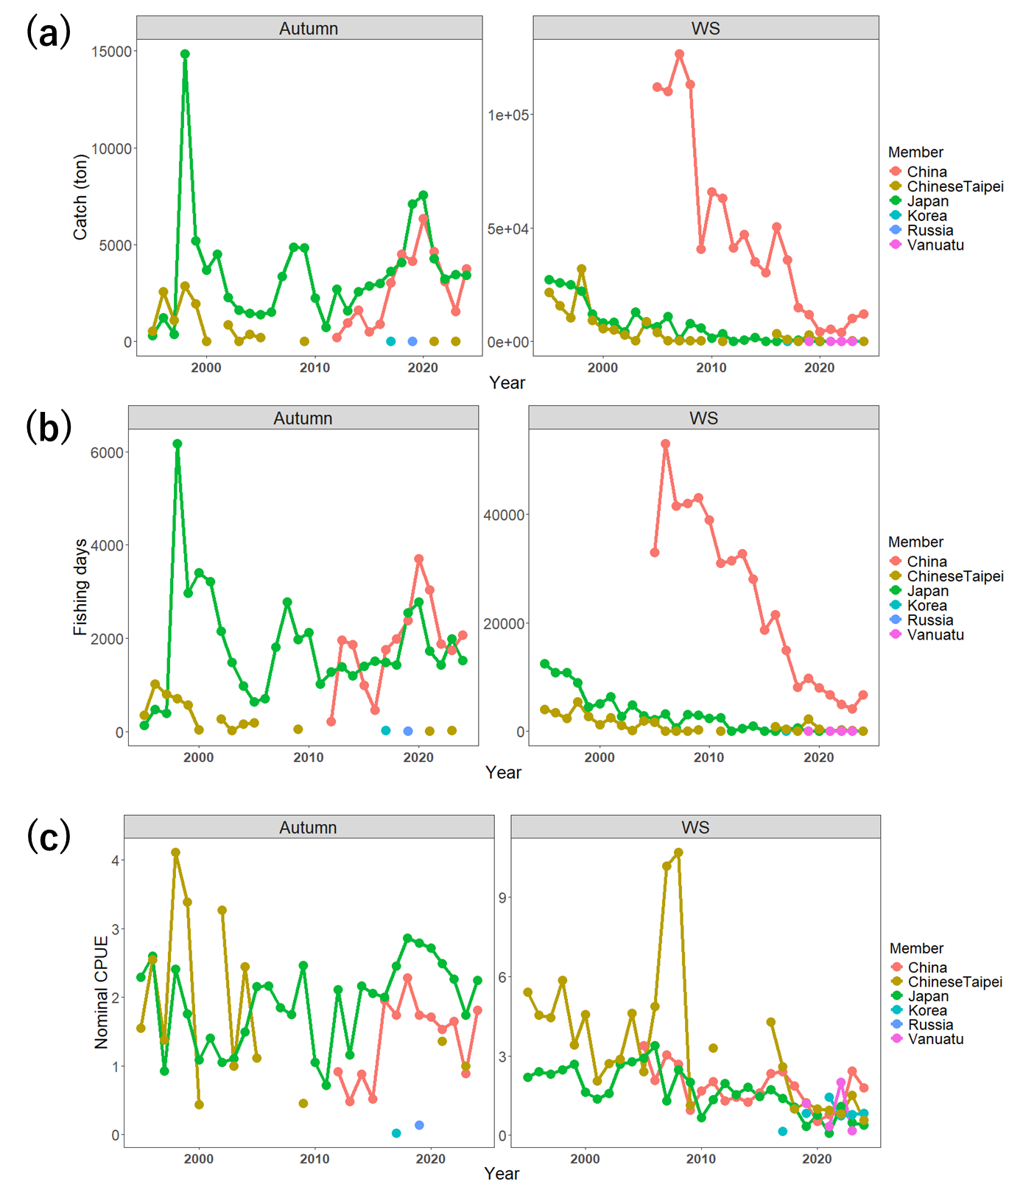
Fig. 1. Annual catch (a), effort (i.e. fishing days) (b), and nominal CPUE (c) of the autumn and winter-spring (WS) cohorts of NFS by NPFC members’ squid-jigging or handlining fleet from 1995 to 2024. Noth that catch and effort by the Russian trawl were not included.

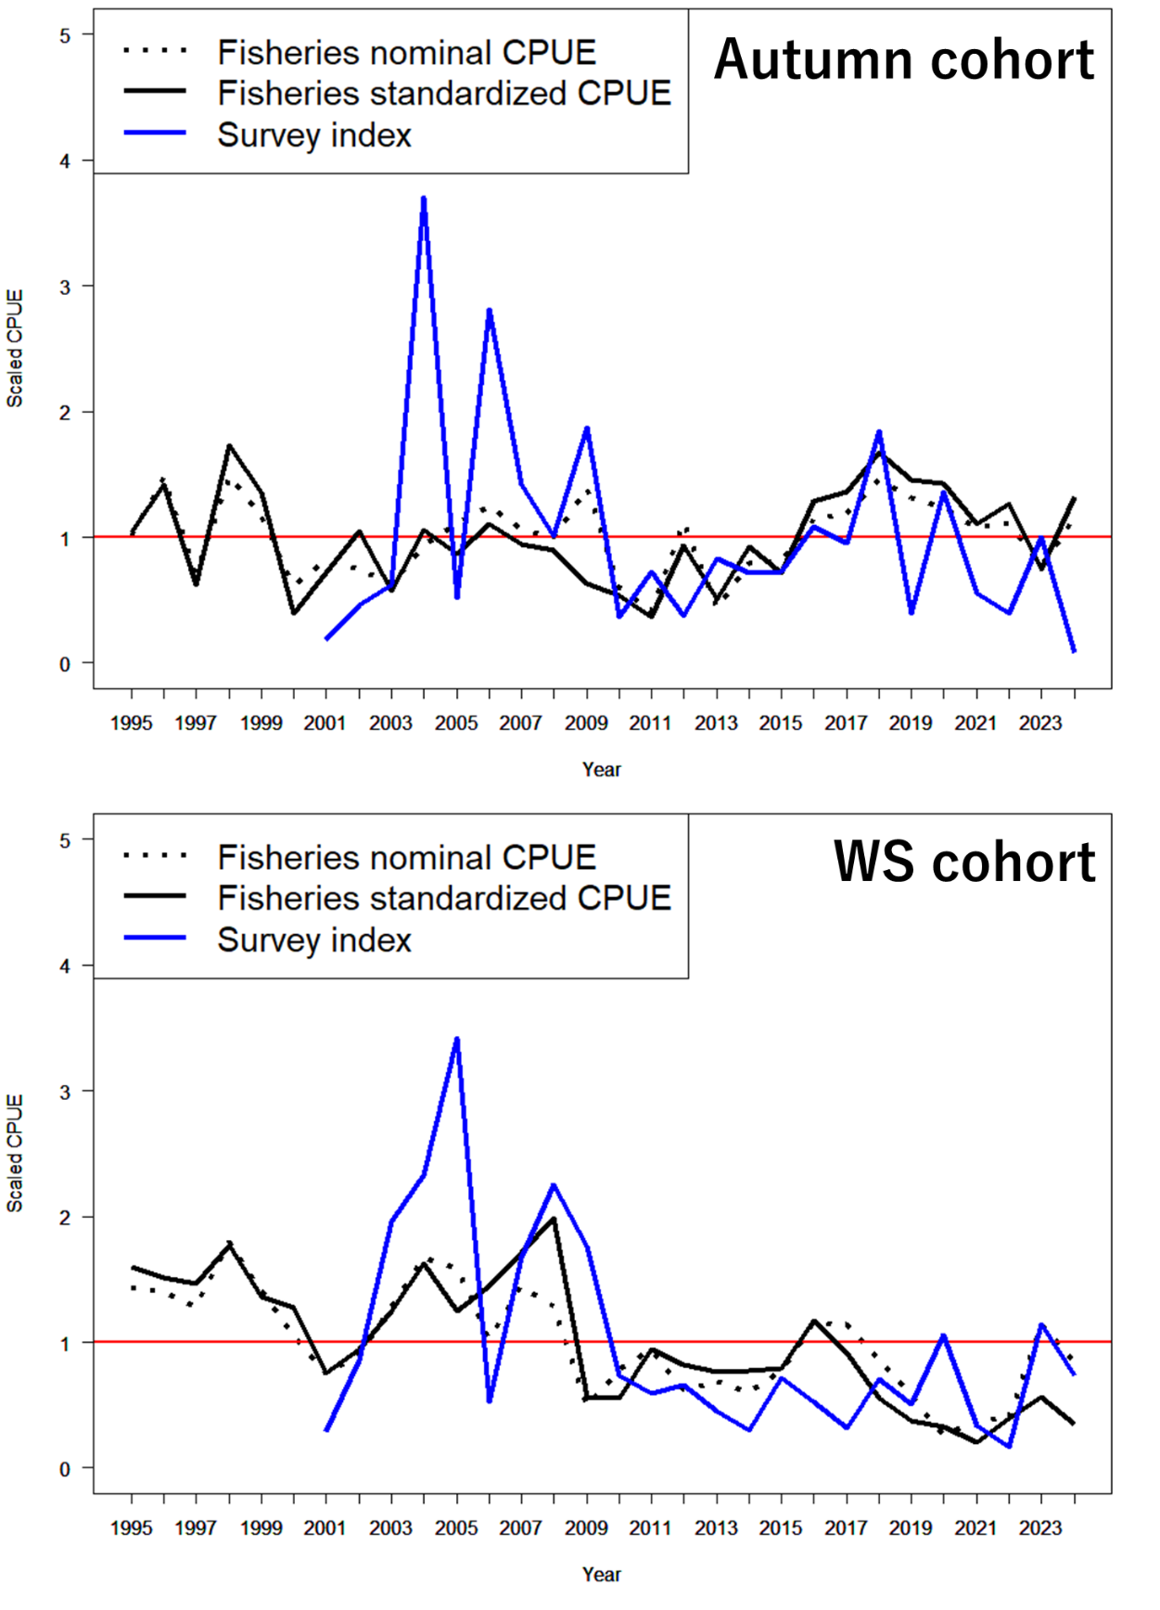
Fig. 2. Nominal CPUE (dotted lines) and standardized CPUE (black lines) from 1995 to 2024, and the abundance index from the Japanese driftnet survey (blue lines) from 2001 to 2024, for the autumn and winter-spring (WS) cohorts. Each value was scaled to a mean value of 1.

Fig. 3. Plots of input data used in SPiCT for the autumn cohort (top panels). Relationships among catch, biomass index, effort proxy, and proportional increase in the index are shown in middle and bottom panels.
Fig. 4. Plots of input data used in SPiCT for the WS cohort (top panels). Relationships among catch, biomass index, effort proxy, and proportional increase in the index are shown in middle and bottom panels.
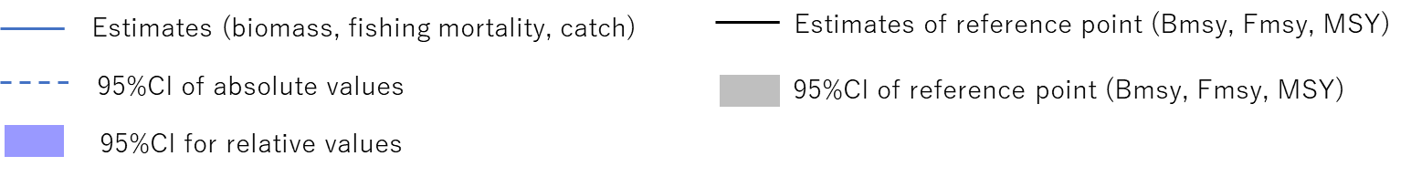

Fig. 5. Result plots for M3 of the autumn cohort.

Fig. 6. Result plots for M4 of the autumn cohort.

Fig. 7. Result plots for M3 of the WS cohort.

Fig. 8. Result plots for M4 of the WS cohort.
Fig. 9. Diagnostic plots for M3 of the autumn cohort.
Fig. 10. Diagnostic plots for M4 of the autumn cohort.
Fig. 11. Diagnostic plots for M3 of the WS cohort.
Fig. 12. Diagnostic plots for M4 of the WS cohort.
Fig. 13. Retrospective plots of relative biomass and fishing mortality (B/Bmsy and F/Fmsy) for M3 of the autumn cohort.
Fig. 14. Retrospective plots of relative biomass and fishing mortality (B/Bmsy and F/Fmsy) for M4 of the autumn cohort.
Fig. 15. Retrospective plots of relative biomass and fishing mortality (B/Bmsy and F/Fmsy) for M3 of the WS cohort.
Fig. 16. Retrospective plots of relative biomass and fishing mortality (B/Bmsy and F/Fmsy) for M4 of the WS cohort.

