NPFC-2024-SSC BFME05-WP20 (Rev. 4)

Skilfish
Species Summary
2024-11-26

Skilfish (Erilepis zonifer)
Common names: Skilfish (English); 白斑裸盖鱼(Chinese); アブラボウズ (Japanese); 큰은대구 (Korean); эрилепис или морской монах (Russian)

Biological Information
Skilfish Erilepis zonifer (Lockington, 1880) is one of the two species belonging to the family Anoplopomatidae, and the only species of the genus Erilepis. Published data suggest that juvenile fish are found in the surface water layer, among floating algae, and are distributed in the open ocean, where they live 4 - 6 years, reaching the length of about 50 cm, after which they switch to the bottom lifestyle. Adult fish inhabit deep rocky bottoms. Young fish have bright white spots on their bodies, but with age their color changes to dark gray, and bright markings become duller and less visible as the fish grows. Skilfish has a dark body, nearly black fins, and large blue eyes above a prominent, cavernous mouth like that of a rockfish (fig. 1). It also has a strong tail fin that is equal to or higher than the fish's head. The fish is a predator, and consumes different species of bony fish, cephalopod mollusks and crustaceans, and may also feed on jellyfish.
Global distribution ranges from the central Japan north to the Commander and Aleutian Islands; Gulf of Alaska south to Monterey Bay (California, U.S.A.). Skilfish were registered on all south Emperor Seamounts (south of 42° E). Skilfish were captured mainly on the seamounts T365+A and Koko using bottom longlines (fig. 2). Skilfish are also captured occasionally on longlines and in pots on seamounts in the Cobb Seamount chain in the eastern North Pacific.
This species lives at depth range from 340 to 1150 meters, according to research surveys, and were captured even at 1438 m depth during commercial fishing. The analysis of changes in the fish body length with depth (fig. 3) shows positive correlation in the research area^ larger fish tend to live deeper [Zolotov et al., 2014].
Skilfish size (body length) in commercial catches ranged from 55 to 201 cm, with an average length of 103.5 cm as recorded by Russian scientific observers in 2014-2018 (fig. 4). The body weight ranged from 4.0 kg to 102 kg, with an average weight of 20.8 kg. Published size composition differed on different seamounts (fig. 5).
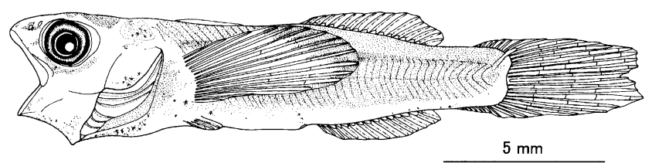 A)
B)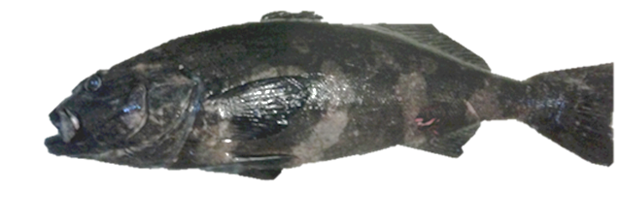
Figure 1: Erilepis zonifer at different developmental stages: A) larva [Okamoto et al., 2010], B) adult (picture made by Igor Maltsev)
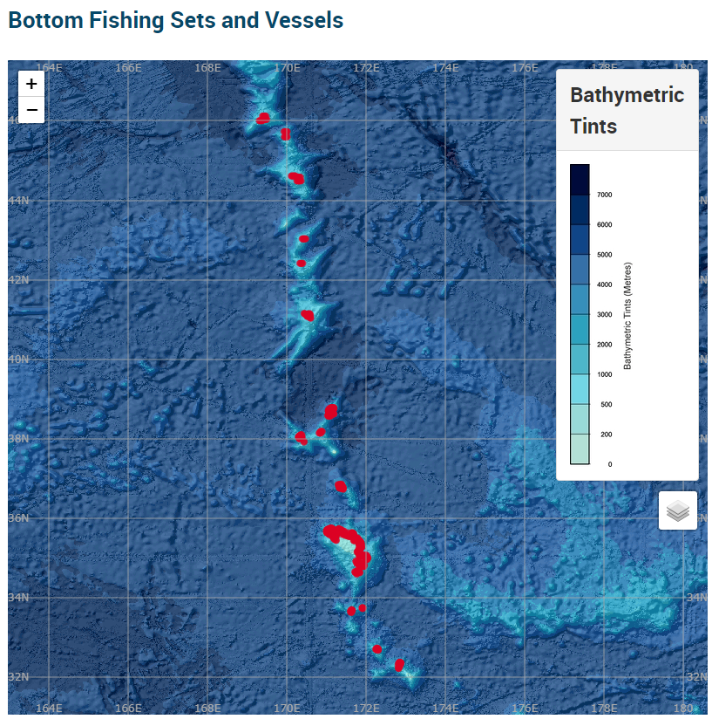
Figure 2: Surveyed area by Russian Long-Liners [https://www.npfc.int/science/gis/bottom_fishing]
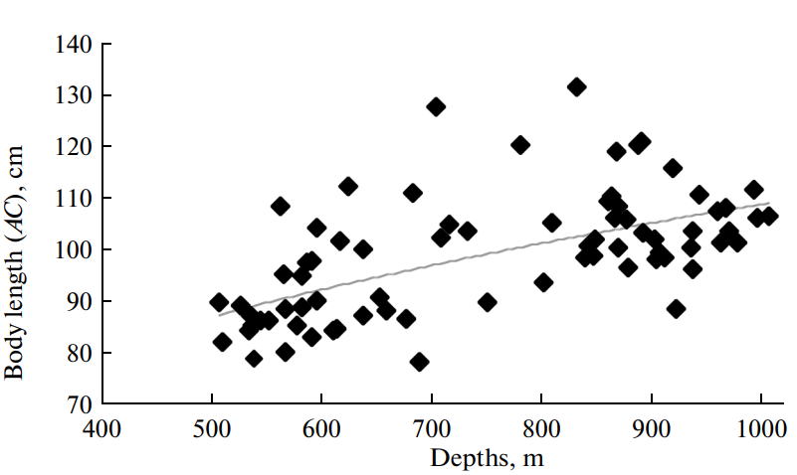
Figure 3: Skilfish body length versus habitat depth at the Emperor Seamounts, June–July 2009: у = 11.632x^{0.3239}, R² = 0.3692 [Zolotov et al., 2014]
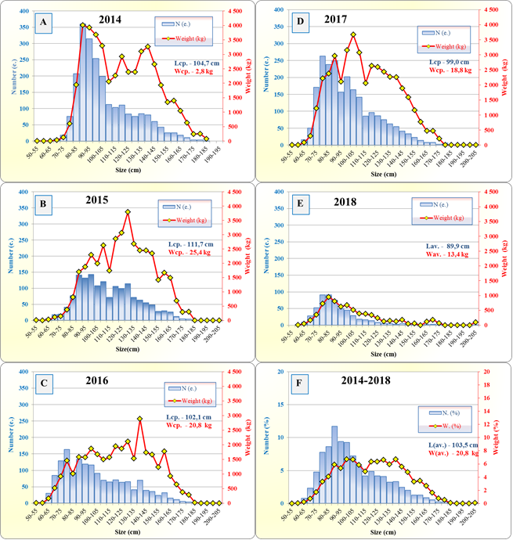
Figure 4: Skilfish body length and weight at the Emperor Seamounts based on longline catches during 2014-2017 (fishing vessel "Palmer") and in 2018 (fishing vessel “Vostok-7”); F – average long-term data, %
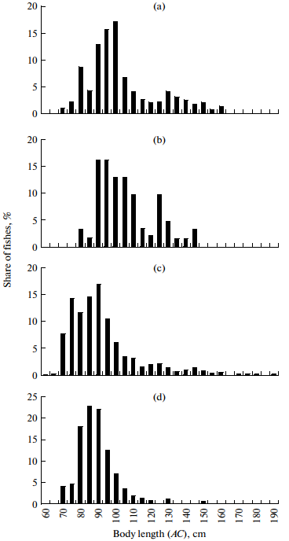
Figure 5: Skilfish body length at the Emperor Seamounts, June–July of 2009: (a) Jingu (M = 103.28 cm, n = 762); (b) Ojin (M = 105.74 cm, n = 61); (c) Northern Koko (M = 92.40 cm, n = 573); (d) Koko (M = 89.07 cm, n = 199)

Fishery
Skilfish was one of the priority species in the Japanese [Belyaev and Darnitskiy, 2005] long-line catches. The fish aggregations of commercial importance were found at several guyots [Baytalyuk et al., 2010; Monakhtina, 2010]. It is also caught by Japanese trawl and gillnet fisheries primarily as bycatch. For several years (2001–2007) this fish was commercially fished by bottom long-lines on a number of Emperor Seamounts. On some markets, this fish was sold under the name “grouper”. In 2009, data on skilfish biology and distribution at the Emperor Seamounts were collected and analyzed by Kamchatka Research Institute of Fisheries and Oceanography (KamchatNIRO) observers on two long-liners [Zolotov et al., 2014]. Later, in 2014-2018, observations were conducted by observers from TINRO, now the Pacific branch of Russian Federal Institute of Fisheries and Oceanography (VNIRO). Catch data for skilfish in Korea is available for the period 2013–2019.

Figure 6: Historical catches of Skilfish in NPFC waters (metric tons)

Figure 7: Historical fishing efforts for Skilfish (days with catches)

Figure 8: Historical CPUE for Skilfish (Cath per day per vessel)

Assessment
The initial biomass of skilfish at Nintoku, Jingu, Ojin, Koko, and Northern Koko seamounts calculated by the Leslie method was assessed at approximately 203.5 tons in 2009 [Zolotov et al., 2014].
An age- or length-structured stock assessment for Skilfish may be feasible considering life history of this species when more data on age-size structure are available (see fig. 4, 5 & 6). At present, given small amount of data, it is impossible to suggest reliable size-age keys for Skilfish. Available data yielded the following traditional von Bertalanffy equation: L_{t} = 183.0 [1 – e^{⎯0.0411(t + 4.1172)}], where L is the fish body length (AC), cm, and t is fish age, years. According to this equation, skilfish at the age of 10, 20, and 30 years reach body length of 105, 115, and 138 cm, respectively [Zolotov et al., 2014].
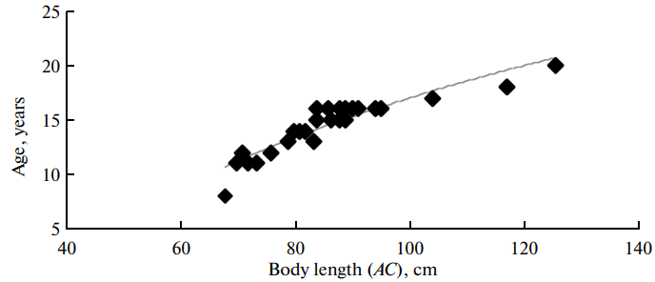
Figure 9: Growth curve of skilfish Erilepis zonifer at the Emperor Seamounts: у = 16.337ln(x) – 58.222, R² = 0.8592 [Zolotov et al., 2014]

Management
Active Management Measures
The following NPFC conservation and management measures pertain to this species:
- CMM 2024-05 For Bottom Fisheries and Protection of VMEs in the NW Pacific Ocean
Available from https://www.npfc.int/active-conservation-and-management-measures
Table 1: Current status of management measures
Item | Status | Description
Biological reference point | Not accomplished | Not established
Stock status | Unknown | Status determination criteria not established
Catch limit | Not accomplished | Not established
Harvest control rule | Not accomplished | Not established
Other | Intermediate | No expansion of fishing beyond 1500 m, No more increase in the fishing vessels
Currently, there is no accepted harvest control rule for this species.

Data Availability
Table 2: Catch data
Data | Member | Fishery | Year | Comments
Annual catch | Japan | Trawl | 2010-present
 |  | Gillnet | 2010-present
 | Korea | Trawl | 2013-2019 | Bycatch less than 1% of total catch
 | Russia | Long-Line | 2000
CPUE | Japan | Trawl | 2010-present
 |  | Gillnet | 2010-present
 | Korea | Trawl | 2013-2019 | Logbook data available
 | Russia | Long-Line | 2014-2018

Table 3: Biological data
Data | Member | Year | Comments
Age | Japan
 | Korea
 | Russia | 2009 | annual ring analysis
Length | Japan
 | Korea
 | Russia | 2014-2018
Maturity | Japan
 | Korea
 | Russia | 2014-2018

References
Baitalyuk, A.A., Karyakin, K.A., and Orlov, A.M., Resources of thalassobathyal Emperor Ridge: exploration, stock condition, and feasibility of commercial expeditions, Vopr. Rybolov., 2010, vol. 11, no. 4 (44), pp. 801–816.
Belyaev, V.A. and Darnitskiy, V.B., Features of oceanography and ichthyofauna composition on the Emperor Ridge, in Deep Sea 2003: Conference Governance and Management of Deep-Sea Fisheries, Shotton, R., Ed., Queenstown, New Zealand: FAO Fish. Proc., 2005, nos. 3/1, part 1, pp. 107–124. http://www.fao.org/docrep/009/a0210e/a0210e09.htm
Monakhtina, S., Skilfish (Erilepis zonifer): traits of biology from a fishery near the Emperor Seamounts in the north-west Pacific Ocean, in 14th PICES Annual Meeting, Abstracts of Papers, Portland, OR, 2010, p. 22.
Okamoto, M., Watanabe, Y., and Asahida, T., A larva of the skilfish, Erilepis zonifer (Actinopterygii: Scorpaeniformes: Anoplopomatidae), from off Northeastern Japan, Spec. Diversity, 2010, vol. 15, pp. 125–130.
Zolotov, O.G., Spirin, I.Y. & Zudina, S.M. New data on the range, biology, and abundance of skilfish Erilepis zonifer (Anoplopomatidae). J. Ichthyol. 54, 251–265 (2014). https://doi.org/10.1134/S0032945214020131

