NPFC-2024-SC09-IP01

NPFC Data Management Systems: Progress and Operational Guidelines

Abstract: This document provides an update on the progress and operational guidance for data management systems related to the Scientific Committee. It is intended for NPFC Members and highlights developments since the 8th Scientific Committee Meeting.

1. NPFC Website Overview
The NPFC website integrates the primary data and information management systems, which cover key areas such as the Members Home, Significant Dates/Events, Pacific Saury Weekly Catch Report, Chub Mackerel Monthly/Weekly Catch Report, GIS Maps, Collaboration, and Annual Reports.
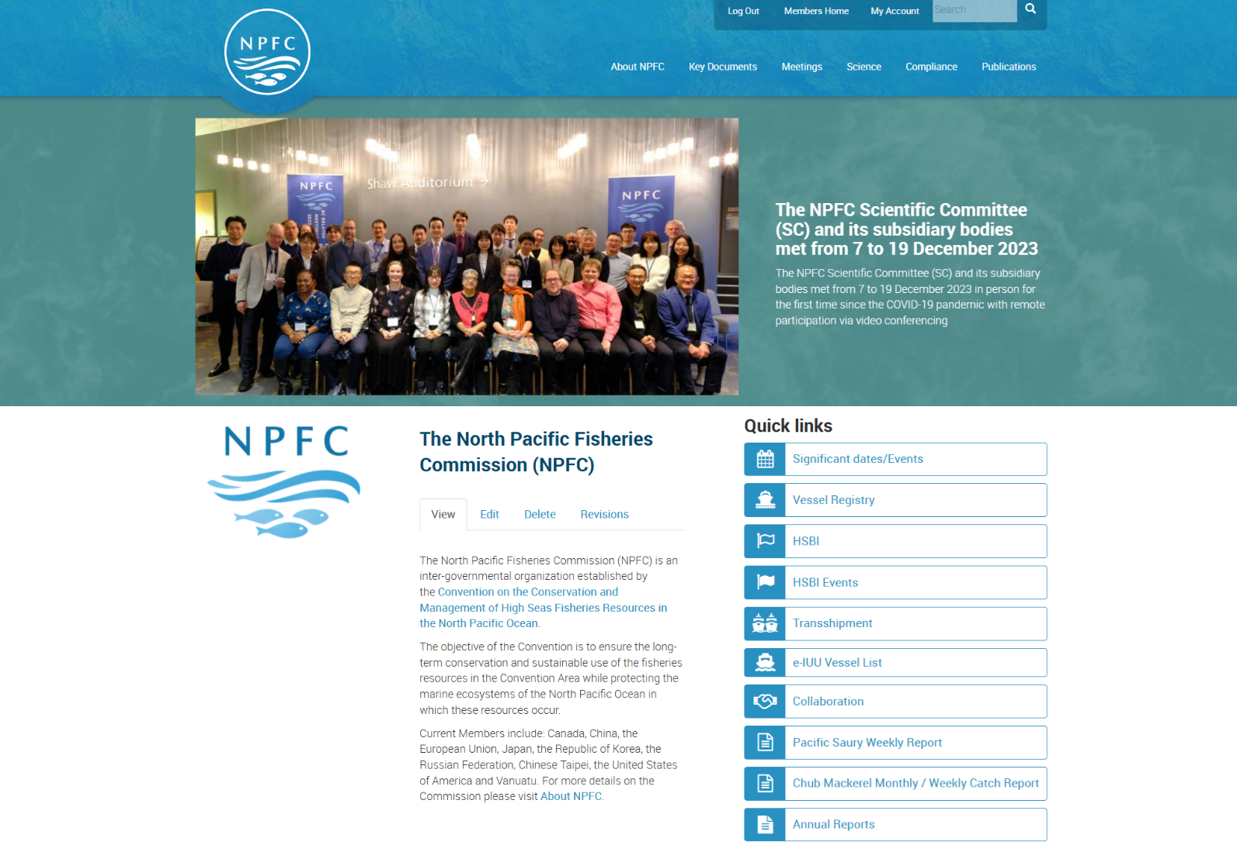

1.1. Members Home (https://www.npfc.int/members)
The Members Home section provides contact information for “Designated Representatives and Official Contacts” and “Focal Points for NPFC Committees and Working Groups”. Key features include:
a. Regularly updated electronic contact lists (HTML format) with updated dates indicated.
b. Group mailing functionality for relevant working groups.
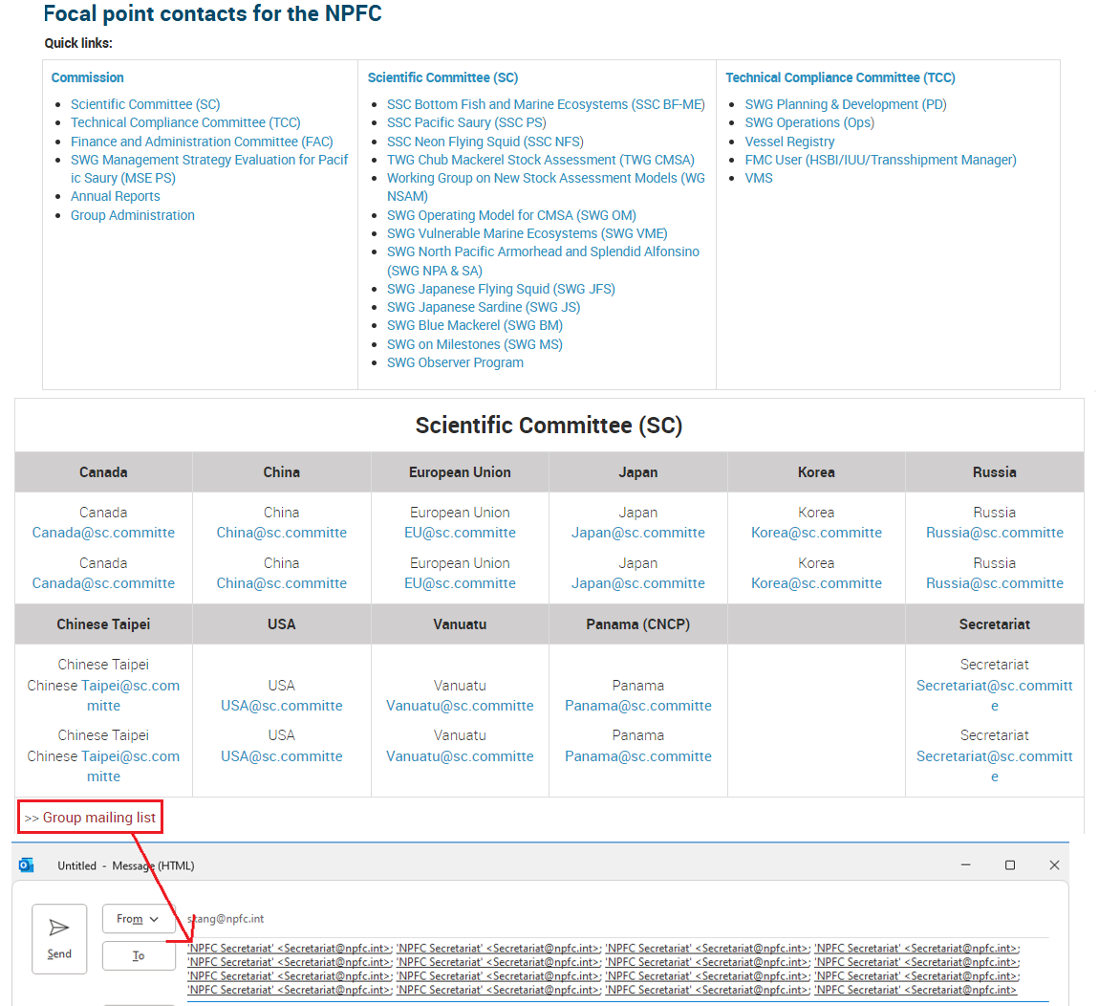
The Secretariat is currently developing a Member management account system which will allow to generate a complete list of membership for each subsidiary body to improve communication among Members. The Secretariat will notify Members and provide a detailed guideline once this development is complete.

1.2. Significant dates/events (https://www.npfc.int/significant-dates-calendar)
The Secretariat maintains the schedules for NPFC’s commission, committees, sub-committees, and working groups. Public access is available. However, the schedules can be also restricted for sensitive events for Members only as necessary.
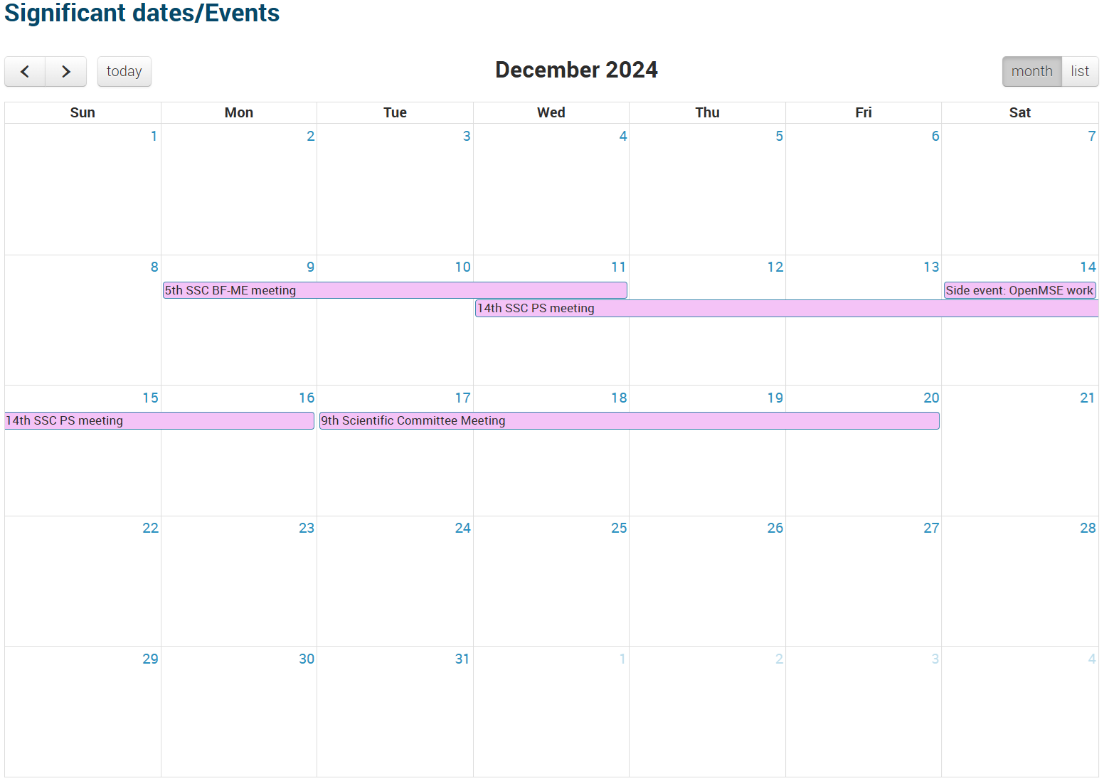

1.3. Pacific Saury Weekly Report (https://www.npfc.int/submissions/weekly-catch)
This section allows Members to view both individual and cumulative Pacific Saury weekly catch data. Aggregate catch data is also publicly accessible under the public domain area on the NPFC website (https://www.npfc.int/pacific-saury-cumulative-catch).
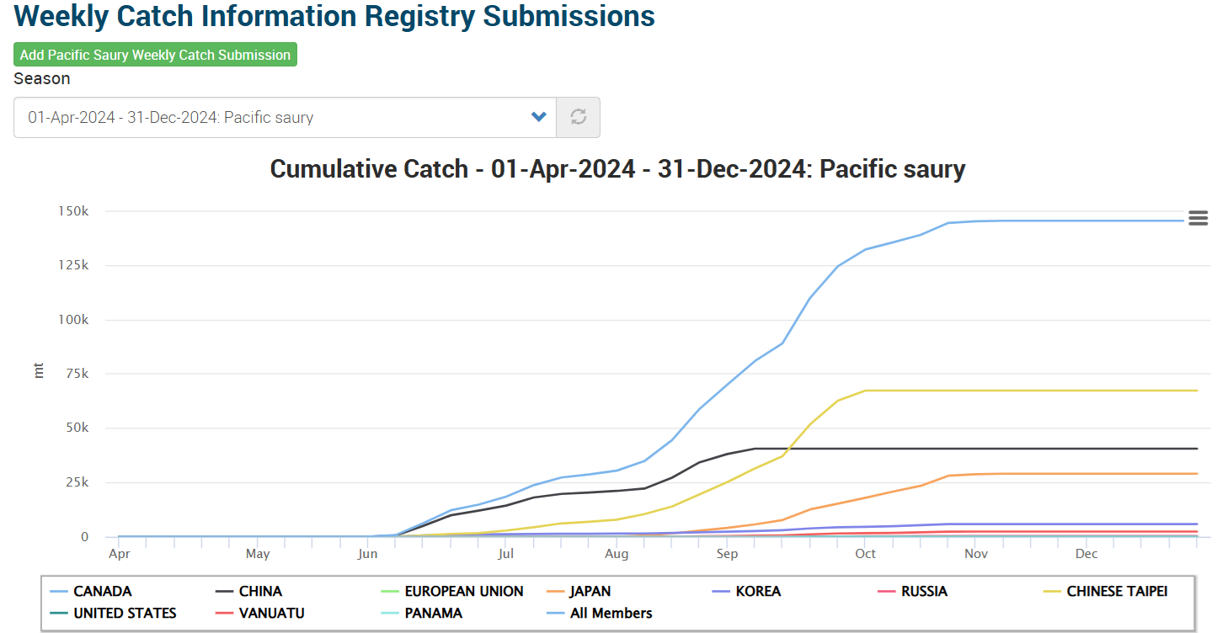
Designated Members (Catch Data Report Managers) are required to submit weekly catch data in metric tons through the data submission page (https://www.npfc.int/irs/add/psw_weekly_catch).
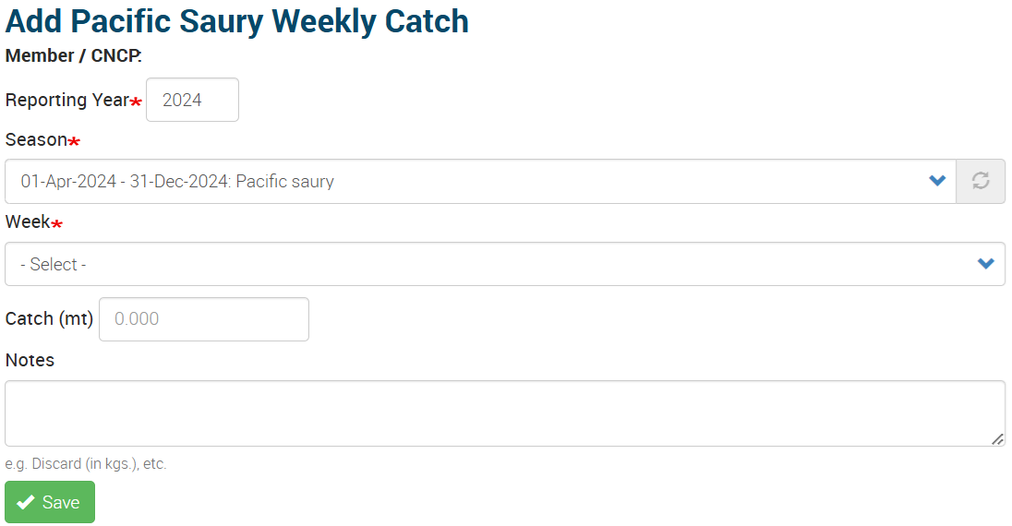
1.4 Chub Mackerel Monthly/Weekly Report (https://www.npfc.int/submissions/weekly-catch/MAS)
The Chub Mackerel Monthly/Weekly Report section has been recently developed as the new Chub Mackerel CMM 2024-07 entered into force.
Members can access individual and aggregate Chub Mackerel catch data by different gear types (Purse Seiners/Trawlers). Cumulative catch data is posted on the public area of the NPFC website (https://www.npfc.int/pacific-saury-cumulative-catch).
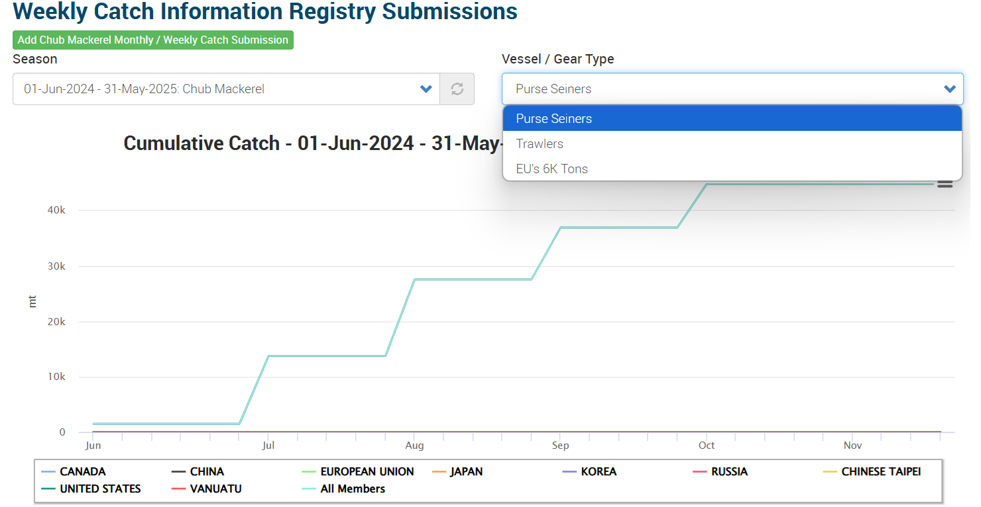
The system transitions from monthly to weekly reporting once the Total Allowable Catch (TAC) reaches 60%.
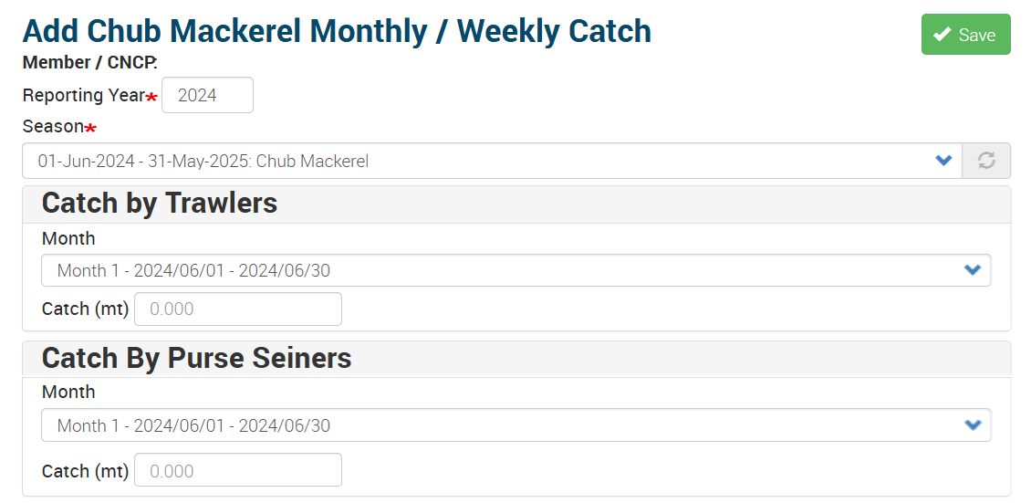
1.5 Collaboration (https://collaboration.npfc.int)
The NPFC Members, CNCP and Observers registered to the particular discussion groups (SC, SSC PS, TWG CMSA, SSC BF-ME, etc) can access the NPFC Collaboration groups. Access is granted based on member requirements.
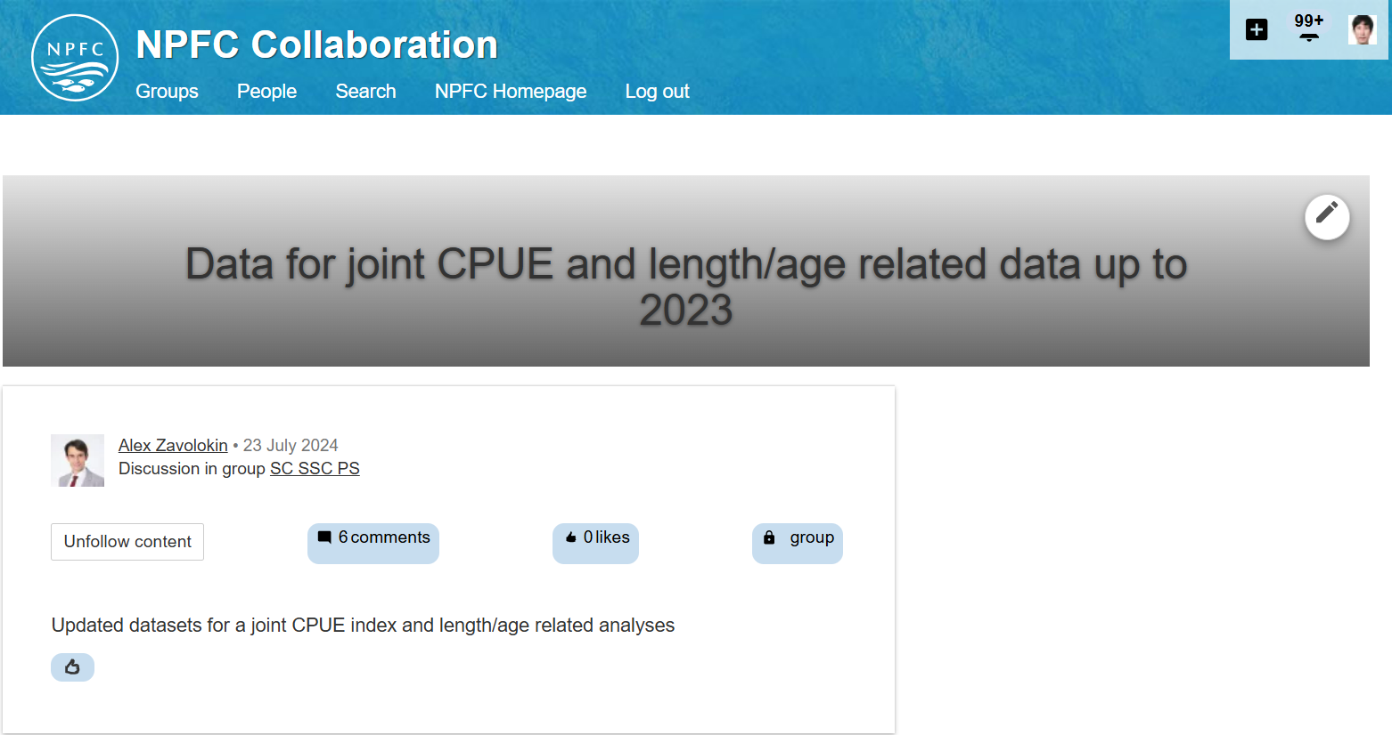

1.6 Annual Reports (https://www.npfc.int/annual-reports-members)
The NPFC Members can access Annual Reports section.
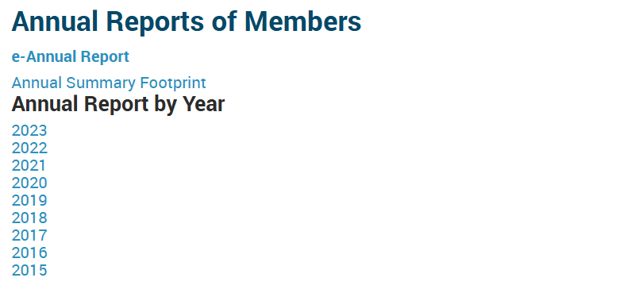
The Annual Reports section also has a link to the e-Annual Report where designated Members (Annual Report Managers) can enter their report for the calendar year. From 2021, the secretariat has requested Members to use the e-Annual Report.

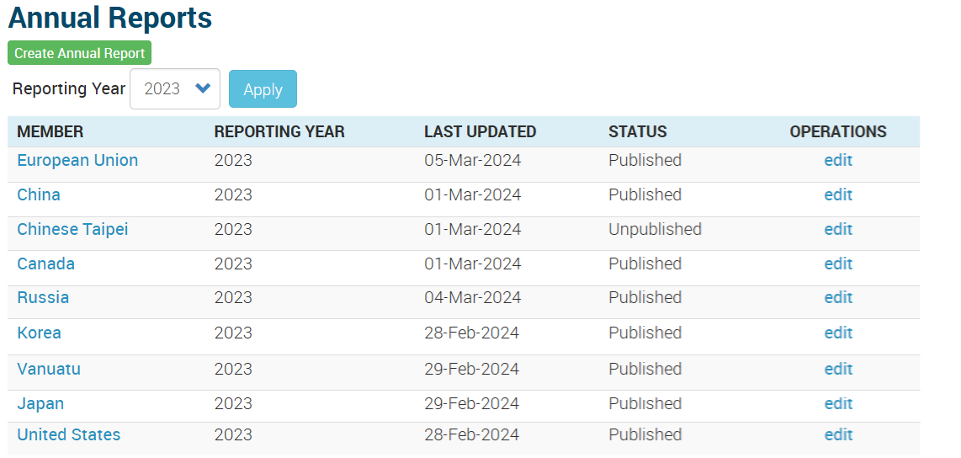

1.7. NPFC GIS Maps
1.7.1 Pacific Saury Map (https://www.npfc.int/science/gis/catch-effort/saury)
The Pacific Saury Map has recently been updated to include the Pacific Saury Catch and Effort data with sea surface temperature grid from 1994 to 2023.

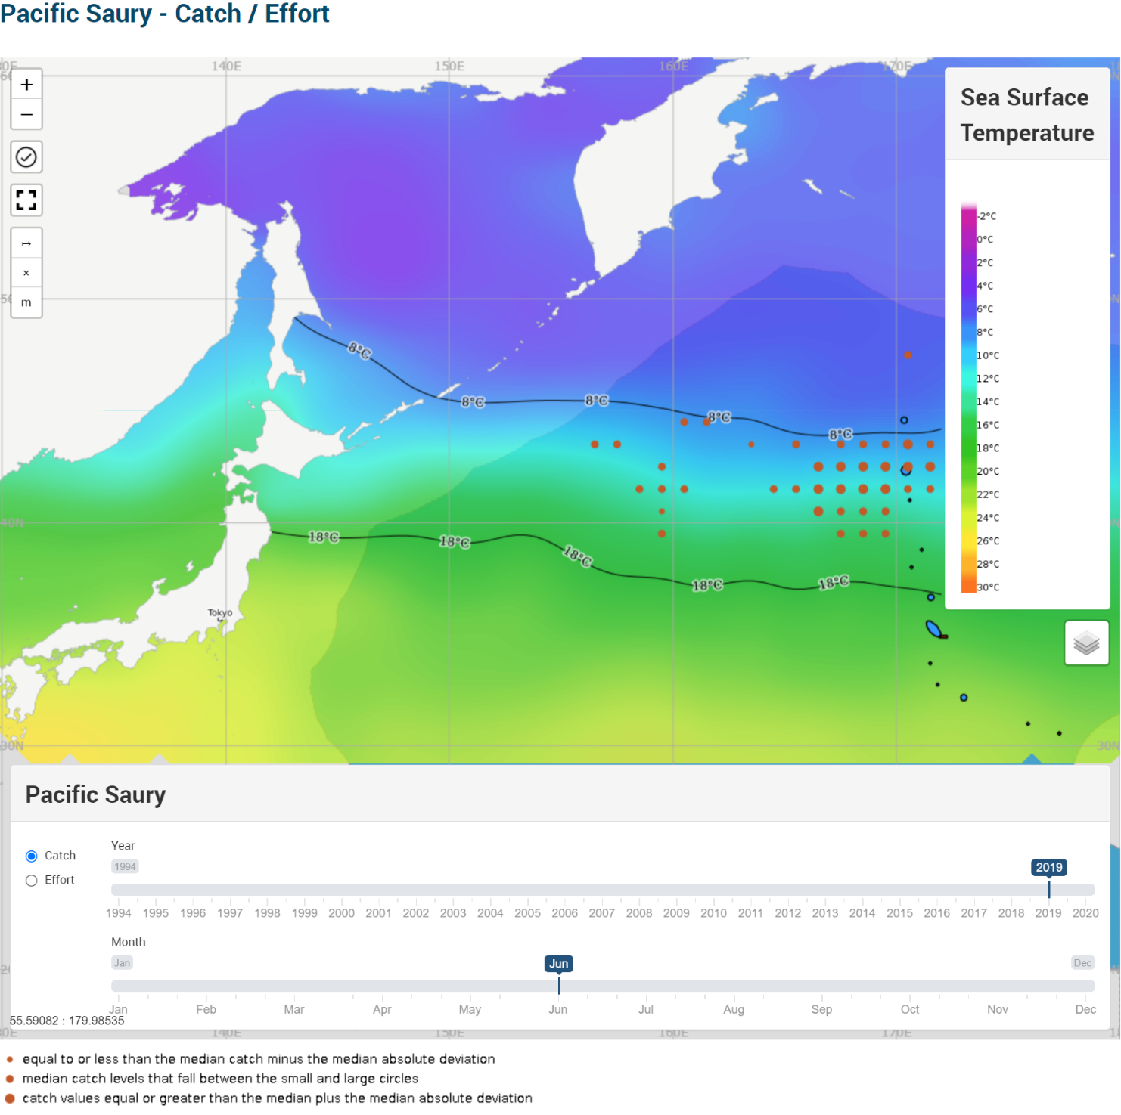

1.7.2 Bottom Fishing Map (https://www.npfc.int/science/gis/bottom_fishing)

The Secretariat developed the Bottom Fishing Map with combined, gear-specific footprints requested by the Small Scientific Committee on Bottom Fish and Marine Ecosystems (SSC BF-ME).
Members can filter the data by the number of sets and number of vessels with different gear types.
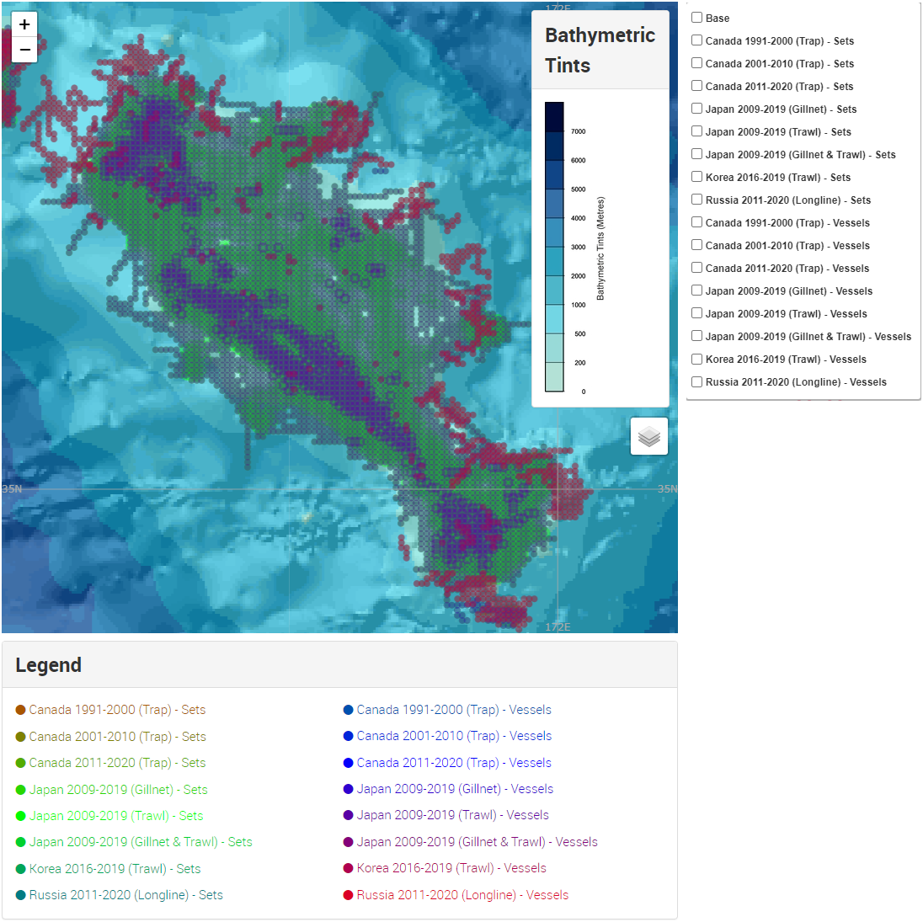

2. NPFC GitHub Repository Update
Abstract:
During the last SC08 meeting, the SC Members expressed interest in utilizing the GitHub Nonprofit Team Plan. The Secretariat officially submitted the application for the GitHub Nonprofit Plan and received the approval message from GitHub. The Secretariat is now coordinating with GitHub to complete the transition.
Current User Summary: Currently, 6 Members, an invited expert and the Secretariat are active within this group.
Member | Name | Number
CANADA | Chris ROOPER | 1
CHINA | Qiuyun MA, Libin DAI, Heng ZHANG | 3
EU | Karolina MOLLA GAZI | 1
JAPAN | Kazuhiro OSHIMA, Momoko ICHINOKAWA, Shota NISHIJIMA, Ken ISHIDA, Yagi TATSUNORI, Kazunari HIGASHIGUCHI, Akihiro MANABE | 7
RUSSIA | Vladimir KULIK, Igor CHERNIENKO | 2
USA | Erin BOHABOY | 1
Invited Expert | Joel RICE | 1
Secretariat | Sungkuk KANG | 1
Total | CANADA, CHINA, EU, JAPAN, RUSSIA, USA, INVITED EXPERT, SECRETARIAT | 17

User Manual: The Data Coordinator has prepared a user manual in cooperation with Members outlining basic steps for utilizing the Git Repository. The manual can be found on the NPFC website under the key documents section (https://www.npfc.int/git-repository-user-manual). This manual can be continuously enhanced based on the feedback from Members.
Currently, the Repository supports the TWG CMSA, with plans to expand support to other groups, such as SSC PS and SSC BF-ME, upon Member request.
The Secretariat will continue managing and supporting the Repository as needed.

3. Conclusion:
The Secretariat will continue to enhance the data management systems to support efficient and secure data handling for the NPFC Members. Members’ feedback and comments are greatly appreciated and will guide future improvements.

