NPFC-2024-SSC PS14-WP05
Summary of the idea exchange between the WGNSAM modelers and biologists in SSCPS

Working group of new stock assessment model and the biologists in Small Scientific Committee on Pacific Saury

1. Introduction
The first meeting of the Working group of new stock assessment model (WG NSAM 2024-01) was held in Shanghai on 27–30 June 2024. Throughout the meeting, WGNSAM recognized that communication between WGNSAM and other biologists in Small scientific committee on Pacific saury (SSCPS) is necessary to develop a biologically plausible stock assessment model. After several times of discussions via web meeting and texts between WGNSAM and the biologists, here we leave the contents of the idea exchange as a SSC document to help both WGNSAM and the biologists retain and organize knowledge in areas unfamiliar to them. These kinds of documents also will be useful to guarantee the transparencies of the new stock assessment model development and to enhance member’s understanding on the modeling and biology of Pacific saury. Note that the answers from different biologists were not necessarily consistent. Here we left them as they were to reflect the differences in opinions from different points of view and leave room for further discussion.

2. Questions/requests/comments from WGNSAM and answers from the biologists
With all of the answers and comments, the name of the person who made the answers or comments was noted. Inquiries about each answer and comment should be directed to them.

2.1. Natural mortality and Longevity
2.1.1. Histograms showing body lengths of Pacific saury in fishery catches peak at about 30 cm and then drop off rapidly to zero at 35 cm (Fig. 1). It is important to explain this pattern in stock assessment modeling. Why is the drop off so rapid and why are there no fish larger than 35 cm? Our working group has discussed at least two hypotheses. The “selectivity hypothesis” asserts that more large fish exist but they are not captured by the fishery. They might not be captured, for example, because they move away from areas where fishing occurs, because they behave differently than smaller fish, because the fishing gear does not work well for large fish or some other reason. The “post-spawning mortality” hypothesis asserts that Pacific saury die quickly at about 35 cm due to exhaustion from spawning. Under this hypothesis, large fish are seldom seen in the fishery because they are already dead. Another hypothesis is that 35 cm is an unusually hard limit on maximum size. The most important questions here are: Does abrupt post-spawning mortality occur? At what size and age does active spawning commence (size is more important than age here). The most important questions about maturity here pertain to spawning activities that relate to mortality. First maturity (occurrence of a few oocytes) is not as important in this context.

>> answer from the biologists (Suyama, Japan)
- First of all, please look at Fig. 2, which summarizes the PS life schedule, as basic information. Since PS’s actual age and the age we recognize by the otolith annual ring are not always consistent, sharing understandings around age determination is essential to discuss life history matters below. Throughout our answers in this document, we refer to age 0 and age 1 not as the actual age, but the ones we recognize from the otolith information. Also, Fig. 2 is very useful to understand the real life schedule of PS. Always keep Fig. 2 beside you!

- I support "post-spawning mortality hypothesis" rather than "selectivity hypothesis" and the third one. Because very few fish with two complete annual rings were sampled, almost all age 1 fish seems to die before May in the 2nd spawning, which is earlier than the fishing season (Suyama 2002, Suyama et al., 2006, Age-length key up to 2023 from Japan: https://collaboration.npfc.int/system/files/2024-07/2000-2023_AL-Key%2820240702%29a.xlsx).

- Although the main reason for that fish over 35 cm have not observed is the “post-spawning mortality hypothesis”, the third hypothesis is partially true: The body length of PS generally saturates around 33 cm. In addition, the length of age 1 fish seems to have decreased in recent years. Fish over 33 cm in size is extremely rare after 2014 in Japanese fishery and surveys that use other kind of fishing gear (Fig. 3, 4).

- Natural mortality might rise up after the 1st spawning, but there is no available information about it to our knowledge.

- Followings are additional information regarding growth of PS. Growth rate of the body length for Pacific saury in Autumn in transition area considered to be very low. I consider that almost no growth in body length after autumn.
- The feeding activity are low in Autumn in transition area (i.e. southward migration period) compared to July to September in Oyashio area (i.e. northward migration period) (Sugisaski and Kurita, 2004).
- Accumulated body reserves in the feeding season, most of them being expended during southward migration for swimming activity and maturation (Kurita 2003). These results indicate that little energy available for growth during this period.
- Otolith growth continues after August, when annual rings start to form this season, consequently the otolith size (radius) of the relative to body length gradually increases in this period (Suyama et al., 2009,2011).

>> answer from the biologists (Huang, Chinese Taipei)
- Chinese Taipei has not conducted specific studies on natural mortality and longevity for Pacific saury. However, recent insights into saury fisheries support post-spawning mortality hypothesis.

- The post-spawning mortality hypothesis posits that repeated spawning leads to a decline in biological condition, making saury more prone to mortality. This pattern aligns with observations in other multiple-spawning species, where energy depletion and physiological stress accumulate over successive reproductive cycles, increasing the risk of death. Such effects have been documented in studies on other fish populations, as discussed by Marshall and Browman (2007), and Jørgensen et al. (2006).

2.1.2. How long is the longevity of Pacific saury? This question arose from the discussion on the life schedule settings. PS’s longevity is described as two years in recent documents, however in some papers (Hotta, 1960; Suyama et al., 2015; Nakayama et al., 2019), up to 2.5 year old PS appeared.

>> answer from the biologists (Suyama, Japan)
- The exact longevity is unknown, but it is very likely that most of the fish die before May in the 2nd spawning season, because the 2nd annual ring formation completes by May at the latest and there are very few fish that completes the 2nd annual ring formation (Sugama 1957, Imai 1993，Suyama 2002, Suyama et al., 2006, Age-length key up to 2023 from Japan: https://collaboration.npfc.int/system/files/2024-07/2000-2023_AL-Key%2820240702%29a.xlsx). This means that there are almost no fish recognized as age 2 or more.

- The reasons why old studies reported fish older than 2 years are:
- The age estimation (in days) of age 1 fish contains large error.
The age in days of age 0 fish is determined by the number of otolith daily rings and the catch date. However, because counting the number of otolith daily rings outside the annual ring is impossible, the age in days of an age 1 fish is estimated using the information of age 0 fish sampled in the previous year, which belongs the same cohort as the target age 1 fish (Kurita et al., 2004). During the northward migration season (May-July), the growth rate is the highest and the increments of the daily rings are maximum (except immediately after hatching). The number of daily rings inside this maximum increment (here, denoted by n) depends on the date of hatch and it can be counted even in age 1 fish. Thus, age 1 fish’s hatch date (and thus age in days) can be estimated by counting n, using the relationship between the hatch date and n observed in the previous year. This method contains large error, so it is thought that some individuals may be determined to be older than 730 days (Suyama et al., 2015). This reason might be true in Suyama et al. (2015) and Nakayama et al. (2019).
- Some fish that hatched in the early breeding season might actually live longer than 730 days or 2 years (see Fig. 1). This reason might be true in all of the three studies above. However, such kind of fish are recognized as age 1 based on the annual ring and, more importantly, can be treated as age 1 in the stock assessment model because it does not contribute to the catch or spawning after May in the 2nd spawning season.
- An old study (Hotta, 1960) estimated the age of PS by combining the information of the otolith annual rings and scales of caught and reared fish. However, subsequent rearing experiments revealed that Hotta’s estimate of the young fish’s growth rate was obviously an underestimate (Watanabe and Kuji 1991, Nakaya et al.,2010).

2.1.3. We use calendar years in modeling with January 1 as the birthdate. Pacific saury spawned in March 2023, for example, are age 0 until January 1, 2024 when they become age 1. They are age 1 till January 1, 2025 when they become age 2. The Working Group is trying to decide whether to use ages 0 to 2+ in modeling or 0 to 1+ (the plus means that at least a small proportion of fish age 3 could be included with age 2 fish in the model’s bookkeeping or that some small proportion of age 2 fish could be included with age 1). Approximately what proportion of Pacific saury survive until age 2? Are the oldest Pacific saury in fishery or survey catches pre- or post-spawning? Absence of post-spawners might indicate they are dead. Are actively spawning fish in poor condition? Poor condition may be a signal that mortality is imminent.

>> answer from the biologists (Suyama, Japan)
- I suggest to use only ages 0 and age 1+ classes rather than 2+, which can be ignored. Although individuals with otoliths with two or more annual rings occasionally appear, the percentage is extremely low (2% even in the most common years; Age-length key up to 2023 from Japan: https://collaboration.npfc.int/system/files/2024-07/2000-2023_AL-Key%2820240702%29a.xlsx). Furthermore, the body lengths of such fish are not larger than those of age 1 fish. Thus, we speculate that the extra rings can be formed even in age 1 fish due to instability in otolith crystal formation (Suyama 2002).

- Condition factor of the spawning fish collected in the winter off the coast of southern Japan are low (Kosaka 2000). Furthermore, large fish (seems to be the oldest) whose oocytes are almost absorbed in their ovaries (i.e. impossible to spawn anymore) sometimes appeared (Suyama 2002). I believe this is the evidence that 1+ fish die soon after spawning and do not survive the next year's fishing season.

- Additionally, I support the settings of date of spawning and hatching in SS3. Although the spawning season of Pacific saury lasts for a very long period (September to June), there is an obvious peak in winter (Wanatabe and Lo,1989).

>> answer from the biologists (Huang, Chinese Taipei)
- In our opinion, using age classes 0 and 1+ is more appropriate for the model. In Chinese Taipei saury fishery, the majority of catch consist predominantly of age-0 and age-1 fish, with age-1 fish making up a significant proportion across different years. For instance, the percentage of age-1 fish varied from around 50% to over 80% from 2007 to 2018 (NPFC, 2020). If on some cases there are older than age 1 saury, their proportion and occurrences is relatively low and inconsistent, which makes it less reliable to include them as a distinct age group.

2.2. Growth
2.2.1. There are important questions about growth of small and large fish. We observe them in fishery data for fish above 15 cm. It would be helpful to have a knowledgeable biologist explain the existing growth studies. What shape is the growth curve for small and large fish? How much variation in size at age is there at small and large sizes? Both the shape and variability around the growth curve are important in stock assessment modeling.

>> answer from the biologists (Suyama, Japan)
- In the past we fitted Von Bertalanffy and Gompertz curves to an age (in days) versus length data of fish larger than around 10 cm, assuming log-normal sample distributions (Nakayama et al., 2019, Fig. 5). The data were broadly gathered from fishery and surveys. The estimated Bertalanffy and Gompertz curves were:

length (cm) = 34.59{1 – exp[–1.548(age – 0.007096)]}, SD of log(length) = 0.1422 and

length (cm) = 30.84 * exp[–3.350 * exp(–3.985 * age)] , SD of log(length) = 0.1357, respectively.

Although these growth curves were fitted to small and large fish’s data at once, fitting distinct curves to the small and large fish separately might be able to extract more information. Also, this fitting seems not to be successful regarding the variation in size: all the older fish (older than 0.8 years) are inside the standard deviation of the prediction error, whereas many younger fish are outside of it. Therefore, it might be better to fit distinct models to the younger and older fish if SS3 modeling will be conducted based on this data.

- There are studies that analyzed the growth of larvae and juveniles (Watanabe et al., 1988, 1997，Oozeki et al., 2003,2004). The growths and natural mortalities differed among the timings and areas of hatch.

- Growth rate in early stage varies depending on the hatching time and area, and they are correlated (Watanabe et al., 1988, 1997，Oozeki et al., 2003, 2004, Nemoto et al., 2003, Suyama et al., 2012, https://www.fra.go.jp/home/kenkyushokai/press/pr2023/files/20230407col_press.pdf).

- Fish that hatch in spring grow faster than those did in autumn (Kurita et al.,2004). Moreover, growth rate of age 0 fish in the west tend to faster than those in the east (Suyama et al., 2012).

>> answer from the biologists (Huang, Chinese Taipei)
- Variability in size at age among Pacific saury, particularly in smaller fish, has been observed in multiple growth studies. For instance, Suyama et al. (2011) noted that age-0 saury exhibits significant seasonal changes in growth rates, which can lead to high variability in size at early life stages.

2.2.2. The question about growth above relates to how individual fish grow but the spawning season is probably protracted so that variation in size at age is probably larger than variability around the growth curve. In addition, immature Pacific saury grow rapidly and size changes through the year. The stock assessment model tries to represent the biological characteristics like length as they occur in the population or fishery in each calendar quarter. Can you estimate the variability in size at age in fishery or survey catches during each of the last two or three calendar quarters when fishing occurs? It would be helpful to review the distribution of ages in each quarter as well although much of this data has been presented to the Working Group over the years.

>> answer from the biologists (Suyama, Japan)
- Your understanding is correct. The size variation of an age group of the caught fish (particularly for age 0) will be larger than that obtained by looking at a certain age in the growth curve (Fig. 5), because the caught fish consists of various ages in days, even if all of them were recognized as age 0. The variation of exploited age 0 fish mainly derived from this variation in the hatch dates, so I consider that the new stock assessment model should include this factor, prior to the temporal/spatial variation of the growth curves explained above.

- However, capturing the size variation of the exploited fish in each quarter is difficult because the fishing season used to be only 4 months (Aug.–Dec.), although in recent years it has expanded to 7 months (May–Dec.).

- Also, if my understanding is correct, the size variation of the fish must be compared under the same selectivity. Therefore, I wonder the comparison between fish caught by different gear (i.e. survey and fishery) can lead to a correct understanding.

- Instead of reviewing quarterly size- and age distributions, here I list up the data obtained from Japanese survey or fishing other than stick held dip nets fishery:

・January-April
We might be able to provide data of set nets or surveys conducted in this season in some years.
・May-July
Japanese stick held dip nets fishery activity conducted in this season only from 2016 to 2019. In addition to this fishery data, survey data for this season is available in 2015. We might be able to provide size composition data for these activities.
・August-December
This period is Japanese stick-held dip nets fishery season. Fisheries data is already shared in a collaboration site with NPFC members as CAS Data.
In addition to the fishery data, survey data is available in some years. We might be able to provide size composition data for these activities.

How to capture the quarterly variation from this data needs to be further discussed.

2.2.3. It would be useful to show monthly size composition plots from the fishery in one or more areas for a series of years. We need to understand the temporal changes in the size distribution of fish in the ocean. It would be nice to add colors for age 0 and age 1 to help us understand when the age 0 fish appear.

>> answer from the biologists (Suyama, Japan)
- Making such a picture is possible from the CAS data submitted by the members, if age determination is made using a single age-length key for each year. If age is determined by area-specific age length keys, then the area determination and additional data manipulation will be required. Also, if using the fishery data, making such a figure in areas and where Japanese fishery did not operated (offshore area in the past) is impossible.

2.2.4. Some members measured the length of PS in fork length, while others in knob length. How is the difference between fork and knob length? It is necessary to clarify if the difference between them is negligible or might affect the stock assessment result.

>> answer from the biologists (Suyama, Japan)
- The difference between the fork length and knob length is almost consistently about 2 mm regardless of body length range (24-33 cm, Kimura 1956).

- I wonder whether this difference can be a problem in SS3. This level of difference might occur by other factors. For example, few millimeters’ Knob length differences occur between frozen and unfrozen raw specimens. If necessary, it might be useful to compare the CAS data from same area, same timing, but by different measuring methods. If their mean body lengths are significantly differ, it might be problematic.

- Also, it might be better to confirm the measuring method of each member. My current understanding is as follows:
China KnL
Japan KnL
Korea FL
Russia FL
Vanuatu KnL
Chinese Taipei KnL

>> answer from the biologists (Huang, Chinese Taipei)
- The difference between fork length (FL) and knob length (KnL) measurements for Pacific saury is minor, ~ 3 mm (Ginting and Huang, 2023). However, converting all measurements to a consistent length metric would enhance the accuracy of stock assessments. Ginting and Huang (2023) provided an approach to transform the relationship between FL and SL to KnL and their relationship is highly linear. Additionally, the study found no significant difference in the length-length relationship by age and sex, indicating that the conversion equation applies consistently across different saury groups of age and sex.

2.3. Spawning
2.3.1 When, where, and how long does spawning last? This question is related to the spawning setting in SS3. Current SS3 is a seasonal model with a single area and spawning occurs only in winter, but plausibility of this setting must be evaluated.

>> answer from the biologists (Fuji, Japan)
- The overall spawning season ranges from September to June. However, identifying the spatiotemporal patterns of the spawning activity and spawning period of an individual fish are very difficult. Previous research has revealed the followings:

・Main spawning season is winter. (Watanabe and Lo, 1989, Kosaka, 2000)
・Winter spawning occurs in the Kuroshio- and Kuroshio Extension- Current regions (Watanabe and Lo, 1989, Fuji et al. 2021a, 2024).
・Autumn and spring spawning mainly occur in the Kuroshio-Oyashio transition region (Watanabe and Lo, 1989, Iwahashi et al. 2006, Hung et al. 2023).
・Larger fish (mainly age-1) spawned at higher SST (16–21°C) in the Kuroshio region, whereas smaller adults (mainly age-0) spawned at lower SST (14–16°C) in the Kuroshio Extension region. Biological traits of Pacific saury such as size and maturation vary spatially in winter (Fuji et al., 2021a).

Because there is no sufficient information to develop models with seasonal spawning, the current simple setting (the instantaneous spawning in January and the single area) seems to be nice for me, at least as a first step.

2.3.2. How is the contribution of age 0 fish to the spawning? This is important when we consider how the spawning process should be modeled. It can be determined by various factors such as maturity, frequency and duration of the spawning activity, and number of eggs per weight relative to age 1 fish. Could you please summarize current knowledges around this issue?

>> answer from the biologists (Fuji, Japan)
- Firstly, I clarify the meaning of “age 0 fish” here. I suppose “age 0 fish” means the fish taking part in the 1st spawning in Fig. 2, although part of it can be recognized as age 1 fish from the otolith information in practice. Also, “the contribution of age 0 fish to the spawning” would be the proportion of age 0 fish (in the meaning above) to the all spawner, including the fish taking part in the 2nd spawning, which belongs to the previous year cohort (they are recognized as age 1).

- In this context, Nakayama et al. (2023) summarized the importance and treatment of age 0 spawning in the age-structured stock assessment model as follows. It is known that not a negligible portion of age 0 fish take part in the spawning (Fuji et al. 2021b). The degree of the age 0 fish contribution in the spawning activity might be one of the key parameters in the age-structured stock assessment models for PS. The degree of contribution is expressed by a product of three factors: the proportion of spawning age 0 fish, the batch fecundity of age 0 fish relative to age 1 fish, and the times of spawning activities of age 0 fish relative to age 1 fish in a single spawning period. In spawning seasons, all age 1 fish are considered to spawn because it is the last spawning season of their lives. On the other hand, it is estimated that about 30% of the age-0 fish spawn (Fuji et al. 2021b). Number of eggs spawned per fish per day during winter in average was 220 for age 0 fish and 740 for age 1 (Fuji et al. 2023). Given the difference in body weight between ages (age-0:53.6 g, age-1:107.8 g, Fuji et al. 2021c), number of eggs per day per body weight (g) was calculated as 4.1 for age 0 and 6.9 for age 1. Age-specific spawning period is unknown, however, Suyama (2013) confirmed age 0 population continued spawning for about four months in tank. Age 1 might spawn considerably more eggs per fish per spawning season than age 0 because in most batch-spawning species the older/larger females begin spawning earlier in the season and continue for longer than younger and smaller females (Marshall, 2016). Therefore, if one expresses the age 0 fish spawning activity by formulating spawning stock biomass calculation as
SSB = γB_{age0}+ B_{age1},
where SSB, B_{age0}, B_{age1} denotes the total spawning stock biomass, total age 0 biomass, and total age 1 biomass, respectively, and γ is the degree of contribution of age 0 fish, which is a constant interpreted as the product of maturation rate, relative fecundity per weight, and relative times of spawning in a spawning season. γ should not be larger than 0.2; relative proportion of maturity and fecundity per weight of age 0 is 0.3 and 0.6 (4.1/6.9), respectively (Fuji et al. 2023), and thus γ is calculated to be 0.18 (0.3 times 0.6), assuming equal spawning periods between ages. In general, older fish are known to have a longer spawning season (Marshall 2016), so γ could be smaller than this value. From this information, we recommend to consider [0.05, 0.2] as a possible range for γ.

- Also, it might be better to consider the annual fluctuation of γ. At least the proportions of age 0 fish experienced spawning to the all age 0 fish have fluctuated year to year, perhaps reflecting the annual fluctuating temporal spawning pattern within each spawning seasons (although the main spawning season is largely winter).

>> answer from the biologists (Huang, Chinese Taipei)
- Observations from the Chinese Taipei fishery indicate that the presence of mature age-0 Pacific saury is minimal. Records show that most age-0 fish caught by Chinese Taipei vessels had very low Gonadosomatic Index (GSI) values, typically around 0.2 (Huang and Huang, 2015). This suggests that while some age-0 fish may begin to mature, the majority remain in a pre-mature state with limited reproductive activity.

2.3.3 There are two types of maturity: physiological maturity (threshold established at cortical alveolar oocyte development stage) and functional maturity (threshold at initial vitellogenic oocyte development stage). Which definition of sexual maturity for PS is more appropriate? This is quite important in the calculation of spawning biomass and stock-recruitment relationship. For the stock assessment of yellowfin tuna in the IOTC, functional maturity is preferable to determine sexually mature fish since it guarantees that the fish will inevitably reproduce in the very short term (Agurtzane et al. 2024).

>> answer from the biologists (Fuji, Japan)
- If your intention is to estimate PS’s maturity curve, then functional maturity is more appropriate than physiological maturity, for the same reason as in the case of yellowfin tuna. However, even functional maturity is not the best way for this purpose: due to the long spawning season, a functionally immature fish in an early spawning season might functionally matured in the late spawning season.

- If you just want to know the proportion of fish participated in the 1st spawning in Fig. 2 (all PS take part in the 2nd one), then the alternative method in Suyama et al. (2016) is appropriate. Suyama et al. (2016) demonstrated that the ovarian arterioles of PS were strongly stained with Victoria blue (VB) for more than 6 months AFTER spawning under rearing conditions. Using this property, Fuji et al. (2021b) identified individuals that had spawned in the 1st spawning season and estimated their proportion.

2.3.4. How long do PS live once they are mature and begin to reproduce? Do we see senescent post-spawning fish throughout the spawning season implying a sort of determinate batch fecundity? Or, do they continue spawning throughout the long spawning season until environmental conditions deteriorate and finally stop spawning across the stock and kill most of the fish? Basically, I want to know if we should assume a mortality shock or pulse at the end of the year in the assessment model or assume that mortality is elevated through the spawning season as fish grow to mature size and then exhaust themselves by spawning.

>> answer from the biologists (Fuji, Japan)
- There are few samplings conducted throughout the spawning season of PS, so it is unclear how the maturity status of PS changes and how mortality progresses over the long spawning period.

- As Fig. 2 shows, we have to consider two types of spawning related mortality: the ones for the 1st and 2nd spawning.

- The 1st spawning related mortality was validated in terms of the otolith annual ring diameter distribution and sex ratio, but no obvious evidences for the mortality increase related to the 1st spawning were found (Fuji et al., 2021b). Therefore, it seems not necessary to consider the 1st spawning related mortality.

- On the other hand, the 2nd spawning by the age 1 fish is the last chance for their reproduction during their life history. All of them die after their 2nd spawning. Age 1 fish may undertake southward migration and spawning at various times. Those that begin spawning at the start of the spawning season may finish spawning and die during the first half of the season, while those that begin spawning in the middle of the season may die at the end of the spawning period.

- Therefore, if the model assumes several month of breeding season, then the elevating mortality is more likely, although the pattern of elevating is not clear. However, if the model assumes the instantaneous spawning on January 1 (question 2.1.3), we do not need to consider this matter. Since the information on the 2nd spawning related mortality above is still insufficient to be included into the stock assessment model, we suggest to adopt the latter option.

2.4. Data availability
2.4.1. This is a question for Japanese scientists. Is length and age composition data available for Japanese survey? If it is available, how is it’s spatial resolution? The current SS3 assumed an identical selectivity for Japanese fishery and survey, although their catch strategy and target size are different.

>> answer from the biologists (Suyama, Japan)
- Japan divided the survey area into three areas (west of 165 °E, 165 °E -180° and 180° - 165 °W). With this or similar level of resolution, Japan can provide the total number of catch individuals in each 1 cm size classes in each of these three survey areas from 2003, as long as we can get permission from the Fisheries Agency. If more detailed data is required, we would like to discuss it with the WGNSAM members and Japanese members.

- Japan is able to provide age length key for each year in the same spatial resolution.

- The use of the provided data is limited to Pacific saury stock assessment in the NPFC SSC PS.

2.5. Environmental Impact (Climate Change)
In your opinion, which population dynamics (e.g., growth, recruitment, natural mortality) or biological parameters have been influenced by environmental variations or climate change? Can you describe the specific ways these processes have been altered? What environmental factors or climatic indices would you suggest incorporating into stock assessment models, and could you provide a guidance of how they could be applied?

>> answer from the biologists (Fuji, Japan)
- Since how to include environment factors and/or indices into stock assessment models seems to be modelers’ field, here we review the existing studies about this issue.

- Growth, recruitment, and natural mortality may all fluctuate due to environmental changes. Recruitment and Natural mortality are strongly related, because recruitment strongly affected by the early stage survival as well as the amount of spawner.

- Regarding growth, as shown in Fig. 3, it has been suggested that it fluctuates over the long term. This is thought to reflect variations in feeding conditions, though the specific mechanisms are not well understood. Similarly, natural mortality rates may also vary over time, but the details remain unclear.

- Fuji et al. (2021d) reviewed the effect of environmental factors on the recruitment. Recruitment of many pelagic fishes, including PS, are thought to be determined by survival during the larval-juvenile stage associating with environmental variations (Watanabe et al. 2003), as well as the amount of spawner. It has been pointed out that the growth of larval PS tends to be higher with higher SST and/or more prey (Oozeki et al. 2004). The growth dependent survival mechanism was confirmed in larval PS (Nakaya et al. 2011). These studies suggest that recruitment of Pacific saury would be higher in years when the environment in the spawning and nursery ground is favorable for larval growth. Oozeki et al. (2015) suggested that larval transportation pathway by Kuroshio is also the important factor affecting the recruitment of Pacific saury. Many previous studies on the relationship between abundance fluctuations of Pacific saury and the environmental factors have focused on the environment of the spawning and nursery grounds of Pacific saury or the climate indices that may affect it. The spawning and nursery grounds of Pacific saury are broadly formed in the transition zone, including subareas such as Kuroshio area, Kuroshio recirculation area, and the Kuroshio-Oyashio Transition and Kuroshio extension from autumn to spring (Fig.6; Iwahashi et al. 2006; Fuji et al. 2021, 2024), so the environment of these areas and season or related climate indices are of interest. For example, Ichii et al. (2018) and Yatsu et al. (2021) found that the CPUE was positively correlated with the winter SST in the Kuroshio recirculation area. Some studies also suggest the relationship between climate indices such as NPGO and SOI and stock abundance of PS (e.g., Tian et al. 2003, Yatsu et al. 2021). However, the detailed mechanism of recruitment fluctuation under the environmental variation is still unknown.

>> answer from the biologists (Huang, Chinese Taipei)
- As a cold-water species, Pacific saury thrives in cooler ocean temperatures. Studies have demonstrated that an increase in SST can lead to a reduction in both body length and weight, as shown in Ito et al. (2013), where growth was hampered due to higher metabolic energy loss and decreased nutrient supply, reducing the availability of prey plankton necessary for growth. This effect is most pronounced for juveniles, whose growth rates directly correlate with survival rates and recruitment success. Additionally, larval mortality was growth dependent, where the environmental factors that affect larval growth play a major role in larval survival and recruitment variation (Nakaya et al., 2011). In addition to the larval growth, Oozeki et al. (2004) reported that oceanographic variables such as sea surface temperature, chlorophyll a concentration, and biomass of copepodite stage copepods were positively correlated with the growth rate of saury larvae in spring and autumn.

- In regards to the environmental factors that could be considered into the stock assessments model, probably incorporating SST and productivity-related indices like chlorophyll-a concentration into stock assessment models would be reasonable.

2.6. Sex ratio
2.6.1. Are there any sex ratio estimates for PS in survey and/or commercial catches. This question has a relatively low priority and will probably not affect assessment modeling but I am curious.

>> answer from the biologists (Fuji, Japan)
Please see Table 3 in Fuji et al. (2021b). The sex ratio was basically not different from 1:1.

3. Questions/requests/comments from the biologists and answers from WGNSAM

3.1. Summary of the available information on PS biology and ecology
So far the SSCPS have had many meaningful discussions to make the new stock assessment model biologically plausible. Throughout these discussions, the biologists have often been asked the same questions over and over again about the availability and treatment of data, and we have often found ourselves repeating the same arguments. This not only wastes time and effort, but also affects the quality of the stock assessment model. In order to cope with this situation, we believe that 1) data providers need to organize the existing data well and 2) data users need to understand and comprehend the provided data well. In order to promote these, Japanese biologists have organized existing data and knowledge, and links to such information, by topic (Supplementary material, Table 1). We hope this will promote mutual understanding between biologists and modelers and contribute to the development of the next stock assessment model.

3.2. Comment on the new stock assessment modeling
Although there is a substantial amount of biological and ecological data on PS, much of it is still not available in stock assessment models. Most data are snapshots capturing only a portion of the population, while stock assessment models must describe temporal changes for the entire population. Japanese biologists are very cautious about developing a complex model. In particular, seasonal reproduction and seasonal growth differences are likely not yet prepared to be included into the model. By adopting a simplified model (e.g., one assuming pulse spawning on January 1 and a single growth curve for the entire population), it may be possible to set aside some of the above issues for now without extensive consideration.

References
Agurtzane U., Giancarlo M.C., Adam L., Gorka M., Dan F., Emmanuel C., Shiham A. (2024). Preliminary 2024 stock assessment of yellowfin tuna in the Indian Ocean. IOTC-2024-WPTT26-11rev1.

Fuji, T., Kurita, Y., Suyama, S., & Ambe, D. (2021a). Estimating the spawning ground of Pacific saury Cololabis saira by using the distribution and geographical variation in maturation status of adult fish during the main spawning season. Fisheries Oceanography, 30(4), 382-396.

Fuji T, Suyama S, Miyamoto H, Nakayama S, Hashimoto M, Naya M, Kawabata A, Nakatsuka S (2021b) Proportion of Pacific saury spawned during their first spawning season estimated by the histological observations of ovary tissues. NPFC-2021-SSC PS07-WP03

Fuji T, Suyama S, Miyamoto H, Nakayama S, Hashimoto M, Naya M, Kawabata A, Nakatsuka S (2021c) Seasonal length-weight relationships and weights at age of Pacific saury. NPFC-2021-SSC PS07-WP10.

Fuji T, Miyamoto H, Nakayama S, Hashimoto M, Suyama S, Nakatsuka S (2021d) A short review of the effects of environmental factors on distribution, migration and recruitment of Pacific saury. NPFC-2021-SSC PS07-WP04

Fuji T, Nakayama S, Hashimoto M, Miyamoto H, Suyama S (2023) Age-specific fecundity of Pacific saury. NPFC-2023-SSC PS11-WP08

Fuji T, Miyamoto H, Abo J, Watai M (2024) Distributions of larvae and juveniles of Pacific saury Cololabis saira during winter in relation to oceanographic structures in the central and western North Pacific Ocean. Fisheries Oceanography, e12697.

Ginting, K. P., & Huang, W.-B. (2023). Length–length and length–weight relationships of Pacific saury (Cololabis saira, Scomberesocidae) in the Northwestern Pacific Ocean. Journal of Ichthyology, 63, 924–929. https://doi.org/10.1134/S0032945223050041

Hotta, H. (1960) On the analysis of the population of the saury (Cololabis saira) based on the scale and the otolith characters, and their growth. Bull. Tohoku, reg. Fish. Res. Lab., 16, 41-64 (Japanese with English abstract)

Hung WC, Hsu J, Chang. YJ, Huang WB, Hsieh CH, Chung MT (2023) Spatiotemporal variations and influential factors affecting reproductive dynamics of Pacific saury in the Northwest Pacific during fishing season. Journal of Fish Biology 103,1335-1346.

Ichii T, Nishikawa H, Mahapatra K, Okamura H, Igarashi T, Sakai M, Suyama S, Nakagami M, Usui N, Naya M, Okada Y (2018). Oceanographic factors affecting interannual recruitment variability of Pacific saury (Cololabis saira) in the central and western North Pacific. Fish Oceanogr 27: 445– 457.

Imai Y (1993) Otolith and scale characteristics of Pacific saury, Cololabis saira, based on otolith type, in the eastern waters off Hokkaido. Sci Rep Hokkaido Fish Exp Stn 43:1–10 (Japanese with English abstract).

Ito, S., Okunishi, T., Kishi, M. J., & Wang, M. (2013). Modelling ecological responses of Pacific saury (Cololabis saira) to future climate change and its uncertainty. ICES Journal of Marine Science, 70(5), 980–990. https://doi.org/10.1093/icesjms/fst089

Iwahashi M, Isoda Y, Ito S, Oozeki Y, Suyama S (2006) Estimation of seasonal spawning ground locations and ambient sea surface temperatures for eggs and larvae of Pacific saury (Cololabis saira) in the western North Pacific. Fish Oceanogr 15: 125-138.

Jørgensen, C., Ernande, B., & Fiksen, Ø. (2006). The trade-off between growth and reproduction: Metabolic scope and the evolution of iteroparity in Atlantic cod (Gadus morhua). Canadian Journal of Fisheries and Aquatic Sciences, 63(4), 870–885.

Kimura K (1956) The standard length of the Pacific saury, Cololabis saira (Brevoort). Bull Tohoku Reg Fish Res Lab 7:1–11 (Japanese with English abstract).

Kosaka S. (2000). Life history of the Pacific saury Cololabis saira in the northwest Pacific and considerations on resource fluctuations based on it. Bulletin of Tohoku National Fisheries Research Institute 63: 1–96 (Japanese with English abstract).

Kurita Y (2003) Energetics of reproduction and spawning migration for Pacific saury (Cololabis saira) Fish Physiology and Biochemistry 28 271-273

Kurita, Y., Nemoto, Y., Oozeki, Y., HAYASHIZAKI, K. I., & Ida, H. (2004). Variations in patterns of daily changes in otolith increment widths of 0+ Pacific saury, Cololabis saira, off Japan by hatch date in relation to the northward feeding migration during spring and summer. Fisheries Oceanography, 13, 54-62.

Marshall, C. T., & Browman, H. I. (2007). Disentangling the causes of maturation decline in exploited fish populations. Marine Ecology Progress Series, 335, 249–251.

Marshall CT (2016) Implementing information on stock reproductive potential in fisheries management: the motivation, challenges and opportunities. In: Jakobsen T, Fogarty MJ, Megrey B, and Moksness E (eds) Fish reproductive biology: implications for assessment and management, second edition. John Wiley & Sons, Ltd.

Nakaya M, Morioka T, Fukunaga K, Murakami N, Ichikawa T, Sekiya S, Suyama S (2010) Growth and maturation of Pacific saury Cololabis saira under laboratory conditions. Fisheries Science 76 45-53

Nakaya M, Morioka T, Fukunaga K, Murakami N, Ichikawa T, Sekiya S, Suyama S, Ueno Y, Shimizu A (2011) Verification of growth dependent survival in early life history of Pacific saury Cololabis saira using laboratory experiment. Env Biol Fish 92 113-123

Nakayama S., Suyama S., Fuji T., Hashimoto M., Oshima K. (2019) A trial calculation of natural mortality estimators for Pacific saury. NPFC-2019-SSC PS05-WP18 (Rev. 1)

Nakayama S, Fuji T, Suyama S, Naya M, Miyamoto H, Hashimoto M (2023) Summary of the possible ranges of the key parameters in the age-structured stock assessment models for Pacific saury. NPFC-2023-SSC PS12-WP02 (Rev.1)

Nemoto Y, Kurita Y, Oozeki Y, Honma T, Hayashizaki K, Ida H (2001) Otolith microstructure of Pacific saury, Cololabis saira.Bull Tohoku Natl Fish Res Inst 64:69–78 (Japanese with English abstract).

North Pacific Fisheries Commission. (2020). Body length distributions and age compositions of the Pacific saury caught by the Chinese Taipei saury fishery in 2007–2018 (NPFC-2020-SSC PS06-WP18).

Oozeki, Y., Watanabe, Y., Kurita, Y., Nakata, K., & Kitagawa, D. (2003). Growth rate variability of Pacific saury, Cololabis saira, larvae in the Kuroshio waters. Fisheries oceanography, 12(4‐5), 419-424.

Oozeki, Y., Watanabe, Y., & Kitagawa, D. (2004). Environmental factors affecting larval growth of Pacific saury, Cololabis saira, in the northwestern Pacific Ocean. Fisheries Oceanography, 13, 44-53.

Oozeki Y, Okunishi T, Takasuka A, Ambe D (2015) Variability in transport processes of Pacific saury Cololabis saira larvae leading to their broad dispersal: Implications for their ecological role in the western North Pacific. Prog Oceanogr 138 448-458

Sugama K (1957) Analysis of population of the saury (Cololabis saira Brevoort) on the basis of character of otolith II. Bull Hokkaido Reg Fish Res Lab 16:1–12

Sugisaki H, Kurita Y (2004) Daily rhythm and seasonal variation of feeding habit of Pacific saury (Cololabis saira) in relation to their migration and oceanographic 14 conditions off Japan. Fish Oceanogr 13 63-73

Suyama S (2002) Study on the age, growth, and maturation process of Pacific saury Cololabis saira (Brevoort) in the North Pacific. Bull Fish Res Agen 5 68-113 (Japanese with English abstract)

Suyama, S., Sakurai, Y., T. Meguro, K. Shimazaki. (1992). Estimation of the age and growth of Pacific saury Cololabis saira in the central North Pacific Ocean determined by otolith daily growth increments. Nippon Suisan Gakkaishi, 58, 1607-1614 (1992) (Japanese with English abstract).

Suyama, S., Kurita, Y., & Ueno, Y. (2006). Age structure of Pacific saury Cololabis saira based on observations of the hyaline zones in the otolith and length frequency distributions. Fisheries Science, 72, 742-749.

Suyama, S., Oshima, K., Nakagami, M., & Ueno, Y. (2009). Seasonal change in the relationship between otolith radius and body length in age-zero Pacific saury Cololabis saira. Fisheries Science, 75(2), 325-333.

Suyama, S., Oshima, K., Nakagami, M., & Kawabata, A. (2011). Seasonal changes in otolith and somatic growth in age-0 Pacific saury Cololabis saira. Fisheries Science, 77(2), 223-233

Suyama S, Nakagami M, Naya M, Ueno Y (2012) Comparison of the growth of age 1 Pacific saury Cololabis saira in the Western and the Central North Pacific. Fisheries Science 78 277-285

Suyama S, Nakagami M, Naya M, Kato Y, Shibata Y, Sakai M. (2015) Stock assessment and evaluation for the western Pacific stock of Pacific saury fiscal year 2015. In Marine fisheries stock assessment and evaluation for Japanese waters (fiscal year 2015) Fisheries Agency and Fisheries Research Agency of Japan. pp 283-336 (Japanese)

Suyama, S., Ozawa, H., Shibata, Y., Fuji, T., Nakagami, M., & Shimizu, A. (2019). Geographical variation in spawning histories of age-1 Pacific saury Cololabis saira in the North Pacific Ocean during June and July. Fisheries science, 85, 495-507.

Tian Y, Akamine T, Suda M (2003) Variations in the abundance of Pacific saury (Cololabis saira) from the north-western Pacific in relation to oceanic-climate changes. Fish Res 60: 439-454

Watanabe Y, Butler JL, Mori T (1988) Growth of Pacific saury, Cololabis saira, in the northeastern and northwestern Pacific Ocean. Fish Bull 86 489-498

Watanabe Y, Lo NCH (1989) Larval production and mortality of Pacific saury, Cololabis saira, in the Northwestern Pacific Ocean. Fish Bull 78 601-618

Watanabe Y, Kuji Y (1991) Verification of daily growth increment formation in saury otoliths by rearing larvae from hatching. Jpn J Ichthyol 38 1-15

Watanabe, Y., Oozeki, Y. and Kitagawa, D. (1997) Larval parameters determining preschooling juvenile production of Pacific saury (Cololabis saira) in the northwestern Pacific. Can. J. Fish. Aquat. Sci. 54:1067–1076.

Watanabe Y, Kurita Y, Noto M, Oozeki Y, Kitagawa D (2003) Growth and survival of Pacific saury Cololabis saira in the Kuroshio-Oyashio transitional waters. J Oceanogr 59 403-414

Yatsu A, Okamura H, Ichii T, Watanabe K (2021) Clarifying the effects of environmental factors and fishing on abundance variability of Pacific saury (Cololabis saira) in the western North Pacific Ocean during 1982–2018. Fish Oceanogr 30 194-204

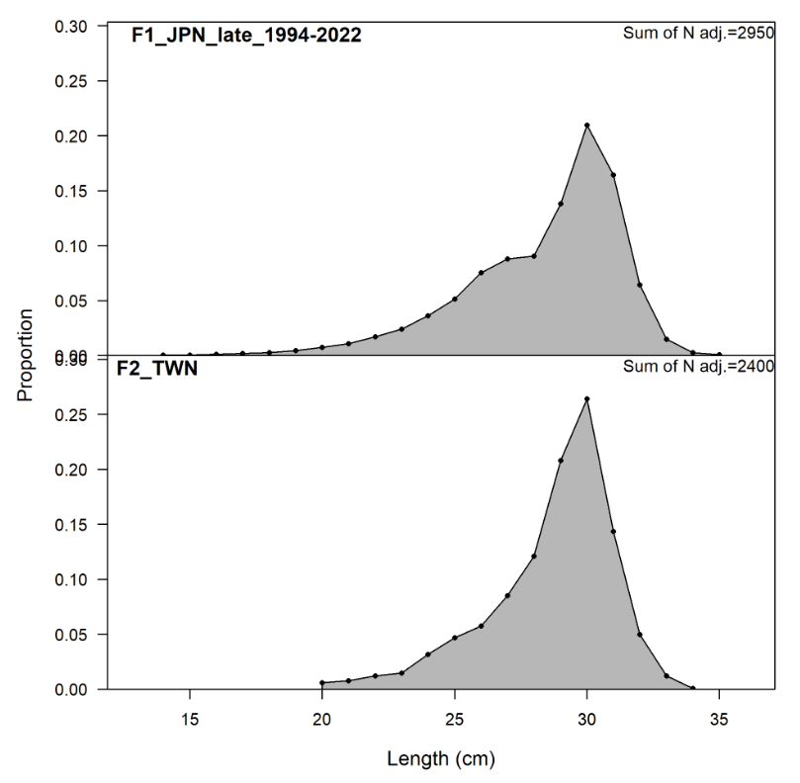
Figure 1. An example fishery length composition output from SS3.

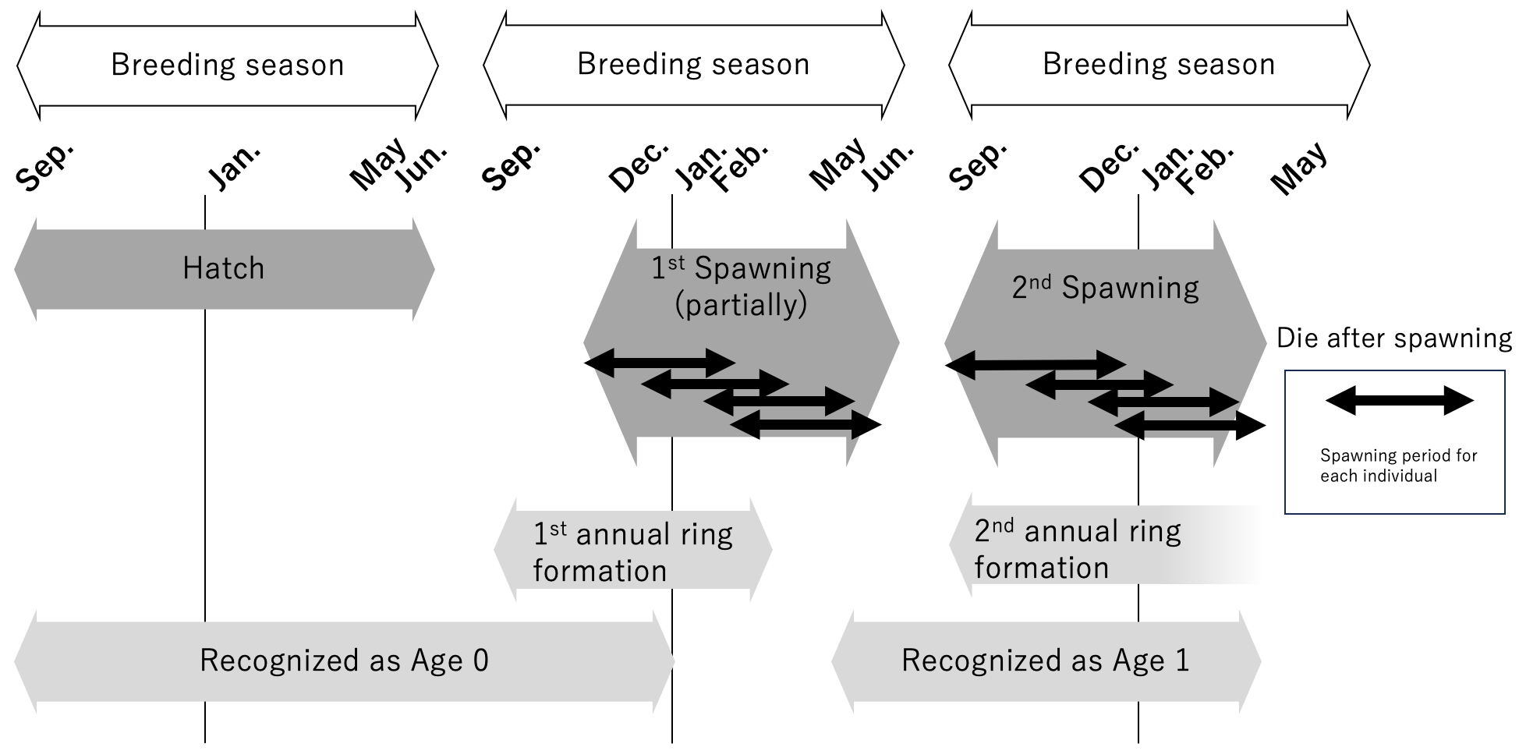
Figure 2. The life schedule and related events of PS. PS’s breeding season ranges from September to June (white arrows), with a peak in winter. However, breeding seasons of a single cohort is shorter than those of entire species (gray arrows). It should be also noted that the duration of spawning of a single fish might be further shorter. PS potentially have two spawning seasons, but only a part of population takes part in the 1st spawning. The proportion of the fish take part in the 1st spawning (i.e. maturation rate) ranges from 13.0 % to 63.1 %, to our knowledge (Suyama et al., 2019., Fuji et al. 2021b). Also, the batch fecundity per weight of the fish in the 1st spawning is lower than that of the fish in the 2nd spawning. The frequency and duration of a single fish’s spawning might be differ between the 1st and 2nd spawning. Since the age of a fish is determined by whether the fish has a complete annual ring or not, our recognition of a fish’s age does not always correspond to the actual age. The annual ring formation starts around September and finishes February at the earliest. The timing of annual ring formation in the latest case is unknown, but seems to finish in May at the latest. Because only very few fish with two complete annual rings are sampled, almost all fish seems to die before May in the 2nd spawning.

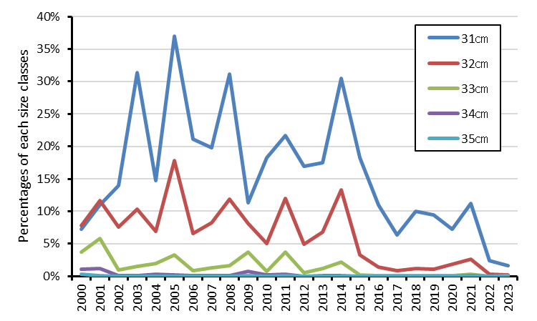
Figure 3. Annual fluctuations in the proportion of each length class (35cm<, 34cm<, 33cm<, 32cm<, 31cm<) in the body length compositions in the Japanese SHD fishery caught fish since 2000. Since 2014, the proportion of length classes over 33cm has been almost 0%.

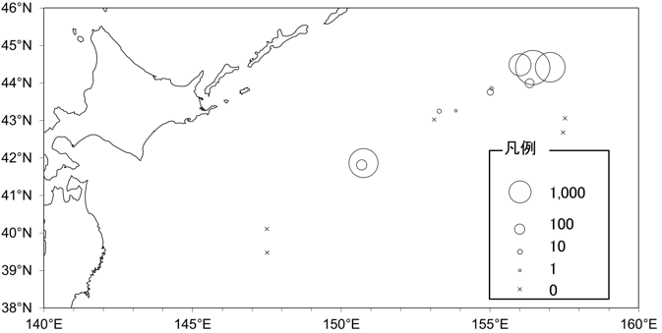
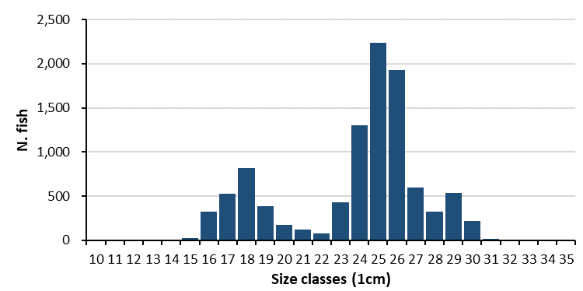
Figure 4. An example of the body length composition of Pacific saury collected by sea surface trawl nets during the peak of Japanese fishing season (October 2023). Body length of the largest fish was 31.6 cm, and no individuals over 32 cm were collected in this survey.

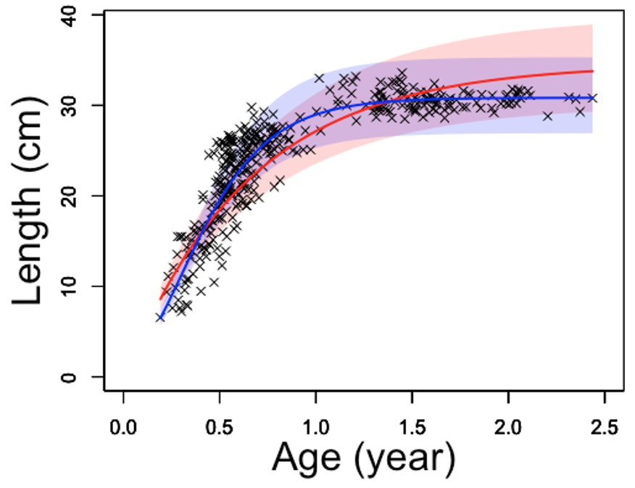
Figure. 5. von Bertalanffy (red) and Gompertz (blue) growth curve fitting to the length versus age data. Shadows around the curves are standard deviations.

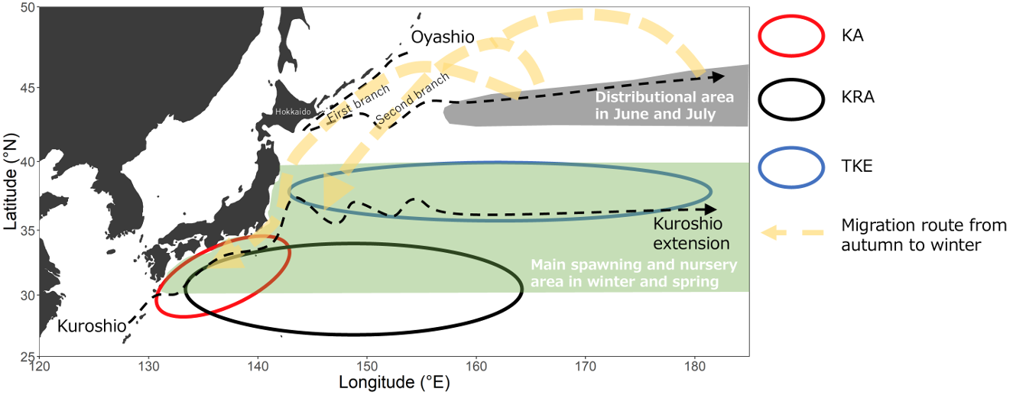

Figure 6. Major oceanographic structures and schematic representation of distribution and migration of Pacific saury in the Northwestern Pacific Ocean between early summer and winter. KA: Kuroshio Area, KRA: Kuroshio Recirculation Area, TKE: Kuroshio-Oyashio Transition and Kuroshio Extension.

