NPFC-2024-SSC PS14-WP02
Potential impact of climate change on habitat suitability of Pacific saury in the Northwestern Pacific Ocean
Kevin Pranata Ginting, Wen-Bin Huang, Hsiang-Chung Chien
Department of Natural Resources and Environmental Studies, National Dong Hwa University
ABSTRACT
This study assessed the potential impact of climate changes on the habitat of the Pacific saury in the Northwestern Pacific Ocean under various scenarios derived from the IPCC AR 6 report. Six environmental variables, namely sea surface temperature, sea surface salinity, sea surface height, dissolved oxygen, mixed layer depth, and net primary productivity, were used to estimate the habitat suitability index (HSI) using the yield density approach. Three periods were divided, namely historical (2001-2014), current (2015-2021), and future (2030, 2050, and 2100) to evaluate the climate change impacts on the Pacific saury. Latitudinally, the center of the saury suitable habitat area (SHA) was generally located around 43 – 44°N in the historical period with a slightly northward movement, shifted to 44.5 – 45.5°N in the current period, and moved to 45-46°N in most of future projections, except for SSP 1-1.9 (the lowest emission scenario). Longitudinally, the saury SHA center was distributed around 164.5- 166°E in the historical period with a slightly eastward movement, shifted to 166-168°E in the current period, then moved eastward for the scenario SSP 2-4.5, 3-7.5 and 5-8.5, and westward for the scenario SSP 1-1.9 and 1-2.6 in the future projections. The grid number of the saury SHA showed a gradually decreasing trend in the historical period and continuously decreased in the current period. In all future projections, the grid number also exhibit a decreasing trend to the lowest in 2100. In addition, the current saury SHA distribution is closely aligned with SSP 1-2.6 (low emission pathway).

Keyword: Pacific saury, climate change, habitat suitability, IPCC AR 6.
- Introduction
Climate change is exerting unprecedented pressure on marine ecosystems, often resulting in spatial shifts in species distribution due to changing environmental conditions (Sarre et al., 2024). Among those affected is the Pacific saury (Cololabis saira), an economically important species in the Northwestern Pacific Ocean (NPFC, 2022). Studies have shown that Pacific saury populations are more influenced by oceanic and climatic factors than by fishing pressures (Liu et al., 2022). Key environmental variables such as sea surface temperature (SST), mixed layer depth (MLD), sea surface height (SSH), sea surface salinity (SSS), dissolved oxygen (DO), and net primary production (NPP) play a significant role in determining the habitat suitability of Pacific saury (Tseng et al., 2011; Hua et al., 2020; Tian et al., 2002; Chang et al., 2018).
In recent years, climate-driven changes have introduced increased variability into these oceanographic variables, potentially altering the distribution and abundance of Pacific saury. For example, rising SST can drive habitat shifts toward cooler, higher-latitude waters (Liu et al., 2022; Hua et al., 2020). Furthermore, changes in DO levels and NPP due to ocean stratification and altered nutrient cycles impact food availability and habitat quality, affecting saury distribution and population dynamics (Liu et al., 2022; Tseng et al., 2011). These environmental changes not only influence habitat suitability but also challenge fisheries management, as shifting fishing grounds could lead to decreased productivity (Tseng et al., 2011; Hua et al., 2020).
To assess these impacts, this study utilizes historical and projected climate data from the CMIP6 dataset, focusing on six critical environmental variables. By applying models like the yield-density model and habitat suitability index (HSI), the study seeks to quantify the relationship between Pacific saury abundance and oceanographic conditions across historical, current, and future scenarios. This analysis is essential for understanding how climate change may reshape Pacific saury habitats, providing insights for sustainable fisheries management in a rapidly changing ocean (Chang et al., 2018; Hua et al., 2020).
- Materials and Methods
  - Data collections
The study focused on the Northwestern Pacific Ocean, specifically within the geographical range of 35°–50°N latitude and 140°–175°E longitude. Data on Pacific saury catch and fishing effort spanning 21 years (2001–2021) were obtained from Taiwan's saury fishery logbooks. Oceanographic data for both historical and projected climate conditions under five different IPCC scenarios were sourced from the Coupled Model Intercomparison Project Phase 6 (CMIP6) database (https://pcmdi.llnl.gov/CMIP6/). The key environmental variables that will be used to examine the Pacific saury habitat suitability includes: Sea Surface Temperature (SST, °C), Sea Surface Salinity (SSS, psu), Sea Surface Height (SSH, m), Mixed Layer Depth (MLD, m), Dissolved Oxygen (DO, mg L⁻¹), Net Primary Production (NPP, mg C m⁻² day⁻¹). All the data were processed into a 1° x 1° spatial resolution with monthly temporal resolution for uniformity in analysis.
  - Study framework
The analysis begins with six key oceanographic variables that influence Pacific saury habitat: SST, SSS, SSH, DO, MLD, and NPP. For each environmental variable, a Suitability Index (SI) is calculated to represent how well each variable supports Pacific saury habitat suitability. The individual SIs are then integrated into an overall Habitat Suitability Index (HSI) using arithmetic mean model (AMM), a composite score reflecting the habitat quality for Pacific saury based on all the environmental factors.
Three temporal segmentation was defined to observe the shift in Pacific saury HSI; first is historical Period (2001–2014) where this period serves as the baseline, using past data to establish a model for suitable habitat conditions based on historical oceanographic data. Second is the current Period (2015–2021) where in this period the HSI based was estimated on more recent data, allowing for the assessment of current habitat conditions and any recent shifts due to ongoing climate change. In the current period, two source of data was used; a non-scenario related data to represent the current state of environmental variables in the Northwestern Pacific Ocean, and a scenario related data from IPCC AR6 report to observe the distribution of the habitat suitability on a different climate change scenario.
Third is the future projections (2030, 2050, 2100) where in this segment the potential future changes in habitat suitability under different climate scenarios was assessed utilizing projections from the IPCC AR6 scenarios (Figure 1).
  - SI and HSI calculation
The value of SI for each environmental variable was calculated using the approach outlined by Hua et al. (2020). Class intervals for each variable were established to examine the distribution of Pacific saury catch (in metric tons), fishing effort (measured in day vessels), and catch per unit effort (CPUE) across different environmental conditions. Within each class interval, SI was calculated through effort-based normalization (Eq. 1), with the SI value set to 1 for the class interval with the highest fishing effort (Chen et al., 2009). The SI values were then fitted to corresponding environmental values to identify optimal conditions for each variable. To model the relationship between SI and each environmental factor, the yield-density model was applied (Eq. 2). The model parameters 𝑎, 𝑏, and 𝑐 were initially estimated using the Marquardt method (Marquardt, 1963), and refined using a quasi-Newton method for non-linear least squares optimization (Yabe and Takahashi, 1991). The Habitat Suitability Index (HSI) was calculated by combining SI values across all environmental variables using the AMM model (Eq. 3).
  - Analysis of potential habitat shifts and number of suitable habitat area
To analyze potential latitudinal and longitudinal shifts in the Pacific saury's suitable habitat, the mean latitude and longitude with HSI values greater than 0.5 were calculated for each year across the three study periods (historical, current, and projected). This approach enabled the assessment of shifts in habitat suitability over time. Additionally, the total area with HSI values above 0.5 was calculated annually within each period to examine yearly variation in the extent of suitable habitat. This analysis helps to visualize both spatial and temporal trends in the distribution of Pacific saury habitats under changing environmental conditions.
- Results
  - SI fitting
The Suitability Index (SI) was fitted to historical oceanographic variables from 2001 to 2014 (Figure 7). Parameters 𝑎, 𝑏, and 𝑐 for six oceanographic variables—sea surface temperature (SST), sea surface salinity (SSS), sea surface height (SSH), dissolved oxygen (DO), mixed layer depth (MLD), and net primary productivity (NPP)—were determined using the yield-density model. The model achieved high R² values across variables, with the highest for SSH (R² = 0.96) and the lowest for NPP (R² = 0.69), indicating a strong fit in most cases (Table 1). Optimum ranges for each variable were consistent with findings from previous studies; for example, the optimum SST for Pacific saury was estimated to be approximately 14.37°C, aligning with other research suggesting an optimal SST range from 11.41°C to 15.7°C for suitable habitats (Chang et al., 2018; Hua et al., 2020).
  - HSI Distribution
The spatial distribution of Habitat Suitability Index (HSI) values in the historical period revealed that high suitability areas were predominantly concentrated between 35°N and 45°N latitude and 150°E and 165°E longitude. Regions with HSI values exceeding 0.5 were mainly observed between 40°N and 45°N, suggesting stability in Pacific saury's suitable habitats over this period. This stable distribution aligns with historical findings, which highlight consistent habitat suitability within these geographic bounds during past decades (Figure 2).
In the current period, HSI estimated using non scenario related data showed a noticeable northward shift (Figure 4A). Areas with high HSI values (> 0.5) became more dispersed, indicating a possible reduction in habitat suitability compared to the historical period (Figure 3). Unlike the stable and concentrated suitable areas of the historical period, recent years have exhibited a more scattered distribution, with suitable habitats extending northward to latitudes above 45°N. In comparing to the different scenario of climate change on the same period, the HSI distribution tend to move northward following the increase in CO₂ emissions. SSP 1-1.9 showed the southernmost HSI distribution while SSP 5-8.5 exhibit a stronger northward shift (Figure 4B). Generally, an eastward shift following the increase in CO₂ emissions can be observed from the scenario data (Figure 5A). The SSP 2-4.5, SSP 3-7.0, and SSP 5-8.5 scenarios projected more pronounced eastward latitudinal shifts in suitable habitats than the one derived from the non-scenario related data, while the SSP 1-1.9 and SSP 1-2.6 exhibited westward trends (Figure 5B).
In the future projections, initial shifts in habitat suitability were observed in 2050 with scenarios SSP 2-4.5, SSP 3-7.0, and SSP 5-8.5 suggesting a more pronounced eastward spread, with high-suitability regions dispersing across a broader latitudinal and longitudinal range. These shifts contrast with the more moderate movements observed in lower-emission scenarios SSP 1-1.9 and SSP 1-2.6, where suitable habitats remain relatively close to their current ranges, showing some westward movement. In 2050, distinctions between scenarios become clearer. High-emission scenarios SSP 3-7.0 and SSP 5-8.5 project a considerable northward and eastward expansion, with peak suitability expected around or above 46°N. These scenarios also show increased latitudinal spread, indicating that habitat suitability may become more fragmented across the Northwestern Pacific Ocean. Lower-emission scenarios, SSP 1-1.9 and SSP 1-2.6, predict a more conservative northward shift while maintaining closer alignment with current ranges, suggesting less disruption to Pacific saury habitat distribution. In 2100, under SSP 3-7.0 and SSP 5-8.5, high-suitability regions shift significantly northward and eastward. These high-emission scenarios indicate substantial displacement of optimal habitats. Meanwhile, lower-emission scenarios SSP 1-1.9 and SSP 1-2.6 forecast relatively stable suitable regions, with moderate northward and minimal eastward shifts, keeping the habitat within a range more similar to historical conditions.
  - Number of suitable habitat area across the Northwestern Pacific Ocean
The Suitable Habitat Area (SHA) plot shows how the habitat for Pacific saury, defined as areas with HSI > 0.5, changes from historical periods to future projections under various SSP scenarios. During the historical period (2001-2014), SHA remained stable, indicating consistent conditions for saury. In the current period (2015-2021), SHA shows a slight decline, suggesting early effects of climate change, with warming temperatures pushing habitats northward.
Future projections indicate a stark contrast based on emission levels. Under lower-emission scenarios (SSP 1-1.9 and SSP 1-2.6), SHA decreases moderately, preserving more habitat within traditional ranges. Higher-emission scenarios (SSP 3-7.0 and SSP 5-8.5) show a steep decline in SHA by 2100, potentially displacing saury from traditional fishing grounds. These trends highlight the importance of emissions mitigation to sustain saury habitats and support fisheries.
References
Chang, Y. J., Lan, K. W., Walsh, W. A., & Hsu, J. (2018). Modelling the impacts of oceanographic variation on habitat suitability for Pacific saury in the Northwestern Pacific Ocean. Fisheries Oceanography, 27, 1–14. https://doi.org/10.1111/fog.12408
Chen, X. J., Li, G., Feng, B., & Tian, S. Q. (2009). Habitat suitability index of Chub mackerel (Scomber japonicus) from July to September in the East China Sea. Journal of Oceanography,65,93–102. http://qdhys.ijournal.cn/hyyhz/ch/reader/create_pdf.aspx?file_no=200906006&year_id=2009&quarter_id=6&falg=1.
Hua, C., Li, F., Zhu, Q., Zhu, G., & Meng, L. (2020). Habitat suitability of Pacific saury (Cololabis saira) based on a yield-density model and weighted analysis. Fisheries Research, 221, 105408. https://doi.org/10.1016/j.fishres.2019.105408
Liu, S., Liu, Y., Li, J., et al. (2022). Effects of oceanographic environment on the distribution and migration of Pacific saury (Cololabis saira) during the main fishing season. Scientific Reports, 12, 13585. https://doi.org/10.1038/s41598-022-17786-9
Marquardt, M. D. (1963). An algorithm for least-squares estimation of nonlinear parameters. Journal of the Society for Industrial and Applied Mathematics, 11, 431–441. https://doi.org/10.1137/0111030
Sarre, A., Demarcq, H., Keenlyside, N., et al. (2024). Climate change impacts on small pelagic fish distribution in Northwest Africa: Trends, shifts, and risk for food security. Scientific Reports, 14, 12684. https://doi.org/10.1038/s41598-024-61734-8
North Pacific Fisheries Commission. (2022). 10th Small Scientific Committee on Pacific Saury Meeting Report (NPFC-2022-SSC PS10-Final Report 62). https://www.npfc.int/sites/default/files/2023-02/SSC%20PS10%20report.pdf
Tian, Y. J., Ueno, Y., Suda, M., & Akamine, T. (2002). Climate-ocean variability and the response of Pacific saury (Cololabis saira) in the northwestern Pacific during the last half century. Fisheries Science, 68, 158–161. https://doi.org/10.2331/fishsci.68.sup1_158
Tseng, C. T., Sun, C. L., Yeh, S. Z., Chen, S. C., Su, W. C., & Liu, D. C. (2011). Influence of climate-driven sea surface temperature increase on potential habitats of the Pacific saury (Cololabis saira). ICES Journal of Marine Science, 68, 1105–1113. https://doi.org/10.1093/icesjms/fsr070
Yabe, H., & Takahashi, T. (1991). Factorized quasi-Newton methods for nonlinear least squares problems. Mathematical Programming, 51, 75–100. https://doi.org/10.1007/BF01586927

TABLE
Table 1. Fitted suitability index parameters based on the yield-density model from the historical period
Variable | Model parameter |  |  | R² | Optimum | 95% Conf Int
Variable | a | b | c | R² | Optimum | Lower | Upper
SST | 34.42 | -4.64 | 0.16 | 0.95 | 14.37±0.45 | 14.11 | 14.62
SSS | 8593 | -521.71 | 7.92 | 0.83 | 32.70±2.07 | 31.58 | 33.02
SSH | 4.19 | 47.95 | 178.96 | 0.96 | -0.13±0.006 | -0.14 | -0.12
NPP | 5.85 | -0.01 | 0.000015 | 0.69 | 547.64±44.46 | 487.04 | 619.05
DO | 349.4 | -83.62 | 5.02 | 0.95 | 8.32±0.06 | 8.24 | 8.4
MLD | 5.98 | -0.74 | 0.033 | 0.72 | 11.76±7.10 | 2.45 | 16.45

FIGURES
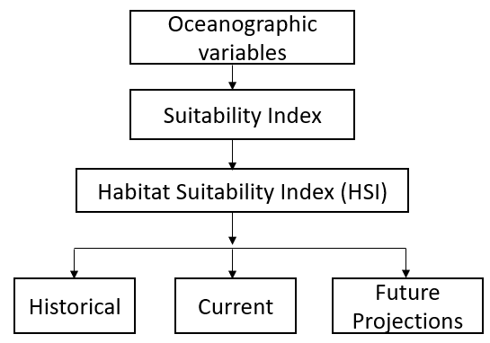
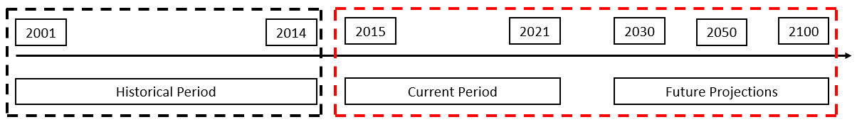
Figure 1. Theoretical framework for assessing the potential impact of climate change on Pacific saury habitat suitability. Dashed black line indicate the historical period which was used to build the HSI model. Dashed red line indicate the current period and historical period which was used as an input to predict Pacific saury HSI.

Figure 2. Annual Habitat Suitability Index (HSI AMM) of Pacific saury in the Northwest Pacific from 2001 to 2014. The spatial distribution of suitable habitats is represented by color intensity, where red indicates areas of high habitat suitability, and blue represents areas of low suitability.
Figure 3. Annual Habitat Suitability Index (HSI AMM) of Pacific saury in the Northwest Pacific from 2015 to 2021. The HSI was estimated using the historical model with non-scenario related oceanographic condition.

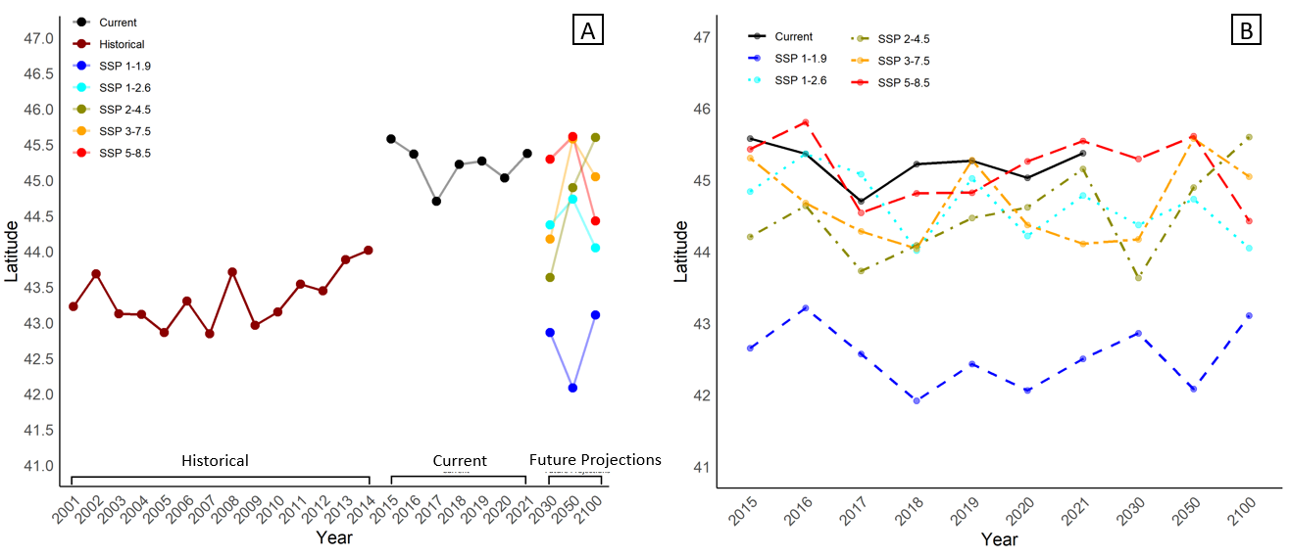
Figure 4. Annual latitudinal shift SHA of Pacific saury. (A). Annual latitudinal shift in SHA on the three period. (B). Comparison of the latitudinal shift in current period and future period between non-scenario and scenario related oceanographic condition.
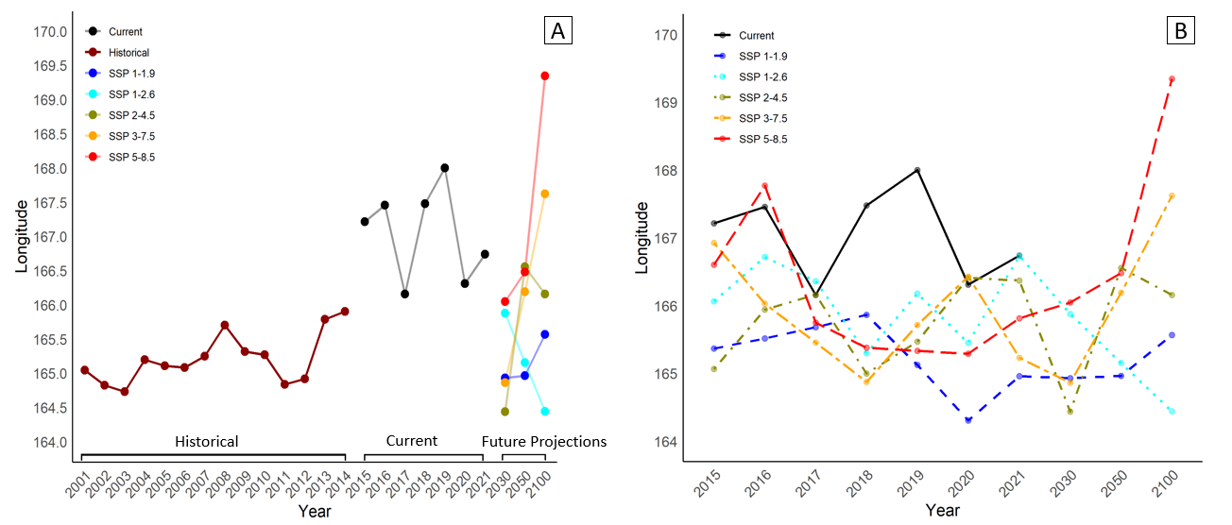
Figure 5. Annual longitudinal shift in suitable habitat area (SHA) of Pacific saury. (A). Annual longitudinal shift in SHA on the three period. (B). Comparison of the longitudinal shift in current period and future period between non-scenario and scenario related oceanographic condition.

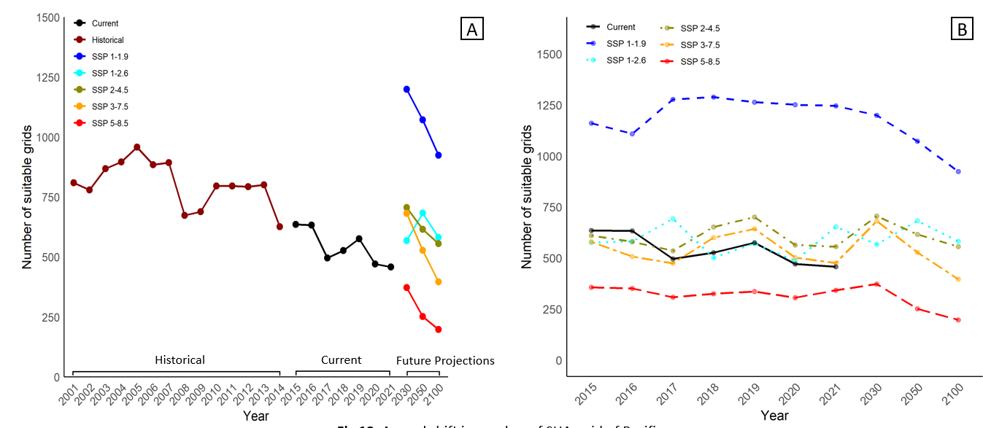
Figure 6. Annual shift in number of suitable habitat area of Pacific saury. (A). Annual shift in number of suitable habitat area grid on the three period. (B). Comparison of the number of suitable habitat area grid in current period and future period between non-scenario and scenario related oceanographic condition.

Equation
Eq 1. Effort based normalization to calculate suitability index for each environmental variable
$${SI}_{i(k)}=\frac{{Effort}_{i(k)}}{{Effort}_{max}}$$

Eq 2. Yield density model to fit each of the suitability index with the respective environmental variables
$$y=\frac{1}{(a+bx+cx^{2})}$$

Eq 3. Arithmetic mean model habitat suitability index
$$HSI=\frac{\text{(}\text{SI_SST + SI_SSS + SI_SSH + SI_DO + SI_MLD +SI_}\text{NPP)}}{6}$$

