NPFC-2024-SSC BFME05-WP16

Reduced fishing effort directed to North Pacific armorhead by Japanese vessels operating in the Emperor Seamount area

by
Kota Sawada

Oceanic Resources Group, Fisheries Resources Institute,
Japan Fisheries Research and Education Agency, Japan

December 2024

This paper may be cited in the following manner:
Sawada, K. 2024. Reduced fishing effort directed to North Pacific armorhead by Japanese vessels operating in the Emperor Seamount area. NPFC-2024-SSC BFME05-WP16. 11 pp. Available at https://www.npfc.int/

Reduced fishing effort directed to North Pacific armorhead by Japanese vessels operating in the Emperor Seamount area

Kota Sawada
Oceanic Resources Group, Fisheries Resources Institute,
Japan Fisheries Research and Education Agency, Japan

Abstract
The recent low level of catch of North Pacific armorhead raised concern about the status of the stock. However, Japan informed that Japanese vessels have voluntarily avoided targeting NPA since 2019, suggesting that the catch level may not directly reflect stock level. In addition, this information led to the hypothesis that the setting of encouraged catch reduced directed fishing effort and fishing pressure on NPA, even though recent annual catch is smaller than the encouraged level. In this study, I tested the hypothesis by two approaches, i.e. the records of intended target by observers and the cumulative catch plots to specify target species in “directed CPUE” method. The results bore out the avoidance of targeting NPA and suggest that the implementation of encouraged catch might be effective in reducing directed fishing pressure on NPA by discouraging fishers against targeting the fish.

Introduction
Based on the concern on the stock status of North Pacific armorhead (hereafter NPA), NPFC implemented management measures including encouraged catch for this stock. If the monitoring survey by fishing vessels finds evidence of strong recruitment, some areas in the Emperor Seamounts are closed and a 12,000 ton (10,000 for Japan and 2,000 for Korea) catch limit is encouraged. In low recruitment years, a 700 ton (500 for Japan and 200 for Korea) catch limit is encouraged. This measure came into force in 2019 and will be revised from encouraged to binding limit since 2025 (NPFC Commission 2024). To date, no evidence of strong recruitment has been detected by the monitoring surveys, and thus the lower limit was applied for all years since 2019.
Since the implementation of this measure, Korean vessel (a trawler) caught NPA only in 2019 and the catch was about 20 tons. Japanese vessels (trawlers and a gillnetter) are continuously fishing NPA. However, the annual catch has been smaller than the encouraged level allocated to Japan (500 tons). The continued low level of catch raised a further concern about the status of the stock (Small Scientific Committee on Bottom Fish and Marine Ecosystems 2022).
However, Japan informed that Japanese vessels have voluntarily avoided targeting NPA since 2019 (Small Scientific Committee on Bottom Fish and Marine Ecosystems 2023), based on the information provided by its fishing industries. Therefore, the catch level may not directly reflect stock level. In addition, this information led to the hypothesis that the setting of encouraged catch reduced directed fishing effort and fishing pressure on NPA, even though recent annual catch is smaller than the encouraged level (Sawada 2023).
In this document, I tested this hypothesis, by the quantification of fishing effort targeting NPA. Directed effort is estimated by two approaches. The first approach relies on the record of intended target species for each operation by scientific observers, based on the information from fishermen, especially fishing masters. This approach reflects the intention of the fishers directly.
The second approach estimates target species from catch species composition, using the “directed CPUE” method (Biseau 1998). While this method was developed to calculate CPUE in multispecies fisheries, Sawada et al. (2017) demonstrated that the intermediate product of this method, i.e. plots of cumulative catch, reflects target shift associated with recruitment fluctuations of NPA, suggesting the utility of them for the monitoring of fishing activities, not only for correcting CPUE. In this study, I focused on this aspect only and did not calculate CPUE. This approach complements the intention-based approach by evaluating the change of catch patterns resulted from the change of intended targets.

Materials and Methods
Data
I used Japanese scientific observer data from 2010 to 2023. Data for 2009 was not used since it starts in the middle of the fishing season. For each fishing operation (tow or set for trawl and gillnet, respectively), observers record the intended target species. Observers also record the amount of retained catch (green weight) by species, and the amount of effort (towing time and number of panels for trawl and gillnet, respectively) for each operation. However, catch was recorded on a daily basis, not set-by-set, for gillnet until 2017.
All calculations and statistical analyses were conducted by R ver. 4.4.1 (R Core Team 2024). Plots were drawn using the R package “ggplot2” (Wickham 2016).

Record of intended target
The amount of fishing efforts targeting NPA based on the observer records of intended target species was calculated by counting the number of operations recorded as targeting NPA or other species, and by summing up the fishing efforts (towing time or number of panels) of those operations, for each year and fishery (trawl and gillnet).
Peason’s $χ^{2}$ test (with Yates' continuity correction) was performed to test the difference of the proportion of operations targeting NPA or others before and after the implementation of encouraged catch. Annual trends of the number of targeted operations and of the targeted fishing efforts were visually inspected.

Cumulative catch plot
A detailed explanation of this method was given by Sawada et al. (2017). Here I provide a minimalistic explanation focusing on the plots presented in this document.
In the process of calculating directed CPUE (Biseau 1998), plots of cumulative catch is produced for each landed species, to specify candidates of target species. For each fishing operation, the contribution of each species to the total weight of the catch (hereafter “species proportion”) is calculated. Then draw a plot with the proportion of the species (x %) as the horizontal axis, and the total cumulative catch of the species derived from the operations whose proportion of the species is less than x % (hereafter “cumulative catch”) as the vertical axis (Fig. 1). Cumulative catch is divided by the total catch of the species to adjust the maximum value as 1.
In cumulative catch plots, target species will show “exponential” or “sigmoid” curve, because those species are mostly caught in the operation with high species proportion. For example, if armorhead is a target species, most catch of armorhead should be derived from the operations in which most of the catch is occupied by armorhead. In contrast, bycatch species should be represented by “saturating” curve, because those species are mostly caught from operations with low proportion of species in catch. The shape of the curve is strongly affected by the target shift associated with recruitment fluctuation of NPA for trawling in the Emperor Seamounts area (Sawada et al. 2017).
In this study, I produced cumulative catch plots of NPA for both trawl and gillnet, separated by years, to visually compare the shapes before and after the implementation of encouraged catch (2019).

Results
Intention-based approach
Table 1 shows the numbers of operations intended to target NPA and others before and after the implementation of encouraged catch. While trawl fisheries targeted NPA in 5317 of 10075 operations (53 %) in 2010-2018, they targeted NPA only in 18 of 3258 operations (0. 55%) in 2019-2023. Gillnet fisheries targeted NPA in 1166 of 5493 operations (21 %) and only 3 of 2427 operations (0.12 %), in 2010-2018 and in 2019-2023, respectively. The proportion of operations targeting NPA significantly differed between 2010-2018 and 2019-2023 for trawl ($χ^{2}=2330.8, df=1, p<0.001$) and for gillnet ($χ^{2}=4198.4, df=1, p<0.001$). As a result of the reduction of NPA-targeted operations, the proportion of efforts targeting NPA also reduced (Table 2).
Figs. 2A show the annual trends of the number of operations targeting NPA. In trawl fisheries, fishing operations targeting NPA has reduced since 2019 and became zero since 2020. In gillnet fisheries, reduction of operations targeting NPA initially occurred in 2014, corresponding to the reduction of NPA catch. Although some fishing operations targeting NPA were recorded between 2016 and 2018, no fishing operations targeted NPA since 2019, except for a small number of operations in 2020. The fishing efforts showed similar patterns (Fig. 2B) with the number of operations.

Catch-based approach
Fig.3 shows cumulative catch plots for NPA for each year. Left and right panels represent gillnet and trawl, respectively. Top and bottom panels represent years until 2018 and since 2019, respectively.
In trawl fisheries, cumulative catch plots for NPA varies from typical target species patterns (exponential) in the years of strong recruitments (2010 and 2012) to those more similar to bycatch species (saturating) in other years, especially in 2016 (Sawada et al. 2017). Since 2019, target species patterns have never been observed, and bycatch-like patterns were observed for most years except for 2019, when an intermediate pattern is observed.
In gillnet fisheries, cumulative catch plots for NPA showed target species patterns in all years (exponential or sigmoid). Patterns from 2019 are unclear, showing intermediate to bycatch-like patterns in three years, target patterns in other two years (2020 and 2023). The annual catch of NPA by gillnet was larger in those years than in other recent years (see NPFC Annual Footprint).

Discussion
This study supports the hypothesis that fishing effort directed to NPA has reduced in the recent years, especially since the implementation of encouraged catch in 2019, even though the actual catch was much smaller than the encouraged level throughout the period. Although it is difficult to determine a causal relationship between management measures and fishing practices from this analysis, it provides a subjective support to the hypothesis emerged from the fishermen’s information.
According to the records of intended target species, only a negligible proportion (less than 1 % in both fisheries) of fishing operations is directed to NPA since 2019, while more than half (trawl) or one-fifth (gillnet) of operations targeted NPA until 2018. This does not necessarily imply that the change has occurred in 2019. For example, the reduction of gillnet operations targeted NPA seems to have started from 2014 (Fig. 2). However, such operations were recorded during 2016-2018, while the number is still limited. Since 2019, operations targeting NPA are almost absent. Thus, our result supports, or at least does not contradict with, the reduction of NPA-targeted fishing efforts since 2019.
Cumulative catch plots also demonstrate that NPA is primarily caught as bycatch, rather than target, especially for trawl fisheries. Again, it is not easy to specify the exact timing and cause of the change, as a typical bycatch pattern was also observed in one year (2016) before the implementation of encouraged catch. However, the bycatch pattern is consistently observed since 2020, suggesting the possible impact of encouraged catch. An intermediate pattern observed in 2019 may be because fishermen were not full adapted to the new fishing practice.
Cumulative catch plots for gillnet fisheries indicated that NPA was mostly caught as target until 2018, while it is less clear since 2019, again suggesting the change of fishing practice. However, typical bycatch patterns were not observed even after 2019 for gillnet, and target-like patterns were still observed in 2020 and 2023. As gillnets are passive gears, avoiding a certain species may be more difficult than in active gears such as trawl nets.

Conclusion
The results of this study bore out the fishermen’s information that they avoid targeting NPA since the implementation of encouraged catch in 2019, although the timing and cause of the change of fishing practice were not specified. The change in targeting likely affects the catchability of each stock. Therefore, using catch level or nominal CPUE as an indicator of stock abundance may lead to a biased conclusion.
The result suggests that the implementation of encouraged catch might be effective in reducing directed fishing pressure on NPA by discouraging fishers against targeting the fish, even though the actual catch was much less than the encouraged level. However, to quantify the reduction of fishing pressure and increase of fish survival, different approaches, such as depletion analysis (Kiyota et al. 2014), are needed.
Finally, this study illustrates how information from fishing industries helps scientists form scientific hypotheses about fishing practice, emphasizing the importance of collaborations between scientists and industries in fisheries science.

Acknowledgements
This work is conducted as part of the research and assessment program for fisheries resources, the Fisheries Agency of Japan, and submitted under the approval of the Agency.

References
Biseau A (1998) Definition of a directed fishing effort in a mixed-species trawl fishery, and its impact on stock assessments. Aquat Living Resour 11(3):119–136.
Kiyota M, Okuda T, Yonezaki S (2014) Depletion model analysis on recent recruitment and exploitation levels of North Pacific armorhead in the Southern Emperor–Northern Hawaiian Ridge seamounts. Document SWG12/WP3/J NPFC
NPFC Commission (2024) Meeting Report. NPFC-2024-COM08-Final Report. 734 pp.
R Core Team (2024) R: A Language and Environment for Statistical Computing
Sawada (2023) Small Working Group on NPA and SA - Summary for 2023. NPFC-2023-SSC BFME04-WP09. 4 pp.
Sawada K, Nishida K, Yonezaki S, Kiyota M (2017) Application of the directed CPUE method to the multispecies bottom fisheries in the Emperor Seamounts region, for the monitoring of stock status and fishing activity. NPFC-2017-SSC NPA02-WP02 (Rev 1). 14 pp.
Small Scientific Committee on Bottom Fish and Marine Ecosystems (2022) 3rd Meeting Report. NPFC-2022-SSC BF-ME03-Final Report. 122 pp.
Small Scientific Committee on Bottom Fish and Marine Ecosystems (2023) 4th Meeting Report. NPFC-2023-SSC BF-ME04-Final Report. 135 pp.
Wickham H (2016) ggplot2: Elegant Graphics for Data Analysis, 2nd ed. Springer International Publishing, Cham.

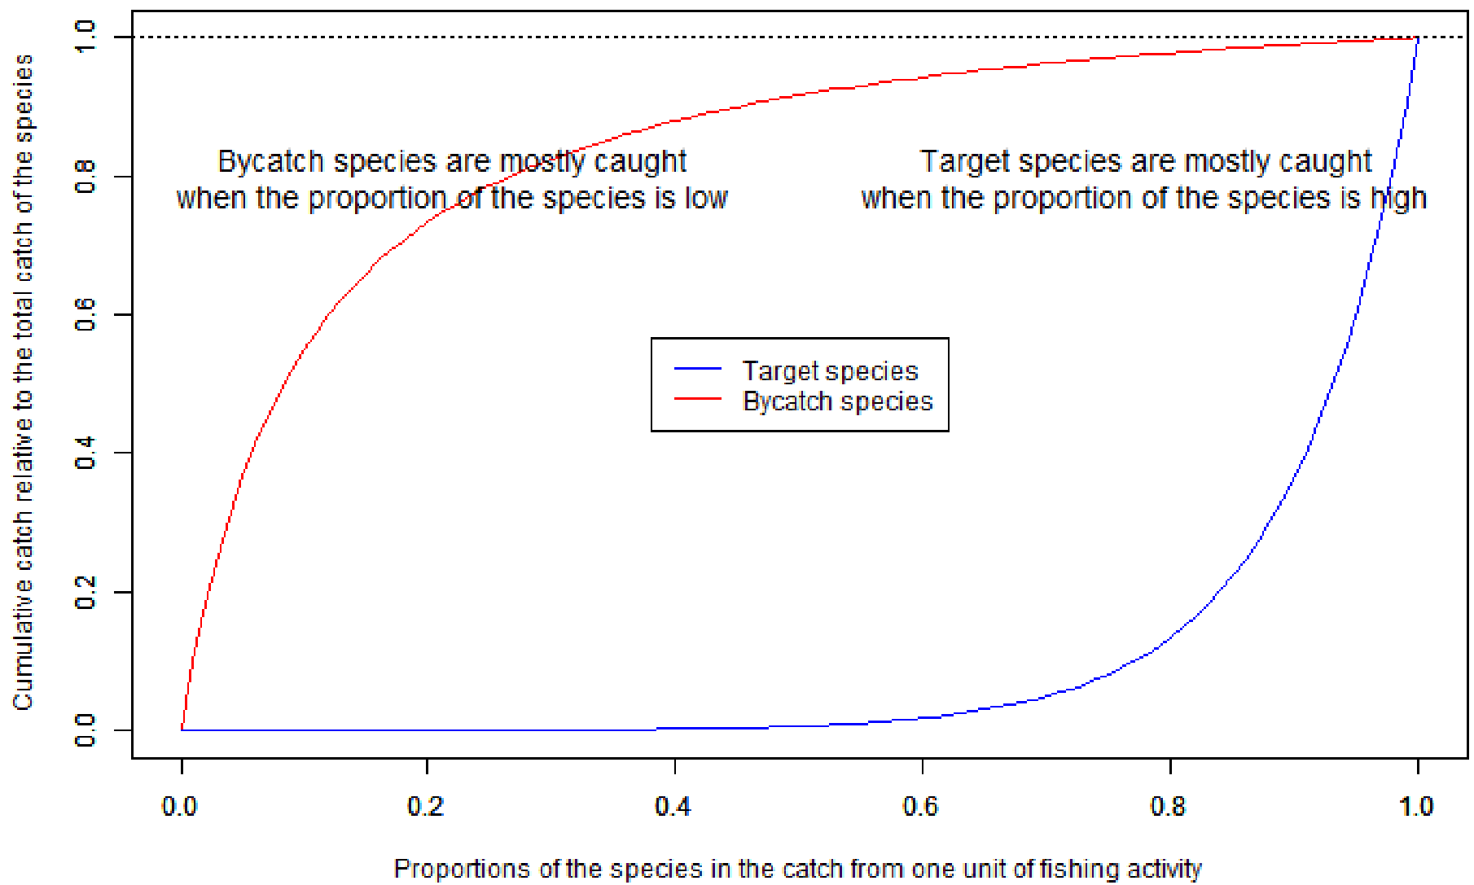

Fig. 1: A schematic drawing of the “cumulative catch plot” (reproduced from Sawada et al. 2017). Imaginary example to illustrate species with clear patterns, not based on the actual data. Most of the catch of a bycatch species (red) is derived from the operations with low proportion of the species. In contrast, most of the catch of the target species (blue) is derived from the operations with high proportion of the species.
Fig. 2A. The annual trends of the number of operations targeting NPA or others for gillnet and trawl.

Fig. 2B. The annual trends of the total fishing efforts targeting NPA or others for gillnet and trawl. Effort is represented by number of retrieved panels in gillnets and towing time (minutes) in trawl.

Fig. 3. Cumulative catch plots for NPA, separated by gears and periods (2010-2018 or 2019-2023).

Table 1. Number of operations recorded as intended to target NPA or others, in 2010-2018 and 2019-2023.
Gear | Trawl |  | Gillnet
Target | NPA | Others | NPA | Others
2010-2018 | 5317 | 4758 | 1166 | 4327
2019-2023 | 18 | 3240 | 3 | 2424

Table 2. Total amount of fishing efforts for operations recorded as intended to target NPA or others, in 2010-2018 and 2019-2023. Effort is represented by towing time (minutes) in trawl and number of retrieved panels in gillnets.
Gear | Trawl |  | Gillnet
Target | NPA | Others | NPA | Others
2010-2018 | 701419 | 475425 | 65240 | 242249
2019-2023 | 3131 | 346210 | 168 | 135724

