NPFC-2024-TWG CMSA09-WP05
Biological reference points and future projections with the results of stock assessment for the Pacific chub mackerel
Momoko Ichinokawa*1, Shota Nishijima*1, Kazuhiro Oshima*1, and Joel Rice*2
*1. Fisheries Resources Institute,
Japan Fisheries Research and Education Agency (FRA)
*2. NPFC consultant
(Corresponding author: Momoko Ichinokawa, ichinokawa_momoko09@fra.go.jp)

Summary
The stock assessment of chub mackerel in the Northwest Pacific was conducted by the Technical Working Group on Chub Mackerel Stock Assessment (TWG CMSA). This document introduces methods for calculating biological reference points and stochastic future projections and shows the results based on the parameters estimated in the stock assessment to provide scientific information that could be used to draft management advice on this stock. We also evaluated the historical spawning potential of this stock by calculating unexploited spawning biomass (SSB) per recruit (SPR0) based on annually changing biological parameters of weight and maturity. The calculated SPR0 shows that the spawning potential of this stock has been drastically changed and significantly decreased to half of the historical average during the most recent 7 years. The varying and decreasing SPR0 results in varying and decreasing estimates of unexploited spawning biomass (SSB0) and SSB achieving maximum sustainable yield (SSB_{MSY}). In addition, because the stock-recruitment relationship estimated in the stock assessment model indicates very weak density dependence in the ranges historically observed with low steepness, the estimated SSB0 and SSB_{MSY} were extreme extrapolations, which may have resulted in these estimates being somewhat uncertain and unrealistic. In light of these findings, stock status and management recommendations are summarized focusing on the points that 1) current SSB is below and fishing mortality rates are above the MSY reference points although the extent is uncertain, 2) future stochastic simulations assuming constant-catch shows future catch amount around 100,000 metric tons per year maintain the stock above the current spawning biomass (2022) with high probability (~90%), 3) development of harvest control rule and target and limit reference points are urgently needed for the long-term sustainable management of this stock.

Introduction
Chub mackerel in the Northwest Pacific Ocean has historically been fished by China, Japan, and Russia, and is an important fishery resource for these Members. Before 2010, this species was mainly caught within Japan's EEZ, but since the early 2010s, catches within the NPFC Convention Area have increased. The priority for stock assessment and management in the NPFC places it as the second most important fish species after Pacific saury. The TWG CMSA has carried out the task of assessing this stock. The stock assessment model to be used was decided in TWG CMSA07, stock assessment data up to the most recent year were prepared in TWG CMSA08, and the first stock assessment was carried out in TWG CMSA09. The stock assessment was conducted using an age-structured state-space stock assessment model called State-space Assessment Model (SAM, Nielsen and Berg 2014).
This document provides useful information for future management of this stock by presenting the methods and results of biological reference points and future projections using the population dynamics parameters of this stock estimated by SAM (NPFC-2024-TWG CMSA09-WP03, NPFC-2024-TWG CMSA09-WP04). The management reference points of F%SPR, F0.1, Fmsy, and SSB_{MSY} were calculated. We also focused on historical changes in SPR0, SSB0, and SSB_{MSY} with annually varying biological parameters of weight and maturity rate at age. In the future projections, simulations based on forward calculations of population dynamics with stochastic recruitment uncertainty were conducted under the assumption of constant catches. The sensitivity of these results to the setting of biological parameters and assessment models was also examined.

Methods

Stock assessment results and biological parameters
This document used parameter estimates in NPFC-2024-TWG CMSA09-WP03 and NPFC-2024-TWG CMSA09-WP04 from the models of B1-Mcom (B1), B2-Mage (B2), S7-JP23cpue (S7), and S8-JP23cpue (S8) (Table 1). The former 2 models are agreed to be used as base cases, while the settings of the latter 2 models are found to be the most influential to the evaluation of current stock status. Biological parameters used for future projections and calculation of biological reference points are assumed as the average values during the most recent 3 years (2020-2022) (bio2020). In addition, the biological parameters averaged during 2010-2019 (bio2010) are used as a sensitivity analysis. Note the sensitivity analysis using bio2010 was only conducted to check the effect of the assumption of biological parameters on the results and that the assumption is not necessarily plausible. As for the assumption of current fishing mortality (Fcur), we used 3 years average during 2020-2022 (Fig. 1).

Biological reference points and evaluation of spawning potential
We calculated commonly used biological reference points such as F%SPR (20%, 30%, 40%, and 50%), F0.1, Fmsy, and SSB_{MSY} with the biological parameters described above (bio2020 and bio2010) and selectivity of Fcur. As for the F-based reference points, relative values to Fcur are shown in the results (e.g. Fmsy/Fcur). The equations to derive these reference points are described in Annex D in the past report for developing an operating model for this stock (https://www.npfc.int/summary-2nd-meeting-small-working-group-operating-model-chub-mackerel-stock-assessment) and definitions of these performance measures are same as the working paper for the sensitivity analysis (NPFC-2024-TWG CMSA09-WP04).
We also calculated annual spawner per recruit (SPR) with historically changing weight and maturity rate at age of this stock (Fig. 2) to evaluate the historically changing spawning potential of this species. SPR is the cumulative weight of equilibrium spawing biomass (g) along its life history (growth, maturity, and natural mortality) of a recruit of fish under a certain fishing mortality coefficient of F. Usually, SPR(F) is defined as
$${\text{SPR(F)}}_{}=\sum_{a=0}^{∞}{\exp\left(-M_{a}-F_{a}\right)g_{a}w_{a}}$$where $M_{a}$, $g_{a}$ and $w_{a}$ is natural mortality rate, maturity rate, and weight at age $a$. With this equation, we defined annually changing SPR without fishing as SPR0_{y} where $F_{a}=0, g_{a}=g_{a,y}, \text{and }{w_{a}=w}_{a,y}$ ($y=1970, 1971, …, 2022$). Similarly, we also calculated MSY reference points under the selectivity of Fcur and SSB0_{y} with biological parameters averaged during each decade (y=1970-1979, 1980-1989, etc.…) to evaluate the effect of the changes in biological parameters on MSY reference points.

Equations for calculating and population dynamics in future projection
The population dynamics model for future projections is the same as that used in SAM. The calculation was conducted by an R package named frasyr (https://github.com/ichimomo/frasyr), which has been developed for the stock assessment of Japanese domestic fisheries resources. In particular, we used the functions for future projection and the calculation of biological reference points in frasyr. The general equations of the forward calculation of the population dynamics are
$$N_{y,a}^{i}=\left\{\begin{aligned}\frac{\hat{α}S_{y}^{i}}{1+\hat{β}S_{y}^{i}}\exp\left(ε_{y}^{i}\right) (a=0) \\ N_{y-1, a-1}^{i}\exp\left(-M_{a-1}-F_{y-1, a-1}^{i}\right) (0<a<6) \\ N_{y-1, a-1}^{i}\exp\left(-M_{a-1}-F_{y-1, a-1}^{i}\right)+N_{y, a}^{i}\exp\left(-M_{a}-F_{y, a}^{i}\right) (a=6+)\end{aligned}\right.$$
where $\hat{α}$ and $\hat{β}$ are stock recruitment parameters estimated by SAM, $N_{y,a}^{i}$ is the number of fish in year $y$ and age $a$ at $i$th iteration, $F_{y,a}^{i}$ is fishing mortality coefficient in year $y$ and age $a$ at $i$th iteration, $ε_{y}^{i}\sim \text{N}\left(0,{\hat{σ}}^{2}\right)$ where ${\hat{σ}}^{2}$ is the variance of process error at recruitment estimated by SAM, and $S_{y}^{i}$ is SSB defined as $\sum_{a=0}^{6}{N_{y,a}^{i}w_{a}g_{a}}$. The equations are generally applied from the end year of the stock assessment period with the initial conditions of $N_{2022,a}^{i}={\hat{N}}_{2022,a}^{}$ in B1 and B2 and $N_{2023,a}^{i}={\hat{N}}_{2023,a}^{}$ in S7 and S8, where ${\hat{N}}_{y,a}^{}$ is the point estimates by SAM. The fishing mortality in the initial and future years is assumed as $F_{2022,a}^{i}={\hat{F}}_{2022,a}^{}$ (${\hat{F}}_{y,a}^{}$ is point estimates by SAM), $F_{2023,a}^{i}= \text{Fcur}$, and $F_{y,a} (y>2023)$ is determined by future harvesting scenarios. The future biological parameters of $w_{a}$ and $m_{a}$ are given according to the scenarios described above (bio2020 or bio2010) for $y≥2023$.
The future harvesting scenario was predetermined as a total catch (CC) ranging from 50 to 400 thousand tons (Table 1). When catch number at age $C_{y,a}^{i}$ in year y and age a is calculated with the Baranov catch equation as $C_{y, a}^{i}=\frac{F_{y, a}^{i}}{F_{y, a}^{i}+M_{a}}\left(1-\exp\left(-F_{y,a}^{i}-M_{a}\right)\right)N_{y,a}^{i}, F_{y,a}^{i}$ is equal to be $x_{y}^{i}Fcur$ with the same selectivity as Fcur and adjustment factor of $x_{y}^{i}$ that is determined to satisfy the equation of $\sum_{a=0}^{6+}{w_{a}C_{y,a}^{i}}=CC$. If we cannot find $x_{y}^{i}$ to satisfy the equation because of too small number of fishes, we took the smaller of the two numbers, $x_{i}=exp⁡(10)$ or fishing mortality corresponding to 99% of total catches when $x_{i}=exp⁡(100)$. The stochastic simulations were conducted 5,000 times for each model and scenario.

Results

Evaluation of the historical spawning potential of SPR0
SPR0_{y} changed annually according to the biological parameters of $w_{a,y}$ and $g_{a,y}$that changed each year (Fig. 3). In particular, SPR0_{y} decreased significantly starting in 2015 and achieved the minimum in 2019, and keep low values during 2020-2023. The average SPR0_{y} for the 2020s (2020-2022) was 205 g in Models B1, S7 and 165 g in Models B2, S8, which is about half of the SPR0_{y} averaged for other decades.

Stock recruitment relationship and biological reference points
In the stock-recruitment relationship estimated by the 4 models, there was almost no density dependence effect within the range of spawning stock biomass and recruitment numbers observed in past, so the SSB0 and SSB_{MSY} calculated based on this stock-recruitment relationship are extrapolated values that greatly exceed the past recruitment and spawning stock biomass (Fig. 4). Furthermore, since the productivity of this stock, represented by SPR0_{y}, has changed significantly over the years as seen in Fig. 3, the estimated values of SSB0 and SSB_{MSY} (even under the single stock-recruitment relationship) varied greatly depending on which year's biological parameters were used. In particular, the estimated SSB_{MSY} based on the biological parameters of the 2010s was equivalent to the SSB0 when using the biological parameters of the 2020s, when growth and maturation were delayed. In addition, even between the four models only with small differences in the estimated stock-recruitment parameters, the MSY reference points differed greatly probably because of the extreme extrapolation. For example, the SSB_{MSY} estimated by Model B1 was 4,770,000 tons, which is about twice the 2,680,000 tons estimated by Model S3 (Table 2).
Biological reference points and some statistics representing recent stock status varied among the 4 models (Table 2) while rough historical trajectories of estimated SSB, recruitment, and exploitation rate (total catch/total biomass) are surprisingly robust except trends of SSB and exploitation rate during the most recent 10 years (Fig. 5). As a general tendency, the assumption of age-specific natural mortality and the models using 2023 CPUE lead to higher fishing mortality and lower spawning biomass, i.e. more pessimistic stock status, in recent years. The trends of spawning biomass in the most recent 3 years are different between B1, B2 and S7, S8: the former models show stable around 1.6 times higher than the historical median SSB (deple_median_last3) while the latter models show decreasing trends toward around historical median SSB (1.2 times higher). The average fishing mortality and exploitation rates varied within the most recent 5 years with the maximum in 2020. The %SPR corresponding to Fmsy is approximately 70% because of low steepness around 0.3, which is robust among the 4 models. The %SPR corresponding to Fcur is 30-40% in B1 and S3 and 20-30% in S7 and S8.

Future projections
The future projection under a constant catch scenario has a much wider prediction interval for future spawning biomass than the projection with a constant Fcur (Fig. 6). Because there is a trade-off between fluctuations in stock abundance and catch, it is impossible to avoid these high fluctuations in stock abundance under the scenario of constant catches. Therefore, in future projections, it is necessary to focus not only on the average values of SSB but also on the lower confidence interval (e.g. lower 5%) of SSB to evaluate the probability of the future SSB falling below a level below which we do not want to fall.
The 5th percentile of the future SSB and average catch and SSB were compared among various harvesting scenarios (Fig. 7). The results differed among the 4 model settings: models S7 and S8 were more pessimistic than models B1 and B2. In the case of the pessimistic scenarios (S7 and S8), the trajectories of 5th percentiles fall below the SSB at 2022 level when CC $>$ 100,000 MT while the corresponding value in B1 and B2 are approximately 150,000 MT, respectively. The total catch of 100,00 MT in S7 and S8 and 150,000 MT in B1 and B2 in 2024 roughly corresponds to the fishing mortality between Fmsy and F60%SPR (Fig. 9). In detail, Table 3 shows the probabilities that future SSB is above the estimated SSB in 2022 based on the results of 5000 times stochastic projections and Table 4 shows average SSB in future.
The results of sensitivity analysis assuming the biological parameters as the average of the 2010s (Fig. 9) provides more optimistic views. These results suggest that the future projection of the stock depends greatly on the assumption of future biological parameters, whether or not the delay in growth and maturation will continue in the future.

Discussion

Importance of the assumption of biological parameters
The historical changes of SPR0_{y} (Fig. 3) revealed that the recent slowing growth caused a serious depletion of spawning potential and a decrease of SSB_{MSY} and SSB0 (Fig. 4) in this stock. The observed historical changes of biological parameters such as weight and maturity have been considered as the response to the changes of stock abundance (i.e. density-dependent changes) (Watanabe and Yatsu (2006) for maturity, Watanabe and Yatsu, (2004) and Kamimura et al (2021) for growth parameters). Our assessment results also show a rough negative relationship between SPR0_{y} and the estimated number of recruits averaged during each decade (Fig. 10), indicating higher abundance of recruits results in lower spawning potential. However, SPR0_{2020’s} has been extremely low compared to the SPR_{y} in the past, even when the fish density was about the same or higher (the 2010s and 1970s). Therefore, there may have been a relationship between SPR0_{y} and density, but it is very difficult to predict the future based on the relationships observed in the past. This indicates that there is great uncertainty about future biological parameters, and by extension, about reference points and future predictions in this stock. Further research on the biological parameters especially for maturity at age, real-time monitoring of biological parameters, and precautionary management advice robust to such uncertainty are needed.
Biological parameters are usually assumed to be constant over time in most stock assessments, and there are a few cases of such drastic changes in biological parameters as observed in this stock assessment. As far as is currently known, Brooks (2014) and Miller and Brooks (2020) demonstrate how do time-varying biological parameters result in the changes of steepness parameters and management reference point and recommend retaining the traditional parameterization of the stock recruit functions in terms of $α$ and $β$ to avoid model misspecification that can result from the steepness parameterization. Our stock assessment model of SAM uses the appropriate parameterization, but caution should be need when applying models that uses the steepness parameter to this stock. Regarding the issue of management reference points, the typical approach for calculating SPR reference points is to use a recent 3–5 year average of the biological parameters (thought to characterize “prevailing environmental conditions”) and fishery selectivity (Miller and Brooks, 2020). Otherwise, there are some studies modeling density-dependent effects on growth and maturity for Atlantic cod (Miller et al 2019, ICES 2016).

Importance of development of harvest control rule
Because the constant catch harvesting strategy exaggerates the uncertainty of future population dynamics (Fig. 6), the strategy is not appropriate for the management of this species having particularly large recruitment fluctuations. The development and introduction of harvest control rules (HCRs) to adjust future catch levels in response to changes in stock status is needed. The important uncertainties to be considered in developing HCRs are listed as 1) uncertainties in biological parameters as discussed above, 2) uncertainties in parameter estimates by SAM although they are not considered in this document, and 3) uncertainties in stock-recruitment relationship with alternative stock-recruitment function to avoid extreme extrapolation (e.g. hockey-stick stock-recruitment relationship, Ichinokawa et al. 2017).
Because development of harvest control rule by management strategy evaluation (MSE) with considering important uncertainties takes a long time, we can only evaluate provisional management measures based on the results of short-term future predictions (< 3 years) under the scenarios of constant catch. For the purpose of the evaluation of provisional management measures, it is important to evaluate management measures that minimize the risk of the stock falling below an undesirable state, and it will probably be necessary to set biomass-based limit reference points as soon as possible.

Summary of status

Trends of stock abundance and fishing mortality
While historical trajectories except for the most recent 10 years are robust among the 4 candidate models, recent levels and trends in fishing mortality and spawning biomass show different trajectories (Figure 5). Considering the differences as potential ranges of uncertainty, the stock biomass in the most recent 3 years has been stable or decreasing at the level around 1.2-1.7 times higher than the historical median SSB. The %SPR corresponding to F current (2020-2022) is 20-40%.

Stock abundance level relative to biomass-based reference point
SSB_{MSY} and SSB0 are found to be unrealistic beyond the ranges of historically observed spawning biomass and recruitment, highly sensitive to the model settings among the 4 candidate models, and time-varying depending on time-varying biological parameters. Due to such difficulties, we cannot recommend using SSB_{MSY}, SSB0, and related reference points as target biomass-based reference points to quantitatively evaluate the current abundance of this stock. On the other hand, because it is a robust result among the 4 candidate models that current spawning biomass is declining and certainly well below SSB_{MSY}, the establishment of biomass-based limit or precautionary reference points below which spawning biomass avoids falling is urgently needed.

Current fishing mortality relative to F-based reference points
The current fishing mortality (2020-2022) is corresponding to F20-40%SPR and is approximately 2-3 times higher than Fmsy (corresponding to F67-74%SPR), depending on the assumption of model settings and natural mortality. Although the estimates of Fmsy remain uncertain due to the difficulties described above, it would be certain that the current fishing mortality exceeds the level of Fmsy.

Future projection
Future spawning biomass is highly dependent on the assumption of future biological parameters and model settings. Under the results from the 4 different model settings, reduction of annual catches to less than 100,000 is needed to keep the future SSB above the most recent level of 2022 with high probability (>90%) in the most pessimistic scenarios, where future biological parameters remain under model S7 or S8.

Recommendation
As for the short-term recommendation (1-2 years), considering the fact that spawning biomass is below potential SSBmsy, fishing mortality is above potential Fmsy, and recent spawning potential is the historically lowest, it is necessary to reduce current fishing mortality at the catch level to avoid further decrease in spawning biomass even under such the lowest spawning potential. The appropriate catch level should be determined by short-term future prediction with biomass-based limit reference points. Based on the future projection results, for the purpose of keeping SSB above the most recent SSB level (2022) with high probability, annual catches of 100,000 metric tons are precautionary even under the most pessimistic scenarios. Under the annual catches of 100,000 metric tons, future SSB will increase on average to be above the 2022 SSB level with about 90% probabilities (Tables 3 & 4).
A critically important recommendations that should be carried out in 2-3 years is to develop a harvest control rule specific to this stock via an MSE process. This HCR should be dynamic and able to adjust annual total catches depending on the stock abundance as well as the target and limit reference points. During the process of the development of MSE, uncertainties in parameter estimates, time-varying or density-dependent biological parameters, and stock-recruitment assumptions should be considered.

References
Brooks, E. N. (2013). Effects of variable reproductive potential on reference points for fisheries management. Fisheries Research, 138, 152–158. https://doi.org/10.1016/J.FISHRES.2012.06.003
Kamimura Y, Taga M, Yukami R, Watanabe C, Furuichi S (2021) Intra- and inter-specific density dependence of body condition, growth, and habitat temperature in chub mackerel (Scomber japonicus). ICES Journal of Marine Science 78: 3254–3264, https://doi.org/10.1093/icesjms/fsab191
ICES (2016) Report of the second workshop on Management Plan Evaluation on Northeast Arctic cod and haddock and Barents Sea capelin (WKNEAMP-2), 25-28 January 2016. https://doi.org/10.17895/ICES.PUB.5296
Ichinokawa M, Okamura H, Kurota H, The status of Japanese fisheries relative to fisheries around the world (2017) ICES Journal of Marine Science, 74: 1277–1287, https://doi.org/10.1093/icesjms/fsx002
Miller TJ, Brooks EN (2021) Steepness is a slippery slope. Fish and Fisheries, 22(3), 634–645. https://doi.org/10.1111/FAF.12534
Miller TJ, O’Brien L, Fratantoni PS (2018) Temporal and environmental variation in growth and maturity and effects on management reference points of Georges Bank Atlantic cod. Canadian Journal of Fisheries and Aquatic Sciences, 75(12), 2159–2171. https://doi.org/10.1139/CJFAS-2017-0124/SUPPL_FILE/CJFAS-2017-0124SUPPLA.TEX
Nielsen A, Berg CW (2014) Estimation of time-varying selectivity in stock assessments using state-space models. Fisheries Research 158:96–101
Watanabe C, Yatsu A (2004) Effects of density-dependence and sea surface temperature on interannual variation in length-at-age of chub mackerel (Scomber japonicus) in the Kuroshio–Oyashio area during 1970–1997. Fisheries Bulletin, 102: 196–206.
Watanabe C, Yatsu A (2006) Long-term changes in maturity at age of chub mackerel (Scomber japonicus) in relation to population declines in the waters off northeastern Japan. Fisheries Research, 78: 323–332.

Table 1. Candidates of settings for future projection and reference points

Model settings | B1-Mcom (B1): base case, age-common M  B2-Mage (B2): base case, age-specific M  S7-JP23cpue (S7): sensitivity with 2023 Japanese CPUE data, age-common M  S8-JP23cpue (S8): sensitivity with 2023 Japanese CPUE data, age-specific M
Biological parameters (weight and maturity) | bio2020: average during 2020-2022  bio2010: average during 2010-2019
Harvesting scenarios | 50, 100, 150, 200, 300, 400 thousand tons after 2024 fishing year

Table 2. All performance measure statistics calculated in each model scenario (same table as NPFC-2024-TWG CMSA09-WP04, but results of the 4 models are picked up)
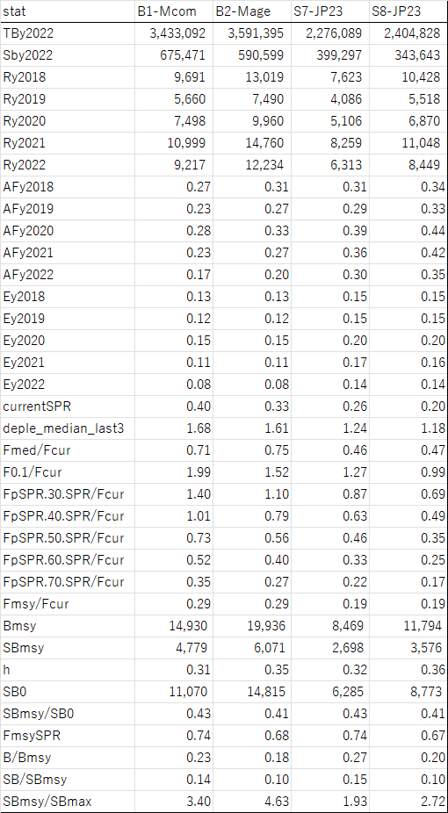

Table 3. Probability that future SSB is above 2022 SSB in each model. Cells with probabilities higher than 90% are colored by green.
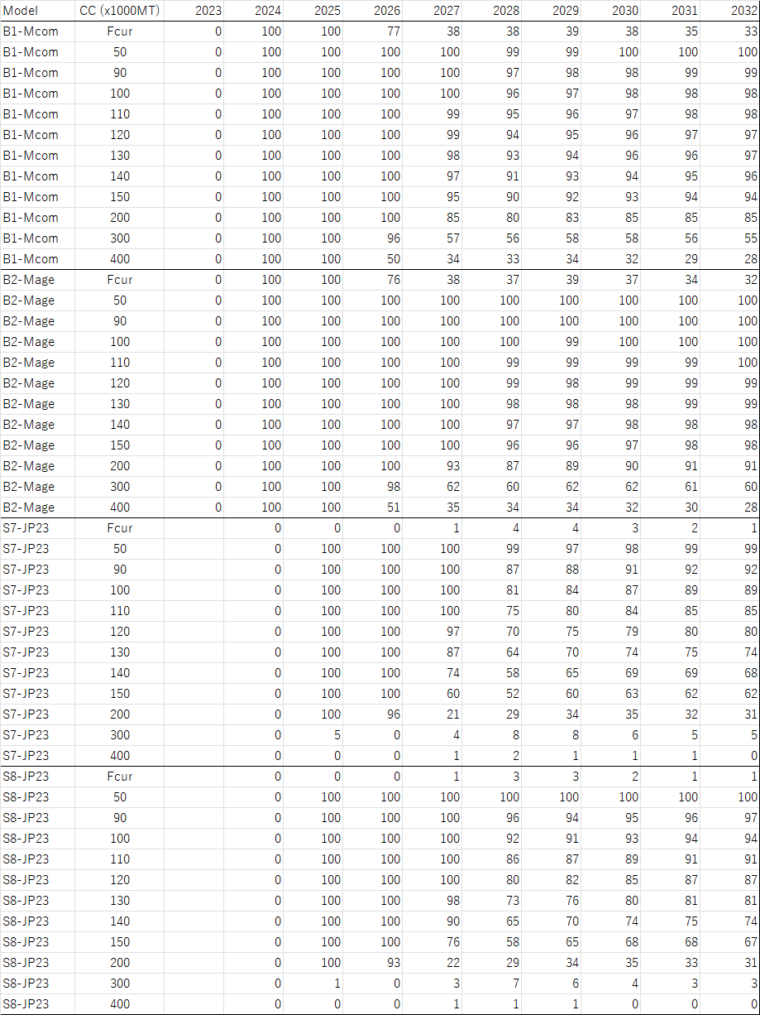

Table 4. Future average SSB.
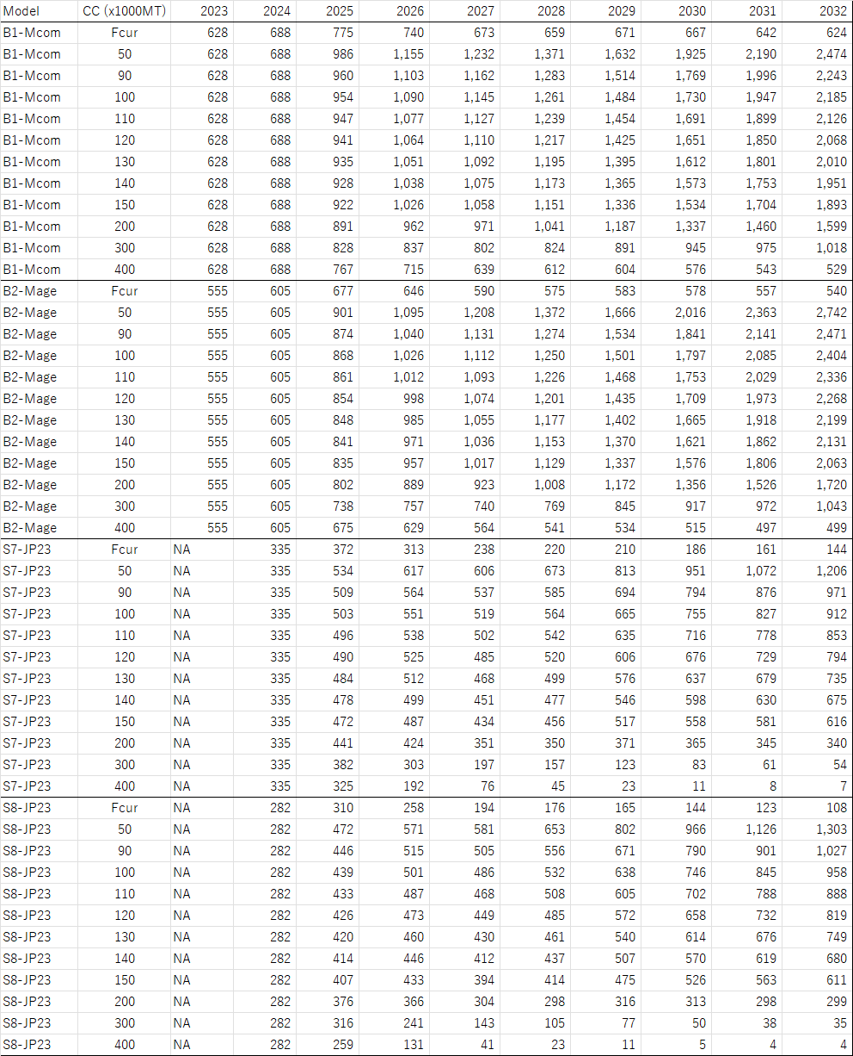

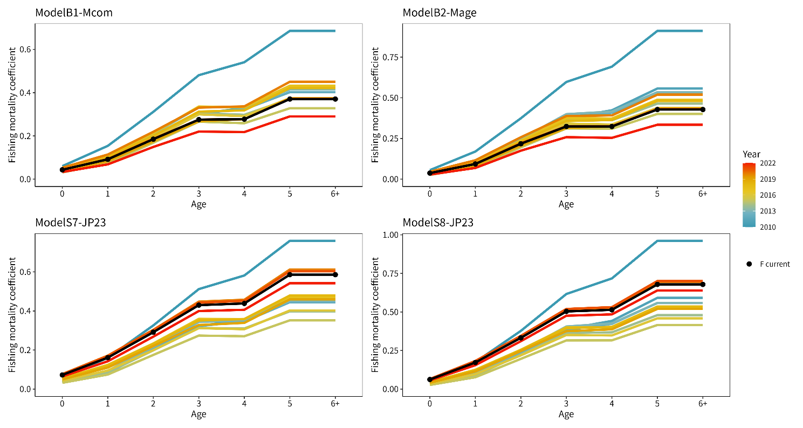
Fig. 1. Fishing mortality coefficient by age assumed as current fishing mortality (Fcur, black solid lines) in calculating reference points. Estimated fishing mortality coefficients by age and year are concurrently shown to be compared.

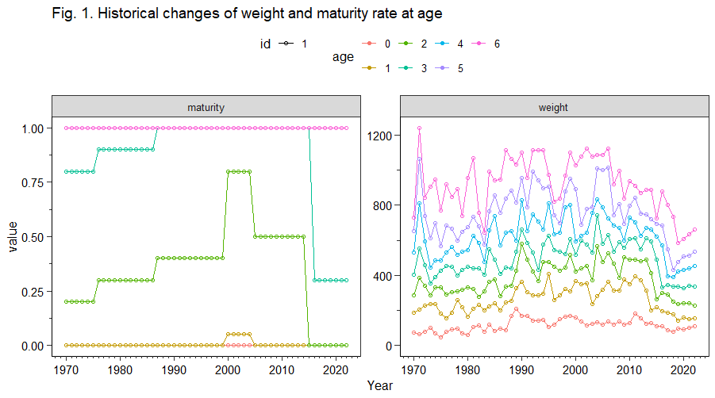
Fig. 2. Historical maturity rate and weight at age assumed in the stock assessment of the Pacific stock of chub mackerel by TWG CMSA09

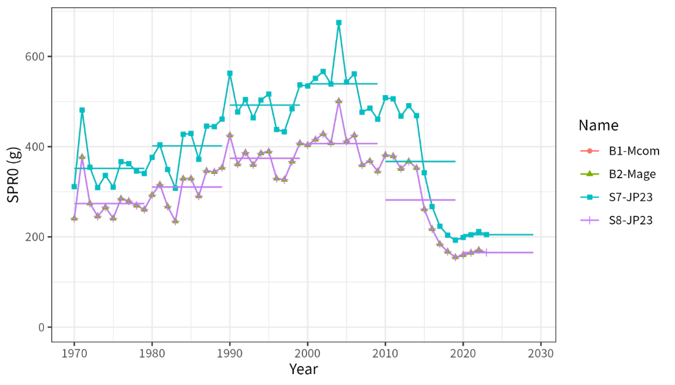
Fig. 3. Spawners per recruit without fishing (SPR0, g) varying with biological parameters of weight, maturity rate, and natural morality rate at age. SPR0 in each year is calculated based on the annually changing biological parameters assumed in the stock assessment. The horizontal line in each decade represents the average value during the decade. Although $w_{a,y}$ and $g_{a,y}$ remained the same among the 4 models, the values of SPR(0, y) differed between B1, S7 and B2, S8 because SPR0 varies depending on the assumed M. Because of that, results from B1 and S7 overlapped as did B2 and S8.

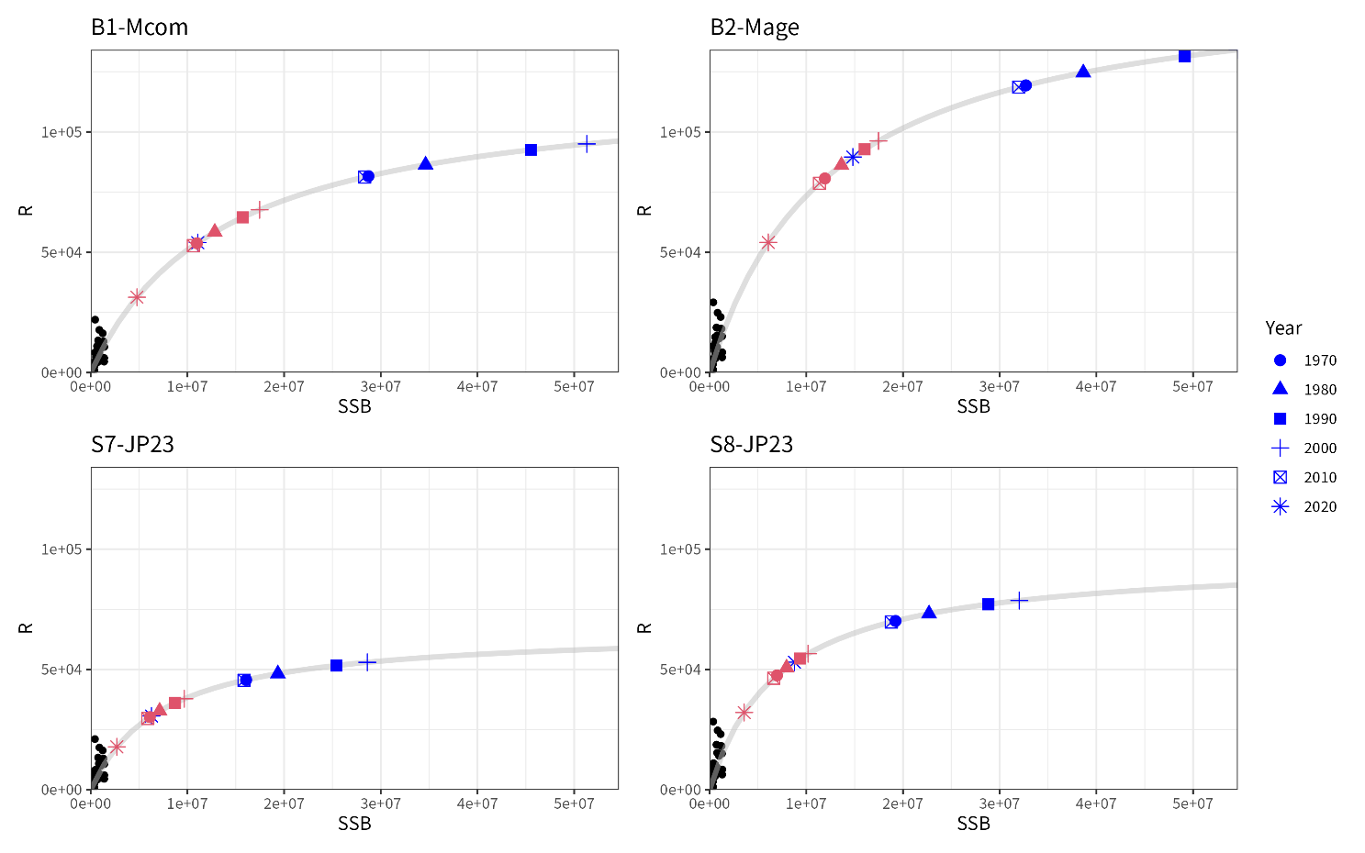
Fig. 4. Estimated stock-recruitment relationship (gray lines) and estimated past SSB and a number of recruits (black circles) overplotted with estimated SSB0 (equilibrium unexploited spawning biomass, blue symbols) and SSB_{MSY} (red symbols). The reference points are calculated using biological parameters averaged during the decades.
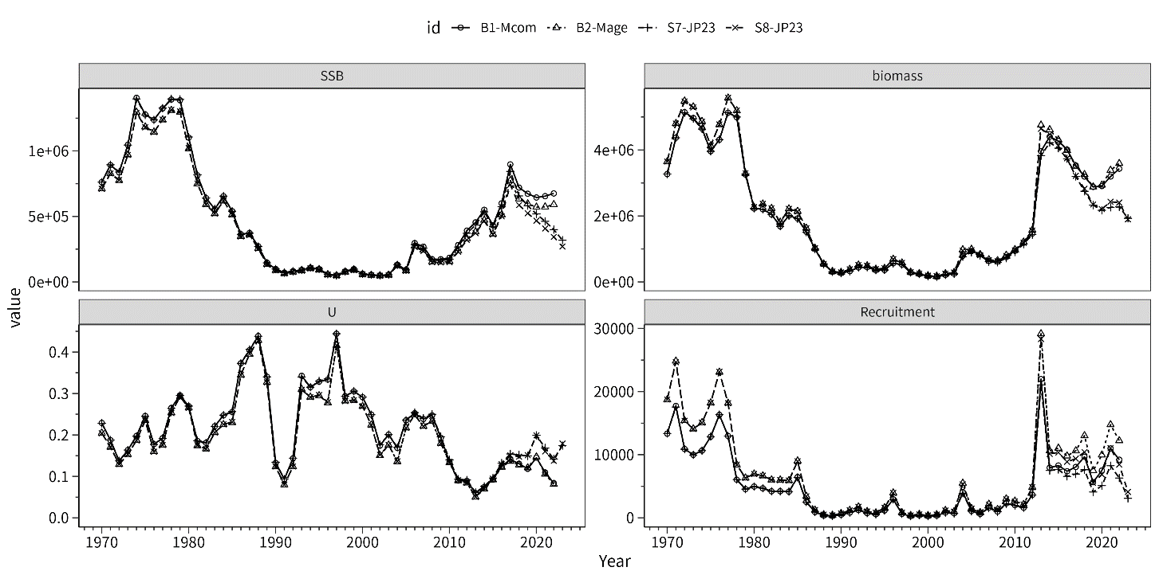Fig. 5. Comparison of trajectories of spawning biomass (SSB), recruitment, and exploitation rates (U, catch/biomass) among the 4 models
(a) B1-Mcom
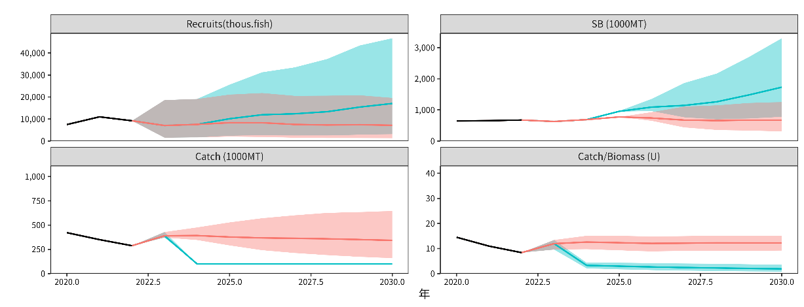
(b) B2-Mage
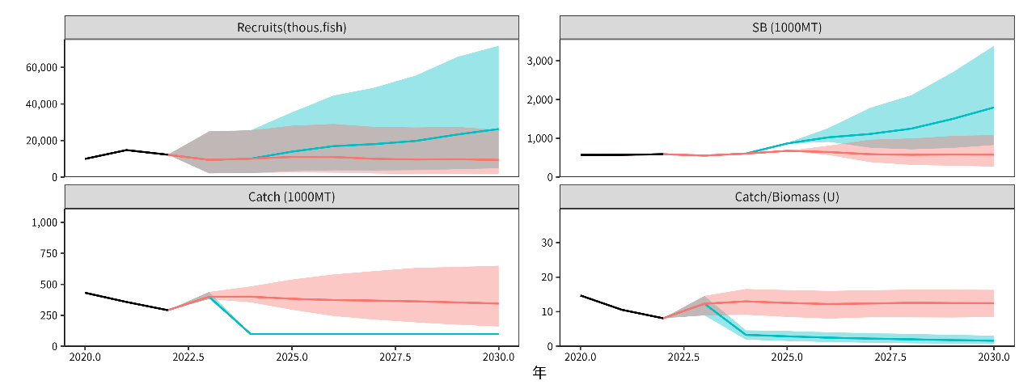
Fig. 6. Examples of stochastic future projection results. In this figure, results based on constant catch=100,000MT (blue) and current F (red) are compared. The shaded areas represent 90% prediction intervals, black solid lines are estimates by SAM, and colored solid lines are average.

(c) S7-Mcom
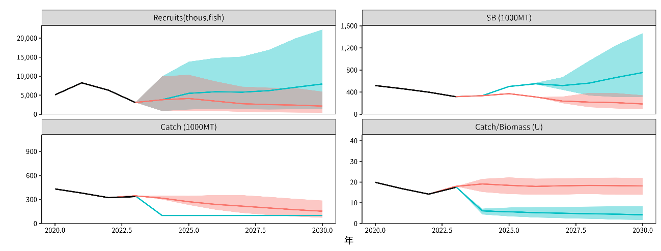
(d) S8-Mage
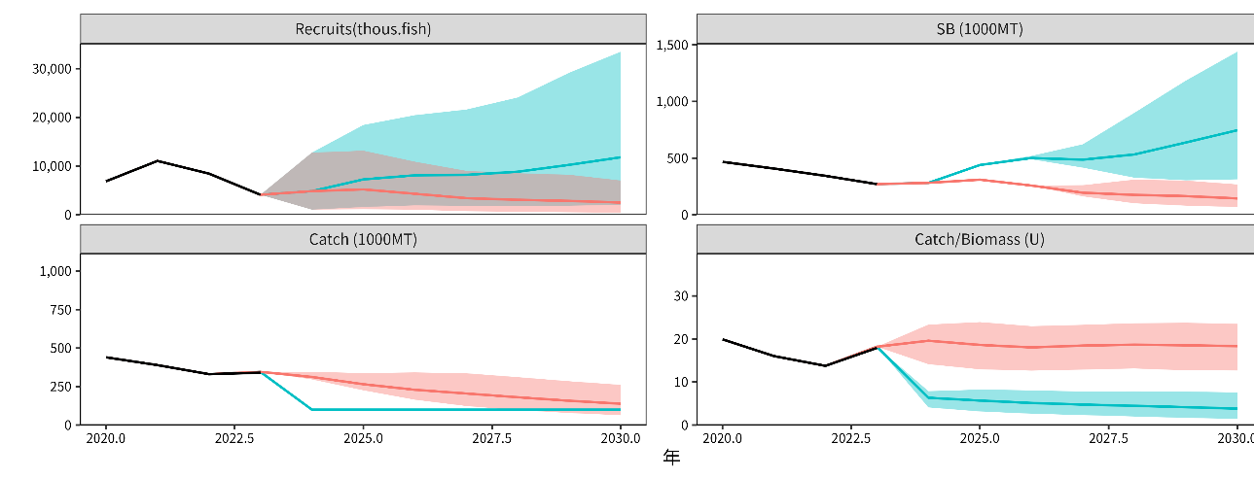
Fig. 6. Continued.

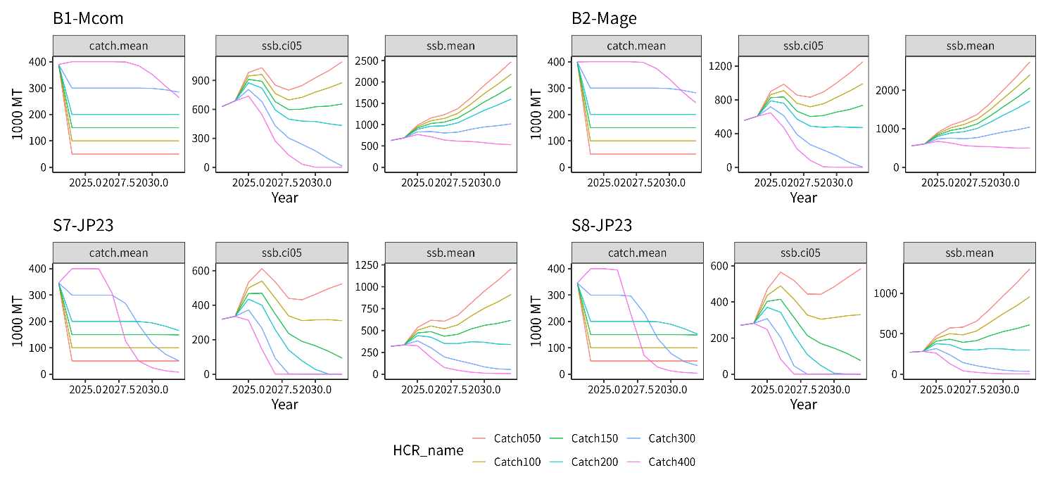Fig. 7. Comparison of future trajectories in different future harvest scenarios (“Catch100” means 100,000MT constant catch) for future average catch (left, catch.mean), lower 5 percentile of spawning biomass (middle, ssb.ci05) and average spawning biomass (right, ssb.mean).
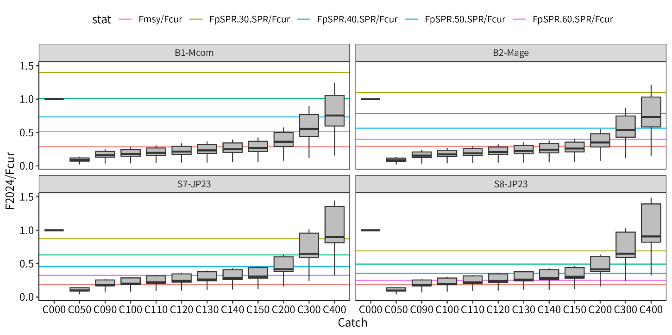
Fig. 8. Relative fishing mortality rates in 2024 to Fcur. The colored horizontal lines represents relative values of biological reference points to Fcur shown by Table 2. C000 means Fcur.

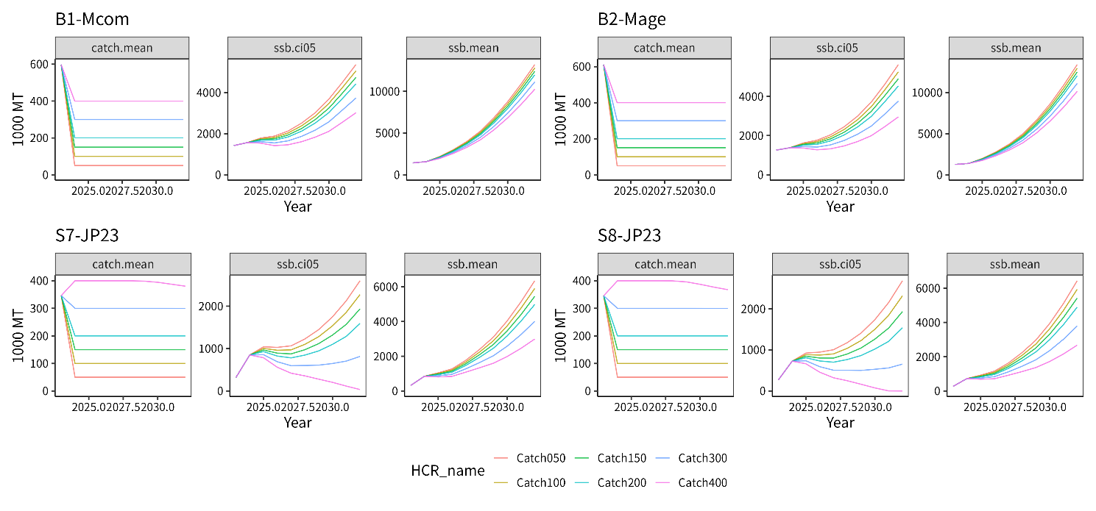
Fig. 9. Results of sensitivity analysis when using biological parameters averaged during 2010-2019 (bio2010). The legend is same with Fig. 7.

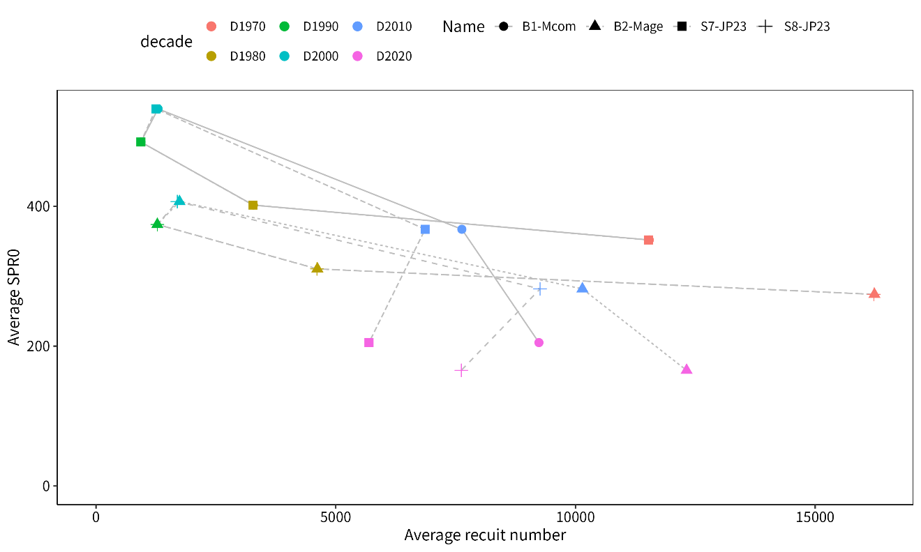
Fig. 10. Relationship between estimated recruitment and SPR0 averaged during decades

