NPFC-2024-TWG CMSA09-WP07

Standardizing monthly egg survey data as an abundance index for spawning stock biomass of chub mackerel in the Northwest Pacific

Ken Ishida, Shota Nishijima, Momoko Ichinokawa and Ryuji Yukami

Fisheries Resources Institute, Japan Fisheries Research and Education Agency

Summary
We estimated egg abundances from monthly egg density data obtained by research surveys, which can be used as an abundance index of spawning stock biomass (SSB) for the Pacific stock of chub mackerel. We applied the vector-autoregressive spatio-temporal (VAST) model to the monthly egg survey data from 2005 to 2023 off the Pacific coast of Japan to cover the spawning ground of chub mackerel. This document provides important references and diagnostics on this standardization according to the “CPUE Standardization Protocol for Chub Mackerel”. The standardized CPUE reached its peak in 2019, but has been on a downward trend since then, reaching its lowest level in 2023 since 2005. Since we found no serious problems in the diagnostics of the spatio-temporal model, we suggest the estimated index can be used as an SSB abundance index for the forthcoming stock assessment of chub mackerel in the Technical Working Group for the Chub Mackerel Stock Assessment.

Background of the chub mackerel egg survey data
In Japan, monthly egg surveys have been intensively conducted off the Pacific coast of Japan in the western North Pacific since 1978 by a historical cooperative system among many national and regional fisheries research bodies. The objective of this egg survey is to monitor egg abundance of major small pelagic fish species such as Japanese sardine, Japanese anchovy, chub mackerel, etc. The survey area roughly covered the major spawning grounds of small pelagic fish off the Pacific coast, mainly inshore waters but also offshore waters related to the warm Kuroshio and cold Oyashio currents. Further details on the objectives and designs of this egg surveys are described in Takasuka et al. (2008a, b) and Takasuka et al. (2017).
For the study of chub mackerel in the western North Pacific, Kanamori et al (2019) estimate spatiotemporal distribution of egg density of chub mackerel to reveal long-term changes in spawning patterns and spawning grounds. In their study, spatio-temporal distribution of egg density of chub mackerel was predicted by the vector-autoregressive spatio-temporal (VAST) model to consider spatial autocorrelation and spatio-temporal interaction.
In this document, we applied the VAST to the egg survey data from 2005 to 2023 to derive egg abundance, which should represent relative SSB. We provide important references and diagnostics on this standardization according to the “CPUE Standardization Protocol for Chub Mackerel” as well as estimated values of abundance indices as the input data of forthcoming stock assessment of chub mackerel.
This working paper was originally submitted to the TWG CMSA08 (Ishida et al. 2024) and updating data up to July 2023 was suggested from the TWG CMSA at that time (NPFC 2024). As suggested, we have updated data up to July 2023 from the previous document (Ishida et al. 2024) and revised results. Appendix A compares the results between before and after this update.

2. Methods

2.1 The data
The monthly egg surveys off the Pacific coast have been conducted by 18 prefectural experimental stations or fisheries research institutes and 2 national research institutes of the Japan Fisheries Research and Education Agency following the same procedure. In the egg surveys, conical or cylindrical conical plankton nets with mouth ring diameters of 45 or 60 cm and mesh sizes of 0.33 or 0.335 mm were towed vertically form 150 m depth (if the depth was <150 m, nets were lowered to just above the bottom). The number of eggs observed by each sampling was then converted into density (number/m²) and averaged arithmetically with 30’ latitude × 30’ longitude horizontal square resolution by month as monthly aggregated data. Further details of the survey method and data aggregation are described in Takasuka et al. (2008 a,b) and Takasuka et al. (2017).
Although the survey data was available throughout the year around the Japanese Islands, we used the data since 2005 when species identification between chub and blue mackerels is conducted. In addition, we further filtered the data for representing the Pacific stock during January to July so that the main spawning season of Pacific stock of chub mackerel was covered (Table 1). The number of observations by year and 30’ latitude × 30’ longitude grid, the number of observations with positive catch, and average egg density are shown in Table 2. The number of observations did not systematically vary among years. The spatiotemporal distribution of survey efforts and average egg density are shown in Fig. 1. Surveys were conducted in the area from 131.5º–149.5º E and 26.5º–42.5º N.
In this document, to account for the spatial autocorrelation and spatio-temporal interaction of the egg density (Kanamori et al. 2019), we incorporated the spatial and spatio-temporal random effects in the model (Table 3) by using VAST (Thorson 2019). While we did not estimate spatial distributions by month in the previous document submitted to this TWG (Nishijima et al. 2022, NPFC-2022-TWG CMSA06-WP10), we here incorporated the monthly effect on spatial distributions into the model according to Thorson et al (2020), because the spatial distributions of chub mackerel eggs depend greatly on months (Kanamori et al. 2019). We present the trends of response variables (the proportion of positive catches and egg density) by the year and month in Fig. 2. Catchability of eggs is considered less affected by environmental variables and, hence, we did not consider the effect of environmental factors in this analysis.

2.2 Full model description and model selection
We used the vector autoregressive spatio-temporal (VAST) model (Thorson 2019), which accounts for the spatio-temporal changes in survey design and observation rates and can accurately estimate relative local densities at high resolution. The model has been used for various objectives such as standardization of CPUE (e.g., Thorson et al. 2015) and understanding of distribution shifts (e.g., Thorson et al. 2016, Kanamori et al. 2019).
The model includes two components, (i) the encounter probability 𝑝_{t,𝑖} for time step t at location i and (ii) the expected egg density 𝑑_{t,𝑖} when spawning eggs are encountered. Encounter probability 𝑝_{t,𝑖} and positive density 𝑑_{t,𝑖} are approximated using Gaussian random fields (a multidimensional generalization of Gaussian process):

$logit p_{t, i}={β_{t}}^{(p)}+{L_{ω}}^{(p)}ω_{i}+{L_{ε}}^{(p)}ε_{t,i},$ (1)
$$log d_{t,i}={β_{t}}^{(d)}+{L_{ω}}^{(d)}ω_{i}+{L_{ε}}^{(d)}ε_{t,i},$$

where, 𝛽_{t} are the time step specific coefficients, 𝐿_{𝜔} and 𝐿_{𝜀} are spatial and spatio-temporal random effects. Since we used the seasonal model of VAST (Thorson et al. 2020), the time step specific coefficient $β_{t}$ is represented as:
$β_{t}=μ_{β}+β_{m}\left(m_{t}\right)+β_{y}\left(y_{t}\right),$ (2)
where 𝜇_{𝛽} is the intercept, which represents the average across all years and months, 𝛽𝑚(𝑚_{𝑡}) is the effect of month m, and 𝛽_{𝑦}(𝑦_{t}) is the effect of year. These parameters are estimated as fixed effects. Although we also consider a model including the interaction between year and month, the model failed to converge, and we dropped this term. Note that even without the interaction term between year and month, this model assumes that seasonal shifts of egg densities can depend on years by the spatio-temporal random effects, 𝐿𝜀. More detailed information on the seasonal VAST model was provided by Thorson (2019) and Thorson et al (2020).
The response variables in the positive density were assumed to follow a gamma distribution with log link, while the occurrence of positive catch was assumed to follow a binomial distribution with logit link. The gamma distribution was used because gamma models generally obtained less biased and more robust estimates than lognormal models and, therefore, it is suggested to use a gamma distribution for index standardization (Cadigan and Myers 2001; Thorson et al., 2021).
Spatial resolution (number of knots) for the spatio-temporal variation was set as 100 in the approximation of $ε_{y,i}$. While the previous document conduct model selection with different spatial resolution, this document cannot show such model selection result because the seasonal model with >100 knots takes too long time for calculations. On the other, we compared AIC between this seasonal model and the model shown in the previous document (Nishijima et al. 2022), which estimated annual, but not monthly, spatial distributions with consideration for the interaction between year and month as an overdispersion factor (random effect).

2.3 Yearly trend extraction
After estimating the parameters using the VAST package in R, monthly egg densities in time t at location s (${\hat{D}}_{t,s}$) were derived from the estimates of equation (1):
$${\hat{D}}_{t,s}={logit}^{-1}\left[{β_{t}}^{(p)}+{L_{ω}}^{(p)}ω_{i}+{L_{ε}}^{(p)}ε_{t,s}\right]×\text{exp}\left[{β_{t}}^{(d)}+{L_{ω}}^{(d)}ω_{i}+{L_{ε}}^{(d)}ε_{t,s}\right],$$
Monthly egg abundances (${\hat{I}}_{t}$,) were then obtained as:
$${\hat{I}}_{t}=\sum_{s}{a_{s}}{\hat{D}}_{t,s}$$
where $a_{s}$ is area associated with location s. We used the area sizes of 30’ latitude × 30’ longitude grids, computed by the R package ‘sf’ (Pebesma 2018) as $a_{s}$. To derive a yearly abundance index, we calculated annual estimates of egg abundance by summing up monthly egg abundance from January to July:
$${\hat{I}}_{y}=\sum_{t}{{\hat{I}}_{y_{t}}}$$

3. Results and Discussion
The AIC of the seasonal VAST model used in this document (102925.8) was much lower than the VAST model presented in the previous document (103980.3). This suggests that the spatial distributions of chub mackerel eggs shifted monthly.
The parameter estimates in the seasonal VAST model were stable as the final gradients of all parameters were nearly zero (absolute values were less than 0.01) (Table 4). The Q-Q plot for the standardized residuals that were obtained using the R package ‘DHARMa’ (Hartig 2022) indicates that the distribution assumption is met (Fig. 3). There were no apparent systematic biases in the spatio-temporal distribution of standardized residuals (Fig. 4). The spatial and temporal patterns of the response variable (predicted abundance) are shown in Fig. 5.
Yearly standardized CPUE and its uncertainty (CV and 95% CI) is shown in Table 5 and Fig. 6. The yearly patterns of index trends were similar between nominal and standardized CPUEs. Both indices indicate that SSB has increased since 2017 but peaked in 2019 and has been decreasing recently. Especially in 2023, both standardized and nominal CPUE were the lowest since 2005 and 1/5 and 1/6 of the average of CPUE during 2020-2022, respectively. It is unlikely that the rapid decline in 2023 is due to standardization, as both standardized and nominal CPUE are in decline.
To discuss possible causes of the decrease in CPUE in 2023, we first focused on nominal values of positive catch rates and average egg density in Table 2. As for the positive catch rates, the value in 2023 (0.10) is no more than a one-half decrease to the average of 2020-2022 (0.15) (Table 2). On the other hand, mean density excluding zero catches in 2023 was found to have decreased by more than a third to the average of 2020-2023 (Table 2). Finally, looking at predicted log density suggests an overall decrease in 2023 across all months and locations (Fig. 5). These observations suggest that although relatively widespread and long periods of spawning occurred in 2023, their average density tends to be small uniformly rather than that spawning in certain seasons or areas of the ocean has been extremely low.
The standardized index obtained from this analysis covers a long time series ranging from periods of low SSB for chub mackerel in the Pacific Ocean to periods of high SSB. This is very valuable information for the CMSA. The standardized indices are particularly useful because they not only cover a wide range of surveys, but also use the cutting-edge VAST models and have good model diagnostic results. Therefore, we propose the estimated index can be used as an SSB abundance index for the forthcoming stock assessment of chub mackerel in the TWG CMSA.

Reference lists
Cadigan NG, Myers RA (2001). A comparison of gamma and lognormal maximum likelihood estimators in a sequential population analysis. Canadian Journal of Fisheries and Aquatic Sciences, 58, 560–567. https://doi.org/10.1139/cjfas-58-3-560
Hartig F (2022). DHARMa: Residual Diagnostics for Hierarchical (Multi-Level / Mixed) Regression Models. R package version 0.4.5, <https://CRAN.R-project.org/package=DHARMa>.
Ishida, K., S. Nishijima, M. Ichinokawa and R. Yukami. (2024) Standardizing monthly egg survey data as an abundance index for spawning stock biomass of chub mackerel in the Northwest Pacific. NPFC-2024-TWG CMSA08-WP05 (Rev. 1).
Kanamori, Y., A. Takasuka, S. Nishijima, M. Ichinokawa, and H. Okamura. (2018) Standardizing abundance index for spawning stock biomass of chub mackerel in the Northwestern Pacific. NPFC-2018-TWG CMSA02-WP03.
Kanamori, Y., A. Takasuka, S. Nishijima, and H. Okamura. (2019) Climate change shifts the spawning ground northward and extends the spawning period of chub mackerel in the western North Pacific. Marine Ecology Progress Series 624:155–166.
Nishijima, S., K. Kanazawa, M. Ichinokawa, R. Yukami, and A. Mamabe. (2022) Standardizing monthly egg survey data as an abundance index for spawning stock biomass of chub mackerel in the Northwest Pacific. NPFC-2022-TWG CMSA06-WP10.
Pebesma, E., 2018. Simple Features for R: Standardized Support for Spatial Vector Data. The R Journal 10 (1), 439-446, https://doi.org/10.32614/RJ-2018-009.
Takasuka A, Oozeki Y, Kubota H (2008a) Multi-species regime shifts reflected in spawning temperature optima of small pelagic fish in the western North Pacific. Marine Ecology Progress Series 360:211-217
Takasuka A, Kubota H, Oozeki Y (2008b) Spawning overlap of anchovy and sardine in the western North Pacific. Marine Ecology Progress Series 366:231-244
Takasuka A, Tadokoro K, Okazaki Y, Ichikawa T, Sugisaki H, Kuroda H, Oozeki Y (2017) In situ filtering rate variability in egg and larval surveys off the Pacific coast of Japan: Do plankton nets clog or over-filter in the sea? Deep-Sea Res I 120: 132−137
Thorson JT (2019) Guidance for decisions using the Vector Autoregressive Spatio-Temporal (VAST) package in stock, ecosystem, habitat and climate assessments. Fish Res 210:143-161
Thorson JT, Pinsky ML, Ward EJ (2016) Model-based inference for estimating shifts in species distribution, area occupied and center of gravity. Methods Ecol Evol 7:990-1002.
Thorson JT, Shelton AO, Ward EJ, Skaug HJ (2015) Geostatistical delta-generalized linear mixed models improve precision for estimated abundance indices for West Coast groundfishes. ICES J Mar Sci J Cons 72:1297-1310
Thorson, J. T., C. F. Adams, E. N. Brooks, L. B. Eisner, D. G. Kimmel, C. M. Legault, L. A. Rogers and E. M. Yasumiishi (2020) Seasonal and interannual variation in spatio-temporal models for index standardization and phenology studies. ICES J. Mar. Sci., 77, 1879-1892.
Thorson JT, Cunningham CJ, Jorgensen E, Havron A., Hulson PJF, Monnahan CC., von Szalay P. (2021). The surprising sensitivity of index scale to delta-model assumptions: Recommendations for model-based index standardization. Fisheries Research, 233, 105745. https://doi.org/10.1016/J.FISHRES.2020.105745

Table 1. Filter “Rules” used on data for CPUE standardization and the effect on the overall sample size.
Filter Applied |  | Number of Records Remaining | Number Removed |  | Number of Records With Chub Mackerel Catch >0
Initial Data set |  | 39462 | - |  | 33197
Remove records except for Pacific stock |  | 25542 | 13920 |  | 24687
Remove records August to December |  | 17073 | 8469 |  | 16505
Final Data Set |  | 17073 | 8469 |  | 16505

Table 2. The summary of the survey data: number of surveys (representing the number of grids with >0 survey by month), number of positive egg density surveys, the positive catch rates, mean egg density including zero catches and excluding zero catches.
Year | Number of observations  (Grids x Months) | Number of positive-catch observations | The positive catch rates | Mean density including zero catches | Mean density excluding zero catches
2005 | 471 | 67 | 0.14 | 45.68 | 321.09
2006 | 784 | 115 | 0.15 | 92.45 | 630.26
2007 | 894 | 103 | 0.12 | 162.85 | 1413.46
2008 | 879 | 80 | 0.09 | 40.73 | 447.49
2009 | 877 | 120 | 0.14 | 39.84 | 291.18
2010 | 888 | 111 | 0.13 | 76.17 | 609.35
2011 | 857 | 109 | 0.13 | 71.99 | 566.04
2012 | 878 | 106 | 0.12 | 129.68 | 1074.15
2013 | 890 | 112 | 0.13 | 122.25 | 971.48
2014 | 946 | 111 | 0.12 | 66.96 | 555.44
2015 | 907 | 104 | 0.11 | 66.96 | 583.99
2016 | 879 | 118 | 0.13 | 50.05 | 372.80
2017 | 834 | 145 | 0.17 | 166.86 | 959.73
2018 | 908 | 176 | 0.19 | 265.95 | 1372.08
2019 | 978 | 177 | 0.18 | 316.74 | 1750.13
2020 | 890 | 149 | 0.17 | 155.02 | 925.94
2021 | 917 | 127 | 0.14 | 99.55 | 718.78
2022 | 958 | 127 | 0.13 | 137.75 | 1039.12
2023 | 870 | 85 | 0.10 | 24.81 | 253.97

Table 3. Summary of explanatory variables used in VAST.
Variables |  | Number of categories | Detail | Note
Year&Month |  | 133 | 2005–2023 times 7 months (Jan. to July)
Spatial random factor |  |  | 0.5x0.5 º grid from 131.5 º –149.5º E and 26.5º–42.5º N
Spatio-temporal random factor |  |  | 0.5x0.5 º grid from 131.5 º –149.5º E and 26.5º–42.5º N

Table 4. Estimated parameters Maximum Likelihood Estimates (MLE), standard deviation (SD), and final gradient value in full model.
Param | MLE | SD | final_gradient
ln_H_input | 0.394 | 0.115 | -3.30E-09
ln_H_input | 0.486 | 0.158 | -4.77E-08
beta1_ft | -7.621 | 0.929 | 1.95E-09
gamma1_cp | 0.872 | 0.319 | 1.58E-09
gamma1_cp | 2.359 | 0.335 | -3.59E-09
gamma1_cp | 3.028 | 0.336 | -7.86E-10
gamma1_cp | 2.950 | 0.341 | -1.48E-09
gamma1_cp | 2.418 | 0.335 | -7.46E-09
gamma1_cp | 1.275 | 0.324 | 1.09E-08
gamma1_cp | 0.255 | 0.639 | -5.20E-09
gamma1_cp | 0.037 | 0.662 | -1.29E-09
gamma1_cp | -0.129 | 0.669 | -9.65E-10
gamma1_cp | 0.306 | 0.658 | -1.28E-09
gamma1_cp | 0.114 | 0.662 | -1.17E-09
gamma1_cp | 0.095 | 0.665 | -1.05E-09
gamma1_cp | 0.228 | 0.674 | -1.27E-09
gamma1_cp | 0.246 | 0.673 | -1.35E-09
gamma1_cp | 0.103 | 0.663 | -1.05E-09
gamma1_cp | 0.219 | 0.668 | -1.42E-09
gamma1_cp | 0.341 | 0.660 | -1.25E-09
gamma1_cp | 0.715 | 0.662 | -1.74E-09
gamma1_cp | 0.854 | 0.650 | -1.71E-09
gamma1_cp | 0.648 | 0.652 | -1.48E-09
gamma1_cp | 0.617 | 0.654 | -1.44E-09
gamma1_cp | 0.575 | 0.652 | -1.61E-09
gamma1_cp | 0.627 | 0.651 | -2.33E-09
gamma1_cp | -0.020 | 0.674 | -4.91E-10
L_omega1_z | -1.864 | 0.234 | 3.38E-08
L_epsilon1_z | -1.268 | 0.066 | 9.67E-07
logkappa1 | -5.300 | 0.085 | 7.69E-07
Epsilon_rho1_f | 0.443 | 0.044 | -1.35E-06
beta2_ft | 18.317 | 0.381 | 7.55E-09
gamma2_cp | -0.235 | 0.274 | 2.63E-09
gamma2_cp | 0.912 | 0.268 | 7.60E-10
gamma2_cp | 0.893 | 0.264 | 2.91E-09
gamma2_cp | 0.485 | 0.269 | 7.50E-10
gamma2_cp | 0.440 | 0.274 | 1.65E-09
gamma2_cp | 0.461 | 0.303 | -1.35E-09
gamma2_cp | 0.361 | 0.338 | 3.06E-11
gamma2_cp | 0.538 | 0.342 | -1.13E-10
gamma2_cp | 0.299 | 0.348 | -9.71E-10
gamma2_cp | 0.120 | 0.329 | -5.94E-09
gamma2_cp | 0.578 | 0.336 | 3.18E-09
gamma2_cp | 0.094 | 0.338 | 1.61E-09
gamma2_cp | 0.633 | 0.343 | 7.61E-11
gamma2_cp | 0.573 | 0.341 | 5.26E-10
gamma2_cp | 0.410 | 0.337 | 2.93E-09
gamma2_cp | 0.585 | 0.339 | 3.44E-09
gamma2_cp | 0.555 | 0.326 | 3.62E-09
gamma2_cp | 0.898 | 0.333 | 5.60E-10
gamma2_cp | 1.072 | 0.324 | -1.46E-09
gamma2_cp | 1.395 | 0.327 | 1.06E-08
gamma2_cp | 0.895 | 0.327 | 1.39E-09
gamma2_cp | 0.612 | 0.326 | -4.45E-09
gamma2_cp | 0.785 | 0.330 | -5.95E-10
gamma2_cp | -0.187 | 0.341 | -1.06E-08
L_omega2_z | -0.527 | 0.089 | 2.22E-08
L_epsilon2_z | 1.023 | 0.056 | -1.49E-07
logkappa2 | -4.266 | 0.125 | 7.14E-08
Epsilon_rho2_f | 0.208 | 0.077 | -1.06E-07
logSigmaM | 0.069 | 0.016 | -1.31E-07

Table 5. Nominal and standardized egg abundance from 2005 to 2023.
Year | Nominal egg abundance  (trillion) | Standardized egg abundance (trillion) | CV  (%) | 95% CI
 |  |  |  | Lower | Upper
2005 | 47.32 | 82.60 | 0.28 | 52.50 | 153.00
2006 | 157.90 | 204.00 | 0.17 | 150.00 | 291.00
2007 | 334.94 | 347.00 | 0.19 | 248.00 | 527.00
2008 | 81.53 | 113.00 | 0.24 | 75.90 | 189.00
2009 | 74.66 | 116.00 | 0.19 | 82.10 | 172.00
2010 | 164.29 | 183.00 | 0.22 | 126.00 | 290.00
2011 | 144.90 | 162.00 | 0.18 | 119.00 | 241.00
2012 | 271.66 | 355.00 | 0.19 | 256.00 | 529.00
2013 | 263.98 | 321.00 | 0.18 | 234.00 | 466.00
2014 | 146.03 | 226.00 | 0.19 | 161.00 | 335.00
2015 | 145.38 | 197.00 | 0.20 | 140.00 | 298.00
2016 | 100.86 | 184.00 | 0.23 | 122.00 | 299.00
2017 | 335.78 | 470.00 | 0.18 | 340.00 | 683.00
2018 | 601.20 | 758.00 | 0.22 | 526.00 | 1215.00
2019 | 746.73 | 887.00 | 0.15 | 667.00 | 1221.00
2020 | 333.50 | 494.00 | 0.18 | 358.00 | 732.00
2021 | 203.05 | 288.00 | 0.20 | 201.00 | 439.00
2022 | 318.53 | 476.00 | 0.21 | 334.00 | 750.00
2023 | 46.56 | 73.90 | 0.22 | 50.00 | 118.00

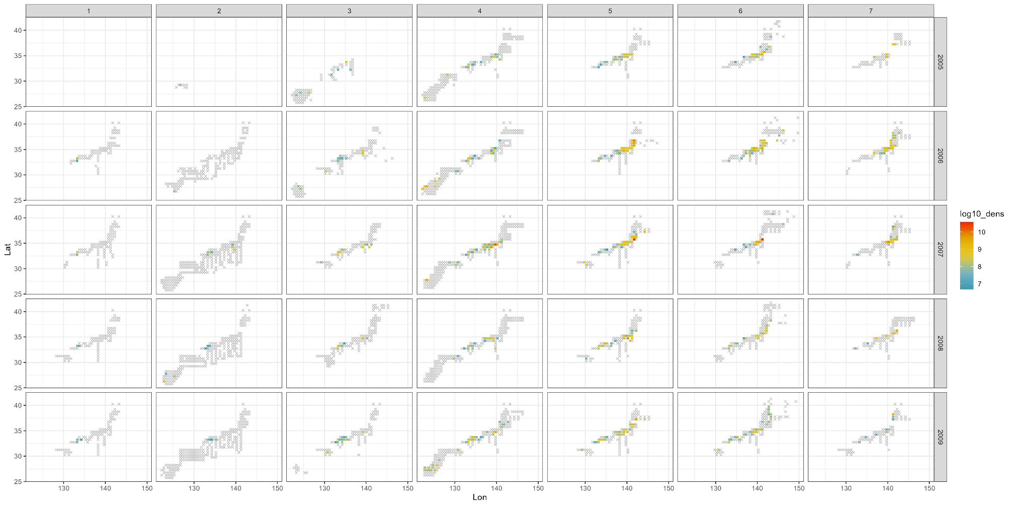
Fig. 1. Spatiotemporal distribution of grids with >0 survey efforts (shown by crosses or colored squares), 0 catch (crosses), and average density (colored squares) (2005-2009). The density is presented with log 10, and x-axis and y-axis are longitude and latitude, respectively.

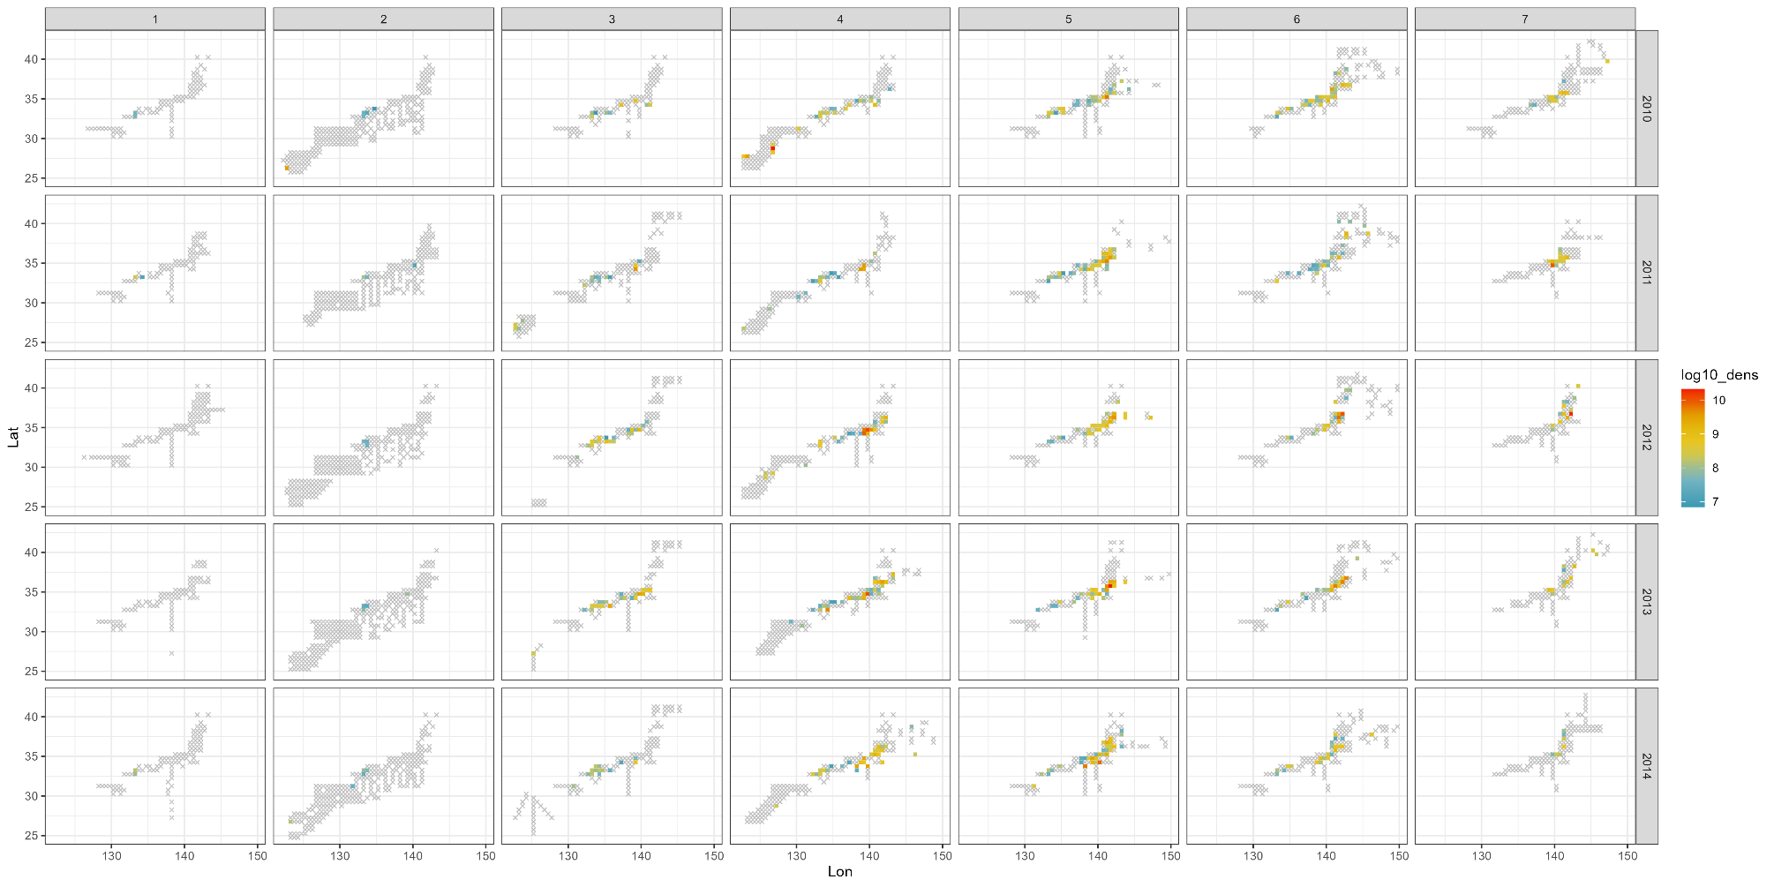
Fig. 1. Continued (2010-2014)

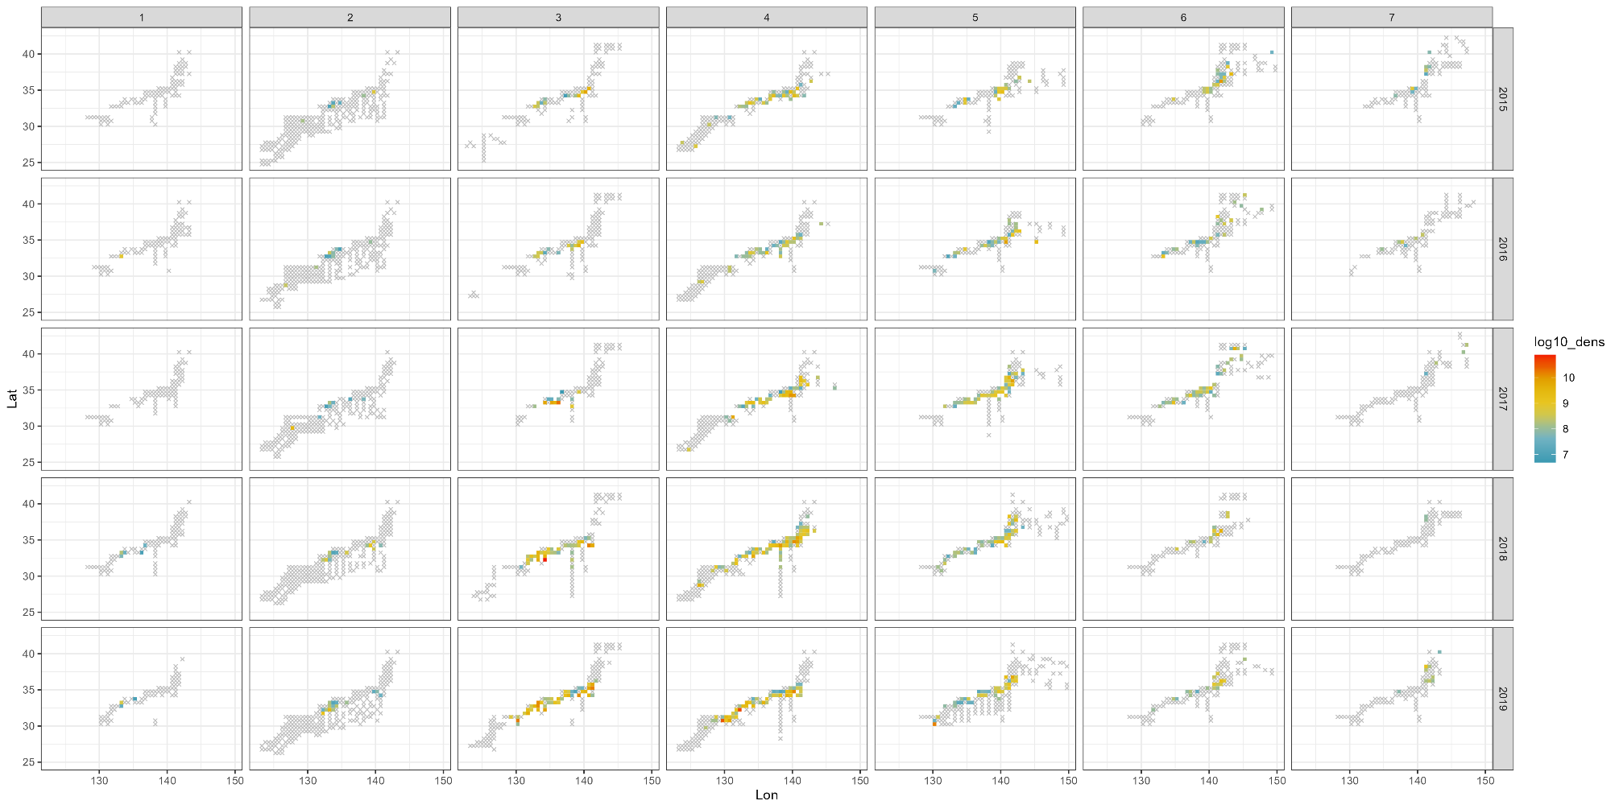
Fig. 1. Continued (2015-2019)

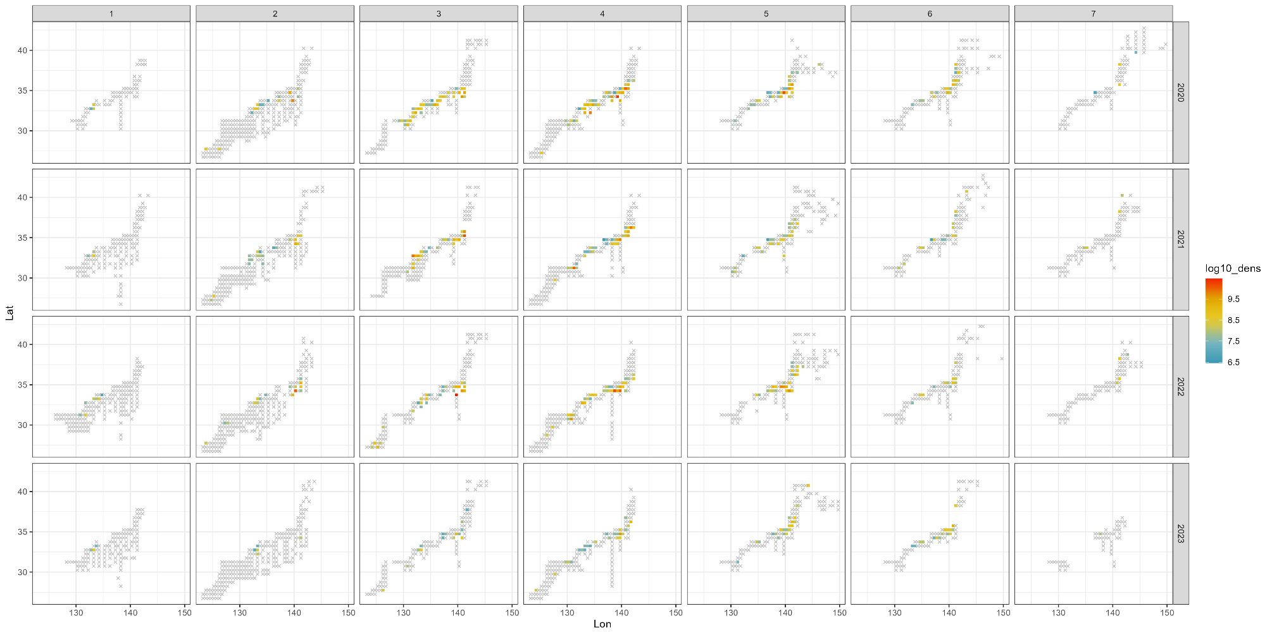
Fig. 1. Continued (2020-2023)

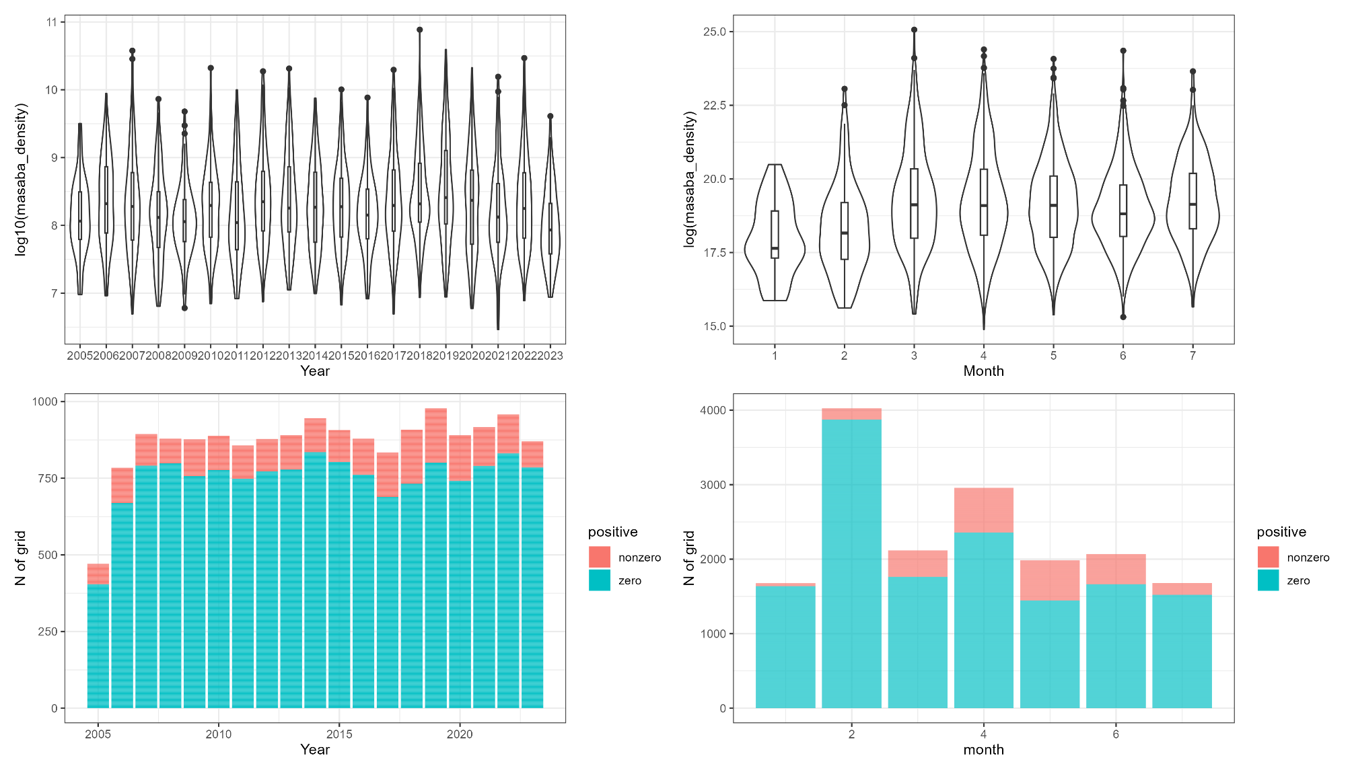
(b)
(a)
(c)
(d)
Fig. 2. The yearly (a) and monthly (b) trend of egg density and the yearly (c) and monthly (d) trend of the number of positive catches. The y-axis in (a) and (b) is the log10 scale and the log scale, respectively. Note that, in the (a) and (b), only positive egg density is shown.

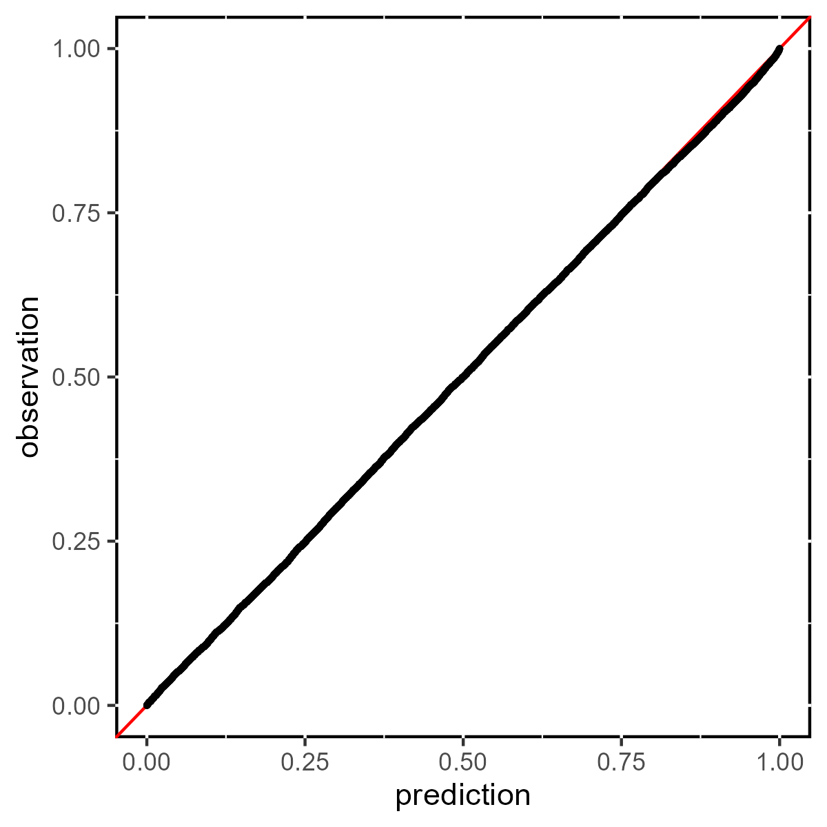
Fig. 3. Quantile-quantile plot of that compares the distribution of the observation and prediction of egg density.

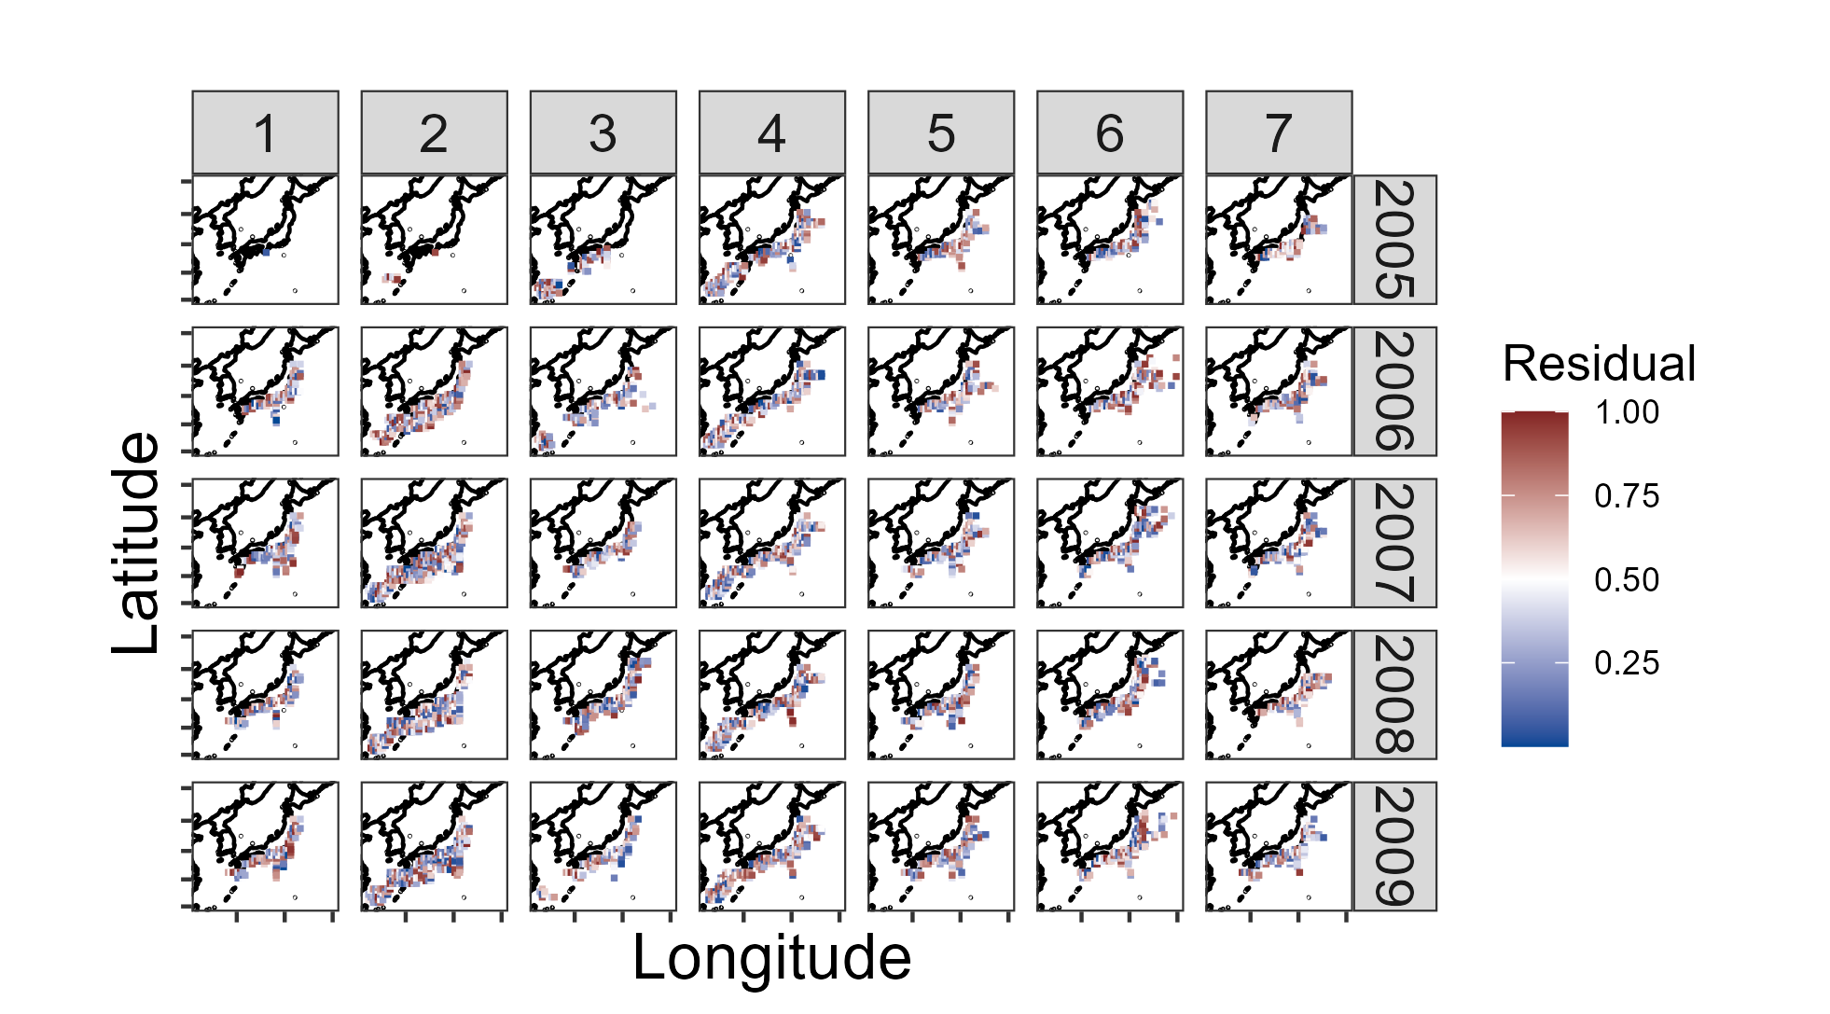
Fig. 4. Spatio-temporal distribution from January to July (column) in 2005-2009 (row) of the residuals.

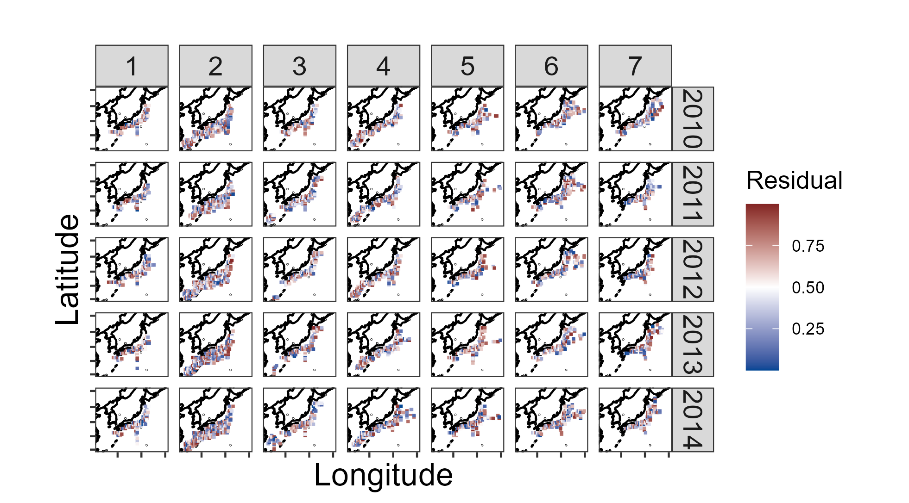
Fig. 4. Continued (2010-2014)

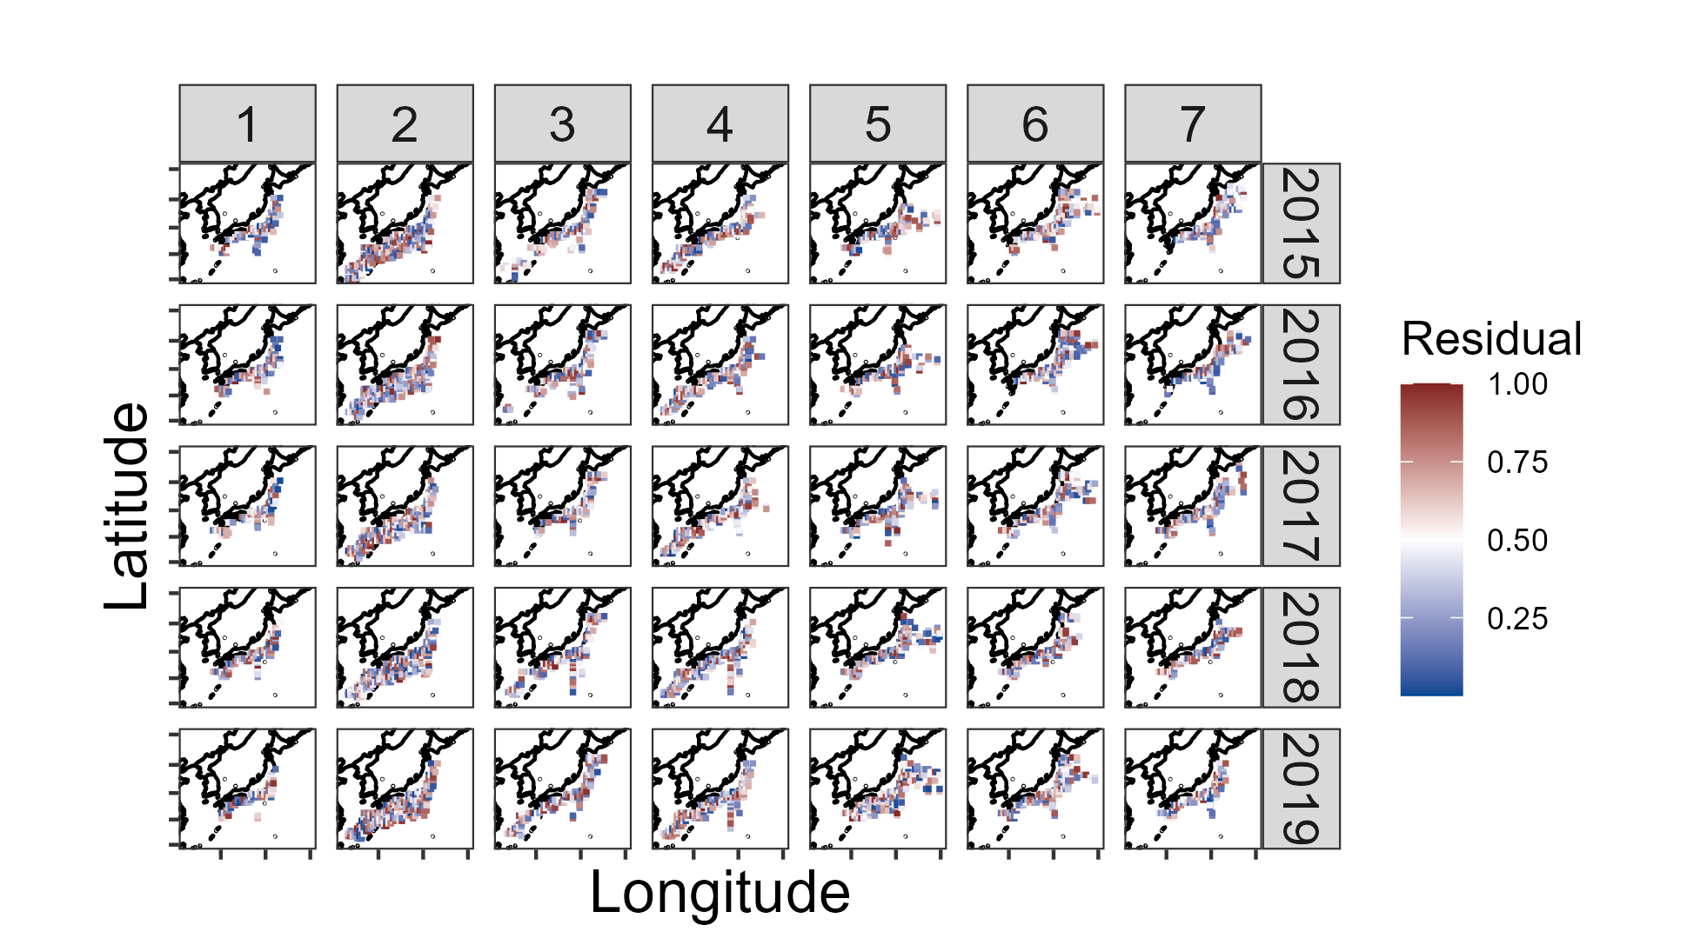
Fig. 4. Continued (2015-2016)

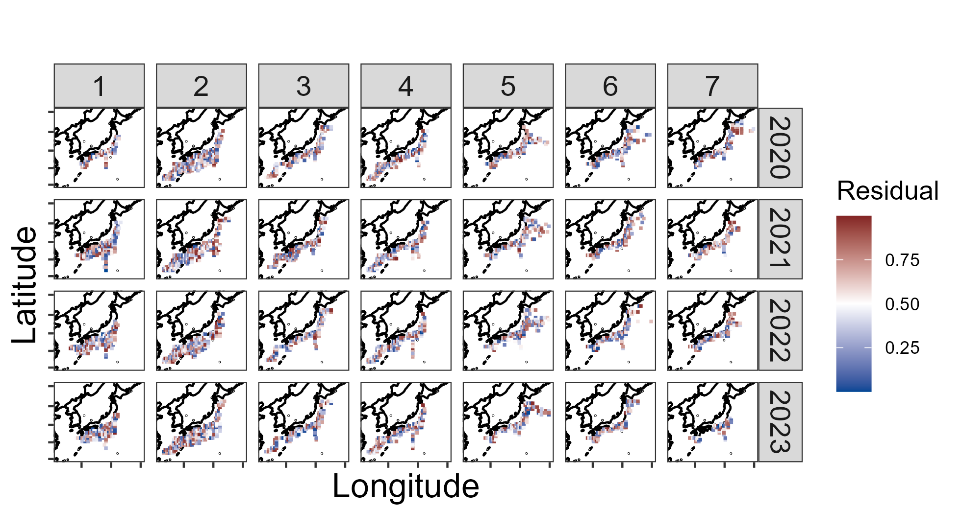
Fig. 4. Continued (2020-2023)

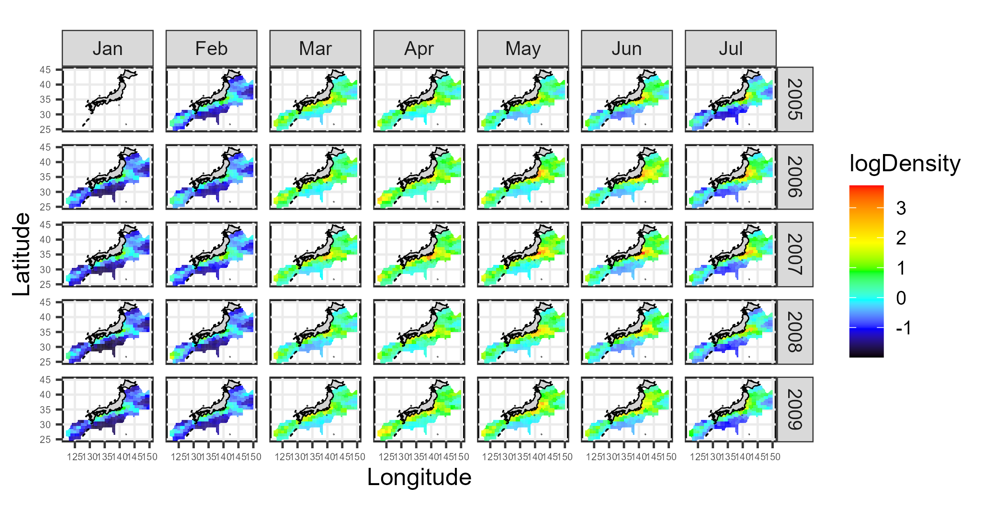
Fig. 5. Spatio-temporal distribution (2005-2009) of the predicted egg abundance.

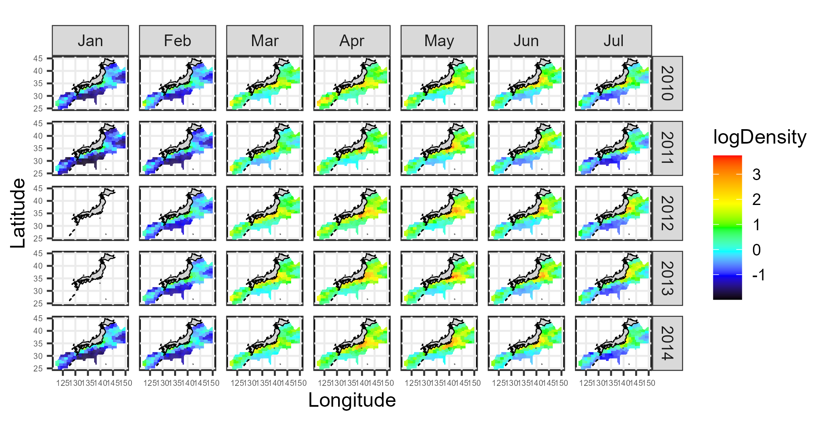
Fig. 5. Continued (2010-2014)

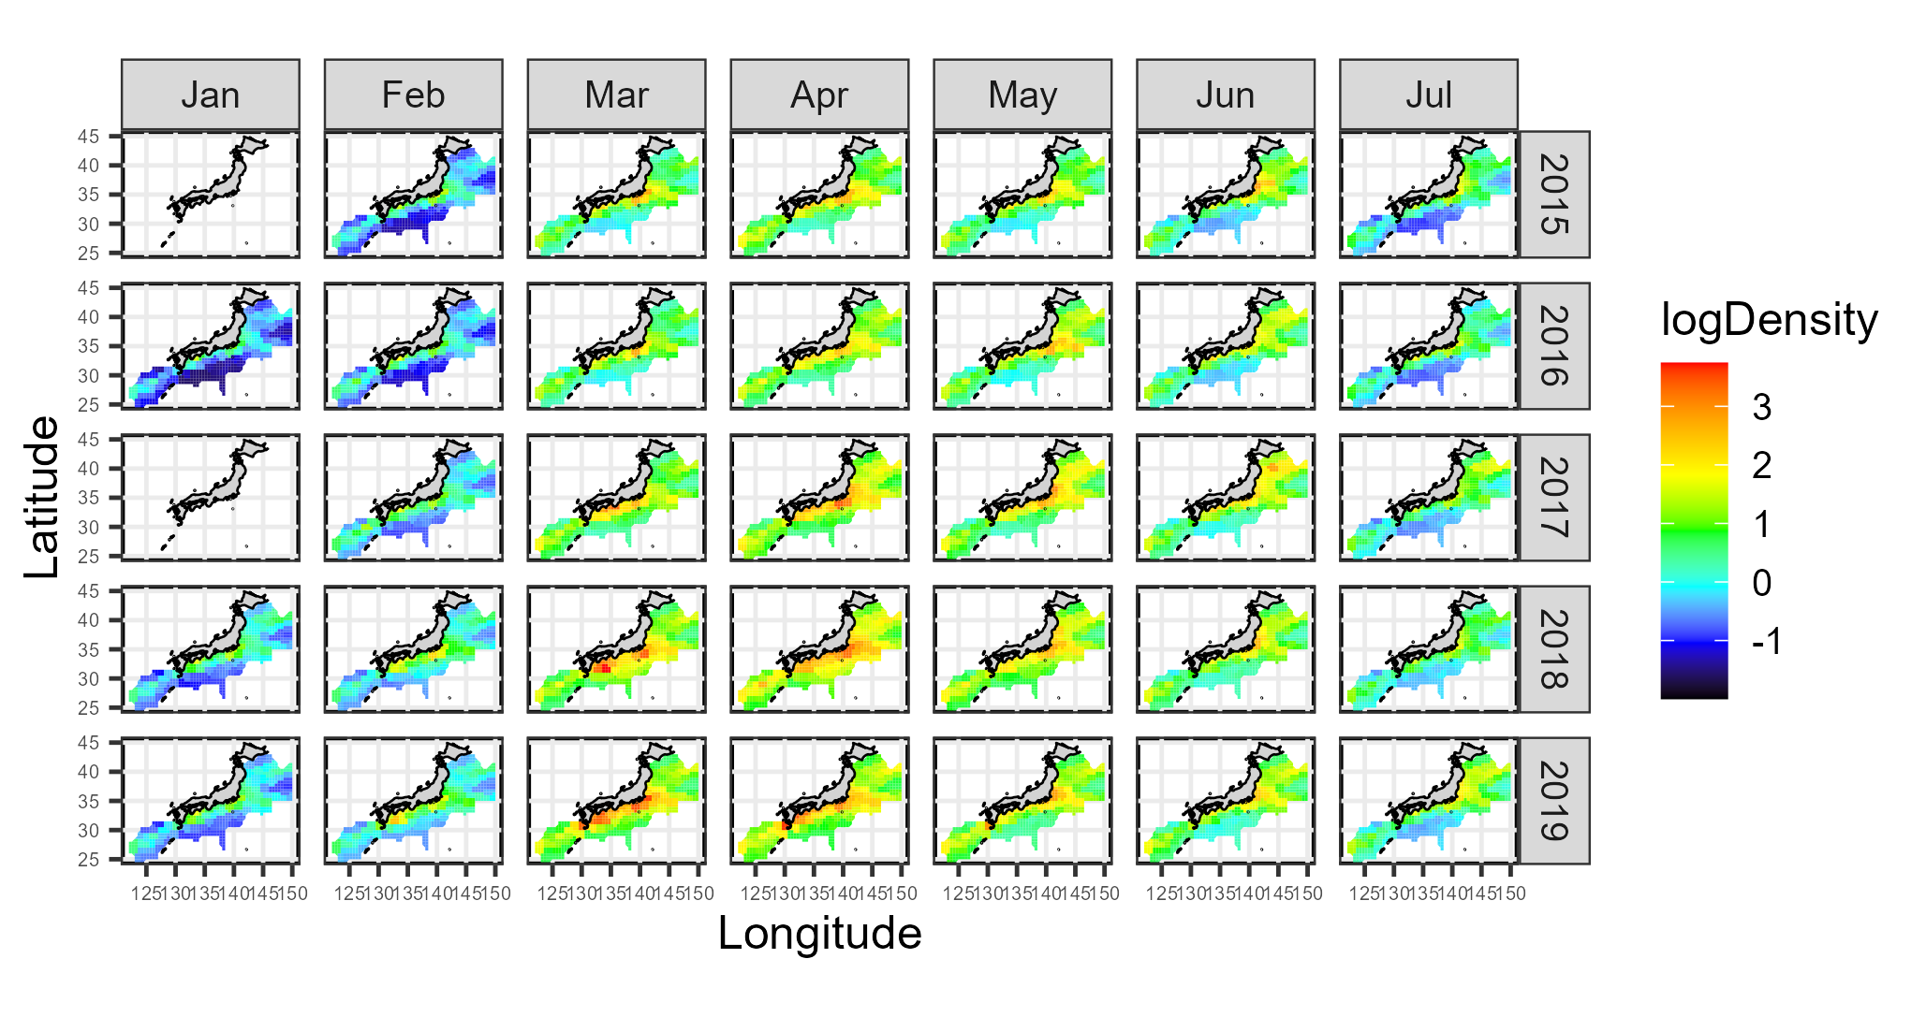
Fig. 5. Continued (2015-2019)

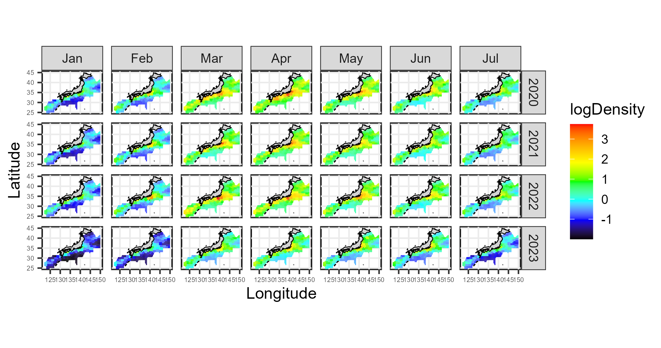
Fig. 5. Continued (2020-2023)

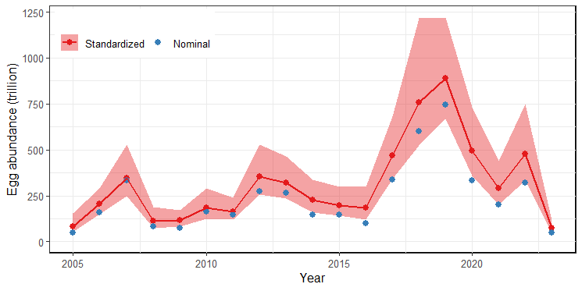
Fig. 6. The yearly patterns of nominal and standardized SSB indices. Red area is 95% confidence interval of the standardized index.

Appendix A: Comparison between previous and revised results
After updating the July 2023 data, 0 catch locations (Fig. A1) and the area of the residual (Fig. A2) are increased, but spatio-temporal distribution of the predicted egg abundance (Fig. A3) and SSB indices (Fig. A4) showed no major differences.

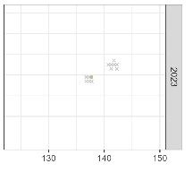
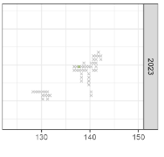
Fig. A1. Comparison of survey locations before (top panel) and after (bottom panel) data updating. Spatiotemporal distribution of grids with >0 survey efforts (shown by crosses or colored squares), 0 catch (crosses), and average density (colored squares).

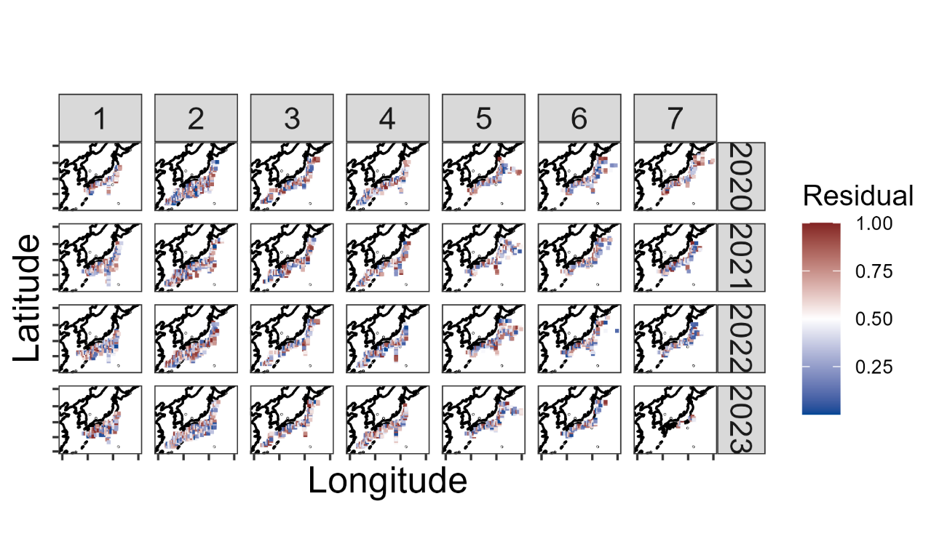
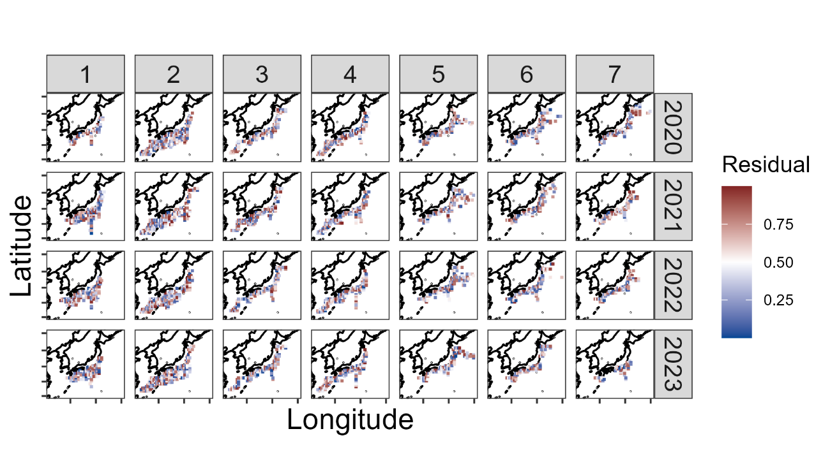
Fig. A2. Comparison of scaled residuals before (top panel) and after (bottom panel) the July 2023 update. Spatio-temporal distribution from January to July (column) in 2020-2023 (row) of the residuals.

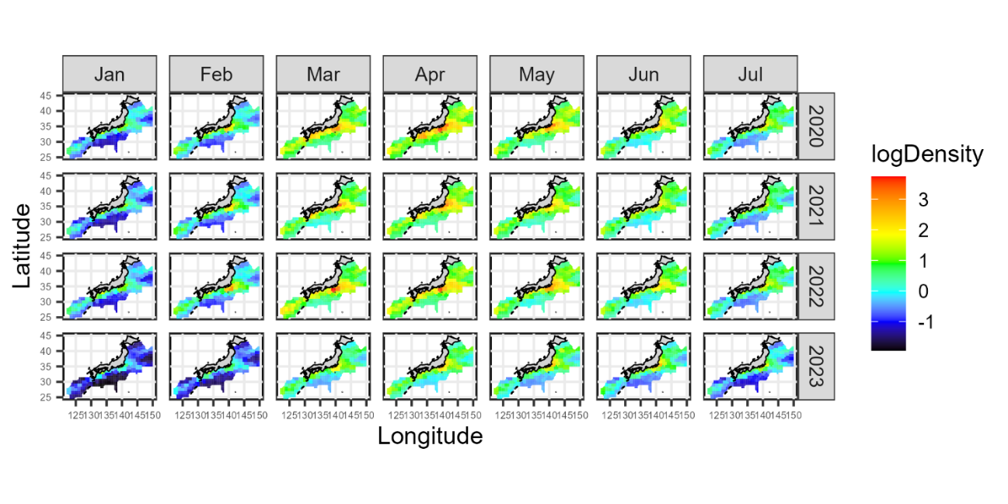
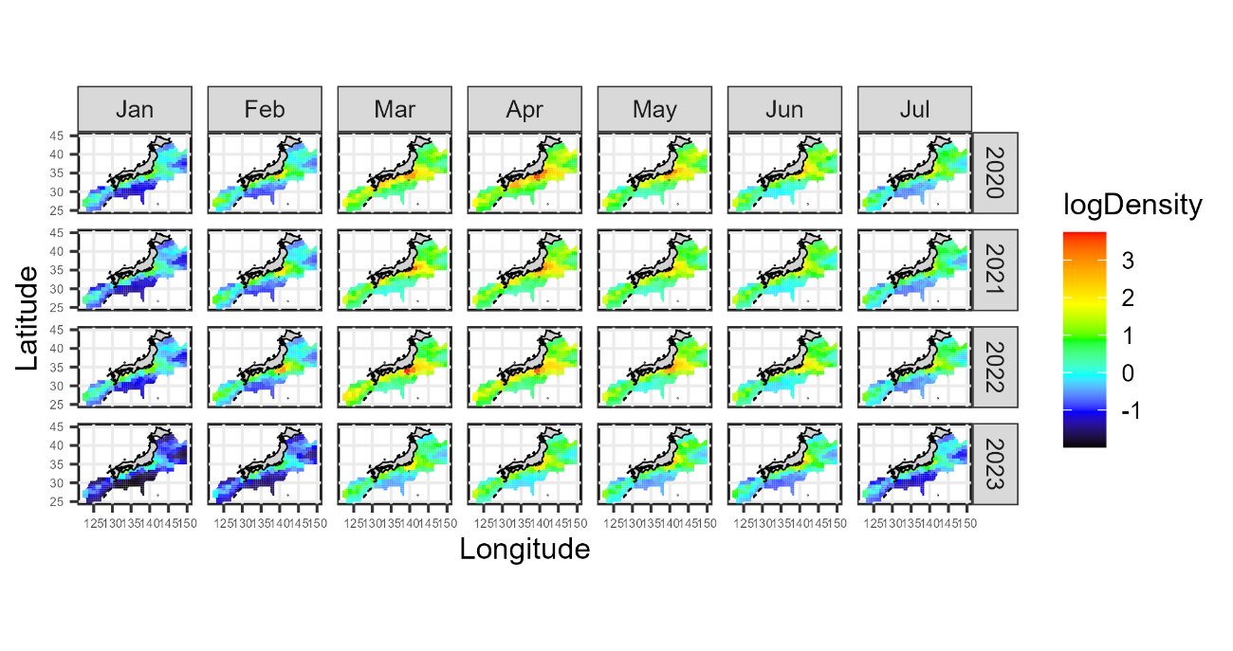
Fig. A3. Comparison of predicted egg densities before (top panel) and after (bottom panel) the July 2023 update. Spatio-temporal distributions by month (column) by year (2020-2023) are shown.

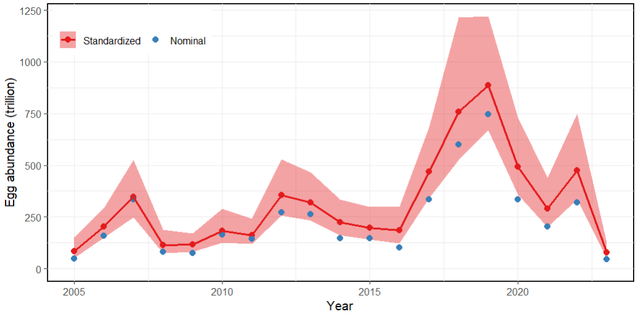

Fig. A4. Comparison of annual egg abundances before (top panel) and after (bottom panel) the July 2023 update. The yearly patterns of nominal and standardized SSB indices.

APPENDIX B: Checklist for the CPUE standardization protocol
No. | Step-by-step protocols | yes/no | Note
1 | Provide a description of the type of data (logbook, observer, survey, etc. ), and the "resolution" of the data (aggregated, set-by-set etc..). This description should also include the representativeness of the data in two tables: (1st table) Number of observations, % Coverage of CPUE fleet (catch), % Coverage of CPUE fleet (effort), Total Catch CPUE fleet (mt), Total Effort CPUE fleet, Percentage of overall catch by member (across all fleets/gears); and (2nd table) Number of records remaining, Number removed, Number of records with chub mackerel catch >0; | Yes | Section 2.1 (page 2) and Tables 1 (page 6) and 2 (page 6)
2 | Conduct a thorough literature review to identify key factors (i.e., spatial, temporal, environmental, and fisheries variables) that may influence CPUE values; | Yes | Section 2.1 (page 2)
3 | Plot annual/monthly spatial distributions of fishing efforts, catch and nominal CPUE to determine temporal and spatial resolution for CPUE standardization | Yes | Fig. 1 (pages 10-13)
4 | Make scatter plots (for continuous variables) and/or box plots (for categorical variables) and present correlation matrix if possible to evaluate correlations between each pair of those variables; | Yes | Fig. 2 (page 14)
5 | Describe selected explanatory variables based on (2)-(4) to develop full model for the CPUE standardization; | Yes | Section 2.2. (pages 2-3) and Table 3 (page 7)
6 | Specify model type and software (packages) and fit the data to the assumed statistical models (i.e., GLM, GAM, Delta-lognormal GLM, Neural Networks, Regression Trees, Habitat based models, and Statistical habitat based models); | Yes | Section 2.2. (pages 2-3)
7 | Evaluate and select the best model(s) using methods such as likelihood ratio test, information criterions, cross validation etc.; | Yes | Section 3. (page 4)
8 | Provide diagnostic plots to support the chosen model is appropriate and assumption are met (QQ plot and residual plots along with predicted values and important explanatory variables, etc.); | Yes | Figs. 3 (page 15) and 4 (pages 16-19)
9 | Present estimated values of parameters and uncertainty in the parameters in table; | Yes | Table 4 (pages 7-9)
10 | Present the relationship between the response variable and the explanatory variables. Check if it is interpretable. | Yes | Fig. 5 (pages 20-23)
11 | Extract yearly standardized CPUE and standard error by a method that is able to account for spatial heterogeneity of effort, such as least squares mean or expanded grid. If the model includes area and the size of spatial strata differs or the model includes interactions between time and area, then standardized CPUE should be calculated with area weighting for each time step. Model with interactions between area and season or month requires careful consideration on a case by case basis. Provide details on how the CPUE index was extracted. | Yes | Section 2.3. (page 3)
12 | Calculate uncertainty (SD, CV, CI) for standardized CPUE for each year. Provide detailed explanation on how the uncertainty was calculated; | Yes | Table 5 (page 9) and Fig. 6 (page 24)
13 | Provide a table and a plot of nominal and standardized CPUEs over time. When the trends between nominal and standardized CPUE are largely different, explain the reasons (e.g. spatial shift of fishing efforts), whenever possible. | Yes | Table 5 (page 9) and Fig. 6 (page 24)

