NPFC-2024-TWG CMSA09-WP06
Revised Standardized Abundance Indices for Ages 0 and 1 Fish of Chub Mackerel from Northwest Pacific Autumn Surveys up to 2023

Shota Nishijima, Momoko Ichinokawa, and Ryuji Yukami
Fisheries Resources Institute, Japan Fisheries Research and Education Agency

Summary
We conducted CPUE standardization of surface trawl surveys in autumn for Pacific chub mackerel using the Vector Autoregressive Spatio-Temporal (VAST) model. We estimated local densities of 0-year-old fish and 1-year-old fish in the Northwest Pacific from 2005 to 2023 with consideration for environmental factors of sea surface temperature (SST) and 30m-depth temperature as well as spatial autocorrelation. We slightly revised model configurations on the 1-year-old fish analysis following a suggestion from the Technical Working Group for the Chub Mackerel Stock Assessment (TWG CMSA), but results little changed. The analysis showed high levels of abundances frequently occurred since 2013. Model diagnostics found no serious problems in residual patterns. We propose the standardized indices to be utilized as the abundance indices of age-0-fish and age-1-fish in the TWG CMSA.

1. BACKGROUND
Japan Fisheries Research and Education Agency (FRA) has conducted a sea surface trawl net survey in a broad range of Northwestern Pacific Ocean (141.5º–175º E and 37.0º–50.0º N, Fig. 1) from September to October annually to collect biological and abundance information on small pelagic fish including chub mackerel (here called autumn survey). The standardized CPUE of young-of-the-year (YOY) fish from this survey had long been used in the Japanese domestic stock assessment of chub mackerel and was submitted to TWG CMSA as working papers several times (e.g., Nishijima et al. 2022). In addition to age 0 fish, FRA has completed age identification for 1-year-old (YO) fish of chub mackerel in the autumn survey samples, and then newly used the standardized CPUE of age 1 fish in the latest Japanese domestic stock assessment (Yukami et al. 2023).
In this working paper, we conducted CPUE standardization for both ages 0 and 1 fish of chub mackerel to propose the obtained standardized abundance indices be used for TWG CMSA. Although in the previous working paper (Nishijima et al. 2022) we used the 'delta-GLM-tree' (Hashimoto et al. 2019) for CPUE standardization, we used the Vector Autoregressive Spatio-Temporal (VAST) model (Thorson 2019) in this paper because VAST was found to outperform the delta-GLM-tree in terms of Akaike Information Criterion (AIC) (Yukami et al. 2023). In the previous working paper (Nishijima et al. 2022), we used in-situ sea surface temperature (SST) and 30m-depth temperature (T30) as covariates, which were highly correlated. In this analysis, we instead used principal components (PC) calculated from principal component analysis (PCA) for SST and T30 as orthogonal covariates. In summary, we have changed the following four points from the previous document (Nishijima et al. 2022):
- Updated data up to 2023,
- Conducted CPUE standardization for not only age 0 fish but also age 1 fish,
- Changed the analysis model from delta-GLM-tree to VAST, and
- Used PC instead of the original variables SST and T30 as orthogonal covariates.
This working paper was originally submitted to the TWG CMSA08 (Nishijima et al. 2024) and two future works were suggested from the TWG CMSA at that time (NPFC 2024):
- Japan could compare the effect of assuming an autoregressive process or an independent and identically distributed (IID) process in the CPUE standardization for its autumn survey.
- Since the spatial coverage of 2023 survey was narrower than those of the surveys of previous years because of bad weather, it would be worthwhile for Japan to investigate what impact, if any, the narrower sampling coverage may have had.
In this working paper, we compared previous results with the autoregressive process and those revised with the IID process according to the first suggestion, which is shown in Appendix A. In the main text, we show the revised results because the independent assumption for temporal and spatio-temporal effects would be preferred as abundance index for stock assessment models. We also investigated the impact of the narrower coverage of 2023 survey data by artificially removing samples of 2022 in the area where no survey was conducted in 2023 to address the second suggestion, which is shown in Appendix B. The text that has been revised and added since the original submission (Nishijima et al. 2024) is shown in red, and revised figures are highlighted in yellow.

2. METHOD

2.1 The data
The sea surface trawl net surveys have been conducted by FRA in a broad range of the Northwestern Pacific in autumn (September and October) annually. The autumn surveys were conducted from 2005 to 2023 in the area approximately of 141.5º–175º E and 37.0º–50.0º N (Table 1, Fig. 1A). The trawling times per towing, which were used as effort, were generally half to one hour (Fig. 1A). The CPUEs were calculated as the number of fish per hour of towing (Fig. 1B-E). The CPUE from the autumn survey has been historically aggregated for fish aged 1 year and older. However, with the implementation of age determination through otoliths, age disaggregation has been conducted for 1-year-old fish and those aged 2 years and older, allowing for the separate analysis of CPUE for 1-year-old fish. It is worth noting that the no survey were conducted near the Pacific coast of Japan in 2023 (Fig. 1A) because a bad weather condition prevented us to conduct the survey there. The TWG CMSA suggested that it would be worthwhile for Japan to investigate what impact, if any, the narrower coverage of 2023 survey data may have had (NPFC 2024). We here examine the effect of narrow survey coverage on standardized CPUE by artificially removing samples of 2022 in the area where the survey was not conducted in 2023 and show results in Appendix B.
The proportions of positive catch were lower than 45% for age 0 and 15% for age 1 until 2012 but became higher than 45% for age 0 and 20% for age 1 from 2013 to 2022 (Table 1). In 2023, however, the proportions of positive catch decreased to 30% for both ages 0 and 1. We used all samples (N = 737) because survey areas did not greatly vary and all the samples recorded necessary information for the analysis (catch, effort, location, and environmental variables).

2.2 Associations between independent variables and between dependent and independent variables
We used in situ SST and T30 as covariates in the previous document, but they were highly correlated with r = 0.67 of Pearson’s correlation coefficient (Fig. 2, left). Such collinearity in multiple regression models could destabilize parameter estimates and prediction to new data, suggesting that it might be problematic in the interpretation of results and model predictions in CPUE standardization. Therefore, we conducted the PCA and used PC1 and PC2 in the analysis, which became orthogonal covariates (Fig. 2, right). PC1 was negatively correlated with SST and T30, indicating a common component of SST and T30. By contrast, PC2 was positively correlated with SST but negatively with T50, reflecting a difference between SST and T50. The proportion of variance of PC1 and PC2 were 83.4% and 16.6%, respectively (Fig. 2).
We found that SST, PC1, and PC2 moderately varied over the years, while T30 seemed to be relatively stable (Fig. 3). SST and T30 tended to be higher in the northeast than in the southwest (Fig. 4A, B). PC1, which was negatively correlated with SST and T50, was thus higher in the northeast (Fig. 4C). PC2 tended to be higher off Hokkaido (Fig. 4D).

2.3 Full model description and model selection
We applied the VAST model (Thorson 2019) to age 0 fish and age 1 fish separately in the autumn survey. In simulations, VAST demonstrated superior overall performance in CPUE standardization compared to generalized linear models or generalized additive models (Grüss et al. 2019). In VAST, the survey CPUE is represented using two linear predictors for each sample i: the encounter probability (p₁(i)) and the density (or CPUE) when encountered (p₂(i)).
$$p_{1}\left(i\right)=β_{1}\left(t_{i}\right)+ω_{1}\left(s_{i}\right)+ε_{1}\left(s_{i},t_{i}\right)+\sum_{k_{1}}^{n_{k1}}{λ_{1}\left(k_{1}\right)Q_{i}\left(i,k_{1}\right) }$$ | (1)
$$p_{2}\left(i\right)=β_{2}\left(t_{i}\right)+ω_{2}\left(s_{i}\right)+ε_{2}\left(s_{i},t_{i}\right)+\sum_{k_{2}}^{n_{k2}}{λ_{2}(k_{2})Q_{i}(i,k_{2})}$$ | (2)
The first term on the right-hand side, $β\left(t_{i}\right)$, represents the coefficient indicating the effect of survey year t. The second term, $ω\left(s_{i}\right)$, signifies the spatial random effect for survey year t, while the third term, $ε\left(s_{i},t_{i}\right)$, denotes the spatiotemporal random effect for survey year t and location s. The fourth term represents the covariate Q influencing catchability, with its corresponding coefficient λ. In the VAST model, initially, spatial distribution is approximated by determining knots through a form of clustering called k-means from spatial information. The spatiotemporal variation in relative density at these knots is then modeled. A previous study recommend using 100 or more knots (Thorson 2019), and following this guidance, we selected 100 knots for this study (n_{S} = 100). The probability density function for spatial effects is modeled using a multivariate normal distribution (MVN):
$$ω_{1}\left(∙,f\right)\sim MVN\left(0,R_{1}\right), ω_{2}\left(∙,f\right)\sim MVN\left(0,R_{2}\right) ,$$ | (3)
where R₁ and R₂ is the Matérn correlation function:
$$R_{1}\left(s_{n},s_{m}\right)=\frac{1}{2^{φ-1}Γ(φ)}×{\left(κ_{1}\left|d\left(s_{n},s_{m}\right)H\right|\right)}^{φ}×K_{υ}\left(κ_{1}\left|d\left(s_{n},s_{m}\right)H\right|\right) ,$$ | (4)
$$R_{2}\left(s_{n},s_{m}\right)=\frac{1}{2^{φ-1}Γ(φ)}×{\left(κ_{2}\left|d\left(s_{n},s_{m}\right)H\right|\right)}^{φ}×K_{υ}\left(κ_{2}\left|d\left(s_{n},s_{m}\right)H\right|\right) .$$ | (5)
In VAST and in this analysis, the estimation of $φ$ is not conducted by assuming $φ=1$ fixed. Here, $Γ$ represents the gamma function, K_{ν} is the modified Bessel function of the second kind, $κ_{1}$ and $κ_{2}$ are decorrelation rate to be estimated, $d\left(s_{n},s_{m}\right)$ is the distance between knots, and H is the matrix representing geographical anisotropy (variation in correlation depending on the direction). However, geographical anisotropy was not assumed ($H=I$) due to challenges in estimation. Similarly, the probability density function for spatiotemporal effects is given as follows:
$$ε_{1}\left(∙,f,t\right)\sim \left\{\begin{matrix}MVN(0,R_{1}) & if t=1 \\ MVN(ρ_{ε1}ε_{1}\left(∙,f,t-1\right),R_{1}) & if t>1\end{matrix}\right. ,$$ | (6)
$$ε_{2}\left(∙,f,t\right)\sim \left\{\begin{matrix}MVN(0,R_{2}) & if t=1 \\ MVN(ρ_{ε2}ε_{2}\left(∙,f,t-1\right),R_{2}) & if t>1\end{matrix}\right. .$$ | (7)
We used different model configurations between age-0-fish and age-1-fish considering the nature of data and estimated parameters (Table 2). In the age-0 analysis, the effects for each year (β) were estimated as fixed effects in both the first and second predictors. In the second predictor (positive CPUE when encountered), we turned-off the spatial effect ($ω_{2}$) for age 0 because in a model with no environmental covariates the variance explained by this spatial effect was almost zero and it was suggested to turn off the spatial effect by the check_fit function in VAST. We tuned-off the spatio-temporal effect in the first predictor (positive CPUE when encountered, $ε_{1}$) for age 0 by the same reason, while we assumed independence of each year in the second predictor ($ε_{2}$).
Regarding age-1-fish, no fish were captured throughout the survey in 2006 and 2007 (Table 2). We therefore estimated the year effect as random effects under the IID process in the first predictor for encounter probability. On the other hand, we assumed that the year effect to be constant over years in the second predictor because the variance explained by the year effect with the IID process was almost zero, revealed by the check_fit function in VAST. We tuned off the spatial effect in the second predictor for age 1 by the same reason as age 0. We assumed the spatio-temporal effects to be independent over years in the first and second predictors so that the abundance index obtained would be likely to be independent among years. These model configurations for the age-1-fish analysis were revised from the initial submission (Nishijima et al. 2024) where we used a temporally autocorrelated process for the temporal and spatio-temporal effects. We compared previous and revised results in Appendix A.
In the analysis, a delta-type model employing the binomial distribution and gamma distribution was utilized. The predicted encounter rate (r₁(i)) and predicted CPUE when encountered (r₂(i)) were expressed using the following equations (Thorson 2017):
$$r_{1}\left(i\right)={logit}^{-1}p_{1}\left(i\right) ,$$ | (10)
$$r_{2}\left(i\right)=a_{i}×\log^{-1}p_{2}\left(i\right) .$$ | (11)
Although the term a_{i} represents the offset variable, it was set to 1 with CPUE as the dependent variable. The probability of observing CPUE is expressed as follows, and the parameters that maximize the marginal likelihood were estimated.
$$\operatorname{Pr}\left(b_{i}=B\right)=\left\{\begin{matrix}1-r_{1}\left(i\right) & if B=0 \\ r_{1}\left(i\right)×g\{\left.B|r_{2}\left(i\right),σ_{m}^{2}\}\right. & if B>0\end{matrix}\right.$$ |  | (12)
The parameters of the aforementioned model are estimated using the maximum likelihood method. In this document, we used the ‘VAST’ package distributed by GitHub (https://github.com/James-Thorson-NOAA/VAST, Thorson 2019), where complex computations involving integrals due to the involvement of numerous random effects are efficiently analyzed using a software called Template Model Builder (Kristensen et al. 2016).
The covariate Q, influencing catchability, includes PC1, PC2, the square terms of PC1 and PC2, and interaction terms between PC1 and PC2 (Table 3). Model selection was conducted using exhaustive search based on Akaike Information Criterion with correction (AICc).

2.4 Yearly trend extraction
The abundance index was calculated by employing the model with minimum AICc. In VAST, densities for each year and location are computed as $d\left(s,t\right)=r_{1}^{*}(x,t)×r_{2}^{*}(x,t)$, where r* is obtained using equations 10 and 11 from equations 1 and 2, excluding the fourth term regarding catchability. The abundance is then determined by summing the product of the area ($a\left(s\right)$) and density for each knot. Since the density is represented by CPUE (individuals/hour) in this analysis, the standardized CPUE (individuals/hour) was calculated by dividing the sum by the total area.
$$I\left(t\right)=\frac{\sum_{s=1}^{n_{s}}{\left(a(s)×d\left(s,t\right)\right)}}{\sum_{s=1}^{n_{S}}{a(s)}}$$ | (13)
The total sum of the areas for each knot from S=1 to 100 (=n_{S}) remains constant across years; therefore, this procedure does not alter the relative trends of the standardized index values.

3. RESULT and DISCUSSION
The selected variables in the best model of age 0 fish were only PC1 and its squared term for both binomial and gamma distributions (Table 3). In the same way, PC1 and its squared term were selected in the best model for age 1 both binomial and gamma distributions (Table 4). The maximum likelihood estimates and standard errors of fixed-effect parameters did not exhibit extreme values, and the gradients were all close to zero (Tables 5, 6). The percent deviance explained was 47.9% for the age 0 fish analysis and 60.0% for the age 1 fish analysis.
We generated scaled residuals using the R package ‘DHARMa’ (Hartig 2022) for model diagnostics. This package enables to simulate the scaled residuals which should theoretically follow the uniform distribution from zero to one. As a result, the QQ plot and the Kolmogorov-Smirnov test showed that the scaled residuals were not significantly deviated from the theoretical prediction of the uniform distribution for both ages o and 1 (Fig. 5). Moreover, the scaled residuals were almost constant in response to varying predicted CPUE and dependent variables (PC1, PC2 and year) (Fig. 6). It also seemed that there were no systematic spatial patterns in the scaled residuals (Fig. 7).
Estimated densities of age 0 fish and age 1 fish were low until 2012, but increased thereafter (Fig. 8). The distribution centroid of age 0 fish has shifted to offshore to east longitude 159 degrees and north latitude 44.5 degrees or higher since 2013. The distribution of 1-year-old fish has more clearly shifted offshore, and over the 19-year period from 2005 to 2023, the centroid of the distribution has increased by approximately 15 degrees in longitude and about 5 degrees in latitude.
The partial dependence plot showed that the encounter probability and the positive CPUE when encountered for age 0 fish exhibited concave-down responses to PC1 (Fig. 9A). Assuming that the original variables SST and T50 change “independently,” the responses to changes in each variable were examined through partial dependence plots. As a result, it was indicated that the expected CPUE was the highest when SST was 17.4°C and T30 was 15.8°C. The encounter probability and positive CPUE of age 1 fish both showed concave-down responses to PC1 and no response to PC2 (not selected in the best model) (Fig. 9B). For age 1 fish, the expected CPUE was the highest when SST was 12.5°C and T30 was 8.8°C.
Standardized CPUE of age 0 remained low until 2012, but high values were frequently observed since 2013 (Fig. 10, upper). Especially in 2013, 2016, and 2018, the values were high, whereas the value of latest year (2023) was the lowest since 2013. This yearly trend of the standardized CPUE was not greatly different from that of nominal CPUE The coefficients of variation (CV) of the standardized age-0 CPUE were in the range of 0.30−0.53 except for 2006 and 2023, when the nominal and standardized CPUEs were the lowest (CV = 0.69 in 2006) or the number of stations was the lowest (CV = 0.79 in 2023) (Table 7).
Standardized CPUE of age 1 also remained low until 2012, and thereafter gradually increased with a fluctuation until 2019 (Fig. 10, lower). However, the standardized CPUE remained stable at moderate levels in latest four years (2020-2023). The standardized values were apparently lower in 2014 and 2018 than nominal values because extremely high CPUE values over 4,500 individuals/hour were observed and smoothed by the temporal and spatio-temporal effects in these years. The CV of the age-1 standardized CPUE were in the range of 0.26−0.41 except for 2006 and 2007, when no individuals of age 1 fish were captured in the survey (CV = 0.64 and 0.65 in 2006 and 2007, respectively) (Table 8).
When comparing the trends of standardized indices for 0-year-old and 1-year-old fish, a consistent pattern emerges where the 2013 and 2018 year classes exhibit higher values in both indices (Fig 11, upper). However, for the 2012, 2015, and 2017 year classes, differences are observed between the two indices. To assess the validity of the newly analyzed index for 1-year-old fish, we also examined the correlation between the logarithmically transformed standardized indices of 0-year-old fish and 1-year-old fish. The results revealed a high correlation, with a Pearson correlation coefficient of 0.84 (Fig. 11, left). Furthermore, a linear regression was conducted with the logarithmically transformed indices of 1-year-old fish as the dependent variable and the logarithmically transformed indices of 0-year-old fish as the independent variable, resulting in a statistically significant outcome (y = 0.09 + 0.60x, t = 6.16, p < 0.001). These findings suggest that the standardized index for 1-year-old fish likely contain information about the abundance of each cohort and are less likely to conflict with the standardized index for 0-year-old fish.
We compared the standardized abundance index of age 1 in the main text with that at the initial submission where we used the autoregressive process for temporal and spatio-temporal effects (Nishijima et al. 2024) in Appendix A. The results showed that the standardized yearly trends little changed (Fig. A1). Moreover, we also conducted a computational experiment by artificially removing samples of 2022 in the area where no survey was conducted in 2023. This analysis also little changed the standardized abundance indices, suggesting a low influence of the narrow spatial coverage in 2023 on the standardized abundance indices. These two analyses ensure the robustness of our CPUE standardization for age-0 and age-1 fish in the autumn survey against model configuration and sampling coverage.
In conclusion, the standardized indices obtained from this analysis cover a long time series from periods of poor chub mackerel recruitment in the Pacific to times of high recruitment. This provides highly valuable information for CMSA. In addition to covering a broad survey area, the use of the cutting-edge VAST model and favorable results from model diagnostics make these standardized indices useful. Therefore, we propose utilizing the two standardized indices from the autumn survey as abundance indices of the numbers of age-0 fish and age-1 fish t for the chub mackerel stock assessment in TWG CMSA.

REFERENCES
Grüss, A., J. F. Walter III, E. A. Babcock, F. C. Forrestal, J. T. Thorson, M. V. Lauretta and M. J. Schirripac (2019) Evaluation of the impacts of different treatments of spatio-temporal variation in catch-per-unit-effort standardization models. Fish. Res., 213, 75–93.
Hartig, F. (2022) DHARMa: Residual Diagnostics for Hierarchical (Multi-Level/Mixed) Regression Models. R package version 0.4.5. https://CRAN.R-project.org/package=DHARMa.
Hashimoto, M., S. Nishijima, R. Yukami, C. Watanabe, Y. Kamimura, S. Furuichi, M. Ichinokawa, and H. Okamura. 2019. Spatiotemporal dynamics of the Pacific chub mackerel revealed by standardized abundance indices. Fisheries Research 219:105315.
Kristensen, K., A. Nielsen, C. E. Berg, H. Skaug and B. M. Bell (2016) TMB: automatic differentiation and Laplace approximation. J. Stat. Softw., 70, 1–21.
Nishijima, S., Kisara Y., Ichinokawa M., Yukami R., Kamimura Y., Manabe A. (2022) Standardizing abundance index for recruitment of chub mackerel in the Northwet Pacific. NPFC-2022-TWG CMSA06-WP11 (Rev. 1).
Nishijima, S., Ichinokawa M., Yukami R. (2024) Standardized abundance indices for ages 0 and 1 fish of chub mackerel from Northwest Pacific autumn surveys up to 2023. NPFC-2024-TWG CMSA08-WP08 (Rev. 1).
NPFC (2024) 8th Meeting of the Technical Working Group on Chub Mackerel Stock Assessment. NPFC-2024-TWG CMSA08-Final Report.
Thorson, J. T. (2017) Three problems with the conventional delta-model for biomass sampling data, and a computationally efficient alternative. Can. J. Fish. Aquat. Sci., 75, 1369-1382.
Thorson, J. T. (2019) Guidance for decisions using the Vector Autoregressive Spatio-Temporal (VAST) package in stock, ecosystem, habitat and climate assessments. Fish. Res., 210, 143-161.
Yukami R., Nishijima S., Kamimura Y., Furuichi S., Watanabe R. (2023) Stock assessment and evaluation for the Pacific stock of chub mackerel (fiscal year 2022). Marine fisheries stock assessment and evaluation for Japanese waters. Japan Fisheries Agency and Japan Fisheries Research and Education Agency, Tokyo, 79pp, https://abchan.fra.go.jp/wpt/wp-content/uploads/2023/04/details_2022_05.pdf

Table 1
Catch and effort information by SURVEY FLEET.
Year | Number of observations (stations) | Total trawling time (h) | Total Catch of age 0 fish (ind) | Number of positive catch  (age 0) | % positive catch  (age 0) | Total Catch of age 1 fish (ind) | Number of positive catch  (age 1) | % positive catch  (age 1)
2005 | 54 | 30.6 | 640.0 | 14 | 25.9 | 50.0 | 5 | 9.3
2006 | 59 | 33.1 | 34.0 | 5 | 8.5 | 0.0 | 0 | 0.0
2007 | 46 | 28.0 | 233.0 | 13 | 28.3 | 0.0 | 0 | 0.0
2008 | 41 | 28.0 | 202.0 | 9 | 22.0 | 75.0 | 4 | 9.8
2009 | 49 | 34.5 | 1843.7 | 22 | 44.9 | 14.8 | 4 | 8.2
2010 | 50 | 39.0 | 647.3 | 19 | 38.0 | 27.7 | 5 | 10.0
2011 | 44 | 31.9 | 114.0 | 12 | 27.3 | 51.0 | 6 | 13.6
2012 | 37 | 33.0 | 607.9 | 16 | 43.2 | 6.1 | 4 | 10.8
2013 | 39 | 31.0 | 38953.4 | 26 | 66.7 | 1910.5 | 24 | 61.5
2014 | 32 | 23.0 | 3265.6 | 23 | 71.9 | 7918.6 | 24 | 75.0
2015 | 34 | 30.0 | 4970.4 | 18 | 52.9 | 116.0 | 17 | 50.0
2016 | 29 | 21.5 | 36196.8 | 15 | 51.7 | 1412.3 | 11 | 37.9
2017 | 29 | 17.5 | 14436.5 | 14 | 48.3 | 965.2 | 13 | 44.8
2018 | 28 | 18.5 | 99627.2 | 26 | 92.9 | 13808.4 | 26 | 92.9
2019 | 26 | 16.6 | 3801.4 | 20 | 76.9 | 7193.8 | 20 | 76.9
2020 | 35 | 23.6 | 21006.7 | 26 | 74.3 | 379.9 | 24 | 68.6
2021 | 43 | 31.5 | 24969.5 | 31 | 72.1 | 1029.1 | 21 | 48.8
2022 | 35 | 25.6 | 14713.4 | 26 | 74.3 | 1397.8 | 21 | 60.0
2023 | 27 | 27.0 | 1898.2 | 8 | 29.6 | 1218.3 | 8 | 29.6

Table 2
Summary of explanatory variables used in VAST.
Variable | Symbol¹ | Number of categories | General configuration | Configuration of age-0-fish analysis | Configuration of age-1-fish analysis
Year | $$β\left(t\right)$$ | 18 | 2005-2023 | Categorical variable with fixed effects in both the first and second predictors | - Estimated as random effects  - Assume to be independent identically distributed (IID) in the first predictor  - Assume to be constant among years in the second predictor
Spatial | $$ω\left(s\right)$$ | - | Estimated as random effects by SPDE approximation | Turn off in the second predictor | Turn off in the second predictor
Spatio-temporal | $$ε\left(s,t\right)$$ | 18  (the number of years) | Estimated as random effects by SPDE approximation | - Turn-off in the first predictor  - Assume to be independent identically distributed (IID) in the second predictor | Assume IID for the first and second predictors
PC1 | $$λ(k)Q_{i}(i,k))$$ | - | - Negative correlation for SST and T30  - Continuous variable as a catchability covariate | No specific configurations for age 0 | No specific configurations for age 1
PC1 squared | $$λ(k)Q_{i}(i,k))$$ | - | Continuous variable as a catchability covariate | No specific configurations for age 0 | No specific configurations for age 1
PC2 | $$λ(k)Q_{i}(i,k))$$ | - | - Positive correlation for SST and negative correlation for T30  - Continuous variable as a catchability covariate | No specific configurations for age 0 | No specific configurations for age 1
PC2 squared | $$λ(k)Q_{i}(i,k))$$ | - | Continuous variable as a catchability covariate | No specific configurations for age 0 | No specific configurations for age 1
PC1 X PC2 | $$λ(k)Q_{i}(i,k))$$ | - | - Interaction between the two PC axes  - Continuous variable as a catchability covariate | No specific configurations for age 0 | No specific configurations for age 1
1: See equations 1-2.

Table 3
Top 20 models from the minimum AICc in the age-0 fish analysis. B: selected by the binomial-distribution model. G: selected by the Gamma-distribution model.
Rank | PC1 | PC1 squared | PC2 | PC2 squared | PC1 x PC2 | Df | logLik | AICc | ΔAICc
1 | B,G | B,G |  |  |  | 47 | -2559.87 | 5220.30 | 0.00
2 | B,G | B,G | B |  |  | 48 | -2559.58 | 5221.99 | 1.69
3 | B,G | B,G | G |  |  | 48 | -2559.84 | 5222.52 | 2.23
4 | B,G | B,G | G |  | G | 49 | -2558.79 | 5222.71 | 2.41
5 | B,G | B,G | B |  | B | 49 | -2558.96 | 5223.06 | 2.77
6 | B,G | B,G | B,G |  |  | 49 | -2559.54 | 5224.22 | 3.92
7 | B,G | B,G | B | B |  | 49 | -2559.57 | 5224.27 | 3.98
8 | B,G | B,G | B,G |  | G | 50 | -2558.49 | 5224.42 | 4.12
9 | B,G | B,G | G | G |  | 49 | -2559.84 | 5224.82 | 4.52
10 | B,G | B,G | G | G | G | 50 | -2558.78 | 5224.99 | 4.70
11 | B,G | B,G | B,G |  | B | 50 | -2558.93 | 5225.30 | 5.00
12 | B,G | B,G | B | B | B | 50 | -2558.96 | 5225.35 | 5.05
13 | B,G | B,G | B,G |  | B,G | 51 | -2557.88 | 5225.50 | 5.21
14 | B,G | B,G | B,G | B |  | 50 | -2559.54 | 5226.51 | 6.22
15 | B,G | B,G | B,G | G |  | 50 | -2559.54 | 5226.52 | 6.22
16 | B,G | B,G | B,G | G | G | 51 | -2558.48 | 5226.70 | 6.41
17 | B,G | B,G | B,G | B | G | 51 | -2558.49 | 5226.71 | 6.42
18 | B,G | B,G | B,G | B | B | 51 | -2558.93 | 5227.59 | 7.30
19 | B,G | B,G | B,G | G | B | 51 | -2558.93 | 5227.61 | 7.31
20 | B,G | B,G | B,G | G | B,G | 52 | -2557.87 | 5227.80 | 7.50

Table 4
Top 20 models from the minimum AICc in the age-1 fish analysis. B: selected by the binomial-distribution model. G: selected by the Gamma-distribution model.
Rank | PC1 | PC1 squared | PC2 | PC2 squared | PC1 x PC2 | Df | logLik | AICc | ΔAICc
1 | B,G | B,G |  |  |  | 13 | -1474.26 | 2975.02 | 0.00
2 | B,G | B,G | G | G |  | 15 | -1472.57 | 2975.81 | 0.79
3 | B,G | B,G | B |  | B | 15 | -1472.61 | 2975.89 | 0.87
4 | B,G | B,G | B,G | G | B | 17 | -1470.93 | 2976.71 | 1.68
5 | B,G | B,G | B |  |  | 14 | -1474.19 | 2976.96 | 1.94
6 | B,G | B,G | G |  |  | 14 | -1474.26 | 2977.09 | 2.07
7 | B,G | B,G | G | G | G | 16 | -1472.29 | 2977.33 | 2.30
8 | B,G | B,G | B | B | B | 16 | -1472.44 | 2977.64 | 2.61
9 | B,G | B,G | B,G | G |  | 16 | -1472.51 | 2977.77 | 2.74
10 | B,G | B,G | B,G |  | B | 16 | -1472.61 | 2977.97 | 2.95
11 | B,G | B,G | B,G | G | B,G | 18 | -1470.64 | 2978.23 | 3.21
12 | B,G | B,G | B | B |  | 15 | -1473.85 | 2978.36 | 3.33
13 | B,G | B,G | B,G | B,G | B | 18 | -1470.75 | 2978.46 | 3.44
14 | B,G | B,G | B,G |  |  | 15 | -1474.19 | 2979.04 | 4.01
15 | B,G | B,G | B,G | B,G |  | 17 | -1472.16 | 2979.17 | 4.15
16 | B,G | B,G | G |  | G | 15 | -1474.25 | 2979.17 | 4.15
17 | B,G | B,G | B,G | G | G | 17 | -1472.22 | 2979.29 | 4.26
18 | B,G | B,G | B,G | B | B | 17 | -1472.43 | 2979.72 | 4.70
19 | B,G | B,G | B,G | B,G | B,G | 19 | -1470.47 | 2979.99 | 4.97
20 | B,G | B,G | B,G |  | B,G | 17 | -1472.61 | 2980.07 | 5.04

Table 5
Maximum likelihood estimates (MLE), standard errors (SE), and final gradients of parameters in the age-0 fish analysis.
Parameter | MLE | SE | Final gradient
beta1_ft | -1.7922 | 0.7257 | 2.08E-10
beta1_ft | -3.4685 | 0.8076 | 4.29E-10
beta1_ft | -1.8878 | 0.7391 | 4.76E-11
beta1_ft | -2.3375 | 0.7535 | 2.09E-10
beta1_ft | -1.3894 | 0.7280 | -8.15E-11
beta1_ft | -1.2921 | 0.7226 | -2.60E-10
beta1_ft | -1.9572 | 0.7509 | 3.21E-10
beta1_ft | -0.3013 | 0.7240 | -7.78E-10
beta1_ft | 0.8928 | 0.7494 | -1.46E-10
beta1_ft | 0.3525 | 0.7777 | -1.72E-10
beta1_ft | -0.4380 | 0.7417 | -3.83E-10
beta1_ft | 0.2864 | 0.7817 | -1.75E-10
beta1_ft | -0.7314 | 0.7855 | 1.33E-10
beta1_ft | 2.2594 | 1.0382 | 3.95E-10
beta1_ft | 0.9158 | 0.8236 | 7.52E-11
beta1_ft | 0.9472 | 0.7630 | -1.70E-10
beta1_ft | 1.1884 | 0.7510 | -2.85E-10
beta1_ft | 1.4326 | 0.7907 | 1.18E-10
beta1_ft | -1.2357 | 0.7906 | -4.20E-11
lambda1_k | -0.2665 | 0.0706 | -2.22E-10
lambda1_k | 0.6775 | 0.1630 | -6.09E-10
L_omega1_z | 1.2590 | 0.2684 | 4.25E-10
logkappa1 | -5.3717 | 0.3346 | -2.65E-09
beta2_ft | 4.6248 | 0.4079 | -3.25E-10
beta2_ft | 2.5686 | 0.6645 | -6.45E-11
beta2_ft | 4.2382 | 0.5228 | -1.18E-11
beta2_ft | 3.8200 | 0.5682 | -8.80E-10
beta2_ft | 4.9572 | 0.4442 | 1.40E-09
beta2_ft | 4.1710 | 0.4447 | -5.16E-10
beta2_ft | 2.7581 | 0.5597 | -1.21E-10
beta2_ft | 4.0757 | 0.4844 | -6.07E-10
beta2_ft | 8.1410 | 0.4540 | 1.05E-09
beta2_ft | 5.4891 | 0.4920 | 3.81E-09
beta2_ft | 5.9242 | 0.4906 | -2.49E-09
beta2_ft | 8.1370 | 0.5820 | 6.51E-10
beta2_ft | 7.3770 | 0.5578 | 2.32E-09
beta2_ft | 9.0683 | 0.4894 | -1.65E-09
beta2_ft | 5.6089 | 0.5190 | 3.05E-09
beta2_ft | 7.4010 | 0.5061 | -2.51E-09
beta2_ft | 6.7798 | 0.4849 | 2.41E-09
beta2_ft | 6.7599 | 0.5062 | -2.04E-09
beta2_ft | 4.5405 | 1.1384 | 6.35E-09
lambda2_k | -0.3823 | 0.0820 | 3.12E-08
lambda2_k | -0.0429 | 0.1335 | 9.89E-09
L_epsilon2_z | 0.2155 | 0.0796 | 5.17E-07
logkappa2 | -5.0799 | 0.5091 | -2.19E-07
logSigmaM | 0.3493 | 0.0368 | 7.05E-08

Table 6
Maximum likelihood estimates (MLE), standard errors (SE), and final gradients of parameters in the age-1 fish analysis.
Parameter | MLE | SE | Final gradient
lambda1_k | -0.3771 | 0.1101 | -8.62E-14
lambda1_k | 0.8356 | 0.2323 | 1.97E-12
L_omega1_z | 1.3427 | 0.3655 | -4.16E-12
L_epsilon1_z | 1.2236 | 0.2738 | -3.09E-11
L_beta1_z | 2.9757 | 0.6811 | 1.03E-11
logkappa1 | -5.8057 | 0.2605 | -1.70E-11
Beta_mean1_c | -1.9077 | 1.2777 | 4.17E-14
beta2_ft | 4.0570 | 0.3393 | -6.39E-14
lambda2_k | -0.3295 | 0.1090 | 5.86E-13
lambda2_k | 0.3244 | 0.1948 | -8.73E-14
L_epsilon2_z | 1.2932 | 0.3186 | -3.20E-13
logkappa2 | -5.5967 | 0.4707 | 3.38E-14
logSigmaM | 0.4079 | 0.0521 | -2.85E-13

Table 7
Nominal and standardized CPUE of age-0 fish with CV and 95% CI from 2005 to 2023.
Year | Nominal (ind/h) | Standardized (ind/h) | CV | Lower 95%CI | Upper 95%CI
2005 | 23.24 | 21.63 | 0.44 | 8.54 | 54.79
2006 | 0.78 | 0.79 | 0.69 | 0.17 | 3.74
2007 | 9.98 | 14.58 | 0.50 | 4.85 | 43.82
2008 | 9.54 | 7.19 | 0.53 | 2.17 | 23.78
2009 | 60.76 | 42.41 | 0.39 | 17.73 | 101.40
2010 | 16.62 | 20.83 | 0.38 | 8.74 | 49.61
2011 | 3.48 | 3.46 | 0.48 | 1.12 | 10.73
2012 | 18.24 | 32.48 | 0.40 | 13.16 | 80.18
2013 | 1287.61 | 2840.92 | 0.36 | 1263.94 | 6385.44
2014 | 117.37 | 177.95 | 0.39 | 73.27 | 432.18
2015 | 166.33 | 209.74 | 0.38 | 86.80 | 506.80
2016 | 1303.30 | 2584.59 | 0.46 | 881.51 | 7578.00
2017 | 685.39 | 821.79 | 0.44 | 286.12 | 2360.30
2018 | 5765.05 | 10287.65 | 0.34 | 4547.86 | 23271.50
2019 | 165.91 | 262.77 | 0.36 | 109.32 | 631.57
2020 | 684.06 | 1611.04 | 0.33 | 713.31 | 3638.59
2021 | 646.41 | 929.35 | 0.30 | 447.15 | 1931.57
2022 | 471.63 | 976.33 | 0.32 | 441.74 | 2157.88
2023 | 70.30 | 39.63 | 0.79 | 4.88 | 322.03

Table 8
Nominal and standardized CPUE of age-1 fish with CV and 95% CI from 2005 to 2023.
Year | Nominal (ind/h) | Standardized (ind/h) | CV | Lower 95%CI | Upper 95%CI
2005 | 1.85 | 6.53 | 0.40 | 1.55 | 27.45
2006 | 0.00 | 0.93 | 0.64 | 0.03 | 31.94
2007 | 0.00 | 1.17 | 0.65 | 0.03 | 43.91
2008 | 3.66 | 5.69 | 0.39 | 1.27 | 25.54
2009 | 0.60 | 1.65 | 0.41 | 0.24 | 11.43
2010 | 1.07 | 3.95 | 0.38 | 0.86 | 18.13
2011 | 2.32 | 3.96 | 0.37 | 0.84 | 18.65
2012 | 0.27 | 5.61 | 0.41 | 0.91 | 34.62
2013 | 65.17 | 70.81 | 0.26 | 30.19 | 166.10
2014 | 341.64 | 124.59 | 0.26 | 56.55 | 274.45
2015 | 4.75 | 17.07 | 0.31 | 5.16 | 56.48
2016 | 90.05 | 116.46 | 0.33 | 37.64 | 360.29
2017 | 105.49 | 50.03 | 0.31 | 17.38 | 143.99
2018 | 1186.44 | 301.42 | 0.31 | 118.00 | 769.98
2019 | 436.80 | 341.63 | 0.33 | 118.67 | 983.51
2020 | 17.36 | 29.97 | 0.29 | 10.46 | 85.89
2021 | 30.17 | 40.49 | 0.29 | 14.81 | 110.67
2022 | 43.74 | 107.58 | 0.26 | 45.68 | 253.36
2023 | 45.12 | 37.73 | 0.34 | 9.39 | 151.62

Figure 1A
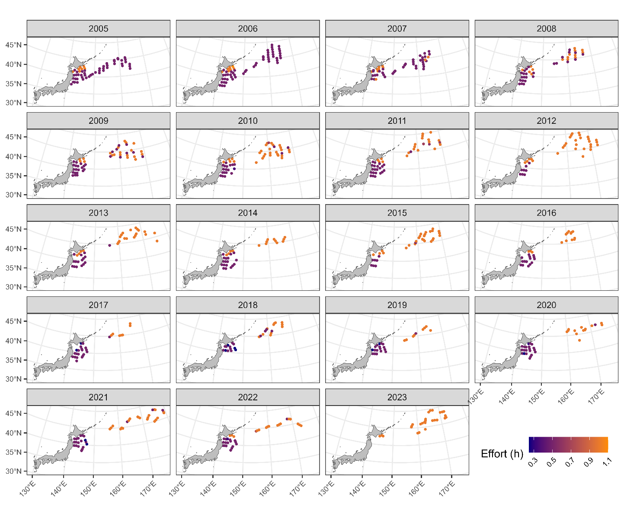
Map of autumn survey stations from 2005 to 2023. Colors indicate trawling time.

Figure 1B
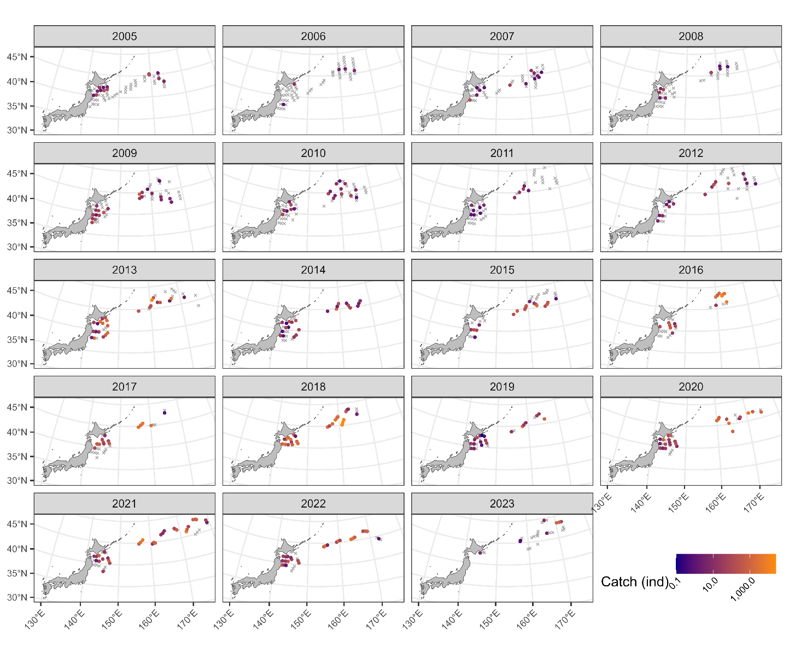
Map of catch amounts of age 0 from 2005 to 2023 in the autumn survey. The gray X indicates zero catch while the colors of circles indicate the amount of positive catch.

Figure 1C
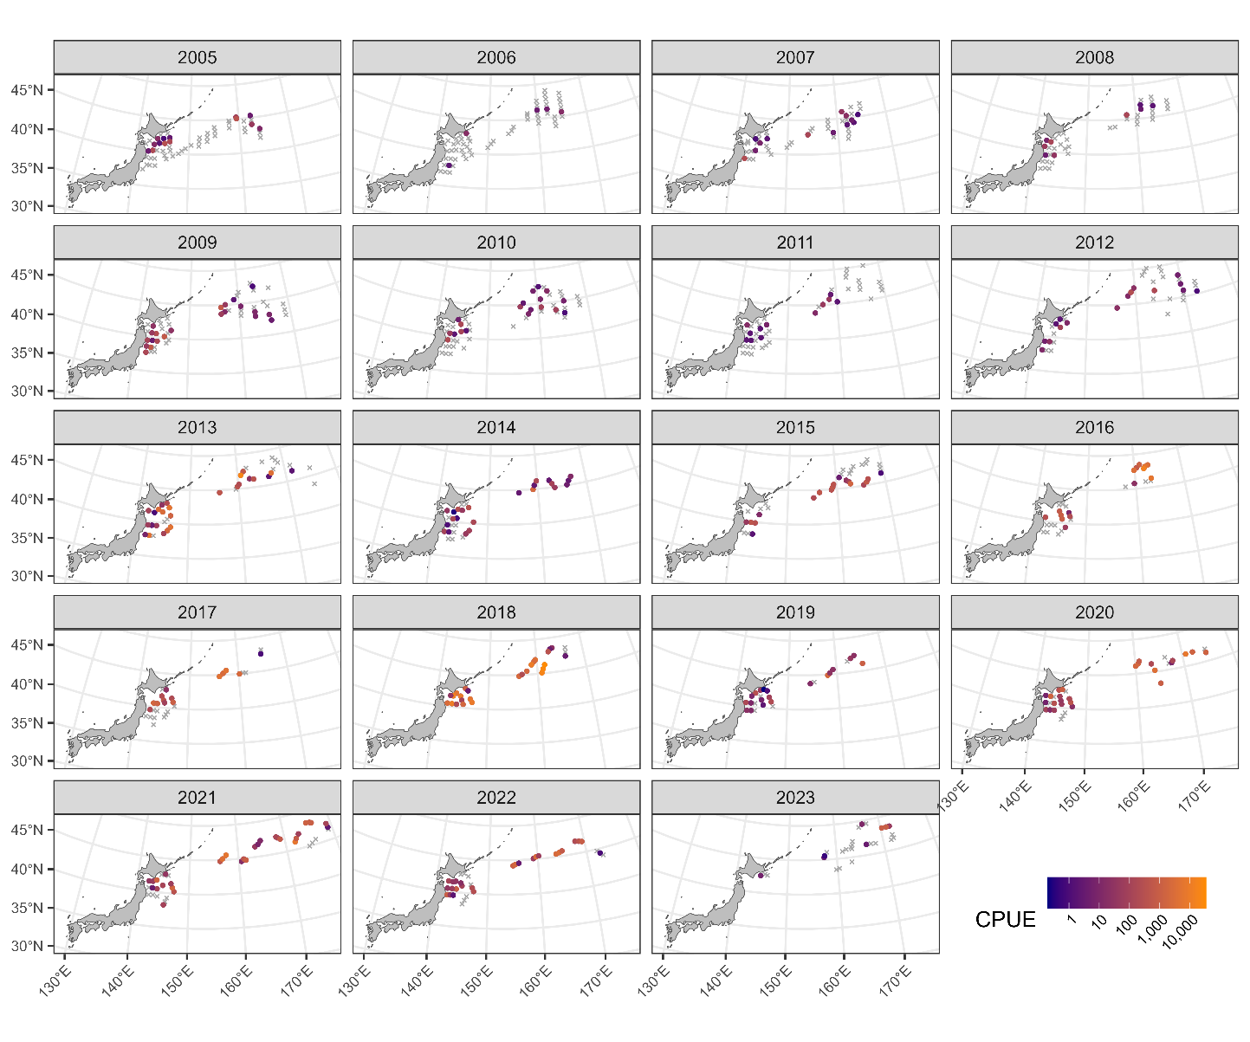
Map of CPUE (ind/h) of age 0 from 2005 to 2023 in the autumn survey. The gray X indicates zero catch while the colors of circles indicate the amount of positive catch.

Figure 1D
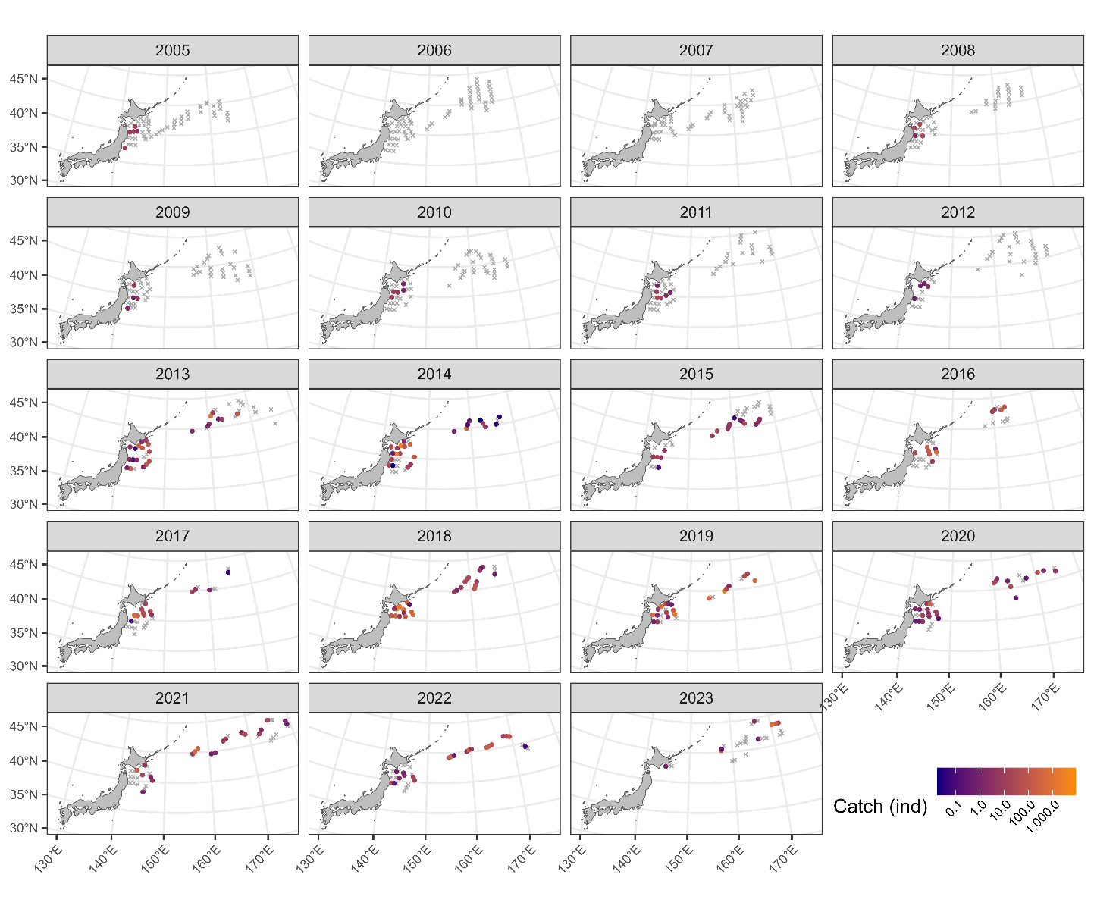
Map of catch amounts of age 0 from 2005 to 2023 in the autumn survey. The gray X indicates zero catch while the colors of circles indicate the amount of positive catch.

Figure 1E
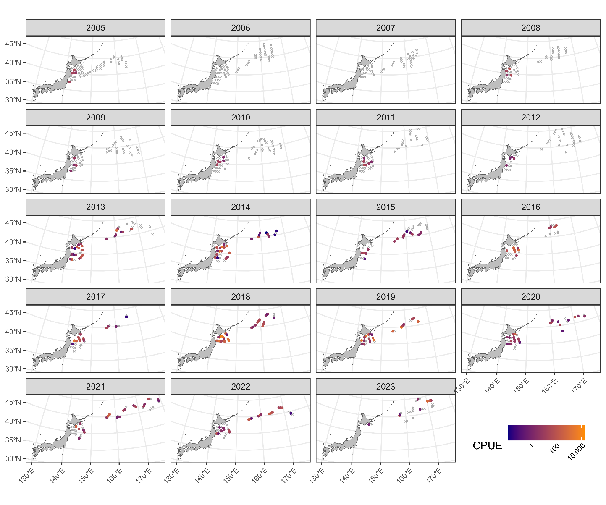
Map of CPUE (ind/h) of age 1 from 2005 to 2023 in the autumn survey. The gray X indicates zero catch while the colors of circles indicate the amount of positive catch.

Figure 2
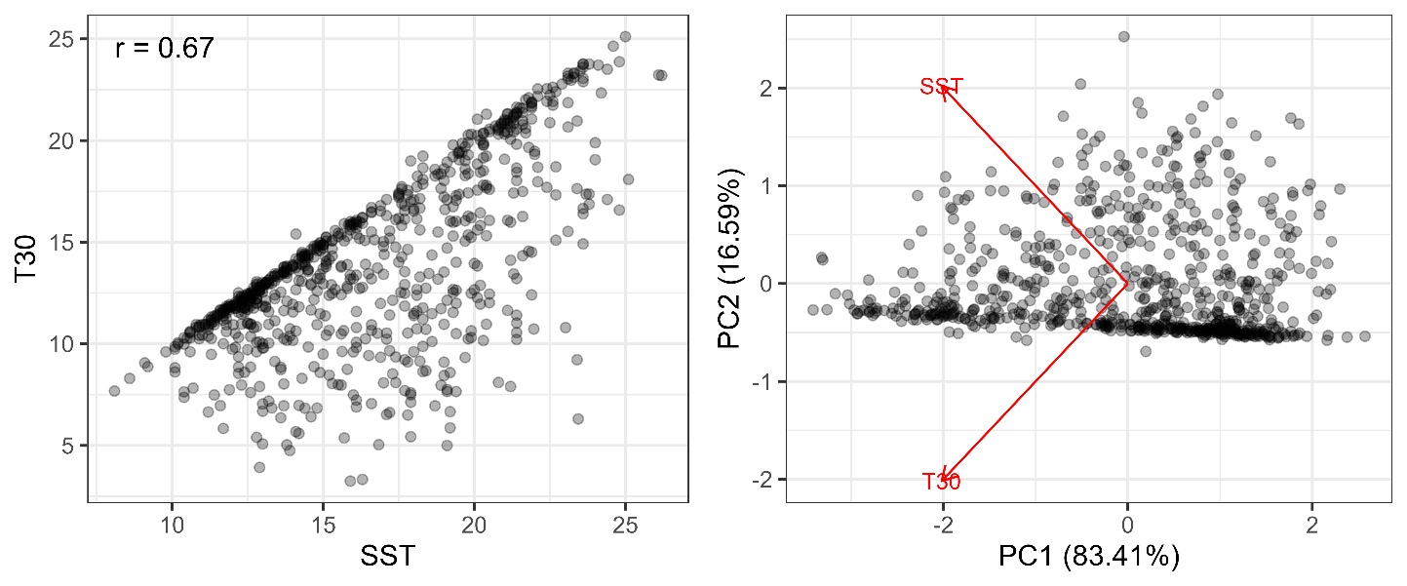
(left) Relationship between SST and T30 (30m-depth temperature). The Pearson’s correlation coefficient is shown at the upper-left corner. (right) Relationship between PC1 and PC2 along with the directions of SST and T30. The proportions of variance in each component are shown in the axis labels.

Figure 3
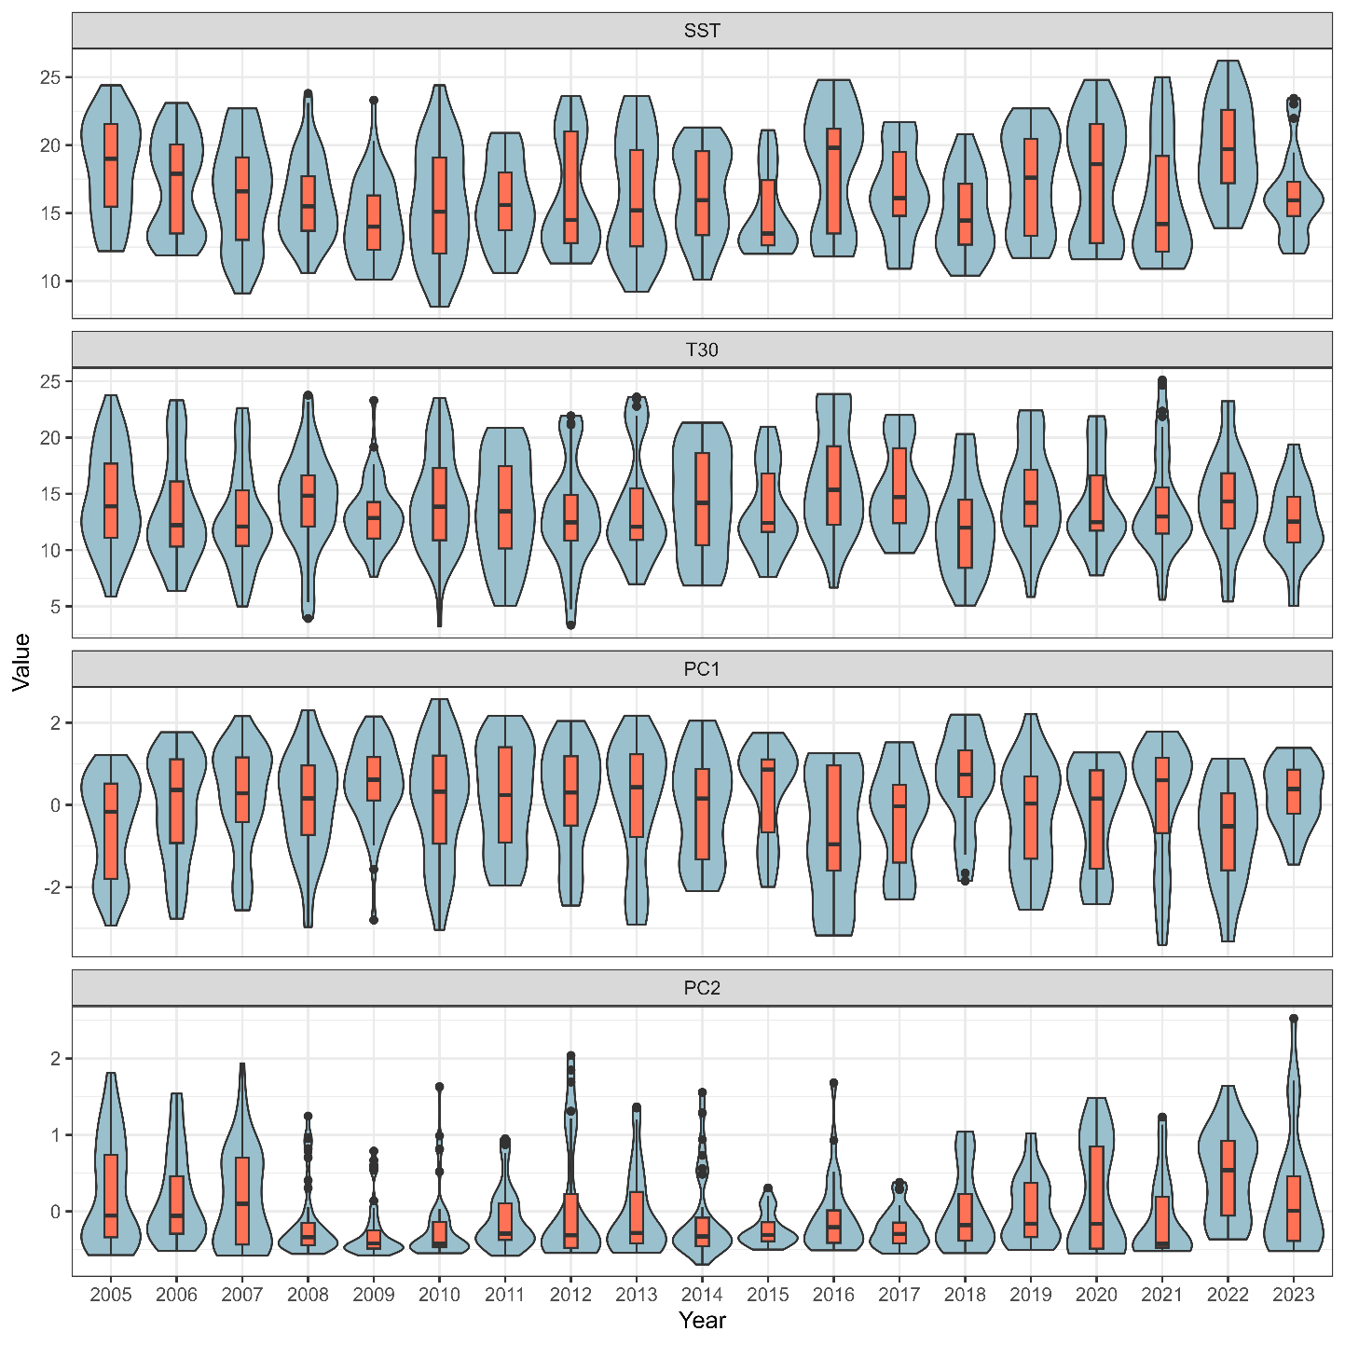
Relationships between year and each of SST, T30, PC1, and PC2 (see Fig. 2).

Figure 4A
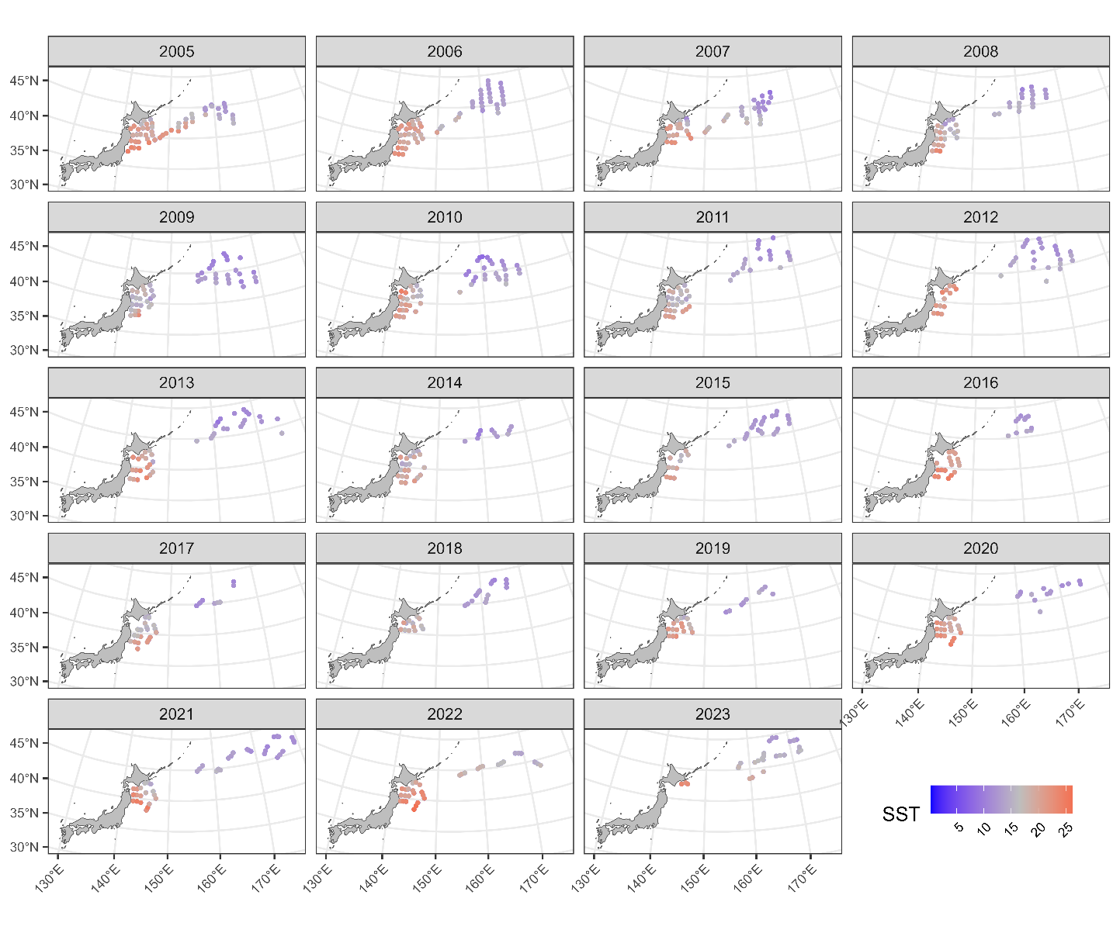
Map of SST from 2005 to 2023.

Figure 4B
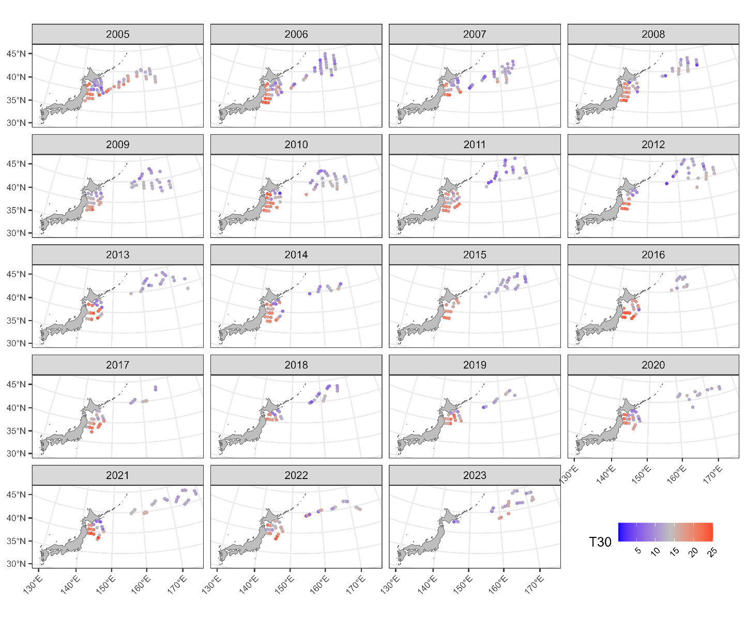
Map of T30 (30m-depth temperature) from 2005 to 2023.

Figure 4C
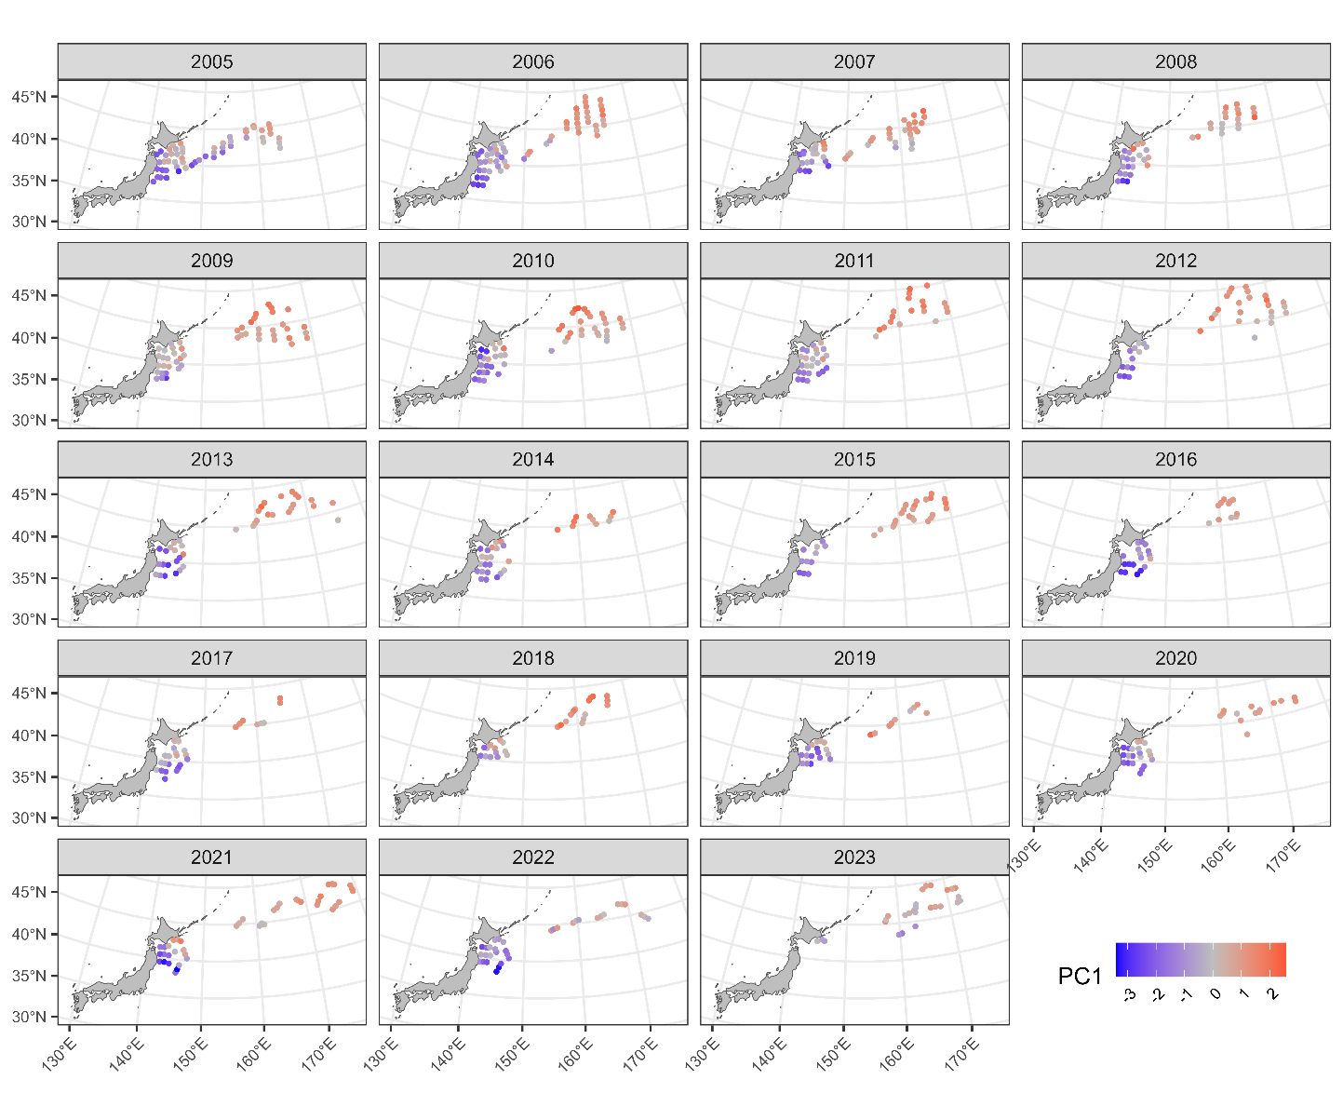
Map of PC1 (see Fig. 2) from 2005 to 2023.

Figure 4D
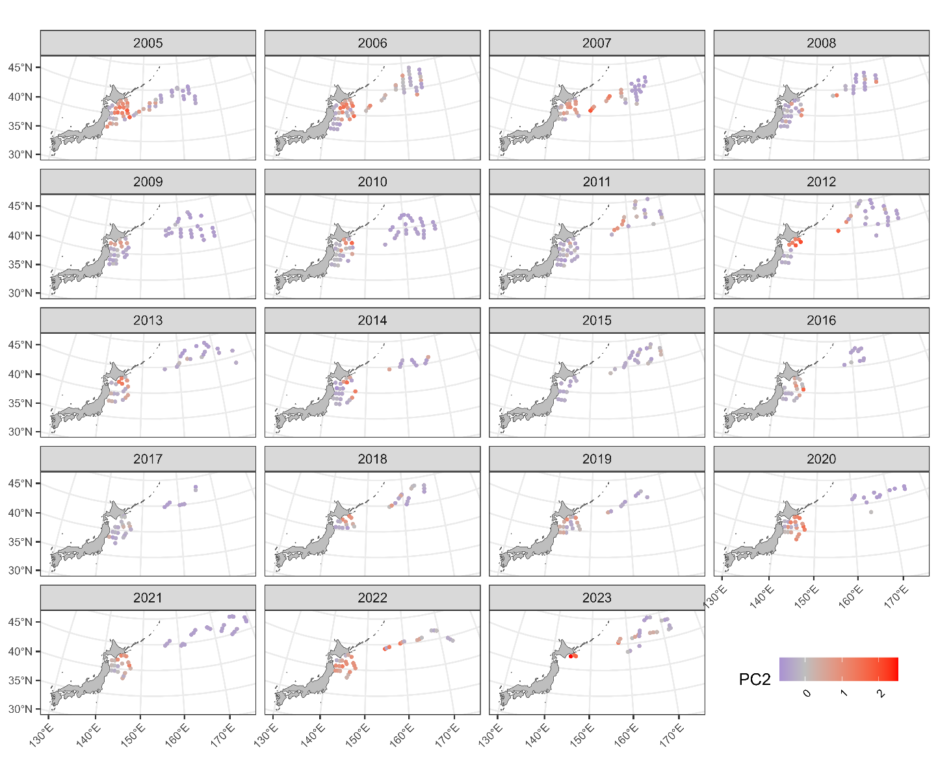
Map of PC2 (see Fig. 2) from 2005 to 2023.

Figure 5
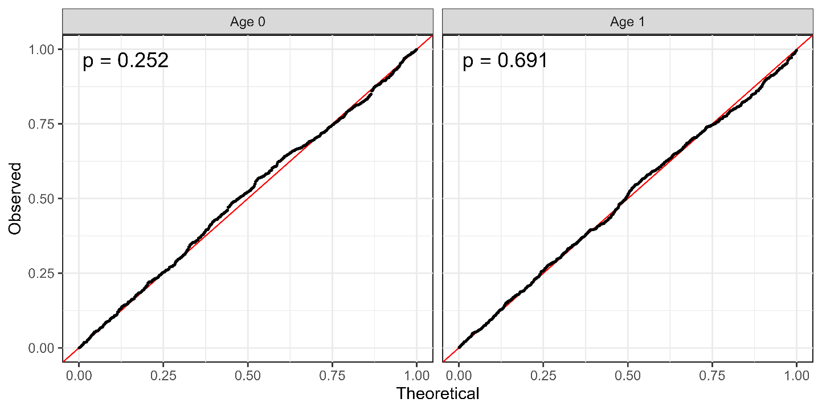
QQ plot for ages 0 (left) and 1 (right) along with p value in the Kolmogorov-Smirnov test at the upper-left corner.

Figure 6A
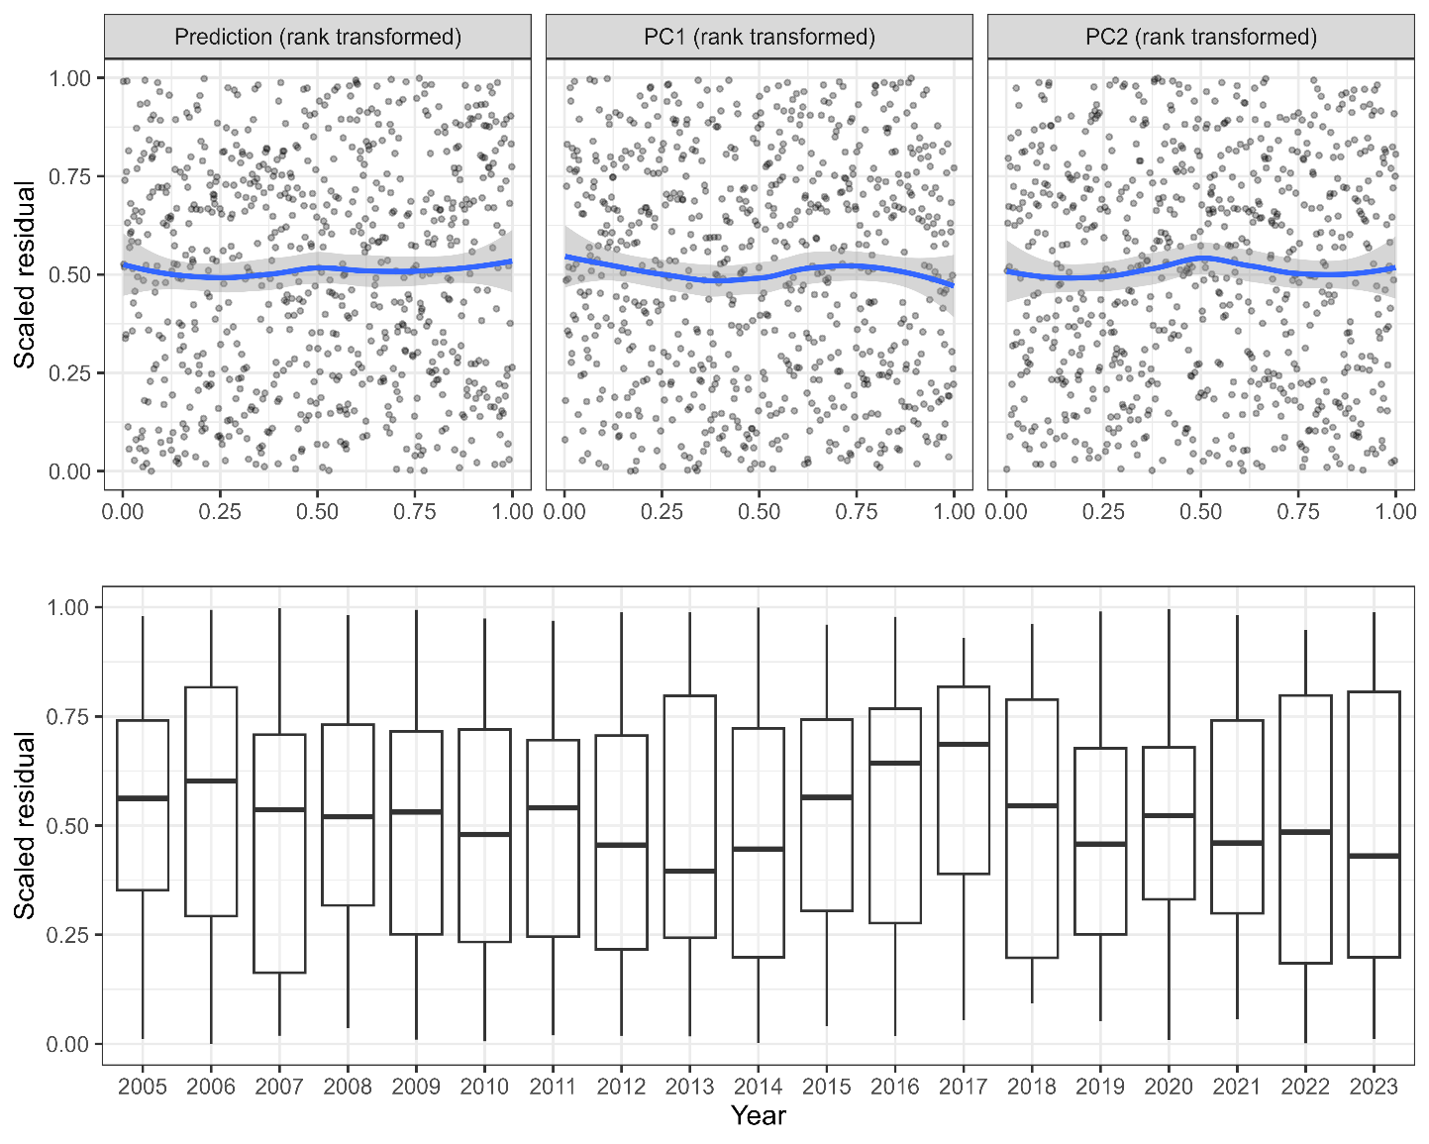
Relationships between scaled residuals and dependent variables or predicted CPUE in the age-0 analysis. Continuous variables are all rank transformed. Smooth curves in blue for the upper panels are described by LOESS.

Figure 6B
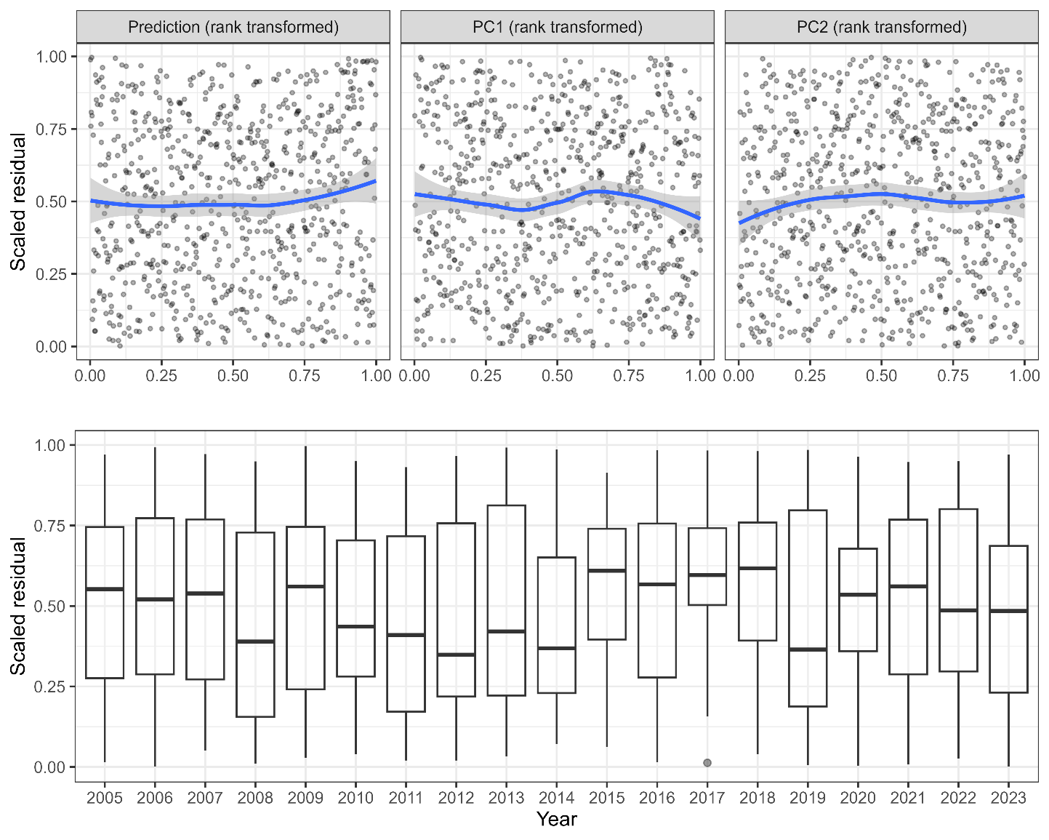
Relationships between scaled residuals and dependent variables or predicted CPUE in the age-1 analysis. Continuous variables are all rank transformed. Smooth curves in blue for the upper panels are described by LOESS.

Figure 7A
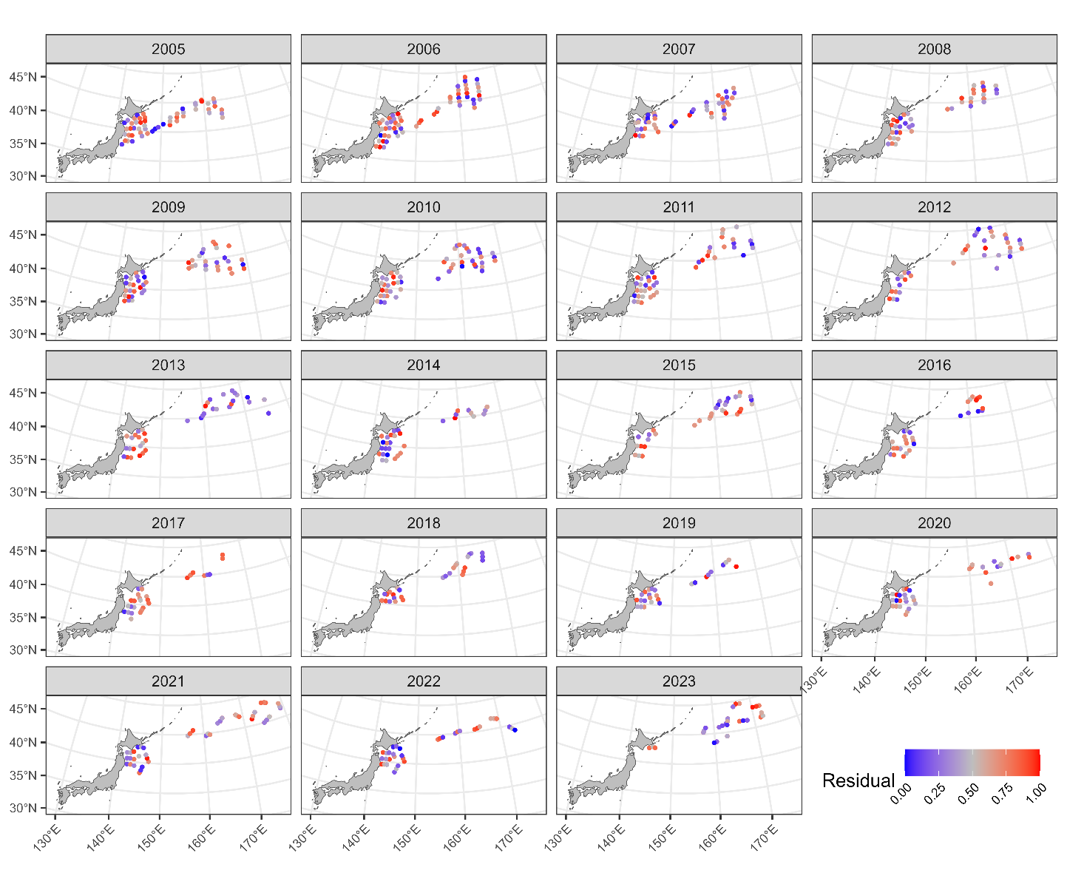
Maps of the scaled residuals from 2005 to 2023 in the age-0 analysis.

Figure 7B
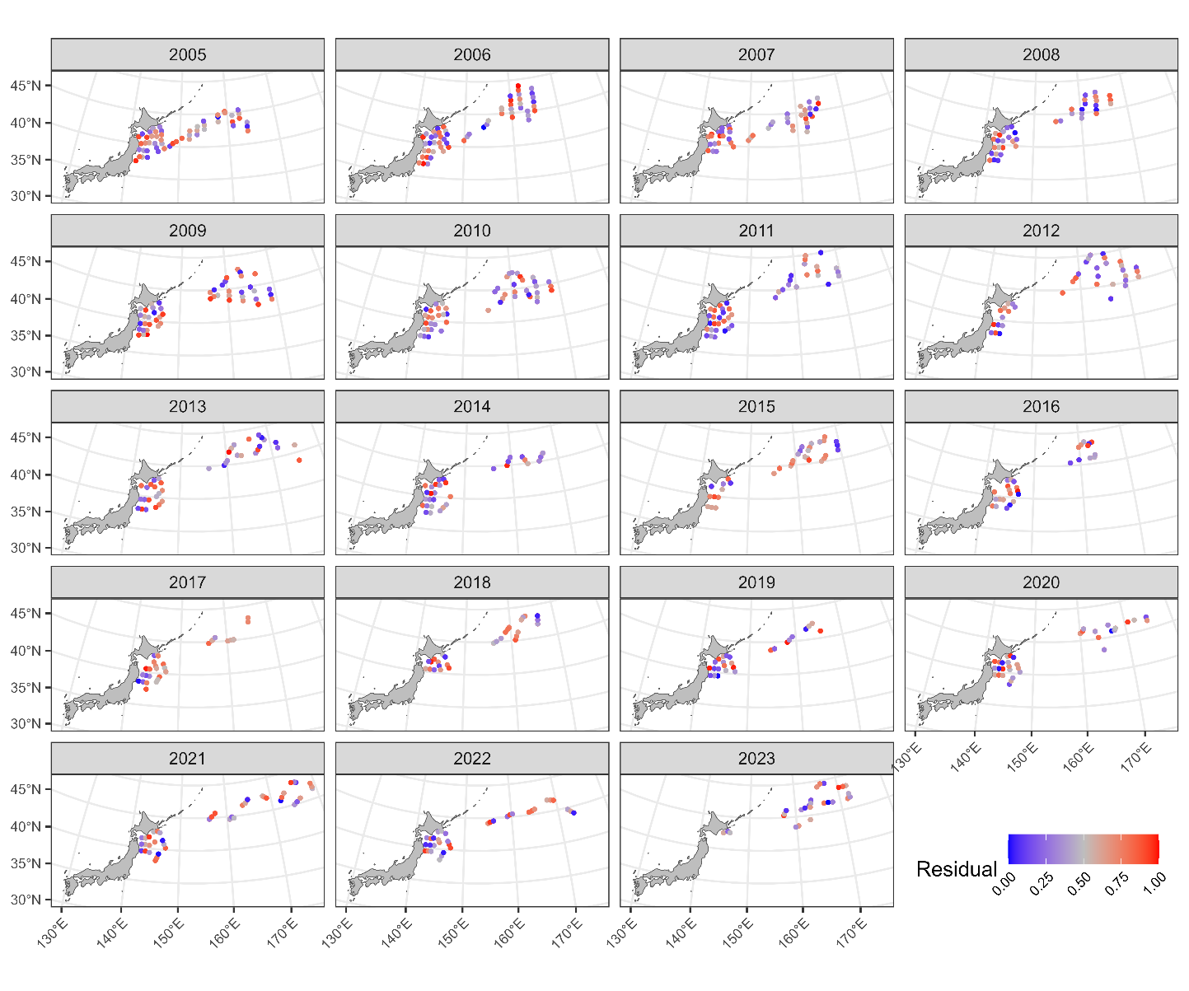
Maps of the scaled residuals from 2005 to 2023 in the age-1 analysis.

Figure 8A
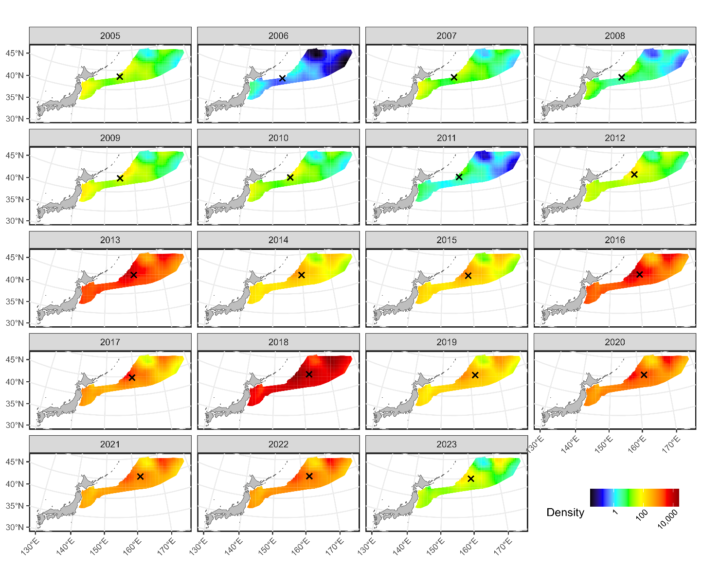
Estimated densities of age-0 fish from 2005 to 2023. The signs of X indicate the centroid of spatial distributions.

Figure 8B
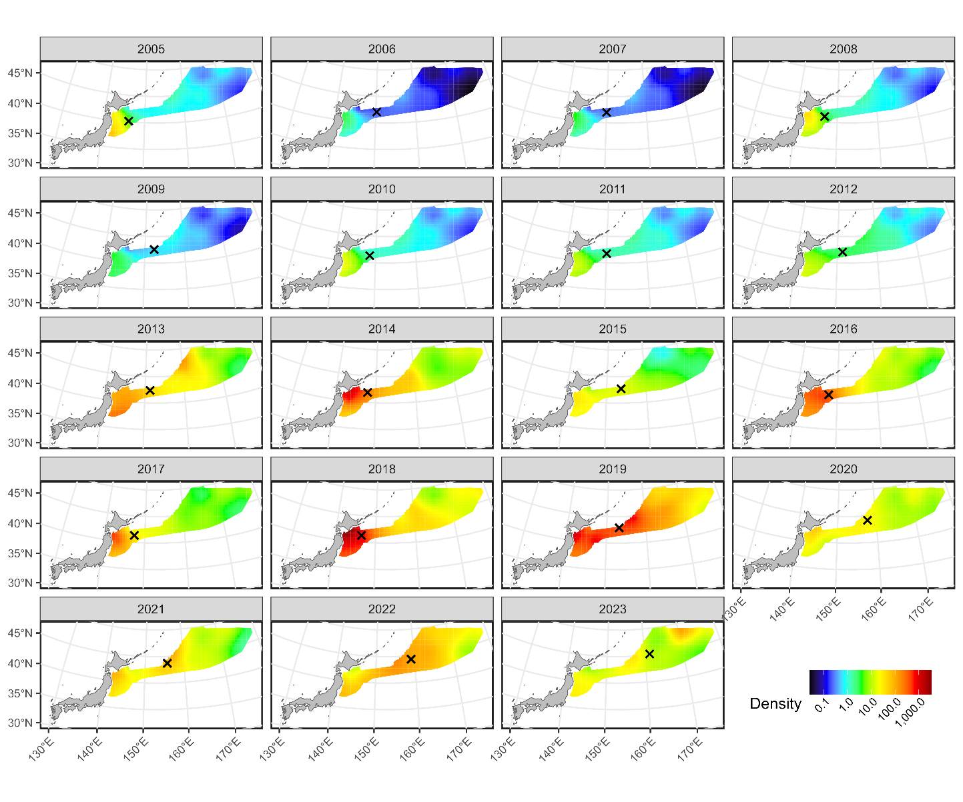
Estimated densities of age-1 fish from 2005 to 2023. The signs of X indicate the centroid of spatial distributions.

Figure 9A
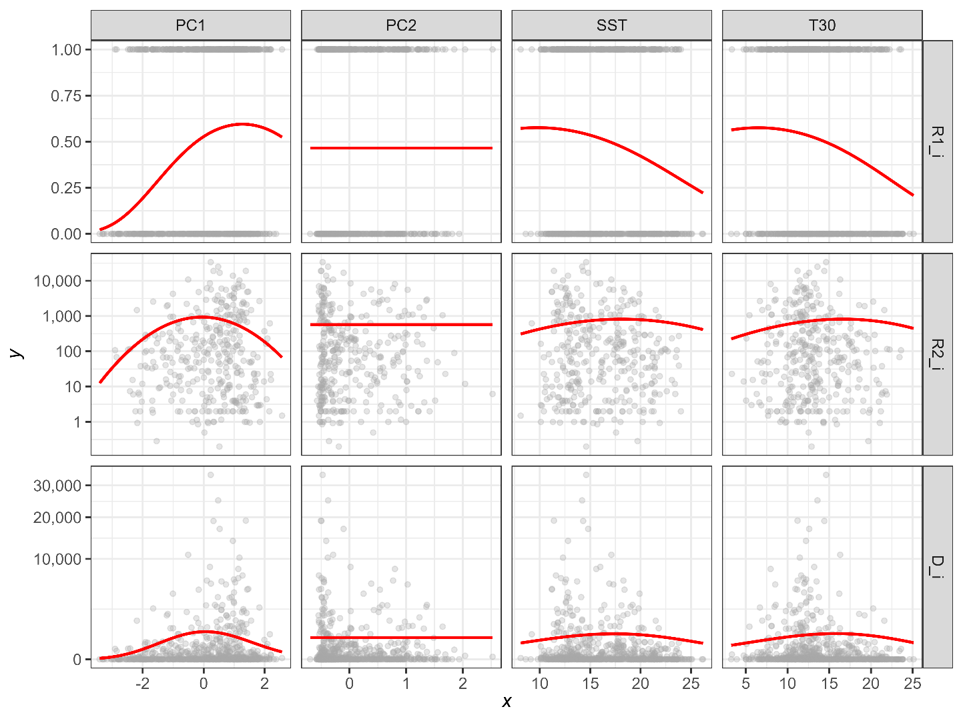
Estimated relationships between environmental variables (PC1, PC2, SST, and T30) and expected CPUE (upper: probability of positive catch, middle: positive catch rate, lower: catch rate) in the age-0 analysis. The expected CPUE versus SST and T30 was calculated with the assumption that the original variables SST and T30 change independently.

Figure 9B
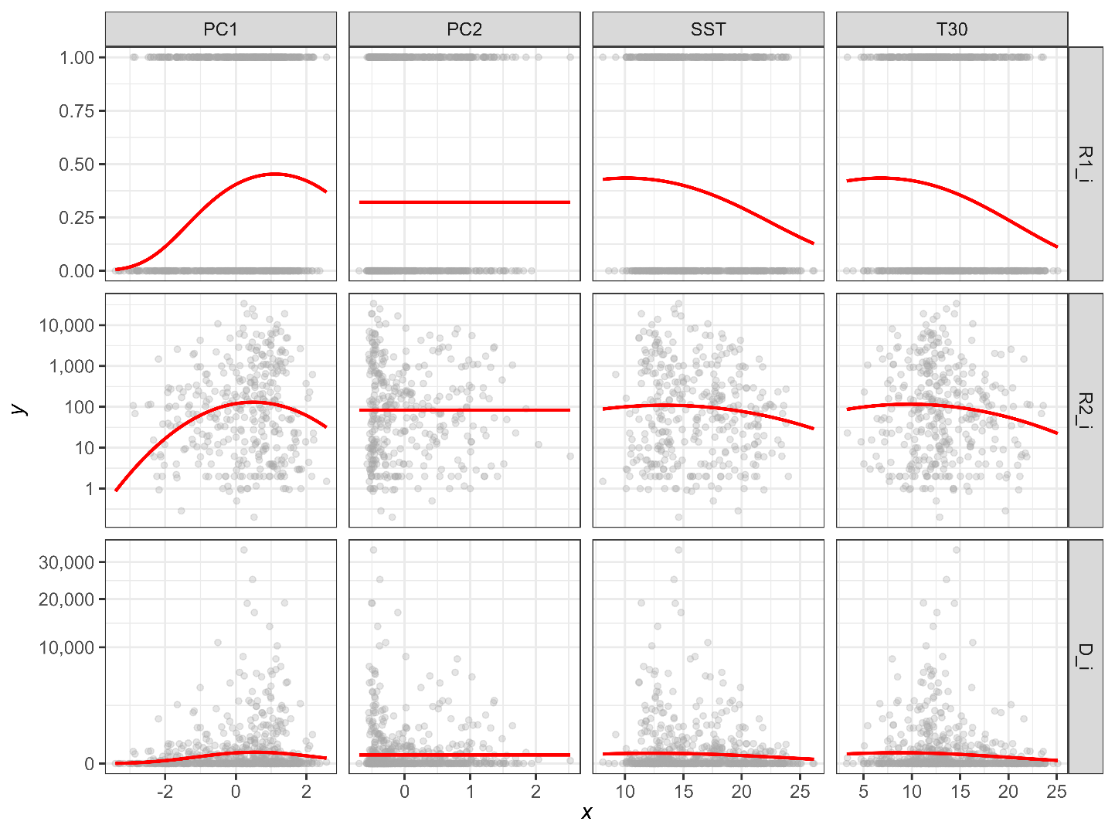
Estimated relationships between environmental variables (PC1, PC2, SST, and T30) and expected CPUE (upper: probability of positive catch, middle: positive catch rate, lower: catch rate) in the age-1 analysis. The expected CPUE versus SST and T30 was calculated with the assumption that the original variables SST and T30 change independently.

Figure 10
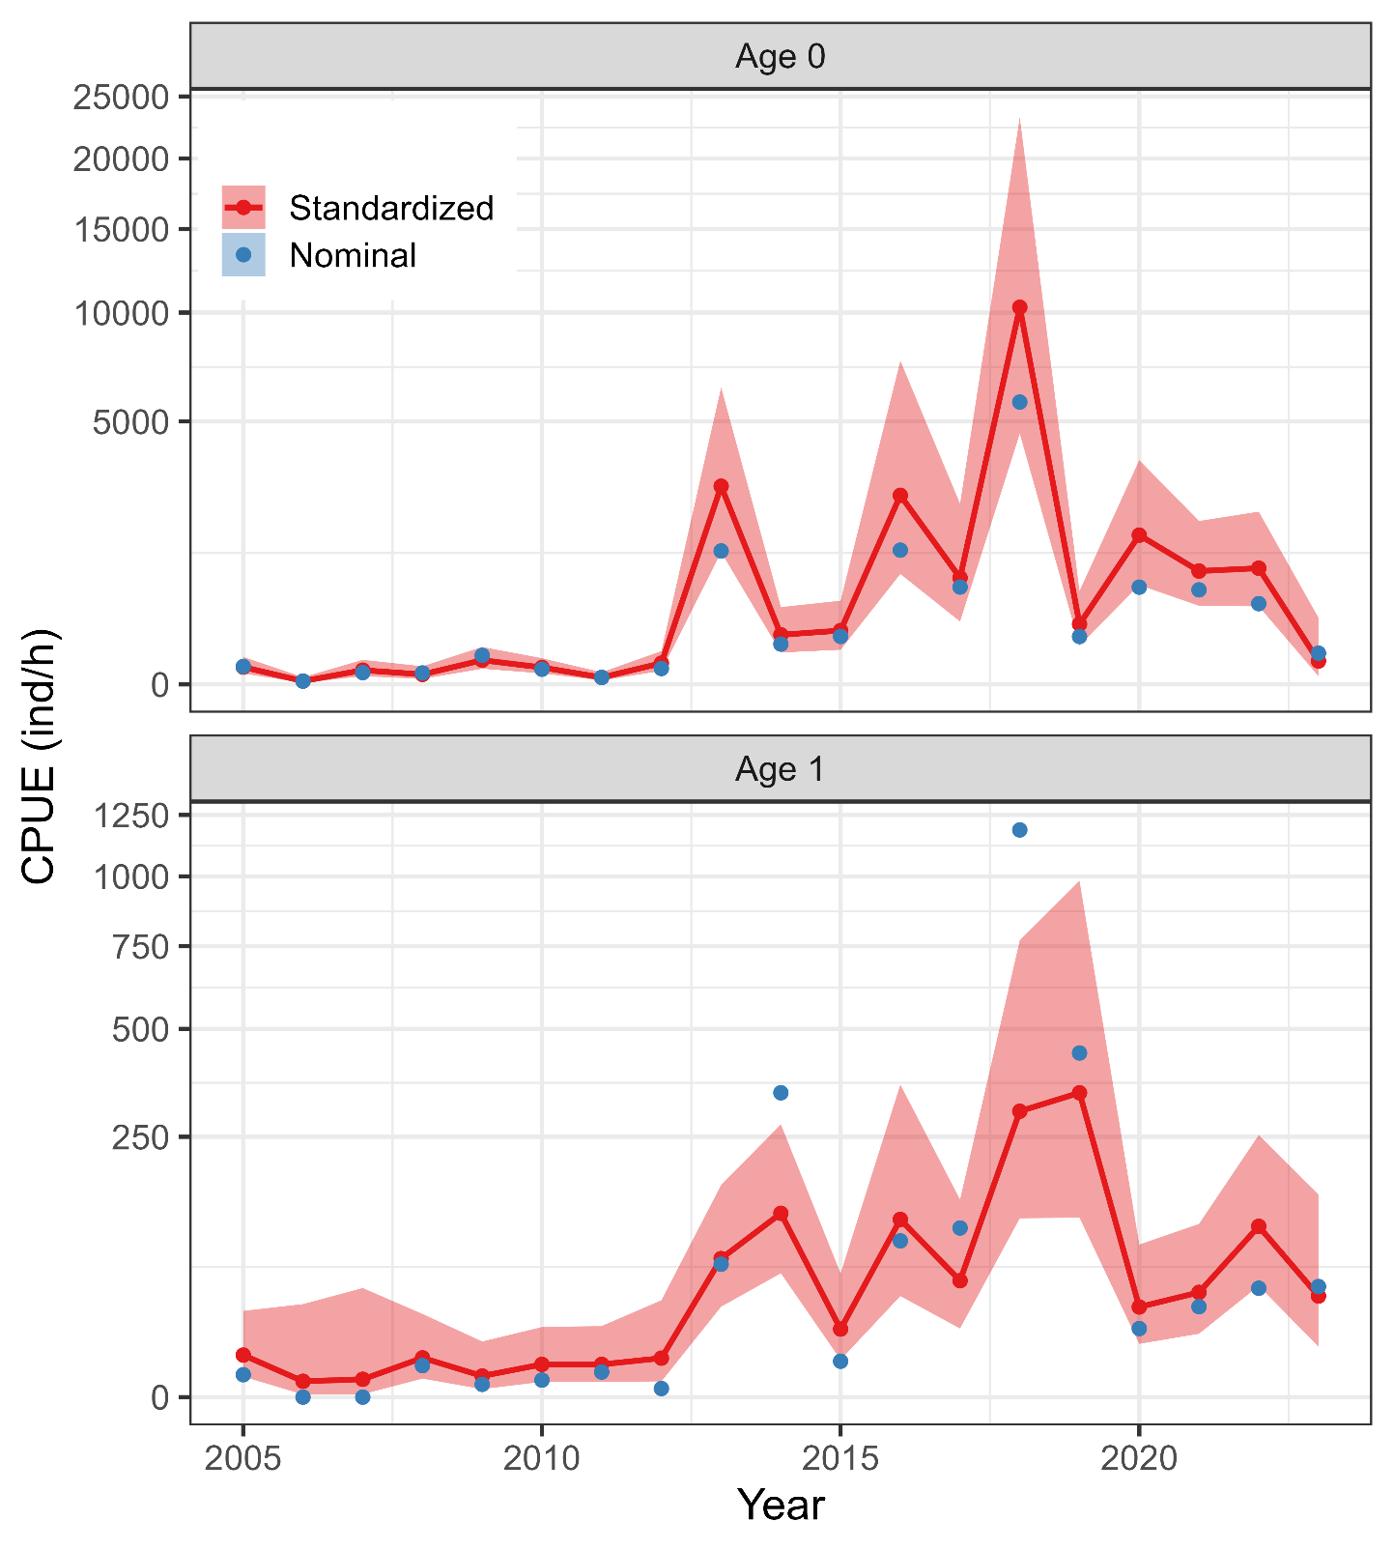
Time series of nominal and standardized CPUE from 2005 to 2023 for age-0 (upper) and age 1 (lower) fish. The shadow area represents 95% confidence intervals of standardized CPUE.

Figure 11
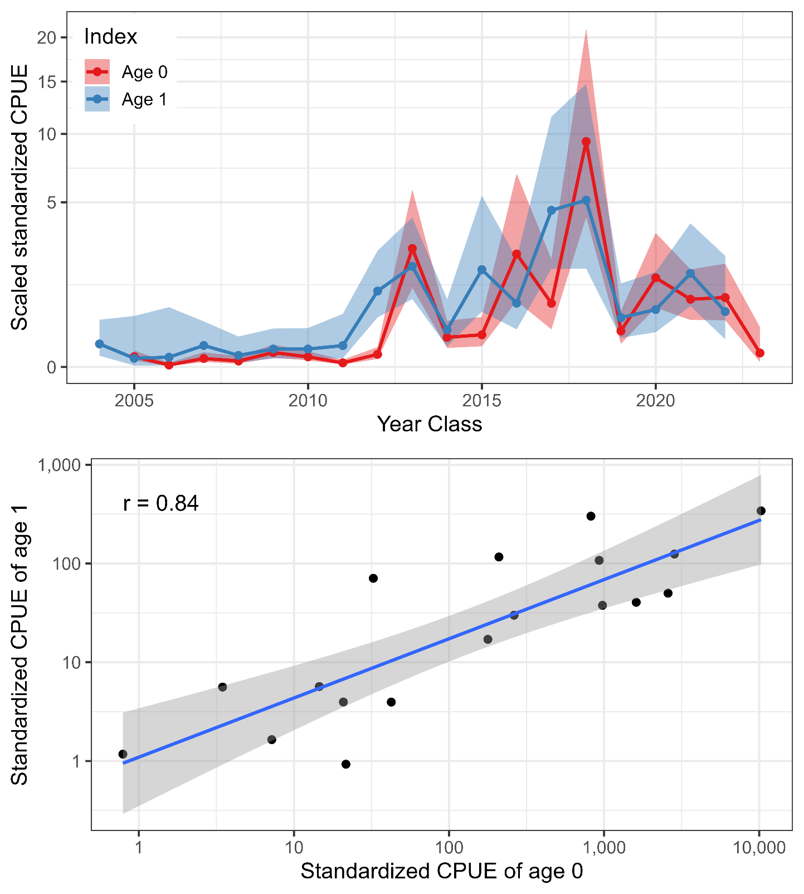
(upper) Trends of scaled standardized indices of ages 0 and 1. Note that the x-axis is year class, which means that, for example, the value of age 0 index in 2005 and that of age 1 index in 2006 are plotted at the same x level. (lower) Relationship between standardized CPUEs of ages 0 and 1. Each point indicates year class. Pearson’s correlation coefficient is shown at the upper-left corner. Prediction from linear regression is shown in the blue line with 95% confidence interval (shadow area).

Appendix A: Comparison between previous and revised results
The change in model settings on the temporal and spatio-temporal effects in the age 1 fish analysis from autoregressive process to IID process affected selected covariates in the best model and responses to environmental covariates (see details in Nishijima et al. 2024). However, the standardized abundance index of age 1 little changed by this revision (Fig. A1). The values of 2014 and 2018 in the revised index became closer to their nominal values probably because of removing the autoregressive process in temporal and spatio-temporal effects.

Figure A1
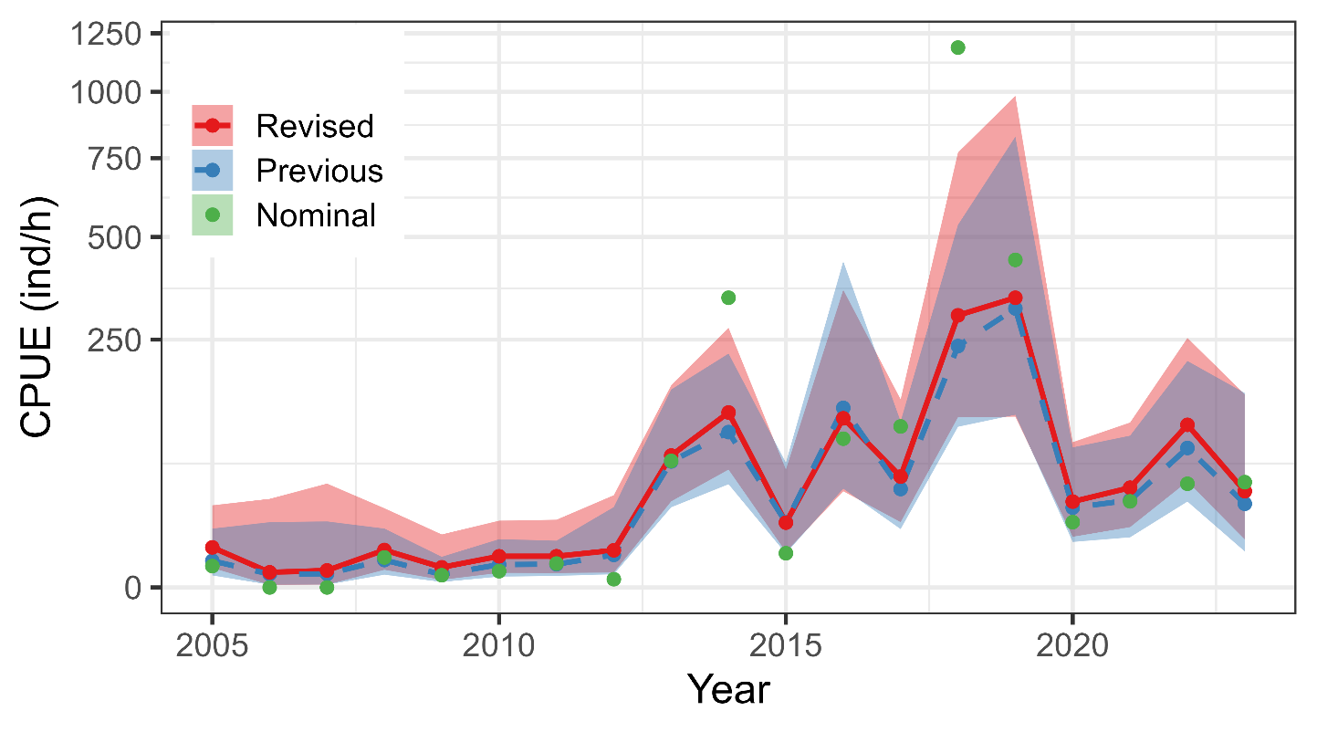
Comparison of standardized abundance indices of age 1 fish in previous and revised analyses.

Appendix B: Computational experiment for the impact of narrower spatial coverage
Reliability of the standardized CPUE in 2023 has been doubtful because no survey was conducted near the Pacific coast of Japan due to bad weather (NPFC 2024). To examine how the narrow spatial coverage affects the standardized abundance indices in the autumn survey, we generated test data by artificially removing data north of 42.4º N in 2022 where no survey was conducted in 2023 (Fig. B1). We applied the same VAST model for age-0 and age-1 fish to the test data and compared results using the test data to those using all data, focusing on 2022. Estimated densities in 2022 using the test data differed from those using all data in southeastern areas near the Pacific coast of Japan: estimated densities of age-0 fish became lower in the test data, while they were higher for age-1 fish (Fig. B2). However, the standardized CPUEs were almost identical between all and test data (Fig. B3): the index value in 2022 changed from 976.33[ind/hour] to 913.03[ind/hour] for age 0 (6.5% decrease) and from 107.58[ind/hour] to 114.27[ind/hour] for age 1 (6.2% increase). The changes were small because the higher density area and the centroid of the distribution were further offshore, and density changes in coastal areas did not have much influence on the standardized abundance indices. The results of this computational experiment ensure the robustness of the standardized abundance indices in 2023, when survey stations were actually low.

Figure B1
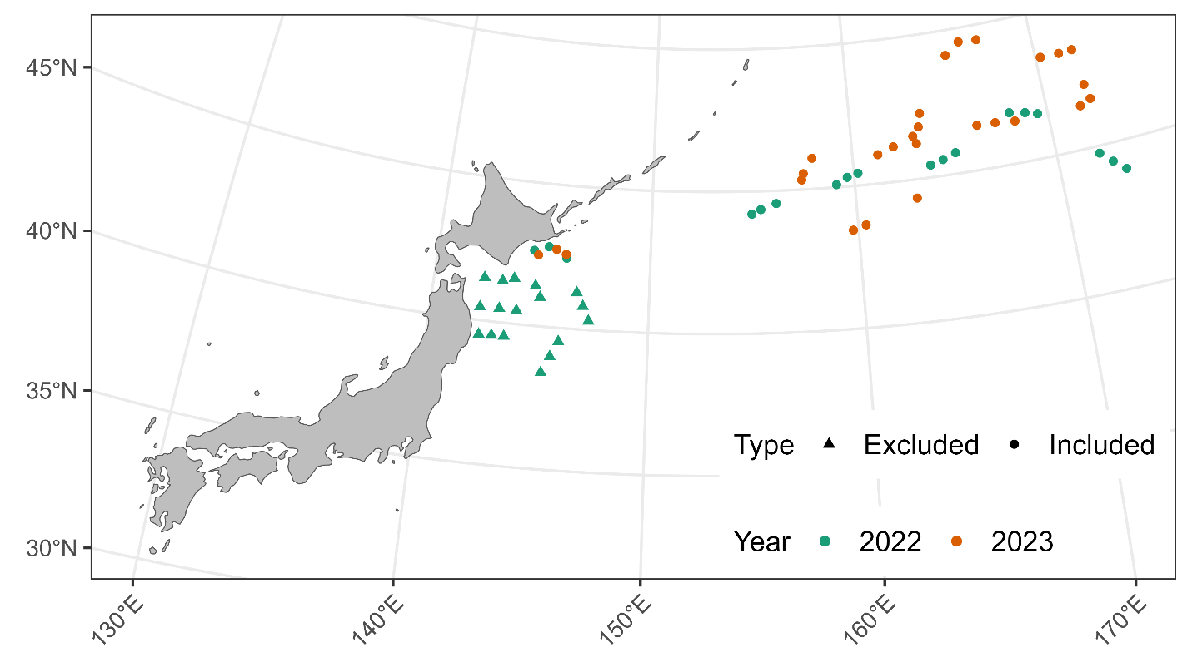
Locations of survey stations in 2022 and 2023. The triangles in green indicate the data excluded from the computational experiment.

Figure B2
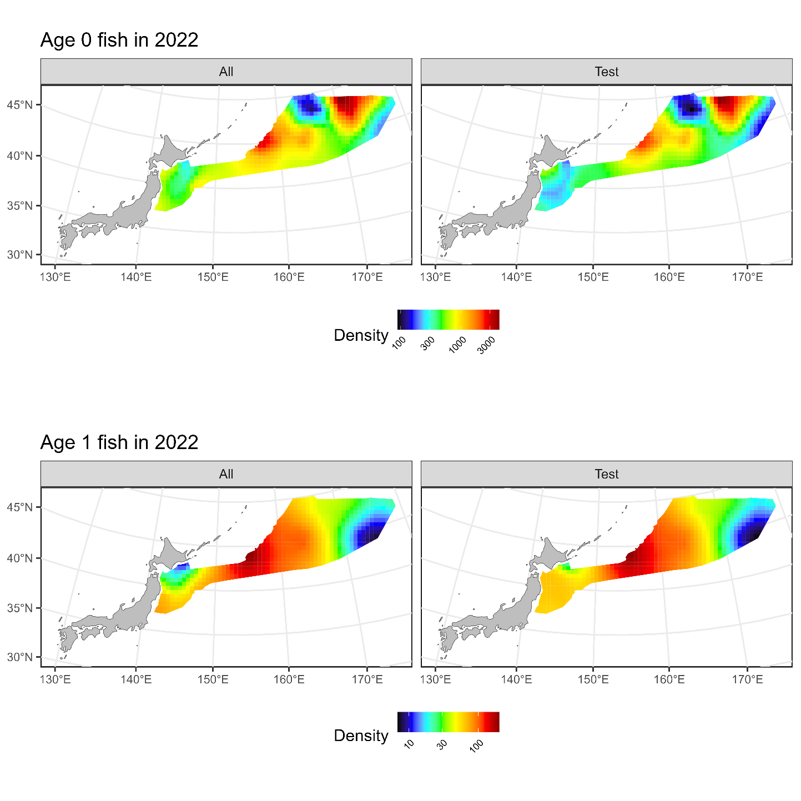
Estimated densities of age-0 (upper) and age-1 (lower) fish in 2022 when using all data (left) and test data.

Figure B3
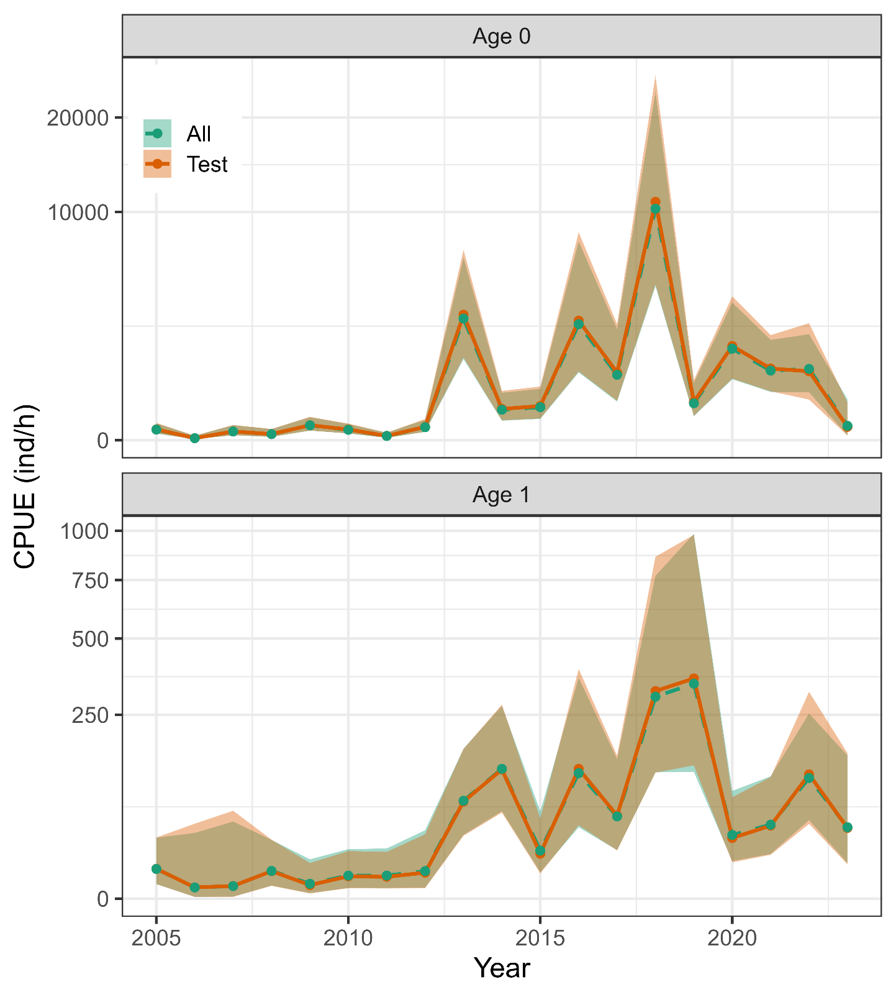
Comparison of standardized abundance indices of age-0 (upper) and age-1 (lower) fish when using all data (green dashed line) and test data (orange solid line).

Appendix C: Checklist for the CPUE standardization protocol
No. | Step-by-step protocols | yes/no | Note
1 | Provide a description of the type of data (logbook, observer, survey, etc. ), and the "resolution" of the data (aggregated, set-by-set etc..). This description should also include the representativeness of the data in two tables: (1st table) Number of observations, % Coverage of CPUE fleet (catch), % Coverage of CPUE fleet (effort), Total Catch CPUE fleet (mt), Total Effort CPUE fleet, Percentage of overall catch by member (across all fleets/gears); and (2nd table) Number of records remaining, Number removed, Number of records with chub mackerel catch >0; | Yes | Section 2.1 (pages 2) and Table 1 (page 9)
2 | Conduct a thorough literature review to identify key factors (i.e., spatial, temporal, environmental, and fisheries variables) that may influence CPUE values; | Yes | Section 1. Background (page 1)
3 | Plot annual/monthly spatial distributions of fishing efforts, catch and nominal CPUE to determine temporal and spatial resolution for CPUE standardization | Yes | Fig. 1, (pages 18-22)
4 | Make scatter plots (for continuous variables) and/or box plots (for categorical variables) and present correlation matrix if possible to evaluate correlations between each pair of those variables; | Yes | Figs. 2-4 (pages 23-28]
5 | Describe selected explanatory variables based on (2)-(4) to develop full model for the CPUE standardization; | Yes | Section 2.3. (pages 3-5) and Table 2 (page 10)
6 | Specify model type and software (packages) and fit the data to the assumed statistical models (i.e., GLM, GAM, Delta-lognormal GLM, Neural Networks, Regression Trees, Habitat based models, and Statistical habitat based models); | Yes | Section 2.3. (pages 3-5)
7 | Evaluate and select the best model(s) using methods such as likelihood ratio test, information criterions, cross validation etc.; | Yes | Tables 3 and45 (pages 11-12)
8 | Provide diagnostic plots to support the chosen model is appropriate and assumption are met (QQ plot and residual plots along with predicted values and important explanatory variables, etc.); | Yes | Figs. 5-6 (page 28-32)
9 | Present estimated values of parameters and uncertainty in the parameters in table; | Yes | Tables 5 and 6(pages 13-14)
10 | Present the relationship between the response variable and the explanatory variables. Check if it is interpretable. | Yes | Figs. 7-9 (pages 31-36)
11 | Extract yearly standardized CPUE and standard error by a method that is able to account for spatial heterogeneity of effort, such as least squares mean or expanded grid. If the model includes area and the size of spatial strata differs or the model includes interactions between time and area, then standardized CPUE should be calculated with area weighting for each time step. Model with interactions between area and season or month requires careful consideration on a case by case basis. Provide details on how the CPUE index was extracted. | Yes | Section 2.4. (page 5)
12 | Calculate uncertainty (SD, CV, CI) for standardized CPUE for each year. Provide detailed explanation on how the uncertainty was calculated; | Yes | Tables 7 and 8 (page 15-16) and Fig. 10 (page 37)
13 | Provide a table and a plot of nominal and standardized CPUEs over time. When the trends between nominal and standardized CPUE are largely different, explain the reasons (e.g. spatial shift of fishing efforts), whenever possible. | Yes | Tables 7 and 8 (page 15-16) and Fig. 10 (page 37)

