NPFC-2024-TWG CMSA-WP15

Catch at length, age length key, and catch at age of chub mackerels Scomber japonicus caught in the northwestern Pacific Ocean by China, Japan, and Russia

Akihiro MANABE*, Ryuji YUKAMI*, Momoko ICHINOKAWA*, Heng ZHANG**, Igor CHERNIENKO***, Emiliya CHERNIENKO***

*Fishery Research and Education Agency (FRA), Japan
**East China Sea Fisheries Research Institute, Chinese Academy of Fishery Science, China
***Pacific branch of VNIRO (TINRO), Russia

Summary
Catch at length, age length key (ALK), and catch at age are analyzed and compared from China, Japan, and Russia. The details on the origin of the data and aging methods are explained. Submitted data from China and Japan use different timing for age incrementation, therefore, in this document, ages are converted based on July 1st as the origin of age incrementation. Catch at age is calculated that Chinese catch number is increasing since 2019 and Japanese and Russian catch numbers are decreasing since 2020. Chinese age composition shows majority of the Chinese catch is less than age-3 fish, and Japanese and Russian catch includes substantial amount of age 4+ fish. This paper recommends adopting Japanese ALKs for Chinese catch at age in 2016 and 2017 where Chinese ALKs are unavailable. This paper also recommends a scenario to estimate catch at age for 2015 for China and 2014-2015 for Russia from the 2016 catch at length data and corresponding Japanese ALK.

Catch at length
Quarterly catch at length from three members are submitted on the collaboration site. The data description is documented in the previous documents (Manabe et al. 2020, Chernienko and Chernienko 2021, NPFC 2022). Table 1 shows the availability of data from each member.

Table 1 Data descriptions for catch at length.
Member | Data range (Year/Quarter) | Data origin
China | 2016/2nd quarter – 2022/4th quarter | Random sampling from catches from fishing boats
Japan | 2014/1st quarter – 2023/2nd quarter, western/eastern parts of Japan | Random sampling from catches at the major landing harbors from each prefecture
Russia | 2016/3rd quarter – 2022/4th quarter | Survey and commercial catch data from the Kuril Islands

Figure 1-4 show the catch at length from China, eastern Japan, western Japan, and Russia on quarterly and yearly basis, and figure 5 shows the comparison of annual catch at length between three members. Chinese catch mainly consists of Q2-Q4 with notable peak in small (< 20cm FL) fish in Q3 and secondary peak around 30cm FL in Q3 and Q4 (Fig. 1). Japanese catch at length is calculated by two regions (western/eastern) due to the difference in catch patterns (Manabe et al. 2020). Significantly greater number of chub mackerels are caught in the eastern region throughout the season (Fig. 2 and 3) with substantial catch in Q1 and Q4 of the calendar year. From 2014 to 2019, the peak of size distribution is around 30cm FL for eastern Japan, however, the peak size of chub mackerels caught in the eastern Japan has declined since 2020 with notable decline in total catch numbers in Q1 and Q4 of 2022 and Q1 of 2023 (Fig. 3). Russian catch at length consists of Q2 to Q4 due to the fishing season. Although the total number of catches is smaller than Japanese counterpart, Russian catch at length illustrates the size of chub mackerels caught is slightly larger than Japan and substantially larger than China, by setting the peak of the mode around 30-35 cm FL in Q4 (Fig. 1-4).
The annual catch at length comparison among three members illustrates that the overall distribution of catch at length is similar among Japan and Russia, however, Chinese catch at length distribution differs especially since 2019 as the peak of the frequency is significantly smaller than the other members (Figure 5).
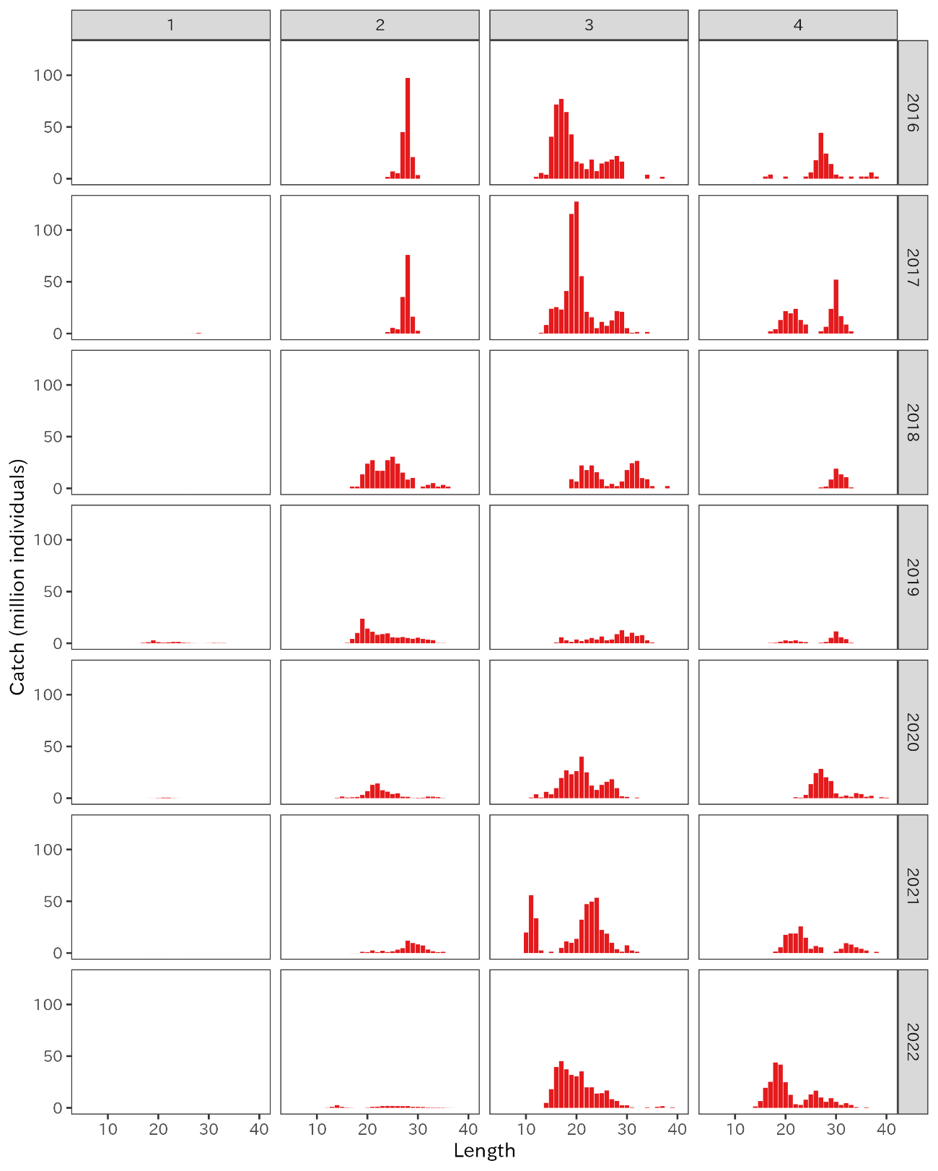
Figure 1. Quarterly catch at length from China from 2016 to 2022.

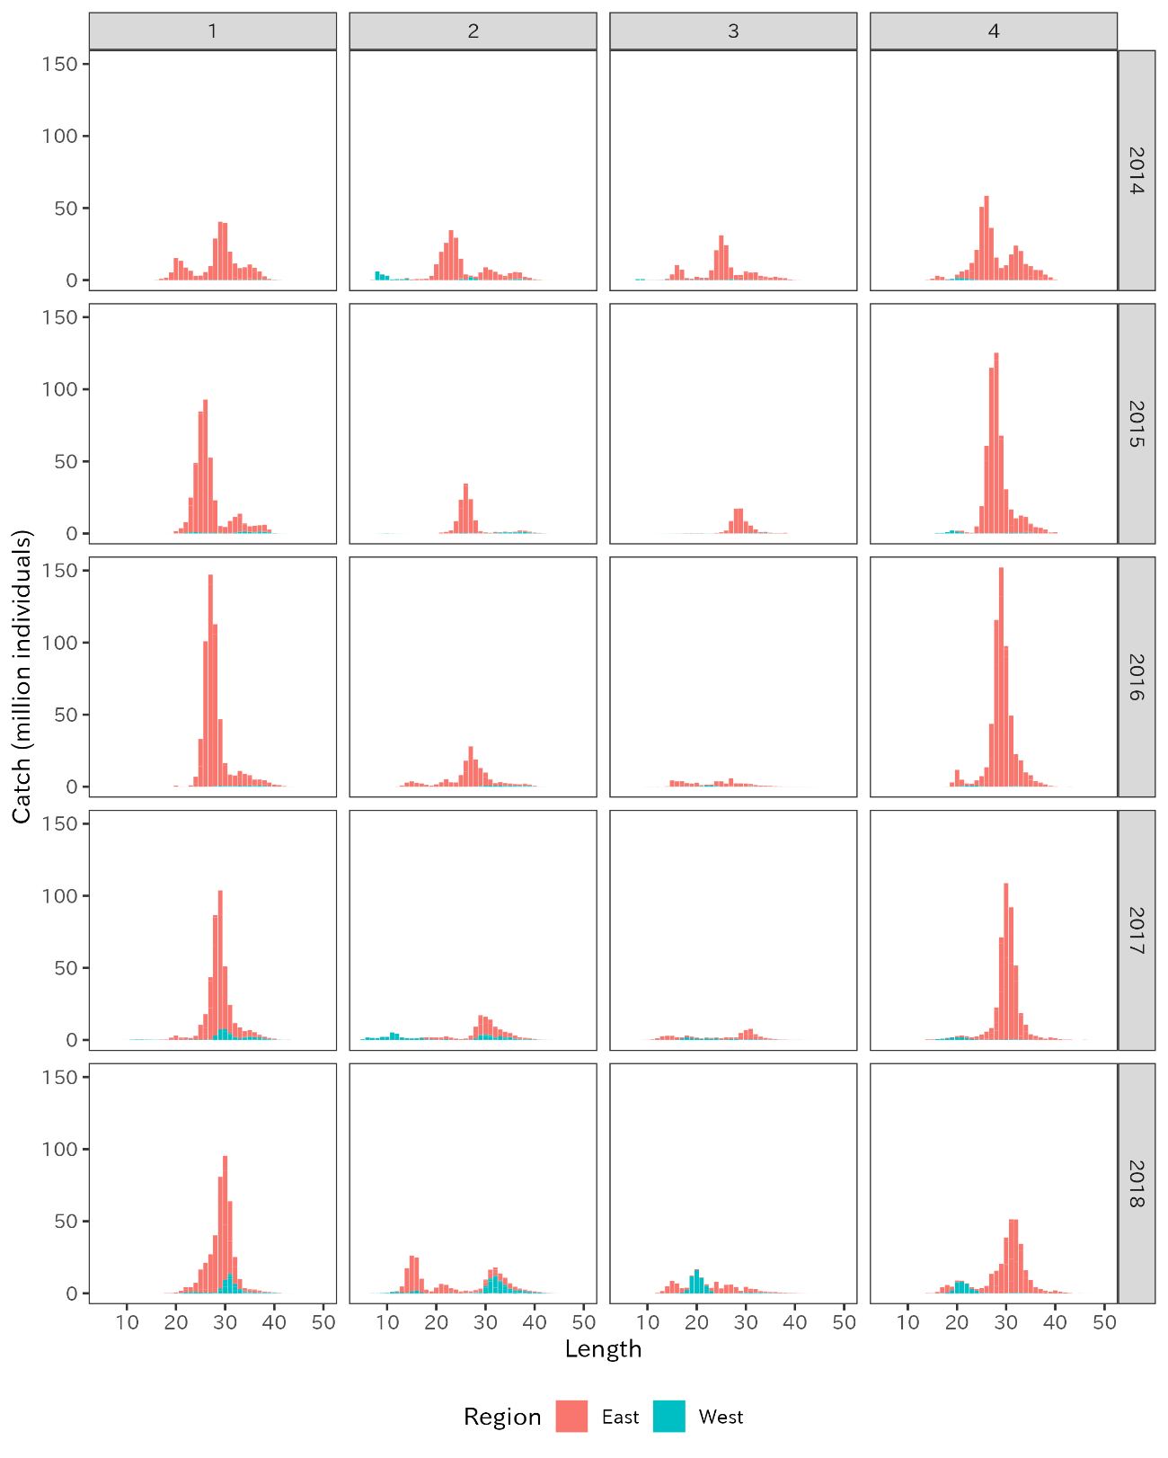
Figure 2. Quarterly catch at length from Japan in 2014-2018

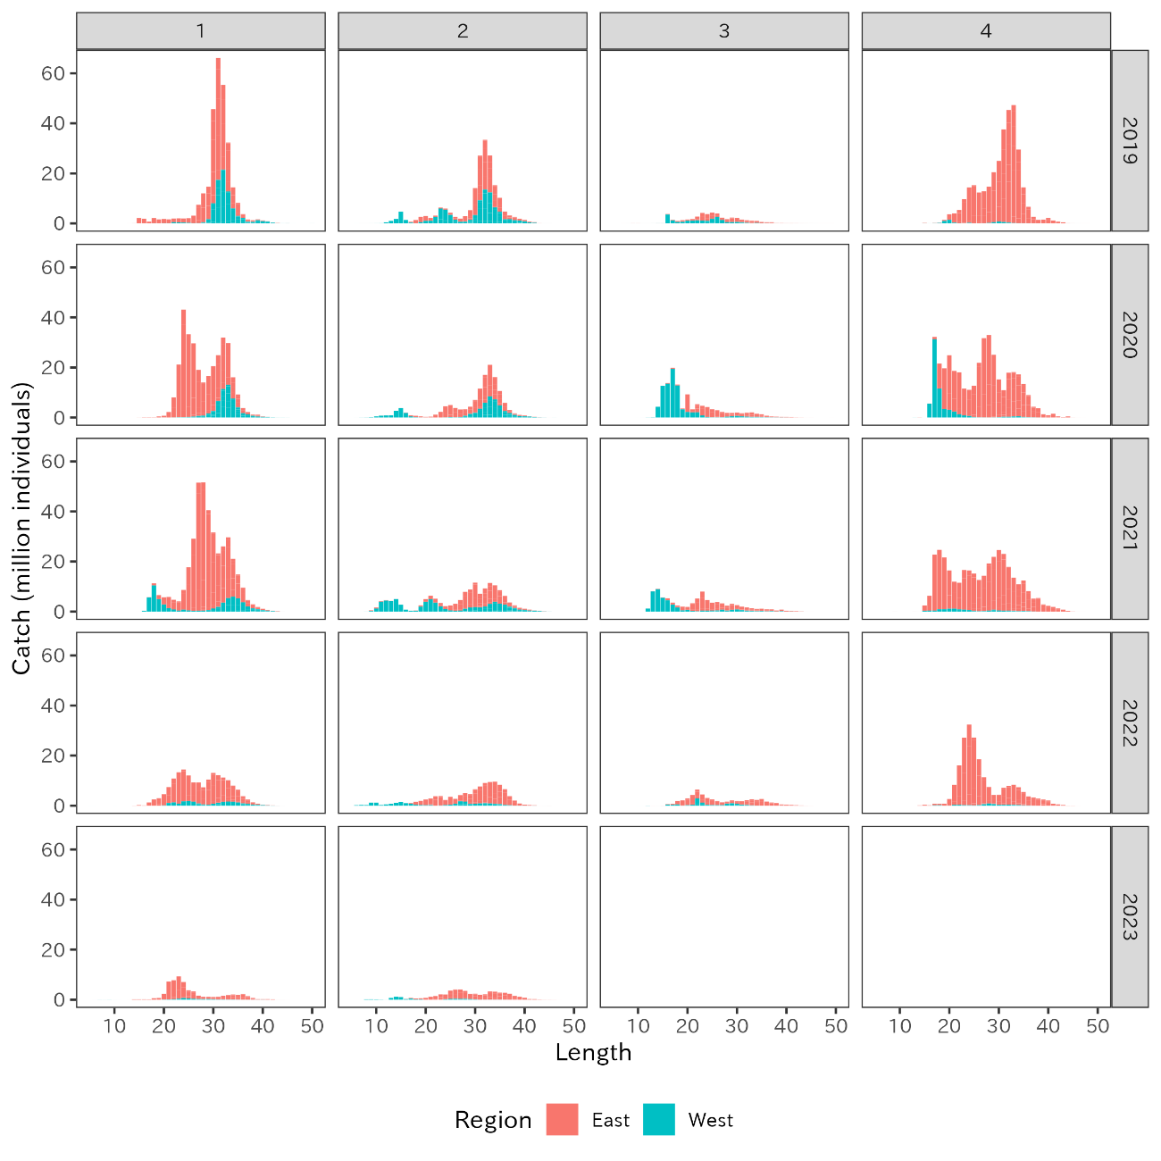
Figure 3. Quarterly catch at length from Japan in 2019-2023.

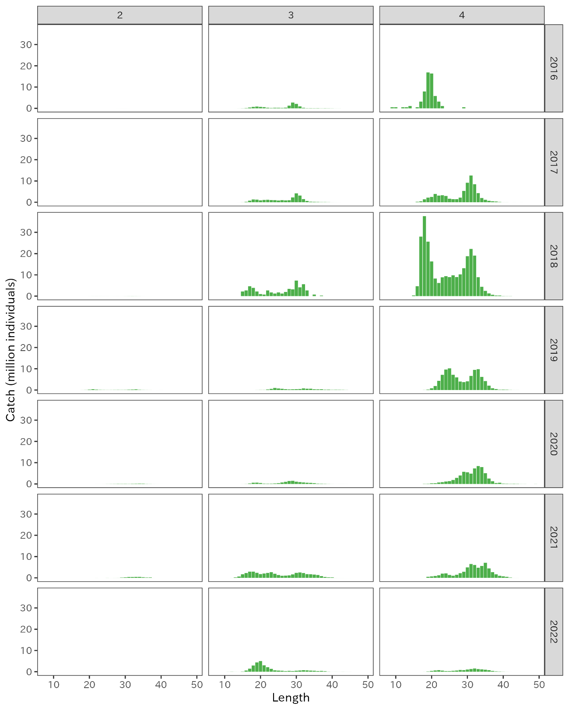
Figure 4. Quarterly catch at length from Russia in 2016-2022.

(a) 2014-2018
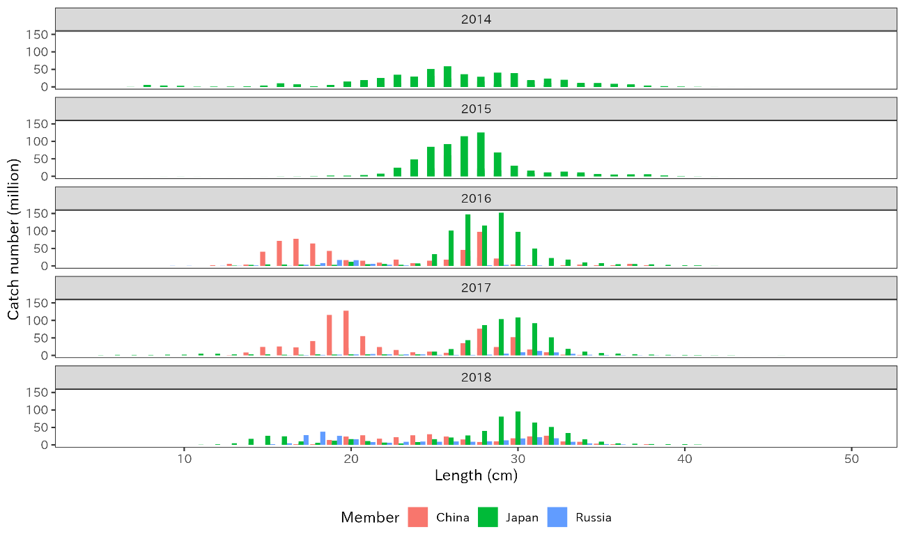
(b) 2019-2023
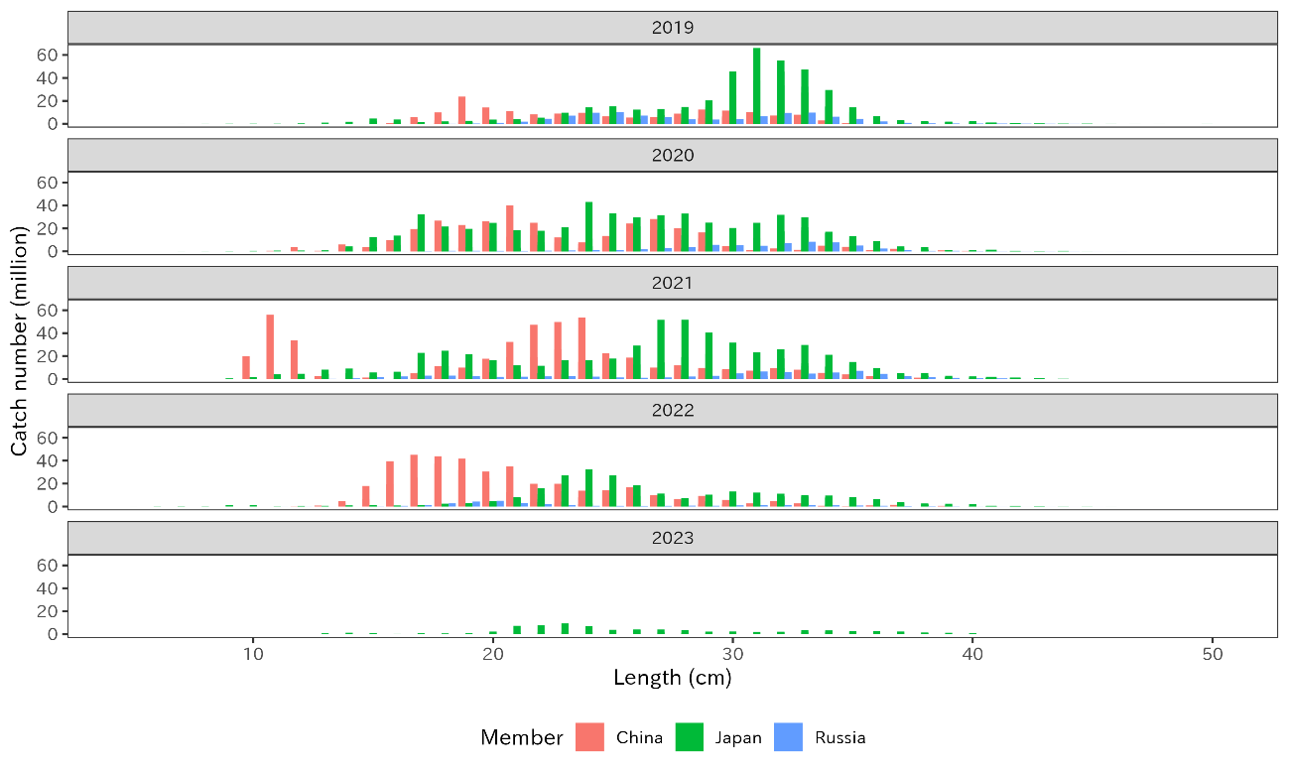
Figure 5. Annual catch at length of three regions from (a) 2014-2018 and (b) 2019-2023.

Age determination
China has determined age of the samples from counting the increments in otolith from the samples caught by commercial vessels (NPFC 2022). The date of age incrementation (i.e., the first day the age is added by 1) is set as January 1st. Ages of the samples are assigned into 0 to 7 and older, which is treated as a plus group of 7+.
In Japan, age determination has been conducted at each prefecture by counting the increments on the scales. The samples are subsampled at random from the length sample and increments of otolith or annulus of scales are counted to estimate the age. The fish at age 7 and older are treated as 7+. The age is treated as all fish increment one year old on July 1st. In case when age-0 fish is recruited into fishery in Q1 and Q2 due to early spawning, the catch is incorporated into Q3 which age-0 fish is recruited into fishery. To segregate age-0 fish in Q1 and Q2 from early spawned age-0 of the following fishing year, the age of early spawned age-0 fish is converted into – 1 (minus one). After catch at age is estimated, the age-minus1 fish is aggregated into age-0 fish in Q3. In case of early spawned fish, the otolith and scale are carefully observed to determine whether the translucent increment is developed or developing to determine the age. For age-0 and age-1 fish in Q1 and Q2, the difference in fork length is also used to determine the age.
While there is a gap in the date of age incrementation between China ana Japan, members had agreed to use fishing year as a base case for the stock assessment of chub mackerel in NPFC-2023-TWG CMSA07. The fishing year begins on July 1st to the June 30th of the following year (i.e., Q3 to Q2 of the following year). Therefore, in the following analysis (i.e., comparison of ALK and catch at age), Chinese and Russian age are adjusted to fishing year by subtracting 1 from the calendar ages at Q1 and Q2 since these two quarters are from the previous calendar year. For example, Q1 and Q2 of 2023 calendar year belongs to 2022 fishing year. Thus, a fish that becomes 1 years old on January 1st of 2023 calendar year is treated as age-0 fish of 2022 fishing year. Since this procedure to subtract 1 year from all age range in Q1 and Q2, the maximum age 7+ in Q1 and Q2 becomes 6+. To align the data quality, age-7+ fish in Q3 and Q4 are combined into age-6+ as well. Since the plus group of Chinese data is converted into 6+, the plus group of Japanese age data is also converted into 6+.

Description of age data
China
Table 2 shows the number of samples used to construct ALK from China. As described in NPFC (2022), China uses forward ALK method (Fridriksson 1934) to develop ALK. Chinse catch of chub mackerels in the conventional area in the northwestern Pacific Ocean has begun in 2015. However, due to the availability of aged samples, ALK is developed from 2nd quarter of 2018, hence the age composition of pre-2018 data is required to be estimated. In the following sections, we provide calculation scenarios for the estimation of age composition of pre-2018 data.

Table 2. Number of samples used to develop Chinese quarterly ALKs
Year | Jan-Mar | Apr-Jun | Jul-Sep | Oct-Dec | Total
2018 | 64 | 102 | 49 | 45 | 260
2019 | 39 | 61 | 53 | 39 | 192
2020 | 29 | 88 | 78 | 82 | 277
2021 | 67 | 114 | 108 | 45 | 334
2022 | 0 | 78 | 65 | 70 | 213
2023 | 0 | 96 | - | - | 96

Japan
Similar to catch at length, determined age is aggregated by two regions: Eastern and Western to consider the different pattern of the catch.
When ALK is developed, it is common that aged sample does not fill all length bins. If certain length bin is missing for age composition data, then the averaged age composition from previous ALKs of the equivalent quarter is used as the default-ALK to supplement the gap. Likewise, if the fish is smaller than 15cm in FL, all fish are considered as age-0 and if the fish is larger than 45 cm in FL, all fish are considered as age 6+. Table 3 shows the number of samples used to develop Japanese ALK with two regions. However, the number is not the exact number of aged samples since they include the numbers from the default-ALK.

Table 3. Number of samples used to develop Japanese ALK. Note that this number may include default-ALK.
Year | Region | Jan-Mar | Apr-Jun | Jul-Sep | Oct-Dec | Total
2014 | East | 745 | 845 | 242 | 539 | 2371
 | West | 104 | 143 | 31 | 32 | 310
2015 | East | 746 | 1051 | 504 | 540 | 2841
 | West | 52 | 70 | 31 | 59 | 212
2016 | East | 464 | 248 | 127 | 278 | 1117
 | West | 248 | 103 | 45 | 51 | 447
2017 | East | 755 | 601 | 205 | 502 | 2063
 | West | 204 | 249 | 152 | 72 | 677
2018 | East | 845 | 670 | 87 | 189 | 1791
 | West | 317 | 399 | 299 | 135 | 1150
2019 | East | 813 | 488 | 342 | 646 | 2289
 | West | 764 | 572 | 129 | 307 | 1772
2020 | East | 1213 | 601 | 411 | 861 | 3086
 | West | 667 | 145 | 31 | 42 | 885
2021 | East | 1015 | 822 | 649 | 847 | 3333
 | West | 30 | 31 | 86 | 92 | 239
2022 | East | 842 | 628 | 513 | 855 | 2838
 | West | 86 | 83 | 211 | 90 | 470
2023 | East | 727 | 553 | 0 | 0 | 1280
 | West | 285 | 174 | 0 | 0 | 459

Russia
Russia does not use independent age-length-key for the catch since the fishing ground is similar to the one from the eastern Japan region. Therefore, Russia uses Japanese age-length-key to construct catch at age data.

Comparison of ALK between China and Japan
Quarterly ALKs from 2018 to 2023 are compared between China, Eastern Japan, and Western Japan (Figure 6). The age-0 fish appears in the small size range (< 20cm FL) in the Q3, representing the young of the year fish. Age-minus 1 fish can be observed in Q1 in Japan and more substantially in Q2 for both China and Japanese ALK, representing early spawning fish that is further converted into age-0 of the following fishing year.
Japanese eastern and western ALKs present significant differences in age distribution (Fig 6a-6f). The age at size is older for the eastern ALK than the western ALK, indicating the growth of the eastern catch is slower. Kamimura et al. (2021) explains that growth rate of chub mackerels in the eastern prefectures may be influenced by the density dependent effect, which is prominently decreased after the introduction of strong 2013-year class. In consideration of the eastern ALK, the reported density effect probably affected to slow down the growth. With the substantial differences between the eastern and western ALKs and possible difference in growth rates, it is recommended to develop different catch at age for the two regions based on different ALK from each region.
According to Heng et al. (2021) and NPFC (2022), the locations of catches by Chinese fleets are around east of Honshu and Hokkaido Islands, which are also adjacent to Japanese EEZ (Figure 7). Since both members target the common migrating population in the adjacent fishing grounds, two ALKs of China and eastern Japan are expected to exhibit the similar pattern. As expected, figure 6 illustrates that the overall trend on patterns of age gradient across fork length are similar in both members throughout all ages. This similar pattern suggests that the age determination from China and Japan may be comparable by treating both ages under a single standard of fishing year.

(a) 2018
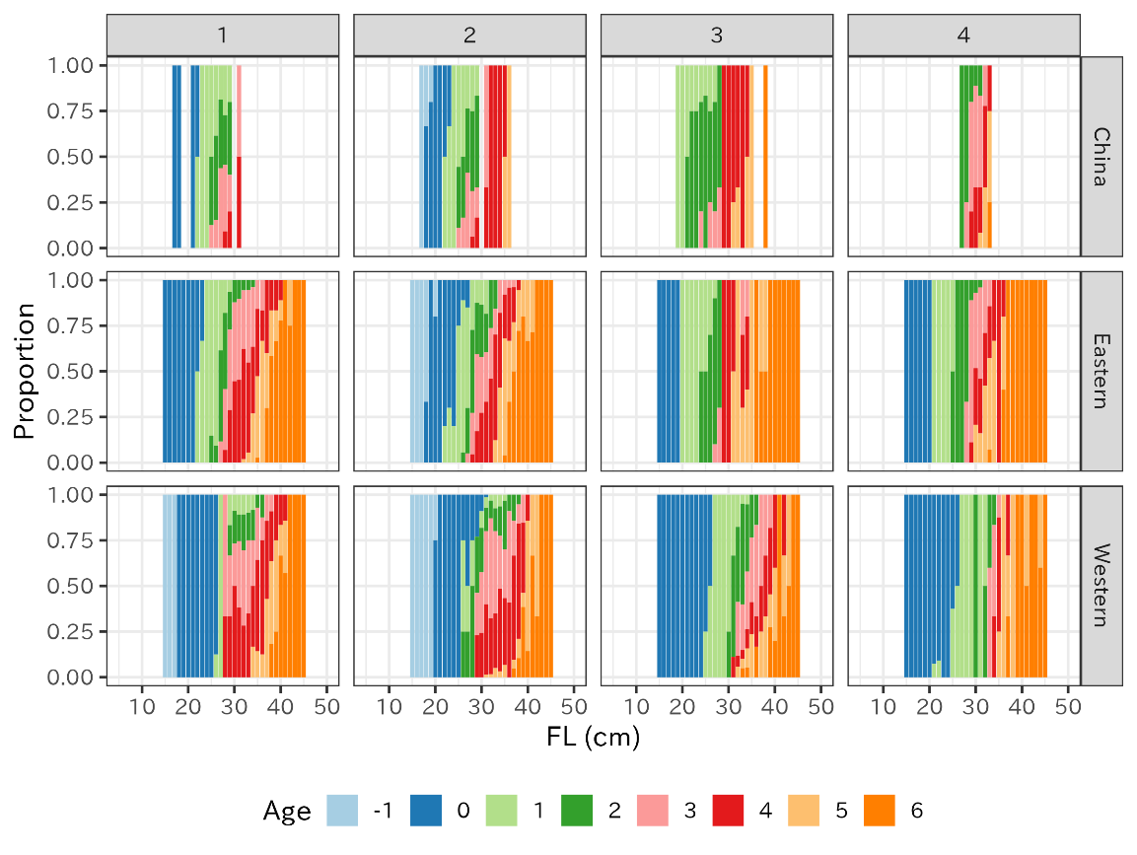

(b) 2019
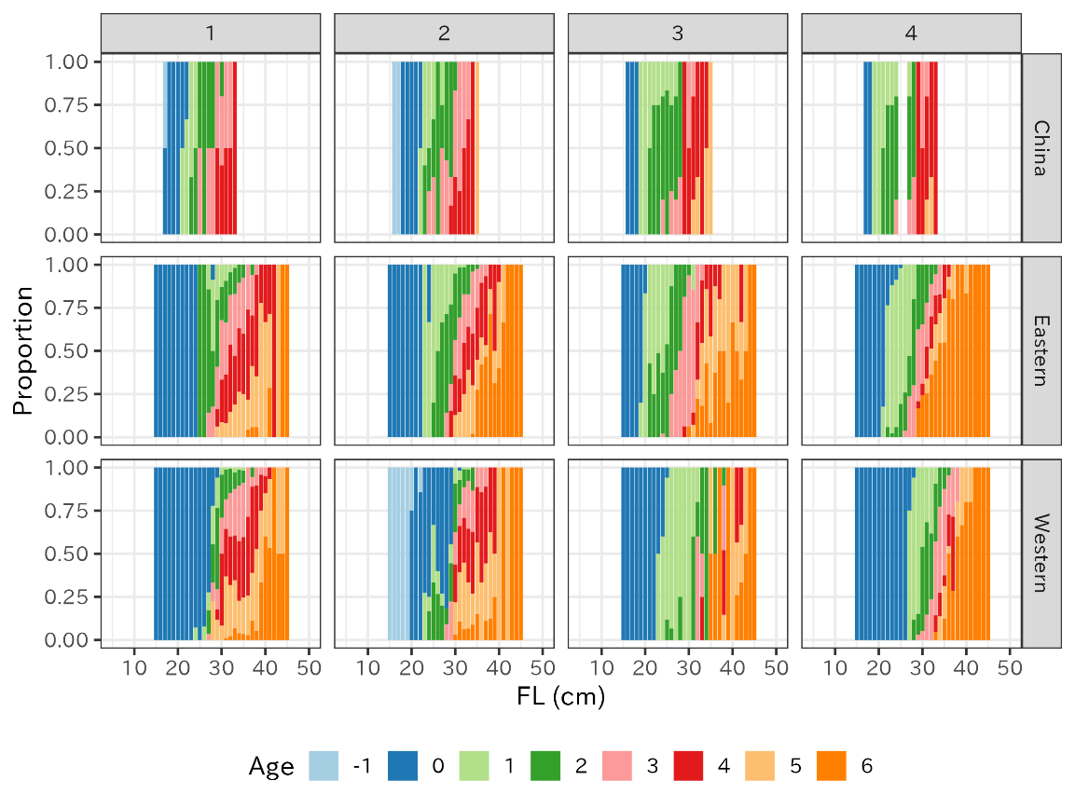
Figure 6. Quarterly ALKs from China, Eastern and Western Japan from 2018-2023 calendar year, with adjusted age for China.

(c) 2020
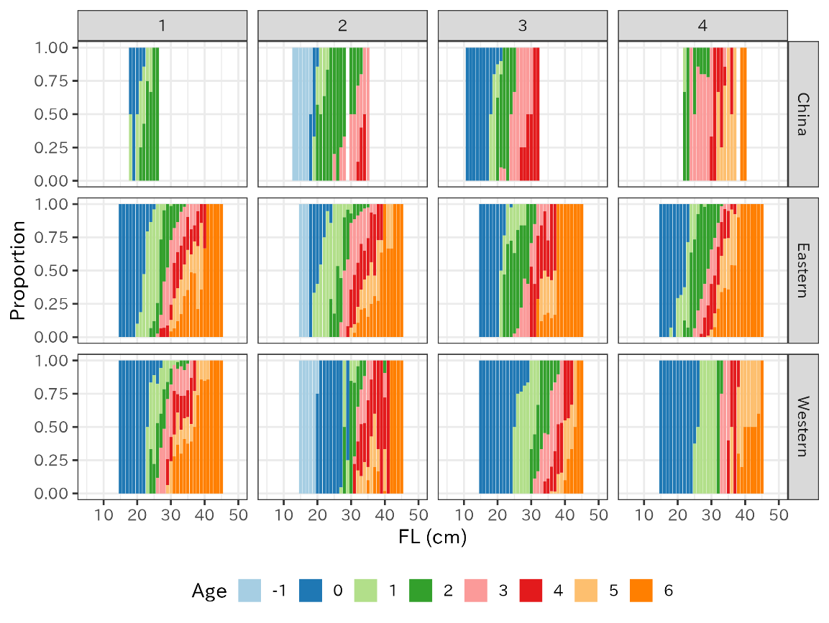

(d) 2021
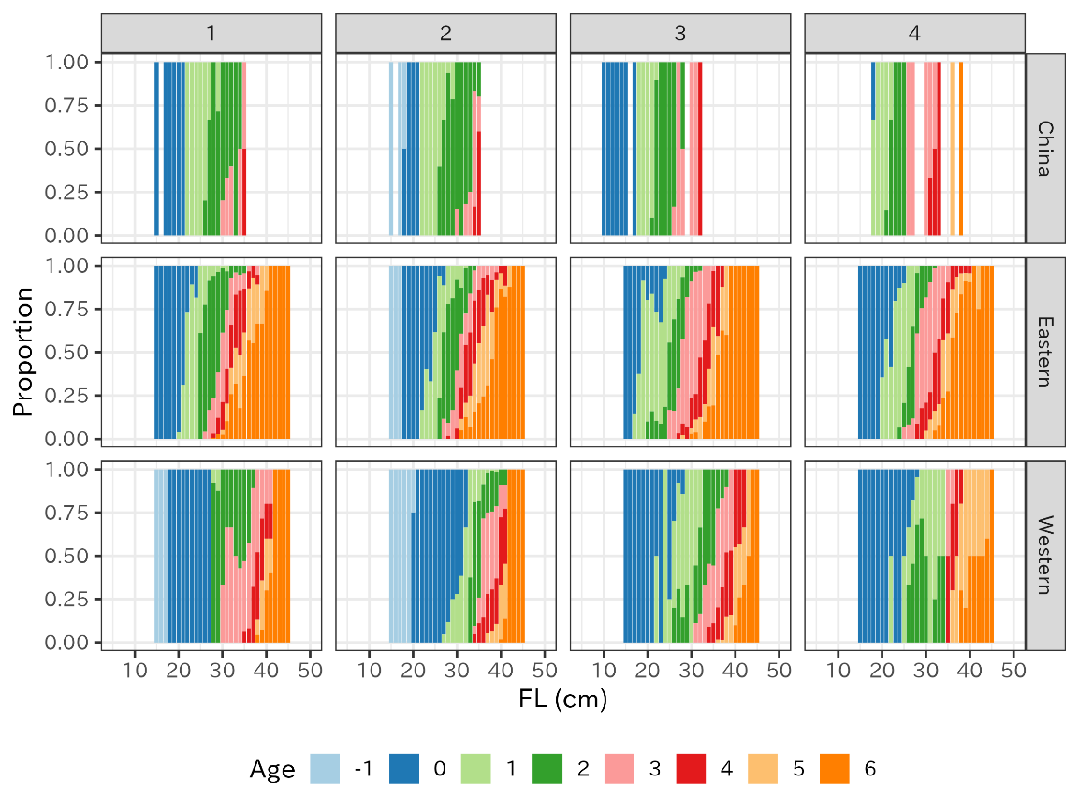
Figure 6. (continued)

(e) 2022
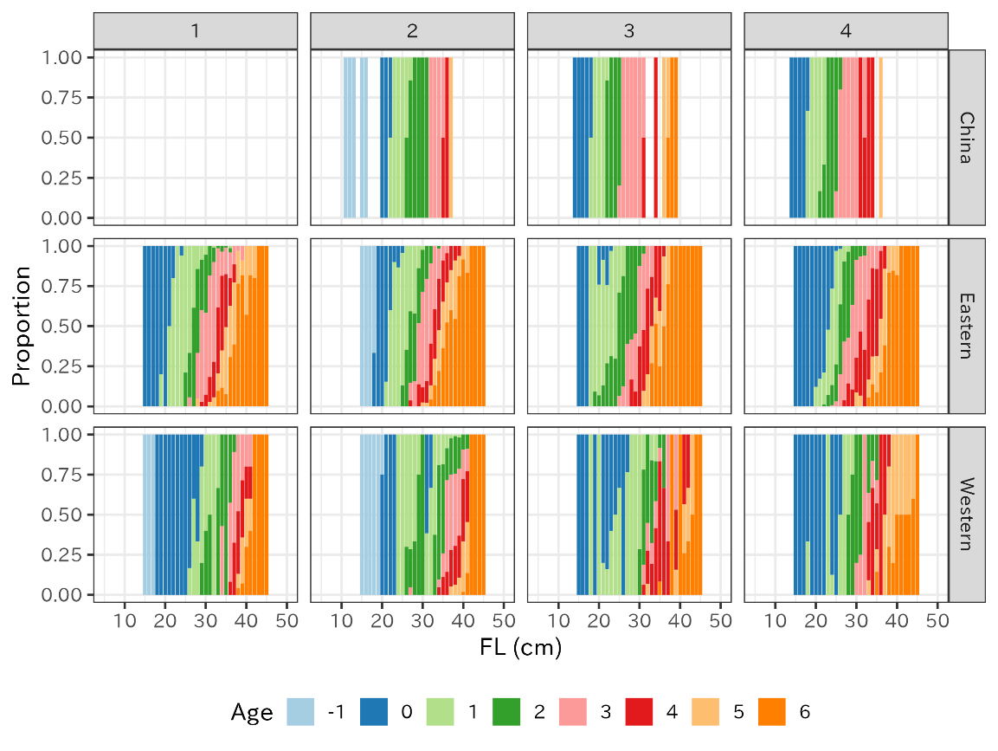

(f) 2023
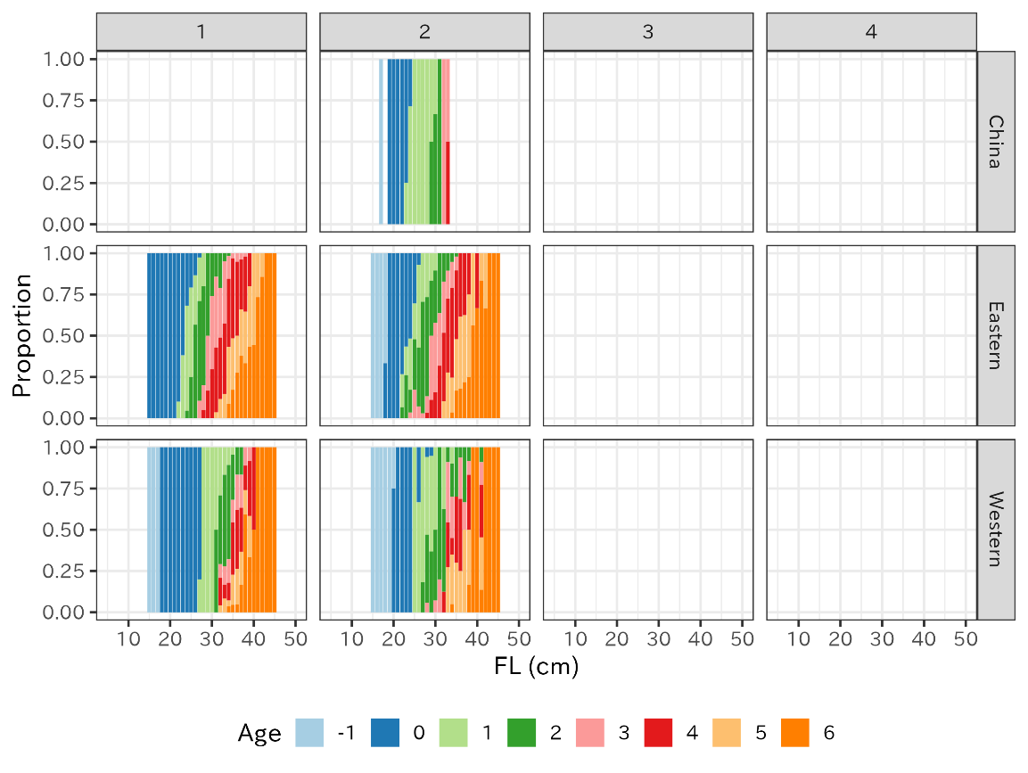
Figure 6. (continued)
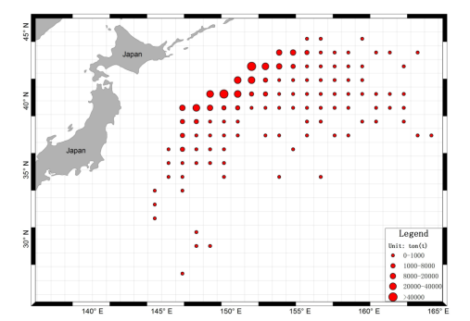
Figure 7. Distribution on the catch of chub mackerel in China in 2015-2019 (from Heng et al. (2021) Figure 7).

Catch at age
Catch at age is calculated by applying ALK to catch at length data. Chinese catch at age are calculated by Chinese ALK of the equivalent quarter, Japanese catch at age are calculated by ALK of the equivalent quarter and region, and Russian catch at age is calculated by eastern Japanese ALK. Detailed methodology on the application of ALK to catch at length is described in Manabe et al. (2021) and NPFC (2022).
Figures 8 and 9 illustrate the catch at age by quarter for each member on a fishing year basis (note that quarter begins from 3). The majority of catch in China consists of age-0 to age-2 in Q3 and Q4 with large catch of age-4 in 2018 fishing year (Fig. 9). Japanese Eastern and Western catch at age exhibit different pattern in catch composition and main fishing season in which Q1 and Q4 are the main season for eastern Japan while western Japan harvests throughout Q1 to Q3 with declined catch in Q4. The age composition differs as eastern Japanese catch at age illustrates significant weight on age-3 + fish after 2016/Q4 as the introduction of 2013 year-class. Western Japan, meanwhile, steadily harvest on age-0 fish in Q3 and Q4 with relatively larger catch of age-3+ fish in Q1 and Q2. Russian catch at age represents significant catch in Q4 in 2017-2021 compared to other quarters. The age composition is relatively evenly distributed, however, more than half of the catch in 2020/Q4 and 2021/Q4 were age-4+, representing catching older fish compared to China (Fig. 9).
Figure 10 and Table 4 show the fishing year-based annual catch at age for three members. As Japanese and Russian catch number declined from 2020 to 2022 fishing year, from 1062 million to 390 million and 78 million to 43 million, respectively, Chinese catch number remain as 463, 565, and 617 million for 2020, 2021, and 2022 fishing year, respectively.

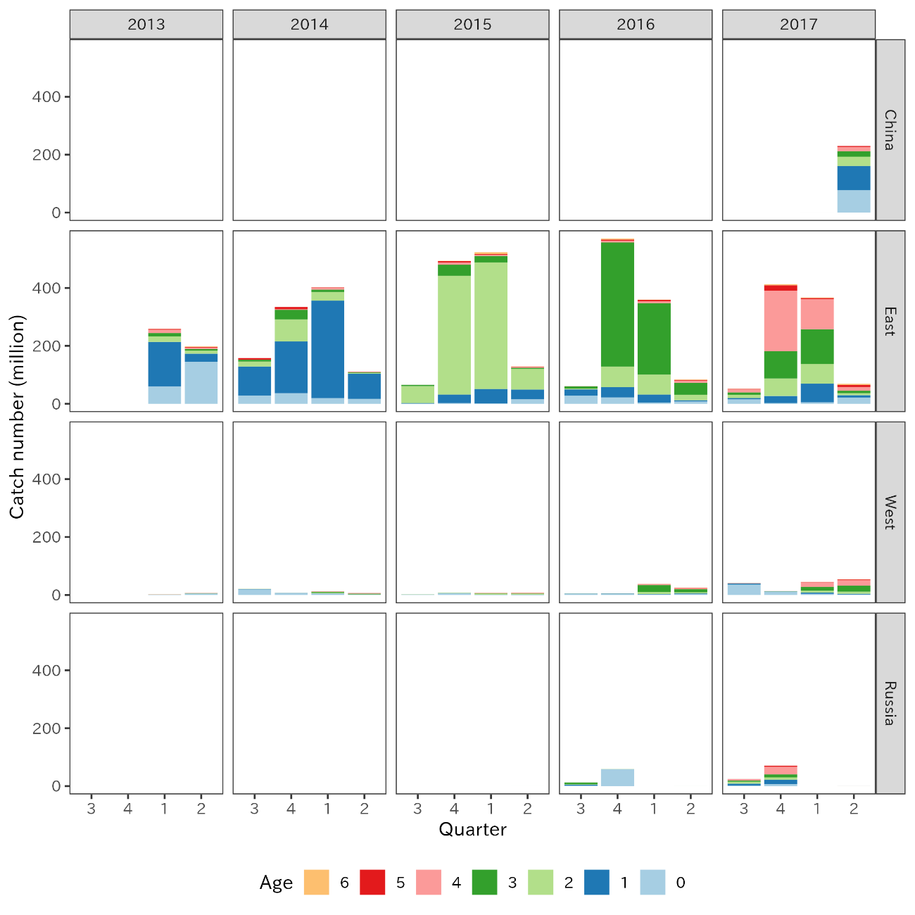
Figure 8. Quarterly catch at age from 2013 to 2017 fishing year, with adjusted age for China and Russia.

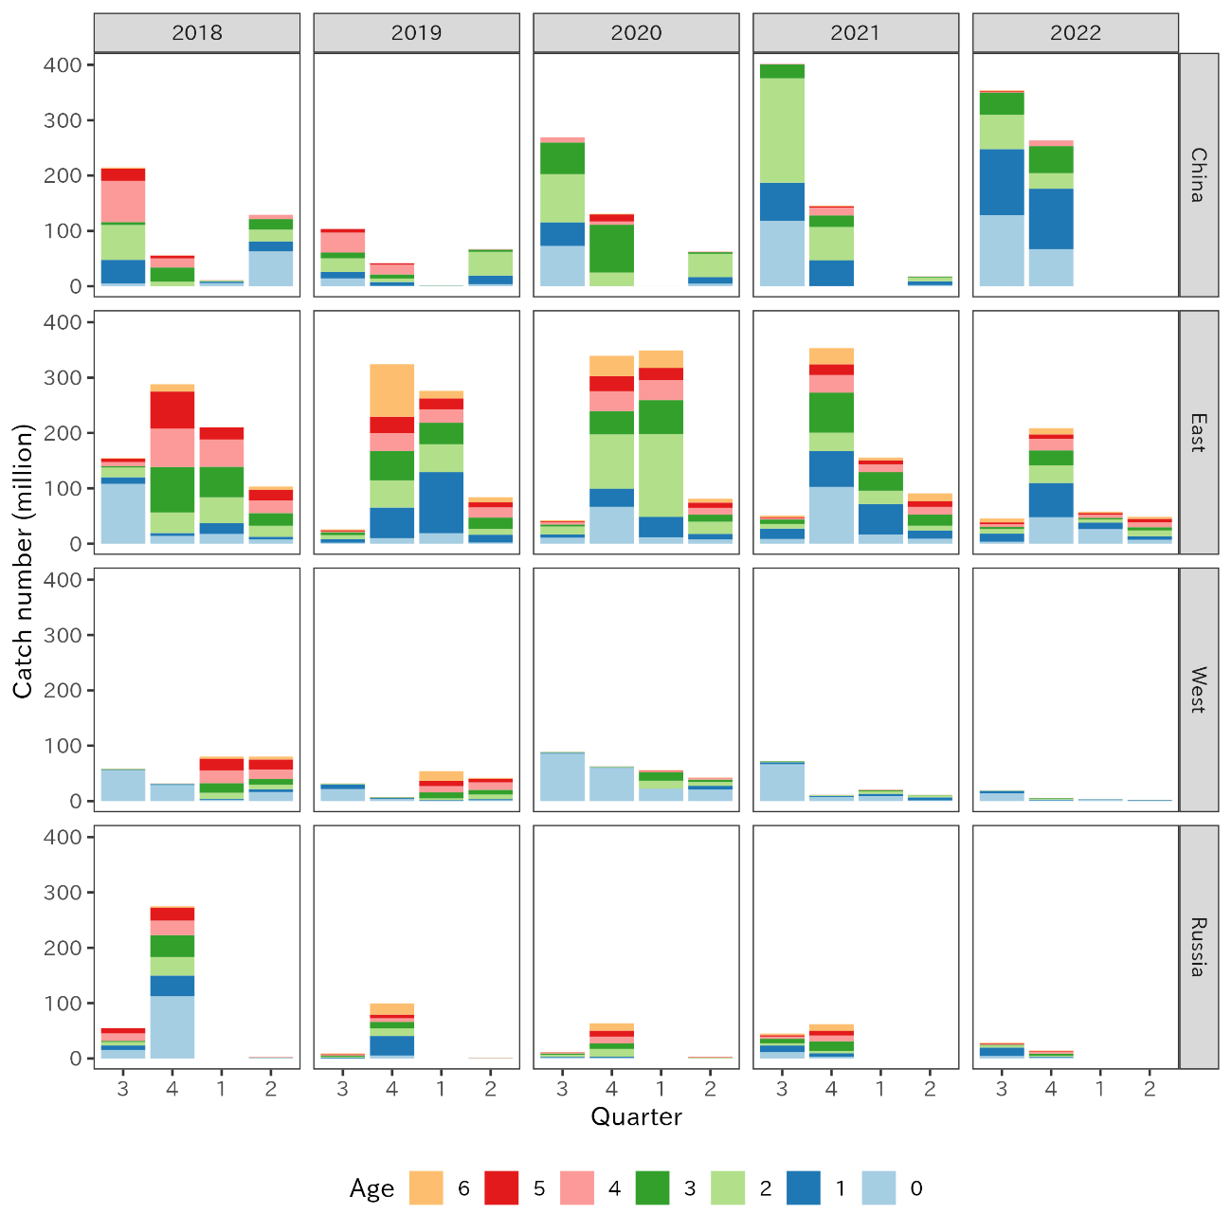
Figure 9. Quarterly catch at age from 2018 to 2022 fishing year, with adjusted age for China and Russia.

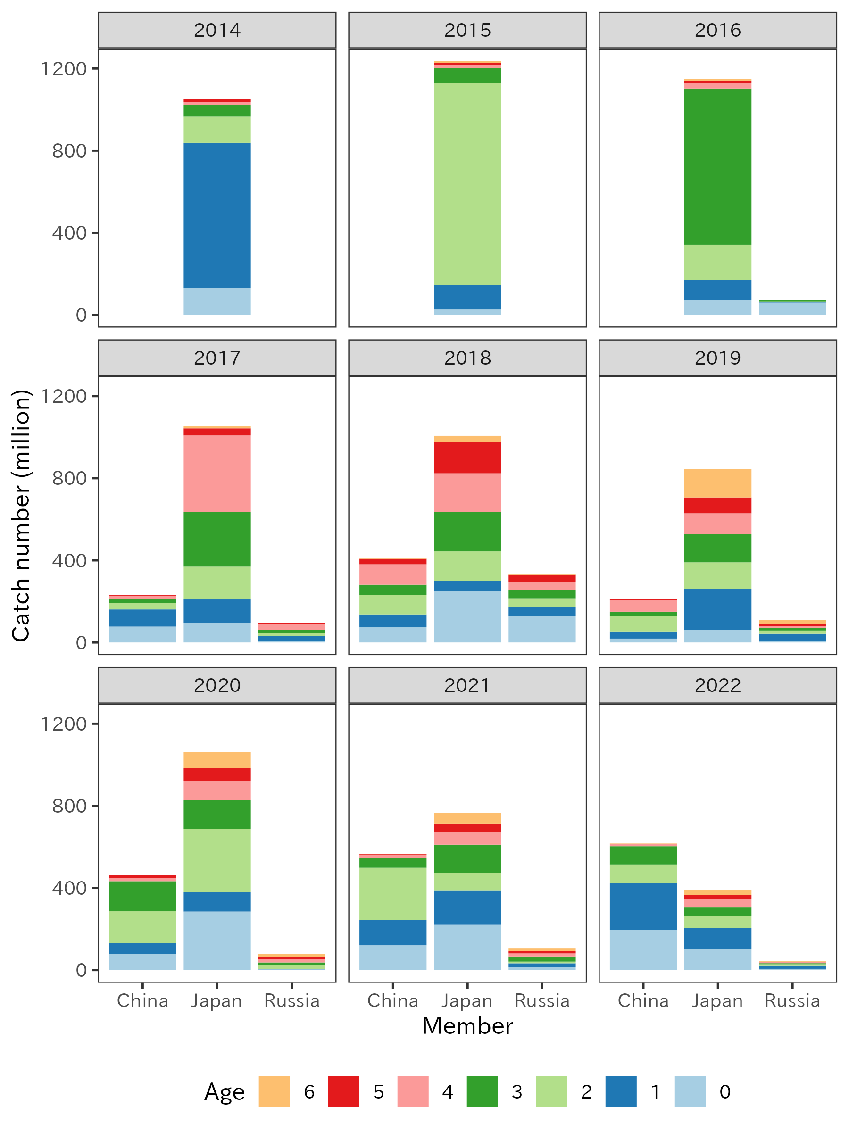
Figure 10. Annual catch at age from three members in fishing year scale, with adjusted age for China and Russia.

Table 4. Annual catch at age from three members in fishing year scale, with adjusted age for China and Russia.

Scenarios to calculate Chinese catch at age in 2016-2017
China has reported the catch mackerels (chub and blue mackerels) since 2015 in the conventional area and sampled catch at length data since 2016/Q2. However, ALKs are only developed since 2018/Q2, therefore catch at length data from 2016/Q2 to 2017/Q4 cannot be converted into catch at age with concurrent ALKs. To calculate catch at age data during the period, three methods are tried in the present paper.

(a) Use average Chinese ALK from 2018-2020
Alternative quarterly ALKs are estimated by taking a mean of 2018-2020 for each quarter and applied to catch at length data.

(b) Use average Chinese ALK from 2018-2022
Similar to (a), quarterly ALKs are yielded by taking an average of all available Chinese ALKs.

(c) Use Japanese eastern ALK
Japanese ALK has been developed for the equivalent period for both eastern and western Japan. Heng et al. (2021) shows the location of the Chinese catch as the conventional area southeast Hokkaido (Figure 7). Since eastern Japanese ALK is established and used by Japan and Russia, eastern Japanese ALK can be applied to the concurrent year/quarter of the Chinese catch at length data.

ALKs from each scenario are shown in figure 11. Among Chinese ALKs, the difference in age pattern is not significant, however, slightly larger proportion of age-1 is seen in Q2 under scenario (b). Japanese ALK in the other hand, describes the actual age composition at the adjacent region, representing greater proportion of age-0 and age-1 in 3rd quarter in 2016 and 2017 than two Chinese counterparts.
The Chinese catch at age for 2016 and 2017 are shown in table 5, figure 12, and 13. In 2016, both averaged Chinese ALKs (scenario a and b) estimate larger number of age-3and age-4 in Q2 and Q3 while Japanese ALK allocates more age-0 to age-3 fish in Q2-4. The difference in ALK affect strongly in 2016/Q2 for 27-28cm FL and 2016/Q Q4 for 35-38cm FL (Fig. 12). In 2017, Japanese ALK yields more age-0 and age-1 fish in 2017/Q3 and 2017/Q4 while both averaged Chinese ALK allocate the catch number into age-2 and age-3 due to the different age composition in 20-25cm FL (Figure 12 and 13).
According to Kamimura et al. (2021), intraspecific density dependent growth is observed since the introduction of a strong 2013-year class. The effect of 2013-year class is seen in 2016 as age-3 and 2017 as age-4 fish. Therefore, method (c) is preferred to (a) or (b) when considering the effect of strong year class of 2013 and cohort-specific growth rates observed by Kamimura et al. (2021).

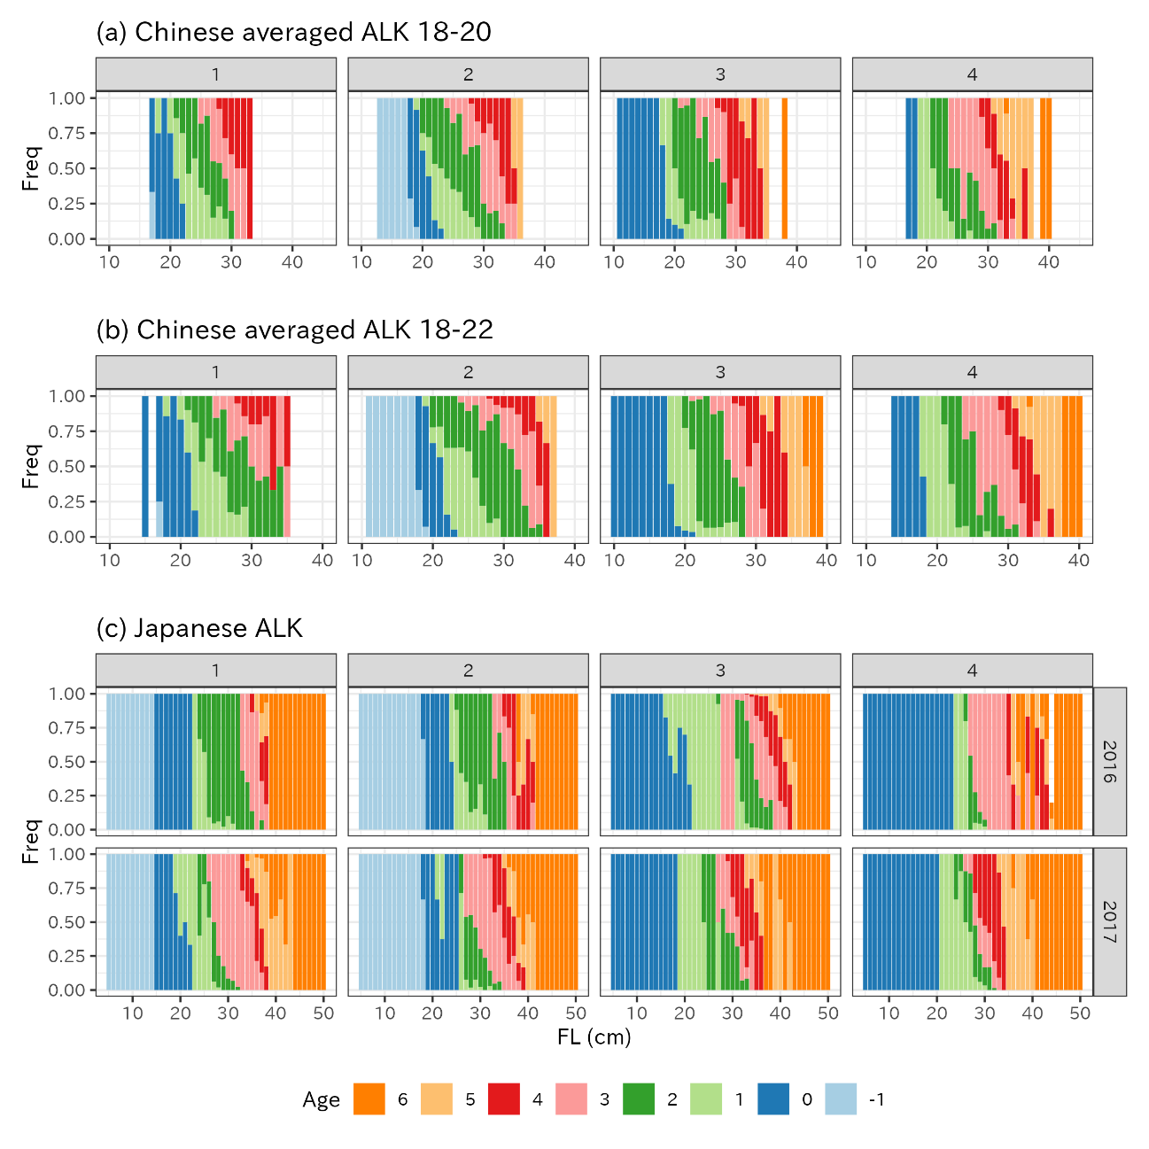
Figure 11. Chinese quarterly age length keys from averaged Chinese ALKs from (a) 2018-2020, (b) 2018-2022, and (c) Japanese ALK for 2016 and 2017. Note that (a) and (b) use adjusted age.
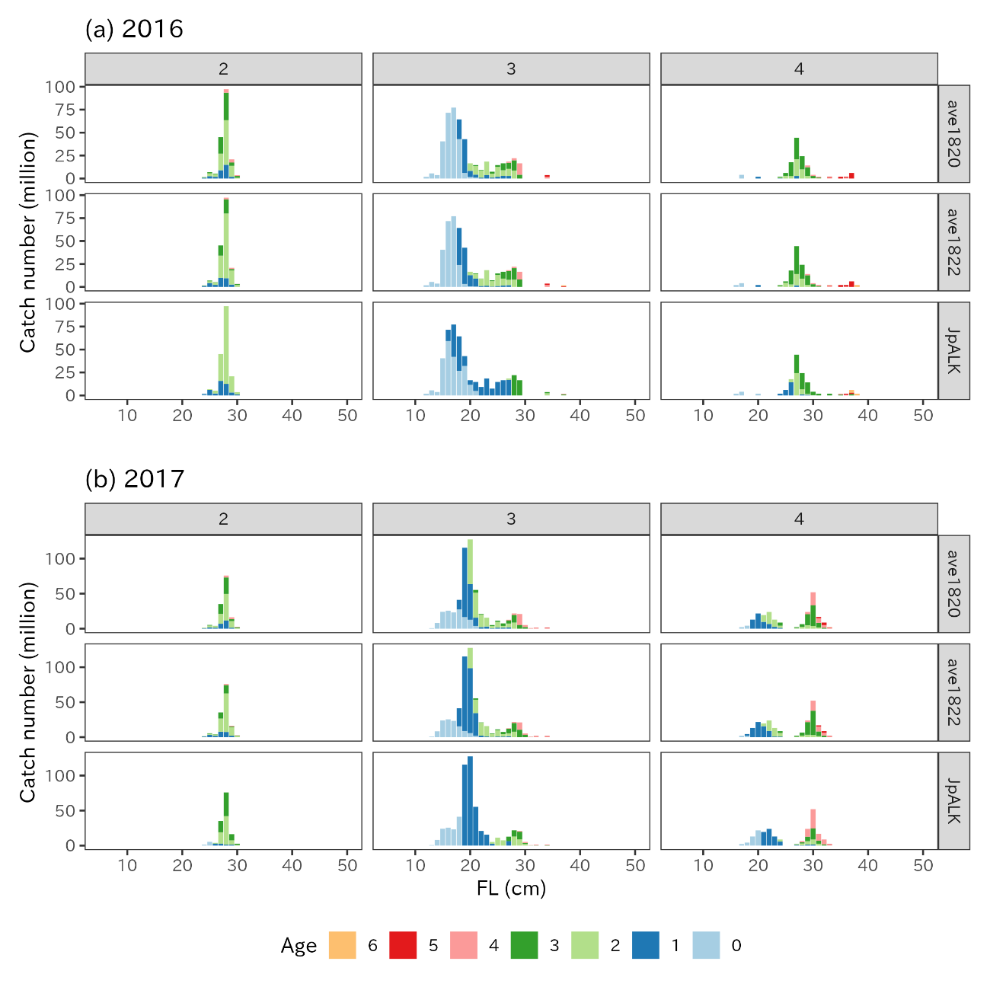
Figure 12. Chinese catch at length with age stratification in 2016 and 2017 using three ALK scenarios.
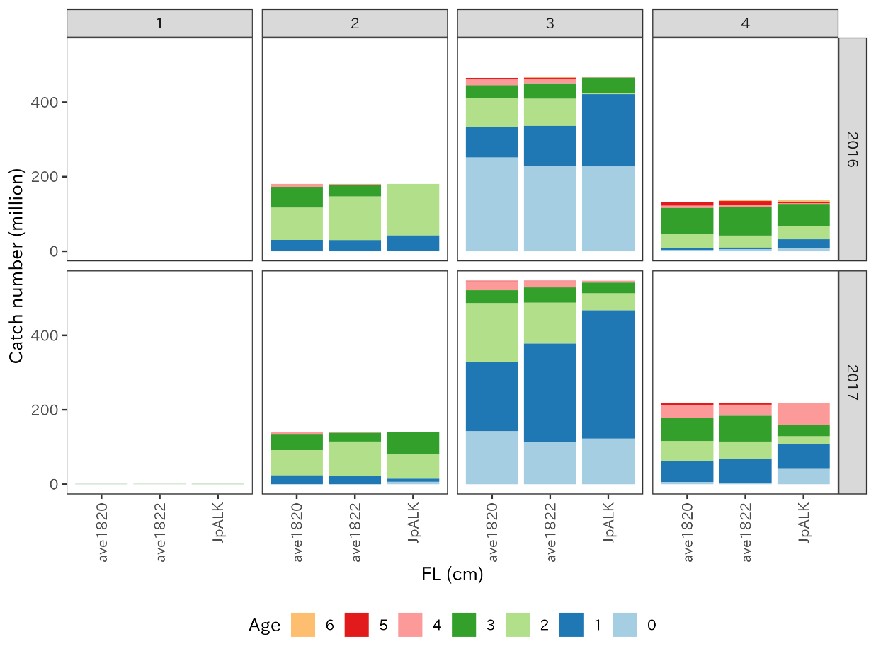
Figure 13. Chinese quarterly catch at age in 2016 and 2017 using three ALK scenarios.

Table 5. Chinse catch at age (million) in 2016 and 2017 using three different ALK scenarios.
Scenarios to calculate on the catch at age for 2014-2015 for China and Russia
Since 2014 and 2015, China and Russia have begun harvesting chub mackerels in the northwestern Pacific Ocean, respectively. The annual summary footprint data shows the catch were present in 2015 for China, and 2014 and 2015 for Russia. However, neither catch at length data nor age composition data are available to construct catch at age, which is required for stock assessment input data. In this section, following recommendation is made to assume the annual catch at data for 2014 in Russia, and 2015 for China and Russia.
In the previous section, a scenario to obtain Chinese catch at age in 2016 based on the Japanese eastern ALK is explained, which further suggests that Japanese eastern ALK may be applied as a proxy ALK for Chinese and Russian ALK if necessary. Since the length composition is known in 2016 from China and Russia, these data can also be used as proxy values for the length composition of 2015 for China and 2014-2015 for Russia. Under an assumption that the weight at age for China and Russia are indifferent between 2014-2016, the same catch at age composition of 2016 is applied into 2014-2015 for China and 2015 for Russia with corresponding ratio to the catch of 2016.
The ratio of catch in 2014-2015 and 2016 in China and 2015 and 2016 for Russia are calculated as in Table 6. Although the Russian catch data combines both chub and blue mackerels, an assumption is made that the ratio of chub/blue mackerel are the same across 2014-2016. Table 6 shows the ratio of catch. The quarterly catch at length for 2014 and 2015 are multiplied by the corresponding ratio to estimate catch at length in number. Since eastern Japanese ALK is used by Russia and recommended to use to supplement ALK where age data is missing for China, corresponding 2014-2015 eastern Japanese ALK are applied to the quarterly catch at length data for China and Russia.
Figure 14 and Table 7 show the estimated annual catch at age in 2014 for Russia and 2015 for China and Russia, with corresponding available catch at age data. Even though the catch at length composition is assumed to be the same as 2016, using ALKs from the corresponding year allow the depiction of the transition of 2013-year class from 2015to 2016 as age-2 to age-3 (Fig. 14).
Catch at age data is year specific, and the one of the reasons is age composition differs every year as different cohorts grow at different growth rates. As Kamimura et al. (2021) presents, cohort-specific growth rate is estimated for the chub mackerel in the northwestern Pacific Ocean especially after 2013-year class. Therefore, the inclusion of ALK from the matching year is critical to correctly describe the trend of the catch. Alternative method to estimate such as simply multiplying the catch at age of 2016 by the ratio of catch, however, the procedure may skew the age composition by over- and under-estimate the strength of cohorts. Therefore, it is recommended to estimate the catch at age of 2014 for Russia and 2015 for China and Russia using the proposed method.
Table 6. Catch of chub mackerel for China and chub and blue mackerels for Russia in 2014-2016 and the catch ratio to 2016.

Table 7. Estimated catch at age from China and Russia. 2016 data and Japanese data for comparison.
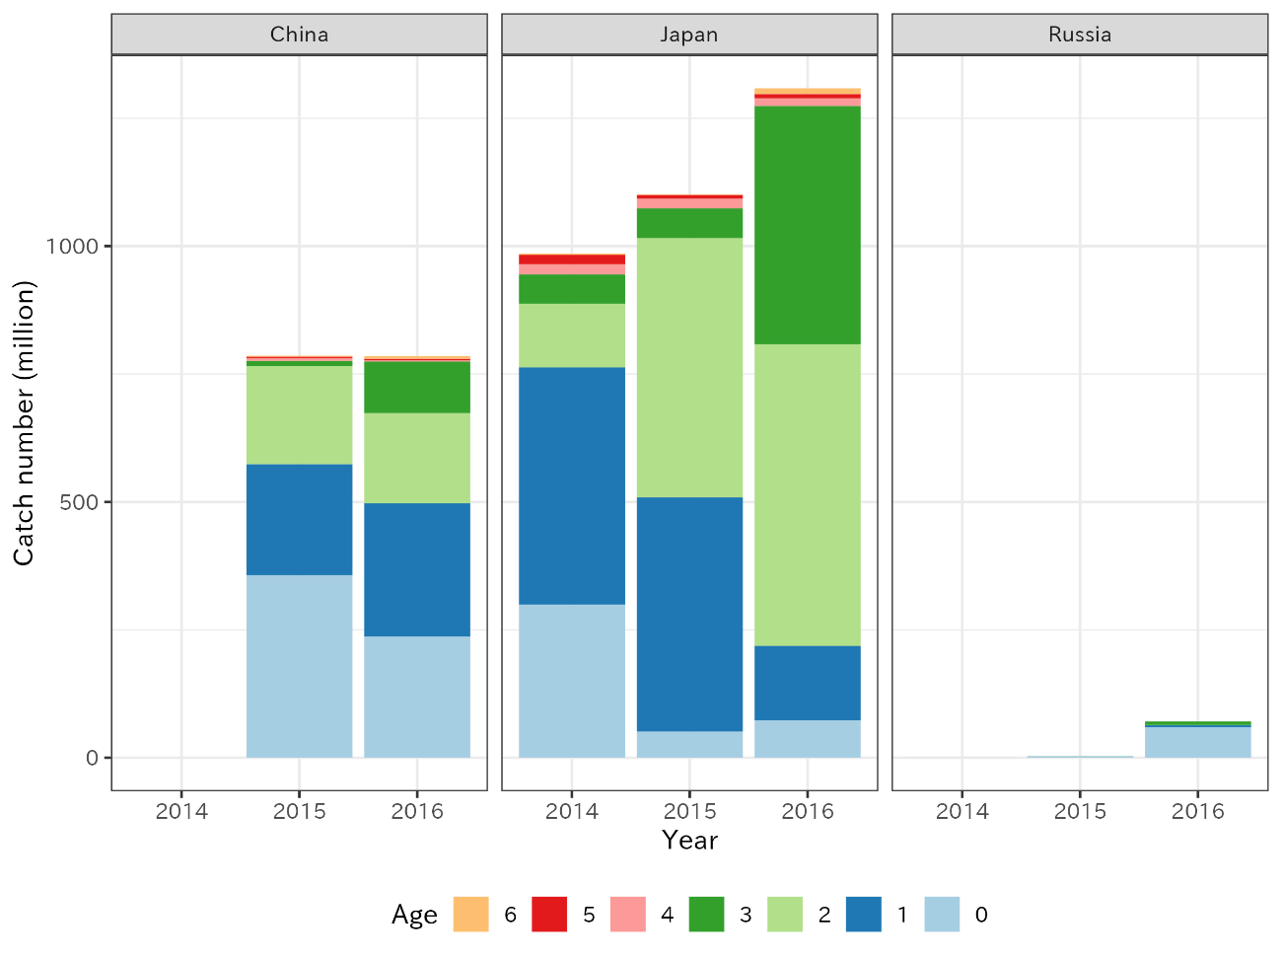
Figure 14. Catch at age of 2014-2016 with alternative catch at age for China and Russia for 2015 and 2014-2015, respectively.

References

Chernienko, E., Chernienko, I. (2021). Catch and weight at age of chub mackerel in Russia. NPFC-2021-TWG CMSA04-WP11. pp1-7.
Fridriksson, A. (1934). On the calculation of age distribution within a stock of cod by means of relatively few age determinations as a key to measurement on a large scale. Rapp. P.-V. Reun. Cons. Int. Explor. Mer., 86, pp1-14.
Heng, Z., Yang, C., Shi, Y., Zhao, G. (2021). Monthly catch data and the maps and description of China’ fishing grounds. NPFC-2021-TWG CMSA04-WP15. pp1-5.
Kamimura Y., Taga, M., Yukami, R., Watanabe, C., Furuichi, S. (2021). Intra- and inter-specific density dependence of body condition, growth, and habitat temperature in chub mackerel (Scomber japonicus). ICES J. Mar. Sci. 78:9, pp3254-3264. doi: 10.1093/icesjms/fsab191
Manabe, A., Ichinokawa, M., Ryuji, Y. (2020). Catch, weight, and maturity at age of the chub mackerel of Japan. NPFC-2020-TWG CMSA03-WP02. pp1-19.
NPFC (2022) Content of the document for data description in China. NPFC-2022-TWG CMSA 05-IP4. pp1-10.

