NPFC-2024-TWG CMSA08-WP13

Length-weight relationship and weight at age of chub mackerel Scomber japonicus caught in the northwestern Pacific Ocean by China, Japan, and Russia

Akihiro MANABE*, Ryuji YUKAMI*, Momoko ICHINOKAWA*, Heng ZHANG**, Igor CHERNIENKO***, Emiliya CHERNIENKO***

*Fishery Research and Education Agency (FRA), Japan
**East China Sea Fisheries Research Institute, Chinese Academy of Fishery Science, China
***Pacific branch of VNIRO (TINRO), Russia

Summary
Length-weight data of chub mackerels caught by China and eastern/western Japan are compared and parameters of length-weight relationship are estimated. The relationship among regions exhibits similar trajectories. Weight at age of chub mackerels is compared from the data by China, eastern/western Japan, and Russia with adjusted age on China and Russia. The weight at age for stock assessment is calculated using the submitted data and arithmetic mean of China, eastern Japan, and Russia is recommended.

Length weight relationship
Length-weight relationship can be used to convert catch at age in number to catch at age in weight, which further calculates weight at age. The relationship is expressed as a logarithmic function of log(Weight) = log(a)+b*log(Length). Table 1 shows number of individuals that length and weight were measured. Among the Chinese measurement data, nine samples are considered as error and removed as outliers due to its deviant weight at length from the majority of the samples. In Japan, the data is obtained by taking a subsample from the catch at the major landing ports in prefectures from Hokkaido to Kagoshima on monthly basis.
Figure 1 shows the quarterly length-weight relationship for each region and figure 2 shows the comparison among regions. Each region exhibits similar scattered plot throughout the quarters with limited amount of data from China in Q1 and Western Japan in Q3 and Q4. When the scattered plots are compared by region for each quarter and year, plots from all regions present overlapping each other, consequently indicating there was not large difference in individual length and weight among regions.
Logarithmic function is applied to the relationship between length and weight and estimated parameters are listed in Table 2 with trajectories depicted in figure 3. When the data samples are low or ranged in narrower size range (e.g., Chinese Q1, 3, 4 in 2018, Q1 in 2020 and 2021), the estimated parameters depict different trajectories from two Japanese curves, however, the overall length-weight relationships are the same. The similarity of length-weight relationship concludes both China and Japan had conducted proper measurement and can be used to convert length into weight. Additionally, with few exceptions, the result suggests Japanese and Chinese length-weight relationships can complement each other if sufficient data is unavailable.

(a) Chinese length-weight
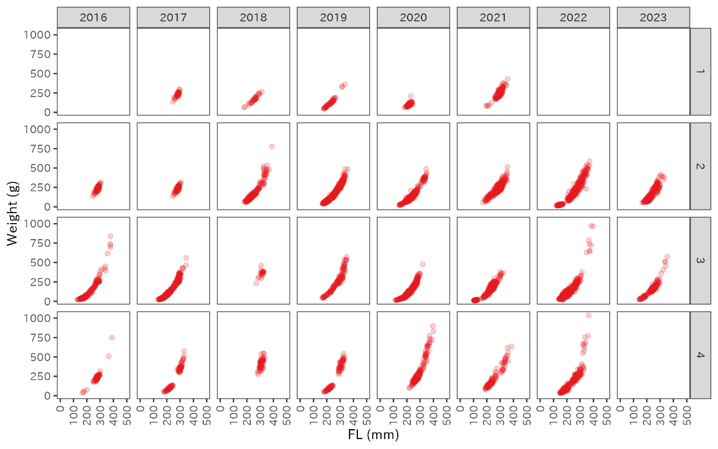
Figure 1. Length-weight relationship for each quarter for different regions (a) China, (b) Eastern Japan, (c) Western Japan.

(b) Eastern Japanese length-weight
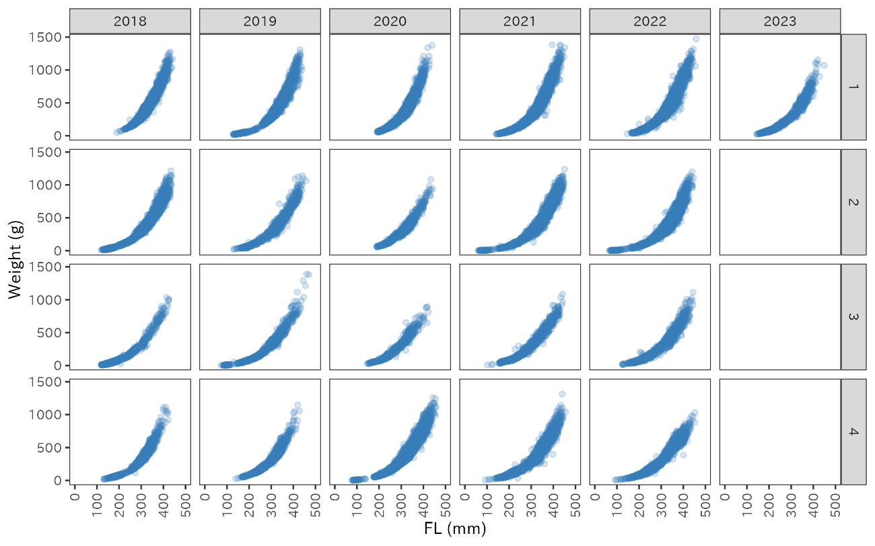
(c) Western Japanese length-weight
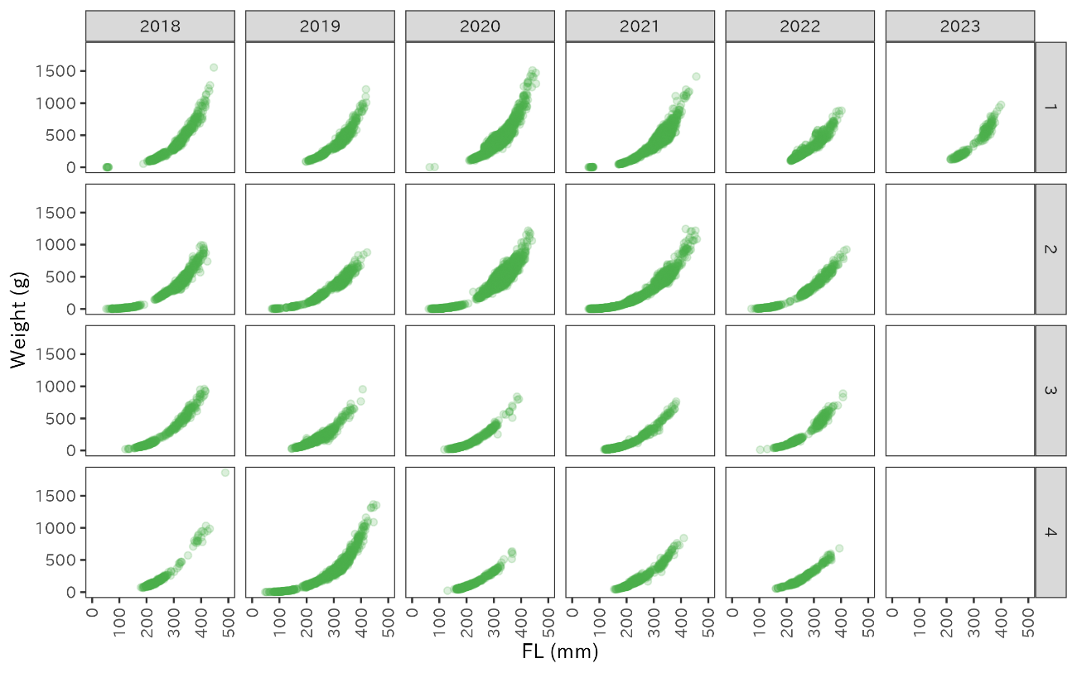
Figure 1. (cont.)

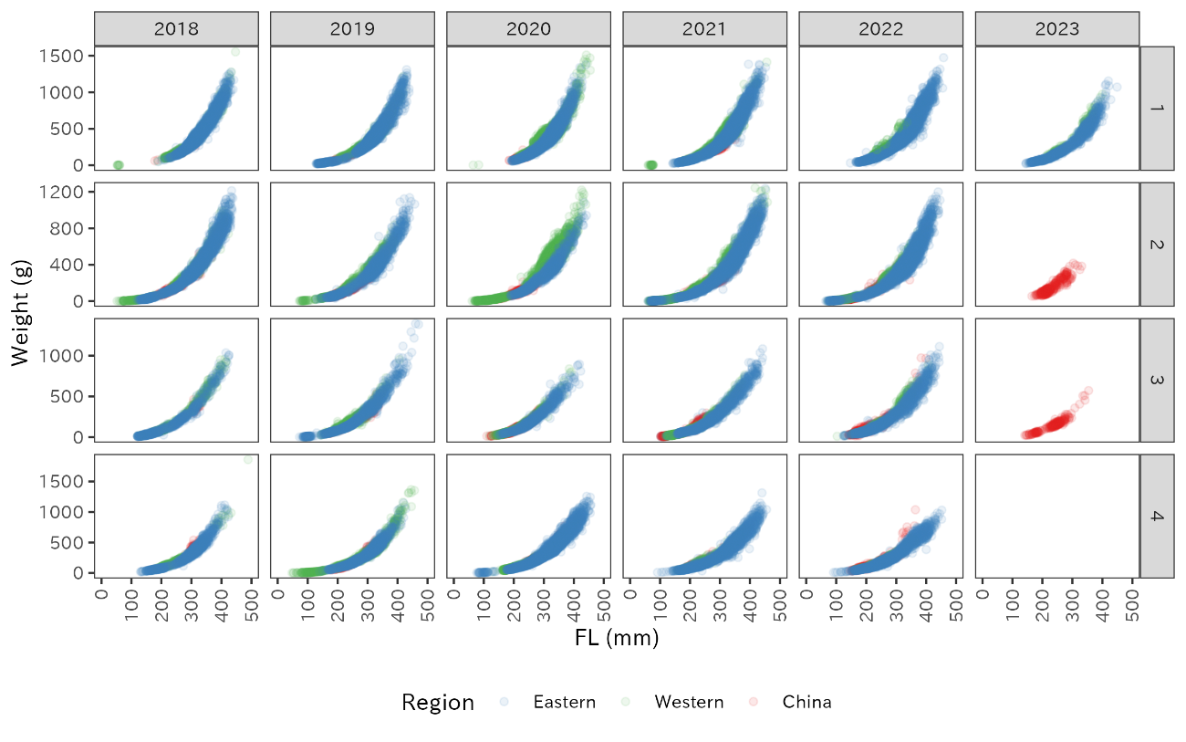
Figure 2. Length-weight relationship for each quarter with different regions.

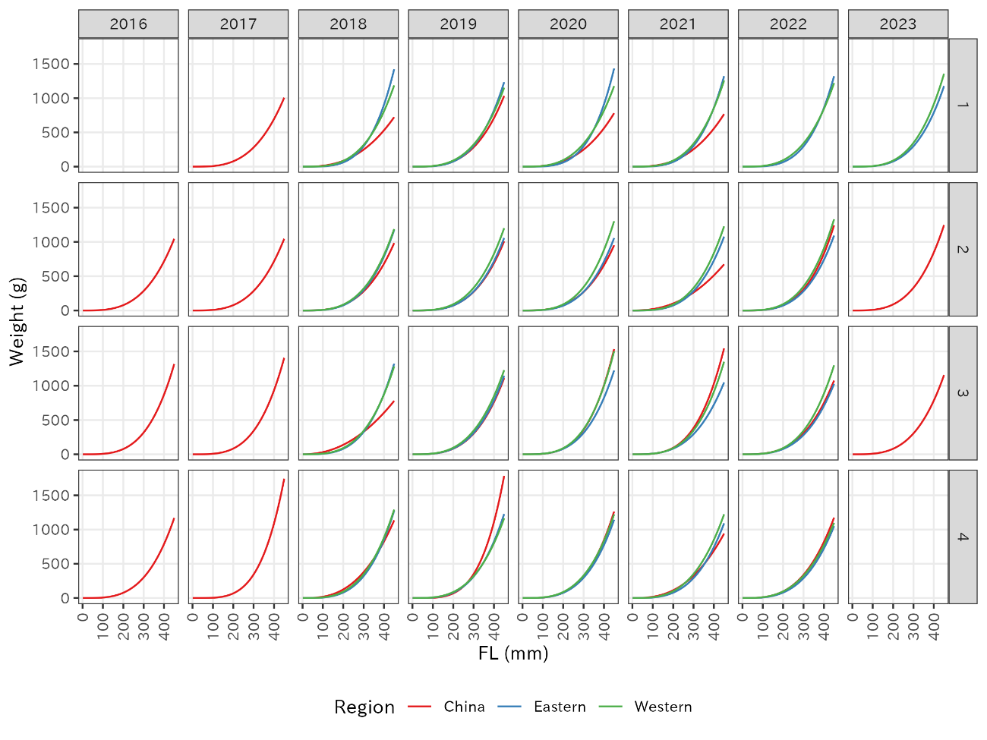
Figure 3. Length-Weight relationship based on estimated parameters.
Table 1. Sample size for the individual measurement data from three regions.

Table 2. Estimated parameters for length weight relationship from each quarter.

Weight at age
Weight at age plays an important role in calculating biomass and spawning stock biomass. Weight at age is calculated from each member: China, Japan, and Russia. Japan calculates weight at age for Eastern and Western region similar on quarterly basis. The detailed methodology is described in Manabe et al. (2020). Similar to the catch at age, age in Q1 and Q2 are subtracted by 1 for China and Russia. Since age-7 only appears in Q3 and Q4, align with catch at age, in which age-7 is aggregated into age-6 to form age-6+, the arithmetic mean of weight of age-6 and age-7 is taken to replace weight at age of 6+ in Q3 and Q4.
Figure 4 shows the trend of weight at age from China, Eastern and Western Japan, and Russia. Since weight at age is affected by the seasonal growth, theoretical weight at age increases as quarter in a year proceeds. Weight at age from eastern and Western Japan depict the increasing trend clearly in younger ages (age 0 to 3) while Age-4+ fluctuates dramatically despite the temporal shift in Japan and Russia mainly due to the size composition of the catch. Meanwhile Chinese weight at age remains steadily for age-0 to age-4.
Figure 5 shows the comparison of weight by age for four regions. Weights at age from all four regions show increasing trend within a fishing year in age-0 to age-3 with similar level of weight for age-0 to age-5 except for the weights from Western Japan. Since the catch from Western Japan consists of the local population and catch from Eastern Japan, China, and Russia consists of the migrating population, the weight at age for Western Japan is estimated to be different from the others. For age 6+, Russian data show significantly heavier weight.

Recommendation for weight at age
Weight at age for each region can be used to calculate the tonnage of the catch, however, a single weight at age is required to convert stock number into stock biomass. Figure 5 shows that weight at age of three regions (China, Eastern Japan, and Russia) are closely to each other. Therefore, it is possible to take an average of weight at age from regions to estimate the representative weight at age. Arithmetic mean of weight at age from all four regions and three regions, which excludes Western Japan, are shown in Figures 6 and 7 in quarterly-scale and annual scale, respectively. Both averaging patterns exhibit similar trajectories however, inclusion of Western Japan increase the weight at age, since the catch of the local population is less likely to be affected by the density-dependent migrating population. Since the stock assessment of chub mackerel in the northwest Pacific Ocean is a stock that distributes over a wide range of EEZ and conventional areas, the focus is weighted in a migrating population. Therefore, the usage of averaged annual weight at age without weight at age of Western Japan is recommended as a weight at age in converting stock number to biomass (Table 3, Figure 7, dotted).
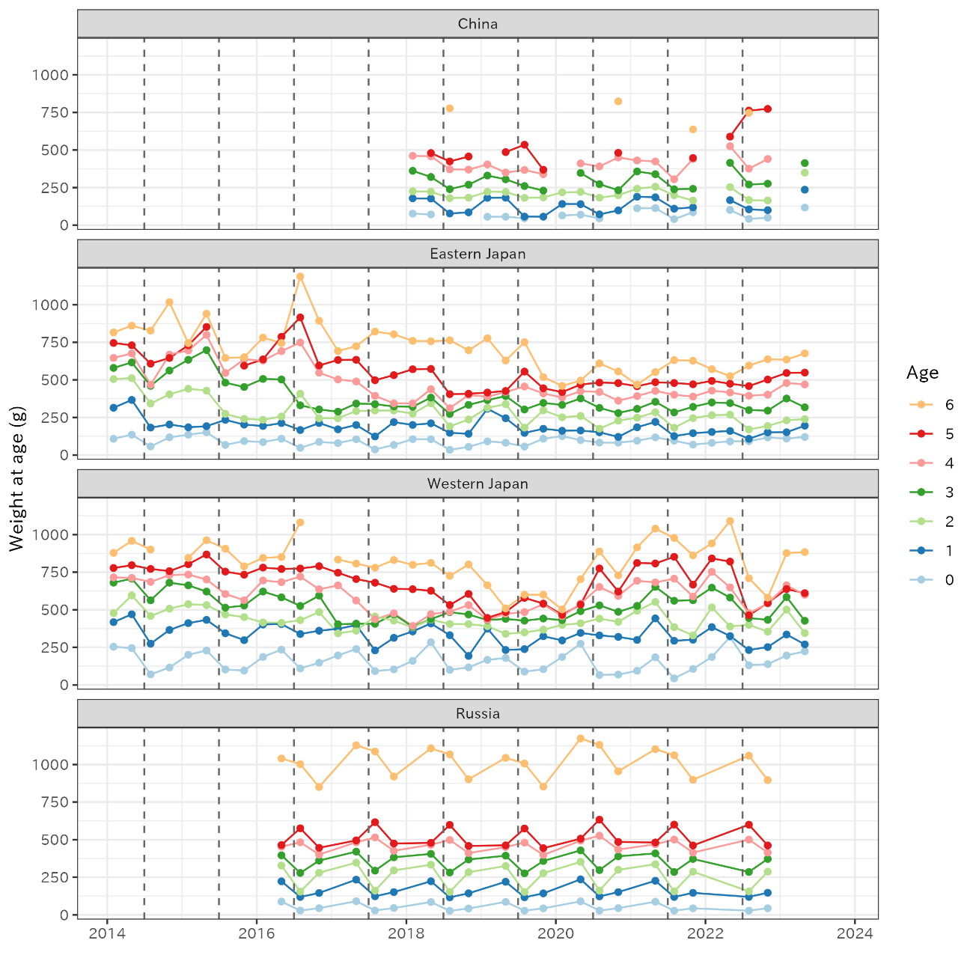
Figure 4. Quarterly weight at age from China, Eastern and Western Japan, and Russia. The vertical dotted line represents the beginning of a fishing year (July 1st). Chinese and Russian ages are adjusted to set the date of age incrementation as July 1st.

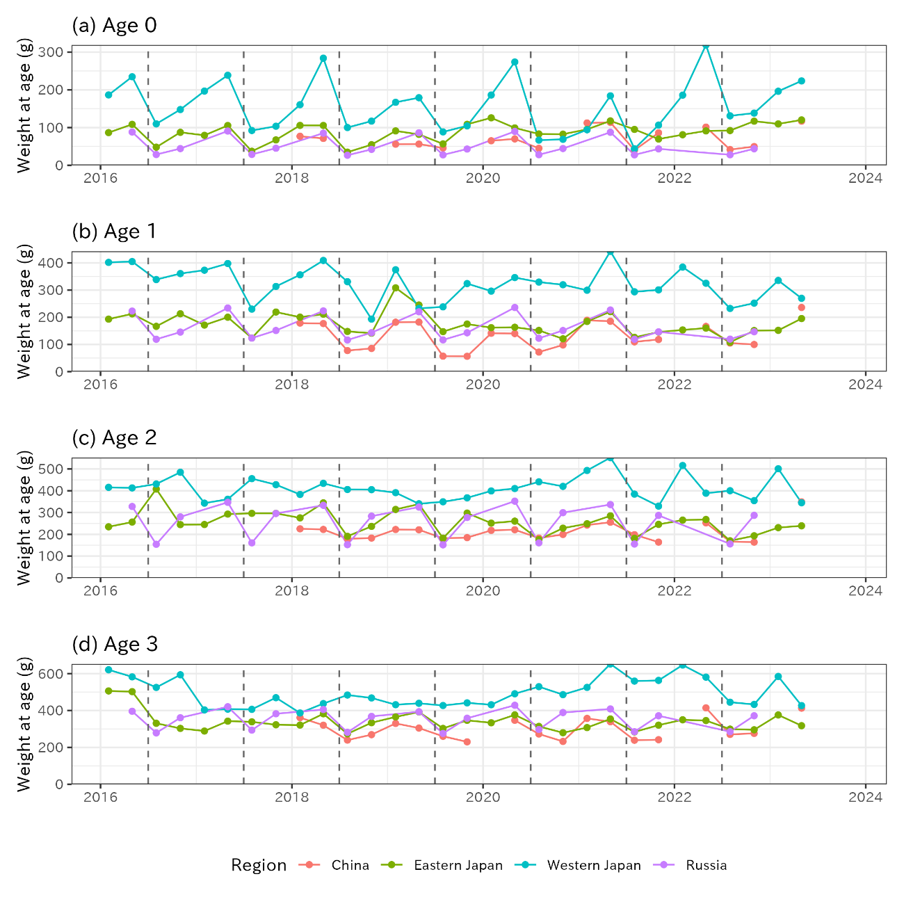
Figure 5. Quarterly weight at age from four regions for age-0 to age-7+. The vertical dotted line represents the beginning of a fishing year (July 1st). Chinese and Russian ages are adjusted to set the date of age incrementation as July 1st.

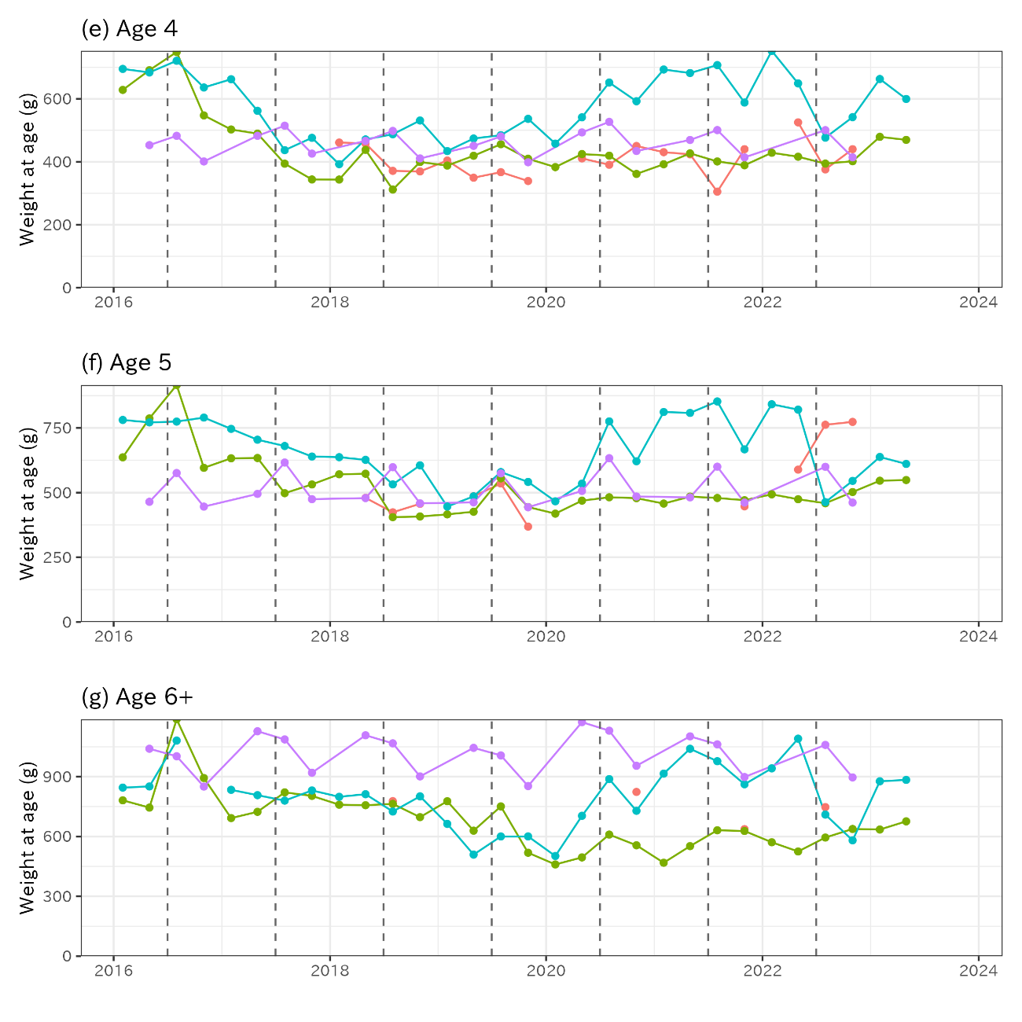
Figure 5. (continued)

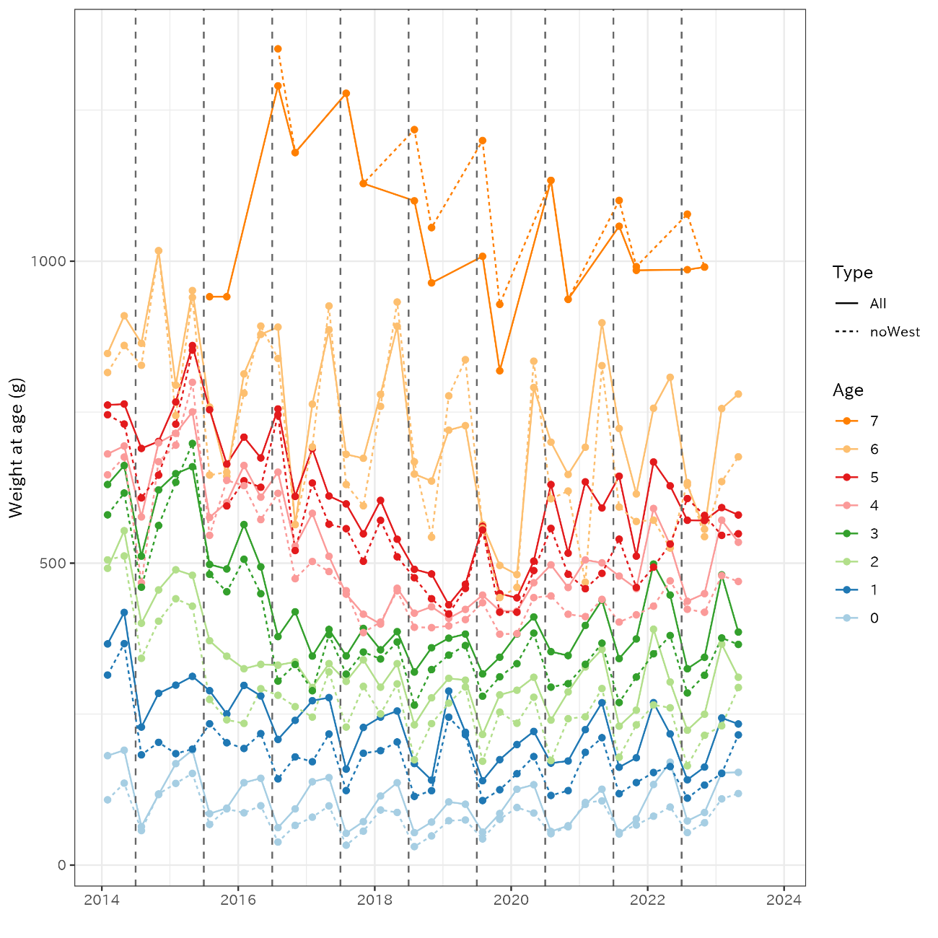
Figure 6. Averaged weight at age by quarter. Solid line represents an average of all four regions and dotted line represents an average that excludes Western Japan. Chinese and Russian ages are adjusted to set the date of age incrementation as July 1st.

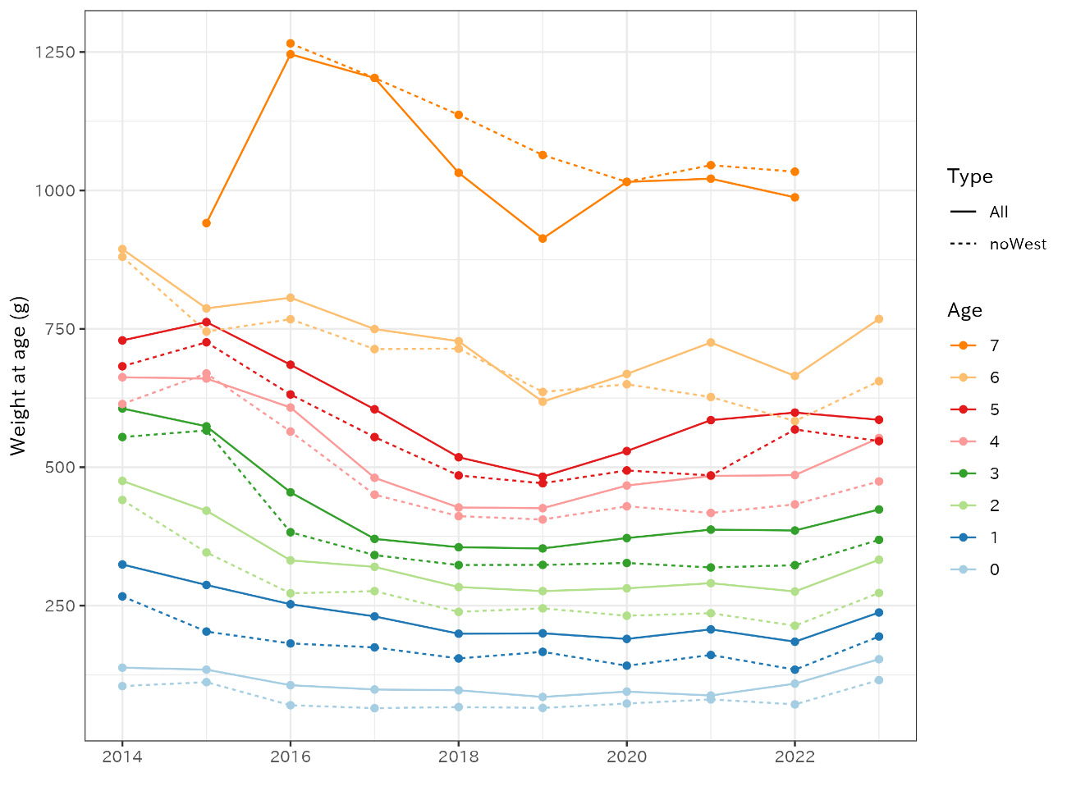
Figure 7. Averaged weight at age by year. Solid line represents an average of all four regions and dotted line represents an average that excludes Western Japan. Chinese and Russian ages are adjusted to set the date of age incrementation as July 1st.

Table 3. Averaged weight at age for two types: “noWest” that excludes data from western Japan and “All” includes all four regions into averaging.

Reference

Manabe, A., Ichinokawa, M., Ryuji, Y. (2020). Catch, weight, and maturity at age of the chub mackerel of Japan. NPFC-2020-TWG CMSA03-WP02. pp1-19.

