NPFC-2024-TWG CMSA08-IP02
Chub mackerel Russian fishery in the northwest Pacific Ocean Pacific Ocean, research activities in 2023
Antonenko D.V.
Pacific Branch of VNIRO ("TINRO")
Fishing in 2023
Russian vessels conducted mackerel fishery in 2023 throughout the year, starting in January, with the exception of March and April. In January and February, fishing took place within the Japanese EEZ, and for the rest of the period in the Russian EEZ. No mackerel fishing was conducted in open waters.

Figure 1 - Russian mackerel fishing areas by month in 2023

Figure 2 - Average catch per effort (CPUE), tons/vessel per day by month for the 2022 and 2023.

Average catch per effort - catch per vessel per day (CPUE) was high during the winter, but was well below 2022 levels. During the summer and first half of fall, CPUE was very low at less than 5 tons, only starting in November did CPUE begin to increase.

Figure 3 - Monthly catches of mackerel by Russian vessels in 2022 and 2023 (tons)

Monthly catches were also highest during the winter in 2023. In the summer catches were minimal and increased in the fall as the number of fishing vessels increased. However, the 2023 catch is significantly lower than the 2022 catch.

Figure 4 - Catch of mackerel by Russian vessels, thousand tons

The Russian mackerel fishery was started in 2016 when 6.7 thousand tons were caught, in 2018 the maximum catch was reached - 98.8 thousand tons and from this year the catch started to decrease and in 2023 the catch was 15.5 thousand tons.

Research activities in 2023.
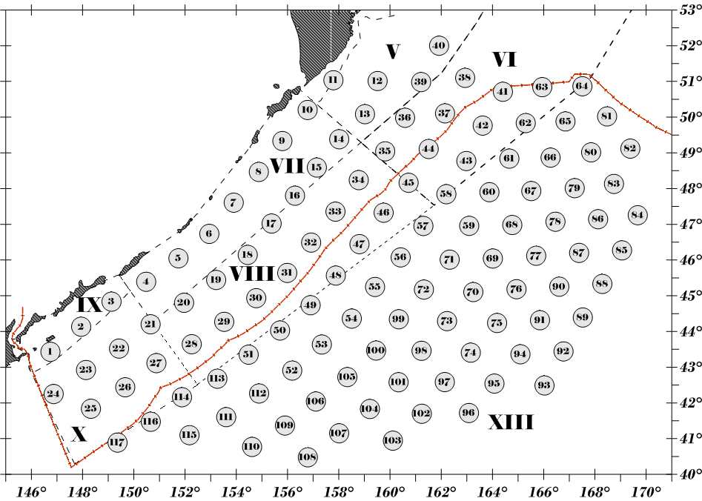
Figure 5 - Grid of trawl survey stations in the Northwest Pacific Ocean

Figure 6 - Spatial distribution of chub mackerel catches (kg/hour trawl) in the epipelagic zone of the northwestern Pacific Ocean 02.06.-07.07.2023.

Russian vessels carry out trawl surveys of the Northwest Pacific Ocean, which covers both the Russian EEZ and open waters to the east off the Kuril Islands. Surveys are carried out in June-July annually, and in some years a second survey is carried out in August-September. Surveys carried out in 2 ways - pelagic trawls and hydroacoustic surveys. According to the assessment of the survey carried out in the first half of summer 2023, the biomass of mackerel in Pacific waters estimated by trawl survey was 116.8 thousand tons, according to hydroacoustic survey data - 439 thousand tons.

