NPFC-2022-SSC PS09-WP07 (Rev.1)

Japanese survey biomass index of Pacific saury
up to 2022 using VAST model

Midori Hashimoto, Shin-Ichiro Nakayama, Taiki Fuji,
Satoshi Suyama, Hiroomi Miyamoto, Miyako Naya and Hiroshi Kubota

Fisheries Resources Institute, Japan Fisheries Research and Education Agency

Summary
Vector Autoregressive Spatio-temporal (VAST) model was applied to Japanese fishery-independent survey data to predict Pacific saury distribution and estimate biomass index from 2003 to 2022. The estimated biomass index from the selected VAST model with minimum AIC indicated similar year trends with the index from a design-based approach. The estimated biomass index dropped to the historical lowest in 2020 since 2003 and recovered but remained at a low level in 2022.

1. Introduction
Japanese fishery-independent survey for Pacific saury (Cololabis saira, PS) has been conducted in the western and central North Pacific Ocean during June to July since 2003 to estimate annual biomass level by swept area method (Fig. 1, Hashimoto et al., 2020a).We have employed a Vector Autoregressive Spatio-Temporal (VAST) model (Thorson, 2019) corresponding to a spatial delta-generalized linear mixed model (spatial delta-GLMM) which allows to predict variation in density across multiple locations and time intervals. It provided PS density in unobserved area in 2020 and 2021 under the assumption that age-specific distribution in these years is consistent with the historical pattern (Hashimoto et al., 2021). The biomass index estimated from the VAST model was used as an essential input to the latest PS stock assessment (NPFC-2021-SSC PS08-Final Report).
In 2022, a part of survey area was covered by a research vessel, Kaiyo-maru with on-board sea surface trawl net (NST-660, Nichimo Co., Ltd.) having higher fishing efficiency than the conventional one used in the other research vessels (NST-99, Nichimo Co., Ltd.). The objective of this working paper is to provide information on the PS biomass index from 2003 to 2022 by applying the VAST model to the survey data up to 2022, taking into account the differences in fishing efficiency of the two trawl nets (Appendix I).

2. Methods
2.1 Data
We used sea surface trawl net survey data for PS at 2391 stations during 2003 to 2022. The survey area was widely set in the temperate and subarctic waters in the western and central North Pacific Ocean to cover PS habitat (Fig. 1). First, an age-length key with 1cm bins was estimated yearly to determine the annual body length threshold between ages, which is the body length bin corresponding to 50% of the proportion of age-1 individuals. We estimated the weight ratio by age at each station using the body weight and length measured. At a few stations where there were no available body weight data measured in the laboratory, the individual body weight was derived from the body length observed on board and the yearly body length–weight relationship. Total catch at each station was then divided into two age groups using the weight ratio. For the 2022 survey, we provisionally used the age-length key estimated by the average of the estimates from 2003 to 2021 and the body length–weight relationship estimated by Fuji et al. (2021). It should be noted that the trawl net survey did not target the age-0 fish smaller than approximately 15 cm. Annual encounter probability and positive catch rate for each age in survey data are summarized in Figure 2.
At 39 of the 136 stations in the 2022 survey, we employed Kaiyo-maru, whose sea surface trawl net (NST-660) is different from the conventional one for the other research vessels (NST-99). According to the comparison trawl surveys conducted in 2003 and 2012, PS density observed by Kaiyo-maru with NST-660 was 2.41 (2.5-97.5th percentiles: 1.18-4.94) times higher than that by the reference vessels with NST-99 (Appendix I). To derive the consistent biomass index with the conventional one (biomass $×$ catchability of the conventional trawl nets), the densities observed by NST-660 was divided by 2.41 to adjust their scale to the ones observed by NST-99.
In-situ SST was recorded at each sampling station using bar thermometers and was used for model fitting. On the other hand, satellite SST data was used for prediction of the fish density. The satellite SST was downloaded from https://psl.noaa.gov/data/gridded/data.noaa.oisst.v2.highres.html (Reynolds et al., 2007), then averaged during 11th June to 10th July and every 1° x 1° grid cell to use as a representative value during the usual survey period at the grid cell.

2.2 Statistical modeling for biomass estimation
The VAST model was employed to estimate the annual PS spatial distributions at age and the year trends of their biomass indices. The VAST model is a spatial delta-GLMM that can predict variation in density across multiple locations and time intervals, and is therefore expected to predict a plausible distribution, even if there is no observation in a part of the survey area. Density, which is defined as catch in weight per unit swept area (kg/km²), for age a, year y and location s [d(s,a,y)] was modeled by considering two components of encounter probability and positive catch rate in the delta-model. Spatial and spatio-temporal variations were incorporated for both components. Spatial correlation between age 0 and 1 in spatial and spatio-temporal variations were estimated simultaneously. The analysis followed Hashimoto et al. (2020b), but we assumed a first-order autoregressive process instead of a random walk process for temporal variation in the spatio-temporal variations and different combinations of SST effects were considered as described below.
SST was used as a density covariate. The relationships with the observed SST are shown in Figure 3. The encounter probability and positive catch rate show optimum SST values for both ages, although the positive catch rates increase at higher SST due to small sample size. Reflecting these relationship with SST, we employed three types of convex SST effect as candidates: quadratic functions of SST and log(SST), and 10 categorical variables of SST (below 8ºC, an interval of 1 ºC between 8 and 16ºC, and over 16ºC). We created 14 candidate models (Table 1) and conducted model selection based on Akaike Information Criterions (AIC) in stepwise manner. Cases 1 to 9 incorporated various combinations of the effects other than SST in both components for encounter probability and positive catch rate. Because case 9 recorded the minimum AIC among cases 1 to 9, the effects regarding SST were added to case 9 (cases 10–14). We first tested the models with consistent treatment of SST for the two components (cases 10–12). Because AIC in the models with the quadratic functions of SST and log(SST) (cases 10 and 11) were obviously smaller than that in the model with categorical SST (case 12), we further tested the mixture of the two functional treatment of SST (cases 13 and 14).
Annual biomass index by age was estimated as:

$B(a,y)=\sum_{g=1}^{n_{g}}{A(g)}×d(g,a,y)$,

where n_{g} is the total number of knots and A(g) represents the area associated with grid g. Standard error estimates of the biomass indices were computed via the generalized delta-method based on a first-order Taylor series expansion. Total biomass index estimate for PS was estimated as:

$B\left(y\right)=B\left(0,y\right)+B(1,y)$.

We calculated the 2.5–97.5th percentiles and coefficient of variation (CV) of the annual biomass indices from 10,000 sample pairs of ages 0 and 1 biomass indices, generated from a multivariate normal distribution that reflects the variance and covariance between log(B(0, y)) and log(B(1, y)). Year trend of the biomass index up to 2022 was calculated using model with the minimum AIC and was compared with that from the swept area method based on stratification along with longitudinal survey lines (for details, see Hashimoto et al. 2020a). To assess the impact of uncertainty of the estimated fishing efficiency of NST-660 relative to NST-99 ($ρ$), we conducted the same biomass indices estimation using the selected VAST model and PS density data from NST-660 adjusted by the lower and upper limits of the 95% confidence interval of $ρ$.
To examine the trait of changes in spatial distribution over time according to Thorson et al. (2016), center of distribution by age was calculated as:

$Z\left(a,y\right)=\sum_{g=1}^{n_{g}}{\{Z\left(g\right)×A(g)×d\left(g,a,y\right)\}}/B(a,y)$,

where $Z\left(g\right)$ represents the location of grid g.

3. Results
3.1 Model diagnostics
The model incorporating a quadratic function of SST for encounter probability and a quadratic function of logarithm of SST for positive catch rate was selected by AIC (Table 1). Regarding model convergence, maximum gradient of the likelihood function in the selected model was 3.1E-08. According to Q-Q plot of residuals of catch rate given encounter probability in the selected model, the assumption of normality was satisfied (Fig. 4).

3.2 Effects of SST
SST functions in the selected model reflected low density in the cold waters for both ages 0 and 1 (Fig. 5). SST of 13.2 °C and 11.8 °C were optimum on encounter probability for age-0 and age-1 PS, respectively. Regarding positive catch rate, SST of 12.2 °C and 9.6 °C were optimum for age-0 and age-1 PS, respectively.

3.3 Distribution patterns
The predicted annual spatial distribution indicated that distribution of age-0 fish was mainly in the east of 180° in 2020 and 2021 and extended around 180° in 2022 (Fig. 6). Main habitat of age-1 fish was located around 170° E in longitude and above 40° N in latitude and another high-density area (a location with a logarithm of density higher than 5 kg/km²) was observed in the east of 180° in 2022. The annual center of spatial distribution for age 0 had shifted eastward since 2010, except for 2017, whereas that for age 1 has fluctuated between 167° E and 179° W (left in Fig. 7). For the north-south direction, little shift was observed compared with the east-west direction for both ages 0 and 1 (right in Fig. 7).

3.4 Annual biomass index
Year trends of age-0, age-1 and total biomass index estimates derived from the selected model were similar to those from the swept area method (Fig. 8). The age-0 biomass index has fluctuated throughout 20 years, being the third highest in 2022 (Table 2). Both the estimated age-1 and total biomass indices dropped to the historical lowest in 2020 since 2003 and slightly recovered in 2021 and 2022. The CV of the total biomass index estimate in 2022 was the same level as previous years, while the CV in 2020 was greatly higher than that in the other years due to the paucity of data (Table 3). The use of lower and upper limits of the 95% confidence intervals of the estimated relative fishing efficiency of NST-660 had little effect on the biomass indices estimates (Fig. 9, Table 4).

4. Discussion
The estimated spatial distribution by age indicated that age-specific density in 2022 was higher over a wide area than in 2020 and 2021. Especially, the densities of age-0 fish were much higher than in the last two years. As a results, the estimated biomass index in 2022 recovered from the historical lowest in 2020 since 2003. It marked the highest since 2017 (the second lowest since 2003) but still remained at a low level. The year trends in age-specific biomass indices from the VAST model were similar to those obtained from the swept area method. The age-1 biomass index, particularly in the early years, had a consistent fluctuation with the one-year lagged age-0 biomass index. This seems to be reasonable for this stock because of the two-year life cycle.
The effect of uncertainty in the estimated relative fishing efficiency of NST-660 ($ρ$) on the biomass indices was very small and negligible. Therefore, we suggest using the biomass index derived from the median value of $ρ$ to update the PS stock assessment.

Acknowledgements
We appreciate Dr. M. Kai and Dr. Y. Tsukahara for useful discussions.

References
Fuji T, Suyama S, Miyamoto H, Nakayama S, Hashimoto M, Naya M, Kawabata S and Nakatsuka S (2021) Seasonal length-weight relationships and weights at age of Pacific saury. NPFC-2021-SSC PS07-WP10.
Hashimoto M, Kidokoro H, Suyama S, Fuji T, Miyamoto H, Naya M, Vijai D, Ueno Y and Kitakado T (2020a) Comparison of biomass estimates from multiple stratification approaches in a swept area method for Pacific saury Cololabis saira in the Northwestern Pacific Ocean, Fish. Sci 86, 445–456.
Hashimoto M, Tsukahara Y, Fuji T, Nakayama S, Suyama S, Naya M, Oshima K and Kai M (2020b) Updated outcomes on application of VAST model to fishery-independent survey data for Pacific saury. NPFC-2020-SSC PS06-WP13.
Hashimoto M, Nakayama S, Fuji T, Suyama S, Miyamoto H, Naya M, Kawabata A and Nakatsuka S (2021) Japanese survey biomass index of Pacific saury up to 2021 using VAST model. NPFC-2021-SSC PS07-WP06.
Reynolds RW, Thomas MS, Chunying L, Dudley BC, Kenneth SC and Michael GS (2007) Daily High-Resolution-Blended Analyses for Sea Surface Temperature. J. Climate 20, 5473–5496.
Small Scientific Committee on Pacific Saury (2021) 8th Meeting Report. NPFC-2021-SSC PS08-Final Report. 56 pp. (Available at www.npfc.int)
Thorson JT (2019) Guidance for decisions using the Vector Autoregressive Spatio-Temporal (VAST) package in stock, ecosystem, habitat and climate assessments. Fisheries Research, 210: 143–161.
Thorson JT, Pinskey ML, Ward EJ (2016) Model-based inference for estimating shift in species distribution, area occupied and centre of gravity. Methods in Ecology and Evolution 7: 990–1002.

Table 1 Model selection based on the values of AIC with the survey data up to 2022. The selected model is case 14.
Case | Model for encounter probability | Model for positive catch rate | AIC | ΔAIC
1 | Year | Year | 21660 | 2038
2 | Year | Year + Site | 21497 | 1874
3 | Year | Year + Site + Year:Site | 21381 | 1758
4 | Year + Site | Year | 20647 | 1024
5 | Year + Site | Year + Site | 20487 | 864
6 | Year + Site | Year + Site + Year:Site | 20368 | 745
7 | Year + Site + Year:Site | Year | 20150 | 527
8 | Year + Site + Year:Site | Year + Site | 19991 | 368
9 | Year + Site + Year:Site | Year + Site + Year:Site | 19872 | 249
10 | Year + Site + Year:Site + SST + SST² | Year + Site + Year:Site + SST + SST² | 19630 | 7
11 | Year + Site + Year:Site + log(SST) + [log(SST)]² | Year + Site + Year:Site + log(SST) + [log(SST)]² | 19629 | 6
12 | Year + Site + Year:Site + 10 categories of SST | Year + Site + Year:Site + 10 categories of SST | 19644 | 21
13 | Year + Site + Year:Site + log(SST) + [log(SST)]² | Year + Site + Year:Site + SST + SST² | 19636 | 13
14 | Year + Site + Year:Site + SST + SST² | Year + Site + Year:Site + log(SST) + [log(SST)]² | 19623 | 0

Table 2 Estimated age-specific biomass indices and their coefficient of variation (CV) derived from the selected VAST model applying to the fishery-independent survey data for Pacific saury from 2003 to 2022. *
Year | Age-0 biomass index (1000MT) ** | CV (%) | Age-1 biomass index (1000MT) | CV (%)
2003 | 193.2 | 24.3 | 1070.1 | 25.9
2004 | 399.0 | 28.3 | 326.7 | 27.5
2005 | 51.6 | 36.5 | 911.1 | 32.5
2006 | 132.5 | 28.7 | 512.4 | 32.6
2007 | 197.4 | 28.8 | 503.2 | 38.5
2008 | 38.5 | 27.5 | 968.6 | 27.1
2009 | 256.8 | 27.7 | 171.0 | 33.3
2010 | 101.8 | 23.6 | 469.0 | 32.1
2011 | 210.7 | 56.6 | 727.5 | 39.9
2012 | 151.8 | 28.1 | 178.6 | 28.3
2013 | 92.4 | 31.4 | 664.1 | 28.2
2014 | 169.2 | 27.4 | 359.3 | 28.0
2015 | 166.1 | 25.4 | 133.4 | 28.2
2016 | 213.1 | 34.7 | 212.1 | 34.8
2017 | 61.9 | 31.7 | 102.8 | 35.0
2018 | 78.7 | 32.5 | 258.1 | 32.9
2019 | 102.4 | 30.6 | 129.0 | 27.3
2020 | 37.1 | 126.3 | 7.4 | 79.2
2021 | 104.7 | 41.7 | 96.2 | 40.7
2022 | 239.4 | 26.1 | 141.2 | 28.0
* Estimated variance-covariance matrix are available at the NPFC collaboration site https://collaboration.npfc.int/node/128.
** Note that the trawl net survey did not target the age-0 fish smaller than approximately 15 cm.

Table 3 Estimated biomass index, their 2.5–97.5th percentiles and coefficient of variation (CV) derived from the selected VAST model applying to the fishery-independent survey data for Pacific saury from 2003 to 2022.
Year | Biomass index (1000MT) | 2.5–97.5th percentiles | CV (%)
2003 | 1263.3 | 832.6 - 1971.4 | 22.5
2004 | 725.7 | 496.5 - 1093.6 | 20.4
2005 | 962.7 | 534.6 - 1763.4 | 30.9
2006 | 644.9 | 396.9 - 1104.8 | 27.4
2007 | 700.5 | 412.9 - 1294.1 | 29.9
2008 | 1007.1 | 621.0 - 1667.1 | 26.1
2009 | 427.8 | 286.5 - 667.3 | 21.9
2010 | 570.8 | 352.1 - 983.4 | 27.1
2011 | 938.2 | 481.3 - 1926.6 | 36.3
2012 | 330.4 | 229.3 - 501.5 | 20.2
2013 | 756.4 | 466.3 - 1238.2 | 25.3
2014 | 528.6 | 353.9 – 817.0 | 21.8
2015 | 299.5 | 209.7 - 444.6 | 19.2
2016 | 425.2 | 267.2 - 708.2 | 25.2
2017 | 164.7 | 102.8 - 275.3 | 25.5
2018 | 336.8 | 211.2 – 575.0 | 26.7
2019 | 231.4 | 156.2 - 355.6 | 21.4
2020 | 44.5 | 10.5 - 259.7 | 112.0
2021 | 200.9 | 112.6 - 375.4 | 31.6
2022 | 380.6 | 264.6 - 567.1 | 19.8

Table 4 Estimated age-0, age-1 and total biomass index (1000 MT) in 2022 under the 2.5, 50, and 97.5th percentiles for the NST-660’s fishing efficiency relative to NST-99 ($ρ$).
$$ρ$$ | Age 0 | Age 1 | Total
1.18 (2.5th ) | 245 (146 - 408) | 148 (86 - 253) | 393 (273 - 585)
2.41 (50th) | 239 (143 - 398) | 141 (82 - 242) | 381 (265 - 567)
4.94 (97.5th) | 235 (141 - 391) | 137 (79 - 234) | 372 (258 - 554)
Estimates in parentheses are the 2.5–97.5th percentiles of 10,000 samples.
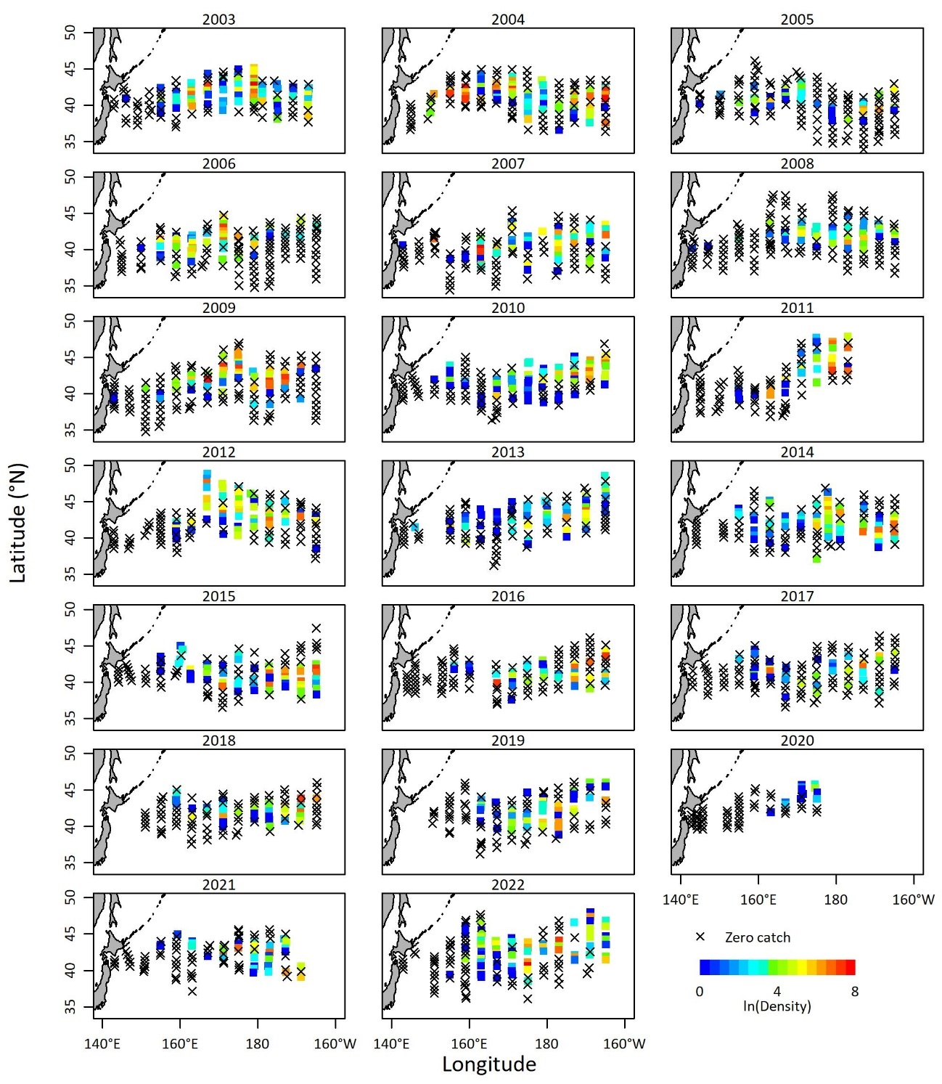
Fig. 1 Map of the density (colored symbols) and zero catches (cross marks) for age-0 Pacific saury in the fishery independent surveys from 2003 to 2022.

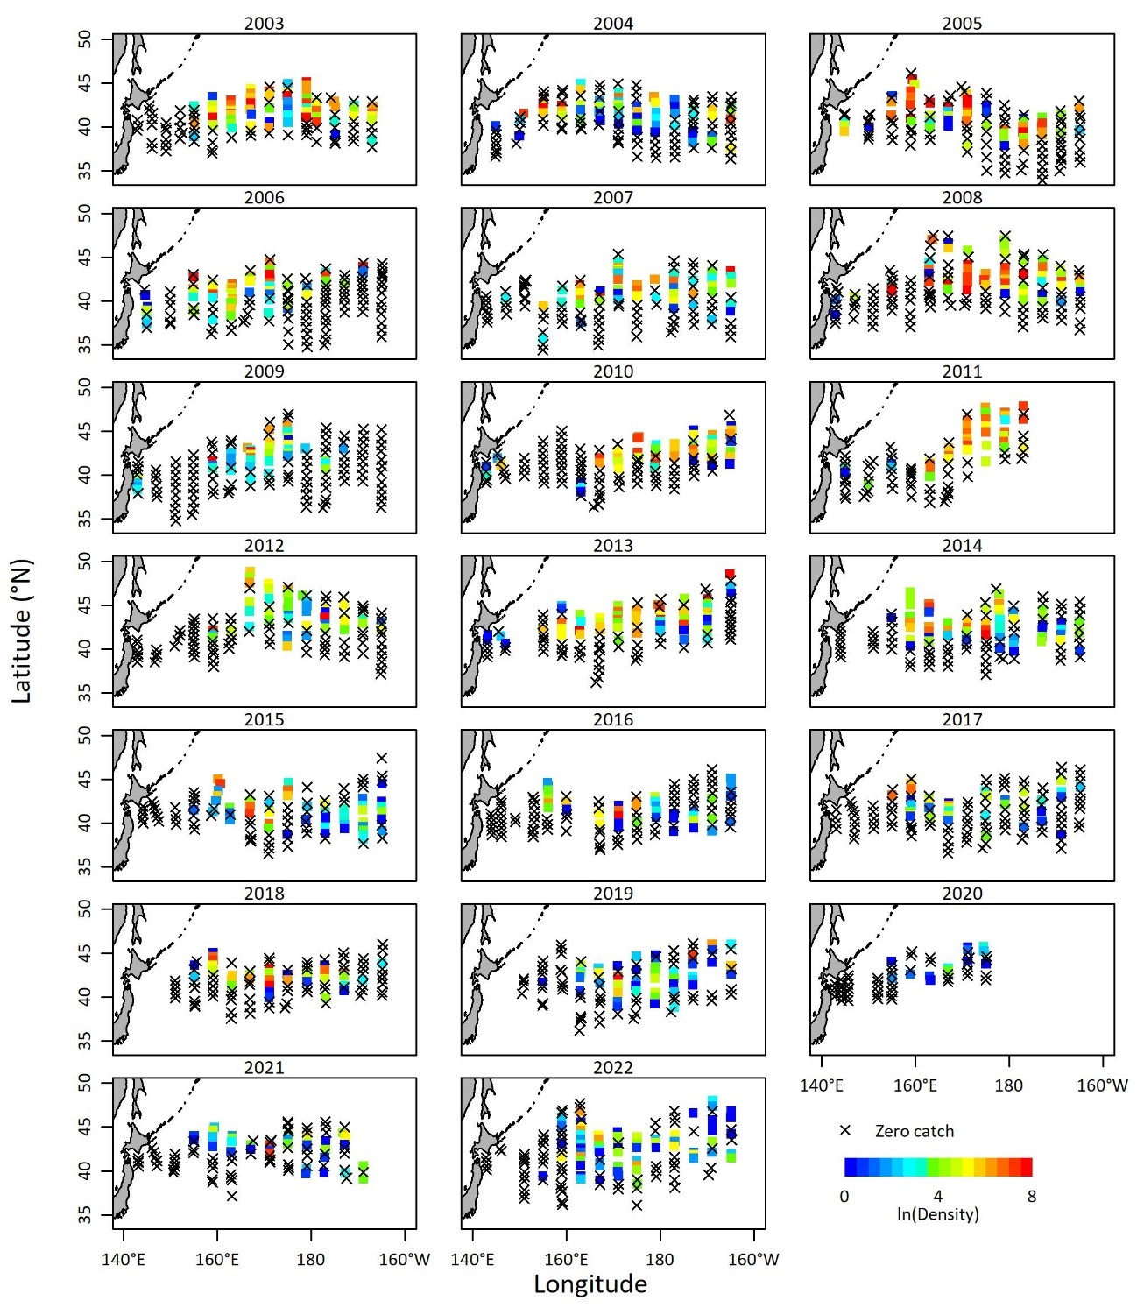
Fig.1 (Continued) for age 1.

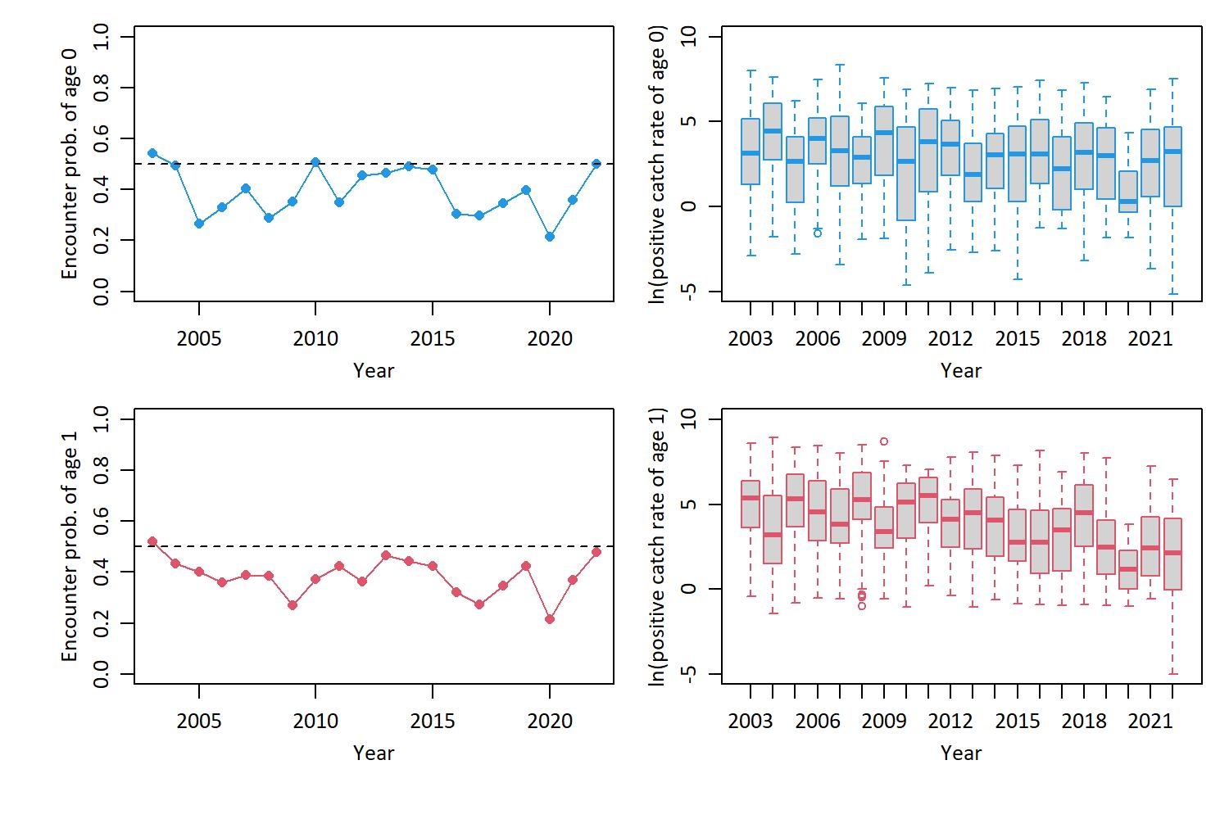
Fig. 2 Annual encounter probability (left panels) and logarithm of annual positive catch rate (right panels) for age 0 (upper panels) and age 1 (lower panels) of Pacific saury in the fishery-independent survey from 2003 to 2022.

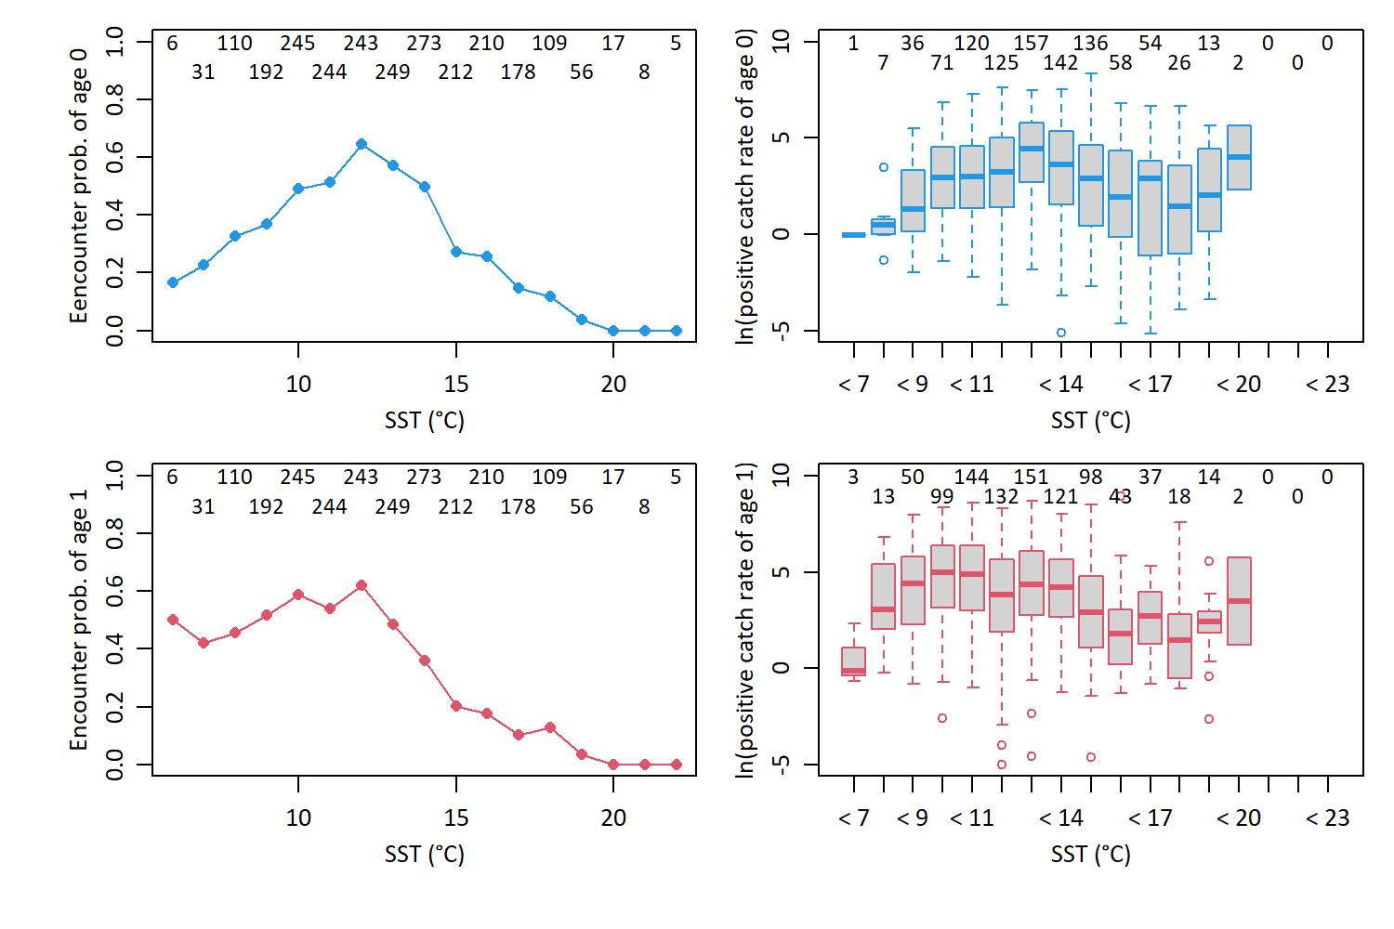
Fig. 3 Relationship between the observed SST and mean encounter probability (left panels) and logarithm of positive catch rate (right panels) for age 0 (upper panels) and age 1 (lower panels) of Pacific saury in the fishery-independent survey from 2003 to 2022. Numbers at the top part of each panel are sample size for each category.

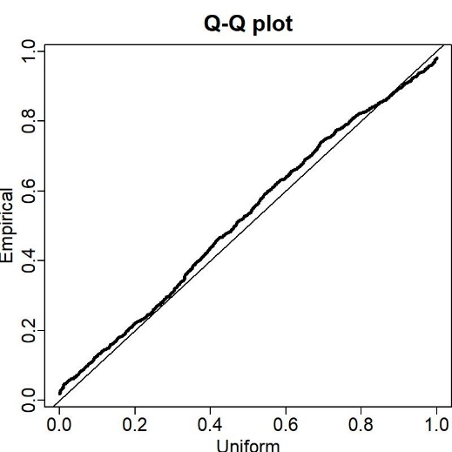
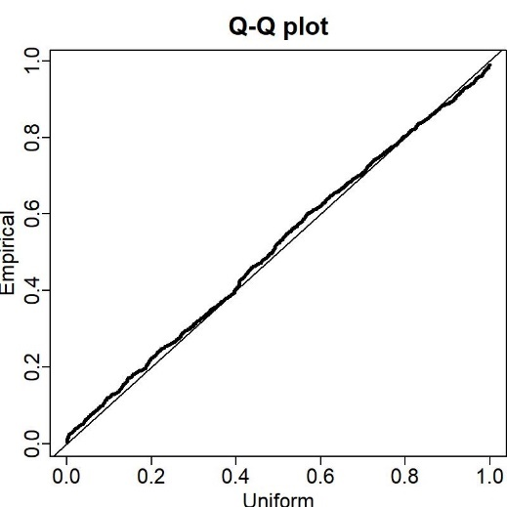

Fig. 4 Q-Q plots of residuals for density given encounter probability in the selected model for age 0 (left) and age 1 (right panel).

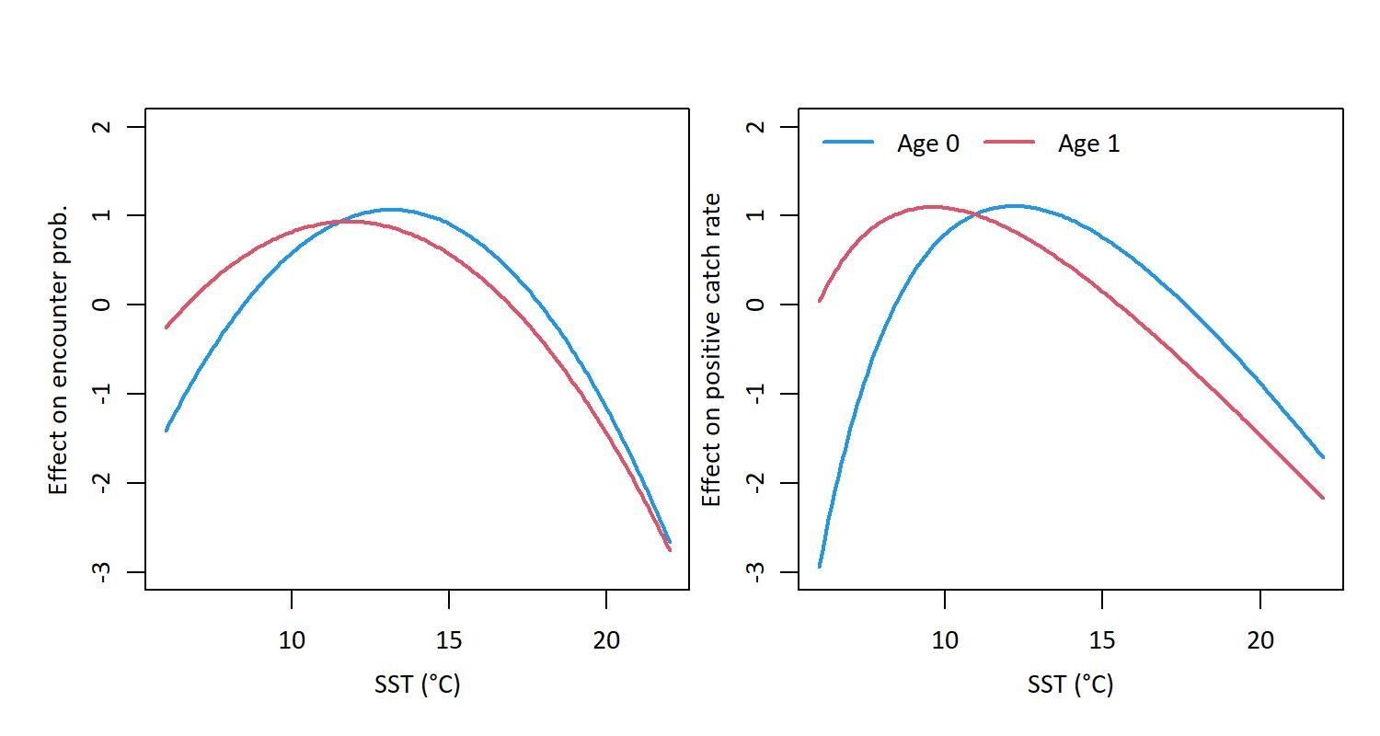
Fig. 5 Relative effect of SST on encounter probability (left panel) and positive catch rate (right panel) when using a quadratic function of SST and a quadratic function of log(SST), respectively.

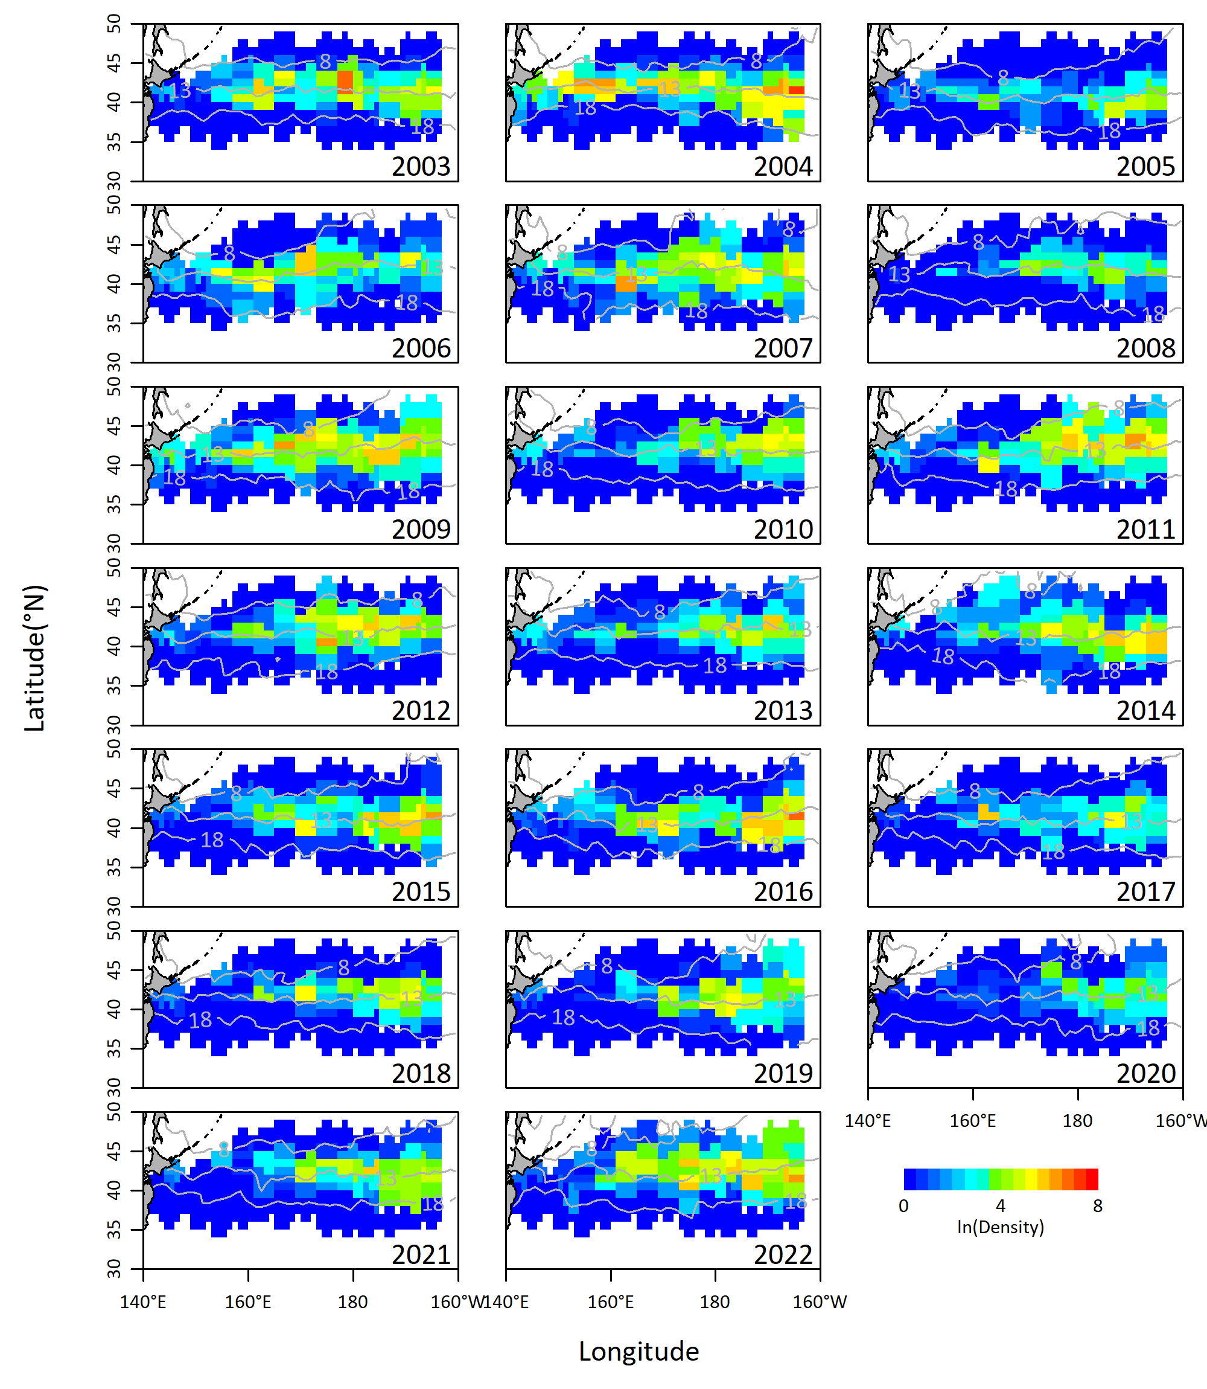
Fig. 6 Annual spatial distribution of predicted log scaled density (tons/km²) for age 0 of Pacific saury from 2003 to 2022, derived from the selected VAST model. Gray lines are contours of the satellite SST at 8, 13, 18 °C.
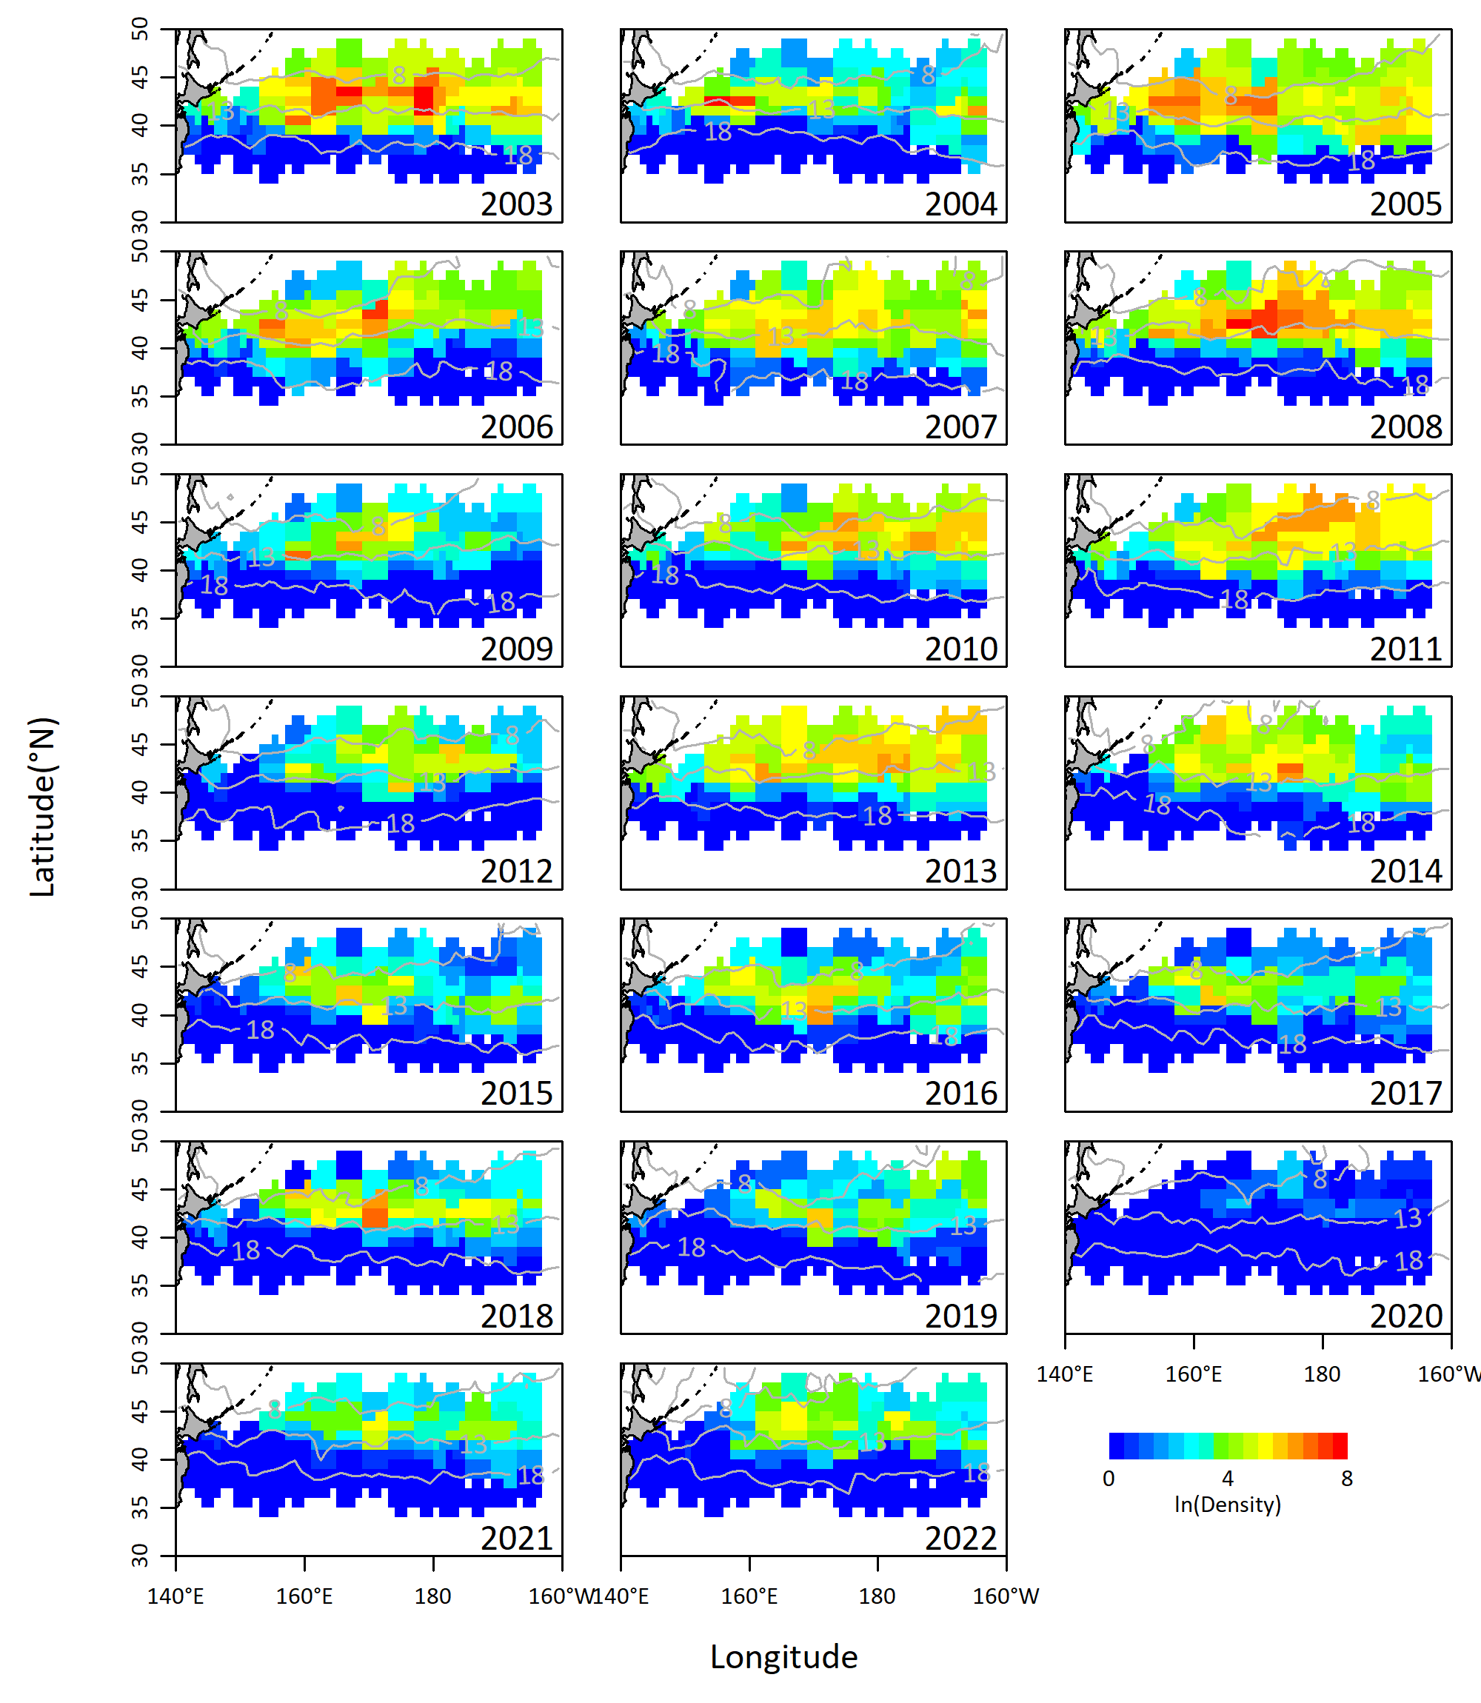
Fig. 6 (Continued) for age 1

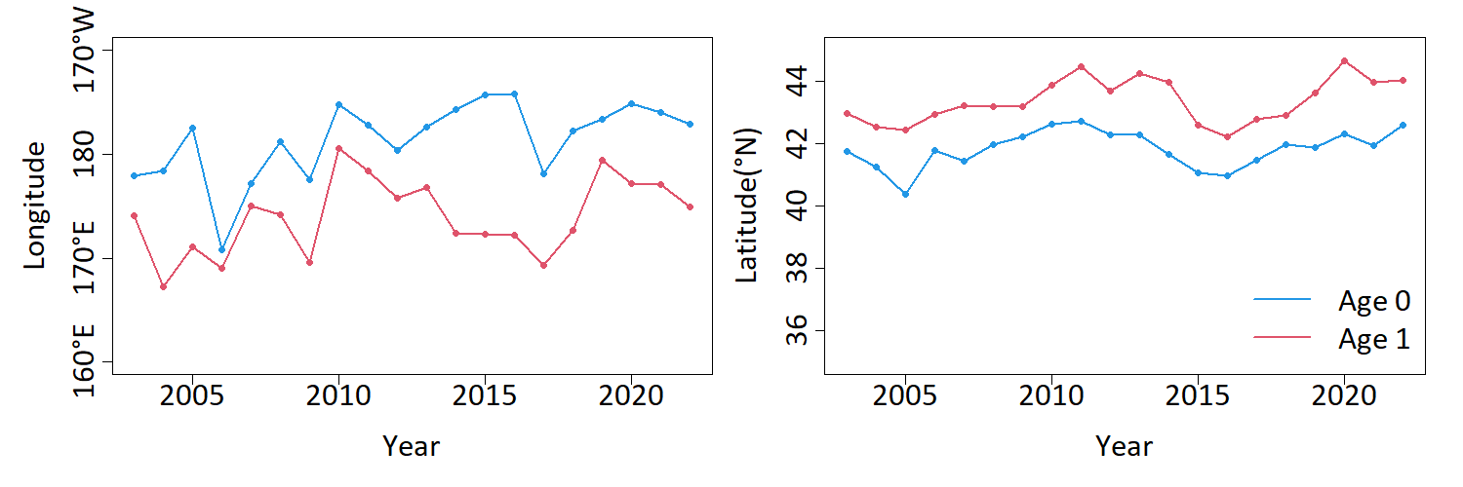
Fig. 7 Shift of the estimated center of distribution in the east-west direction (left) and in the north-south direction (right) from 2003 to 2022 for ages 0 and 1 of Pacific saury.

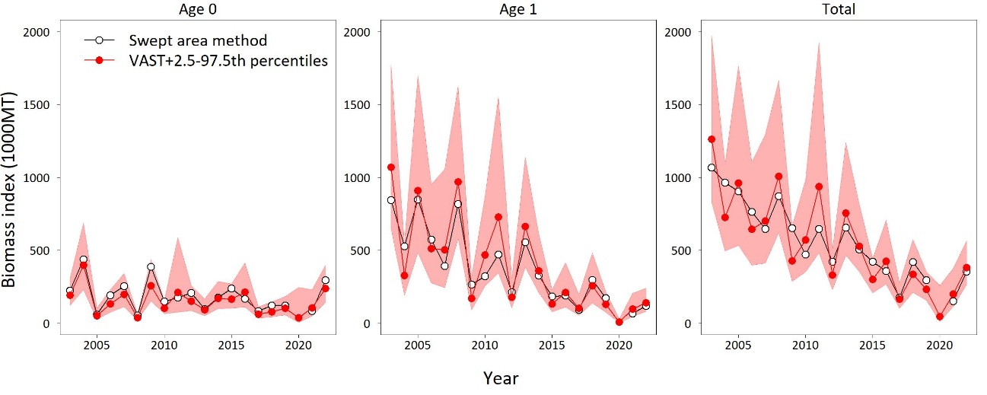
Fig. 8 Year trends in the estimated age-0, age-1 and total biomass index for Pacific saury from 2003 to 2022 derived from the selected VAST model, compared to those from the swept area method (except in 2020). Red polygons indicate the 2.5–97.5th percentiles of 10,000 samples.

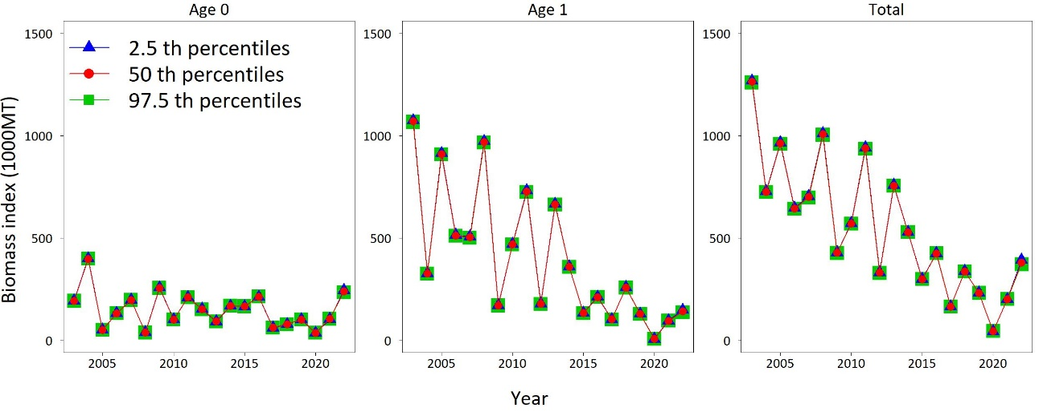
Fig. 9 Comparison with year trends in the estimated age-0, age-1 and total biomass index for Pacific saury from 2003 to 2022 derived from the selected VAST model under the 2.5, 50, and 97.5th percentiles for the NST-660’s fishing efficiency relative to NST-99.

Appendix I. Estimating relative fishing efficiency of NST-660 (Kaiyo-maru)

In the survey in 2022, we used Kaiyo-maru (2630 GRT), whose on-board surface trawl net size (NST-660, Nichimo Co., Ltd., the net length is ca. 165m and the horizontal length of the net opening is 52m) is different from the ones we have used so far (NST-99, Nichimo Co., Ltd., the net length is ca. 90m and the horizontal length of the net opening is 24m). The differences in net size might lead to a difference of fishing efficiency, even if we calibrate the fish densities by dividing the number/weight of fish by swept areas. Therefore, we estimated the fishing efficiency of NST-660 relative to NST-99 to calibrate the density data for the VAST analysis based on a result of comparison trawl surveys conducted in 2003 and 2012 (Table A1). In the surveys, Kaiyo-maru with NST-660 and reference ships with NST-99 trawled at the same location.
The data includes catch (kg) and swept area (km²) of eleven pairs of trawls by Kaiyo-maru and reference vessels. The reference vessels were Hokuho-maru (664 GRT) and Kaiyo-maru No. 7 (499 GRT, note that this vessel is distinct from “Kaiyo-maru”) in 2003 (seven trawls) and 2012 (four trawls), respectively.
We created a statistical model to estimate the fishing efficiency of NST-660 relative to NST-99. We assumed that when the density of PS in an area ith pair of trawls performed was λ_{i} (kg/km²), then the catch weight by NST-99 [w_{1, i} (kg)] and NST-660 [w_{2, i} (kg)] follow Tweedie distributions

w_{1, i} ~ Tweedie(q λ_{i} a_{1, i}, φ, p) and

w_{2, i} ~ Tweedie($ρ$ q λ_{i} a_{2, i}, φ, p),

where a_{x, i}, φ, p, and $ρ$ are swept area of NST-660 (x = 1) or NST-99 (x = 2), scale and power parameters of the tweedie distribution, and the fishing efficiency of NST-660 relative to NST-99, respectively.
q λ_{i} was treated as a random effect (q and λ_{i} are not separable), and we assumed that log(q λ_{i}) follows a normal distribution with mean μ and standard deviation σ.

log(q λ_{i}) ~ Normal(μ, σ²).

All of the parameters and corresponding 95% confidence intervals were estimated by the maximum likelihood method. As a diagnostics, we also observed the gap between the real catch (w_{1, i} and w_{2, i}) and expected catch (q λ_{i} and r q λ_{i}).
The estimated parameters and their confidence intervals are shown in Table A2. The estimated 2.5, 50, and 97.5 percentiles for the NST-660’s fishing efficiency relative to NST-99 ($ρ$) were 1.18, 2.41, and 4.94, respectively. The catch observations were inside the 95% prediction intervals of the estimated catch in all of the eleven trawls for both vessels (Figure A1).

Table A1. The data of comparison trawl surveys in 2003 and 2012.
Trial | Catch by Kaiyo-maru (kg) | Catch by reference vessels (kg) | Area swept by Kaiyo-maru (km²) | Area swept by reference vessels (km²)
1 | 5.39 | 1.38 | 0.411 | 0.214
2 | 1315.62 | 712.58 | 0.469 | 0.229
3 | 1537.80 | 62.32 | 0.529 | 0.220
4 | 54.59 | 8.08 | 0.417 | 0.222
5 | 1.58 | 0 | 0.446 | 0.227
6 | 0.18 | 0 | 0.385 | 0.226
7 | 276.83 | 47.64 | 0.417 | 0.222
8 | 53.81 | 0 | 0.414 | 0.200
9 | 211.04 | 79.18 | 0.419 | 0.197
10 | 2.60 | 1.03 | 0.406 | 0.187
11 | 2.50 | 0 | 0.390 | 0.190

Table A2. Parameter estimates.
Parameters | 2.50% | 50% | 97.50%
$$ρ$$ | 1.18 | 2.41 | 4.94
φ | 1.51 | 2.89 | 5.50
p | 1.45 | 1.61 | 1.75
μ | 2.12 | 3.48 | 5.72
σ | 1.60 | 2.61 | 4.26

Figure A1. Comparison of the real and estimated catch weight (kg) in the eleven trials for the NST-99 and NST-660. The black circles are the observed catch. The white circles and error bars indicate the expected catch and corresponding 95% prediction intervals estimated from the model.

