NPFC-2020-SSC PS06-WP16

Age-determination and age-length keys for Pacific saury,
Cololabisa saira, from 2000 to 2018

Suyama Satoshi, Hajime Matsui, Taiki Fuji, Shin-Ichiro Nakayama, Midori Hashimoto and Kazuhiro Oshima

Fisheries Resources Institute, Japan Fisheries Research and Education Agency

Summary
The Small Scientific Committee on Pacific Saury (SSC PS) noted the need to share catch-at-age (CAA) data. In response to this need, we provided seasonal age-length key (ALK) information which had been posted on the NPFC Collaboration Site and could be utilized for estimation of CAA by each Member. In this document, we detailed our age determination method and described derivation method for ALKs for May to July and August to December from 2000 to 2018. Especially, a criterion to determine age 0 during fishing season was specified with taking into consideration a long spawning period of this species. We suggest our age determination method can be applied for all Members as a uniform method and then the Members should obtain their own ALKs from fish caught by their fisheries for future stock assessment.

- Introduction
The Small Scientific Committee on Pacific Saury (SSC PS) noted the need to share biological data, such as catch-at-size (CAS) and catch-at-age (CAA) data, for work towards the use of age-structured stock assessment models. (NPFC-2019-SSC PS04-FinalReport). Although conventional method to convert from CAS data to CAA data is to apply age-length keys (ALK) to CAS data, some members have not obtained ALK from their catch. Japan has conducted age determination of Pacific saury (PS) with otoliths since the 1980s (Suyama et al. 2006). We uploaded the seasonal ALKs（May to July and August to December）from 2000 to 2018 to the NPFC Collaboration Site for utilizations of those members to make CAA data. This report specified concept of age determination which should be applied to this species and subsequently explain how to acquire the seasonal ALKs which had been posted on the NPFC Collaboration site.

- Materials and methods
  - Method for age determination
The maximum life span of PS is about 2 years, and PS stock structure consists of two year-classes of ages 0 and 1 (Suyama et al. 2006). This species has a very long spawning period for 10 months from September to June with reaching peaks from January to March (Watanabe and Lo 1989). To determine accurate hatch months of PS individuals, count of otolith daily growth increments is available (Watanabe et al, 1988, Suyama et al.,1996, Kurita et al., 2004). However, it is impossible to serve information on monthly age for the stock assessment works in a timely manner due to quite time-consuming process to obtain daily age data.
Figure 1 illustrates the fishing season for PS, the PS spawning season and timing of the otolith annual ring formation in order to share a thought for age determination. The fishing season of the NPFC-PS Members starts in May and ends in December (NPFC-2018-TWG PSSA03-WP02, NPFC-2018-TWG PSSA03-WP03, NPFC-2018-TWG PSSA03-WP04, NPFC-2018-TWG PSSA03-WP06b, NPFC-2018-TWG PSSA03-WP08, and NPFC-2018-TWG PSSA03-WP12; available at www.npfc.int NPFC-2018-TWG PSSA03-Final Report), including two different spawning seasons in the beginning and ending periods. Age-0 fish sequentially recruit to the PS fishing between May and December in their first year after hatching. Those fish hatched in the first four months, which correspond to September to December, of the spawning period practically reach age 1 in the second half of the fishing period because of a long duration of spawning. It is reasonable to regard fish hatched in a single spawning season as an identical year class. Therefore, we can determine fish caught in their first fishing season after the recruitment as age 0. Annual ring in PS otolith is known to be formed between September and February (Hotta 1960; Suyama and Sakurai, 2000; Suyama et al., 2011). Fish caught in the second half of the fishing period, of which otoliths have an annual ring in the process of formation on the edge (hereafter called as incomplete annual ring), are determined as age 0.
Suyama and Sakurai (2000) categorized the annual ring formation status in otolith into four types as follows:
Type I, no complete annual ring (Fig. 2-A and B).
Type II, a single complete annual ring with weak definition at outer rim of the hyaline zone (Fig. 2-C).
Type III, a single complete annual ring which is visually definitive and surrounded by D)
Type IV, two complete annual rings (Fig. 2-E).
Type I otolith and types II to IV otoliths are regarded as age-0 and age-1, respectively. As for the type II otolith, starting point of the hyaline zone formation is definitive, whereas visual contrast of color is not definitive at the outer rim area of that zone, which takes on dark-gray and spread wider than the hyaline zone. Since the second hyaline zone was formed regardless of the season, the individuals that had type IV were also considered as age 1. Fish with type II otolith frequently appear west of 160 ° E in June-July (Suyama et al., 2012). Fish with type IV otolith rarely appear.
Furthermore, the otoliths in one of the following two cases were excluded from subject for age determination:
1) otoliths having three hyaline zones and more (Fig. 2-F).
2) otoliths that were partially or extremely thin, with a transparent part that was different from the hyaline zone. In the latter case, it is considered that vaterite has replaced aragonite (Fig. 2-G and H).

  - Calculation process of age-length keys
    - Sample collection
Samples for age-length keys were caught by stick-held dip net and sea-surface trawl net. The stick held dip net was used for research or commercial fishing. The research fishing activities were conducted from May to July in 2016, 2017 and 2018, whereas the commercial fishing, which is a traditional one in Japan, was operated from August to December off Japan. The fishery-independent survey, which has been carried out from June to July since 2003, applies the sea-surface trawl gears. The research fishing and the survey cover the waters west of 165°W, whereas the commercial fishing after August is operated west of 155°E. In addition, small number of samples were collected from other small-scale fisheries and surveys (Fig. 3).
At sampling stations of the research vessels where more than 80 individuals were caught, 80 fish were randomly selected as subjects for measurement and otolith extraction. On the other hand, for samples collected by commercial fishing vessels, 80 fish were randomly selected for age-determination. A total of 101,922 otoliths were analyzed (Table 1). In general, the otolith on right side was used for age determination and was embedded in epoxy resin. Sampled fish were classified into age-0 (type I), age-1 (types II to IV) and unidentified through age determination. Data for each individual were aggregated into each season (May to July and August to December).

    - Derivation of ALK
Percentages of age-1 fish (N of age-1/ (N of age-0 and age-1)) were calculated to each 1-cm length class. Subsequently, a logistic curve was fitted to the percentages of age 1 fish at each 1-cm length class through the least squares method. The length at which 50% of the fish were age 1 (L50) was defined as an index of the boundary between the age 0 and age 1 fish.

- Results and discussion
A total of 47,896 (47.0%) and 51,789 (50.8%) individuals of 101,922 individuals were determined as age-0 and age-1, respectively. Rest of those individuals (2,237 (2.2%)) could not be determined. Age length key in each season from 2000 to 2018 were shown in Table 2 and Fig. 4.
There were annual variations of L50 (Table 3). L50 from May to July and from August to December varied from 25.3 (2008) to 29.1 (2000) and from 28.2 (2018 and 2019) to 30.7 (2001), respectively. The annual variation of L50 would be caused by annual differences in growth by each age cohort and/or age composition.
The samples served for provision of the seasonal ALKs were derived from different fishing gears of trawl net and stick held dip net and different operational processes of fishery-independent survey and commercial fisheries. Those differences would be caused the differences in length composition of catch among them, resulting in those in age composition. The ALKs provide by Japan can be applied to calculate tentative CAA for the initial trial of the age-structured stock assessment model. It is, however, highly recommended that the Member prepare their own ALK using sample derived from each Member’s fishery for the future stock assessment.

- References
Hotta H. (1960) On the analysis of the population of the Pacific saury (Cololabis saira) based on the scales and the otolith characters, and their growth. Bull. Tohoku. Reg. Fish. Res. Lab. 16:41–64.
NPFC-PS, Russia. (2018) Data for joint CPUE index and joint map of catch and effort of Pacific saury by Russia. NPFC-2018-TWG PSSA03-WP02.
NPFC-PS, Vanuatu. (2018) Data for joint CPUE index and joint map of catch and effort of Pacific saury by Vanuatu. NPFC-2018-TWG PSSA03-WP03.
NPFC-PS, China. (2018) Data for joint CPUE index and joint map of catch and effort of Pacific saury by China. NPFC-2018-TWG PSSA03-WP04.
NPFC-PS, Japan. (2018) Data for joint CPUE index and joint map of catch and effort of Pacific saury by Japan. NPFC-2018-TWG PSSA03-WP06b.
NPFC-PS, Korea. (2018) Data for joint CPUE index and joint map of catch and effort of Pacific saury by Korea NPFC-2018-TWG PSSA03-WP08 (Rev. 1).
NPFC-PS, Chinese Taipei. (2018) Data for joint CPUE index and joint map of catch and effort of Pacific saury by Chinese Taipei. NPFC-2018-TWG PSSA03-WP12.
NPFC-PS. (2019) Report of the 4th Meeting of the Technical Working Group on Pacific Saury Stock Assessment, NPFC-2019-TWG PSSA04-Final Report.
Kurita Y, Nemoto Y, Oozeki Y, Hayashizaki K, Ida H. (2004) Variations in patterns of daily changes in otolith increment widths of 0? Pacific saury, Cololabis saira, off Japan by hatch date in relation to the northward feeding migration during spring and summer. Fish Oceanogr. 13[Suppl 1]: 54–62.
Suyama S, Sakurai Y, Shimazaki K. (1996) Age and growth of Pacific saury Cololabis saira (Brevoort) in the Western North Pacific Ocean estimated from daily otolith growth increments. Fish. Sci. 62:1–7.
Suyama S, Sakurai Y (2000) Formation period of the otolith hyaline zones of Pacific saury, Cololabis saira (Brevoort) in the western North Pacific Ocean. Tohoku Reg Fish Res Lab 63:97–108.
Suyama S, Kurita Y, Ueno Y. (2006) Age structure of Pacific saury Cololabis saira based on observations of the hyaline zones in the otolith and length frequency distributions. Fish. Sci. 72:742–749.
Suyama S, Oshima K, Nakagami A, Kawabata. (2011) Seasonal changes in otolith and somatic growth in age-0 Pacific saury Cololabis saira. Fish. Sci. 77:223–233.
Suyama S, Nakagami M, Naya M, Ueno Y. (2012) Comparison of the growth of age-1 Pacific saury Cololabis saira. in the Western and the Central North Pacific. Fish. Sci. 78:277–285.
Watanabe Y, Butler JL, Mori T. (1988) Growth of Pacific saury, Cololabis saira, in the northeastern and northwestern Pacific Ocean. Fish. Bull. US 86: 489–498.
Watanabe, Y., Lo, N.C.H. (1989) Larval production and mortality of Pacific saury, Cololabis saira, in the Northwestern Pacific Ocean. Fish. Bull. US 78: 601–613.

Tables

Table 1 Number of the individuals that were provided for age-determinations in each month

Table 2 Percentages of the age-1 fish in each 1 cm-length classes.
Table 3 Estimated length (L₅₀) at which 50% of individuals were age-1 fish from 2000 to 2018

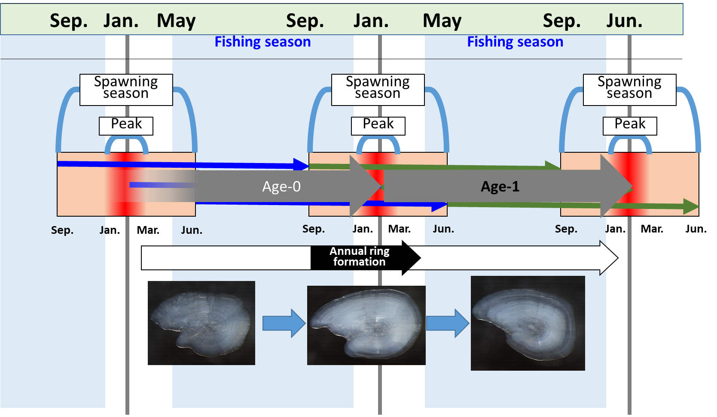 Fig.1 Schematic diagram of annual ring formation.

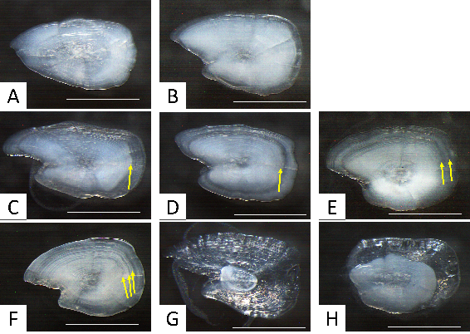Fig.2 Photograph of the otolith of age-0 (A and B), age-1 (C, D, and E) and otoliths whose age could not be determined (F, G and H). A. Type I, no complete annual ring. B. Type I, no complete annual ring with incomplete first annual ring on the edge of otolith. C. Type II, a single complete annual ring with weak definition at outer rim of the hyaline zone. D. Type III, a single complete annual ring which is visually definitive and surrounded by the opaque zone. E. Type IV, two complete annual rings. F. Otoliths having three hyaline zones and more. G, H. Otoliths that were almost all part (G) or partially of otolith (H) consist of extremely thin, and a transparent part that was different from annual ring. This transparent part is considered that vaterite has replaced aragonite.
Fig.3 Location of sampling stations in each month in the North Pacific off Japan from 2000 to 2018
See attached excel file after 2003

Fig.4 Length compositions of Pacific saury that were provided for age-determination and the percentages of age-1 fish in each 1 cm-length class.

See attached excel file after 2003

