NPFC-2019-SSC PS05-MIP01

DETAILS FOR THE 5th MEETING OF THE SMALL SCIENTIFIC COMMITTEE ON PACIFIC SAURY
13-16 November 2019
Shimonoseki, Japan

This is general information to assist you in your travels to the meeting. This information package includes:
- Dates
- Venue of the Meeting
- Meeting Contact Documentation
- Visa Information
- Accommodation
- Airport Information and Transport to the Recommended Hotels
- Map
- Meeting Registration
- Social Events
- Other Information

DATES

13-16 November 2019.

VENUE OF THE MEETING
The meeting will be held at Kaikyo Messe in Shimonoseki:
3 Chome-3-1 Buzendacho, Shimonoseki, Yamaguchi, Japan 750-0018;
Tel: +81-83-231-5600;
Website: http://www.kaikyomesse.jp/
Meeting room: 9 Floor, Kaikyo Hall.
Secretariat room: 9 Floor, Conference Room 901.

MEETING CONTACT DOCUMENTATION
Online registration service for participants is on the NPFC website www.npfc.int. Please log in to be able to register. The deadline for registration is November 6, 2019.

VISA INFORMATION
An official invitation letter is essential for participants to apply for a Japanese visa. Please check in advance if you need a Japanese visa for your trip. Each delegation who applies for a Japanese visa is requested to provide information in the form of Attachment 1 by October 13, 2019 to Mr. Ryotaro Okazaki (ryotaro_okazaki770@maff.go.jp). Please note that applicants who belong to the same organization or institute are encouraged to provide compiled information in one file.

ACCOMMODATION
Each participant is responsible for making his or her own hotel arrangements. Recommended hotels are listed in the table below:
Hotel Name | Transportation | Reservation
Plaza Hotel Shimonoseki | 10-15 minute walk to the meeting venue | 6,000+ JPY/night (including breakfast)  11-10 Hananochō, Shimonoseki, Yamaguchi, Japan 750-0014  Tel: +81-83-223-3333  http://www.plazahotel.co.jp/  35 rooms have been blocked for meeting participants. The deadline for reservation is 30 October 2019. Please fill in the form (Attachment 2) and send it to Ms. Miyoko Mita mmita@npfc.int and Secretariat Secretariat@npfc.int
Toyoko Inn | 5-10 minute walk to the meeting venue | 6,000+ JPY/night  2-chōme-7-10 Buzendachō, Shimonoseki, Yamaguchi, Japan 750-0018  Tel: +81-83-234-1045  https://www.toyoko-inn.com/search/detail/00174/
Dormy Inn Premium Shimonoseki | 5-10 minute walk to the meeting venue | 12,000+ JPY/night  3-40 Hosoeshinmachi, Shimonoseki, Yamaguchi, Japan 750-0017  Tel: +81-83-223-5489  https://www.hotespa.net/hotels/shimonoseki/
AIRPORT INFORMATION AND TRANSPORT TO THE RECOMMENDED HOTELS
The recommended hotels are located within 10-20-minute walk from Shimonoseki Station. Options for transportation from Tokyo and overseas to Shimonoseki Station are listed below.

- From Fukuoka International Airport
  - By Bus through Tenjin
The trip takes about 3 hours and costs about 1,800 JPY. Please take a bus to the Nishitetsu Tenjin Expressway Bus Terminal. Then change to a bus to the Shimonoseki Station. The bus schedule and fare are attached (Attachment 3).
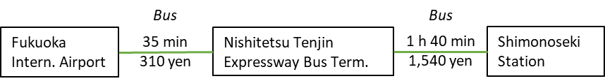
  - By Direct Bus to Shimonoseki
There is also a direct bus to the Shimonoseki Station, however it operates only three times per day. The trip takes about 2 h 20 min and costs about 1,500 JPY. The bus schedule and fare are attached (Attachment 3).

- From Yamaguchi Ube Airport
  - By Bus
The trip takes about 1 h 30 min and costs about 1,500 JPY. Please take a limousine bus from the airport to the Shimonoseki Station.

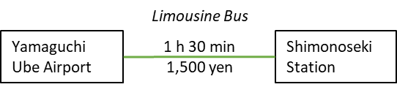

- From Tokyo by Shinkansen
  - By Shinkansen and Local Train
The trip takes about 5 h 30 min and costs about 20,000 JPY. Please take a Shinkansen train from Tokyo to the Kokura Station. Then change to Kagoshima/San-yo Line to the Shimonoseki Station.
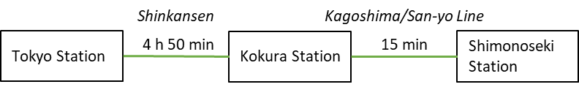

MAP
Meeting venue and recommended hotels

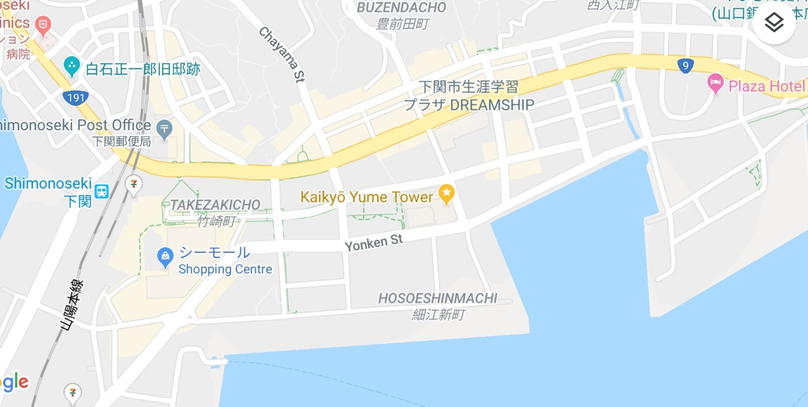
Dormy Inn
Kaikyo Messe
Toyoko Inn
Restaurant Nagoya
Plaza Hotel

MEETING REGISTRATION
Participants will be able to register and pick up their information package from 9:30 to 10:00 on the first day of the meeting. If this registration time is not convenient for you, please ask the Secretariat staff in the meeting room for your registration.

SOCIAL EVENTS
Participants are invited to a reception which will be held in the Nagoya restaurant on 13 November at 7:00-9:00pm.

OTHER INFORMATION

WiFi
SSID: NPFC2019
Password: 20Shimonoseki19

Electricity
The voltage in Japan is 110 Volt. Japanese electrical plugs have two, non-polarized pins which fit into North American outlets, as shown on the picture. A portable plug adaptor may be necessary to use your electronic devices.

EMERGENCY INFORMATION
Police Emergency call – 110
Fire, Ambulance or Emergency call – 119
Emergency Rescue

******************************************************************************
If you have any questions regarding visa, please do not hesitate to contact:
Mr. Ryotaro Okazaki
E-mail: ryotaro_okazaki770@maff.go.jp
Tel: +81-03-3591-1086

If you have any questions regarding meeting preparations, please do not hesitate to contact:
Dr. Aleksandr Zavolokin
E-mail: azavolokin@npfc.int
Tel: +81-3-5479-8717
Attachment 1

Fisheries Agency of Japan is willing to prepare an Invitation Letter for your visa application to attend the scientific meeting which will be held in Shimonoseki, Japan.

Please fill in the required information on the invitee as follows:

EXAMPLE

First Name: Kengo
Last Name: TANAKA
Sex (F/M): M
Organization: Fisheries Agency,
Title: Senior Fisheries Negotiator, Fisheries Agency
Passport Number: YYYY
Date of Birth: August 8, 1962
Date of Issue: March 06 2012
Date of Expiry: March 06 2022
Passport Issuing Authority: Ministry of Foreign Affairs, Japan
Period of Stay in JAPAN: January 20 – January 22, 2015
Place of Applying for visas: Embassy of JAPAN in Moscow, Russia
Arrival Airport: Narita International Airport
Departure Airport: Narita International Airport
Hotel Name: Shinagawa Prince Hotel

First Name:
Last Name:
Sex (F/M):
Organization:
Title:
Passport Number:
Date of Birth:
Date of Issue:
Date of Expiry:
Passport Issuing Authority:
Period of Stay in JAPAN:
Place of Applying for visas:
Arrival Airport:
Departure Airport:
Hotel Name:

Attachment 2

Plaza Hotel Shimonoseki
Room Reservation Form

Please send the reservation form to Ms. Miyoko Mita mmita@npfc.int and the Secretariat Secretariat@npfc.int by 30 October 2019.

Name of Guest |  | Passport/Travel Document Number
Check-in Date |  | Check-out Date
Credit Card Number |  | Name of Credit Card Holder
Type of Room | Rate per night |  | No. of Guests | Smoking/  Non-smoking
Double | 6,000+ JPY (including breakfast and tax) |  |  | Smoking  or  Non-smoking
Twin | 7,000+ JPY (including breakfast and tax) |  |  | Smoking  or  Non-smoking
Payment Method | The room charge shall be paid upon check-out by cash or credit card (Visa, MasterCard, UnionPay, JCB, American Express, Diners, PayPay)
Information | - Check-in time is 14:00. The earlier check-in is subject to room availability. Check-out time is 11:00.
Information | - Cancellation policy:  Free cancellation until 2 days before check-in date;  20% of the room rate if cancelled on the day before check-in;  80% of the room rate if cancelled on the day of check-in;  100% for no-show.

Attachment 3
Bus schedule and fare from/to Fukuoka International Airport or Nishitetsu Tenjin Expressway Bus Terminal to/from Shimonoseki

