NPFC-2019-TWG CMSA02-MIP01 (Rev. 2)

DETAILS FOR THE TWG CMSA MEETING, BRP/HCR/MSE WORKSHOP AND TWG PSSA MEETING
27 February – 9 March 2019
Yokohama, Japan

This is general information to assist you in your travels to the meetings. This information package includes:
- Dates
- Venue of Meetings
- Meeting Contact Documentation
- Visa Information
- Accommodation
- Airport Information and Transport to the Recommended Hotels
- Map
- Meeting Registration
- Social Events
- Other Information

DATES

The meetings commence on 27 February 2019 and carry on through to 9 March 2019 as follows:

2nd meeting of the Technical Working Group on Chub Mackerel Stock Assessment (TWG CMSA):

Informal meeting of Small Working Group on Operating Model for CMSA, 27 February

Plenary of TWG CMSA, 28 February – 2 March

Biological Reference Point/Harvest Control Rule/Management Strategy Evaluation Workshop (BRP/HCR/MSE WS), 4-5 March

4th meeting of the Technical Working Group on Pacific Saury Stock Assessment (TWG PSSA), 6-9 March.

VENUE OF MEETINGS
The meetings shall be held at MM Park Building in Yokohama:
5th Floor, TKP Garden City Premium Minato Mirai,
3-6-3, Minatomirai, Nishi-ku, Yokohama-shi, Kanagawa-ken 220-0012;
Tel: +81-45-650-6701;
Website: https://www.kashikaigishitsu.net/facilitys/gcp-minatomirai/
Meeting and Secretariat room: 5th Floor, Room G.

MEETING CONTACT DOCUMENTATION
Online registration service for participants is on the NPFC website www.npfc.int. Please log in to be able to register. The deadline for registration is February 20, 2019.

VISA INFORMATION
An official invitation letter is essential for participants to apply for a Japanese visa. Please check in advance if you need a Japanese visa for your trip. Each delegation who applies for a Japanese visa is requested to provide information in the form of Attachment 1 by January 28, 2019 to Mr. Ryotaro Okazaki (ryotaro_okazaki770@maff.go.jp).

ACCOMMODATION
Each participant is responsible for making his or her own hotel arrangements. There are many hotels in central Yokohama. Recommended hotels are listed in the table below:
Hotel Name | Transportation | Reservation
New Otani Inn Yokohama Premium | 15-minute walk to the meeting venue. | 15,000+ JPY yen/night  1-1-7 Sakuragi-cho, Naka-ku, Yokohama City, Kanagawa Prefecture 231-8331  http://www.newotani.co.jp/innyokohama/index.html
Hotel Vista Premio Yokohama Minato-Mirai | 10-minute walk to the meeting venue. | 11,000+ JPY/night  6-3-4 Minatomirai, Nishi-ku, Yokohama City, Kanagawa Prefecture 220-0012  https://www.hotel-vista.jp/yokohama-minato-mirai/index_e.html
Washington Hotel Yokohama Sakuragicho | 15-minute walk to the meeting venue. | 13,000+ JPY/night  1-101-1 Sakuragi-cho, Naka-ku, Yokohama City, Kanagawa Prefecture 231-0062  http://yokohama-s.washington-hotels.jp/
AIRPORT INFORMATION AND TRANSPORT TO THE RECOMMENDED HOTELS
The venue of the meetings, MM Park Building, is located near Minatomirai Station on the Minatomirai Line in Yokohama. Two of the recommended hotels, New Otani Inn and Washington, are situated close to Sakuragicho Station on the JR Negishi Line. The hotel Vista Premio Yokohama Minato-Mirai is within 5-10-minute walk from Minatomirai Station.

- From Haneda International Airport to hotels in Sakuragicho, Yokohama (recommended airport for easy access to the meeting venue)
  - By Train
The trip takes about 30 minutes and costs about 600 JPY. Please travel to Yokohama Station by Keikyu Line. Then change to Negishi Line and get off at the next station, Sakuragicho. The recommended hotels (New Otani Inn and Washington) are within walking distance (1-3 min).
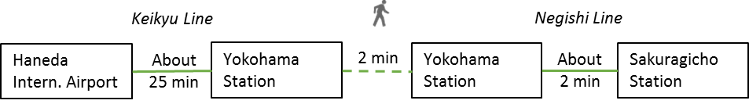

  - By Limousine Bus and Taxi
The trip takes about 40 minutes and costs 2,000-2,500 JPY. Please take the Limousine Bus bound for Yokohama City Air Terminal (YCAT). Then take a taxi to hotels in Sakuragicho area (New Otani Inn and Washington). For timetable and more information on the Limousine Bus, please visit http://www.ycat.co.jp/en/
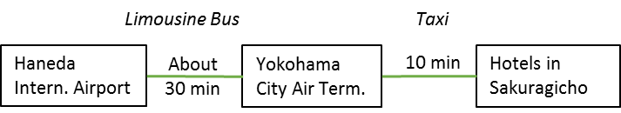

- From Narita International Airport to hotels in Sakuragicho, Yokohama
  - By Train
The trip takes about 90 minutes and costs about 4,000-4,500 JPY. Please travel to Yokohama by JR Narita Express (N’EX). Then change to Negishi Line and get off at the next station, Sakuragicho. The recommended hotels (New Otani Inn and Washington) are within walking distance (1-3 min). For timetable and more information, please visit: N’EX http://www.jreast.co.jp/e/nex/index.html
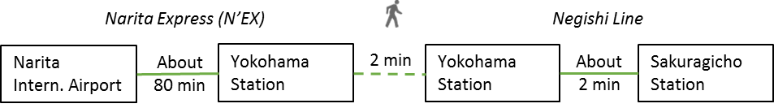

  - By Limousine Bus and Taxi
The trip takes about 2 hours and costs 5,000-6,000 JPY. Please take the Limousine Bus bound for Yokohama City Air Terminal (YCAT). Then take a taxi to hotels in Sakuragicho area (New Otani Inn and Washington). For timetable and more information on the Limousine Bus, please visit http://www.ycat.co.jp/en/
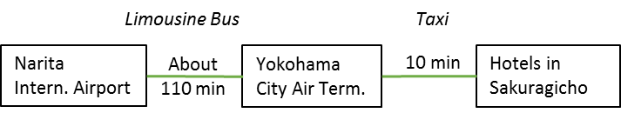

MAP
Meeting venue and recommended hotels in Sakuragicho and Minatomirai areas
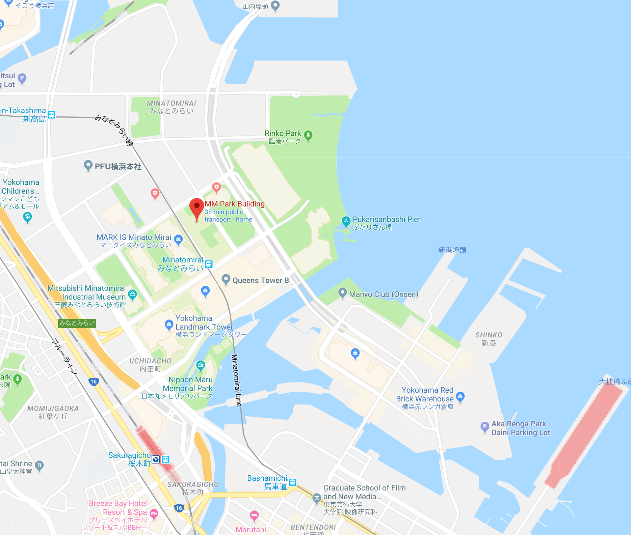
Restaurant Musee
Meeting venue
Hotel Vista Premio
Washington Hotel
New Otani Inn
MEETING REGISTRATION
Participants will be able to register and pick up their information package from 8:30 to 9:00 on the first day of each meeting. If this registration time is not convenient for you, please ask the Secretariat staff in the meeting room for your registration.

SOCIAL EVENTS
Participants are invited to a reception which will be held in the Restaurant Musée (www.musee-ts.com) on March 6 at 6:30-9:00pm.

OTHER INFORMATION
WiFi
SSID: NPFC2019
Password: 20Yokohama19

Electricity
The voltage in Japan is 110 Volt. Japanese electrical plugs have two, non-polarized pins which fit into North American outlets, as shown on the picture. A portable plug adaptor may be necessary to use your electronic devices.

EMERGENCY INFORMATION
Police Emergency call – 110
Fire, Ambulance or Emergency call – 119
Emergency Rescue

******************************************************************************
If you have any questions regarding visas, please do not hesitate to contact:
Mr. Ryotaro Okazaki
E-mail: ryotaro_okazaki770@maff.go.jp
Tel: +81-03-3591-1086

If you have any questions regarding meeting preparations, please do not hesitate to contact:
Dr. Aleksandr Zavolokin
E-mail: azavolokin@npfc.int
Tel: +81-3-5479-8717
Attachment 1

Fisheries Agency of Japan is willing to prepare an Invitation Letter for your visa application to attend the scientific meetings which will be held in Yokohama, Japan.

Please fill in the required information on the invitee as follows:

EXAMPLE

First Name: Kengo
Last Name: TANAKA
Sex (F/M): M
Organization: Fisheries Agency,
Title: Senior Fisheries Negotiator, Fisheries Agency
Passport Number: YYYY
Date of Birth: August 8, 1962
Date of Issue: March 06 2012
Date of Expiry: March 06 2022
Passport Issuing Authority: Ministry of Foreign Affairs, Japan
Period of Stay in JAPAN: January 20 – January 22, 2015
Place of Applying for visas: Embassy of JAPAN in Moscow, Russia
Arrival Airport: Narita International Airport
Departure Airport: Narita International Airport
Hotel Name: Shinagawa Prince Hotel

First Name:
Last Name:
Sex (F/M):
Organization:
Title:
Passport Number:
Date of Birth:
Date of Issue:
Date of Expiry:
Passport Issuing Authority:
Period of Stay in JAPAN:
Place of Applying for visas:
Arrival Airport:
Departure Airport:
Hotel Name:

